**LAB # 07**

functions

# *OBJECTIVE:*

*Create python function using different arguments types*

HOME tasks

***EXERCISE***

1. ***Point out the errors, if any, and paste the output also in the following Python programs.***

**Code 1**

* **Code(incorrect)**

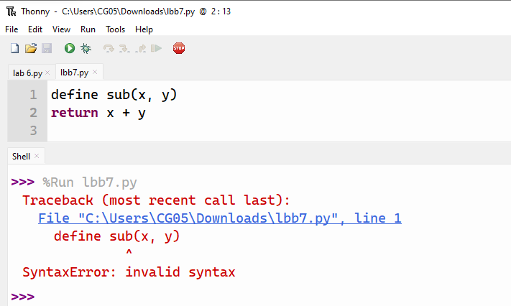

* **Code(correct one):**

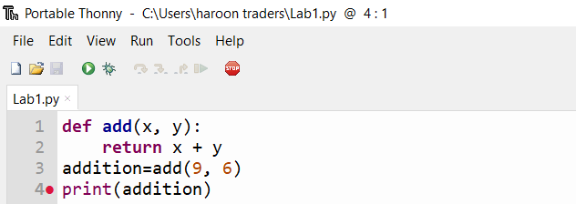

* **Output:**

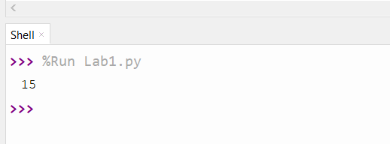

**Code 2**

* **Code(incorrect)**

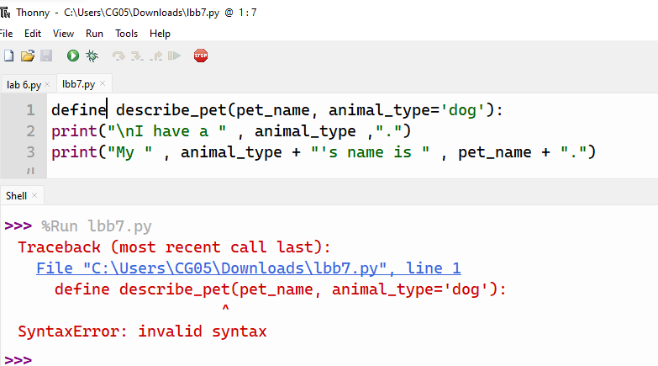

* **Code(correct one):**

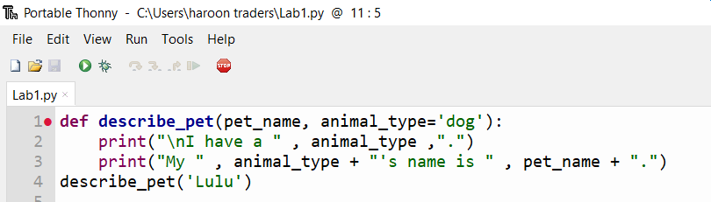

* **Output:**

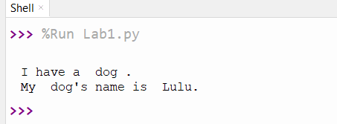

**Code 3**

* **Code(incorrect)**

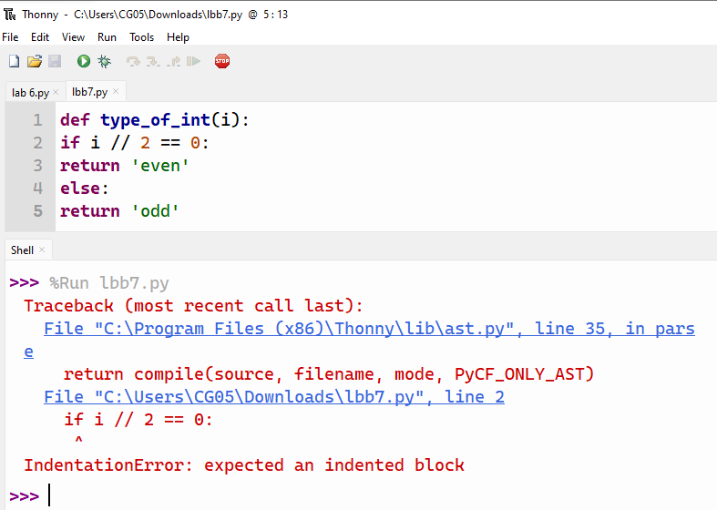

* **Code(correct one):**

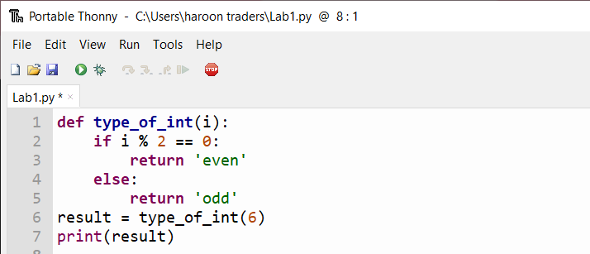

* **Output:**

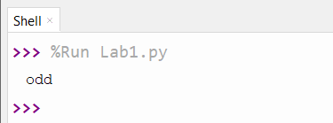

1. ***What would be the output of the following programs:***

**Code 1**

* **Code:**

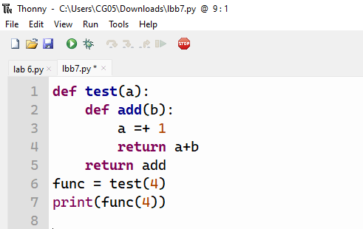

* **Output:**

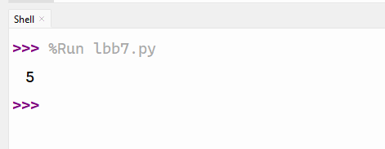

**Code 2**

* **Code:**

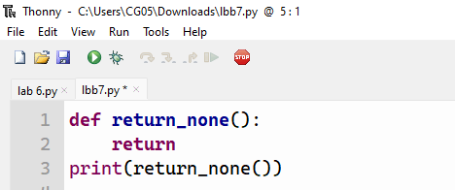

* **Output:**

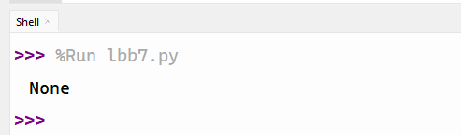

**Code 3**

* **Code:**

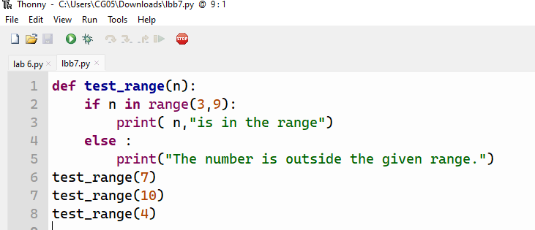

* **Output:**

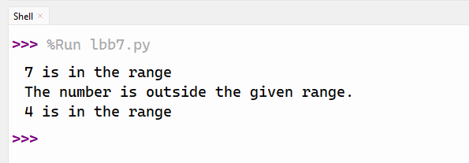

1. ***Write Python programs for the following****:*

*Write a function called favorite_book() that accepts one parameter, title. The function should print a message, such as One of my favorite books is Alice in Wonderland. Call the function, making sure to include a book title as an argument in the function call*

**Code 1**

* **Code:**

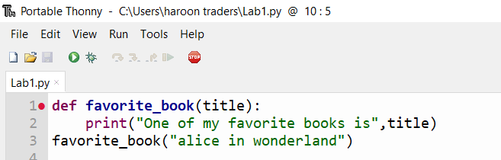

* **Output:**

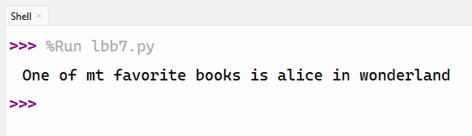

*2. Write a function called max( ), that returns the maxium of three integer numbers.*

**Code 2**

* **Code:**

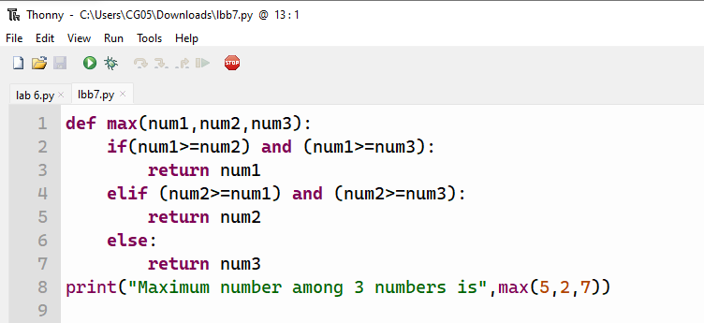

* **Output:**

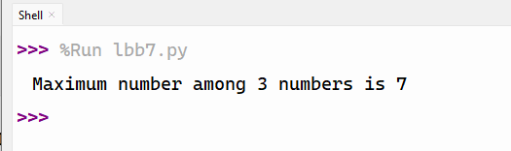

**OR**

* **Code:**

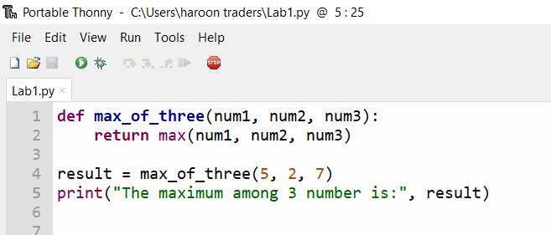

* **Output:**

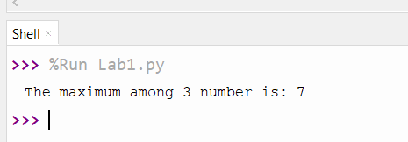

*3. Write a Python program to find GCD of two numbers*

**Code 3**

* **Code:**

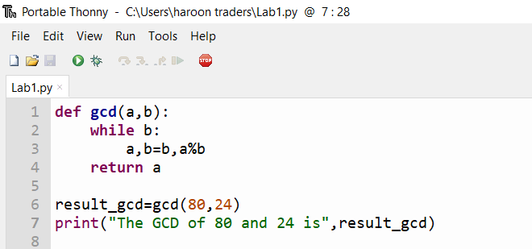

* **Output:**

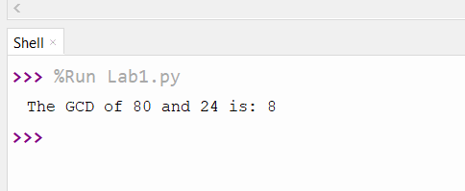

*Write a function called describe_city() that accepts the name of a city and its country. The function should print a simple sentence, such as Reykjavik is in Iceland. Give the parameter for the country a default value. Call your function for three different cities, at least one of which is not in the default country*

**Code 4**

* **Code:**

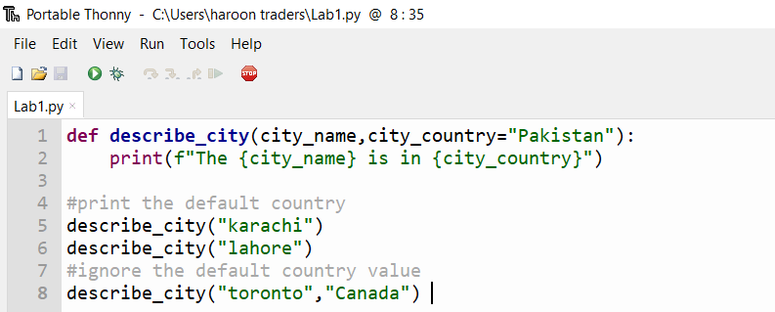

* **Output:**

