**LAB # 08**

listing

# *OBJECTIVE:*

*Exploring list/arrays in python programming*

HOME tasks

***EXERCISE***

1. ***Point out the errors, if any, and paste the output also in the following Python programs.***

**Code 1**

* **Code(incorrect)**

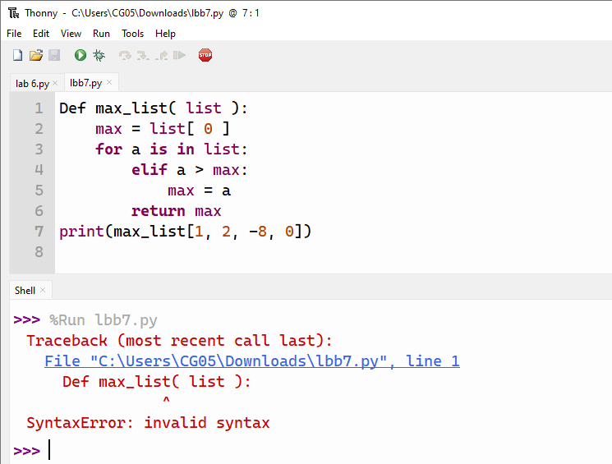

* **Code(correct one):**

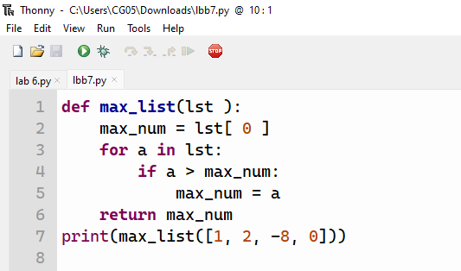

* **Output:**

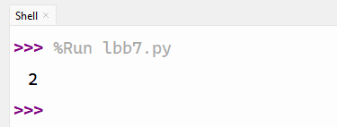

**Code 1**

* **Code(incorrect):**

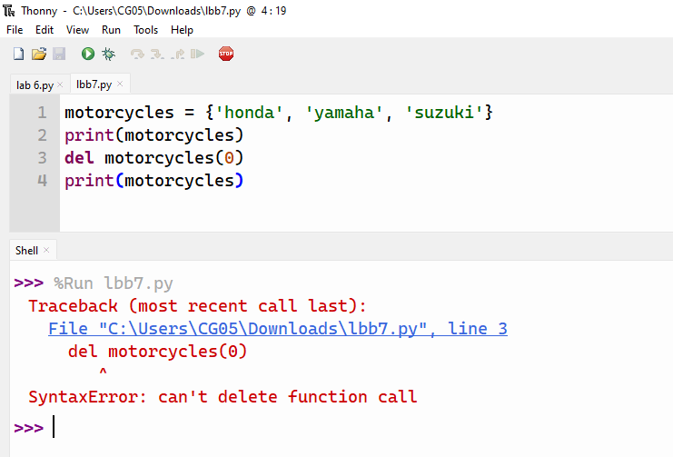

* **Code(correct one):**

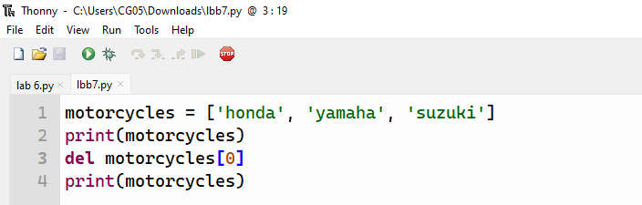

* **Output:**

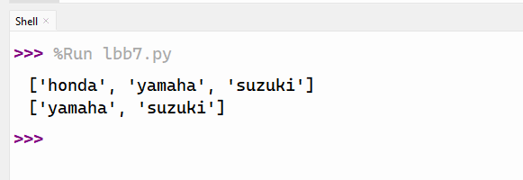

**Code 3**

* **Code(incorrect):**

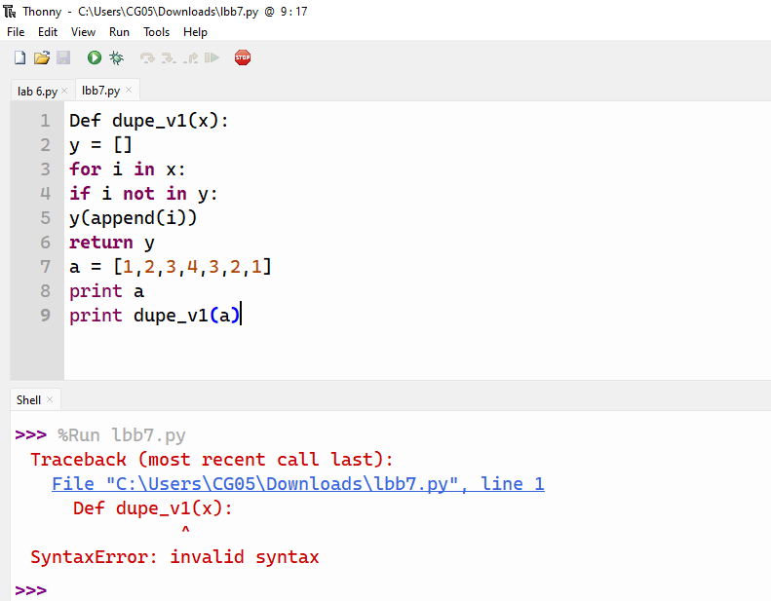

* **Code(correct one):**

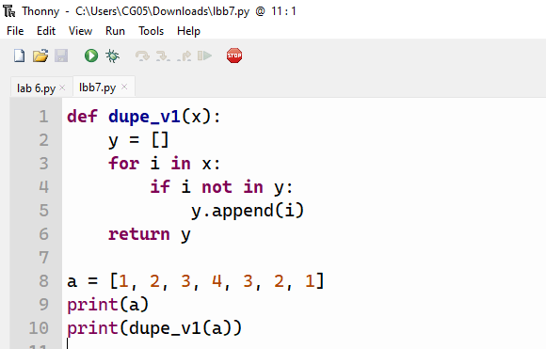

* **Output:**

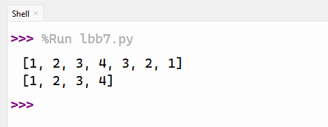

1. ***What would be the output of the following programs:***

**Code 1**

* **Code**

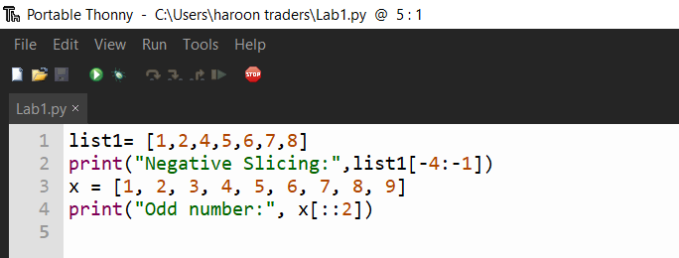

* **Output:**

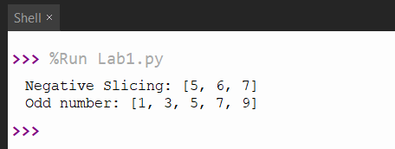

**Code 2**

* **Code**

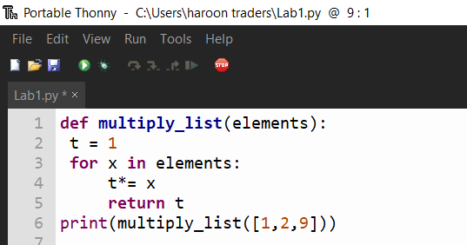

* **Output:**

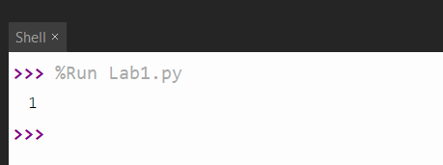

**Code 3**

* **Code**

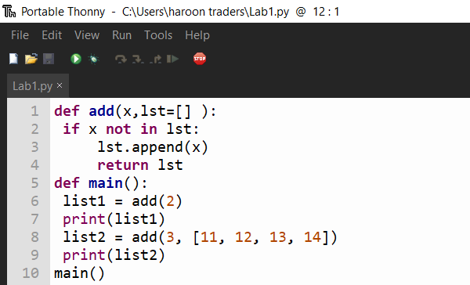

* **Output:**

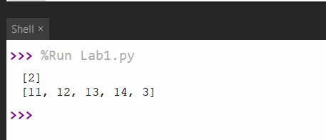

* ***Write Python programs for the following***

**Code 1**

1. *Write a program that store the names of a few of your friends in a list called ‘names’. Print each person’s name by accessing each element in the list, one at a time.*

* **Code**

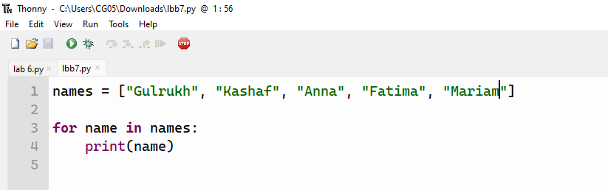

* **Output:**

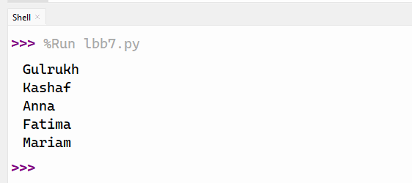

**Code 2**

2*.Write a program that make a list that includes at least four people you’d like to invite to dinner. Then use your list to print a message to each person, inviting them to dinner. But one of your guest can’t make the dinner, so you need to send out a new set of invitations. Delete that person on your list, use del statement and add one more person at the same specified index, use the insert( ) method. Resend the invitation*

* **Code:**

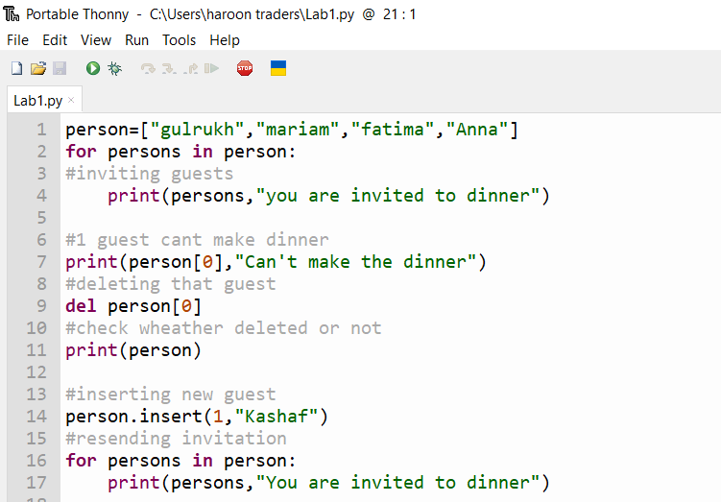

* **Output:**

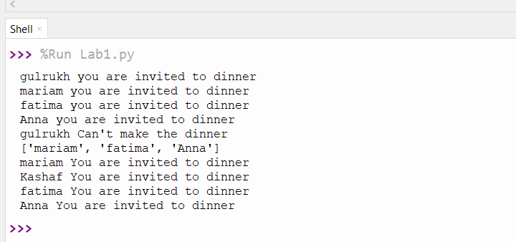

**Code 3**

1. *Write a program that take list = [30, 1, 2, 1, 0], what is the list after applying each of the following statements? Assume that each line of code is independent.* • *list.append(40)* • *list.remove(1)* • *list.pop(1)* • *list.pop()* • *list.sort()* • *list.reverse()*

* **Code**

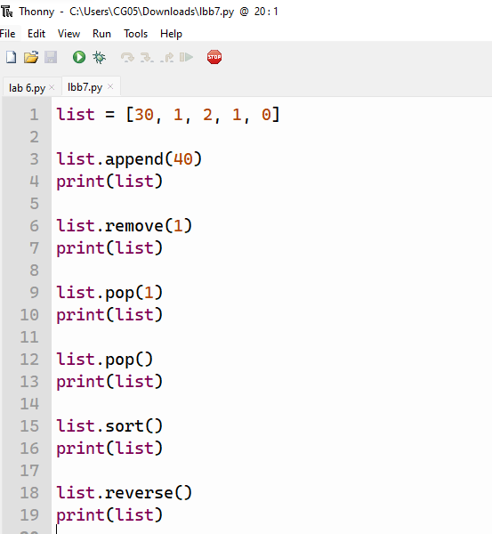

* **Output:**

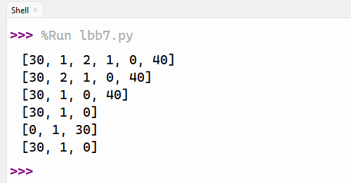

*3. Write a program to define a function called ‘printsquare’ with no parameter, take first 7 integer values and compute their square and stored all square values in the list*

* **Code**

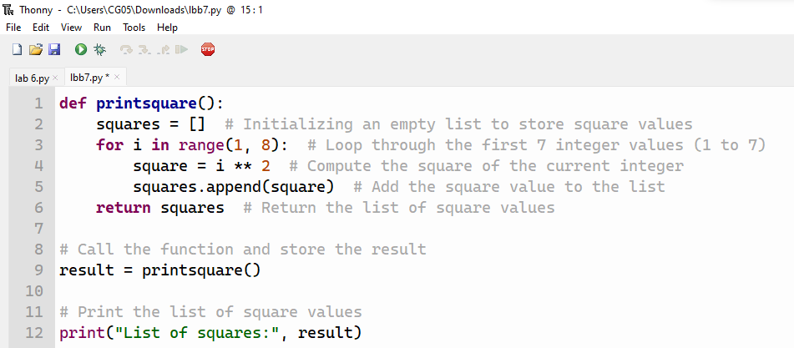

* **Output:**

