**LAB # 09**

SEARCHING & SORTING

# *OBJECTIVE:*

*Searching and sorting data in the form of list*

HOME tasks

***EXERCISE***

1. ***Point out the errors, if any, and paste the output also in the following Python programs.***

**Code 1**

* **Code(incorrect)**

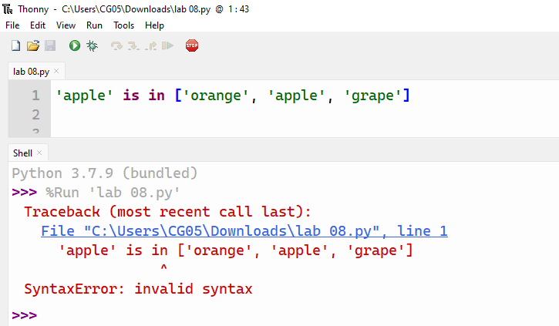

* **Code(correct one):**

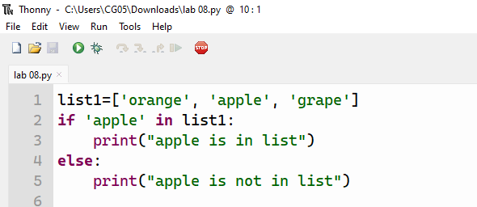

* **Output:**

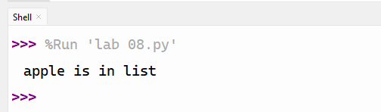

**Code 2**

* **Code(incorrect)**

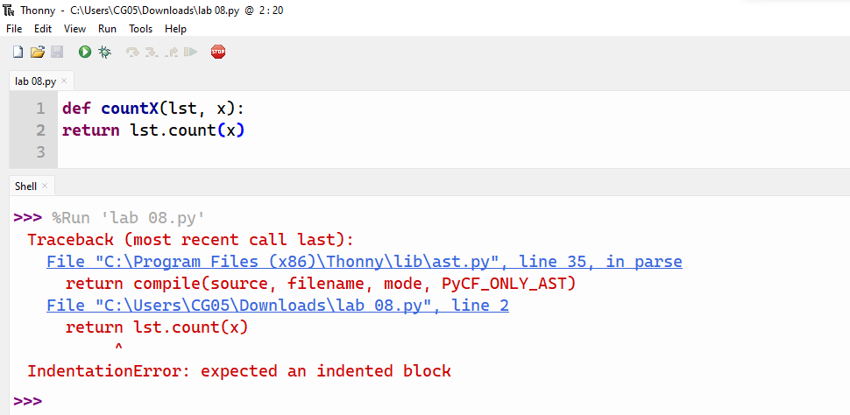

* **Code(correct one):** *the interpreter doesnot throw an error because you only define the function*

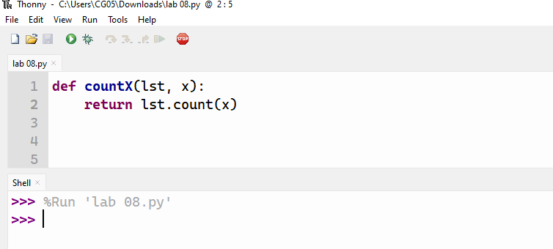

1. ***What would be the output of the following programs***

**Code 1**

* **Code:**

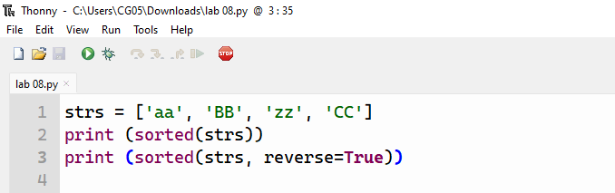

* **Output:**

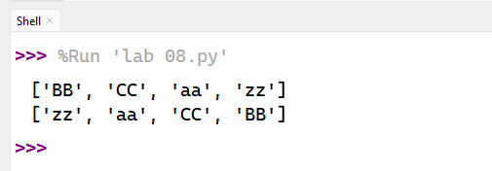

**Code 2**

* **Code:**

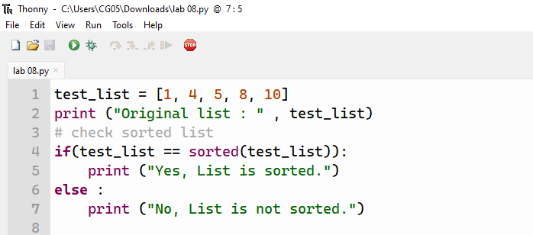

* **Output:**

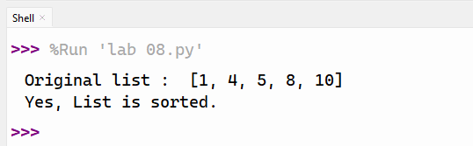

1. ***Write Python programs for the following****:*

*Write a program that take function which implements linear search. It should take a list and an element as a parameter, and return the position of the element in the list. The algorithm consists of iterating over a list and returning the index of the first occurrence of an item once it is found. If the element is not in the list, the function should return ‘not found’ message.*

* **Code:**

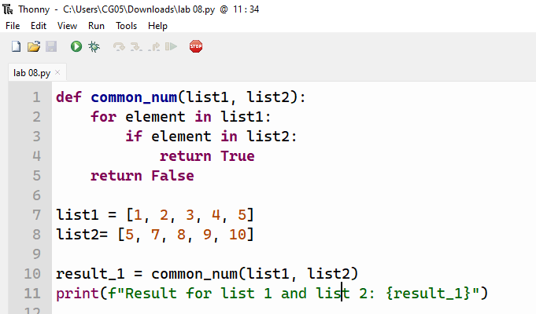

* **Output:**

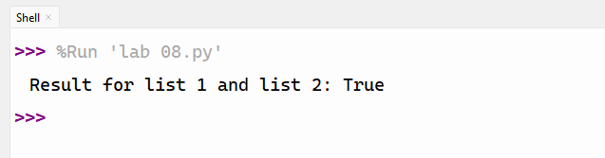

*Write a program that create function that merges two sorted lists and call two list with random numbers*.

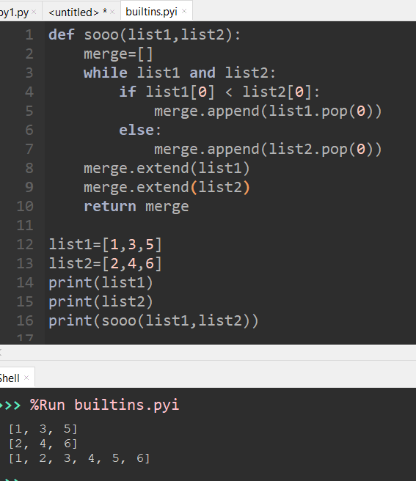

*Write a program that create function that takes two lists and returns True if they have at least one common member. Call the function with atleast two data set for searching.*

* **Code:**

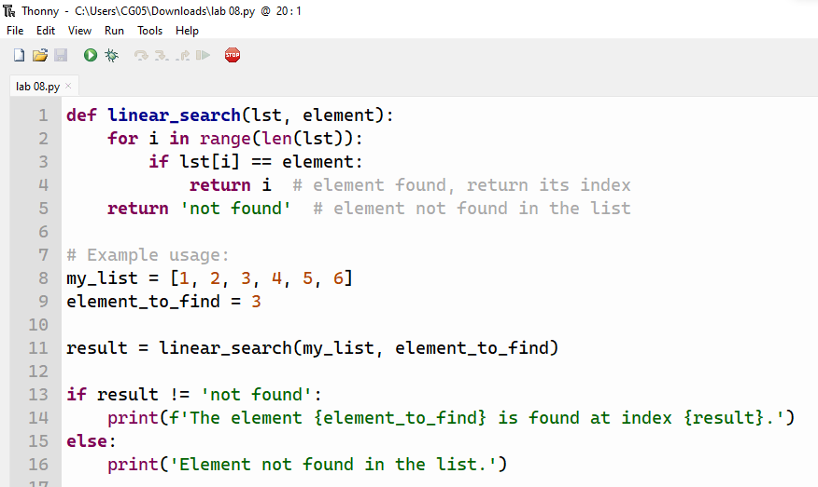

* **Output:**

