Software Requirements Specification

for

ProMag

Version 1.0

Prepared by

Group Name: ProMag Team

|  |  |  |
| --- | --- | --- |
| Gulrukh | CS-017 | [*786gul92@gmail.com*](mailto:786gul92@gmail.com) |
| Nimra Sadaqat | CS-026 | [*nimra.sadaqat@gmail.com*](mailto:nimra.sadaqat@gmail.com) |
| Zoya Shahbaz | CS-028 | [zoyashahbaz@yahoo.com](mailto:zoyashahbaz@yahoo.com) |
|  |  |  |
|  |  |  |

|  |  |
| --- | --- |
|  |  |
|  |  |
|  |  |
| Instructor: | Sir Kashif Asrar |
| Date: | 17 Feb 2017 |

Contents

Revisions iv

1 Introduction 1

1.1 Document Purpose 1

1.2 Product Scope 1

1.2.1 Description 1

1.2.2 Benefits 1

1.2.3 Corporate Goals or Business Strategy 1

1.3 Intended Audience and Document Overview 1

1.4 Definitions, Acronyms and Abbreviations 2

1.4.1 Android Studio 2

1.4.2 Integrated Development Environment (Ide) 2

1.4.3 Firebase 2

1.4.4 Admin 2

1.4.5 Login Id 2

1.4.6 GUI 2

1.4.7 Smart Device 2

1.5 Document Conventions 2

1.6 References and Acknowledgments 3

2 Overall Description 4

2.1 Product Perspective 4

2.2 Product Functionality 5

2.3 Users and Characteristics 5

2.4 Operating Environment 5

2.5 Design and Implementation Constraints 5

2.6 User Documentation 6

2.7 Assumptions and Dependencies 6

2.2.1 Assumptions 6

2.2.2 Dependencies 6

3 Specific Requirements 7

3.1 External Interface Requirements 7

3.1.1 User Interfaces 7

3.1.2 Hardware Interfaces 10

3.1.3 Software Interfaces 11

3.1.4 Communications Interfaces 11

3.2 Functional Requirements 11

3.2.1 For User 11

3.2.2 For Project Head 12

3.3 Behaviour Requirements 13

3.3.1 Use Case View 13

4 Other Non-functional Requirements 14

4.1 Performance Requirements 14

4.1.1 Scalability 14

4.1.2 Efficiency 14

4.1.3 Response time 14

4.1.4 Work load 14

4.1.5 Contracturial consideration 14

4.2 Safety and Security Requirements 14

4.2.1 Safety Requirements 14

4.2.2 Security requirements 14

4.3 Software Quality Attributes 15

4.3.1 Reusability 15

4.3.2 Interoperability 15

4.3.3 Availablity 15

4.3.4 Correctness 15

4.3.5 Reliablity 15

5 Other Requirements 16

Appendix A – Data Dictionary 17

Revisions

| Version | Primary Author(s) | Description of Version | Date Completed |
| --- | --- | --- | --- |
| Draft Type and Number | Full Name | Information about the revision. This table does not need to be filled in whenever a document is touched, only when the version is being upgraded. | 00/00/00 |

# 

# Introduction

ProMag is the project management software that enable it’s user to manage the projects easily,effectively and efficiently. Its chatting capability make the interaction between project members effective and availability of documents make the project scheduling easier.

## Document Purpose

This Software Requirements Specification provides a complete description of all the functions and specifications of the ProMag application.

It will explain the purpose and features of the application, its interface, what will it do and the constraints under which it must operate.

The main purpose of the ProMag is the effective management of the project that is an essential part of any project development. Efficient and effective project management leads to projects success. In ProMag any user can create a project and add members to the project. Each member is then assigned different tasks and the deadline is given to achieve that task. The tasks are stored in a repository that can be accessed by any member of the group. Members can interact with each other through chat facility. Time efficiency, updated scheduling, good communication between the team make the project management easier

## Product Scope

### Description

This application can facilitate students, freelancers, project developers or an organization to manage their projects effectively and efficiently.

### 1.2.2 Benefits

There are various benefits of managing project through ProMag some of them are that its cost and time effective, accurate, updated, and availability of interaction between each member of the group via chat facility, all these properties are responsible for effective project management.

### Corporate Goals or Business Strategy

This application will make project management simple i.e. interaction between members; updated and compiled project data saves a lot of work and project can be managed effectively.

Having an efficient and customized chatting facility saves a lot of effort and time, because usually, problems are solved easily through interaction between the members.

Through this application an Organization can cross-analyze the project progress and project schedule and then can take efficient decisions using that analysis.

## Intended Audience and Document Overview

This document is intended to be submitted to the teacher and also for developer’s ease.

The rest of this SRS is organized as follows:

* Section 2 gives an overall description of the software. It gives what level of proficiency is expected of the user, some general constraints while making the software and some assumptions and dependencies that are assumed.
* Section 3 contains most important features presented with detailed description, and requirements. It gives specific requirements which the software is expected to deliver. Functional requirements are given in this section. This section is written primarily for the developers and describes in technical terms the details of the functionality of the product and about safety and performance.
* Section 4 will contain nonfunctional requirements of the product.
* Section 5 will contain other requirements that are not covered in SRS.

## Definitions, Acronyms and Abbreviations

### Android Studio

It is an official IDE used for creating android applications. It is specifically designed for android app

### Integrated Development Environment (Ide)

An integrated development environment (IDE) is a software suite that consolidates the basic tools developers need to write and test software. Typically, an IDEcontains a code editor, a compiler or interpreter and a debugger that the developer accesses through a single graphical user interface (GUI).

### Firebase

Firebase is a [mobile](https://en.wikipedia.org/wiki/Mobile_application) and [web application](https://en.wikipedia.org/wiki/Web_application) platform with tools and infrastructure designed to help developers build high-quality apps. Firebase is made up of complementary features that developers can mix-and-match to fit their needs

### Admin

ADMIN stands for Administration. ADMIN in this project will be a project manager of each project.

### Login Id

ID stands for identification. Login ID is used to login into the application.

### GUI

GUI stands for graphical user interface. A user interface based on graphics (icons and pictures and menus) instead of text; uses a mouse as well as a keyboard as an input device, where the user clicks on a visual screen that has icons, windows and menus, by using a pointing device. GUI makes it easy for the user, therefore makes user-friendly.

### Smart Device

A smart device is an electronic device that is cordless (unless while being charged), mobile (easily transportable), always connected (via Wi-Fi, 3G, 4G etc.) and is capable of voice and video communication, internet browsing, "geo-location" (for search purposes) and that can operate to some extent autonomously.

## Document Conventions

In general this document follows the IEEE formatting requirements. Use Arial font size 11, or 12 throughout the document for text. Use italics for comments. Document text should be single spaced and maintain the 1” margins found in this template. For Section and Subsection titles please follow the template.

## References and Acknowledgments

* IEEE Std 830-1998 .IEEE Recommended Practice for Software Requirements Specifications. IEEE Computer Society, 1998.
* http://www.scribd.com/doc/9138468/Software-Requirement-Specification-SrsMidtems
* <http://www.processimpact.com/process_assets/srs_template.doc>
* https://www.lucidchart.com

# Overall Description

## Product Perspective

This is a mobile based application that enables project development in a systematic manner, this will provide a platform for systematic, on time and more productive project development. It includes subsystems needed to fullfill software requirements for project management. In addition, the Promag has interfaces to the external system such as firebase that provide database services, which is the major subsystem for this project.Promag will use firebase services for chat.firebase will act as a media between phone and cloud server for data transfer.

Other subsystems for ProMag include “Accounts” that will be focusing on the management of user accounts their data and chats, furthermore it has subsystem for “document management” this will maintain the documents, uploads by the user and content related to certain project so that the users could easily access it. Another subsystem is for “project management” that will deal with projects created, project team , task assigned and folders. Chat is another important feature of this application.

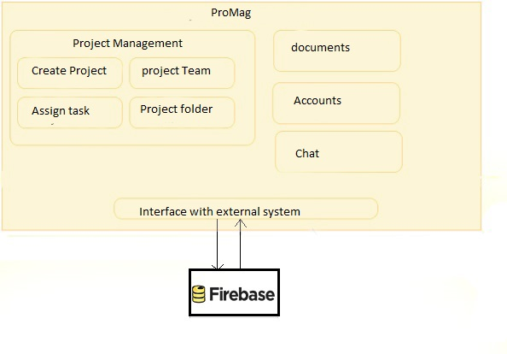

## Product Functionality

The following list offers a brief outline and description of the main functionalities of the SplitPay system.

* provides a framework for project management
* supports multiple projects
* provides user account managment
* supports distributed development(modular approach)
* allows to define task
* supports resource management i.e sharing of documents.
* provides user accounts management
* Enabling members to communicate through chat.

## Users and Characteristics

The system is intended to be used by various users, this could be used for software development process whether it is to be done by student or by software houses.each project would have a project head and team members.Any user can create a project and add team members, the one who creates project is fuctionally a team head and can assign task to other members.

|  |  |
| --- | --- |
| Project Head | Create project, create project team and assigns individual tasks to the team members, project head have the right to delete a project or review project. |
| Project Team Member | Responsible for a particular task or part of a task. They have their own account, can share documents through uploading or creating folders and discuss project progress with other members of the team through chat |

## Operating Environment

For operating it on computer systems using an emulator, 3 GB RAM minimum, and 8 GB RAM is recommended, Windows 10/8/7 (32- or 64-bit) operating systems can support this software.

For operating on a smart android device android version Android 2.3 "Gingerbread” or above is required with API level 24 or above . If the above specified hardware and software environment is used it can coexist with most of the other applications.

## Design and Implementation Constraints

Some of the design and implementation constraints are as follows:

* Insufficient RAM can cause a trouble in running this software.
* Backward version of android will not be supported.
* Windows 10 is recommended.
* Latest version of android sdk is required.
* Latest JDK is required.

## User Documentation

User needs a manual that defines the flow of how this software will help him in development, after that he need to know how to start the project, adding members, assigning task to each member, managing the upload and download of the documents , managing files that are being shared by the team members and how to review project if project is behind shedule.user must be provided with help regarding managing this own personal user account. All these information needs to be provided to help out the user.

## Assumptions and Dependencies

### Assumptions

For PorMag it is assumed that, it will be supported by the android version on phone when the finished product will be tested on mobile, as it is supported on emulator during development stages.

### Dependencies

This application is highly dependent on android version of the smart device and internet availability. This application also depends on the users using this application. User must be previously familiar with the use of android application to operate ProMag.

# Specific Requirements

## External Interface Requirements

### User Interfaces

#### Welcome Screen



This screen will be shown to the user until the register page is loaded.

#### Register Page

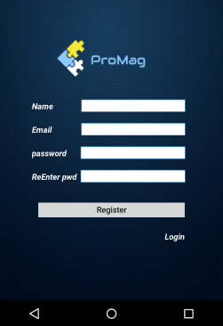

* For first-time users only
* Prompts the user to enter account information to be stored on the server
* Notifies the user if their information is invalid

#### Login Page

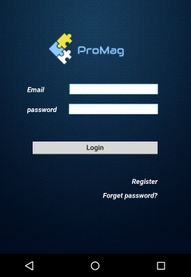

* If the user is already registered, he can navigate from registration page to the login page
* Prompts the user to enter validated email address and password
* Notifies the user if their information is invalid
* Also help the user to recover password if he forgets password

#### Dashboard

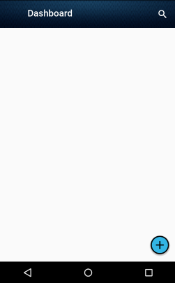

* Shows all projects, and how much the user owes the projects collectively
* User can select a project to open a View Project (in a separate menu)
* It will also contain a navbar which will help the user to navigate through the app

#### Navbar

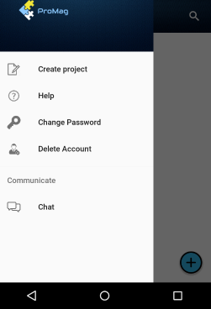

* Help option will provide the user a user manual
* Change Password will allow the user to change his/her password by providing the recent password
* Delete Account will allow the user to delete his/her account by providing the recent password
* Create Project will allow the user to create a new project

#### Create Project

* Prompts user to name the project
* Allows the user to select members by searching them through their email address
* Allows the user to assign task to the member
* Allows the user to add documents to the project
* The project creator will have the role of “Project Head”

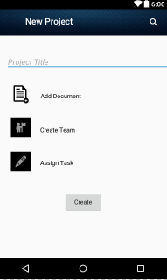

#### View Project

* Allows the user chat with other members of the project
* Allows the user to views or download documents added by the project head
* Allows the user to view task status of other members or view documents
* Allows the user to change the status of his task and share documents related to task with other members
* Shows (graphically) how much the users owes or is o
* wed by each member of the group
* Group leaders have additional options
* Add / Remove members
* Change status of any task
* Change due date of any task
* Delete task
* Delete project

### Hardware Interfaces

ProMag is intended as a mobile application for the Android platform and hence is solely supported on Android-powered devices. By using the standard programming tools for Android (Android Studio 2.2.3) we are able to let the built in functionality to mask the hardware interface. Since the application must run over the internet, so the hardware will require to connect internet. Messages and data exchanged between Android devices are transmitted to and handled by the application server. This produces the illusion of peer-to-peer interactivity between group members, however this is not the case as all interactions always run through the central server first.

### Software Interfaces

The ProMag app is to be developed under the Android operating systems using the Java JDK (Java Development Kit) and the Android SDK (software development kit) tools. ProMag is being developed specifically for Android 2.3 (Gingerbread) and all versions released after it. The Android platform supports push messages that will be used to synchronize data between the local application and the main application server.

#### Incoming and outgoing items

* Incoming items consists of invitations of projects, messages, documents and notifications about due dates of assigned tasks from server to the user.
* Outgoing items consists of projects created, project members, tasks, due dates, messages and documents sent by the user to the server.

#### Services and communications

Promag relies on Firebase server push and pull protocols to be fully functional. Communication will occur in occasional, short bursts between a user’s phone and the Firebase server in the following situations:

* Whenever a new user creates account
* Whenever a new project is created and members are added to it
* Whenever a task is created and due date is assigned to the task
* Whenever a user uploads or downloads a document
* Whenever the user sends or receives a message

### Communications Interfaces

The ProMag application will be using FireBase platform. Firebase provides a real time database, storage area and backend as a service. The application calls for a real time database that stores user information and details of the projects created by users. The Firebase platform uses HTTP

server protocol. The HTTP server protocol will use a push protocol to push notifications of updates onto the Android phones. Furthermore, whenever a user opens the ProMag app from their phone, a pull protocol will be used to retrieve and sync the latest project, documents and messaging updates from the server.

## Functional Requirements

### For User

#### User Registration

When the application is installed and run for the very first time, the user is presented with an initial registration/welcome screen. This screen prompts the user to create an account on the ProMag server using the display name, email address and password. Completing this process will create and store an account for the user on the ProMag server enabling all of the application’s synchronization capabilities. After completing the registration, user is taken to main screen.

#### Dashboard

The Dashboard screen will be the main screen of application. From this screen the user will be able to view and manage existing Projects. There is a notification option on the dashboard which will notify the user about the updates in the projects. The dashboard also contains a navigation bar which provides the options of Create Project, Change Password and Delete Account to the User.

* If the user selects Change Password he will be presented with a form asking for the existing password and new password
* If the user selects Delete Account he will be presented with a form asking for the existing password and confirm deleting account
* If the user selects Create Project he will be able to create new project

#### View and Manage Existing Project

The user can view any project from the dashboard. By selecting any project he will be taken to a new screen. This screen prompts the user to select chat, tasks, documents of that project:

* If the user selects chat he will be able to view chat and he will be able to chat with other members of the project
* If the user selects documents he will be able to view the documents added in the project, download them or share a document with other members
* If the user selects tasks, he will be able to view tasks and my task. By selecting other task he will be able to view the tasks status, their due dates and and documents attached to the tasks. By selecting my task he will be able to change task status, share document related to that task and view the due date of the task.

### For Project Head

Any user who creates the project will be the project head.

#### Project Creation

By selecting the create project option from dashboard the user is presented a screen asking for Project Title, Add Members, Create task. If the user selects add members option he will be able to add members by searching them through their email address. If the user selects create task he will be presented a new screen asking for task name, assign task and due date.

#### View and manage Project

The project head can view and change the status of all tasks. He will be able to view and add documents in all tasks. He will also be able to change the due date of task or delete any task.

## Behaviour Requirements

### Use Case View

# Other Non-functional Requirements

## Performance Requirements

### Scalability

ProMag should be able to handle a number of User. For eample 1000 users at a time.

### Efficiency

Performance should not be an issue because all of our server queries involve small pieces of data. Changing screens will require very little computation and thus will occur very quickly.

### Response time

The transaction response ,that is document upload or download time, effects the performance of software so it should take minimum time, so the online Firebase that have fastest response time but it also depends on the internet connectivity.

### Work load

Workload is defined as the work, a system can support . Increase in workload can be managed easily in this system because of use of Firebase.

### Contracturial consideration

The project should be completed before due date and should be properly tested and verified by the due date. Requirements specified by this document and abstract should be accomplished.

## Safety and Security Requirements

### Safety Requirements

* ProMag will not affect data stored outside of its servers nor will it affect any other applications installed on the user’s phone.
* It cannot cause any damage to the phone or its internal components.
* No such heavy downloadable in the software which can lead to system crash.
* The only potential safety concern associated with this application applies to virtually all handset apps: ProMag should not be used while operating a vehicle or in any other situation where the user’s attention must be focused elsewhere.

### Security requirements

* No external user will be allowed to have access to the FireBase server.
* The new profile formed is validated against the given email address.
* Only the project members can acces the project’s content.
* The app or app’s database should not be manipulated by the user. In case of any such manipulation by the registered user, strict actions to be taken for the safety of safety of the system.

## Software Quality Attributes

### Reusability

Promag is based on such subsystems which can be reused in various mobile applications. Subsystems like chat, documents managment and account management can be reused in number of mobile applications. This Software will be beneficial for implementing future softwares as well.

### Interoperability

ProMag will be interoperabile, it will be uploading documents from the file area of the mobile phone hence using the file manager, and downloaded documents will be stored in file area of the mobile.This communication and exchange of information with other internal systems of the mobile make PorMag interoperabile.

### Availablity

As ProMag is an online android application and is operable in all android devices with version 4.3 and above, we can say that its availability is high.

### Correctness

Specifications defined in this document are completely implemented in ProMag which shows its correctness.

### Reliablity

Reliability of software depends on correctness and availability of software as both attributes are available in this software we can say that ProMag is reliable.

# Other Requirements

<This section is **Optional.** Define any other requirements not covered elsewhere in the SRS. This might include database requirements, internationalization requirements, legal requirements, reuse objectives for the project, and so on. Add any new sections that are pertinent to the project.>

Appendix A – Data Dictionary

**User Table:**

|  |  |  |  |
| --- | --- | --- | --- |
| Field ID | Caption | Data Type | Field Size |
| u_name | User Name | String | - |
| u_email | Email Address | String | - |
| u_password | Password | String | Min 6 letters |

**Project Table:**

|  |  |  |  |
| --- | --- | --- | --- |
| Field ID | Caption | Data Type | Field Size |
| p_name | Name | String | 20 |
| p_date | Date of Creation | timespan | - |
| p_id | Project ID | Integer | - |

**Project Members:**

|  |  |  |  |
| --- | --- | --- | --- |
| Field ID | Caption | Data Type | Field Size |
| P_id | Project ID | Integer | - |
| M_email | Member’s email | String | - |

**Project Folder:**

|  |  |  |  |
| --- | --- | --- | --- |
| Field ID | Caption | Data Type | Field Size |
| p_id | Project ID | Integer | - |
| F_name | Folder name | String | 20 |

**Project Messages:**

|  |  |  |  |
| --- | --- | --- | --- |
| Field ID | Caption | Data Type | Field Size |
| P_id | Project ID | Integer | - |
| S_name | Sender Name | String | - |
| m-datetime | Message Date Time | Timespan | - |
| message | Message | String | - |

**Project Tasks:**

|  |  |  |  |
| --- | --- | --- | --- |
| Field ID | Caption | Data Type | Field Size |
| P_id | Project ID | Integer | - |
| T_name | Task Name | String | 20 |
| D_date | Due Date | Timespan | - |
| T_mem_id | Members ID | String | - |