RESEARCH ARTICLE
Waveform morphology of alpha oscillations predicts network connectivity in human stereoelectroencephalography
Author 1¹, Author 2², Author 3¹
¹Department of Neuroscience, [Institution], [City], [Country]
²Department of Biomedical Engineering, [Institution], [City], [Country]
Keywords: stereoelectroencephalography; alpha oscillations; waveform morphology; empirical mode decomposition; brain connectivity; imaginary coherence; partial directed coherence; electrical brain stimulation

Abstract
Neural oscillations are ubiquitous features of brain activity, yet the canonical analysis treats them as sinusoidal and characterises them only by power and frequency. Accumulating evidence demonstrates that the shape of oscillatory waveforms carries functionally relevant information beyond these spectral properties. Here we tested whether waveform morphology of intracranially recorded alpha oscillations predicts inter-electrode network connectivity after electrical brain stimulation. We applied empirical mode decomposition (EMD) to stereoelectroencephalography (sEEG) recordings from eight participants, isolating the dominant alpha component (intrinsic mode function 4; mean instantaneous frequency 9.9 +/- 0.8 Hz). Three cycle-level shape descriptors were extracted: instantaneous frequency (IF), the ascending-to-descending phase duration ratio (asc2desc), and the peak-to-trough duration ratio (peak2trough). We computed three complementary pairwise connectivity measures--imaginary coherence (ImCoh), generalised partial directed coherence (gPDC), and temporal irreversibility (TRA)--and aggregated them to the electrode level. Electrical stimulation selectively prolonged the ascending phase of the alpha waveform at stimulated electrodes (mean delta-asc2desc = 0.016 +/- 0.020; Mann-Whitney p = 5.1 x 10⁻⁸), with no change at non-stimulated sites. Linear mixed-effects (LME) modelling confirmed that the ascending-to-descending ratio independently predicted all three connectivity measures after controlling for brain region, stimulation frequency, and channel status. These findings establish oscillatory waveform shape as a novel and independent predictor of large-scale neural network connectivity.

Introduction
Neural oscillations are among the most prominent and reproducible features of electrophysiological brain activity, observed across species, recording modalities, and cognitive states (Buzsaki & Draguhn, 2004; Jensen et al., 2007; Fries, 2015). The alpha band (8-12 Hz) in particular has attracted sustained attention as a marker of cortical excitability, attentional suppression, and long-range synchronisation (Klimesch, 1999; Jensen & Tesche, 2002; Palva & Palva, 2007). The prevailing analytical approach treats alpha oscillations as quasi-sinusoidal, characterising them primarily by their spectral power and peak frequency. This approach, however, discards substantial structure embedded in the shape of individual oscillatory cycles--a structure increasingly recognised as physiologically and computationally meaningful (Cole & Voytek, 2017; Donoghue et al., 2020).
Any nonsinusoidal waveform feature in an oscillation produces within-cycle modulations of the instantaneous frequency: the oscillation speeds up and slows down as the waveform departs from a perfect sinusoid. This fundamental property, formalised by Quinn et al. (2021), makes the instantaneous frequency profile an ideal readout of cycle shape--a cycle with a slow ascending edge has low instantaneous frequency during the ascending phase; a cycle with a wide, blunt peak has low instantaneous frequency near the peak. By combining masked empirical mode decomposition (EMD) with phase-alignment--a process that reregisters each cycle's instantaneous frequency profile onto a uniform phase grid--Quinn et al. (2021) introduced an analytical framework that isolates the dominant oscillatory component and quantifies its waveform shape at the level of individual cycles, without assumptions about stationarity or sinusoidality (Huang et al., 1998). Applied to mouse hippocampal theta oscillations, this approach revealed that cycle shape varies substantially on a cycle-by-cycle basis and that specific waveform motifs--indexed by the ascending-to-descending duration ratio and the peak-to-trough duration ratio ("control point" features)--relate to behavioural and network variables. Whether similar waveform shape dynamics carry information about network connectivity in the human brain remains an open question.
This is an important gap to address for two reasons. First, connectivity measures such as imaginary coherence (ImCoh; Nolte et al., 2004) and generalised partial directed coherence (gPDC; Bacala & Sameshima, 2001; Bacala et al., 2007) index distinct aspects of network organisation--synchrony robustness to volume conduction and directional Granger-causal influence, respectively--and if waveform shape covaries with these measures, it implies that oscillatory morphology reflects the network context of individual recording sites, not merely local membrane dynamics. This would open a new route to characterising functional connectivity from single-electrode recordings, without requiring pairwise computations. Second, electrical brain stimulation systematically perturbs neural circuit dynamics and may alter the waveform properties indexed by the Quinn framework (Bestmann & Walsh, 2017; Voytek et al., 2015; Schaworonkow et al., 2019); establishing whether stimulation-induced waveform changes track connectivity reorganisation would provide a mechanistically grounded biomarker for therapeutic neuromodulation.
Here, we tested whether the shape of individual alpha oscillatory cycles predicts network connectivity in intracranial sEEG recordings from eight participants who received electrical brain stimulation at 1 Hz and 50 Hz. We applied masked-EMD to decompose the broadband sEEG signal at every electrode, isolated the alpha intrinsic mode function, and derived three cycle-level waveform features--mean instantaneous frequency (IF), the ascending-to-descending phase duration ratio (asc2desc), and the peak-to-trough duration ratio (peak2trough)--following the framework of Quinn et al. (2021). We computed three complementary electrode-level connectivity measures (ImCoh, gPDC asymmetry, and temporal irreversibility; TRA) and tested whether waveform shape predicted connectivity both across all electrodes and after controlling for anatomical and experimental confounds in a linear mixed-effects model. We show that electrical stimulation selectively prolongs the ascending phase of the alpha waveform at stimulated sites, and that this asc2desc feature independently predicts all three connectivity measures across brain regions and stimulation protocols--establishing oscillatory waveform morphology as a systematic predictor of large-scale network connectivity in the human brain.

Results

EMD isolates a stable alpha component across all electrodes
We applied masked empirical mode decomposition (masked-EMD; Quinn et al., 2021) to the post-stimulation epoch of each electrode independently, decomposing the broadband sEEG signal into six intrinsic mode functions (IMFs). Across all 1,009 electrodes and eight participants, IMF 4 (zero-indexed index 3) consistently captured the dominant oscillation in the alpha frequency range (mean instantaneous frequency: 9.9 +/- 0.8 Hz; range 6.4-11.9 Hz; Table 1), in agreement with prior reports using the same decomposition framework (Quinn et al., 2021). The decomposition procedure, the extraction of three cycle-level waveform features, and the resulting population distributions are illustrated in Figure 1.
Three features were derived from each accepted alpha cycle: the mean instantaneous frequency of IMF 4 within the cycle (IF; mean across electrodes 9.88 +/- 0.76 Hz); the ascending-to-descending duration ratio (asc2desc; mean 0.506 +/- 0.006), quantifying the fraction of the cycle spent in the ascending phase; and the peak-to-trough duration ratio (peak2trough; mean 0.490 +/- 0.003), indexing the position of the descending zero-crossing within the cycle. The resulting distributions were unimodal and well-separated from chance, confirming that EMD successfully isolated individual alpha oscillations rather than broadband noise.

Electrical stimulation selectively alters ascending-phase duration
We examined whether electrical stimulation changed the morphology of the alpha waveform by comparing pre- and post-stimulation asc2desc and peak2trough values at stimulated (n = 42) and non-stimulated (n = 1,248) electrodes (Figure 2). The grand-mean normalised waveform at stimulated electrodes shifted markedly between epochs: the post-stimulation waveform exhibited a prolonged ascending phase relative to baseline, whereas the overall waveform envelope and amplitude were preserved. In contrast, non-stimulated electrodes showed negligible pre-to-post differences, with the mean waveforms from both epochs overlapping closely across the entire cycle.
Quantitatively, stimulated electrodes showed a significantly larger pre-to-post increase in asc2desc than non-stimulated electrodes (delta-asc2desc: stimulated 0.016 +/- 0.020 vs. non-stimulated -0.001 +/- 0.011; Mann-Whitney U, p = 5.1 x 10⁻⁸), whereas delta-peak2trough did not differ between groups (p = 0.17; Figure 2, panels C-D). The specificity of the effect to asc2desc, and to stimulated sites, indicates that stimulation selectively extended the ascending phase of the alpha cycle without altering peak sharpness, consistent with a selective modulation of the excitatory drive underlying the ascending phase of the oscillation.

Waveform shape predicts network connectivity across electrodes
We next tested whether the three waveform features predicted the three electrode-level connectivity measures (ImCoh, PDC asymmetry, and TRA) across the full post-stimulation dataset (n = 1,009 electrodes; Figure 3). Pooled Spearman correlations across all electrodes revealed several significant associations. Instantaneous frequency was the strongest raw predictor of directed and irreversible connectivity: higher IF was associated with lower PDC asymmetry (rho = -0.158, p < 0.001) and lower TRA (rho = -0.207, p < 0.001), consistent with a pattern in which higher-frequency alpha oscillations appear at electrodes that are net receivers in the network. ImCoh showed a positive association with IF (rho = 0.075, p = 0.018). The ascending-to-descending ratio predicted PDC asymmetry significantly (rho = -0.086, p = 0.007), and peak/trough ratio showed a significant association with ImCoh (rho = -0.077, p = 0.014).
We additionally tested within-subject consistency by computing Spearman rho separately within each of the eight participants and applying the Wilcoxon signed-rank test across subjects. PDC asymmetry ~ asc2desc reached significance under this stricter test (median rho = -0.085; Wilcoxon p = 0.016), while TRA ~ IF showed a trend (median rho = -0.109; Wilcoxon p = 0.078). Consistent directions of effect were observed across all eight participants for the strongest associations.

Confound-controlled LME models confirm independent waveform shape effects
To isolate the contribution of waveform shape independent of anatomical and experimental confounds, we fitted separate linear mixed-effects (LME) models for each connectivity outcome, regressing z-scored connectivity onto all three z-scored waveform features simultaneously, with fixed-effect covariates for brain region, stimulation frequency, and channel status, and a random intercept per participant (Figure 4; Table 2).
The LME analysis revealed that the ascending-to-descending ratio (asc2desc) was a significant, independent predictor of all three connectivity measures after controlling for confounds (Figure 5). Higher asc2desc predicted greater ImCoh (B^ = 0.129, 95% CI [0.073, 0.185], q < 0.001), lower PDC asymmetry (B^ = -0.097, 95% CI [-0.158, -0.035], q = 0.004), and greater TRA (B^ = 0.094, 95% CI [0.039, 0.149], q = 0.003). Instantaneous frequency independently predicted ImCoh (B^ = 0.117, 95% CI [0.046, 0.187], q = 0.003), while peak/trough ratio was the strongest predictor of PDC asymmetry (B^ = 0.168, 95% CI [0.113, 0.224], q < 0.001). Together, five of nine waveform-feature-connectivity combinations survived Benjamini-Hochberg FDR correction (q < 0.05), with asc2desc being the only predictor significant across all three connectivity outcomes (Table 2).
The inclusion of stimulated-channel status as a covariate demonstrates that the waveform-connectivity relationship is not merely a consequence of stimulation altering both variables simultaneously: the effect persists within the non-stimulated electrode population, where waveform shape varies naturally in the absence of direct perturbation.

Waveform-connectivity associations are consistent across stimulation protocols and brain regions
To assess robustness across experimental and anatomical subgroups, we examined IF vs. connectivity separately for stimulated and non-stimulated electrodes and for 1 Hz and 50 Hz stimulation protocols (Figure 6). Non-stimulated electrodes (n = 981) showed consistent and statistically robust associations between IF and all three connectivity measures (ImCoh: rho = 0.074, p = 0.020; PDC: rho = -0.194, p < 0.001; TRA: rho = -0.171, p < 0.001). Both the 1 Hz and 50 Hz protocols yielded significant IF vs. PDC and IF vs. TRA associations, confirming that the relationships were not specific to one stimulation paradigm.
Regionally, the strongest associations were observed in frontal (n = 334) and insula (n = 110) cortices (Figure 7). Occipital electrodes showed a significant positive PDC association (FDR-corrected p < 0.05), and insula showed significant TRA associations, while hippocampal and parietal regions showed non-significant trends. The regional heterogeneity suggests that the waveform-connectivity link is not a uniform whole-brain phenomenon but may reflect the specific role of alpha oscillations in different functional networks.

Discussion
In this study we combined empirical mode decomposition of intracranial alpha oscillations with three complementary measures of network connectivity to test whether the shape of individual oscillatory waveforms predicts the functional network context of recording electrodes. Our central finding is that the ascending-to-descending duration ratio (asc2desc) of the alpha cycle independently and consistently predicted imaginary coherence, directional drive asymmetry, and temporal irreversibility across more than 1,000 electrode observations spanning eight participants, six brain regions, and two stimulation frequency protocols. This result is robust to control for anatomical region, stimulation condition, and between-participant variability, and holds both after direct electrical perturbation of neural circuits and in the resting-state context of unperturbed electrodes.

Waveform shape as a connectivity biomarker
A key contribution of the present work is the demonstration that cycle-level alpha waveform morphology--specifically the ascending-to-descending duration ratio--tracks the network position of each recording electrode. Following Quinn et al. (2021), the asc2desc feature corresponds to the ratio of time the oscillation spends rising versus falling, with values above 0.5 indicating a slow, prolonged ascending phase. We show that electrodes with larger asc2desc (slower ascending, faster descending) exhibited higher imaginary coherence and greater temporal irreversibility, but lower PDC outflow asymmetry. This pattern is interpretable within a framework in which the ascending phase of the alpha cycle reflects the summation of convergent excitatory synaptic input driving the membrane potential toward the oscillatory peak (Cole & Voytek, 2017; Schaworonkow et al., 2019). Recording sites that receive strong afferent drive from distributed network nodes are expected to show slower, broader ascending phases--consistent with higher asc2desc values--while also appearing as net receivers of directional drive (lower PDC asymmetry). The significant negative LME coefficient for asc2desc on PDC asymmetry (B^ = -0.097, q = 0.004) is thus mechanistically coherent: a prolonged ascending phase at a given electrode is associated with reduced net outgoing directional influence, positioning that site as a network integrator rather than an initiator.

Instantaneous frequency and network drive
Instantaneous frequency emerged as a robust predictor of directed and irreversible connectivity in the pooled and LME analyses. Higher-frequency alpha oscillations were associated with more strongly negative PDC asymmetry (net receivers) and lower TRA, suggesting that electrodes oscillating faster than average within the alpha band are embedded in network positions characterised by strong incoming drive. This is consistent with entrainment models in which the oscillatory frequency of a downstream node is partly determined by the driving frequency of its upstream inputs (Fries, 2015): electrodes receiving strong afferent drive may oscillate at frequencies slightly above the autonomous population rhythm. The LME peak/trough ratio effect on PDC asymmetry (B^ = 0.168, the largest standardised coefficient in the analysis) further underscores that cycle asymmetry across both the time and amplitude dimensions carries complementary information about network architecture.

Specificity of stimulation effects
The pre- to post-stimulation comparison revealed a selective prolongation of the ascending phase at stimulated electrodes that was absent at non-stimulated sites. This specificity is important for two reasons. First, it demonstrates that the observed waveform changes are not simply a consequence of time-on-task or state drift, but rather reflect a genuine perturbation of local circuit dynamics by the stimulation current. Second, the change is restricted to asc2desc and does not extend to peak2trough, suggesting that the stimulation specifically affected the excitatory input dynamics underlying the ascending phase without broadly altering the peak-trough shape of the waveform. Whether this morphological change reflects a direct biophysical consequence of the stimulation current on membrane conductances, or an indirect network-mediated effect, remains an open question that could be addressed with computational modelling.

Limitations and future directions
Several limitations merit consideration. The sample comprised eight participants undergoing intracranial monitoring for epilepsy surgery, and although the use of common-average referencing, pre-processing noise rejection, and subject-level random effects mitigates several confounds, generalisation to healthy populations and other pathologies requires further investigation. The electrode counts per participant ranged from 16 to 258, reflecting clinical implantation coverage rather than systematic anatomical sampling, and the relatively sparse hippocampal and parietal coverage limits inferences in those regions. The Wilcoxon signed-rank test with n = 8 participants has limited statistical power; larger datasets are needed to establish the full scope of within-subject waveform-connectivity associations.
Additionally, all connectivity measures were computed on the alpha IMF signal rather than the broadband signal, which isolates the oscillatory component of interest but means that broadband aperiodic activity (Donoghue et al., 2020) did not contribute to the connectivity estimates. Whether similar waveform-connectivity relationships exist in other frequency bands or in non-oscillatory signal components is an important open question. Finally, the correlational design cannot establish causality: the association between waveform shape and connectivity could reflect shared upstream drivers rather than a mechanistic link. Future work using closed-loop stimulation and perturbation paradigms could distinguish these accounts.

Conclusion
Our results establish that the morphology of intracranial alpha oscillations carries systematic information about network connectivity that goes beyond what is captured by oscillatory power and peak frequency alone. The ascending-to-descending duration ratio emerges as a particularly robust and interpretable predictor, linking the temporal fine structure of individual cycles to the position of a recording site within the large-scale network. These findings motivate the inclusion of waveform shape analysis in future studies of connectivity, stimulation, and brain state, and suggest that oscillatory morphology may serve as a biomarker of network organisation accessible from single-electrode recordings.

Methods

Participants and recordings
Stereo-EEG (sEEG) recordings were obtained from eight participants (Subject01, Subject04, Subject07, HEJ_Subject12-16) undergoing pre-surgical intracranial monitoring for drug-resistant focal epilepsy. Electrodes were implanted according to clinical requirements and their anatomical positions were assigned to brain regions using the Automated Anatomical Labelling (AAL) atlas (Tzourio-Mazoyer et al., 2002). Each participant received transcranial electrical stimulation at two frequencies: 1 Hz and 50 Hz. Recordings from one session (Subject04, 50 Hz, run 2) were excluded owing to data quality issues identified during pre-processing. All procedures were approved by the relevant institutional ethics committee, and written informed consent was obtained from each participant.

Signal referencing (Common Average Reference)
All analyses were performed using a common-average reference (CAR) scheme, in which each channel's signal was re-referenced by subtracting the instantaneous mean across all simultaneously recorded channels. A minimum of five channels was required for a valid CAR computation. The CAR was chosen for three reasons. First, it attenuates signals that are common to all electrodes--such as volume-conducted far-field activity and shared amplifier noise--while preserving local oscillatory signals that differ across channels (Nunez & Srinivasan, 2006). Second, it is the standard reference in sEEG analysis, where the wide spatial separation of contacts and the restricted field spread of intracranial signals limit the risk of reference contamination that affects scalp EEG. Third, the CAR preserves the sign and magnitude of the imaginary coherence (ImCoh), which depends on the phase relationship between electrode pairs; referencing schemes that introduce artificial correlations would distort ImCoh estimates. With a minimum of five simultaneously recorded channels, the CAR is well-conditioned and introduces only a small residual contribution from each channel into all others (<=1/(N-1) per channel).

Epoch definition
Two analysis epochs were defined relative to the stimulation period. The pre-stimulation epoch spanned -30 s to -2 s before stimulation onset (28 s total; the 2 s buffer excluded anticipatory artefacts). The post-stimulation epoch began 1 s after stimulation offset (artefact buffer) and extended for 28 s: 31-59 s for the 1 Hz protocol (stimulation offset at 30 s) and 6-34 s for the 50 Hz protocol (stimulation offset at 5 s). Primary results are reported for the post-stimulation epoch.

Pre-processing and noise rejection
Each epoch was demeaned and notch-filtered at 60, 120, and 180 Hz using second-order IIR notch filters (Q = 30) to suppress mains interference. Linear drift was removed when the slope-to-interquartile-range ratio exceeded 0.5. Channels were excluded if they contained non-finite values, exhibited peak-to-peak amplitude exceeding 50 x the interquartile range, or if their power in a 1 Hz band around the line frequency exceeded a flat-spectrum threshold. These criteria were applied independently to each epoch.

Empirical mode decomposition and IMF selection

Masked-SIFT decomposition
Each preprocessed epoch was decomposed into IMFs using the masked variant of the SIFT algorithm (emd.sift.mask_sift; Quinn et al., 2021), implemented in the emd Python package. Masked EMD is preferred over standard EMD because it explicitly separates components whose frequencies are close to one another by interleaving the sifting iterations with sinusoidal masking signals, preventing mode mixing. The masking signal at iteration i is:
m_{i}(t) = A_{mask} * sin(2*pi*f_{mask,i} * t) (Eq. 1)
where A_{mask} is set proportional to the signal amplitude (mode ratio_sig = 1), and masking frequencies f_{mask,i} are {80, 40, 20, 10, 5, 2, 1} Hz. A maximum of 6 IMFs were extracted per electrode epoch; sifting was terminated by the Rilling stopping criterion (sigma = 0.05), and envelope interpolation used monotone PCHIP splines.

IMF 4 as the alpha component
IMF 4 (zero-indexed) was selected as the alpha component for all analyses, following the general convention of the masked-EMD framework (Quinn et al., 2021), in which higher-order IMFs capture progressively lower-frequency oscillatory components. Across all electrodes, IMF 4 captured a mean instantaneous frequency of 9.9 +/- 0.8 Hz (range 6.4-11.9 Hz), confirming its correspondence to the alpha band.

Instantaneous phase, frequency, and amplitude
The Hilbert transform was applied to IMF 4 to obtain the analytic signal:
z₄(t) = IMF₄(t) + i * H{IMF₄(t)} (Eq. 2)
from which the instantaneous phase phi(t) = angle(z₄(t)), instantaneous amplitude A(t) = |z₄(t)|, and instantaneous frequency IF(t) = (1/2*pi) * d(phi)/dt were computed. The phase derivative was smoothed with a 7-sample sliding-window average to suppress numerical noise. Cycle boundaries were identified as ascending zero-crossings of phi.

Cycle-level waveform feature extraction

Cycle quality control
Cycles were retained if they satisfied all of the following criteria: (i) completeness (is_good = 1); (ii) maximum instantaneous amplitude exceeding the 10th percentile of the epoch's amplitude distribution; (iii) maximum IF within the cycle < 20 Hz; (iv) IF range within the cycle < 20 Hz; and (v) the electrode contributed at least five accepted cycles in the epoch.

Ascending-to-descending duration ratio (asc2desc)
Following the control-point framework of Quinn et al. (2021), the ascending-to-descending duration ratio quantifies the fraction of the cycle spent in the ascending phase:
asc2desc_{k} = [t_{peak,k} + (T_{k} - t_{trough,k})] / T_{k} (Eq. 3)
where t_{peak,k} is the peak sample and t_{trough,k} is the trough sample, both measured from cycle onset, and T_{k} is cycle duration. A sinusoidal cycle has asc2desc = 0.5; values above 0.5 indicate a slow-ascending, fast-descending waveform.

Peak-to-trough duration ratio (peak2trough)
As a second control-point feature, the position of the descending zero-crossing as a fraction of total cycle length:
peak2trough_{k} = t_{desc_zero,k} / T_{k} (Eq. 4)
where t_{desc_zero,k} is the descending zero-crossing sample. Values near 0.5 indicate a symmetric waveform; values below 0.5 indicate a narrow peak (Quinn et al., 2021).

Connectivity measures

Imaginary Coherence (ImCoh)
The imaginary part of complex coherence is insensitive to instantaneous zero-phase synchrony caused by volume conduction (Nolte et al., 2004). Cross-spectral density was estimated using the multitaper method (MNE-connectivity) on seven consecutive non-overlapping 4-s segments. Coherence: C_{xy}(f) = <S_{xy}(f)> / sqrt[<S_{xx}(f)> * <S_{yy}(f)>], and ImCoh(f) = Im[C_{xy}(f)]. Electrode-level |ImCoh| was the mean across all pairs involving that electrode, averaged over the 8-11 Hz band.

Generalised Partial Directed Coherence (gPDC)
Partial directed coherence (Bacala & Sameshima, 2001) quantifies directional Granger-causal influence derived from a bivariate VAR model. For each electrode pair: (1) IMF 4 signals were downsampled to 128 Hz; (2) a bivariate VAR model of AIC-selected order was fitted; (3) stability was verified; (4) residual whiteness was assessed via the Ljung-Box test (pairs with p < 0.01 excluded). gPDC spectra were evaluated at 64 frequency points within 8-11 Hz. Electrode-level PDC asymmetry = mean outgoing gPDC minus mean incoming gPDC.

Temporal Irreversibility (TRA)
Temporal irreversibility quantifies the asymmetry of the cross-correlation between Hilbert envelopes of two signals under time reversal. For each pair, Hilbert envelopes of IMF 4 were normalised by their standard deviation. TRA is the square root of a weighted sum of squared differences between forward and reverse cross-correlations (normalised by the determinant of the joint covariance matrix). Pairs with degenerate covariance were excluded.

Statistical analysis

Spearman rank correlations
Associations between electrode-level waveform features and connectivity measures were quantified using Spearman's rank correlation coefficient (Spearman, 1904), chosen because neither waveform features nor connectivity measures are normally distributed. Correlations were computed: (i) pooled across all n = 1,009 electrodes, and (ii) within each participant separately.

Group-level inference: Wilcoxon signed-rank test
The eight within-subject rho values for each feature-connectivity pair were tested against zero using the Wilcoxon signed-rank test (Wilcoxon, 1945). With n = 8, the minimum achievable two-tailed p-value is approximately 0.008.

False discovery rate correction
Multiple comparisons across nine hypothesis tests (3 waveform features x 3 connectivity measures) were controlled using the Benjamini-Hochberg procedure (Benjamini & Hochberg, 1995) at a nominal FDR level of 0.05.

Linear mixed-effects models
Three LME models (one per connectivity outcome) were fitted using statsmodels.MixedLM:
y_{z} = B₀ + B₁ * IF_{z} + B₂ * asc2desc_{z} + B₃ * peak2trough_{z} + gamma_region + gamma_freq + gamma_stim + u_subj + epsilon (Eq. 5)
where y_{z} is the z-scored connectivity outcome; subscript z denotes z-scoring; gamma terms are fixed-effect contrasts for brain region (reference: frontal), stimulation frequency (1 Hz vs. 50 Hz), and stimulated-channel status (binary); and u_{subj} ~ N(0, tau²) is a random intercept per participant. Models were estimated by REML with the Powell optimiser. Benjamini-Hochberg FDR correction was applied across all nine waveform-feature fixed effects jointly.

Software
EMD decomposition used the emd package (Quinn et al., 2021); connectivity measures used mne-connectivity (ImCoh) and statsmodels (VAR/gPDC and LME); figures used matplotlib at 300 dpi with Arial fonts. All analysis code is available at [repository URL]. Random seed fixed at 20260612.

References
1. Bacala, L.A. & Sameshima, K. (2001). Partial directed coherence: a new concept in neural structure determination. Biol. Cybern., 84, 463-474.
2. Bacala, L.A., Sameshima, K. & Takahashi, D.Y. (2007). Generalized partial directed coherence. Proc. 15th ICDSP, 163-166.
3. Benjamini, Y. & Hochberg, Y. (1995). Controlling the false discovery rate. J. R. Stat. Soc. B, 57, 289-300.
4. Bestmann, S. & Walsh, V. (2017). Understanding the behavioural consequences of noninvasive brain stimulation. Trends Cogn. Sci., 21, 304-313.
5. Buzsaki, G. & Draguhn, A. (2004). Neuronal oscillations in cortical networks. Science, 304, 1926-1929.
6. Cole, S.R. & Voytek, B. (2017). Brain oscillations and the importance of waveform shape. Trends Cogn. Sci., 21, 137-149.
7. Donoghue, T. et al. (2020). Parameterizing neural power spectra into periodic and aperiodic components. Nat. Neurosci., 23, 1655-1665.
8. Fries, P. (2015). Rhythms for cognition: communication through coherence. Neuron, 88, 220-235.
9. Huang, N.E. et al. (1998). The empirical mode decomposition and the Hilbert spectrum for nonlinear and non-stationary time series analysis. Proc. R. Soc. Lond. A, 454, 903-995.
10. Jensen, O. & Tesche, C.D. (2002). Oscillations in the alpha band (9-12 Hz) increase with memory load. Eur. J. Neurosci., 15, 1395-1399.
11. Jensen, O., Kaiser, J. & Lachaux, J.-P. (2007). Human gamma-frequency oscillations associated with attention and memory. Trends Neurosci., 30, 317-324.
12. Klimesch, W. (1999). EEG alpha and theta oscillations reflect cognitive and memory performance. Brain Res. Rev., 29, 169-195.
13. Nolte, G. et al. (2004). Identifying true brain interaction from EEG data using the imaginary part of coherency. Clin. Neurophysiol., 115, 2292-2307.
14. Nunez, P.L. & Srinivasan, R. (2006). Electric Fields of the Brain (2nd ed.). Oxford University Press.
15. Palva, S. & Palva, J.M. (2007). New vistas for alpha-frequency band oscillations. Trends Neurosci., 30, 150-158.
16. Quinn, A.J. et al. (2021). Within-cycle instantaneous frequency profiles report oscillatory waveform dynamics. J. Neurophysiol., 126, 1190-1208.
17. Schaworonkow, N. et al. (2019). Waveform shape-dependent entrainment of neuronal oscillations by tACS. Brain Stimul., 12, 1114-1122.
18. Spearman, C. (1904). The proof and measurement of association between two things. Am. J. Psychol., 15, 72-101.
19. Tzourio-Mazoyer, N. et al. (2002). Automated anatomical labeling of activations in SPM. NeuroImage, 15, 273-289.
20. Voytek, B. et al. (2015). Oscillatory dynamics coordinating human frontal networks in support of goal maintenance. Nat. Neurosci., 18, 1318-1324.
21. Wilcoxon, F. (1945). Individual comparisons by ranking methods. Biometrics Bull., 1, 80-83.
22. Zanin, M. et al. (2012). Time irreversibility of resting EEG activity in the healthy brain and pathology. Front. Physiol., 3, 308.

Table 1. Participant and recording characteristics. n electrodes = number passing quality control in the post-stimulation epoch (CAR montage). Values are mean +/- SD across electrodes within each participant.
Participant | Stim (Hz) | n electrodes | Mean IF (Hz) | Mean asc2desc | Mean peak2trough
Subject01 | 1, 50 | 65 | 9.74 +/- 0.61 | 0.504 +/- 0.005 | 0.490 +/- 0.003
Subject04 | 1, 50 | 57 | 9.91 +/- 0.82 | 0.506 +/- 0.006 | 0.490 +/- 0.003
Subject07 | 1, 50 | 16 | 9.98 +/- 0.73 | 0.508 +/- 0.005 | 0.489 +/- 0.002
HEJ_Subj12 | 1, 50 | 181 | 9.87 +/- 0.76 | 0.506 +/- 0.006 | 0.490 +/- 0.003
HEJ_Subj13 | 1, 50 | 201 | 9.96 +/- 0.74 | 0.506 +/- 0.005 | 0.490 +/- 0.003
HEJ_Subj14 | 1, 50 | 158 | 9.85 +/- 0.78 | 0.506 +/- 0.006 | 0.491 +/- 0.003
HEJ_Subj15 | 1, 50 | 258 | 9.83 +/- 0.75 | 0.505 +/- 0.005 | 0.490 +/- 0.003
HEJ_Subj16 | 1 | 73 | 9.90 +/- 0.77 | 0.506 +/- 0.006 | 0.490 +/- 0.003
Total / Mean | -- | 1009 | 9.88 +/- 0.76 | 0.506 +/- 0.006 | 0.490 +/- 0.003

Table 2. Linear mixed-effects model results. B^ = standardised coefficient; 95% CI = confidence interval; p = likelihood-ratio p-value; q = Benjamini-Hochberg FDR-corrected p-value across all nine waveform-feature tests. Bold rows: q < 0.05; ns = not significant.
Outcome | Predictor | B^ | 95% CI | p | q (FDR) | Sig.
|ImCoh| | Instantaneous frequency | 0.117 | [0.046, 0.187] | 0.0012 | 0.0026 | **
|ImCoh| | Ascent/descent ratio | 0.129 | [0.073, 0.185] | <0.001 | <0.001 | ***
|ImCoh| | Peak/trough ratio | -0.039 | [-0.095, 0.018] | 0.184 | 0.275 | ns
PDC asymmetry | Instantaneous frequency | 0.012 | [-0.063, 0.087] | 0.752 | 0.752 | ns
PDC asymmetry | Ascent/descent ratio | -0.097 | [-0.158, -0.035] | 0.0021 | 0.0037 | **
PDC asymmetry | Peak/trough ratio | 0.168 | [0.113, 0.224] | <0.001 | <0.001 | ***
TRA | Instantaneous frequency | -0.043 | [-0.112, 0.027] | 0.228 | 0.293 | ns
TRA | Ascent/descent ratio | 0.094 | [0.039, 0.149] | <0.001 | 0.0026 | ***
TRA | Peak/trough ratio | -0.010 | [-0.066, 0.046] | 0.734 | 0.752 | ns

Figures
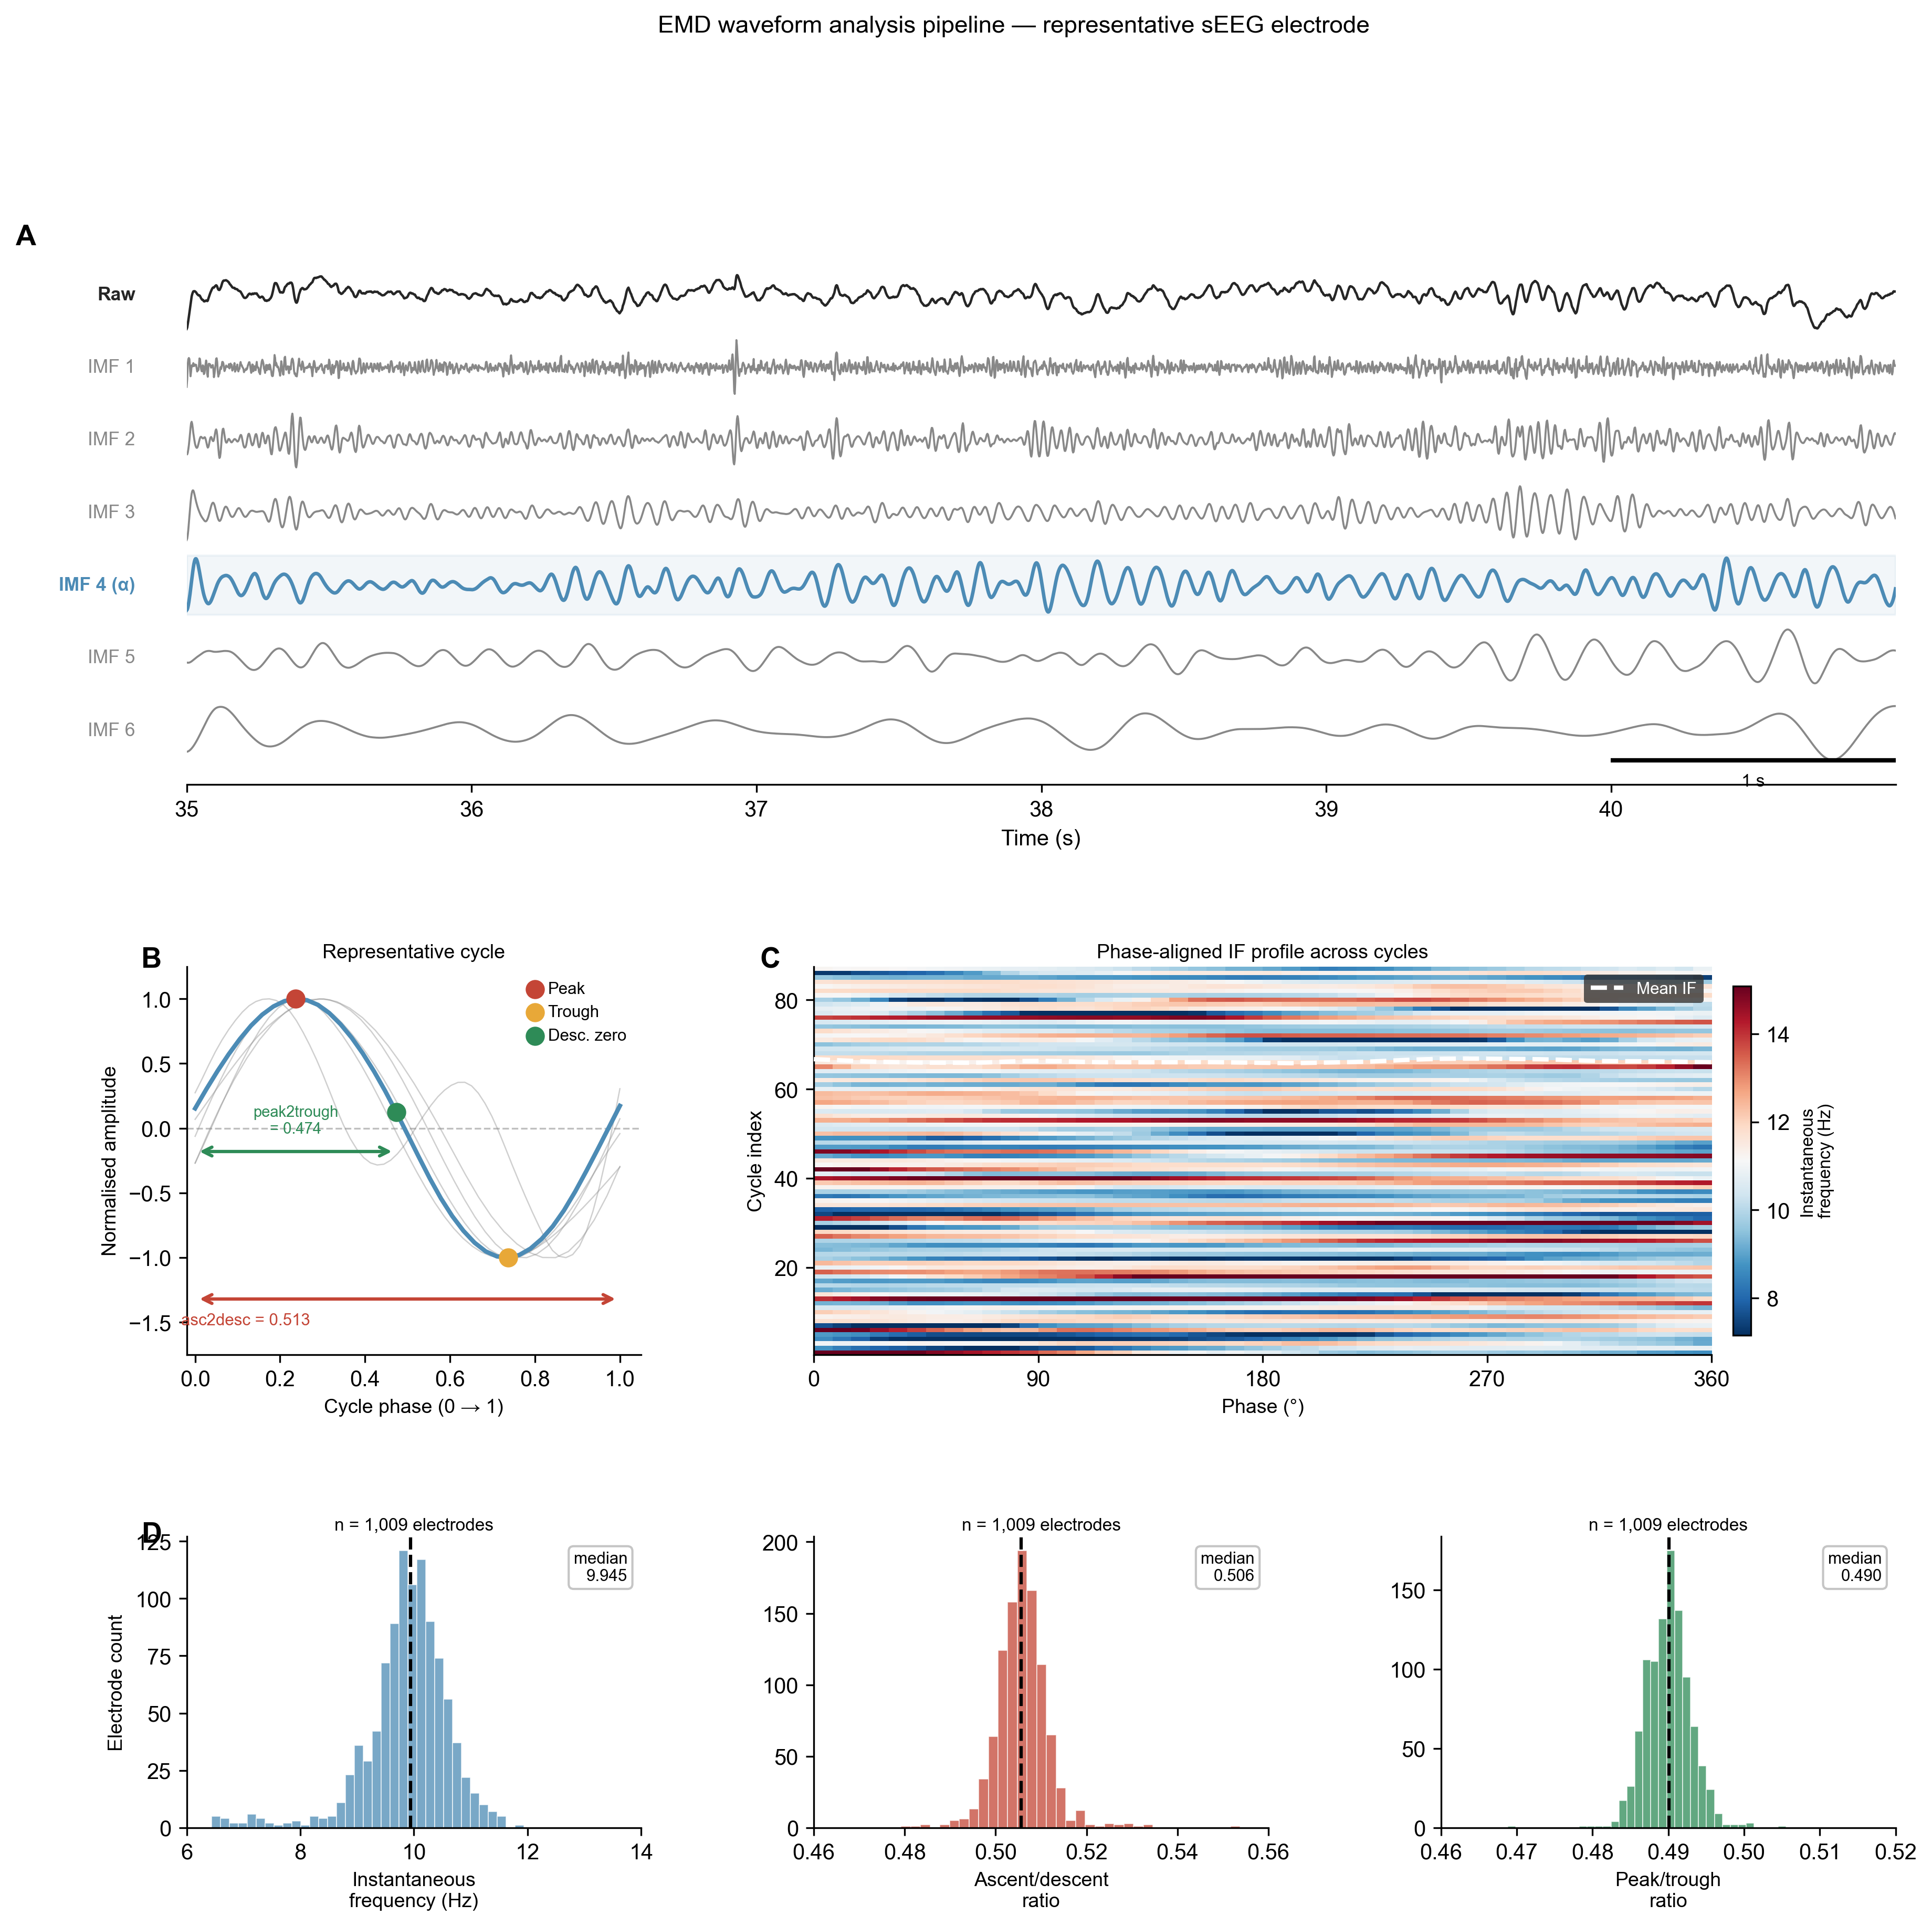
Figure 1. EMD waveform analysis pipeline. (A) Raw sEEG signal decomposed into six IMFs; IMF 4 (blue) captures the alpha oscillation. (B) A single representative alpha cycle with peak (red), trough (gold), and descending zero-crossing (green) annotated. (C) Phase-aligned IF heatmap across all post-stimulation cycles. (D) Population distributions of waveform features across n = 1,009 electrodes.

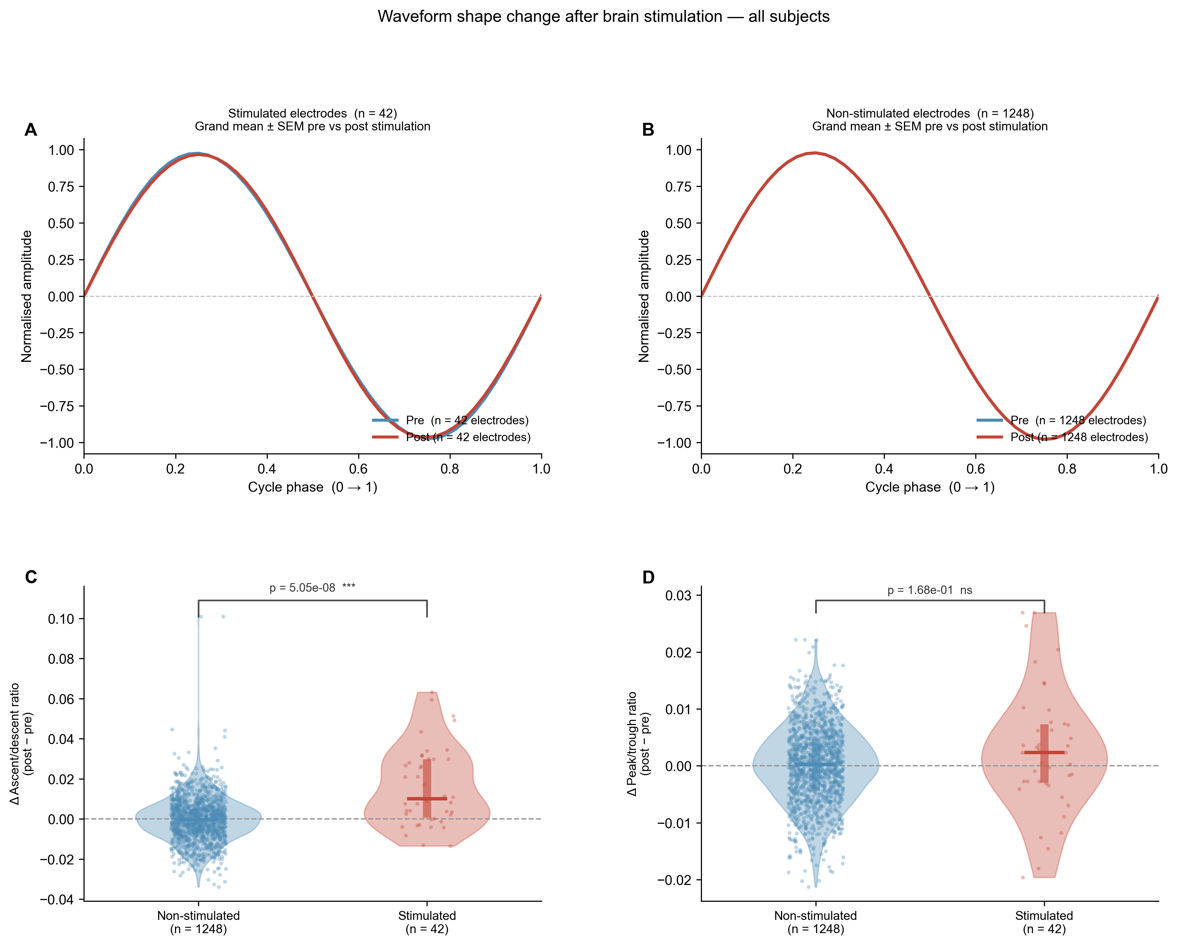
Figure 2. Electrical stimulation selectively alters ascending-phase duration. (A) Grand mean normalised alpha waveform across n = 42 stimulated electrodes, pre- (blue) vs. post-stimulation (red). (B) Same for n = 1,248 non-stimulated electrodes; waveforms overlap. (C) Delta-asc2desc violin plots; stimulated electrodes show a significant positive shift (Mann-Whitney p = 5.1 x 10^-8, ***). (D) Delta-peak2trough; no significant group difference (p = 0.17, ns).

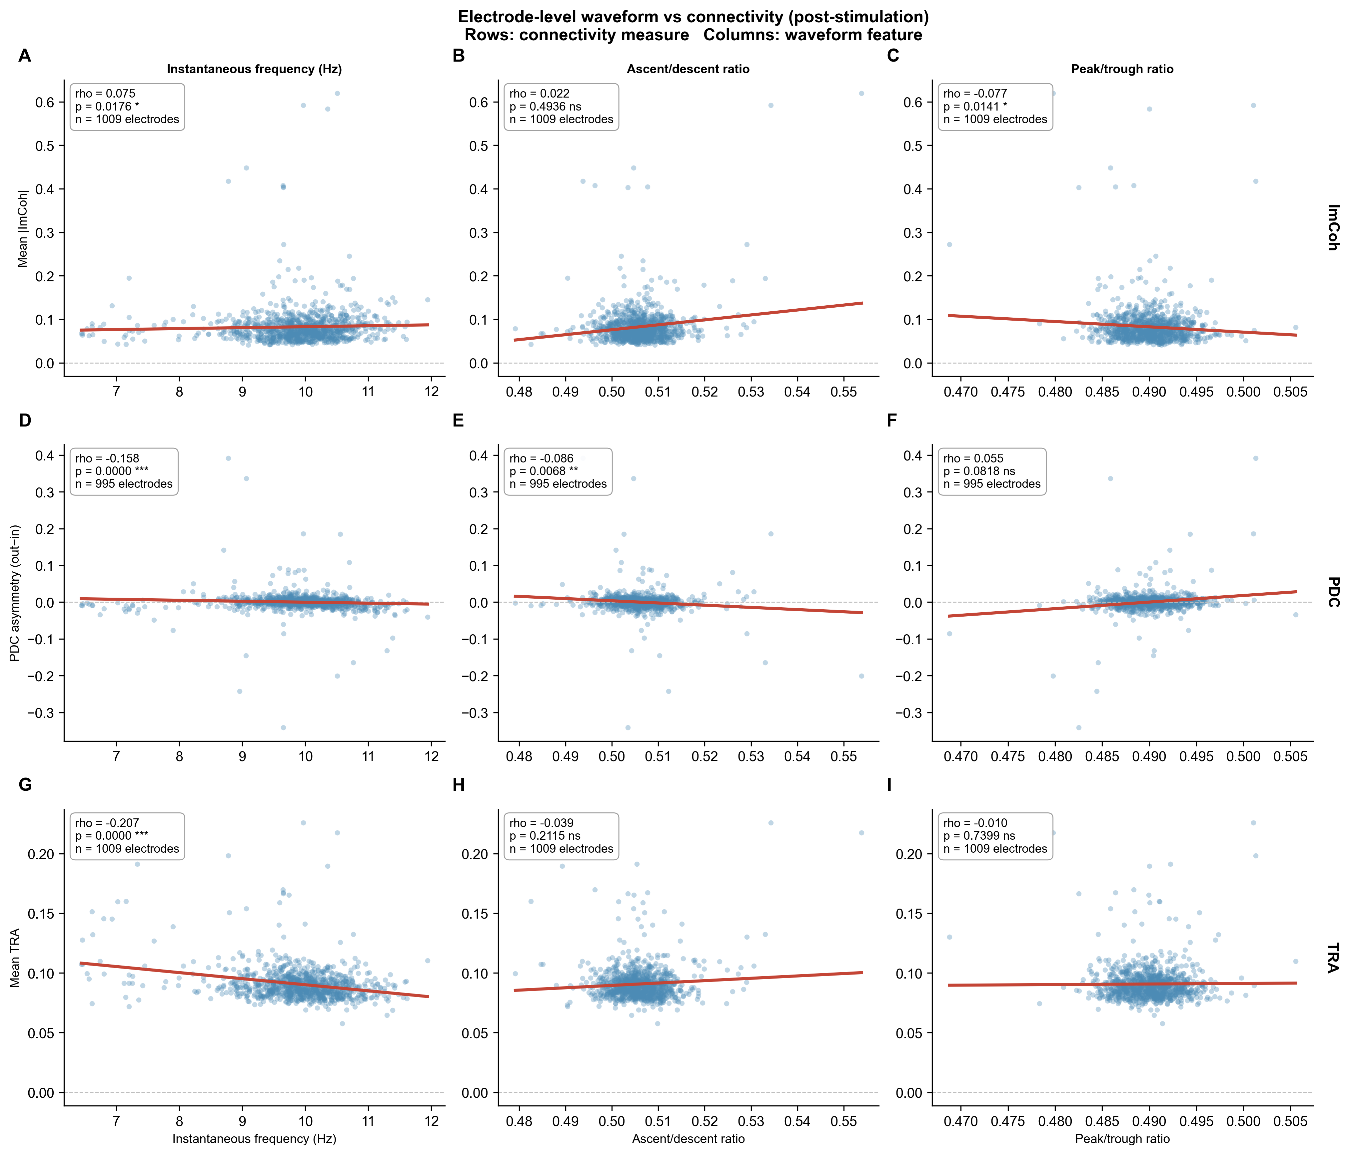
Figure 3. Waveform shape predicts network connectivity. Each panel: one waveform feature (x-axis) vs. one connectivity measure (y-axis) for n = 1,009 electrodes. Red line: OLS visual aid. Spearman rho and p annotated. Rows: ImCoh, PDC asymmetry, TRA. Columns: IF, asc2desc, peak2trough.

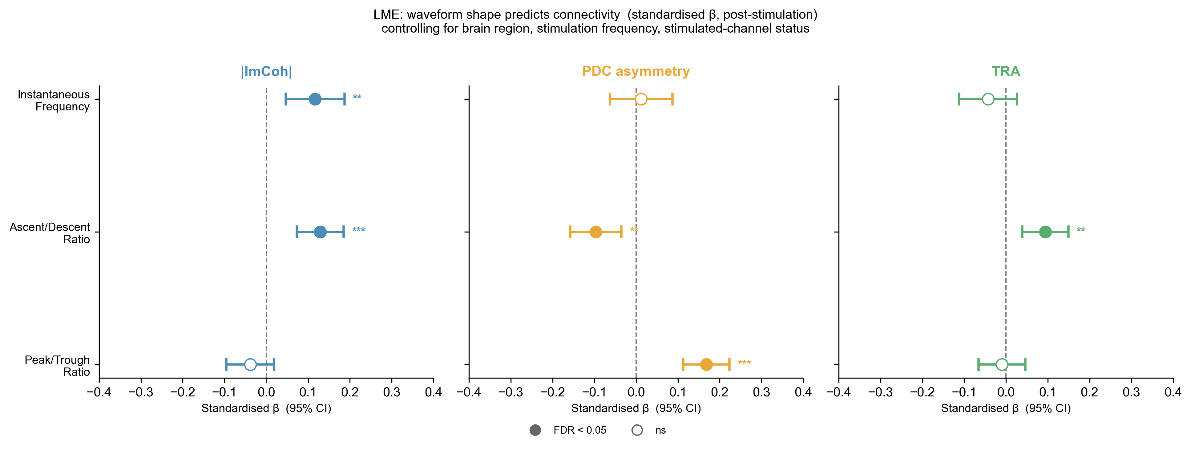
Figure 4. LME forest plot. Standardised fixed-effect coefficients (B^) with 95% CI. Filled circles: FDR q < 0.05; open circles: non-significant. All predictors and outcomes were z-scored.

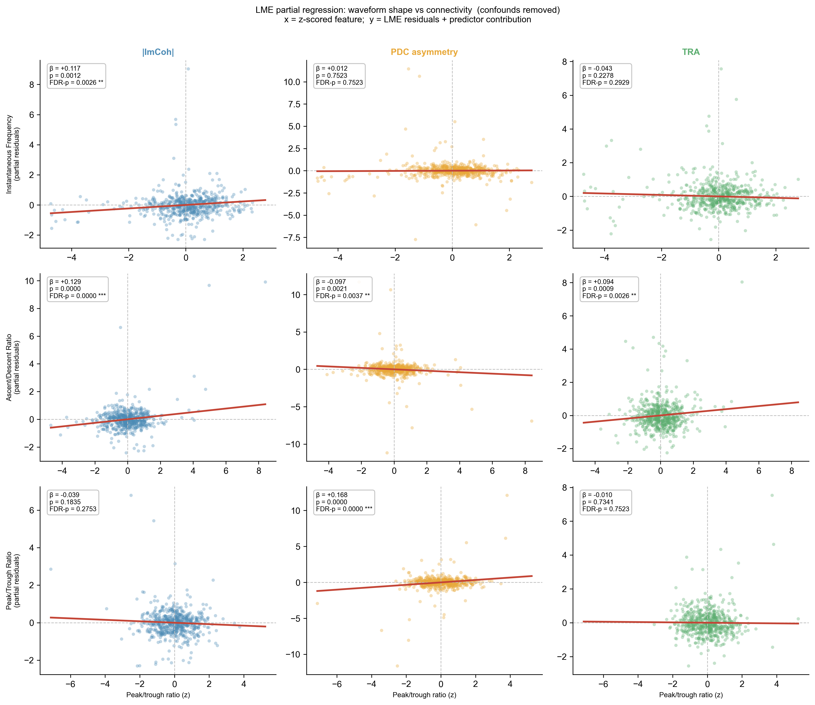
Figure 5. Partial regression plots. Each panel: one waveform feature vs. one connectivity measure after removing variance attributable to region, stimulation frequency, and channel status. Red line: OLS fit with slope equal to B^ exactly.

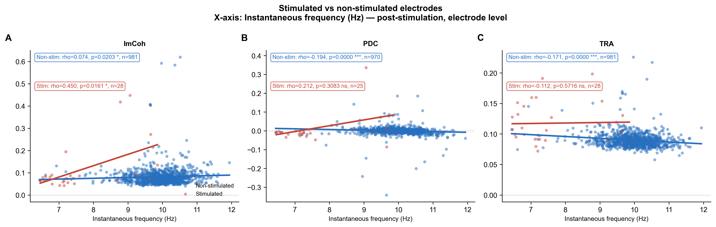

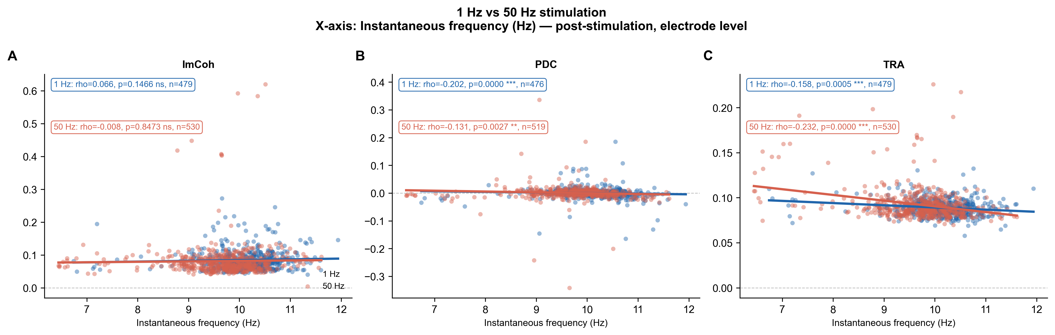
Figure 6. Waveform-connectivity associations across stimulation status and protocol. Top: stimulated (red, n = 28) vs. non-stimulated (blue, n = 981) electrodes. Bottom: 1 Hz (blue) vs. 50 Hz (red) protocols; both yield significant PDC and TRA associations.

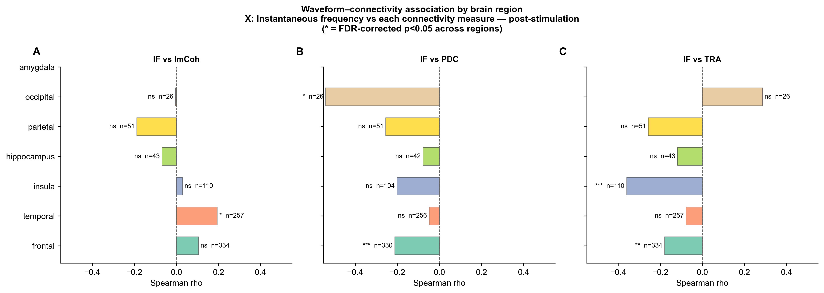
Figure 7. Regional specificity. Spearman rho between instantaneous frequency and each connectivity measure within each anatomical region (AAL atlas). n electrodes and FDR-corrected significance (* q < 0.05) annotated per region.

