Proof of Concept

### 1. **Why We need This?**

In Technical world we are grwoing every single day. Pre-COVID-19, the [healthcare industry](https://www.healtheuropa.eu/cyber-security-critical-for-healthcare-industry-in-wake-of-covid-19/103620/) was treading a slow but sure course toward digital transformation and Artificial Intelligence (AI). Global health data is increasing at an enormous rate. It will be more than 2,300 exabytes (one exabyte = one billion gigabytes) by 2022.

The breadth of data availability is limited in India, given that a lot of health data is predominantly on paper. Majority of the healthcare industry still relies on the conventional data streams, i.e. internal ops data and external data from the audit of sales and prescriptions.

Building on automation, artificial intelligence (AI) has the potential to revolutionize healthcare and help address some of the challenges set out above. There are several definitions of AI, but this report draws from a concise and helpful definition used by the European Parliament, “AI is the capability of a computer program to perform tasks or reasoning processes that we usually associate with intelligence in a human being.

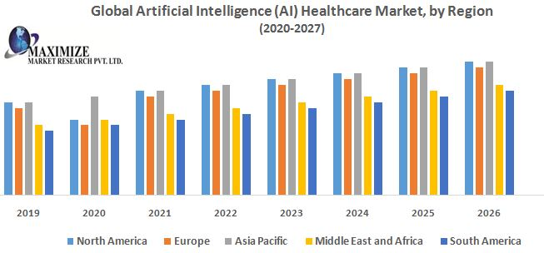Involment of AI in health care indusrty acc. To different regions:

### 2: **Approach to Get**

We already know the contribution of AI in health Industry and data is increasing every moment so we need those systems which can performe intelligent task and handle enormous datapoints. Our product can change the way of seeing healthcare system in india. We don’t need to relies on the conventional data streams.

1. We will build an AI algorithm that perform image processing task in give the prediction with high accuracy and precision.

2. Construct the database that handle billions of records and perform roboust task.

3. Develop Cloud based service that connect database and AI algorithm.

4. As we know applied AI task is an iterative process so we will train our algorithm again when we need to improve accuracy and minimize the loss.

5. Develop a desktop application that will be feasible to hospital systems that they are using already.

6. We will be foucsing on user’s feedbacks that how our software is performing and also will maintain the privacy of the patient’s details.

## What happens after Proof of Concept?

### 3: **Prototype our Solution and Test**

Our next step is foucing on building a prototype of our product that will be ready for testing in our environment.

We already trained our an algorithm on small datasets we got good results.

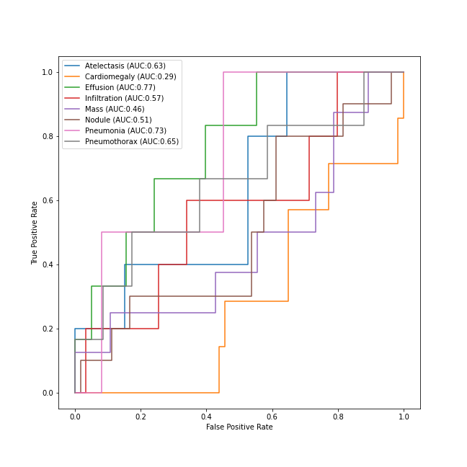

We will be trained this algorithm on large datasets and make some changes to this algorithm

Feature Sets in our product(User Side):

1. Login with their credentials and choose their plan before login

2. A test screen where radiographer put details of patient and upload the chest X-ray and submit all details.

3. Access the records of patients and get their reports.

Feature Sets (server side):

1. A robust API (application programming Interface) that handle all the queries made by user

2. A database will have all the patients and user’s records.

3. An admin Dashboard where admin can montiored the application

### 4: **Create a Minimum Viable Product**

We will carete an MVP that will be ready to install and test in user’s system and it will function on the user’s side just like the final product. It will offer an opportunity for more feedback that will tell us if the product in its current iteration resonates with users and stakeholders.

### Step 5: Design a Roadmap

From all of the information you’ve gathered in each of the previous steps, create a roadmap that describes what you’ve learned and outlines a recommended step-by-step process for building the product. Think of this roadmap as a set of blueprints for constructing a building. With this roadmap as a guide, everyone will be kept on the same page through product development and will have a clear picture of what the end goal is.

1. **Defining time frame**

It’s very important to define a time frame after consulting business, managers, and clients. A POC is not a complete ML project, so you can’t invest too much time covering each aspect, else it will end up being too complicated.