1. **Introduction to Numpy**

**Program 1**: Import Numpy and implement array.

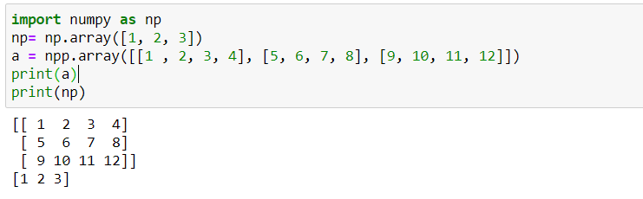

**Program 2**: Create an array with only zeros and ones.

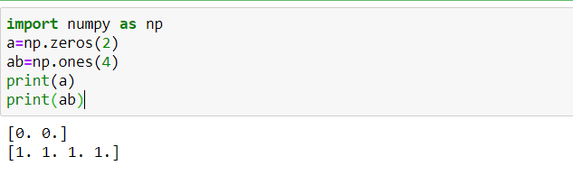

**Program 3**: Program to show function of delete and sort function.

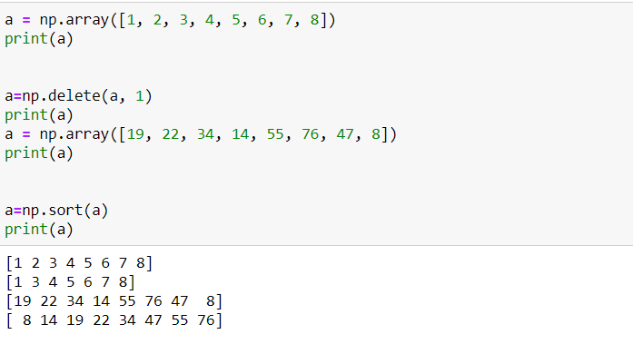

**Program 4**: Program to show the dimension of a 2d array. 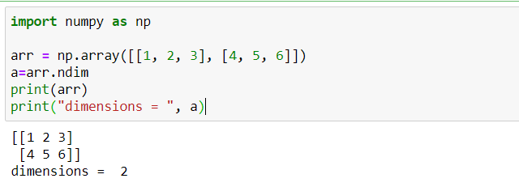

**Program 5**: Program to show the working of size function.

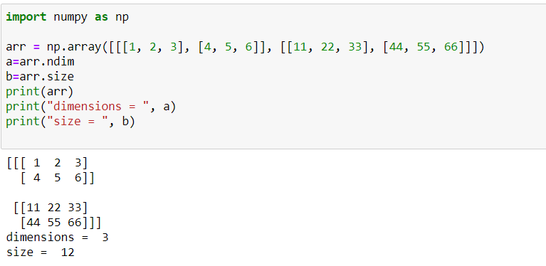

**Program 6:** Shape and Reshape function.

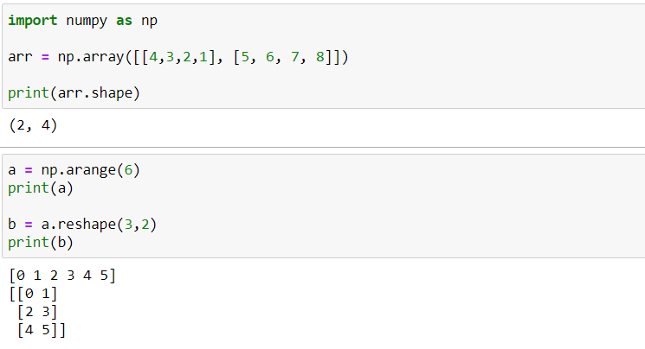

1. **Numpy Arithmetic operations.**

**Program 1**: Perform arithmetic operations using Numpy on array.

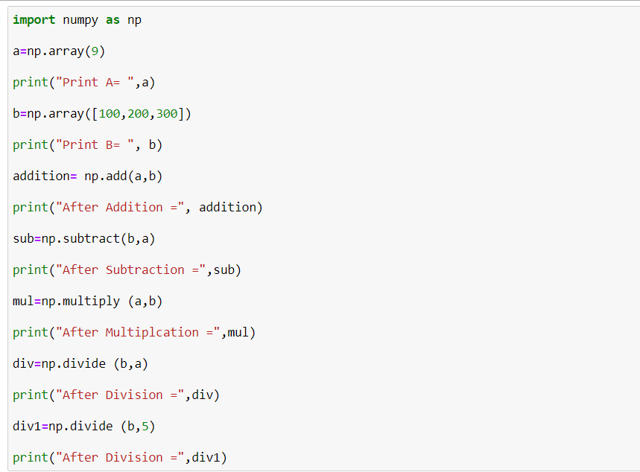

Output:

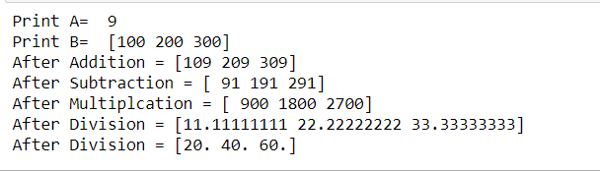

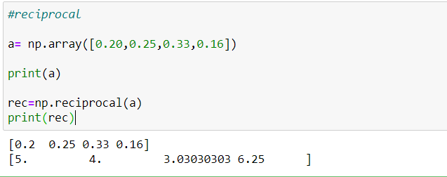**Program 2**: Find the reciprocal of the array elements.

**Program 3**: Find the remainder values of the array elements when divided by other array elements.

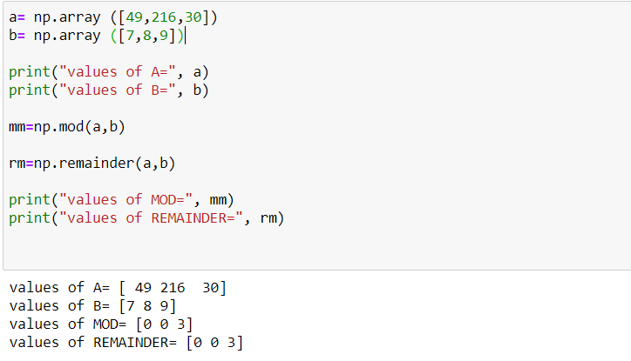

**Program 4**: Find real, imaginary and conjugate values.

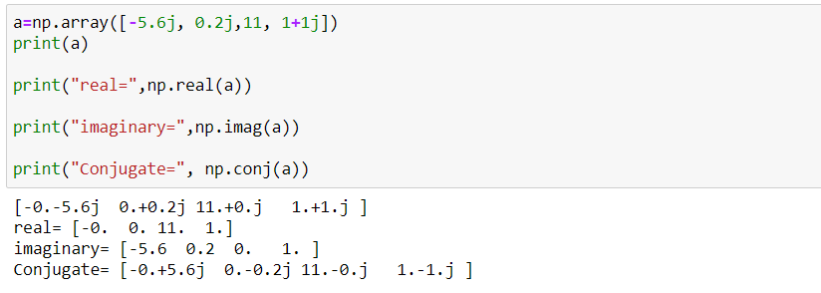

**Program 5**: Rounding up the array elements.

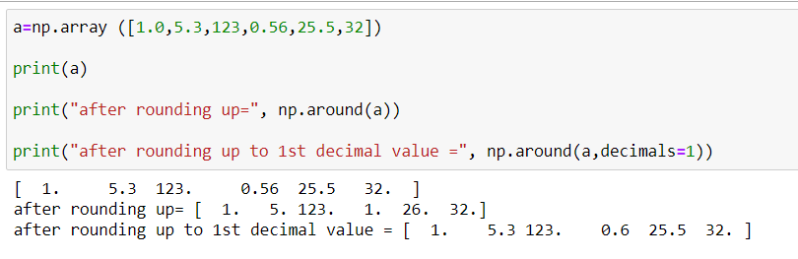

**Program 6**: floor and ceil function.

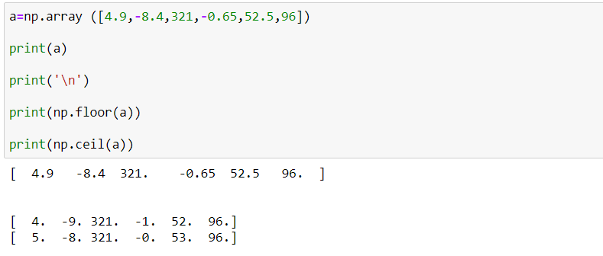

Thank You.