1. **If else statements**

Objective: To perform if-else loop

Outcome: check whether number is even or odd, print grade, vote eligibility using if else statements.

Conclusion: Successfully implemented if-else loop.

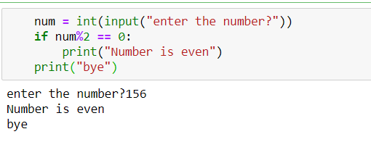1.Program to check if the number is even

# 2.Program to check the largest among three numbers

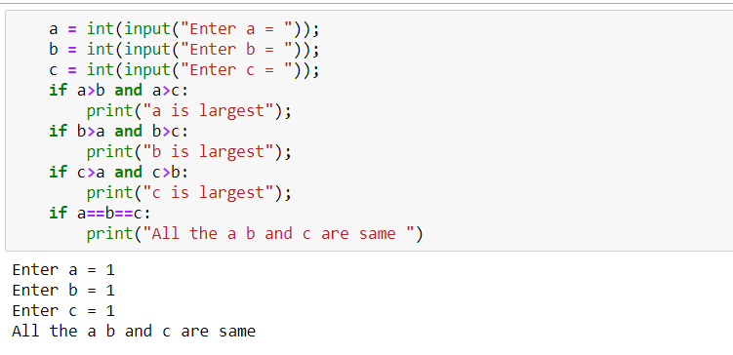

# 3.Program to evaluate the age eligible for voting

# 4.Program to check whether the number is equal to 10,50 or 100

# 5.Program to calculate the grade of a student

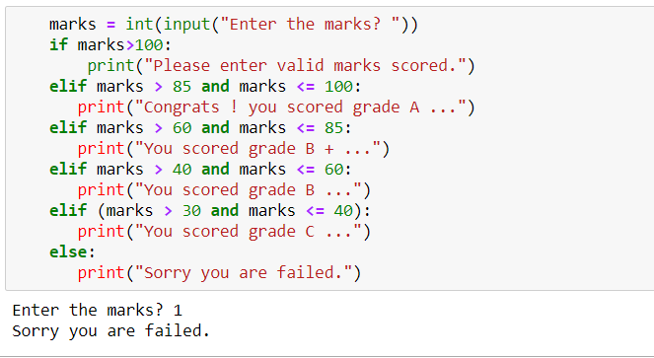

# List

# Objective: To perform lists and dictionary operations.

# Outcome: Tuple operations like Concatenation, Adding/Deleting elements, accessing elements, replacing elements ,Appending lists

# Conclusion: Successfully completed the Dictionaries and tuple operations.

# 1.Program to implement the list and manipulate.

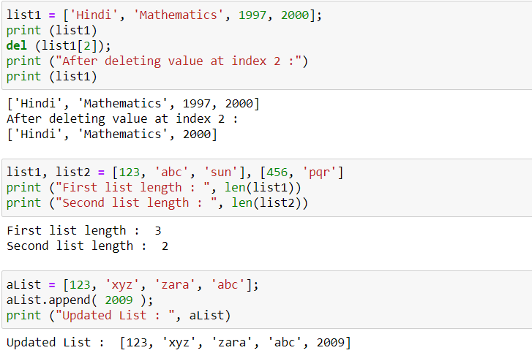2.Program to implement the append function on list.

# String operations

# Objective: To perform String operations using break, continue

# Outcome: String operations like Concatenation, Append,

# Conclusion: Successfully implemented String operations

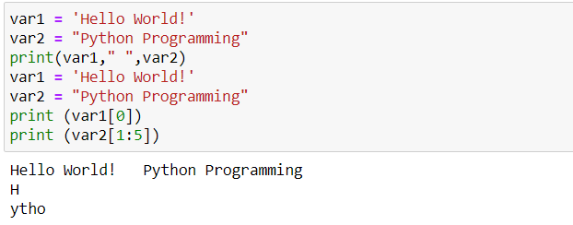1.Program to access the character from the string.

2. program toinput string and access the string and capitalize the string

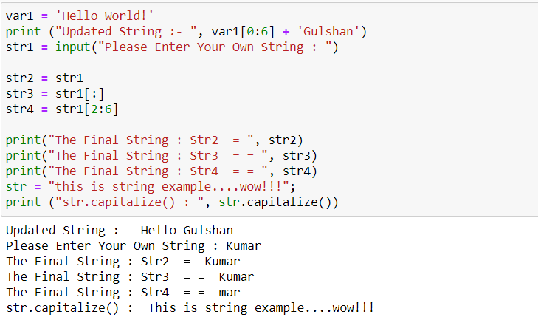

3.program to show the function of count()-returns the number of occurrences of substring sub in the range [start, end].

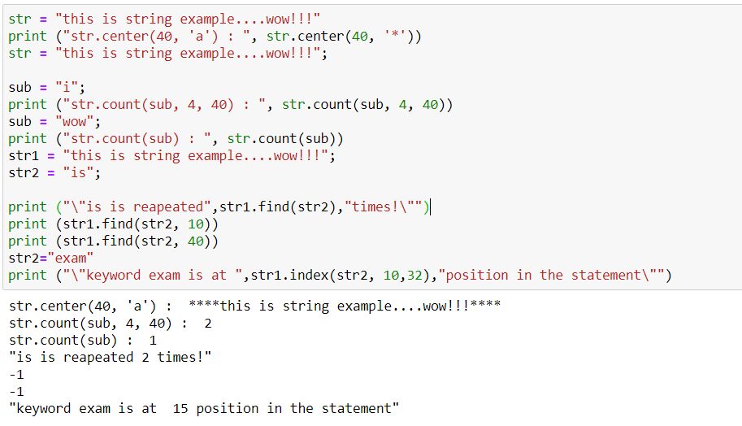

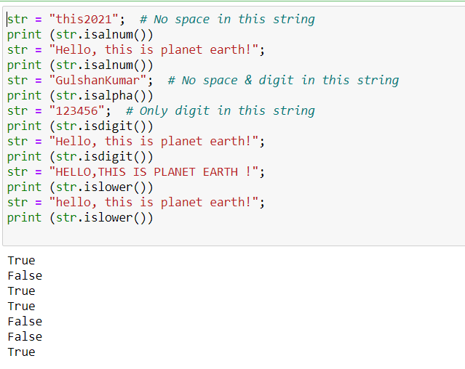4. Program to show the function of isalnum()-checks whether the string consists of alphanumeric characters.

5.Program to show the function of isnumeric(), istitle(), isspace(), isupper()

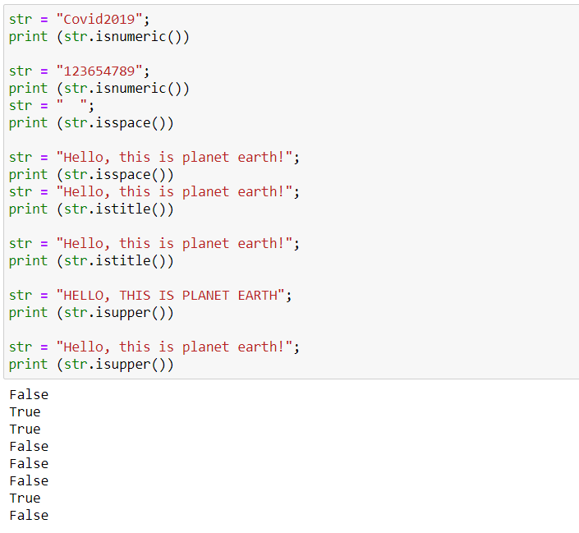

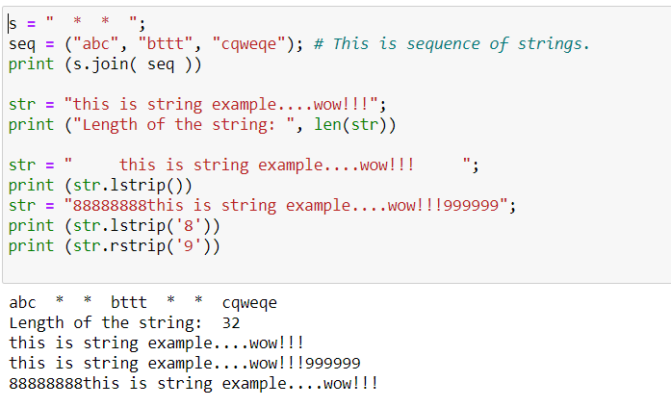6.Program to show function join()-returns a string in which the string elements of sequence have been joined by str separator.

7.Program to return largest character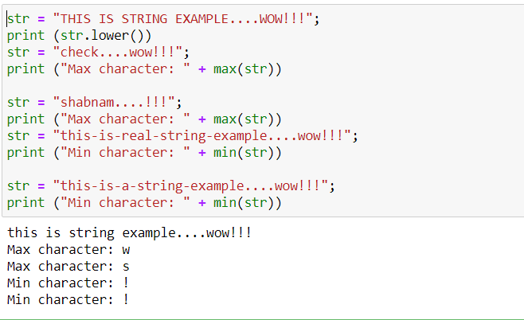.

# D. Dictionaries

# Objective: To perform lists and dictionary operations.

# Outcome: Tuple operations like Concatenation, Adding/Deleting elements, accessing elements, replacing elements ,Appending lists

# Conclusion: Successfully completed the Dictionaries and tuple operations

1.Program to implement Dictionary and access value using key.

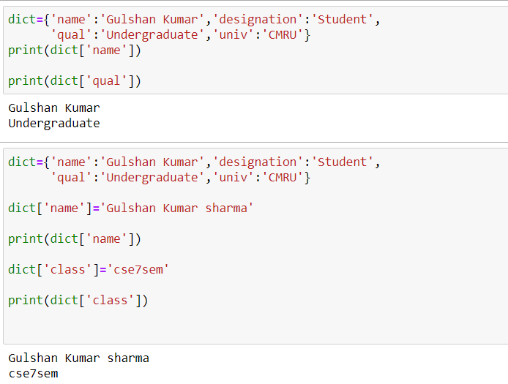

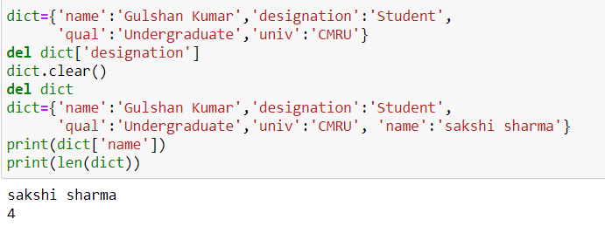2.Program to show the function of del(), Len()

3. Program to access the values and items and ovverride the key.

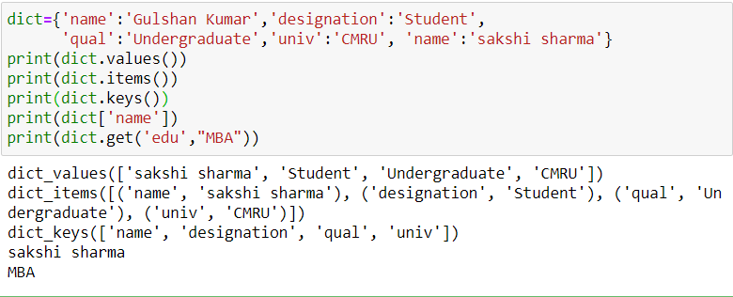

4.Program to copy one dictionary item to another dictionary.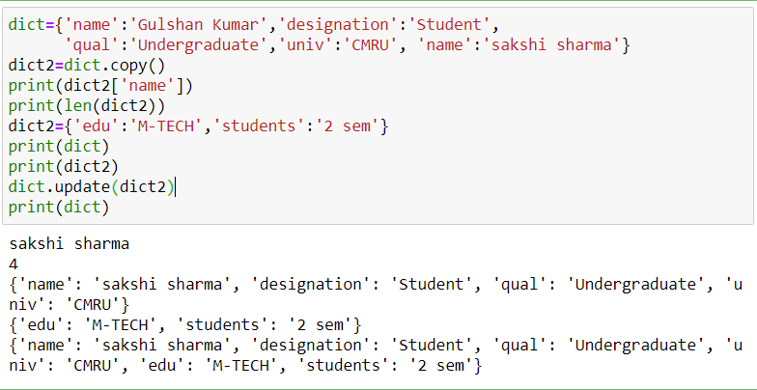

**E. Tuples**

# Objective: To perform lists and dictionary operations.

# Outcome: Tuple operations like Concatenation, Adding/Deleting elements, accessing elements, replacing elements ,Appending lists

Conclusion: Successfully completed the Dictionaries and tuple operations

1.Program to create a tuple and access the elements of tuple.

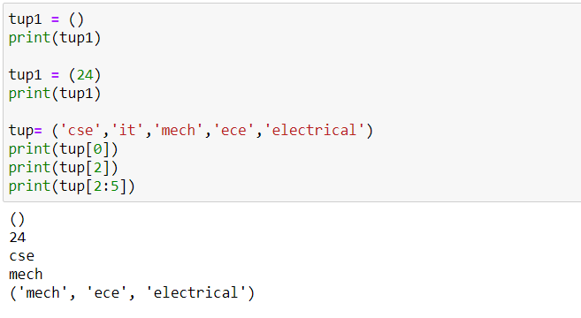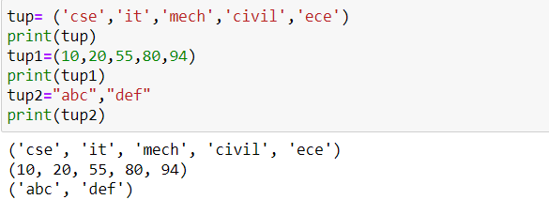

2.Program to del a tuple.

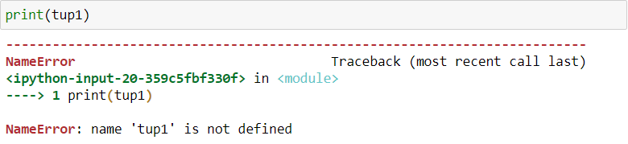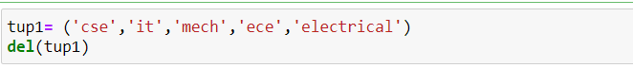

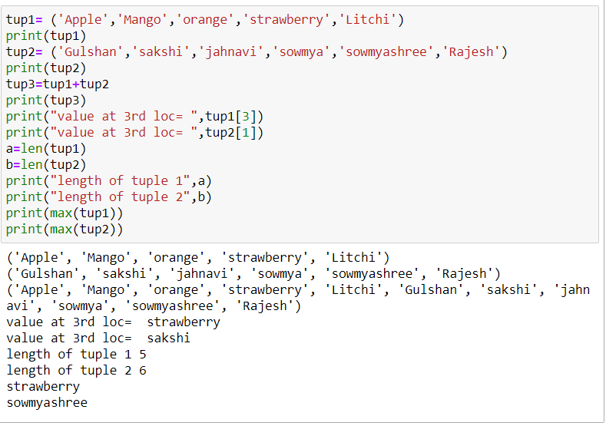

**F. Function**

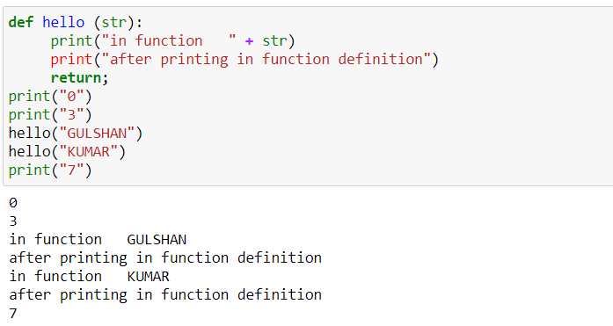1.Program to understand the syntax of function.

2.Program to print a list using function.

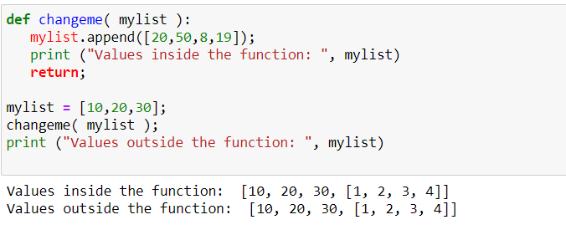

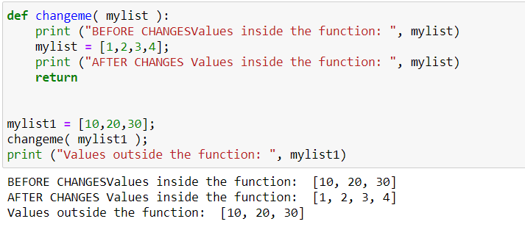

**G .Loops**

Objective: To perform loops operations using break, continue

Outcome: Working with loops using continue break

Conclusion: Successfully implemented file operations

**1.**Program to Calculate multiplication table.

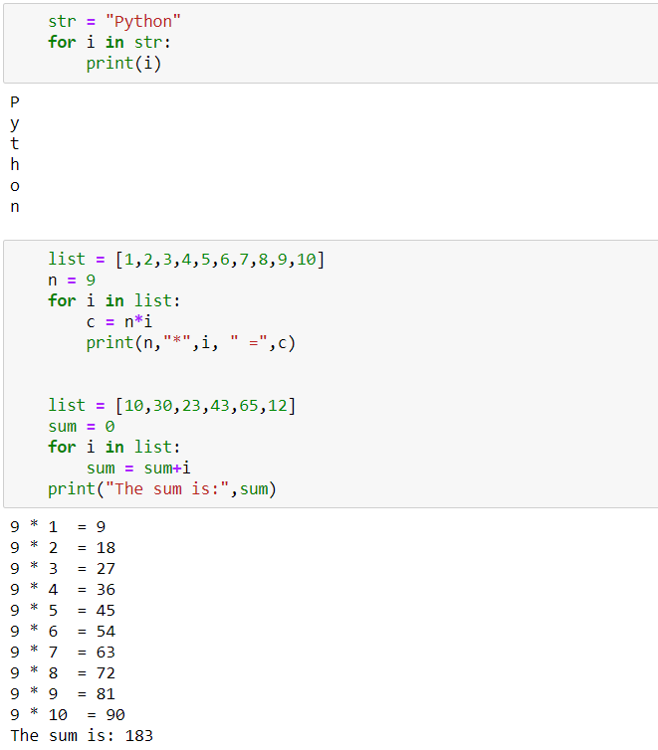

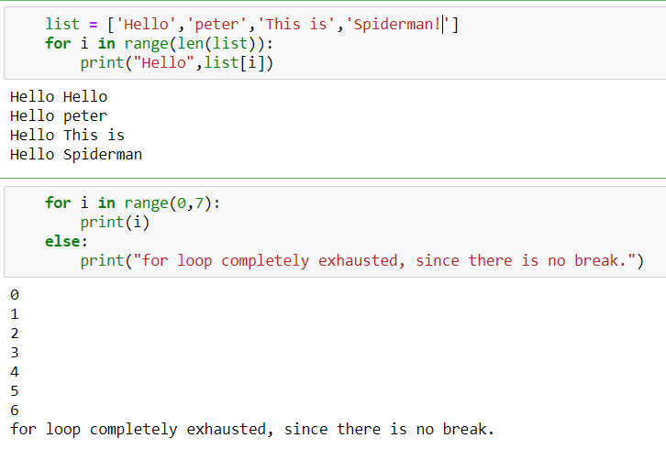

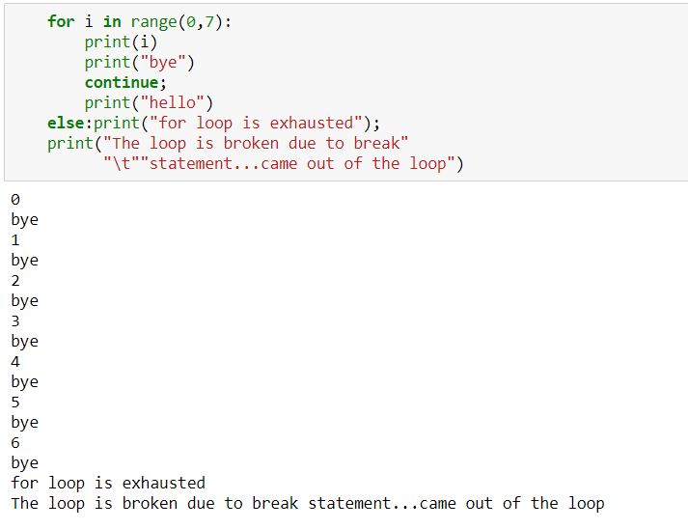

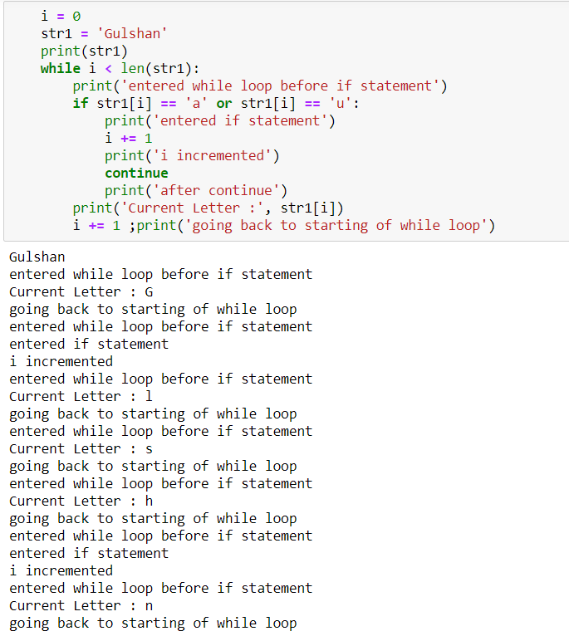

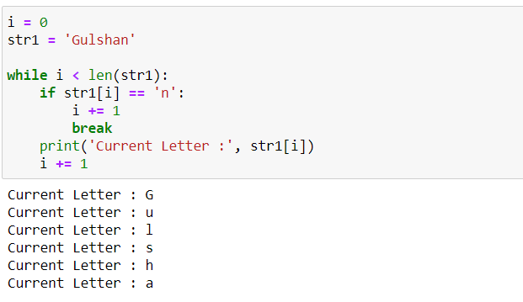

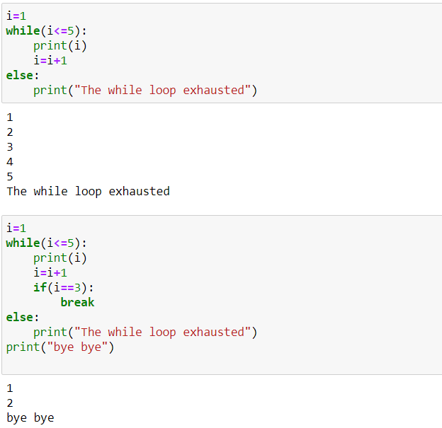

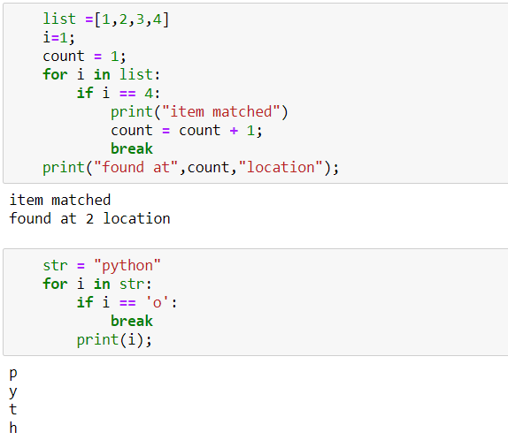

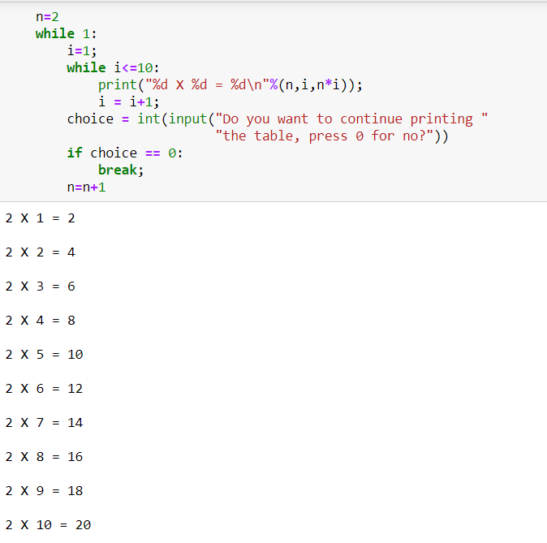

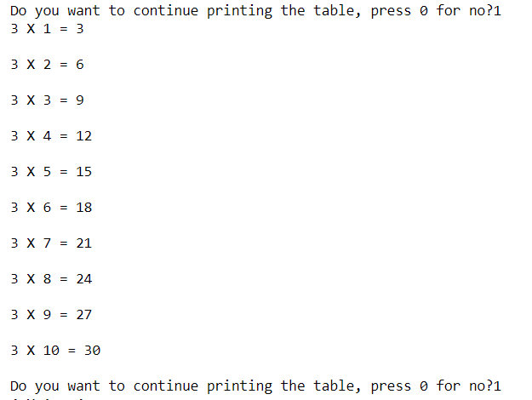

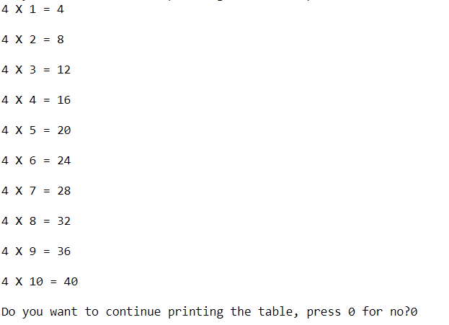

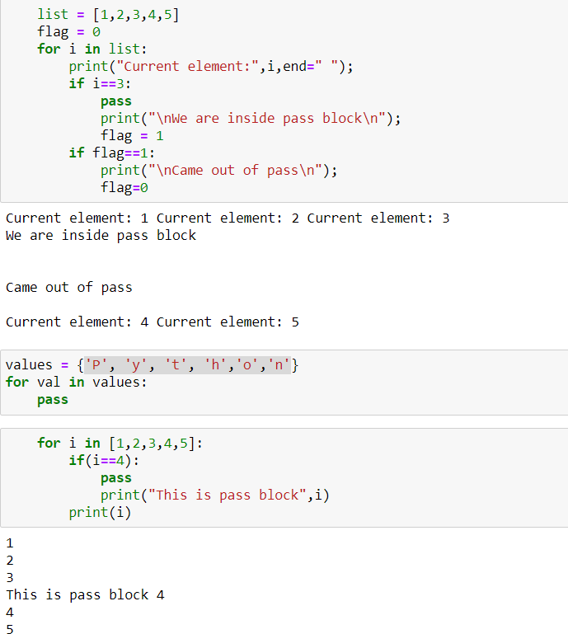

**H .Numpy**

Objective: To perform Numpy operations

Outcome: File operations like Addition, Power, Reciprocal, Multiplication, Modulus, Division

Conclusion: Successfully implemented Numpy operations

1. **Introduction to Numpy**

**Program 1**: Import Numpy and implement array.

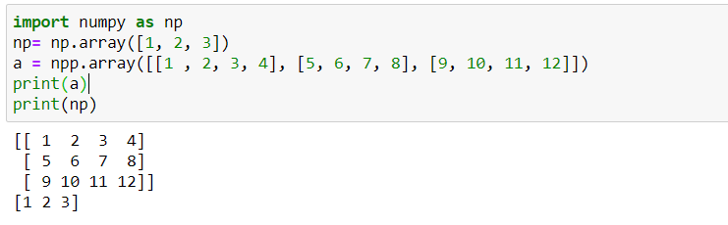

**Program 2**: Create an array with only zeros and ones.

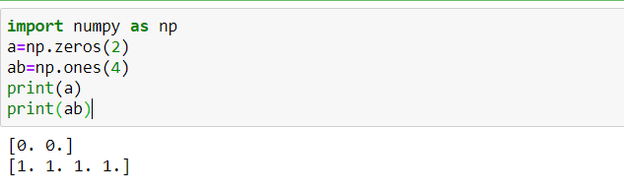

**Program 3**: Program to show function of delete and sort function.

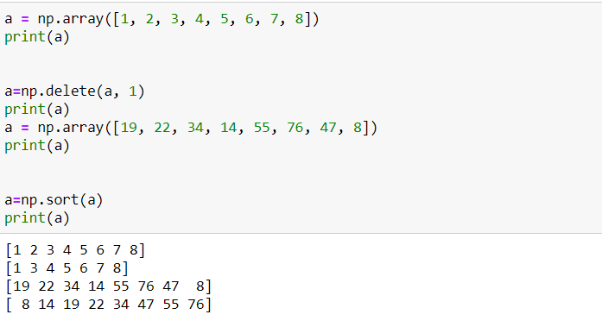

**Program 4**: Program to show the dimension of a 2d array. 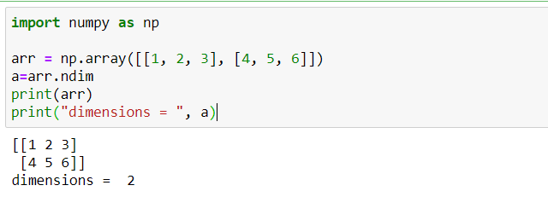

**Program 5**: Program to show the working of size function.

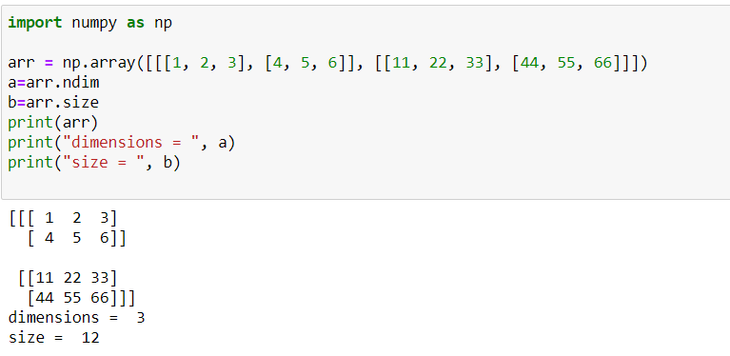

**Program 6:** Shape and Reshape function.

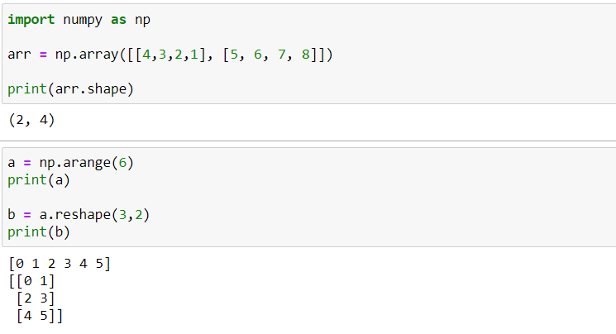

1. **Numpy Arithmetic operations.**

**Program 1**: Perform arithmetic operations using Numpy on array.

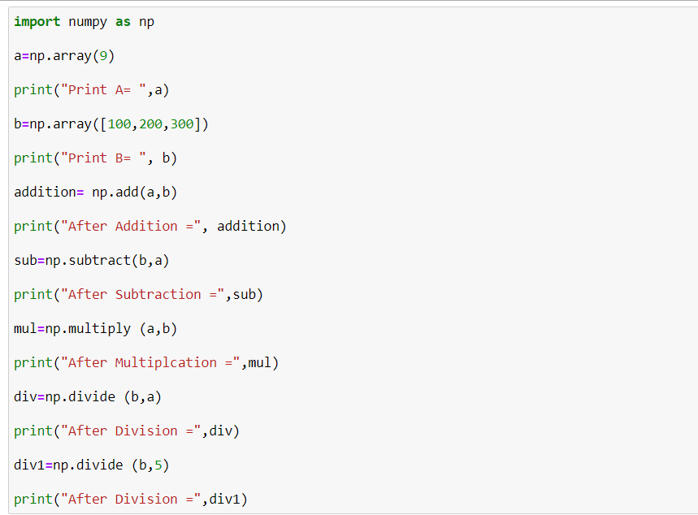

Output:

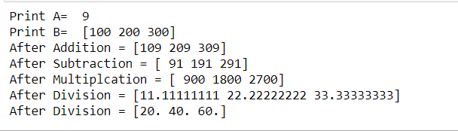

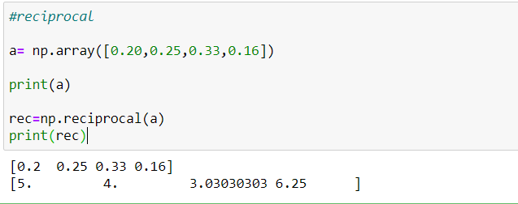**Program 2**: Find the reciprocal of the array elements.

**Program 3**: Find the remainder values of the array elements when divided by other array elements.

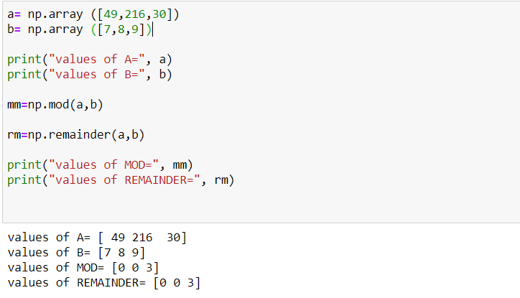

**Program 4**: Find real, imaginary and conjugate values.

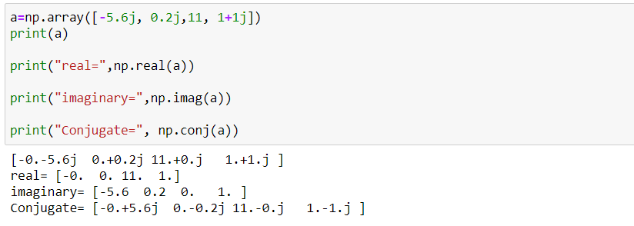

**Program 5**: Rounding up the array elements.

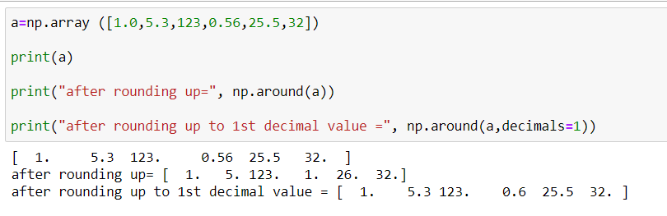

**Program 6**: floor and ceil function.

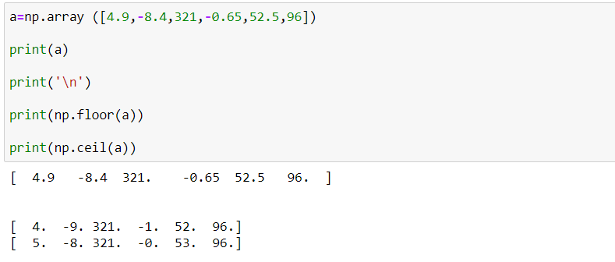

1. **Numpy array search**

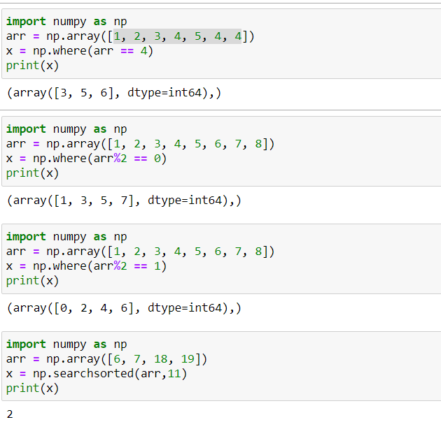

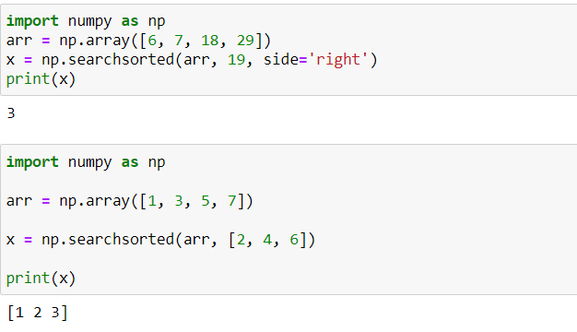

1. **Restaurant**

Objective: To choose a restaurant

Outcome: Select either between Veg or Non-Veg restaurant

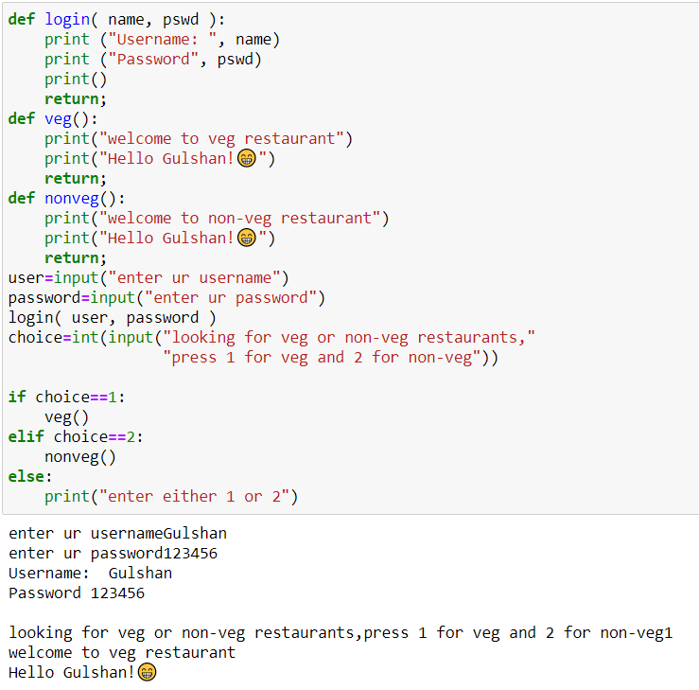Conclusion: Successfully implemented Restaurant choice

1. **Recharge plan**

