# Marathon Skills ss - Style Guide

## Overview

This style guide defines the visual identity for Marathon Skills 2015. Any applications/programs, documents, training materials, etc must follow this guide.

This style guide has been created to make sure that everything developed for Marathon Skills 2015 is consistent and professional. It covers professionalism, colours, logo use, fonts, etc.

## Professionalism

To make sure that Marathon Skills 2015 is respected as a professional organisation, follow these rules.

Ensure that all interfaces, documents, etc are clean, consistent, visually-appealing and free of errors. They must be easy to read and easy to understand.

Use good alignment and appropriate whitespace. Group user interface elements together logically as needed to make the system easy to use.

Use labels and help messages to guide users through the system.

## Fonts

### Heading Font

This font must be used for all heading text.

|  |
| --- |
| Open Sans Semibold |

### Body Font

This font must be used for all body text.

|  |
| --- |
| Open Sans Light |

### Alternate Font

This alternate font can be used if you do not have access to the Open Sans font.

|  |
| --- |
| Arial |

## Logo

The logo for Marathon Skills Brazil 2015 has been updated to match the host country’s colours. For 2015, green, yellow and blue have been chosen because they are the main colours on the Brazilian flag.

### Main full-colour logo *(logo-2015-full-colour.png)*

This is the main logo to use. This is to be used over a light background colour.

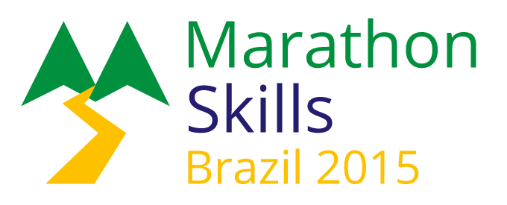

### Monochrome Logo *(logo-2015-monochrome.png)*

This is a monochrome (no colour) version of the main logo. This is to be used over a light background colour.

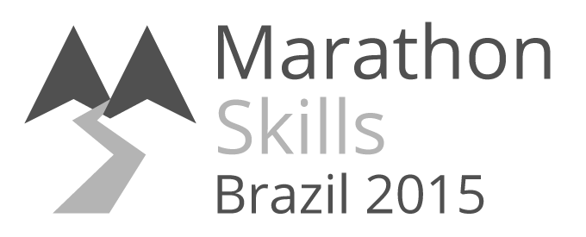

### Light-coloured Logo *(logo-2015-for-dark-background.png)*

This is a light-coloured version of the main logo. This is to be used over a dark background colour. Examples show the logo over different background colours.

|  |  |
| --- | --- |
| C:\Users\Nerdwood\Desktop\marathon-skills\logo\logo-2015-for-dark-background.png | C:\Users\Nerdwood\Desktop\marathon-skills\logo\logo-2015-for-dark-background.png |
| C:\Users\Nerdwood\Desktop\marathon-skills\logo\logo-2015-for-dark-background.png | C:\Users\Nerdwood\Desktop\marathon-skills\logo\logo-2015-for-dark-background.png |

## Colours

### Primary colours

|  |  |  |
| --- | --- | --- |
| Sample | Name | RGB colour code |
|  | Brazil Green | R: 0  G: 144  B: 62 |
|  | Brazil Yellow | R: 253  G: 193  B: 0 |
|  | Brazil Blue | R: 36  G: 29  B: 112 |

### Secondary colours

|  |  |  |
| --- | --- | --- |
| Sample | Name | RGB colour code |
|  | White | R: 255  G: 255  B: 255 |
|  | Light Grey | R: 235  G: 235  B: 235 |
|  | Mid Grey | R: 180  G: 180  B: 180 |
|  | Dark Grey | R: 80  G: 80  B: 80 |
|  | Black | R: 0  G: 0  B: 0 |