Header and carousal Image 1

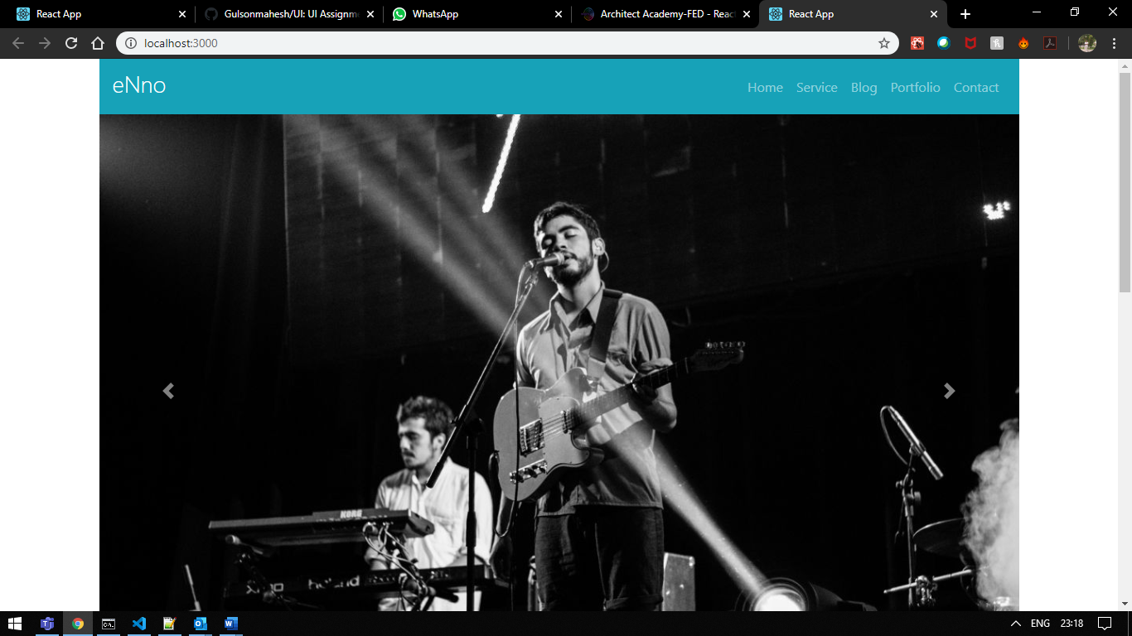

Header and carousal Image 2

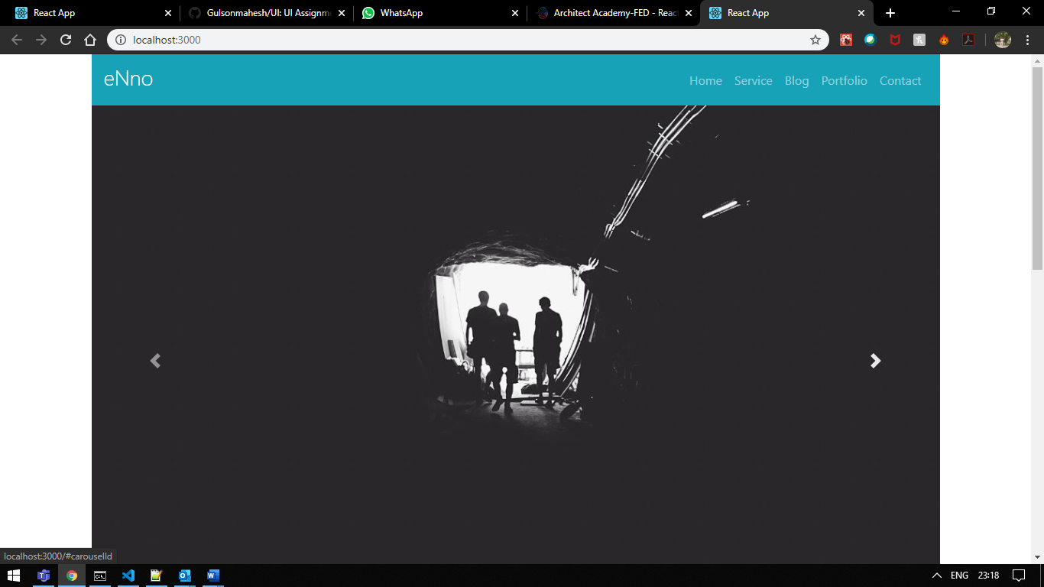

Carousal Image 3 with Left and right slider and Bottom Bullats for Navigation on Button Click

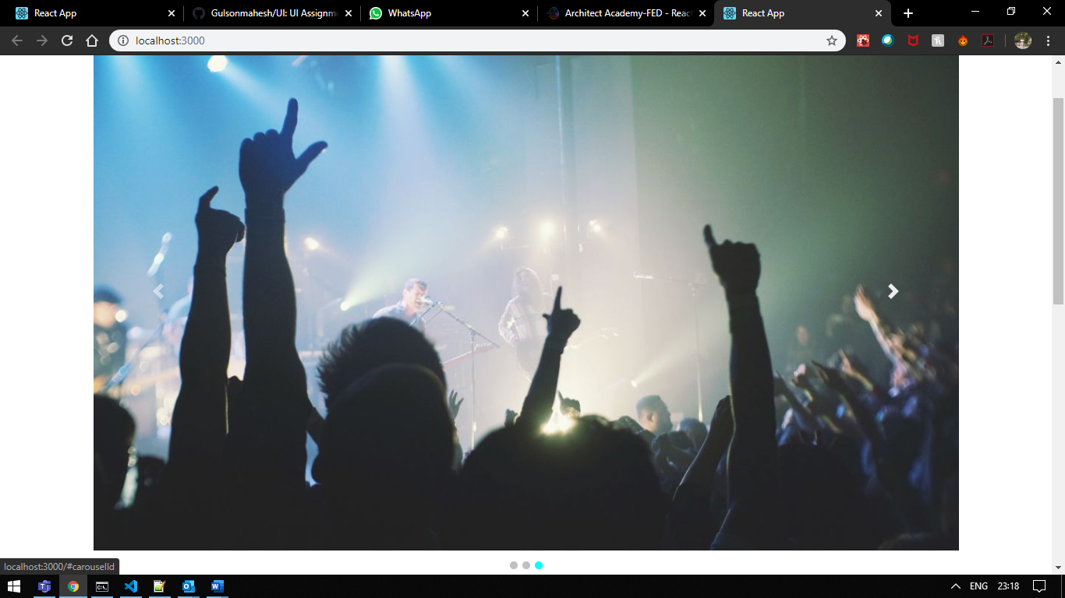

Central Body Content with One row of Information and two rows of 3 cards with each total 6 cards and integrated with Font Awesome class Icons.

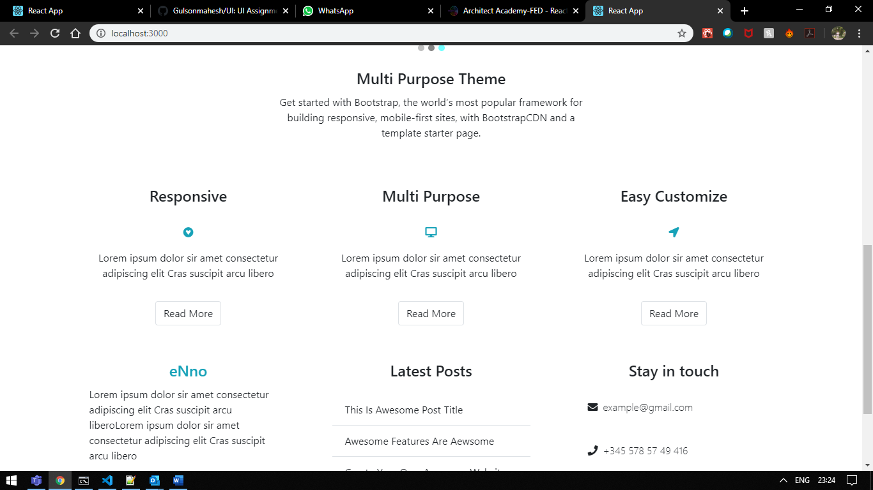

Footer :

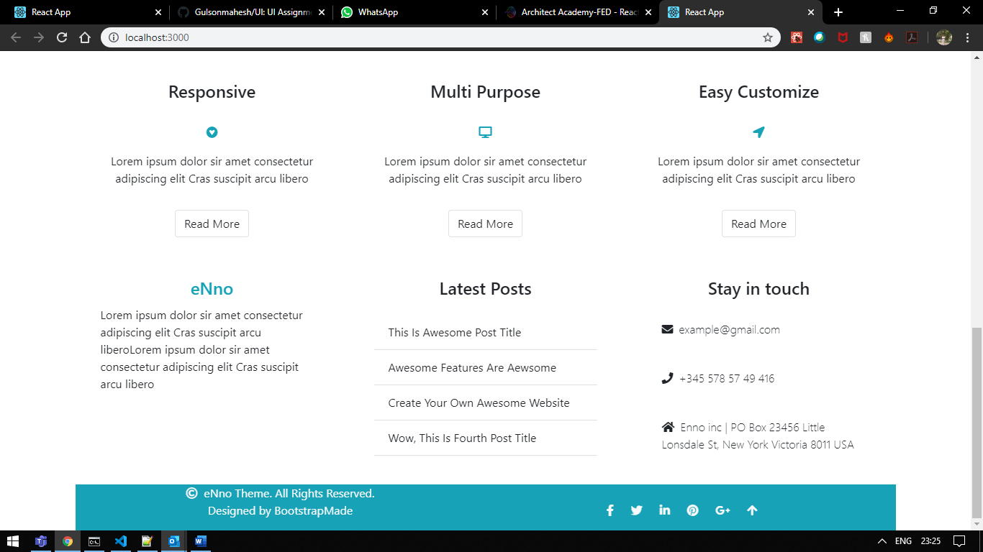

In footer click of the Up arrow will scroll the screen to Top.

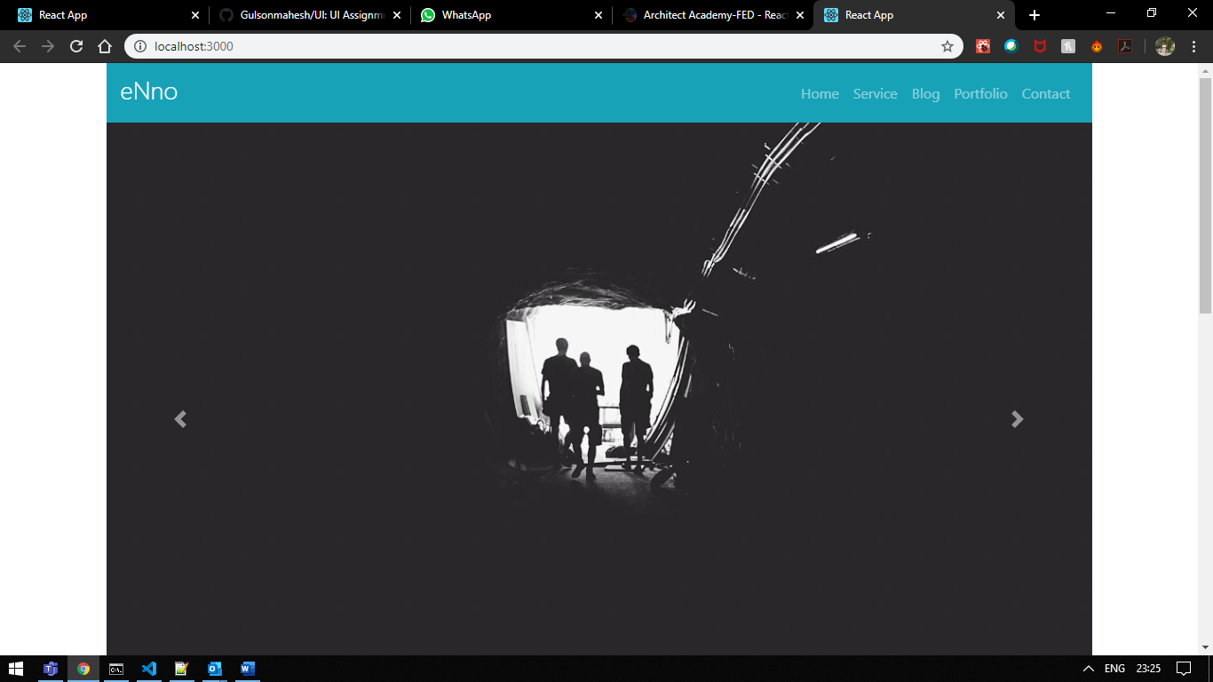

Mobile View :

IN Mobile view row layout has been changed to Column layout of each column have 100% width.

The Menu has been changed to a small scroll type view. Galaxy S3 was selected to view the page Layout in Mobile Devices.

Initial :

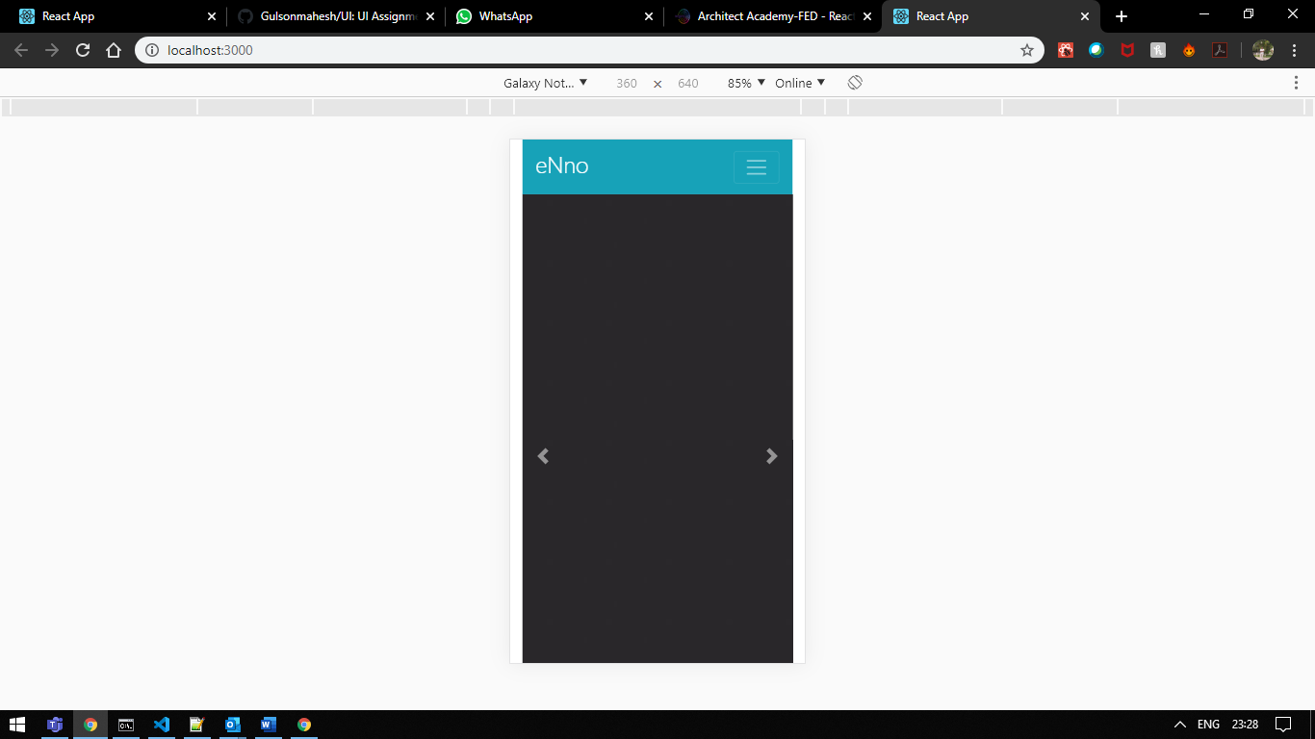

On clicking three lines to open the navigation Menu and also the Cursor has been changed to circle from the desktop pointer

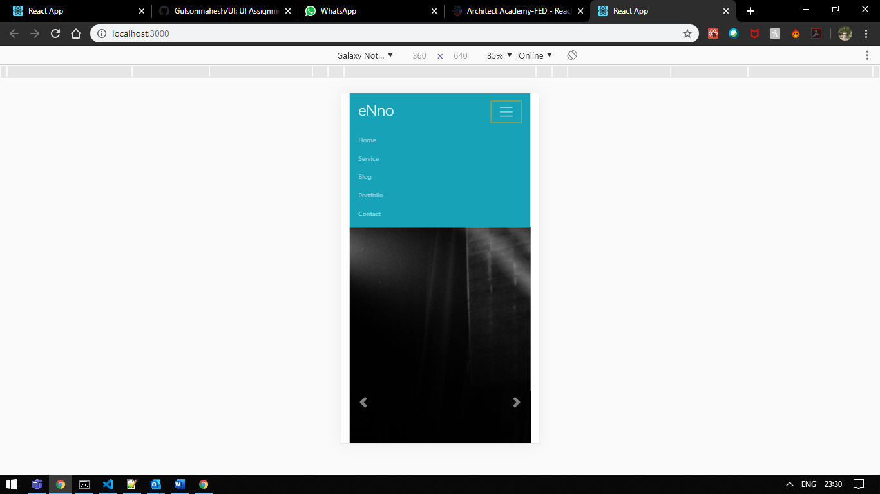

Row view has been changed to Column View. Screen 1:

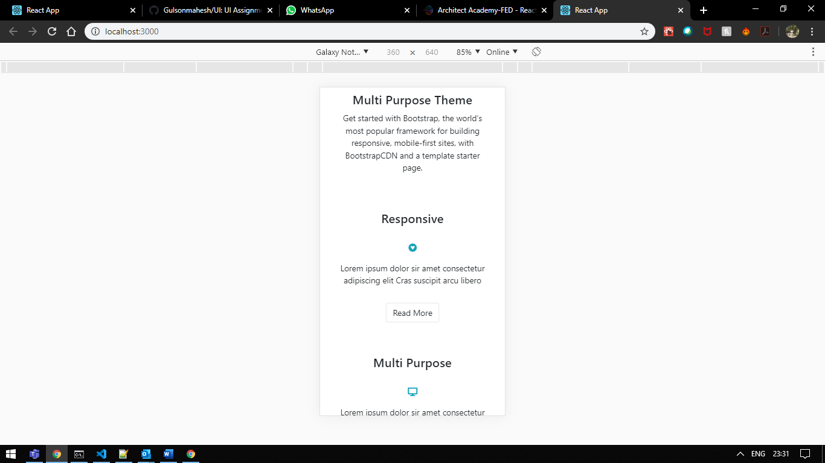

Screen 2:

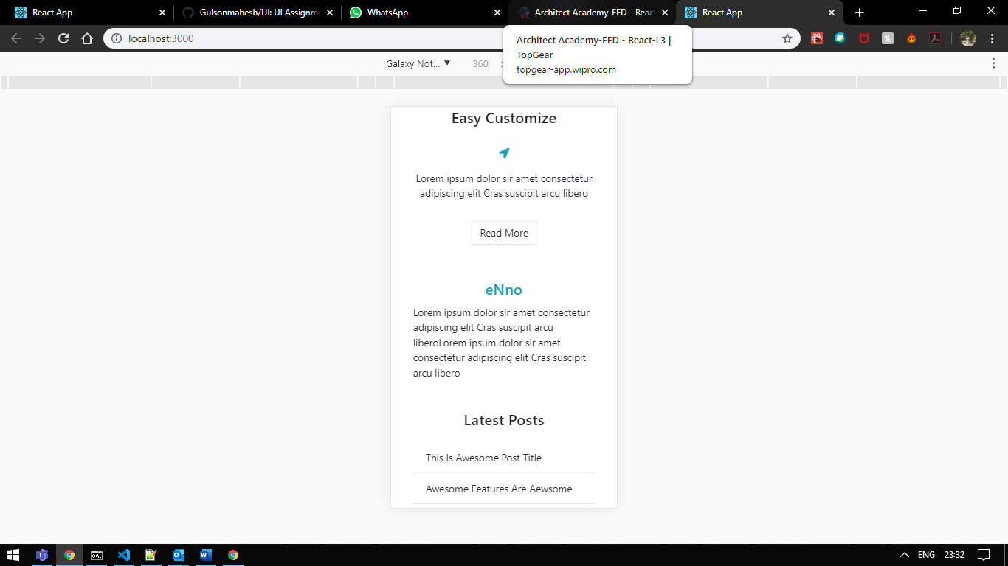

Screen 3:

This screenshot shows the page that it had a footer and incorporated with Font Awesome icons

