1. Condition Based Quary:

Synatx:

Select col1,col2,col3

From table1

Where col1=

(select col_n1

from table2

where col_n2=value)

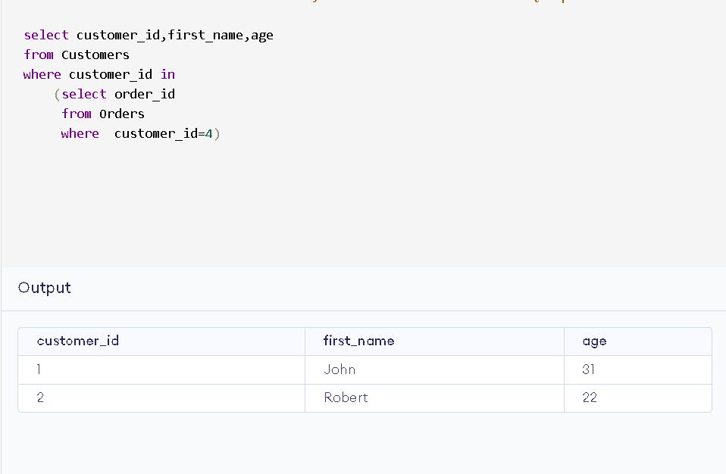

In this case 🡪 In and = ( in give multiple values, and = gives only single value (first_value)).

1. Insert table1 to table

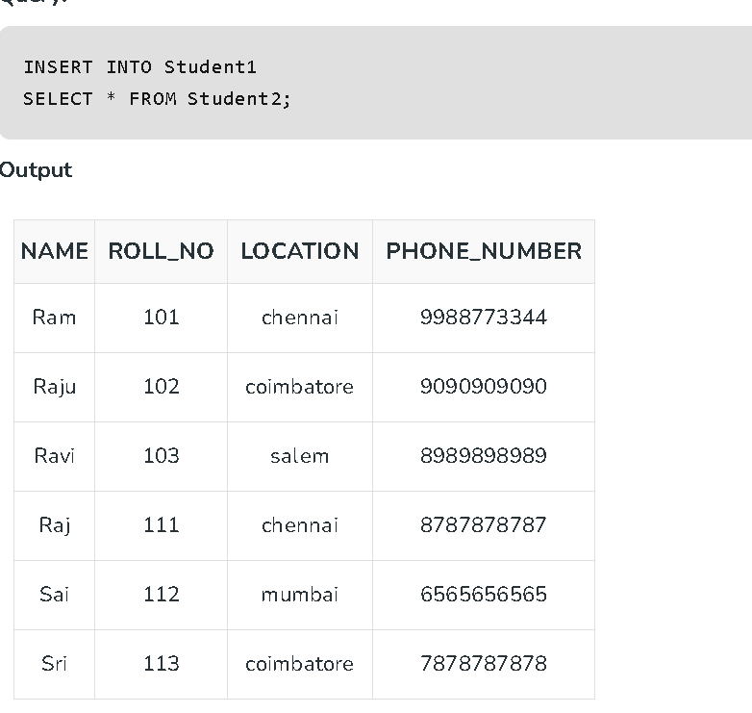

1. Delete columns in table

