1. Condition based :

* Two tables lo matching columns mandatory
* Matching column used in first where condition and select column_name (matching column) is used.
* Table2 based on condition to see the output from table 1.

Create tables:

--create table class ("name" varchar(30),"roll_no" int,"location"varchar(30),"phone_number"int)

--insert into Class

--values("prasanna",1,"kothapalli",1236544559),("pavani",1,"kothapalli",1236544759),("chandrika",5,"Ghantasala",1236544749),("sravani",3,"kothapalli",1236544758),("meghana",6,"Ghantasala",1236545449)

--create table student("name" varchar(30),"roll_no" int,"section" varchar(15))

--insert into Student

--values ("prasanna",1,"A"),("sravani",5,"B"),("meghana",2,"c")

Difference between in and =

* In condition satisfy it gives multiple values in a table to the output in all satisfied cases will display.

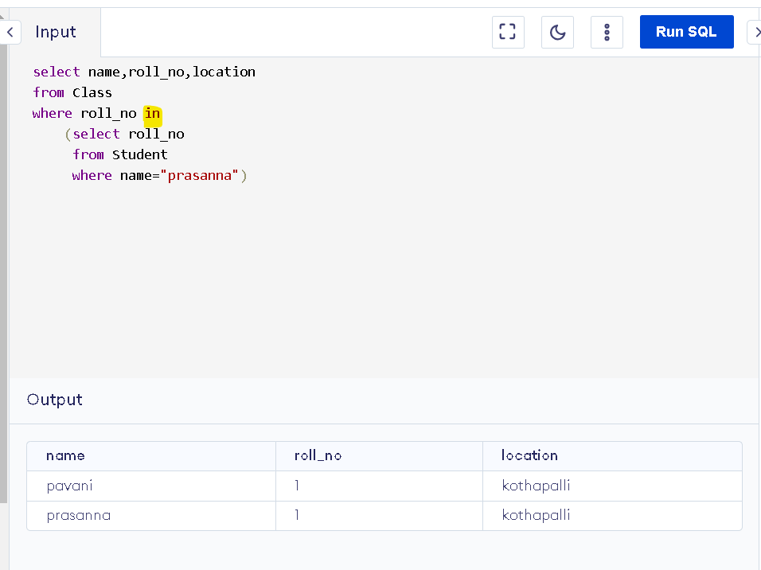

* = condition will show all satisfied codition will display an output.

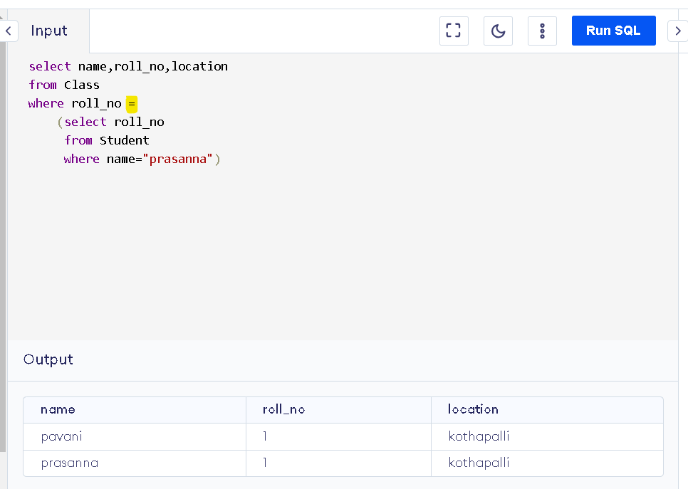

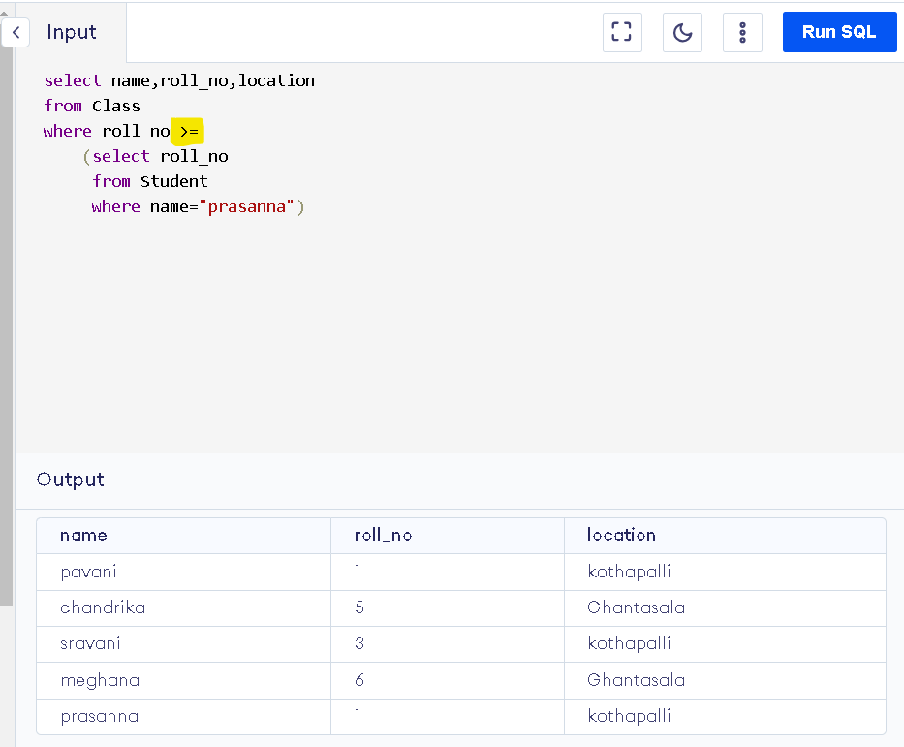

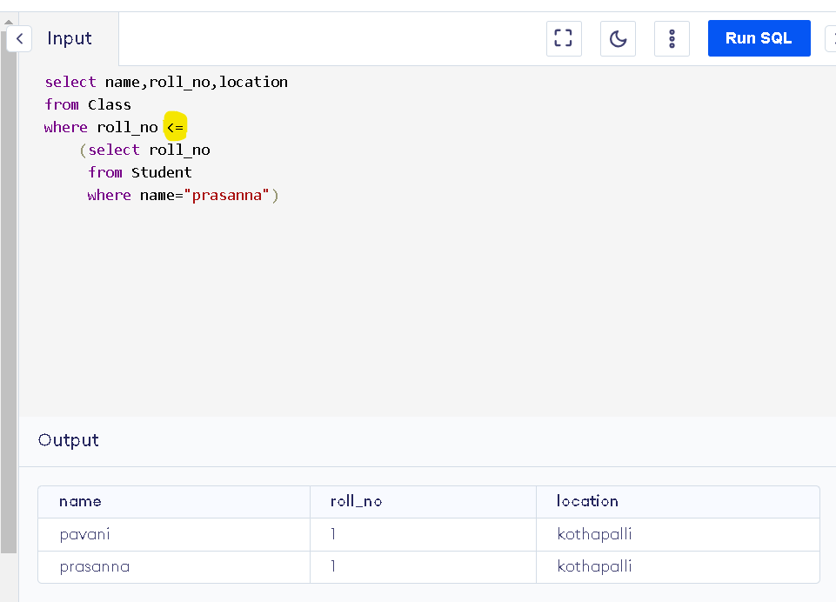

1. Insert table1 to table2:

