School of Computer Science and Artificial Intelligence

Lab Assignment # 14

Name of Student : G. Vamshi
Enrollment No. : 2303A51448
Batch No. 21

Task Description 1 – (Landing Page Design)
- Create a simple landing page for a product or service. Include a header, hero section, and footer.
Requirements:
- Use HTML and CSS to structure the page.
- Use AI to suggest layout alignment and typography.
- Ensure the page is responsive across devices.

Prompt:-
create a landing page for a website for a product or service. It should have a header, a main section with some content, and a footer. Use appropriate HTML tags and structure to create the page.

Code:-
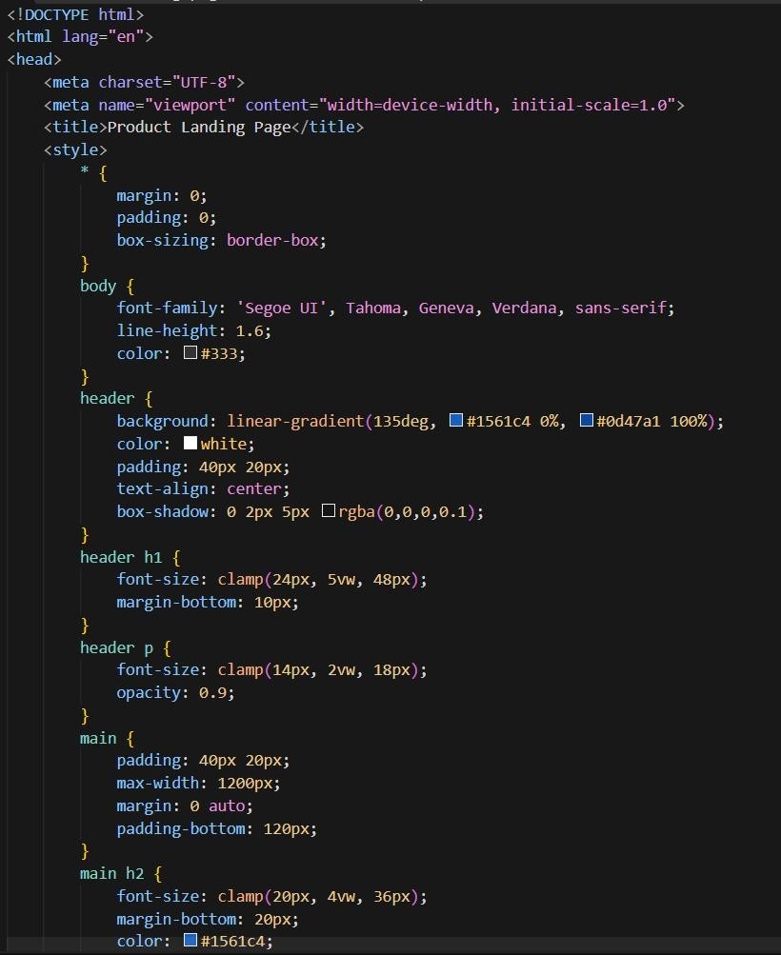

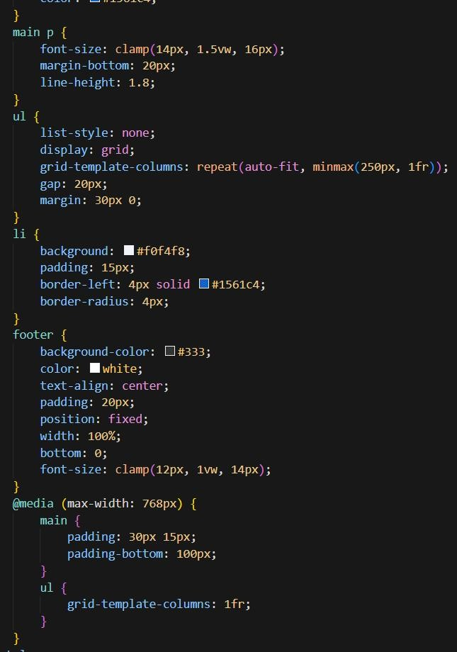
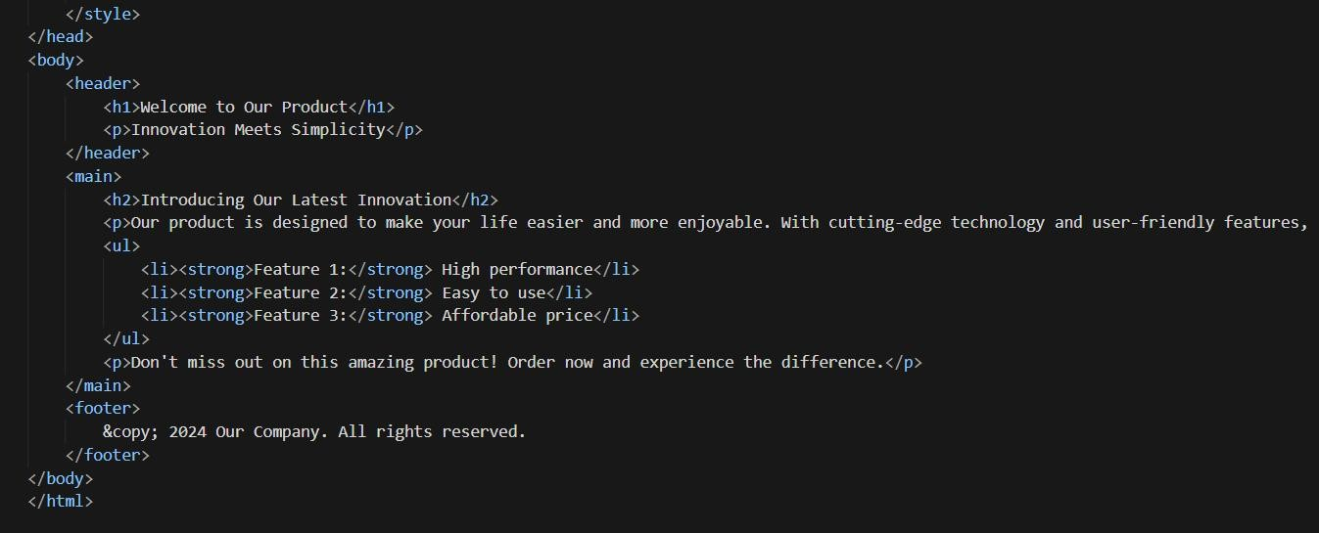

Output:-
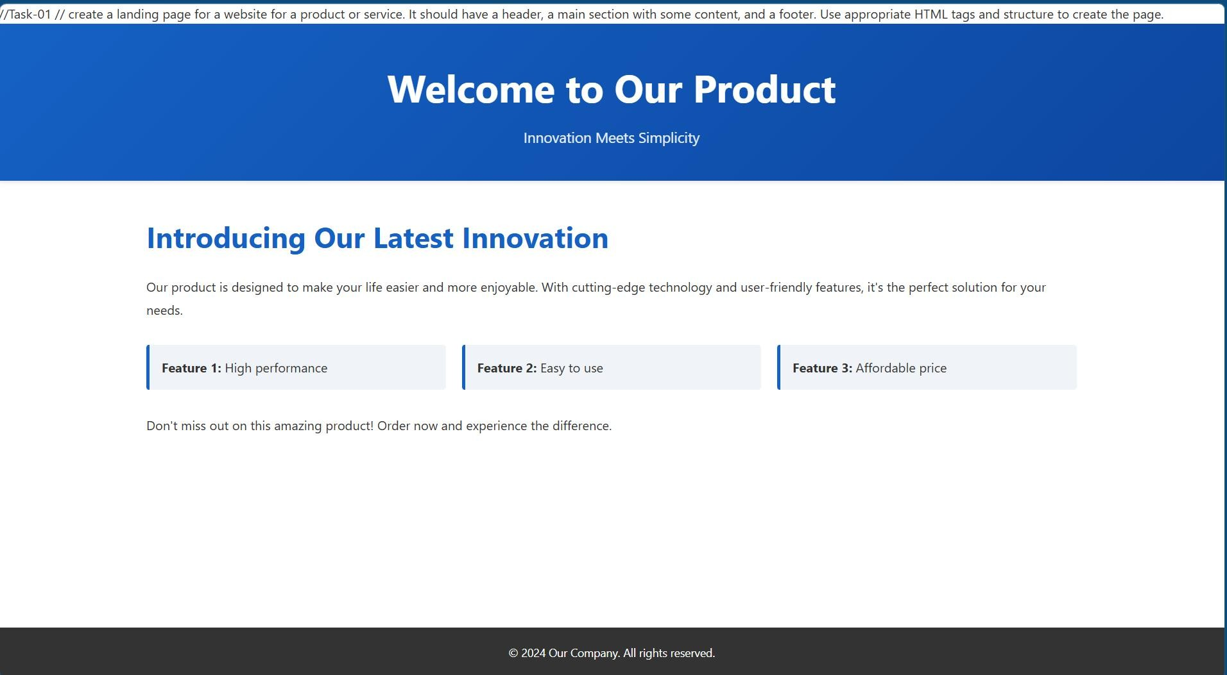

Justification:-
Showcases a product section with clear headings and bullet points to highlight key features and benefits for users. Focuses on readable layout and persuasive copy to improve user engagement and conversion.

Task Description 2 – (Theme Toggle Feature)
- Provide a button to switch between light and dark themes.. Requirements:
- Use JavaScript to toggle CSS classes.
- Use AI assistance to manage color contrast and accessibility.
- Ensure theme preference applies instantly on click.

Prompt:-
create a button that can switch light and dark themes using javascript to toggle css classes and to manage color contrast and accessibility to ensure theme perfomance instanly on clicking.

Code:-
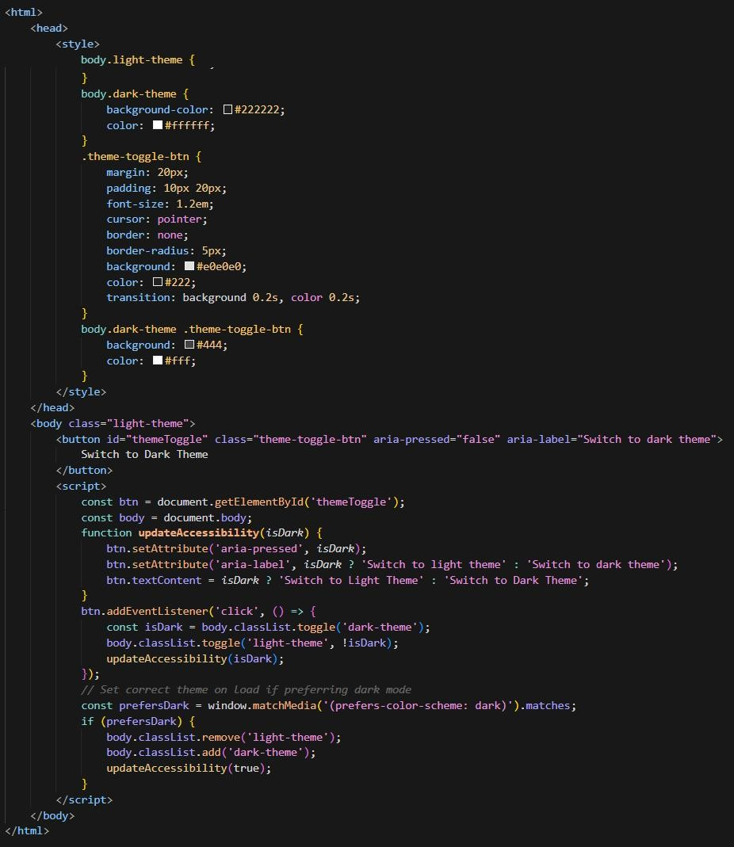

Output:-
In white Theme
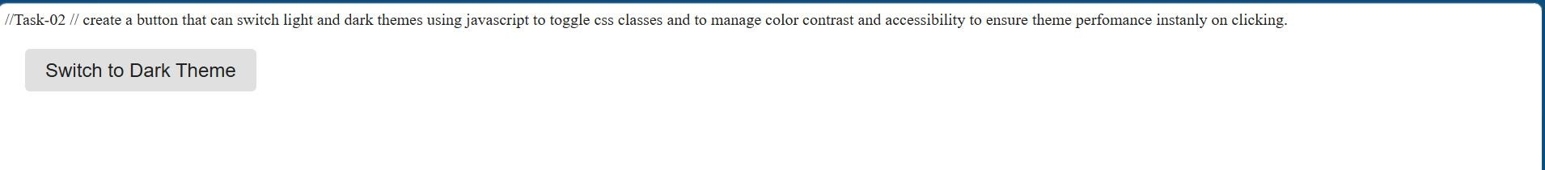
In Black Theme

Justification:-
Implements a theme toggle button that instantly switches between light and dark modes using class-based styling. Improves accessibility and user comfort by adjusting colors dynamically without reloading the page.

Task Description 3 – (User Feedback Form)
- Create a feedback form with fields: Username, Rating, Comments. Requirements:
- Use JavaScript to validate required fields.
- Display success or error messages dynamically.
- Use AI to improve form usability and layout.

Prompt:-
create a feedback form with info of username, rating, comments using javascript to validate required field and usabilty and layout.

Code:-
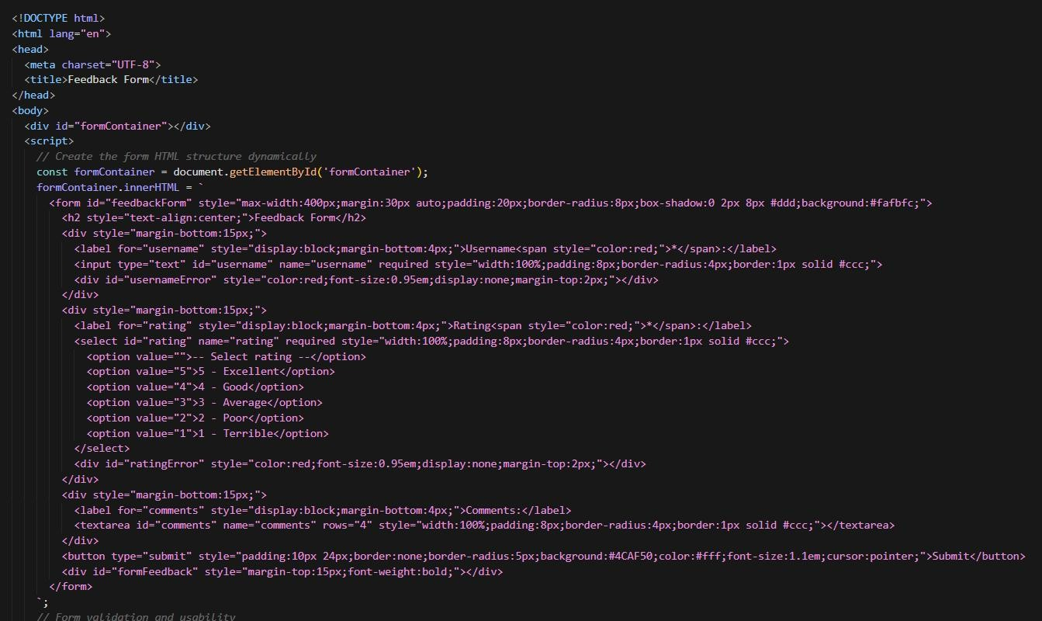

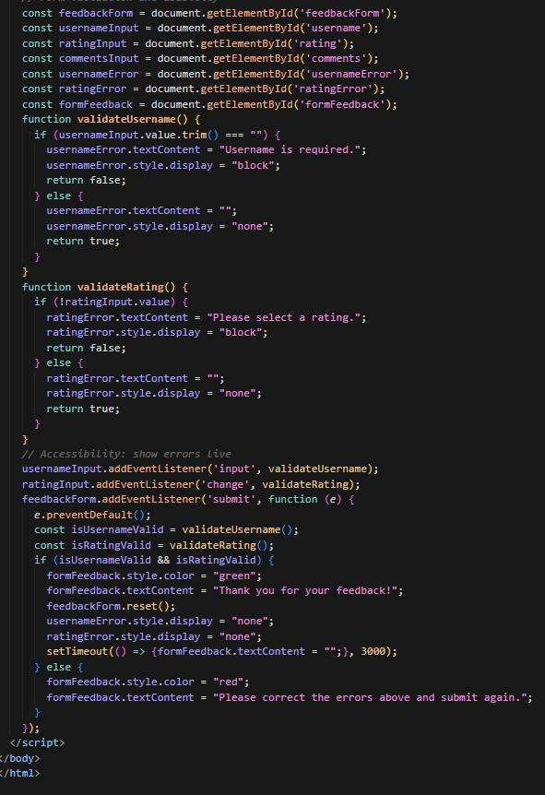

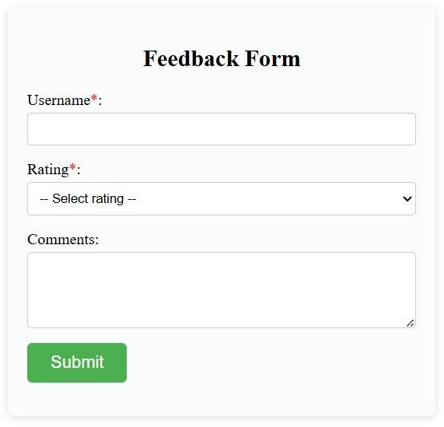
Output:-

Justifications:-
Builds a feedback form capturing username, rating, and comments with JavaScript validation for required fields. Enhances usability by preventing incomplete submissions and guiding users to correct input errors.

Task Description - 4 (Image Gallery with JavaScript)
- Task: Display a small image gallery on a web page. Requirements:
- Use JavaScript to dynamically load images.
- Add next/previous navigation buttons.
- Use AI to optimize layout responsiveness.

Prompt:-
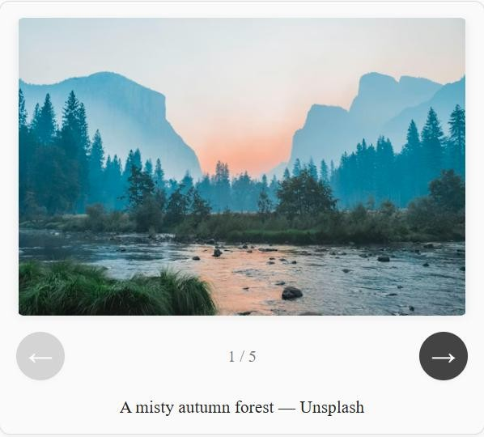
create a small image gallery on a webpage using html,js to dynamically load images and add navigations on next/previous buttons and optimize layout responsiveness, HTML structure for the image gallery

Output:-
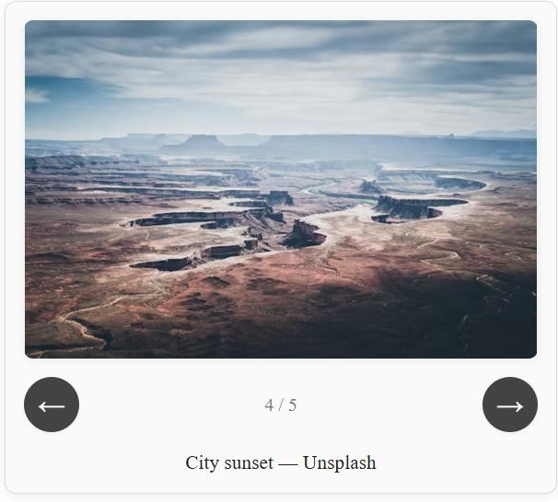

Justification:-
Creates a responsive image gallery that dynamically loads images and supports next/previous navigation buttons. Provides a clean, interactive browsing experience optimized for different screen sizes

Code:
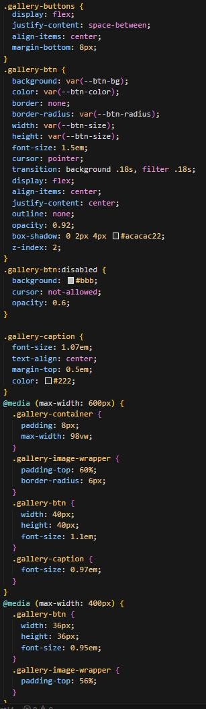
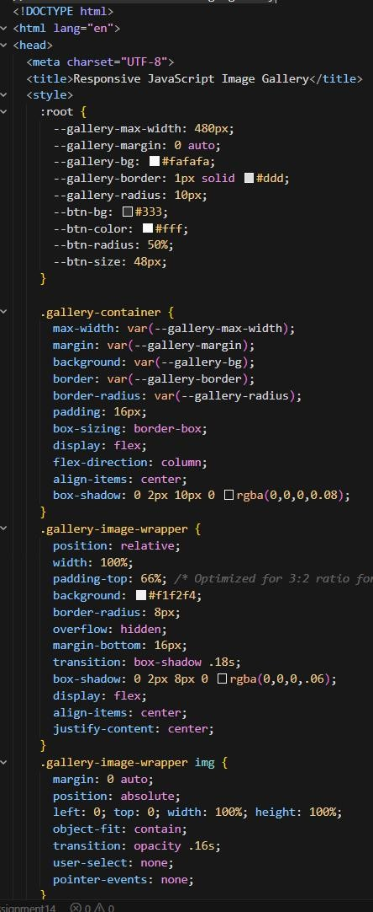

-
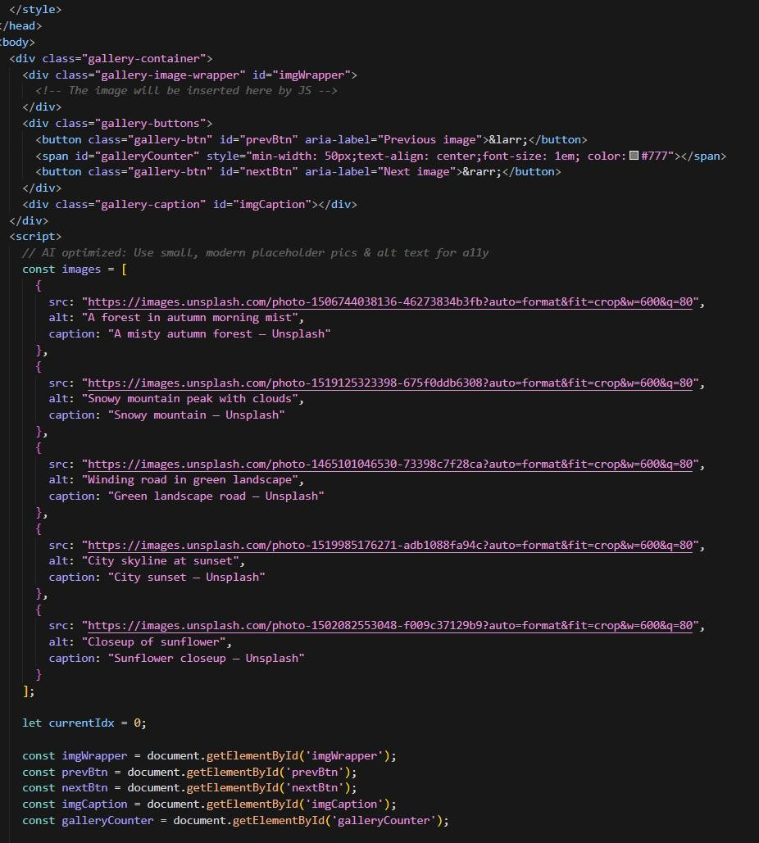
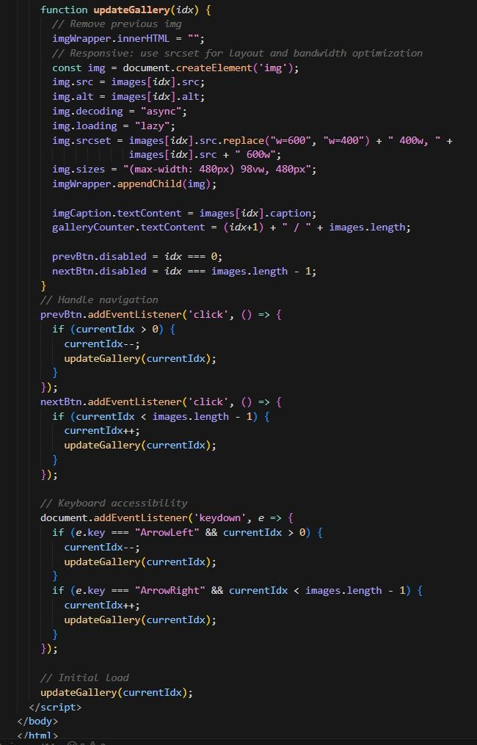

Task Description - 5: (Notification Banner)
- Display a notification banner at the top of the page. Requirements:
- Use JavaScript to show and hide the banner.
- Style the banner using CSS.
- Use AI to ensure smooth transitions and clean UI behavior.

Prompt:-
create a webpage to dispaly the notification banner at th e top of the page using html,js to show the hidden the bannerand style the banner using css to ensure smooth transition and clean UI behaviour.

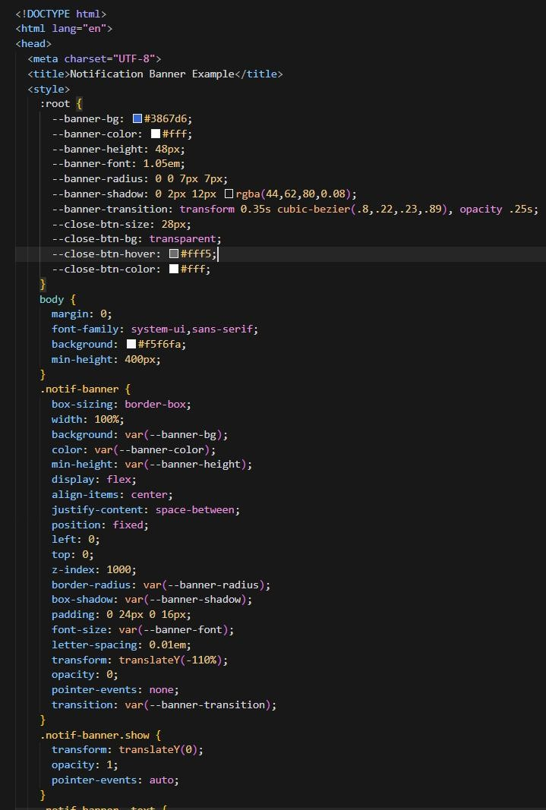
Code:
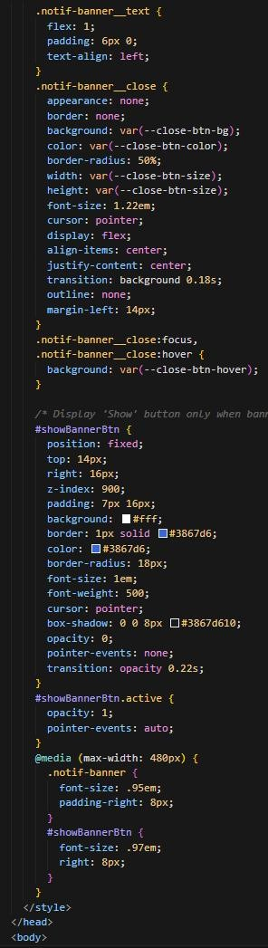

-

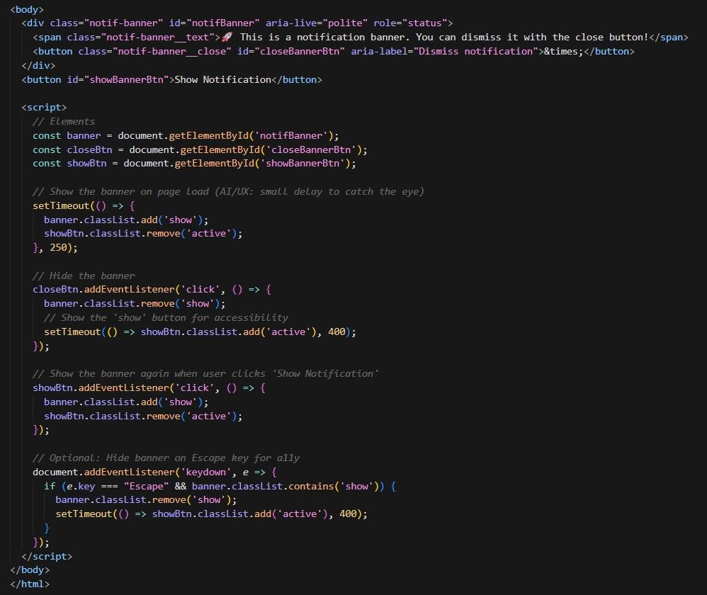

Output:-

Justification:-
Displays a notification banner at the top of the page that can be shown or hidden using JavaScript. Uses smooth transitions and styled layout to deliver important messages without disrupting the overall UI.

