AI ASSISTED CODING
LAB ASSIGNMENT-1
Name: G.Vamshi
HT.NO: 2303A51448
Batch: 21
Question-1:
AI-Generated Logic Without Modularization (Factorial without Functions)
Prompt:
# generate a code to get factorial of a number without using functions
Code and Output Screenshot:
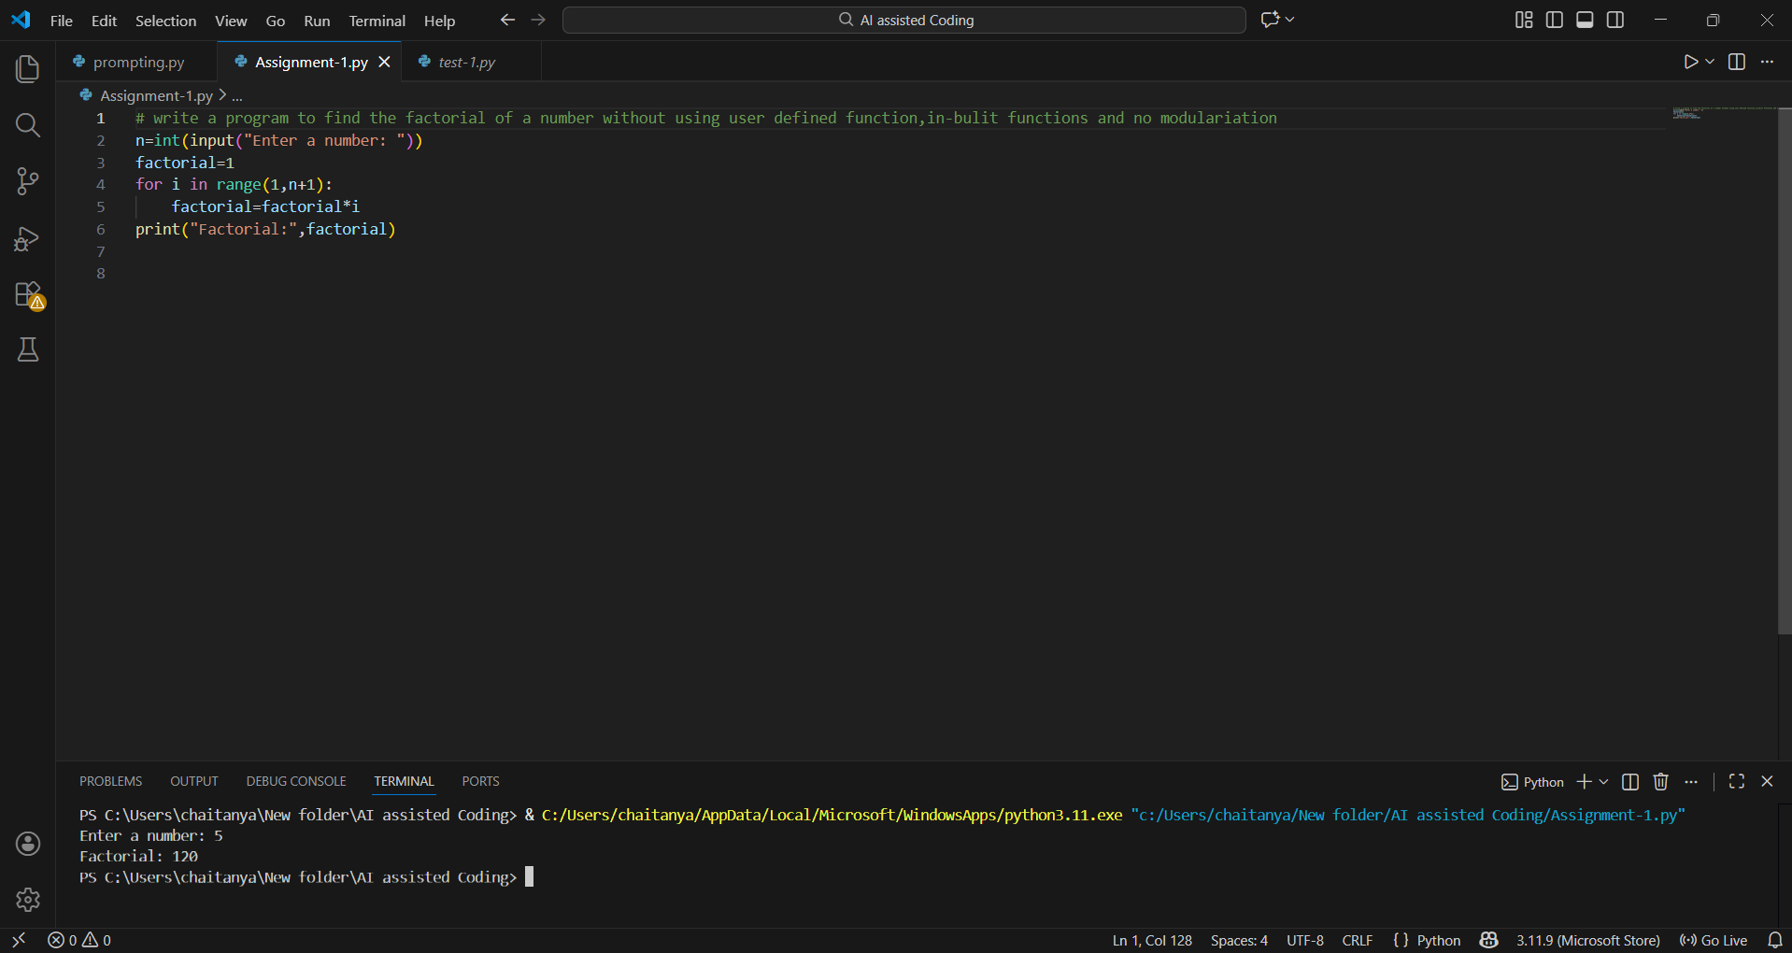
Observation:
Using GitHub Copilot has been a game-changer in helping me understand the logic behind loops and control flow. It saves time by handling syntax details, variable initialization, and loop conditions, letting me focus on problem-solving. Overall, it feels like an intelligent coding assistant that boosts both confidence and speed—while still encouraging me to strengthen my fundamentals alongside it.
Question-3: Modular Design Using AI Assistance (Factorial with Functions)
Prompt: # generate a code to get factorial of a number with using functions
Code and Output Screenshot:
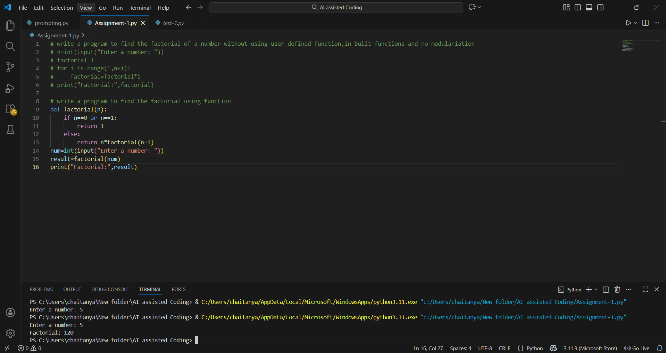
Observation:
Using GitHub Copilot for a modular design made the code more structured and easier to understand.
It suggested clear function names, meaningful parameters, and helpful inline comments that improved readability.
By separating the factorial logic into a reusable function, Copilot naturally encouraged good programming practices, especially for beginners
Question-4: Comparative Analysis – Procedural vs Modular AI Code (With vs Without Functions)
Comparison Table:
Feature | Without Functions | With Functions
Code Structure | Simple and linear | Organized and modular
Calling Mechanism | Runs directly | Invoked through function calls
Code Length | Generally shorter | Slightly longer due to function definitions
Reusability | Difficult to reuse | Easily reusable across multiple programs

Technical Report:
For debugging, modular code has a clear advantage, as issues can be traced directly to a specific function, whereas procedural code becomes harder to manage as scripts grow longer.
Regarding AI dependency, both styles require careful human review, but modular design reduces the risk slightly by making AI-generated logic easier to read and validate.
In terms of logic clarity, procedural code works for very small programs, but modular code scales better by organizing functionality into well-named functions that enhance readability and understanding.
Question-5: AI-Generated Iterative vs Recursive Thinking
Iterative:
Prompt: # generate a code to get factorial iteratively
Code :
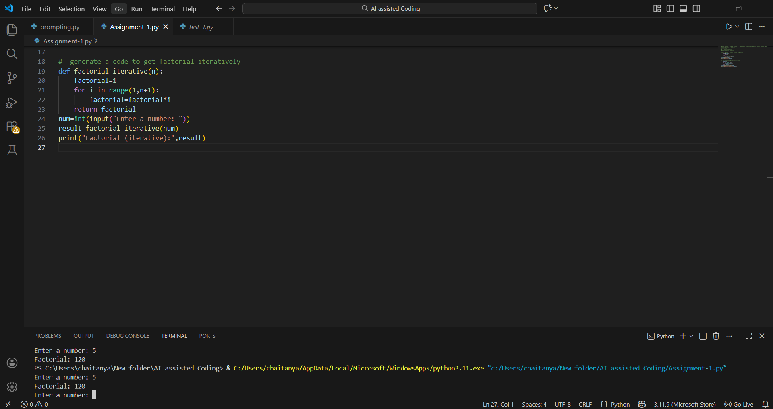
Recursive:
Prompt: # generate a code to get factorial recursively
Code :
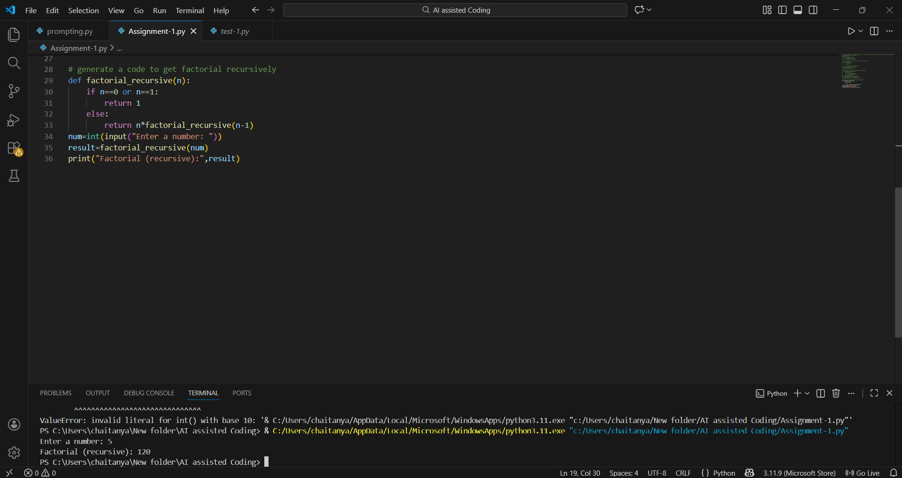
Execution Flow Explanation:
In the iterative approach, a loop multiplies numbers from 1 to the input step by step.
In the recursive approach, the function calls itself with smaller values until reaching a base case, then multiplies results as the calls return.
Iterative is straightforward, while recursive breaks the problem into smaller, elegant subproblems.
Comparative Analysis:
Readability: Iterative code is usually easier for beginners to follow, while recursion mirrors mathematical definitions but can be harder to trace step by step.
Limitations: Recursion is not ideal for very large inputs, performance-critical tasks, or problems that don’t naturally fit a recursive structure due to stack overflow risk.
Performance: Iterative approaches are generally faster and more memory-efficient, while recursion adds overhead due to repeated function calls and stack usage.
Memory: Iterative code uses constant space, whereas recursion consumes extra stack memory for each call, which can be problematic for large inputs.

