AI Assisted Coding
Assignment-9.2

Name: G.Vamshi
Ht.No: 2303A51448
Batch: 21

TaskDescription-1(Documentation–FunctionSummary Generation)
Prompt:
add a short functional summary as a docstring for every function in this file. The summary must explain the function purpose only, without describing logic or implementation steps.
Code:
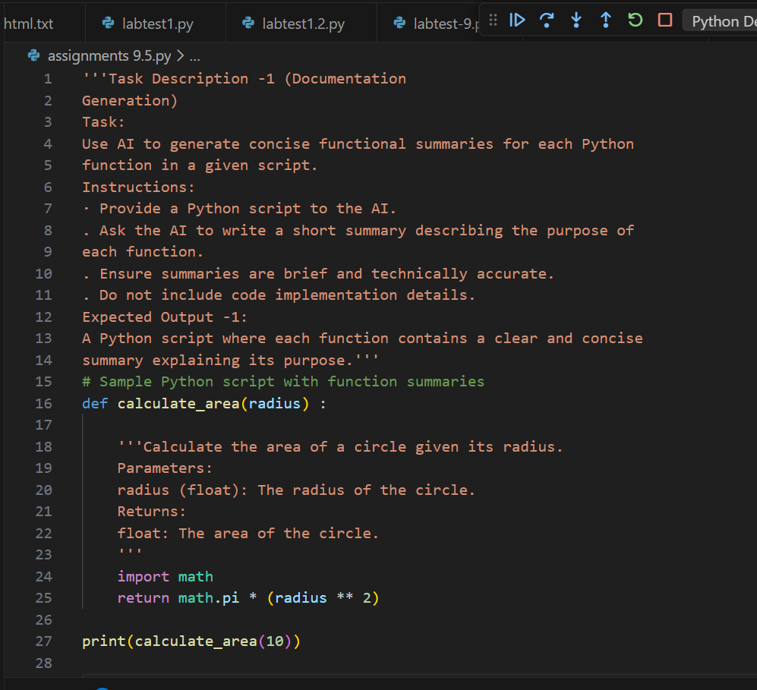

Output:
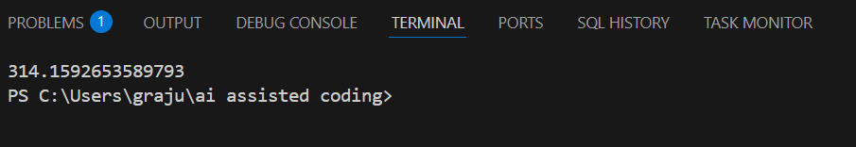

Observation:
AI-generated function summaries help improve code readability by clearly describing the purpose of each function. The summaries make it easier for developers to understand the program structure without analyzing the implementationdetails.Thisapproachalsosupportsfastermaintenanceand documentation consistency.

TaskDescription-2(Documentation–Logical Explanation for Conditions and Loops)
Prompt:
Add a brief explanation of the logic behind each condition and loop statements. Explain only decision - making and loop statements
Code:
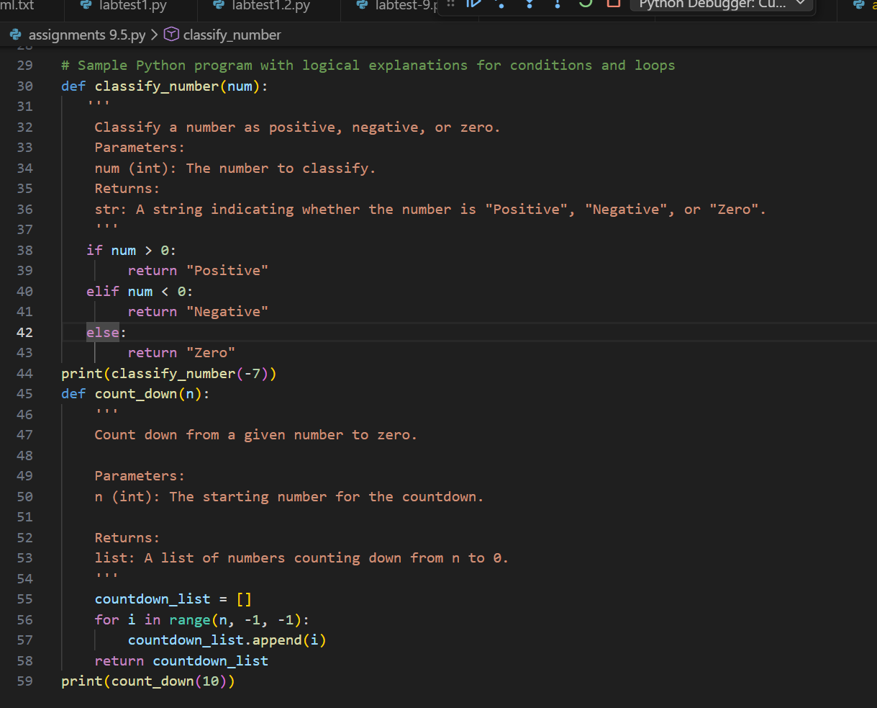

Output:
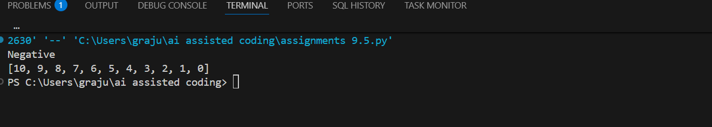

Observation:
AI-generatedexplanationsforconditionsandloopsclarifythedecision-making flow and iteration behavior within the program. These logical comments help users quickly understand how the program controls execution paths. As a result, debugging and code comprehension become more efficient.

TaskDescription-3(Documentation–File-Level-Overview) Prompt:
Generate a file summarizing the overall functionality of the script, including the purpose of the main function and how it interacts with the user.
Code:
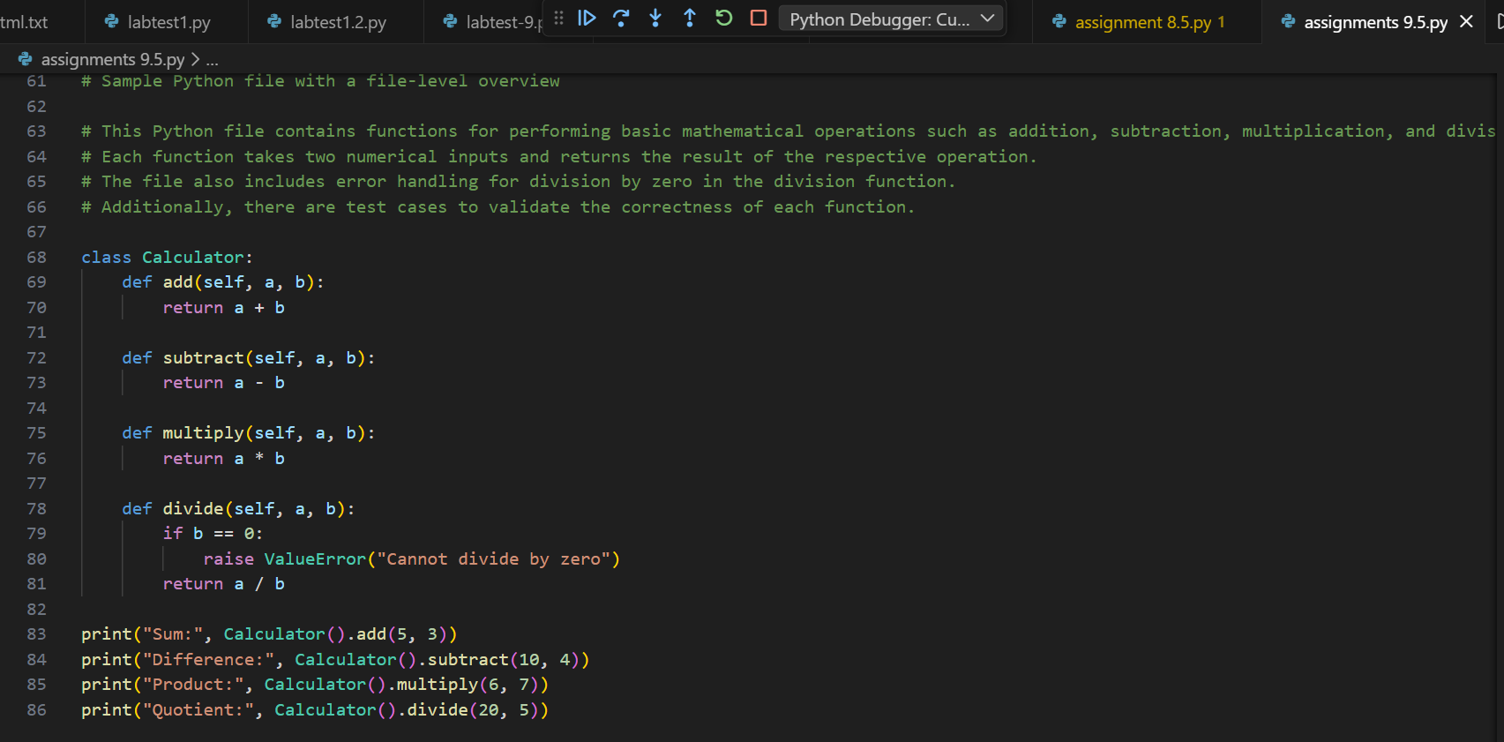

Output:
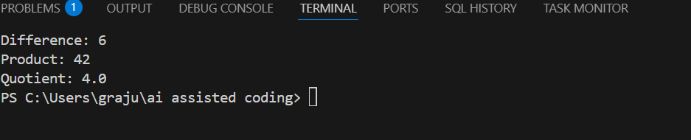
9
Script Summary:
This script defines a function called add, subtract, multiply, divide calculates the mathematical operations. The script also checks for an error occurred when divided by zero it throws the error “Value Error”.
Observation:
The AI successfully generated a concise file-level overview summarizing the overall purpose and functionality of the Python program. The overview was placedatthebeginningofthefileanddescribedtheprogramataconceptual level without including implementation details. This improved the readability of the code and helped users quickly understand the program’s objective.

TaskDescription-4(Documentation–Refine Existing Documentation)
Prompt:
Rewrite the existing comments to improve clarity and consistency while keeping the original meaning unchanged. Do not modify the program logic.
Code:
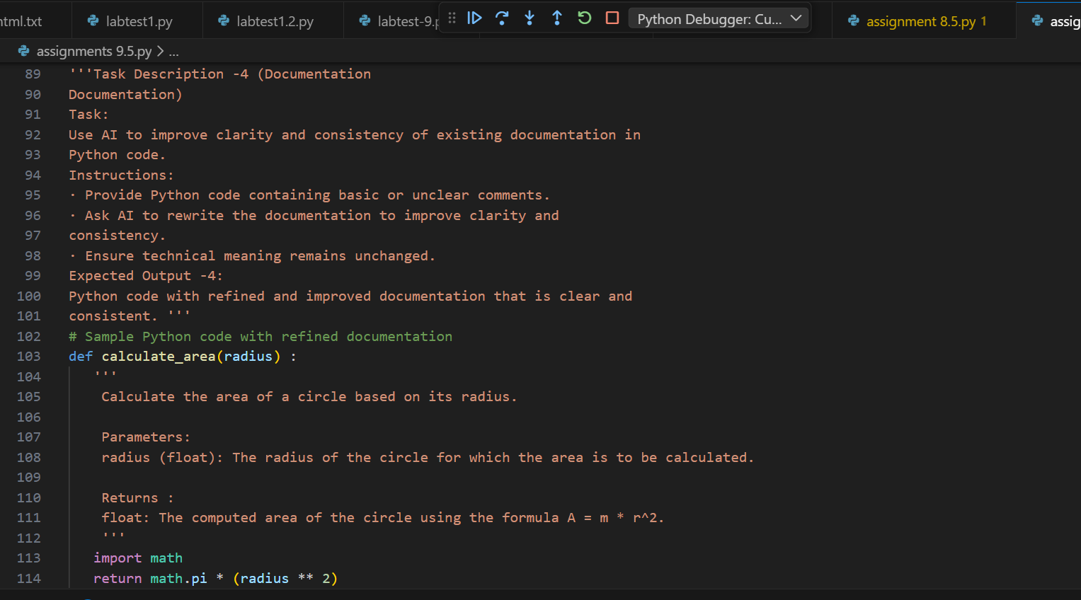

Output:


Observation: The script proved the clarity and consistency of the existing comments without altering the program’s functionality. The refined documentation provided clearer explanations while preserving the original technical meaning. This enhancement made the code easier to read, understand, and maintain.

TaskDescription-5(Documentation–Prompt Detail Impact Study) Brief Prompt:
Write a short one-line documentation comment describing the purpose of the following function.
Code:
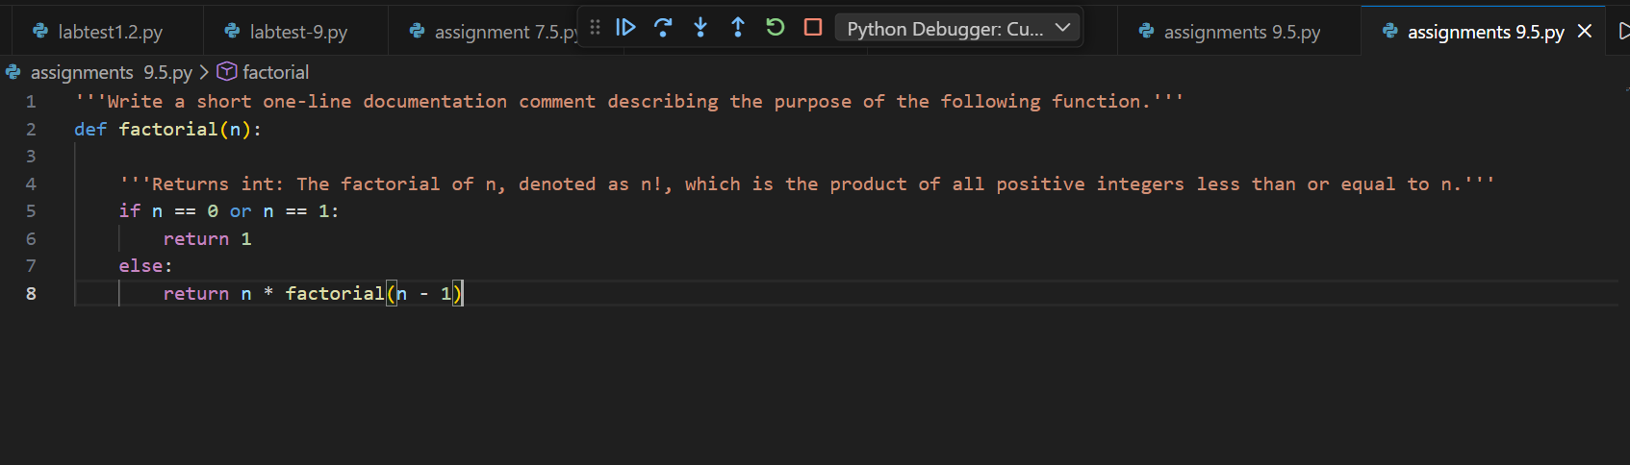

Output:
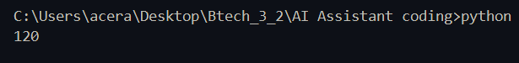
Detailed Prompt:
Writeaclear3–5linedocumentationcommentforthefollowingfunction describing its purpose, inputs, outputs, and overall behavior.
Code:
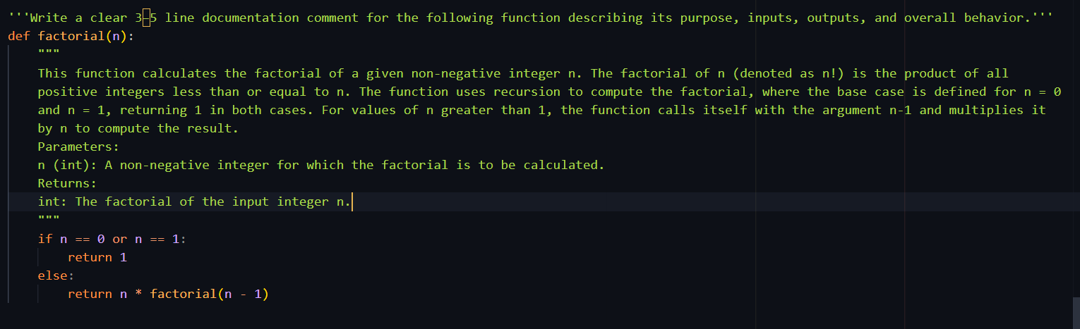Output:


Observation:

Criteria | BriefPromptOutput(One-  lineComment) | DetailedPromptOutput(3–5line  Docstring)
Completeness | Provides only the basic purposeofthefunction. | Includes purpose, input description,output,andbehavior details.
Clarity | Clearbutveryminimal explanation. | Moredescriptive,structured,and easier to understand.
Accuracy | Correctbutlimited technicalinformation. | Highlyaccuratewithfulltechnical context and parameter details.

