INTERNSHIP REPORT

**AIM:** **To create an interactive platform where users can design their own space explorers. This user-friendly blog allows readers to explore different planets, encounter alien species, and enjoy captivating space-themed features.**

A Report Submitted to

Jawaharlal Nehru Technological University Kakinada, Kakinada in partial fulfillment for the award of the degree of

## BACHELOR OF TECHNOLOGY

**IN**

**COMPUTER SCIENCE AND ENGINEERING**

Submitted by

**GUDIBANDI DHANUSH KUMAR REDDY (22KN1A0551)**

**GUMMALA LIKHITHA (22KN1A0554)**

**NAIDU JAHNAVI (22KN1A0563)**

**NAGULLA MOHAN CHAND (23KN5A0506)**



**DEPARTMENT OF COMPUTER SCIENCE AND ENGINEERING**

# NRI INSTITUTE OF TECHNOLOGY

**Autonomous**

##### (Approved by AICTE, Permanently Affiliated to JNTUK, Kakinada) Accredited by NBA (CSE, ECE, EEE, MECH & IT), Accredited by NAAC with ‘A’ Grade ISO 9001: 2015 CertifiedInstitution

**Pothavarappadu (V), (Via) Nunna, Agiripalli (M), Krishna Dist., PIN: 521212, A.P, India.**

**2024-2025**

|  |  |
| --- | --- |
| NRI | **NRI INSTITUTE OF TECHNOLOGY**  (An Autonomous Institution, Approved by AICTE, Permanently Affiliated to JNTUK, Kakinada)  Accredited by NBA (CSE, ECE , EEE, MECH & IT ), Accredited by NAAC with ‘A’ Grade ISO 9001: 2015 Certified Institution  Pothavarappadu (V), (Via) Nunna, Agiripalli (M), Krishna Dist., PIN: 521212, A.P, India. |

**CERTIFICATE**

The is to certify that the “Internship report” submitted by **GUDIBANDI DHANUSH KUMAR REDDY**(**RegdNo:22KN1A0551**),**GUMMALA LIKHITHA(RegdNo:22KN1A0554** ,**NAIDU JAHNAVI** (**RegdNo:22KN1A0563**),**NAGULLA MOHAN CHAND(RegdNo:23KN5A0506**) is work done by her and submitted during YEARS academic year, in partial fulfillment of the requirements for the award of the degree **of BACHELOR OF TECHNOLOGY in COMPUTER SCIENCE AND ENGINEERING, at Codegnan IT Solutions Pvt Ltd.** In collaboration with **Andhra Pradesh State Council of Higher Education .**

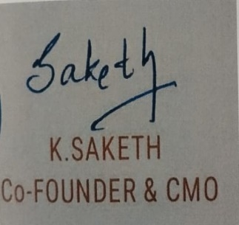

**INTERNSHIP COORDIANTOR Head of the Department**

(Dr. D. SUNEETHA)

**EXTERNAL EXAMINER**

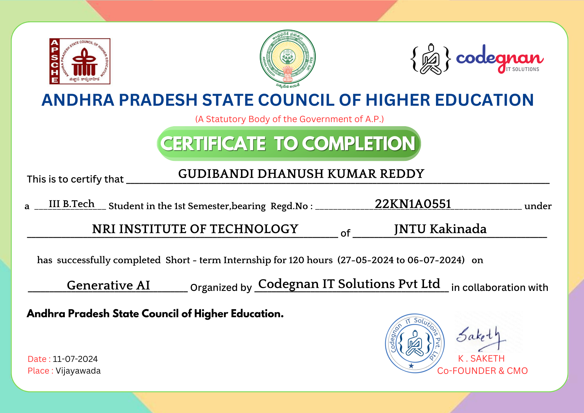

## CERTIFICATE OF INTERNSHIP CERTIFICATE OF INTERNSHIP

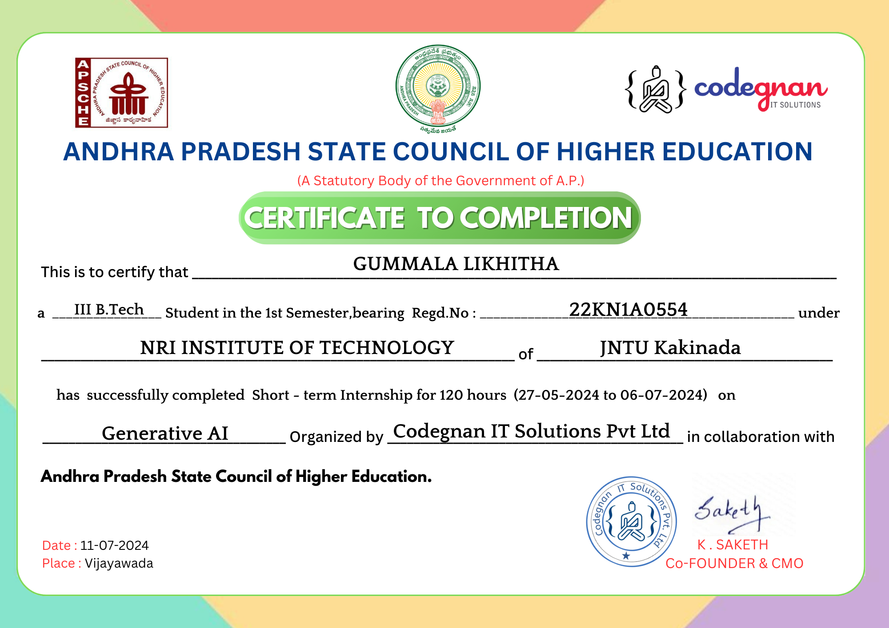

## CERTIFICATE OF INTERNSHIP

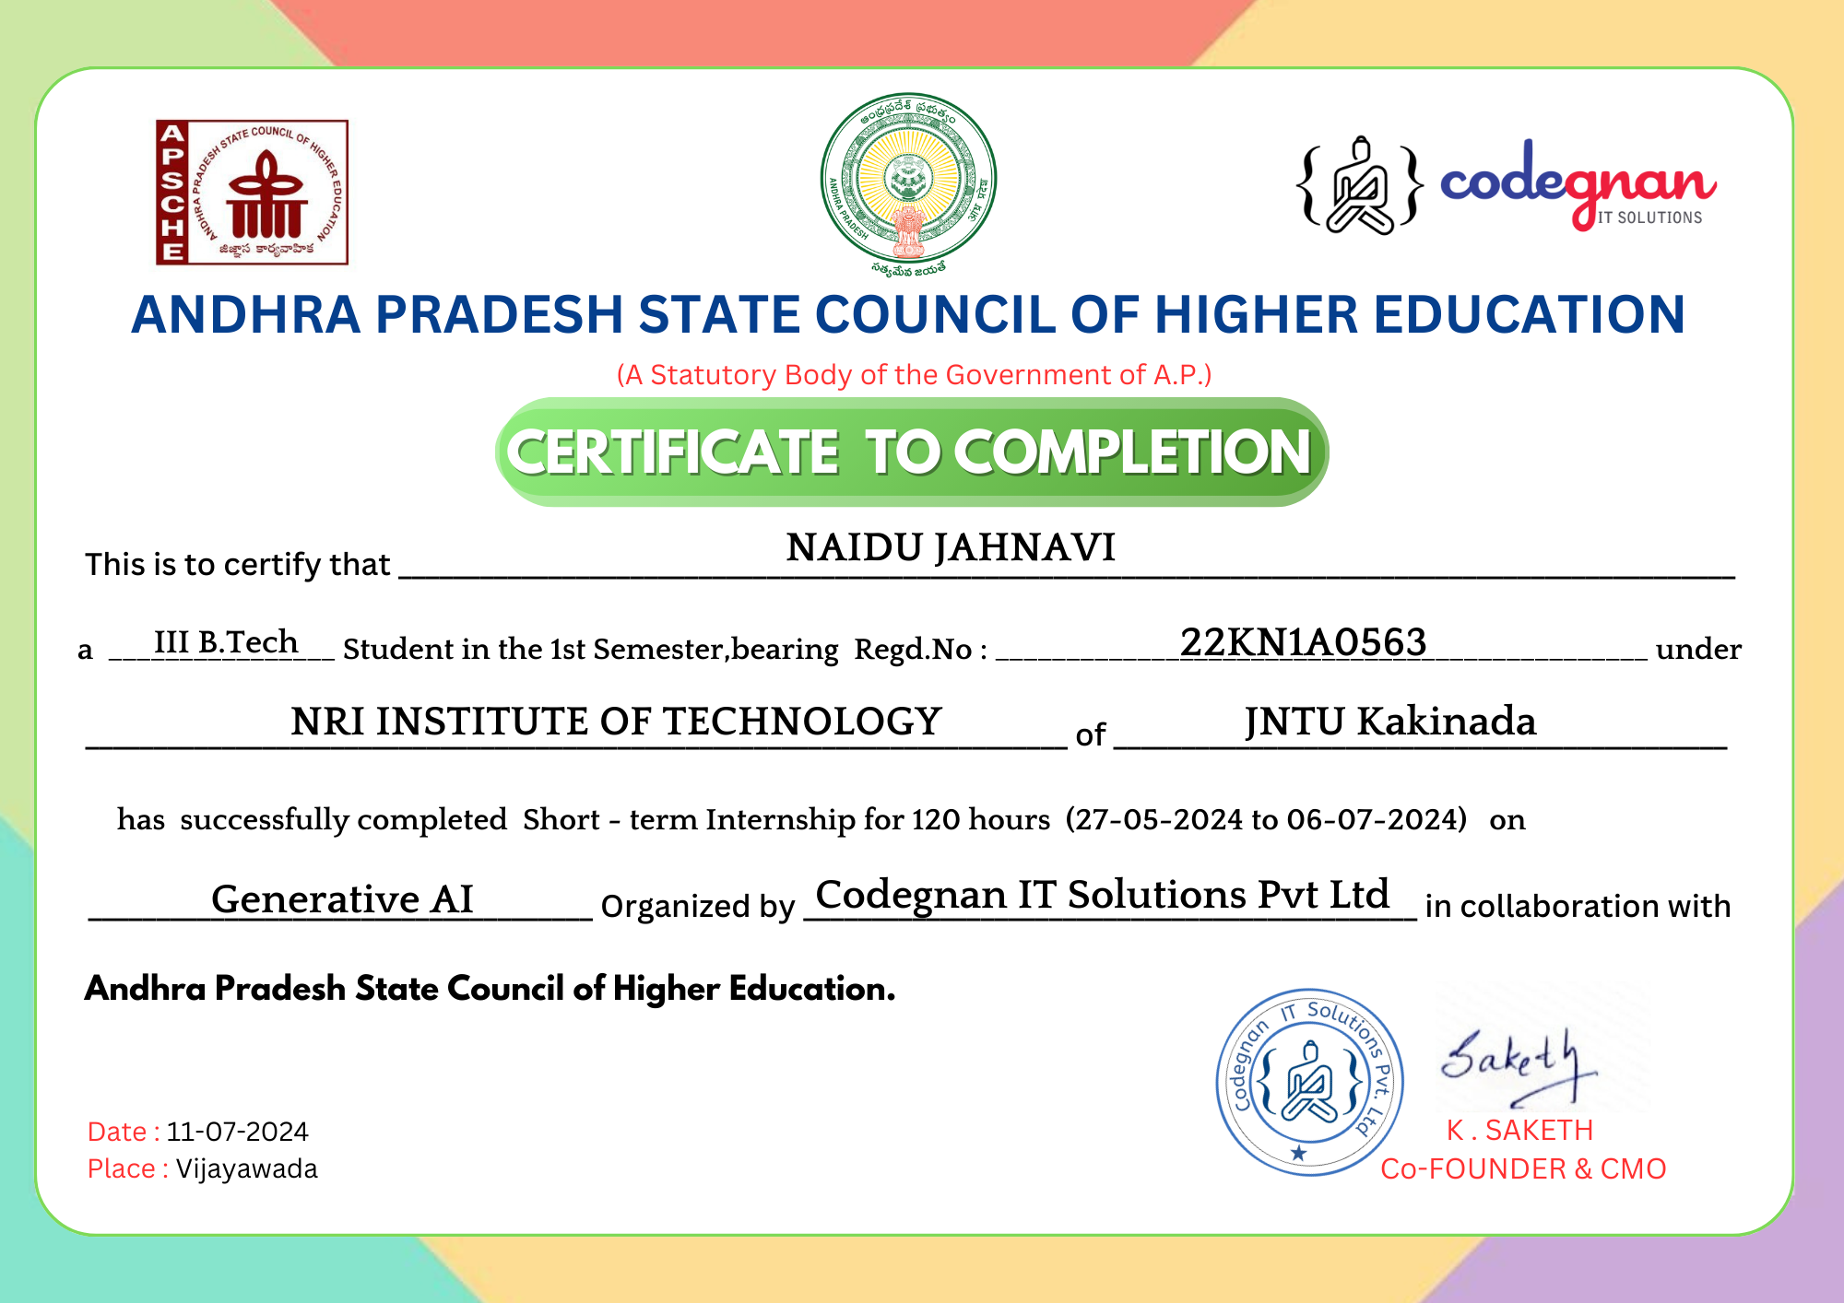

## CERTIFICATE OF INTERNSHIP

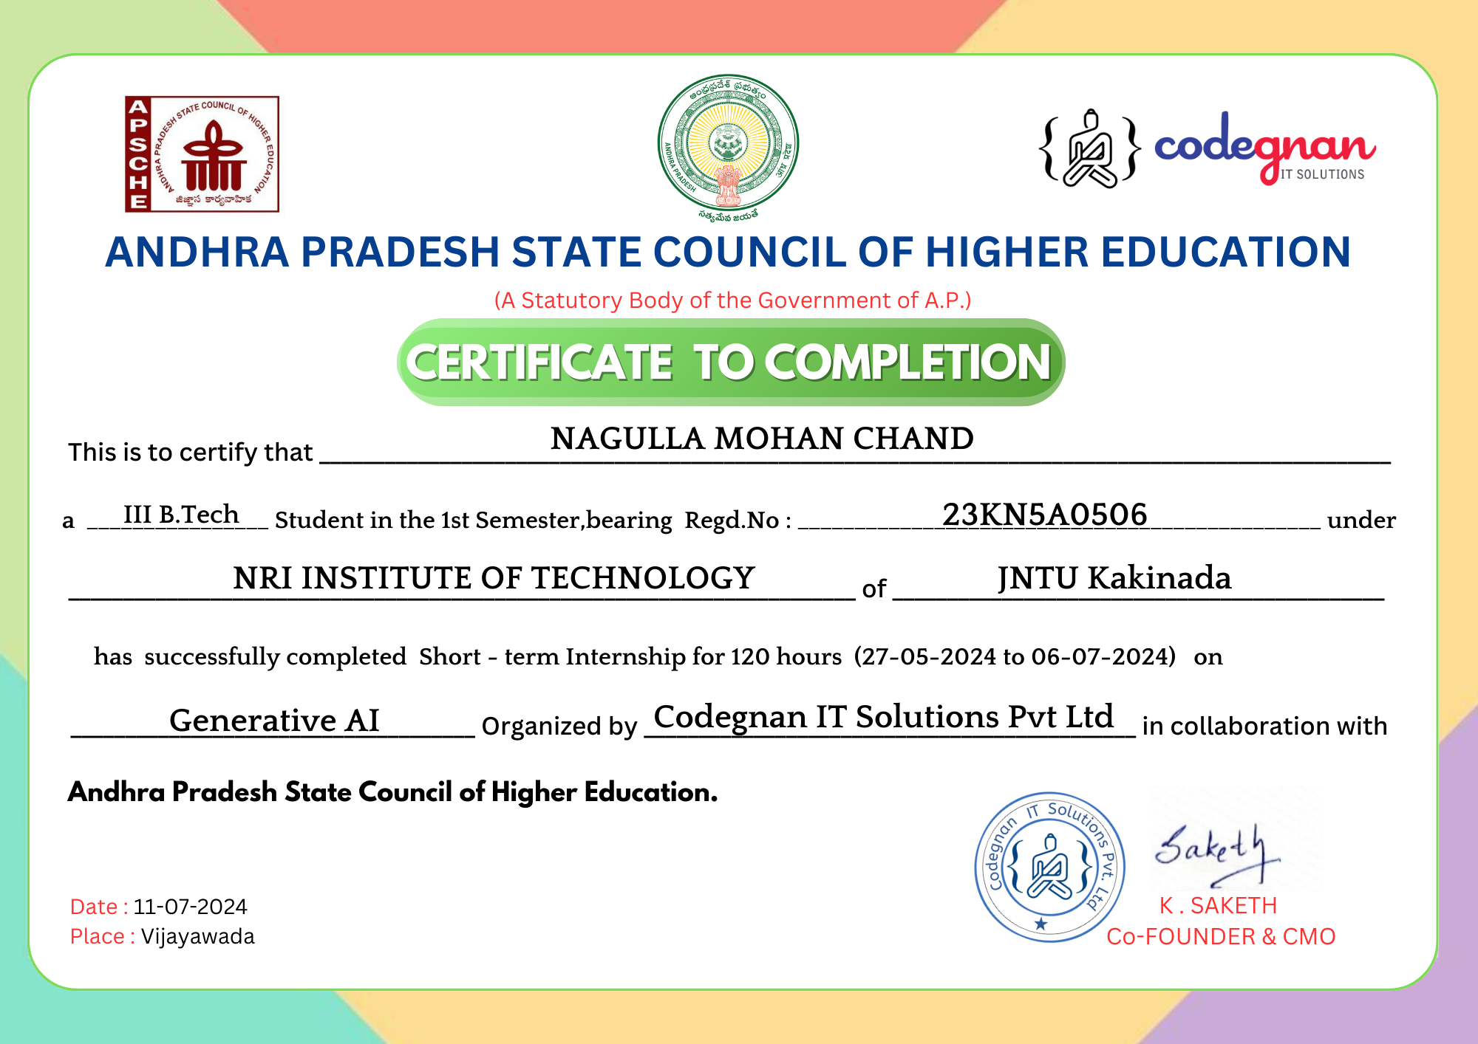

## ACKNOWLEDGEMENT

We take this opportunity to thank all who have rendered their full support to our work. The pleasure, the achievement, the glory, the satisfaction, the reward, the appreciation and the construction of our project cannot be expressed with a few words for their valuable suggestions.

We are expressing our heartfelt thanks to **Head of the Department, Dr. D. SUNEETHA**

garu for her continuous guidance for completion of our Project work.

We are extending our sincere thanks to **Dean of the Department, Dr. K. V. SAMBASIVA RAO** for his continuous guidance and support to complete our project successfully.

We are thankful to the **Principal, Dr. C. NAGA BHASKAR** garu for his encouragement to complete the Project work.

We are extending my sincere and honest thanks to the **Chairman, Dr. R. VENKATA RAO garu & Secretary, Sri K. Sridhar** garu for their continuous support in completing the Project work.

Finally, We thank the Administrative Officer, Staff Members, Faculty of Department of CSE, NRI Institute of Technology and our friends, directly or indirectly helped us in the completion of this project.

**Name:GUDIBANDI DHANUSH KUMAR REDDY RegdNo:22KN1A0551**

**Name:GUMMALA LIKHITHA Regd No:22KN1A0554**

**Name:NAIDU JAHNAVI Regd No:22KN1A0563**

**Name:NAGULLA MOHAN CHAND Regd No:23KN5A0506**

# ABSTRACT

The  ‘**Space Explorer’**  project is designed to push the boundaries of autonomous space exploration by integrating advanced robotics, artificial intelligence, and cutting-edge sensor technologies. Its primary goal is to develop a fully autonomous exploration system capable of navigating and studying distant celestial bodies, such as planets, moons, asteroids, and comets, without direct human control. This system is intended to perform scientific tasks, such as analyzing surface composition, measuring atmospheric conditions, and identifying potential resources or signs of life, while operating in the harsh and dynamic environment of space.

Central to the project’s vision is the development of intelligent autonomous decision-making capabilities. The Space Explorer will utilize AI algorithms for navigation, hazard detection, and real-time adaptation to unforeseen challenges. This includes avoiding obstacles, adjusting flight paths, and selecting optimal scientific instruments based on environmental cues. These capabilities will ensure that the Space Explorer can operate independently for extended periods, conducting valuable research even in remote and difficult-to-reach areas of the solar system and beyond.

In addition to its technological innovations, the Space Explorer project aims to contribute to long-term space exploration goals, such as laying the groundwork for future human missions to distant planets. The insights gained from autonomous missions will enhance our understanding of planetary systems, help identify potential sites for human colonization, and support the sustainable exploration of space. By fostering international collaboration and pushing technological boundaries, the project seeks to make significant contributions to the global space exploration community, advancing scientific knowledge and paving the way for future interplanetary exploration.

**INDEX**

# S.no CONTENTS Pageno

1. **Introduction 1****3**
2. **Analysis 15**
3. **Software requirements specifications …17**
4. **Tools 20**
5. **Coding** … 27
6. **Screenshots 30**
7. **Conclusion 32**
8. **Weblinks 34**

**Learning Objectives/Internship Objectives**

**WEEKLY OVERVIEW OF INTERNSHIP ACTIVITIES**

|  |  |  |  |
| --- | --- | --- | --- |
| **1st WEEK** | **DATE** | **DAY** | **NAME OF THE TOPIC/MODULE COMPLETED** |
| 27/05/24 | Monday | Introduction to the Project: Gen AI for Space Explorer |
| 28/05/24 | Tuesday | Understanding Select Country Module and Data Flow Design for Space Explorer |
| 29/05/24 | Wednesday | Designing for Selecting Country in Space Explorer |
| 30/05/24 | Thursday | Introduction to ChatGPT for Generating Space Elements |
| 31/05/24 | Friday | Working with DALL-E for Visual Space Design Elements |
| 1/06/24 | Saturday | Understanding Space Elements: Planets, Stars, and Color Schemes |

Internships are generally thought of to be reserved for college students looking to gain experience in a particular field. However, a wide array of people can benefit from Training Internships in order to receive real world experience and develop their skills.

An objective for this position should emphasize the skills you already possess in the area and your interest in learning more

Internships are utilized in a number of different career fields, including architecture, engineering, healthcare, economics, advertising and many more.

Some internship is used to allow individuals to perform scientific research while others are specifically designed to allow people to gain first-hand experience working.

Utilizing internships is a great way to build your resume and develop skills that can be emphasized in your resume for future jobs. When you are applying for a Training Internship, make sure to highlight any special skills or talents that can make you stand apart from the rest of the applicants so that you have an improved chance of landing the positi

|  |  |  |  |
| --- | --- | --- | --- |
| **2nd WEEK** | **DATE** | **DAY** | **NAME OF THE TOPIC/MODULE COMPLETED** |
| 03/06/24 | Monday | Designing Space Elements with Leonardo.ai |
| 04/06/24 | Tuesday | Money Creation Module: Integrating Elements |
| 05/06/24 | Wednesday | Documenting the content and images into a file |
| 06/06/24 | Thursday | Designed login page and user html pages |
| 07/06/24 | Friday | Designed view projects page |
| 08/06/24 | Saturday | Optimized responsiveness and styling using Bootstrap |

|  |  |  |  |
| --- | --- | --- | --- |
| **3rd WEEK** | **DATE** | **DAY** | **NAME OF THE TOPIC/MODULE COMPLETED** |
| 10/06/24 | Monday | Connected to backend using JavaScript |
| 12/06/24 | Wednesday | Developed a module to connect to Google Drive API |
| 14/06/24 | Friday | Integrated flask with Google Drive Module |
| 17/06/24 | Monday | Fixed few bugs in file uploading |
| 19/06/24 | Wednesday | Implemented Additional features like videos |
| 21/06/24 | Friday | Established connection to Frontend |

|  |  |  |  |
| --- | --- | --- | --- |
| **4th WEEK** | **DATE** | **DAY** | **NAME OF THE TOPIC/MODULE COMPLETED** |
| 24/06/24 | Monday | Moved database to cloud using Drive |
| 26/06/24 | Wednesday | Pushed code to Github for deployment |
| 28/06/24 | Friday | Started deploying the application on render |
| 01/07/24 | Monday | Fixed errors on fronted and backend after deployment |
| 02/07/24 | Tuesday | Updated UI |
| 03/07/24 | Wednesday | Optimized code |

|  |  |  |  |
| --- | --- | --- | --- |
| **5th WEEK** | **DATE** | **DAY** | **NAME OF THE TOPIC/MODULE COMPLETED** |
| 04/07/24 | Thursday | Design& Analysis |
| 05/07/24 | Friday | Coding |
| 06/07/24 | Saturday | Testing |

**CHAPTER 1**

**INTRODUCTION**

# 1.INTRODUCTION

Space exploration is the scientific study of outer space using advanced technologies like spacecraft, telescopes, and robotic missions. It aims to uncover knowledge about the universe, the origins of our solar system, and the potential for extraterrestrial life. Since the launch of Sputnik 1 in 1957, space exploration has significantly advanced our understanding of space, science, and technology.

The primary goal of space exploration is to study celestial bodies, including planets, moons, and asteroids, to answer fundamental questions about the cosmos. This involves understanding planetary compositions, star systems, and the potential for life beyond Earth. Discoveries by space probes and telescopes have provided valuable insights into the solar system's formation and the vastness of space.

Space exploration addresses scientific discovery and global challenges. Technologies like satellite communications, GPS, and weather forecasting, developed for space missions, improve life on Earth. Studying other planets' atmospheres also enhances our understanding of Earth's climate and climate change.

Another motivation for space exploration is expanding human civilization beyond Earth. As Earth's resources dwindle, settling on other planets like Mars offers a potential solution for humanity's long-term survival. Off-planet colonies could reduce dependence on Earth’s ecosystems and open new resource opportunities.

Robotic missions are vital for exploring distant planets and moons without the risks of human space travel. Space probes and rovers, like NASA's Curiosity and the Voyager probes, gather critical data from remote locations, paving the way for future human missions.

Advances in space technologies, such as propulsion systems and reusable rockets, support long-duration missions. Innovations like ion drives and nuclear propulsion reduce travel times, while reusable rockets, pioneered by companies like SpaceX, make space missions more affordable and accessible.

International collaboration is essential for modern space exploration. Programs like the International Space Station (ISS) demonstrate successful partnerships among countries, sharing resources and expertise. As missions grow more complex, global cooperation will be crucial for future success.

In conclusion, space exploration drives scientific discovery, technological progress, and humanity’s future in space. It expands our understanding of the universe, addresses global challenges, and ensures long-term survival. With advancing technologies and international partnerships, space exploration will continue to shape human progress.

**CHAPTER 2**

**ANALYSIS**

# 2.SYSTEM ANALYSIS

Space exploration has greatly expanded our knowledge of the universe, providing critical insights into the formation of our solar system, the possibility of life on other planets, and the nature of distant celestial bodies. Missions to Mars, the Moon, and beyond have revealed key information about planetary conditions, geology, and the potential for human colonization. These discoveries are vital for both scientific progress and understanding Earth's place in the cosmos.

Space exploration has driven numerous technological advancements, from satellite communications and GPS to advanced imaging and materials science. Many technologies initially developed for space missions have become integral to modern life, improving industries like telecommunications and medicine. The advent of reusable rocket technology by companies like SpaceX is also lowering the cost of space travel, making future exploration more feasible.

The economic potential of space exploration is growing rapidly. The commercial space industry now encompasses satellite deployment, space tourism, and even asteroid mining, which could provide valuable resources like rare metals. As the space industry expands, it has the potential to create high-tech jobs and stimulate innovation, contributing to global economic growth.

However, space exploration comes with significant challenges. The high cost of space missions remains a major barrier, requiring substantial financial investment for spacecraft development, infrastructure, and human space travel. Additionally, the physical risks of long-duration space missions, including radiation exposure and the effects of microgravity on human health, must be addressed to ensure the safety of future astronauts.

Environmental concerns are also emerging as space exploration increases. The growing amount of space debris poses a threat to operational satellites and future missions. Rocket launches contribute to atmospheric pollution, and there are concerns about their impact on the ozone layer. Sustainable practices, such as cleaner propulsion technologies and space debris management, are becoming essential as space exploration accelerates.

Ethical issues are central to the future of space exploration. The prospect of colonizing other planets, especially Mars, raises concerns about contaminating alien ecosystems and the ethics of altering other worlds. Additionally, the increasing role of private companies in space raises questions about the fair distribution of resources and the ownership of space.

International collaboration has been a key component of successful space missions. Projects like the International Space Station (ISS) demonstrate the power of global cooperation, with multiple countries working together for scientific advancement. As private companies become more involved, maintaining international partnerships will be critical to ensure space exploration benefits all of humanity.

Looking to the future, space exploration holds vast potential. With advancements in technology, human missions to Mars, lunar bases, and the discovery of life on other planets could be within reach. Space exploration promises to further expand our knowledge, drive technological innovation, and open up new economic frontiers, offering exciting possibilities for the future of humanity. Space exploration has greatly expanded our knowledge of the universe, providing critical insights into the formation of our solar system, the possibility of life on other planets, and the nature of distant celestial bodies. Missions to Mars, the Moon, and beyond have revealed key information about planetary conditions, geology, and the potential for human colonization. These discoveries are vital for both scientific progress and understanding Earth's place in the cosmos.

# Requirement Analysis

# 

**CHAPTER 3**

**SOFTWARE REQUIREMENTS SPECIFICATIONS**

# 3.SOFTWARE REQUIREMENTS SPECIFICATIONS

**System configurations**

The software requirement specification can produce at the culmination of the analysis task. The husotion and per Romance allocated to software as part of system engineering are refined by established a complete information description, a detailed functional description, a representation of xystem behavior, and indication of performance and design constrain, appropriate validate criteria, and other information pertinent to requirements.

### Software Requirements

Operating System:Windows 7 or above

Coding Language:HTML,CSS AND JS

### Hardware Requirements

#### Client Site:

Processor:Intel Pentium IV

Speed:2.00 GHz

RAM:2.00 GB

Hard Disk:150 GB

Keyboard (104 keys):Standard Keyboard

Screen Resolution:1024 x 764 Pixels (Standard)

#### Server Site:

Processor:Intel Pentium IV

Speed:2.00 GHz

RAM:2.00 GB

Hard Disk:150 GB

Keyboard (104 keys):Standard Keyboard

Screen Resolution**:**1024 x 764 Pixels (Standard)

**CHAPTER 4**

**TOOLS**

# 4.TOOLS

#### Generative AI for Space Explorer

Generative AI for space explorer integrates cutting-edge tools like ChatGPT, DALL·E, Leonardo AI,ElevenLabs Ai and Gemini with development technologies like HTML, CSS and JS to create visually compelling, secure, and scalable for story telling voices. These tools work together to streamline both the design and user interaction processes for physical and story telling voices.

### Key Tools

### ChatGPT:

### Generates space-themed content for visuals and storytelling.

### Offers feedback to refine designs and narratives.

### Customizes interactive experiences based on user input.

### DALL·E:

### Creates high-resolution space visuals, from star systems to alien landscapes.

### Visualizes concepts for spacecraft and planetary designs.

### Leonardo AI:

### Designs AR-ready space elements like star maps and planetary effects.

### Blends styles for futuristic and classical storytelling aesthetics.

### Gemini:

### Analyzes trends to inspire space-themed content.

### Produces intricate elements like starship overlays and constellations.

### ElevenLabs AI:

### Generates expressive voices for narrators and characters.

### Supports multilingual storytelling for diverse audiences.

### This toolkit brings creativity and innovation to crafting engaging Space Explorer experiences.

### Canvas:

* Organizes and presents space exploration concepts, visualizing missions and interstellar narratives.
* Enables real-time collaboration and supports customized layouts for planning space missions.

**Claude AI**

* Generates innovative ideas for space missions and simulates astronaut-AI dialogues for mission scenarios.
* Analyzes space data trends to assist with planning and strategy for deep-space exploration..

**Tailwind CSS**

* Simplifies the design of responsive, visually engaging interfaces for space exploration platforms.
* Customizes space aesthetics like cosmic visuals and ensures a seamless user experience across all devices.

This toolkit brings creativity and innovation to crafting engaging Space Explorer experiences.

### Web FrameWorks for Story Telling Voices

**HTML and CSS**

* **User Interface**: Builds the frontend structure and design, offering a seamless user experience.
* **Responsive Design:** Ensures compatibility across devices, making storytelling accessible on all platforms.

**JavaScript**

* **Dynamic Interactions:** Enables real-time updates, such as loading story audio or displaying images, directly in the browser.
* **Custom Scripts:** Facilitates loading content from various modules like **Story**, **Images**, or **Audio**, enhancing interactivity.

#### Integration Workflow

1. **Frontend (HTML, CSS & JS):** Users interact with the platform to select stories, narrations, and media.
2. **AI Tools (ElevenLabs, ChatGPT, Leonardo AI):** Collaboratively generate and deliver dynamic storytelling content in various formats.
3. **Output Delivery:** Provides narrations, visuals, and interactive features tailored to user preferences in real tim

# 

**CHAPTER 5**

**CODING**

**5.CODING**

**HTML FILE:**

<!DOCTYPE html>

<html lang="en">

<head>

    <meta charset="UTF-8">

    <meta name="viewport" content="width=device-width, initial-scale=1.0">

    <title>Space Explorer</title>

    <link rel="stylesheet" href="space.css">

</head>

<body>

    <header>

        <div class="logo">

            <img src="C:\Users\gumma\OneDrive\Desktop\Genai\logo.jpg" alt="Space Logo" />

        </div>

        <h1>Space Explorer</h1>

        <button class="explore-btn" onclick="exploreMore()">Explore</button>

    </header>

    <main>

        <div class="container">

            <span id="planet-name"></span>

            <div class="sun">

              <img src="C:\Users\gumma\OneDrive\Desktop\Genai\sun_.jpg" alt="sun">

            </div>

            <div class="mercury"></div>

            <div class="venus"></div>

            <div class="earth">

              <div class="moon"></div>

            </div>

            <div class="mars"></div>

            <div class="jupiter"></div>

            <div class="saturn"></div>

            <div class="uranus"></div>

            <div class="neptune"></div>

            <div class="pluto"></div>

          </div>

    </main>

    <script src="space.js"></script>

</body>

</html>

**CSS FILE**

body {

    margin: 0;

    font-family: Arial, sans-serif;

    background-color: #000;

    color:black;

}

header {

    display: flex;

    justify-content: space-between;

    align-items: center;

    padding: 10px 20px;

    background-color:white;

    border-bottom: 2px solid #333;

    color:#000;

}

.logo img {

    height: 50px;

    width: auto;

}

h1 {

    margin: 0;

    font-size: 24px;

    color:black;

}

.explore-btn {

    /* background-color: #007BFF; */

    background-color: #000;

    color: #fff;

    border: none;

    padding: 10px 15px;

    font-size: 16px;

    border-radius: 5px;

    cursor: pointer;

    transition: background-color 0.3s;

}

.explore-btn:hover {

    /* background-color: #0056b3; */

    background-color: #898383;

}

main {

    display: flex;

    justify-content: center;

    align-items: center;

    height: calc(100vh - 70px);

    color:black;

}

.space-image {

    max-width: 100%;

    max-height: 100%;

    border: 5px solid #333;

    border-radius: 10px;

}

.container {

    font-size: 6px;

    width: 40em;

    height: 40em;

    position: relative;

}

img{

    height: 130%;

    width: 130%;

}

.sun {

    display: flex;

    align-items: center;

    justify-content: center;

    position: absolute;

    top: 15em;

    left: 15em;

    width: 10em;

    height: 10em;

    border-radius: 50%;

    box-shadow: 0 0 3em rgb(255, 128, 0);

    animation: orbit 50s linear infinite;

    background-image: url('sun.jpg');

}

.mercury,

.venus,

.earth,

.moon,

.mars,

.jupiter,

.saturn,

.uranus,

.neptune,

.pluto {

    position: absolute;

    border-style: solid;

    border-color: white transparent transparent transparent;

    border-width: 0.1em 0.1em 0 0;

    border-radius: 50%;

}

.mercury {

    top: 12.5em;

    left: 12.5em;

    width: 15em;

    height: 15em;

    animation: orbit 68.7s linear infinite;

}

.venus {

    top: 10em;

    left: 10em;

    width: 20em;

    height: 20em;

    animation: orbit 48.7s linear infinite;

}

.earth {

    top: 6em;

    left: 6em;

    width: 28em;

    height: 28em;

    animation: orbit 36.5s linear infinite;

}

.moon {

    top: 2em;

    right: -1em;

    width: 7em;

    height: 7em;

    animation: orbit 2.7s linear infinite;

}

.mars {

    top: 2em;

    left: 2.5em;

    width: 36em;

    height: 36em;

    animation: orbit 26.5s linear infinite;

}

.jupiter {

    top: -2em;

    left: -2em;

    width: 45em;

    height: 45em;

    animation: orbit 21s linear infinite;

}

.saturn {

    top: -7em;

    left: -7em;

    width: 55em;

    height: 55em;

    animation: orbit 17s linear infinite;

}

.uranus {

    top: -12em;

    left: -12em;

    width: 65em;

    height: 65em;

    animation: orbit 19s linear infinite;

}

.neptune {

    top: -17em;

    left: -17em;

    width: 75em;

    height: 75em;

    animation: orbit 15s linear infinite;

}

.pluto {

    top: -22em;

    left: -22em;

    width: 85em;

    height: 85em;

    animation: orbit 18s linear infinite;

}

.mercury::before,

.venus::before,

.earth::before,

.moon::before,

.mars::before,

.jupiter::before,

.saturn::before,

.uranus::before,

.neptune::before,

.pluto::before{

    content: '';

    position: absolute;

    border-radius: 50%;

    animation: orbit 30s linear infinite;

}

.mercury::before {

    top: 1.5em;

    right: 0.8em;

    width: 2em;

    height: 2em;

    background-image: url('mercury.png.jpg');

    background-size: cover;

}

.venus::before {

    top: 2em;

    right: 2em;

    width: 2em;

    height: 2em;

    background-image: url('venus.png.jpg');

    background-size: cover;

}

.earth::before {

    top: 3em;

    right: 0em;

    width: 5em;

    height: 5em;

    background-image: url('earth.jpg');

    background-size: cover;

}

.moon::before {

    top: 0.8em;

    right: 0.2em;

    width: 1.2em;

    height: 1.2em;

    background-image: url('moon.jpg');

    background-size: cover;

}

.mars::before {

    top: 5em;

    right: 3em;

    width: 3em;

    height: 3em;

    background-image: url('mars.png.jpg');

    background-size: cover;

}

.jupiter::before {

    top: 6em;

    right: 3em;

    width: 5em;

    height: 5em;

    background-image: url('juputer.jpg');

    background-size: cover;

}

.saturn::before {

    top: 7.5em;

    right: 5em;

    width: 4.5em;

    height: 4.5em;

    background-image: url('saturn.png.jpg');

    background-size: cover;

}

.uranus::before {

    top: 9em;

    right: 6.5em;

    width: 4em;

    height: 4em;

    background-image: url('uranus.png.jpg');

    background-size: cover;

}

.neptune::before {

    top: 10em;

    right: 8em;

    width: 4em;

    height: 4em;

    background-image: url('neptune.png.jpg');

    background-size: cover;

}

.pluto::before {

    top: 11em;

    right: 10em;

    width: 4em;

    height: 4em;

    background-image: url('pluto.jpg');

    background-size: cover;

}

.star {

    position: absolute;

    background-color: white;

    border-radius: 50%;

    z-index: -1;

}

@keyframes orbit {

    to {

        transform: rotate(360deg);

    }

}

**JS FILE:**

function exploreMore() {

    // alert("Get ready to explore the universe!");

    window.open('explore.html');

}

function createStars() {

    const container = document.querySelector("body");

    for (let i = 0; i < 1000; i++) {

      // Increase the number of stars to 1000

      const star = document.createElement("div");

      star.className = "star";

      star.style.width = ".1px";

      star.style.height = ".1px";

      star.style.top = Math.random() * 100 + "%";

      star.style.left = Math.random() * 100 + "%";

      container.appendChild(star);

    }

  }

  createStars();

**CHAPTER 6**

**SCREENTSHOTS**

**6.SCREENSHOTS**

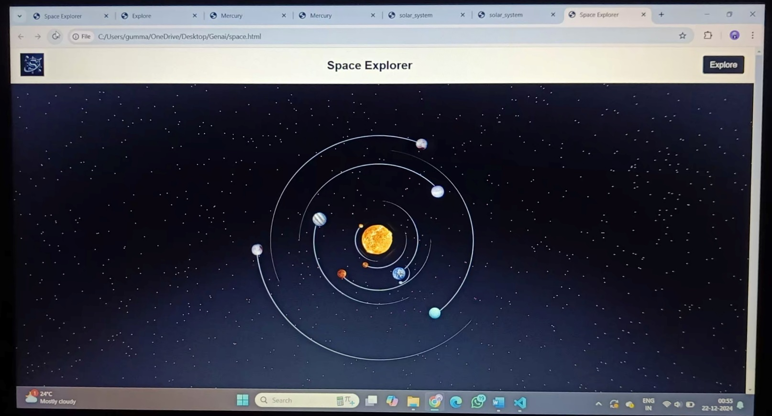

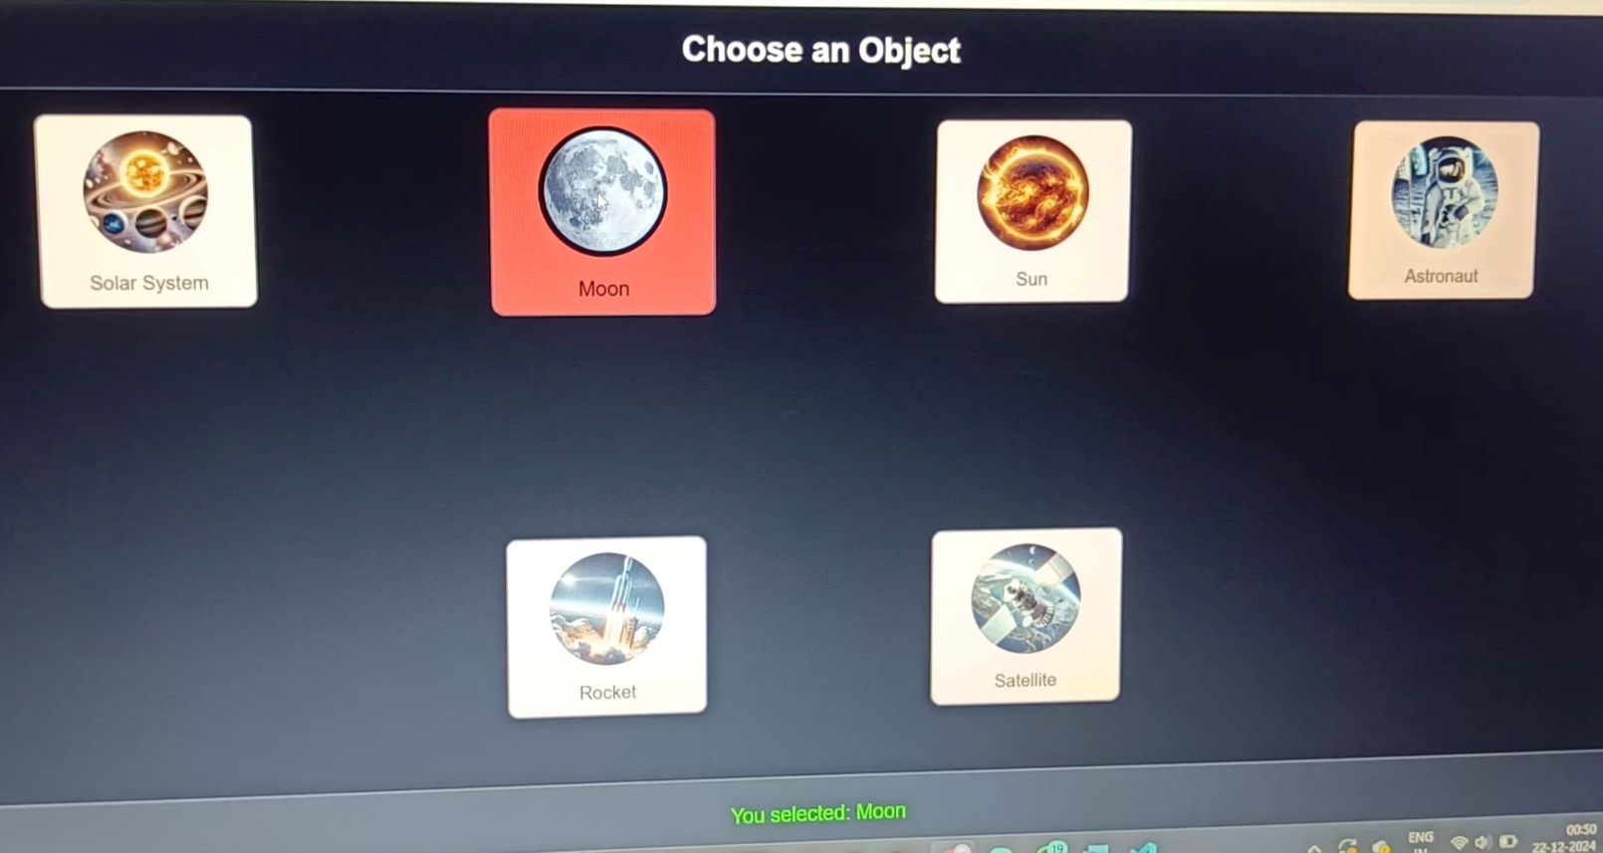

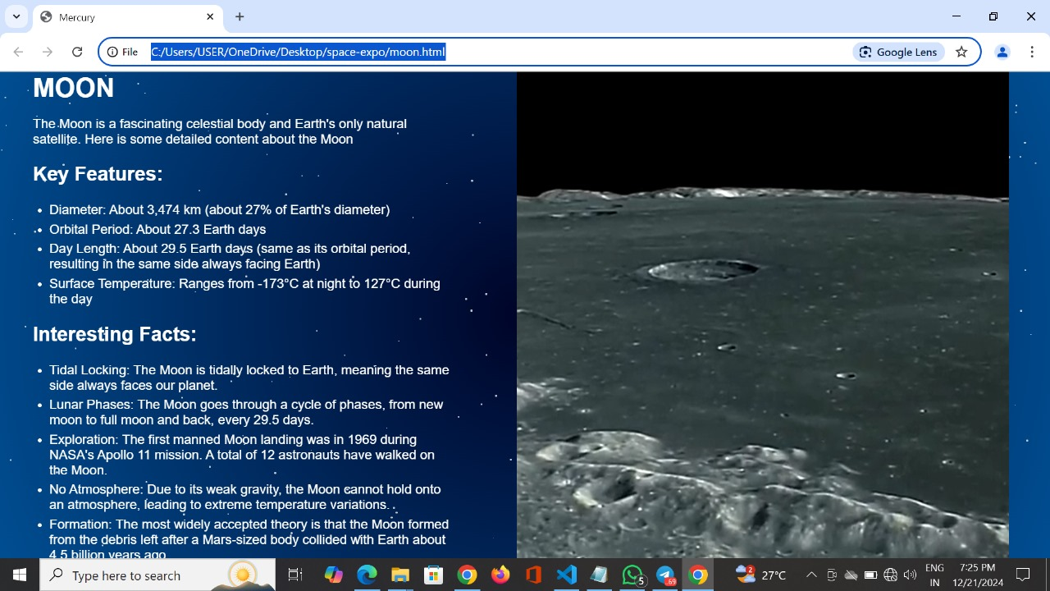

**CHAPTER 7**

**CONCLUSION**

# 7.CONCLUSION

# Space exploration is a remarkable journey that begins with choosing a specific object of interest, such as a planet, moon, or asteroid, and delving into its mysteries. By focusing on these celestial bodies, scientists have gathered invaluable data about the conditions and history of the universe. For instance, Mars exploration has revealed evidence of ancient water flows, offering tantalizing hints about the possibility of past life and the potential for human colonization. Once facts are generated through robotic missions, telescopes, and other advanced technologies, they are carefully analyzed and organized to create meaningful presentations. These findings are shared through detailed reports, visual media, and interactive tools, making the knowledge accessible to scientists, educators, and the general public. Such efforts allow the world to better understand the complexities of space and inspire further research. Ultimately, the sharing of knowledge is at the heart of space exploration. By communicating discoveries effectively, we empower future generations to continue this quest and address global challenges through innovation. Space exploration not only expands our understanding of the cosmos but also brings humanity closer together, fostering collaboration, inspiration, and a shared vision for the future.

**CHAPTER 8**

**WEB LINKS**

# 8.WEBLINKS

# OpenAI: *ChatGPT Documentation*. Accessed from [ChatGPT](https://chatgpt.com/)

# DALL·E: *Image Generation for Visual Design*. [Dalle](https://openai.com/index/dall-e-3/)

# Leonardo AI: *AI for Artistic and Design Enhancements*. *Documentation available online at* [Leonardo](https://leonardo.ai/)

# Canvas AI: *Collaborative Writing and Editing Tool. Accessed from Canva.*Canva

**Claude AI:** *Conversational AI for Advanced Assistance.* Accessed from Claude AI. **Cladue Ai**