Machine Learning-Based Analysis of Netflix User Watching Behaviour
Assignment Proposal
Submitted by:
Gummalla Yashwanth
MSc Program
University of Europe for Applied Sciences
Supervisor: Prof. Dr. Raja Hashim Ali
Dataset Details
Dataset Name: Netflix User Watching Behaviour Dataset
Source Link:
Netflix User Watching Behavior Dataset on Kaggle
Number of Rows: 50,000
Number of Columns: 20
Type of Task: Classification and Clustering
Target Variable: churned
Problem Statement
Streaming platforms such as Netflix generate large volumes of behavioural and engagement data from users. Understanding user viewing behaviour, engagement patterns, subscription usage, and churn tendencies is essential for improving customer retention and enhancing recommendation systems. Traditional analysis methods are limited in identifying complex behavioural relationships within large-scale streaming datasets. Therefore, machine learning techniques can be applied to predict customer churn, analyse engagement behaviour, and identify meaningful user segments for data-driven decision making.
Research Questions
- RQ1: How accurately can machine learning models predict customer churn using Netflix user behavior data?
- RQ2: Which user behavior factors contribute most significantly to customer churn prediction?
- RQ3: How does user age influence average watch time and viewing behaviour on Netflix?
- RQ4: What is the relationship between user engagement metrics and customer retention behavior?
- RQ5: Which machine learning algorithm provides the best performance for Netflix churn prediction?
- RQ6: What relationships exist between watch time, binge watching, recommendation click rate, and customer engagement?
- RQ7: Can clustering techniques identify distinct Netflix user segments based on viewing behavior and engagement patterns?
Proposed Methodology
- Load and understand dataset
- Handle missing values
- Remove duplicate records
- Encode categorical variables
- Apply feature scaling
- Split data into training and testing sets (80:20)
- Train multiple machine learning models
- Evaluate models using appropriate metrics
- Perform feature importance analysis
- Conduct correlation and demographic analysis
- Apply clustering techniques for customer segmentation
- Generate publication-ready tables and figures
- Select the best model based on predictive performance and interpretability
Machine Learning Models
- Logistic Regression
- Decision Tree
- Random Forest
- K-Means Clustering
Evaluation Metrics
- Accuracy
- Precision
- Recall
- F1-score
- ROC-AUC
- Correlation Analysis
- Cluster Analysis
RQ1. Customer Churn Prediction
- Research Question
- How accurately can machine learning models predict customer churn using Netflix user behavior data?
- Expected Results
- Machine learning models are expected to successfully predict customer churn using behavioral and engagement-related features. Ensemble methods such as Random Forest are expected to achieve higher predictive performance compared to baseline models.
Table I. Model Performance Comparison
Model | Accuracy | Precision | Recall | F1-Score
Logistic Regression | 0.8046 | 0.647381 | 0.8046 | 0.717479
Decision Tree | 0.6586 | 0.678935 | 0.6586 | 0.668266
Random Forest | 0.8046 | 0.647381 | 0.8046 | 0.717479

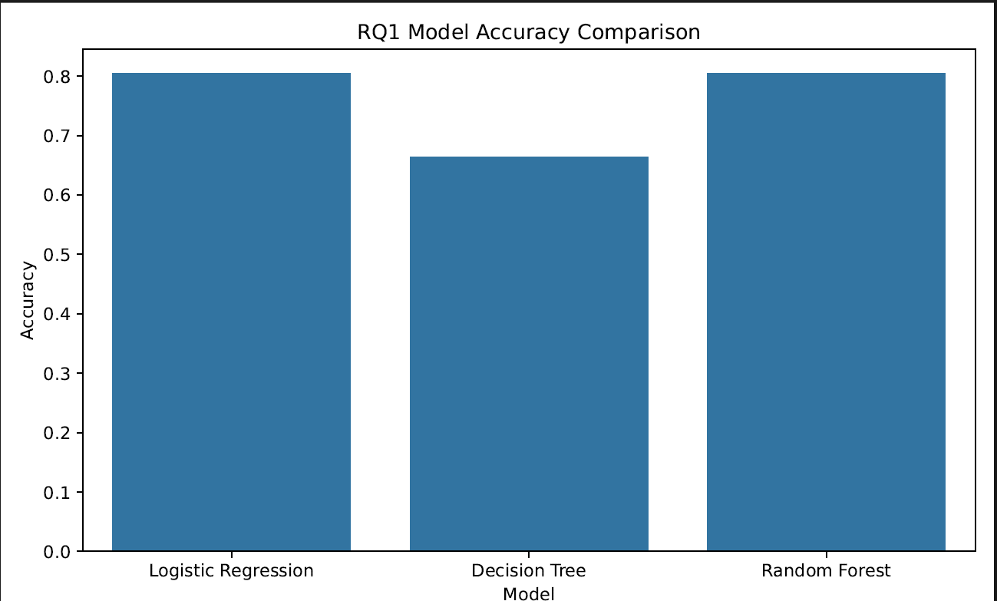
RQ2. Feature Importance Analysis
Research Question
Which user behavior factors contribute most significantly to customer churn prediction?
Expected Results
Behavioral variables such as average watch time, recommendation click rate, and binge watching frequency are expected to significantly influence churn prediction outcomes.
Table II. Feature Importance Analysis
Rank | Feature | Importance Score
1 | user_id | 0.090775
2 | avg_watch_time_minutes | 0.083942
3 | recommendation_click_rate | 0.077188
4 | completion_rate | 0.073582
5 | days_since_last_login | 0.072963
6 | account_age_months | 0.070691
7 | age | 0.06966
8 | content_interactions | 0.069498
9 | rating_given | 0.068512
10 | watch_sessions_per_week | 0.055158
11 | binge_watch_sessions | 0.051381
12 | country | 0.043892
13 | favorite_genre | 0.040411
14 | payment_method | 0.026747
15 | primary_device | 0.026213
16 | devices_used | 0.020939
17 | monthly_fee | 0.020221
18 | gender | 0.020171
19 | subscription_type | 0.01806
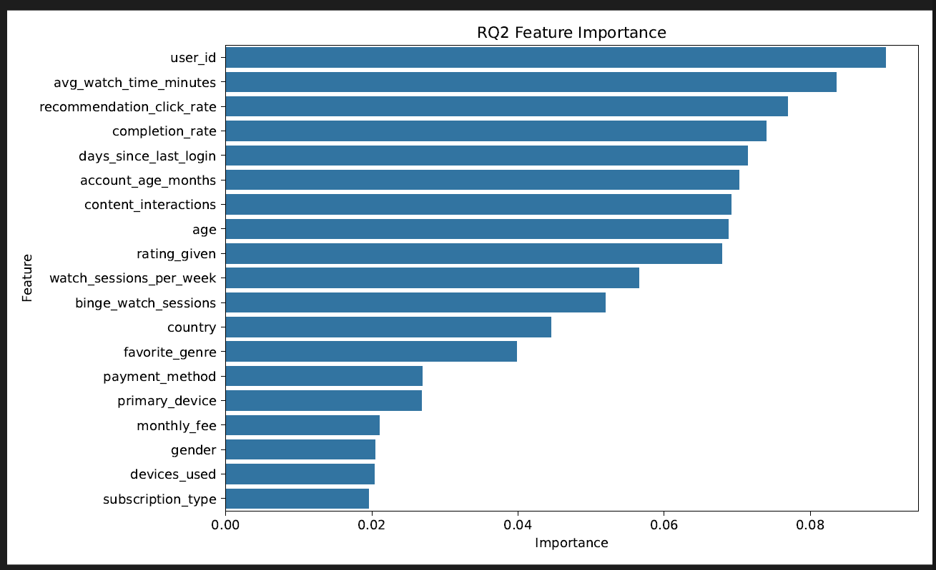
RQ3. Demographic Analysis
Research Question
How does user age influence average watch time and viewing behavior on Netflix?
Expected Results
Younger users are expected to exhibit higher viewing activity and binge watching behavior compared to older age groups.
Age Group | Average Watch Time (Minutes)
<18 | 148.046305
18–25 | 155.672158
26–35 | 155.262081
36–45 | 154.329756
46–55 | 153.946328
55+ | 156.557747
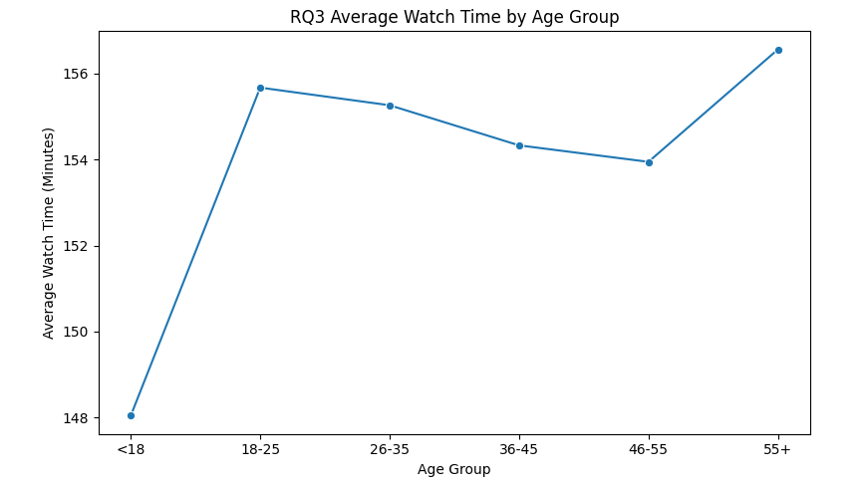
RQ4. Engagement and Retention Analysis
Research Question
What is the relationship between user engagement metrics and customer retention behavior?
Expected Results
Users with higher engagement levels are expected to show lower churn probability and higher retention rates.
Table IV. Engagement and Retention Relationship

Content Interactions | Churned
5 | 0
7 | 0
27 | 0
9 | 0
49 | 0
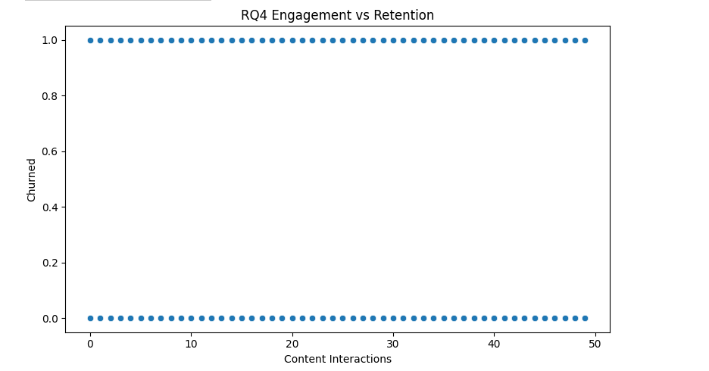
RQ5. ROC Curve Comparison
Research Question
Which machine learning algorithm provides the best performance for Netflix churn prediction?
Expected Results
Random Forest is expected to achieve the highest ROC-AUC score due to its ability to capture complex nonlinear relationships in the dataset.
Table V. ROC-AUC Comparison
Model | ROC_AUC
Logistic Regression | 0.494421
Decision Tree | 0.492025
Random Forest | 0.505007
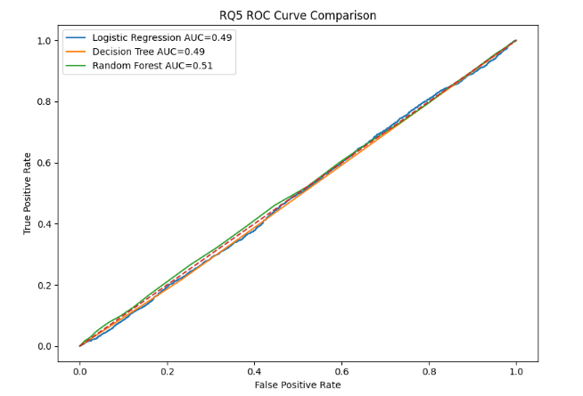
RQ6. Correlation Analysis
Research Question
What relationships exist between watch time, binge watching, recommendation click rate, and customer engagement?
Expected Results
Strong positive correlations are expected between watch time, binge watching frequency, and engagement-related variables.
Table VI. Correlation Analysis Matrix
Variable | Days Since Last Login | Churned
user_id | 0.003145 | -0.001125
age | 0.002316 | -0.002417
gender | 0.000538 | 0.00404
country | 0.002494 | -0.00556
account_age_months | 0.002224 | -0.006852
subscription_type | 0.004961 | 0.008164
monthly_fee | -0.004023 | -0.006194
payment_method | 0.003505 | 0.001085
primary_device | 0.001482 | -0.005943
devices_used | 0.007411 | 0.002238
favorite_genre | -0.001577 | 0.007114
avg_watch_time_minutes | 0.003144 | -0.005022
watch_sessions_per_week | 0.006993 | -0.003505
binge_watch_sessions | 0.000527 | -0.003292
completion_rate | -0.001558 | -0.001839
rating_given | -0.005846 | 0.003255
content_interactions | -0.001302 | -0.00672
recommendation_click_rate | -0.006101 | -0.002262
days_since_last_login | 1 | 0.000453
churned | 0.000453 | 1
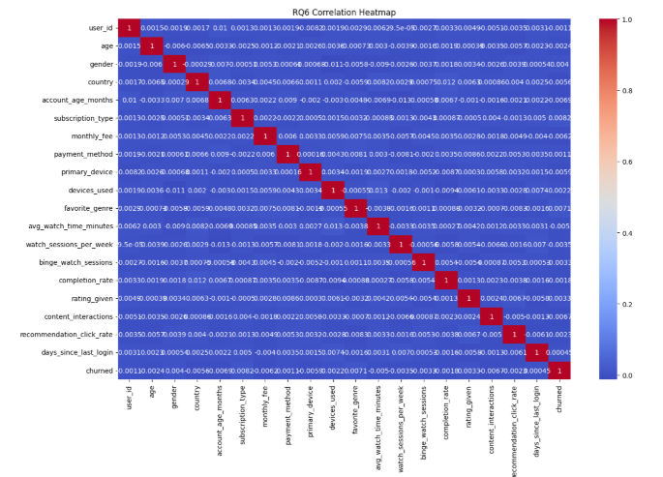
RQ7. Customer Segmentation
Research Question
Can clustering techniques identify distinct Netflix user segments based on viewing behavior and engagement patterns?
Expected Results
K-Means clustering is expected to identify distinct user groups based on watch time and engagement patterns.
Table VII. Customer Segmentation Summary
Cluster | Days_Since_Last_Login | Churned
0 | 29.327795 | 0.198117
1 | 29.272925 | 0.203682
2 | 29.628766 | 0.196087
