Network Knight
AlphaBuild 2 Professor FAQ
  - Technical explanation and presentation preparation
Build reference network_knight_alphabuild2
Prepared November 3 2026
Network Knight is a working local Windows security monitoring application. It collects actual Windows events and protection settings, stores evidence in SQLite, applies explainable detection rules, and displays alerts and component health in a React dashboard served by FastAPI. This guide explains the current build and the technical questions that may come up during a project review.

1. What is the short explanation I can give my professor?
“Network Knight turns real security information from my Windows computer into a searchable local dashboard. A FastAPI backend receives Windows events and Defender/firewall observations, applies 14 rules, and saves the evidence and alerts. React refreshes the dashboard automatically, and component health tells me when collection is limited or unavailable.”

2. What problem does the project solve?
Security information is spread across Windows event channels and protection settings. Network Knight brings these sources into one view, highlights selected conditions that deserve investigation, and connects each alert to its supporting records. It also makes a collection failure visible so an empty screen is not mistaken for a secure computer.

3. What does this build actually deliver?
One setup-and-start launcher; two real local collectors; authenticated ingestion; deterministic event and correlation rules; persistent events and alert review status; search and CSV export of loaded records; and visible server/collector health with separate enable, disable, and restart controls.

4. What should I avoid claiming?
Do not claim complete attack coverage, AI threat prediction, packet inspection, automatic remediation, enterprise deployment readiness, or remote-computer collection. This is a single-computer monitoring build. An alert is a reason to investigate, and a healthy heartbeat is evidence of collector activity rather than proof of complete security coverage.
Guide map Foundations and architecture 2–3 • Collection and protection 4–5 • Detection and correlation 6–7 • Health and persistence 8–9 • API and dashboard 10–11 • Setup and verification 12–13 • Demonstration and future work 14–15 • References 16

Foundations and technology choices

5. What is the project based on?
It continues the supplied Sentinel and Network Knight starter materials, including a React dashboard starter and a local monitoring starter. The published build retains React/TypeScript dashboard scaffolding and Windows event parsing, with a Python FastAPI/SQLite runtime, real-only collection, protection monitoring, process supervision, unified startup, and operational feedback. It is an application assembled and extended from starter code and established libraries; it is not a new operating-system logging engine.

6. Is it a SIEM or an antivirus?
It is best described as a small local security monitoring application with SIEM-like collection, normalization, correlation, and review. It does not replace antivirus or implement malware scanning. The malware rule reports a Defender detection already made by Microsoft Defender. The current system is host based even though its name includes Network.
Layer | Technology in this build | Purpose
Dashboard | React 19, TypeScript, TanStack Router | Views, routing, state presentation
Build and styling | Vite 7, Tailwind CSS 4, UI libraries | Bundle frontend into dist
HTTP backend | Python, FastAPI, Uvicorn | API routes and local static hosting
Collection | PowerShell and Python | Read Windows channels and protection state
Storage | SQLite and local JSON files | Evidence, alerts, progress, preferences

7. Why FastAPI and React?
FastAPI keeps ingestion, validation, detection, storage access, and component controls behind a clear HTTP interface. React separates presentation from collection and lets dashboard components update from shared state. Uvicorn runs the API. These are design choices for a small working product, not claims that this stack is inherently superior to every alternative.

8. Why SQLite rather than a cloud database?
SQLite fits a one-laptop deployment: no separate database service, account, or hosted backend is needed. The code enables write-ahead logging and wraps ingestion and detection in the same transaction. Database access uses a lock inside the app. This simple design needs further load testing and architectural changes before a large multi-host deployment. [S1, S10]

9. Does the build need Supabase, cloud hosting, or machine learning?
The active monitoring path uses local FastAPI and SQLite. Some unused integration files remain from scaffolding, but the runtime dashboard store fetches the local API. No Supabase setup is required. Detection uses explicit Python rules; there is no trained model, training dataset, anomaly score, or model accuracy claim.

Architecture and data flow
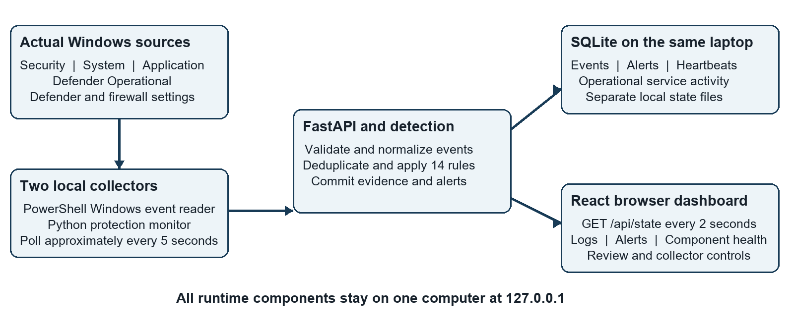
Figure 1 Runtime architecture of the current single-computer build. Arrows show the principal data path; dashboard writes return to FastAPI.

10. Where is the server and how do I access it?
The server runs on the same laptop as the collectors. Start-Network-Knight.cmd launches Uvicorn/FastAPI at http://127.0.0.1:8787/. Open that address in a local browser. 127.0.0.1 is the loopback interface of the computer using it, so the same address on a friend’s computer refers to their computer, not yours.

11. What happens from a Windows event to a visible alert?
The Windows collector reads the event, parses its fields, assigns a normalized action, and sends JSON to /api/ingest using the local collector key. FastAPI validates the batch and skips duplicate records. Each newly inserted event is checked by the rule engine. Evidence and resulting alerts commit together. React obtains the latest state on its next refresh and updates the dashboard.

12. What runs as a separate process?
There is a FastAPI server process, a Python protection collector process, and a PowerShell Windows Event Log collector process. The server supervisor manages its two children. The browser is the interface, not the collector. Closing the browser leaves the server and collectors running; stopping the foreground app stops its managed children. [S1–S4]

Real log collection and normalization

13. Exactly which Windows logs are collected?
The configured channels are Security, System, Application, and Microsoft-Windows-Windows Defender/Operational. The collector reads records from all four channels when permitted, not just the IDs with detection rules. Other applications’ private files, arbitrary websites, packets, and every available Windows channel are outside the configured scope. Get-WinEvent is the Windows event-reading interface. [S4, S8]

14. Are the initial records simulated?
No. On first access to a channel, the collector begins near its latest record number to import up to approximately 50 recent real records. It then follows a saved per-channel cursor, fetching at most 200 records per channel per poll. Initial records may predate startup, so an alert created now can refer to an older Windows event. Show both the original event time and alert creation time.

15. How are different events made consistent?
The parser converts Windows XML and messages into a common event shape. Fields include timestamp, source, host, IP, account, normalized action, severity, message, external ID, and details. Details preserve such context as Windows event ID, record ID, provider, and parsed fields. For example, failed Windows authentication becomes login_failed; unfamiliar events remain general Windows context. Unknown account or IP values are retained as unknown.

16. How are timestamps and severity handled?
The backend accepts timezone-aware ISO 8601 timestamps, normalizes them to UTC, and rejects timestamps more than five minutes in the future. It handles Windows fractional-second precision. Known event mappings and Windows levels inform event severity; alert severity comes from the matching rule. A critical alert is a prioritization label, not a calculated probability that compromise occurred.

17. Why might a real event be missing?
Possible causes include permission denial, auditing not enabled, an unreadable or empty channel, overwritten Windows records, the initial history limit, a paused collector, sleep, or a collection/upload error. The app does not enable audit policy or invent substitute records. Administrator rights can improve Security-channel access, but they do not create events that Windows never audited.

18. What prevents retry duplicates?
Windows records carry an external ID built from record ID and original event time. SQLite has a unique index on dataset, source, host, and external ID. The collector advances its cursor only after successful acceptance. A retry can therefore return duplicate counts without reinserting the same event. This is retry deduplication, not a guarantee against every possible duplicate observation from independent sources. [S1, S4]

Antivirus and firewall observations
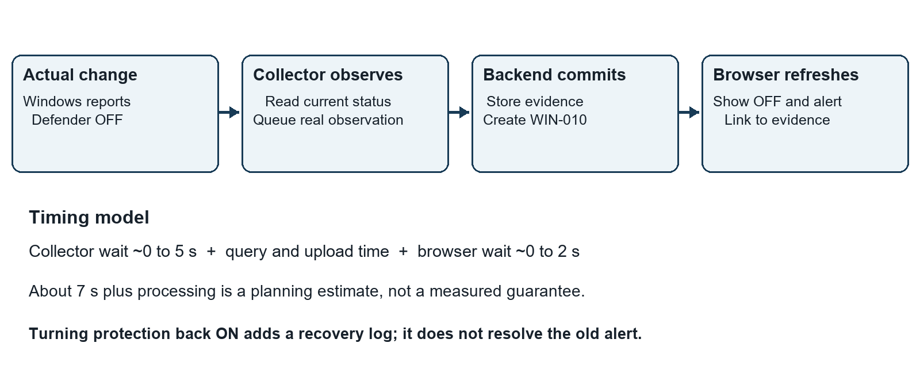
Figure 2 Defender OFF observation to dashboard alert. Timing describes polling intervals, not a benchmark.

19. How does it know that my antivirus is actually OFF?
The protection monitor runs Get-MpComputerStatus and reads AntivirusEnabled and RealTimeProtectionEnabled. Its Defender check is ON only if both are true; either false produces an OFF observation and high-severity WIN-010. A missing or failed query means unavailable rather than an invented OFF state. Separately, Defender Operational event 5001 can trigger WIN-010. [S3, S7]

20. Does it repeatedly alert every five seconds while protection is OFF?
The monitor persists previous observations and only emits initial states or changed states. An initial OFF value creates an alert; an unchanged OFF value does not create one every poll. Restoring protection emits a recovery event. Repeated toggles and an independent Windows event can still produce additional real evidence or alerts.

21. Does Defender OFF mean every antivirus product is OFF?
No. This version checks Microsoft Defender, not the health of every third-party antivirus. Another product can legitimately cause Defender to become inactive or passive. The alert wording must be interpreted as the observed Defender state. The collector also does not prove who changed a setting or why.

22. What does the firewall rule check?
Get-NetFirewallProfile -PolicyStore ActiveStore supplies the enabled state of Domain, Private, and Public profiles. Each disabled profile can produce WIN-011. A profile setting is not proof that current traffic uses that profile or that a specific port is exposed. Collection is read-only; Network Knight does not disable or reconfigure protection. [S3]

Active detection rule catalog
The build contains 14 active rules. They match normalized actions and specific Windows evidence; the collector must have access to the relevant source. The catalog below reflects backend/detection.py. [S2]
Rule | Severity | Trigger or threshold
AUTH-001 | High | At least 5 failed logins in 60 seconds for the same source, host, IP, and account
AUTH-002 | High | Successful login after at least 5 failures in 5 minutes for that same source, host, IP, and account
AUTH-003 | High | At least 10 failures across 5 known accounts in 5 minutes from the same known IP, source, and host
WIN-001 | Critical | Security 1102: audit log cleared
WIN-002 | Medium | Security 4720: account created
WIN-003 | Medium | System 7045 or Security 4697: service installed
WIN-004 | High | Defender Operational 1116: Defender threat detected
WIN-005 | Medium | Security 4740: account locked out
WIN-006 | Medium | Security 4726: account deleted
WIN-007 | High | 4732, 4728, or 4756 with a recognized Administrators, Domain Admins, or Enterprise Admins group SID
WIN-008 | High | Security 4719: audit policy changed
WIN-009 | Medium | Security 4698: scheduled task created
WIN-010 | High | Defender 5001 or antivirus/real-time protection observed OFF
WIN-011 | High | A Windows Firewall profile initially observed OFF or changed to OFF

23. Why flag normal administrative activities?
Installing a service, creating an account, or scheduling a task can be legitimate or malicious. These rules surface important changes for review; they do not establish malicious intent. An authorized installation may still correctly match the rule while requiring no incident response.

24. Can the rules be changed or disabled individually?
The active catalog and logic live in backend/detection.py and can be changed in code and tested. This build provides component-level collection controls, not a complete rule configuration or per-rule disable interface. Rule changes do not automatically reprocess the full historical database.

Correlation and alert interpretation
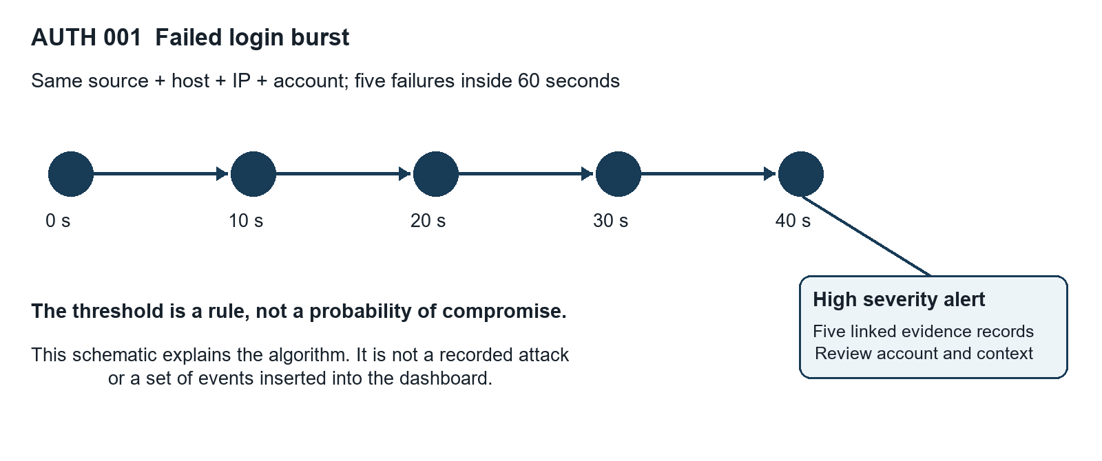
Figure 3 Conceptual AUTH-001 window. The illustrated times explain the rule and are not dashboard demo data.

25. How is correlation implemented?
For a newly inserted event, Python queries prior stored events in a time window using the appropriate dataset, source, host, IP, and sometimes account. AUTH-001 uses 60 seconds; AUTH-002 and AUTH-003 use 300 seconds. The current event is included in the relevant queries. Batch records are processed in timestamp order; database indexes support the window lookup. [S1, S2]

26. Why do known IP addresses and usernames matter?
Password spraying requires a known IP and at least five distinct known usernames. A success-after-failures match requires a known account. The burst rule can still group missing values as received, so unknown fields limit confidence about attribution. The protection monitor’s 127.0.0.1 field identifies local reporting; it is not an attacker address.

27. How are repeated alerts and late events treated?
Correlation alerts for the same rule and grouping can merge evidence when the existing alert was updated within 60 seconds. Its review status is preserved, including resolved status. Single-event rules create their own alerts. Late records in separate uploads are not fully re-correlated against every earlier success, and independent Windows/protection observations can yield separate Defender alerts.

28. What can I say about false positives and false negatives?
Legitimate administration, mistyped passwords, and Defender passive mode can produce matches that are not attacks. Missing audit data, inaccessible channels, short protection changes between polls, unusual event formats, and threshold choices can hide activity. There is no measured precision, recall, or false-positive rate for this build. Rule tests establish expected behavior for tested cases, not universal detection accuracy.

Monitoring health and user feedback

29. How do I know the collectors are actually working?
The dashboard shows the server and each collector separately, with state, process ID, latest heartbeat, and a detail message. A collector needs a recent matching heartbeat rather than merely an existing process. A heartbeat older than a newly started child is disregarded. After 30 seconds without a fresh heartbeat, coverage is reported offline. [S5]
Visible state | Meaning
Starting | A component was launched and its first fresh heartbeat is pending
Running | Fresh heartbeat reports normal collection
Limited access | Collector reports a source or query limitation; available collection can continue
Offline or Failed | Heartbeat is stale, a process failed, or a startup error occurred
Disabled by you | Saved user choice has paused this Network Knight collector
Server unreachable | Browser cannot confirm current server or collector health

30. Why can the server be Running while Windows logging is limited?
The API can respond normally while Windows denies a channel query. Health is therefore component specific. A Security-channel access failure does not prevent readable System or Application records from being collected. Running the launcher as Administrator may address permission failures; the channel detail explains what actually happened.

31. What feedback happens when something stops?
The terminal provides startup and error feedback. The dashboard has status cards, a persistent banner, notifications on connection and component changes, and recent service activity. If the server becomes unreachable, collector status becomes unknown and current protection cards become unavailable. These are dashboard notifications; there is no separate email or Windows desktop notification service.

32. Is service activity another kind of security alert?
It is separate operational history about observed application/component state changes. It helps explain when collection started, degraded, or stopped. It is not a fabricated intrusion record. In this implementation some transitions are recognized when dashboard state is requested, so service history is not a complete independent operating-system service audit.

33. Does Disable Protection Monitor turn off Windows antivirus?
No. The disable controls only pause Network Knight’s collector. They do not disable Defender, Windows Firewall, or auditing. Preferences persist across starts. Enabling a collector resumes collection; restarting an offline or failed collector requests a new managed process and waits for new health evidence.

Persistence and evidence handling

34. Where is information saved?
The default data directory is backend/data beneath the build folder. network-knight.sqlite contains events, alerts, collector heartbeat state, and service_activity. Separate local files hold the generated collector key, monitoring preferences, Windows cursors, and protection state with its pending upload outbox. The NETWORK_KNIGHT_DATA environment variable can select another local data directory. [S1, S3–S5]

35. Will old logs be there after restarting Windows?
Yes, saved application records and alert statuses remain on disk until they are deliberately removed. Reboot does not clear SQLite. Collection resumes only when Network Knight starts again. The ordinary foreground launcher is not automatically installed as a Windows startup service, and the laptop must be awake to observe live protection state.

36. What happens while the server or laptop is offline?
A separately running protection monitor queues observations locally and retries uploads, with a 20,000-pending-event guard. The normal managed app usually stops its children when it stops. The Windows collector resumes from its saved cursor and can catch up on retained channel records. Changes that happen and reverse while no protection checks run may be missed; overwritten Windows records cannot be recovered.

37. Does resolving an alert remove the evidence?
No. The alert can be open, acknowledged, or resolved, and can be reopened. Updating review status does not delete its linked events or change Windows configuration. Restoring protection does not automatically resolve an earlier alert because its historical evidence still deserves review.

38. How should I back up or start fresh?
Stop the server and its collectors, then back up the entire backend/data directory together. This protects SQLite files, cursors, queued observations, preferences, and the key as one installation state. For a completely new installation state, rename the stopped data directory and start again; new state and a new key will be created. This also resets cursors and may reimport recent real Windows events. There is no general reset button in this build. Do not clear Windows evidence merely to tidy the dashboard.

39. Are the records tamper proof or automatically retained forever?
No. They are local files without signed evidence, immutable storage, or a separate trusted audit server. A user with sufficient local rights can alter or delete them. There is no automatic retention, rotation, archival policy, or database encryption configured by the app. Stored records can grow until the operator manages them. CSV exports and backups can contain sensitive host, user, IP, and message data.

API contract and security boundaries
Method and route | Role | Write requirement
GET /api/health | Server identity and runtime information | Local access
GET /api/state | Events, alerts, rules, collectors, services | Local access; live dataset only
POST /api/ingest | Receive a batch of collector events | Generated Bearer key
POST /api/heartbeat | Collector status and protection checks | Generated Bearer key
PATCH /api/alerts/{id} | Change alert review status | Local dashboard header
POST /api/services/{service} | Enable or disable a collector or all | Local dashboard header
POST /api/services/{service}/restart | Restart protection or Windows collector | Local dashboard header

40. Who is allowed to submit logs?
Collectors present a generated 32-byte random key encoded as hexadecimal in Authorization: Bearer. FastAPI compares the credential with secrets.compare_digest. The key stays in the local data directory and is not sent to the React app. Possession of the key authorizes a submitter; it does not cryptographically prove that every submitted event came from Windows.

41. What validation is performed?
Bodies are limited to 1 MiB. Ingestion accepts 1–500 events per request and validates all normalized rows before inserting the batch. Required text fields, severity, timestamps, optional port, and details shape are checked. Dataset and origin are assigned by the backend. Length bounds reduce oversized text fields. SQL values are parameterized; dynamic identifiers come from fixed code-controlled field names. [S1]

42. What protects the local web interface?
The launcher binds to 127.0.0.1, and middleware rejects foreign Host values and mismatched Origin values. Dashboard writes require X-Network-Knight: dashboard. Responses include a same-origin Content Security Policy, no-store caching, and nosniff. These controls reduce accidental exposure and unwanted browser requests in a trusted local setup; the fixed dashboard header is not a user password or strong identity boundary.

43. Is it safe to expose this server directly to the Internet?
The current build is designed for one trusted local user. It has no production user login, role model, TLS deployment, per-device identity, or remote enrollment. Local reads are not protected by a login. A local attacker or compromised administrator can defeat local trust. Changing the bind address or port forwarding is not a complete remote monitoring design. [S1, S6]

Dashboard behavior and performance

44. Are alerts genuinely real time?
They are near real time through polling. The protection monitor targets approximately five-second cycles, the Windows collector waits five seconds after its work, and React fetches state every two seconds. A recorded change can often appear in about seven seconds plus query, upload, and processing time. Windows processing, backlog, sleep, browser throttling, or slow requests can extend this. There are no WebSockets or server-sent events in this build.

45. How does React update without reloading the page?
src/lib/sentinel/store.ts keeps shared state, uses useSyncExternalStore to notify components, and periodically fetches /api/state. It tracks already-seen alert IDs to display notifications for newly observed alerts after the initial load. It also compares component states and reports transitions. The first page load shows historical alerts without presenting every old alert as a new one.

46. Are charts and exports the entire database?
No. /api/state returns up to the newest 10,000 events and 1,000 alerts, and adds older evidence linked to visible alerts. It also reports the total event count and whether the result is truncated. Dashboard filtering, charts, and CSV export operate on the loaded records. They must not be described as a complete historical database export or an organization-wide security score. [S1]

47. What happens when an API request hangs or fails?
Normal frontend requests have a ten-second timeout; collector controls allow 25 seconds. The store avoids overlapping refresh requests. A failure marks the server unreachable and prevents stale protection information from being presented as current. Retained historical evidence can still exist in the browser, but live coverage cannot be confirmed until reconnection.

48. What are the scalability limits?
The system uses one SQLite database and serializes its access with an application lock. Sending a large state snapshot every two seconds is simple but can become costly as loaded data grows. There is no server-side paginated history UI, message broker, distributed ingestion, load benchmark, or high-availability deployment. The one-laptop build has been exercised, but CPU, memory, events-per-second capacity, and percentile latency have not been formally measured.

49. Can a user receive an alert when the browser is closed?
Collection and persistence continue while the foreground server is running, but in-dashboard notifications require the page to be open. Reopening the dashboard shows stored alerts. Browser display notifications are not a substitute for a separate delivery service, and this build does not send push, email, SMS, or operating-system notifications.

Setup and day to day operation

50. What should a friend do to run the build?
Use Windows with Python 3.11 or newer and the Windows py launcher, extract the whole project, then run Start-Network-Knight.cmd in network_knight_alphabuild2. For Security-channel access, right-click the launcher and choose Run as administrator. The first run needs internet to install locked Python dependencies. It creates the project virtual environment, verifies packages, starts all enabled components, and opens the local dashboard. No separate logging launcher is needed.

51. Does a general user need Node or a React development server?
No. The production React bundle is included in dist and served by FastAPI. Node is needed only to rebuild frontend source. For development use the package-lock file and the documented npm commands, then refresh the FastAPI-served page. Python is still a one-time prerequisite; the launcher does not silently install system-wide Python.
npm ci
npm run build

52. What must stay open and what happens at shutdown?
For normal foreground operation, keep the launcher terminal open. Ctrl+C requests shutdown of FastAPI and its managed collectors. Closing only the browser does not stop monitoring. A Windows restart ends that foreground session; start the launcher again afterward. Do not run scheduled and manual copies of the same installation together.

53. Can it run automatically in the background?
An optional advanced installer registers one elevated sign-in scheduled task that supervises the app and both collectors. It is separate from normal startup and is not installed silently. It needs appropriate setup permissions and a signed-in, awake computer. Its script was syntax checked, but actual task registration and execution after sign-in were not part of the recorded verification. It should not be described as a verified installed Windows Service.

54. How do I pause one feature or check status?
Use the dashboard controls or Disable-Protection-Monitor.cmd and Disable-Windows-Logging.cmd. Check-Network-Knight.cmd prints current component health. Saved disable choices survive restart. Enable all monitoring is available on the dashboard, with an advanced launcher for use while the app is closed. Disable-Background-Monitoring.cmd removes the optional background task; it does not change Windows protection.

55. What if port 8787 is busy?
The launcher checks the occupant. If it is the same managed installation, it opens the existing dashboard. If it belongs to another or older instance, startup reports the conflict. Stop the correct old instance or use an alternative local port through run.py --port 8788. Do not terminate an unidentified process solely because it owns that port. [S6]

Verification and defensible evidence

56. What has actually been tested?
VERIFICATION.md records 29 passing backend/setup/control tests, a clean first dependency installation, the real main launcher path, real HTTP persistence and lifecycle smoke tests, a React production build, PowerShell syntax checks, and browser checks of status and component controls. The 29 tests were rerun from the published Build 2 folder on November 2, 2026. This is recorded build verification, not a claim that every test was rerun while preparing this guide. [S9]

57. How can there be test fixtures if the dashboard uses only real logs?
Automated tests use controlled inputs and isolated temporary databases so thresholds, validation, persistence, and OFF/recovery behavior can be asserted reliably. Those inputs are not seeded into the production dashboard. A test fixture is evidence that a code path behaves as expected; a real collector smoke test provides separate evidence of Windows integration.

58. Was antivirus disabled to prove detection?
The recorded verification did not disable Windows security settings. OFF and recovery logic was checked with isolated fixtures; actual read-only collection and dashboard integration were separately exercised. A live demonstration of an actual change should be clearly identified as a separate authorized observation, not retroactively presented as part of the earlier test evidence.

59. Which important limits remain unverified?
Security-channel collection was limited by the test account’s real permissions. Background task registration/sign-in execution, third-party antivirus coverage, multi-host operation, long-duration reliability, formal resource consumption, and detection accuracy against labeled attacks were not established. The tests do not constitute a penetration test or prove immunity to local tampering.

60. How can my professor reproduce the checks?
Run the following commands from the extracted build after setup. The smoke tests use isolated app data and real read-only collectors. They pause Network Knight components rather than change Defender or firewall settings. Consult README.md and VERIFICATION.md for prerequisites and expected limitations.
.\.venv\Scripts\python.exe -m unittest discover -s backend/tests -v
.\.venv\Scripts\python.exe tools/verify_http.py
.\.venv\Scripts\python.exe tools/verify_services.py
powershell.exe -NoProfile -ExecutionPolicy RemoteSigned -File
backend/tests/windows_rules.test.ps1
The final PowerShell command is shown across two lines for readability; enter it as one command.

61. What would make the evaluation scientifically stronger?
Define expected observations and ground truth; measure event-to-ingestion and ingestion-to-display latency separately; record median and 95th-percentile latency; test restart, backlog, permission loss, and long runtimes; and evaluate rules on labeled benign and authorized attack cases. Report precision/recall only for that documented test set, including missed and ambiguous cases. These are proposed evaluation steps, not results already achieved.

Demonstration and troubleshooting

62. What is a convincing five minute demonstration?
Start with the single launcher. Show actual server and collector status, then a real Windows event and its source details. Open a real alert and trace its linked evidence and timestamps. Acknowledge it, restart the app, and show that the review status persists. Disable only Windows logging, show that protection collection stays active, then enable it and wait for a fresh heartbeat. Explain any Limited access state rather than hiding it.

63. What if I want to demonstrate an actual antivirus OFF alert?
Use only an authorized test computer and an approved demonstration procedure. Observe the actual Defender setting, allow collection and refresh time, then inspect WIN-010 and its real evidence. Restore protection promptly and show the recovery log. The app itself does not switch protection off. Organization policy or tamper protection may prevent a change; do not bypass those controls or replace a failed observation with simulated logs.

64. Why might Defender show OFF but I see no new alert?
Check whether this OFF state was already recorded, since unchanged states are not alerted every poll. Also check collector health, saved disable settings, heartbeat freshness, pending uploads, and whether Defender status is actually available. The displayed alert list may already contain the matching earlier alert. A Windows 5001 event is an independent route and depends on the channel record being available.

65. Why are there no login or password spraying alerts?
Windows must record appropriate Security events, the collector must be allowed to read them, and the events must meet the rule’s time window and grouping requirements. Password spraying additionally needs a known shared IP and enough distinct known accounts. One failed local sign-in does not meet the threshold. Do not claim absence of an alert proves no attempts occurred.

66. What if the dashboard shows old logs after I restart?
That is expected persistence. Refreshing the page or restarting the server does not delete the database. Original Windows event time and alert creation time describe different things. A new data directory can import recent historical Windows records again. Starting fresh locally and clearing the operating system’s Event Logs are different operations.

67. What should I say if the professor asks whether it catches every attack?
“No. It detects a defined set of observable conditions from four configured Windows channels and protection status checks. Its coverage depends on auditing, permissions, event availability, and polling. The current value is a working path from real local evidence to explainable alerts, with visible collection health. Broader coverage needs more sources, measured evaluation, and additional engineering.”

Scope future work and project ownership

68. Can it monitor a second computer on another network today?
No. Both collectors explicitly restrict their destination to local HTTP addresses, and the server is bound to loopback. Even a second computer on the same Wi-Fi is outside the supported current design. Changing an IP address alone would not address enrollment, authentication, trust, transport protection, or source attribution.

69. Would the computers have to be on the same network eventually?
No. A future endpoint agent could initiate outbound connections to a reachable authenticated central server over HTTPS, or use an approved private VPN. That design must handle device identity, credential rotation/revocation, replay and duplicate protection, local queuing, clock differences, firewall policy, and per-device health. Such a design is proposed work; there is no implemented remote agent enrollment in this build.

70. What would you improve next?
First, measure latency and reliability and improve deployment packaging. Next, add server-side paging and retention management, document and test audit prerequisites, and strengthen evidence integrity and least-privilege collection. For multi-computer support, add authenticated device enrollment and encrypted transport before widening server access. Rule configuration and additional sources can then grow with explicit tests and coverage documentation.

71. What is the engineering contribution beyond drawing a dashboard?
The working contribution is integration: real read-only collectors, normalized event ingestion, transactional evidence and detection, correlation windows, persistence and retry state, unified setup, supervised component controls, and honest health feedback. These behaviors are concrete and reviewable in source and tests. Presentation should identify reused starter components, libraries, and assisted work rather than imply that every file was written from scratch.

72. How should I answer questions about AI assistance and attribution?
Describe the assistance actually used, the starter code and frameworks reused, and the implementation and verification you personally understand and can demonstrate. Follow your course’s disclosure requirements. Be ready to walk through a collector, one rule, the ingestion transaction, and a failed-heartbeat case. A polished interface is not evidence of independent authorship; source history and an accurate explanation matter.

73. How does GitHub relate to the running system?
GitHub stores the versioned source and included frontend bundle; it is not the runtime log server. Emily’s team repository is kosse001/SeniorDesign, and the personal fork is Gummybro/SeniorDesign_alphabuilds. A fork is a separate repository copied from another repository with its own changes and permissions. Build 2 is in network_knight_alphabuild2, preserving Build 1. Local runtime data, keys, dependencies, and test databases should stay out of shared source.

Source references and technical terms
Implementation references below refer to network_knight_alphabuild2 in the team repository at commit 0cf0e83fec6142eb432054a2c7818f0361c59cbd. This identifies the code snapshot described in this guide. The recorded test results are dated in VERIFICATION.md. External documentation explains the underlying interfaces rather than certifying this application.
[S1] backend/app.py — API routes, validation, SQLite schema, transaction, limits, and local middleware.
[S2] backend/detection.py — 14 rules, SQL time windows, group SID checks, and alert merge behavior.
[S3] backend/protection_monitor.py — Actual protection queries, state changes, retry outbox, and local destination restriction.
[S4] backend/collector/start-collector.ps1 and windows-event.ps1 — Configured channels, cursors, parsing, provenance, and upload acknowledgement.
[S5] backend/service_control.py — Saved controls, process supervision, heartbeat age, and health states.
[S6] bootstrap.py and run.py — Dependency setup, localhost hosting, port conflict handling, startup, and shutdown.
[S9] README.md and VERIFICATION.md — Setup instructions, recorded tests, and practical verification limits.
Frontend reference src/lib/sentinel/store.ts, src/routes/, package.json, and dist/ explain polling, dashboard actions, routing, and the included bundle. requirements-lock.txt and package-lock.json pin reproducible dependencies. API metadata reports 2.1.0 while package.json still reports 2.0.0; AlphaBuild 2 is the folder/release label.
Team build source
https://github.com/kosse001/SeniorDesign/tree/0cf0e83fec6142eb432054a2c7818f0361c59cbd/network_knight_alphabuild2
[S7] Microsoft Learn Get-MpComputerStatus
https://learn.microsoft.com/en-us/powershell/module/defender/get-mpcomputerstatus
[S8] Microsoft Learn Get-WinEvent
https://learn.microsoft.com/en-us/powershell/module/microsoft.powershell.diagnostics/get-winevent
[S10] SQLite Write Ahead Logging
https://www.sqlite.org/wal.html
FastAPI framework documentation
https://fastapi.tiangolo.com/

Useful terms
Normalization converts different source records into a common structure. Correlation connects related records within a defined scope and time window. A cursor remembers the last accepted channel record. A heartbeat reports recent collector activity. Provenance records where evidence came from. An outbox holds observations awaiting upload. WAL is SQLite write-ahead logging. A SID is a Windows security identifier. Loopback means network traffic addressed to the same computer.

