Network Knight System Design
  - Design phase report
AI Assisted Cybersecurity Log Monitoring and Threat Detection System
Arif Shahriar Anik | Senior Design | October 28 2026
Our primary design connects selected security records to persistent evidence and explainable alerts. The current local baseline uses a Windows collector, Node.js, SQLite and a browser dashboard. AI assistance and broader operating system support remain development goals.
Design status: Existing describes implemented code; planned describes work to build and verify. The initial demo screenshots illustrate the interface and may change as development progresses.

Assignment coverage
Professor requirement | Location in this report
System Architecture | Section 1 and Figure 1
Database or Data Model Design | Section 2 and Figures 2 and 3
Technology Stack and Design Justification | Section 3
Standards Cybersecurity Frameworks Benchmarks and Constraints | Section 4
Context Diagram | Section 5 and Figure 4
Data Flow Diagram | Section 6 and Figure 5
User Interface and Experience Design | Section 7 and Figures 6 through 10
Security and Risk Considerations | Section 8 and Figure 11

Supporting material: Appendix A records the implementation baseline and original measurable requirements. Appendix B gives the local demonstration steps. Appendix C provides the team explanation guide. Appendix D preserves the implementation checklist.

1 System Architecture
Network Knight monitors selected security events on a Windows workstation. It collects Windows Event Logs and requests to its own monitored HTTP endpoints, normalizes and stores records, evaluates six explainable rules, and presents alerts with supporting evidence. An operator investigates alerts and acknowledges, resolves, or reopens them.
The architecture combines a browser client, modular monolithic Node.js backend, separate PowerShell collector, and SQLite database. Presentation, application logic, and persistence are three logical tiers deployed on one workstation. This supports an inexpensive academic prototype without a cloud dependency.
Status convention: Existing means present in the inspected code. Planned means a proposed implementation or operational improvement. Benchmark targets are acceptance criteria, not measured results. No framework certification or full compliance is claimed.
The supported deployment assumes one trusted Windows operator and an uncompromised host. The tool does not capture arbitrary network traffic, monitor every application, use AI, or automatically block threats. Its rejecting lab login endpoint demonstrates detection and is not dashboard authentication.

System architecture and component responsibilities
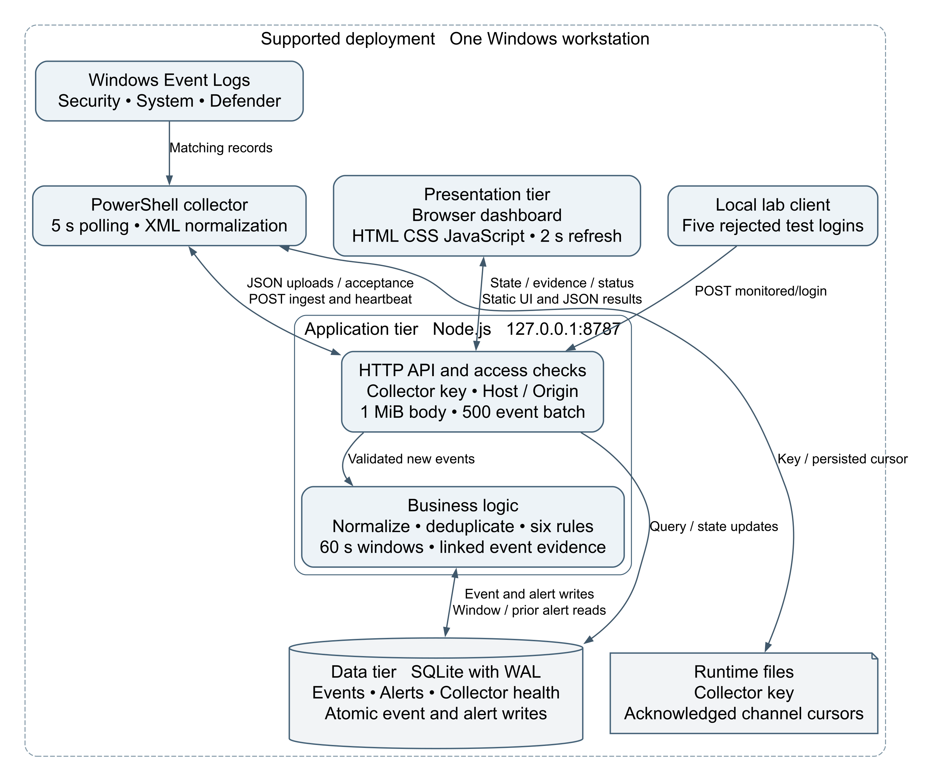
Figure 1 System architecture and component responsibilities

Validation and detection are logical modules inside the backend rather than separate services. All HTTP traffic remains on loopback.
Component | Responsibility | Access boundary
Browser | Presentation, filters, evidence and investigation actions | Untrusted log content must be escaped
HTTP server | Static assets, routes and API controls | Local binding; dashboard currently trusts OS user
Ingestion logic | Authenticate collector, validate batch, normalize, deduplicate and commit | Bearer key for ingestion and heartbeat
Rule engine | Correlation, alert creation and evidence updates | Server side business logic
SQLite | Persistent events, alerts and collector health | Local file; no database listener
PowerShell collector | Channel queries, XML parsing, upload and heartbeat | Security channel may need elevated rights
Runtime files | Secret key and acknowledged record positions | Windows ACL protection required

Decisions and tradeoffs
1. Modular monolith: Easy to launch, inspect and debug within a senior design schedule. One process is a shared failure domain. Planned refactoring separates routing, validation, rules and repositories without adding distributed deployment.
2. SQLite: Transactions and parameters provide reliable local persistence without a database server. Synchronous database work can block the Node.js event loop; WAL does not eliminate that limitation.
3. PowerShell polling: Native Windows integration avoids another agent dependency. Polling introduces latency and can miss overwritten logs during outages.
4. Deterministic rules: Reproducible and explainable without training data. Coverage is narrow; a rule match requires investigation.
5. Local boundary: Loopback reduces remote exposure but does not authenticate local processes or protect against malware executing as the operator.
6. Two second browser refresh: Simple for one operator. Streaming and queues are deferred until measurements justify operational complexity.

Authentication and authorization
Existing: Ingestion and heartbeat require a randomly generated 32 byte secret encoded as hex, compared using a length check and timing safe comparison. Dashboard reads have no user login. Alert updates require X-Network-Knight: dashboard and global Host/Origin restrictions. That header helps resist browser cross origin mutation; it is not a user credential and can be sent by local programs.
Planned local controls: Explicit Windows ACLs for runtime files, an unelevated Node.js process, collector elevation only where necessary, and documented secret rotation. Code executing as the trusted operator remains a residual risk.
Conditional shared or remote extension: Before changing binding, add established identity provider authentication, server enforced viewer/analyst roles, administrator controls, privileged MFA, HTTPS, secure HttpOnly session cookies, CSRF protection, expiration and revocation. Collector credentials must never authorize operator actions. These are not existing components.

2 Database or Data Model Design

Existing schema
Timestamps are UTC ISO 8601 text. Application code supplies most constraints; existing tables lack foreign keys and severity/status CHECK constraints.
Table | Fields and types | Keys and constraints
events | id INTEGER; source TEXT; external_id TEXT nullable; timestamp TEXT; received_at TEXT; kind TEXT; severity TEXT; host TEXT; ip TEXT; username TEXT; message TEXT; details TEXT | id primary key; all remaining fields NOT NULL except external_id; details holds JSON text
alerts | id INTEGER; rule TEXT; title TEXT; severity TEXT; status TEXT default open; created_at TEXT; updated_at TEXT; group_key TEXT; evidence TEXT | id primary key; all remaining fields NOT NULL; evidence holds a JSON array of event IDs
collectors | id TEXT; last_seen TEXT; status TEXT; detail TEXT | id primary key; remaining fields NOT NULL; latest heartbeat replaces prior state

Existing indexes are partial unique events(source,host,external_id) when external_id is not null; correlation events(kind,source,host,ip,username,timestamp); and alerts(rule,group_key,created_at). Rules live in code. Events have no collector foreign key.
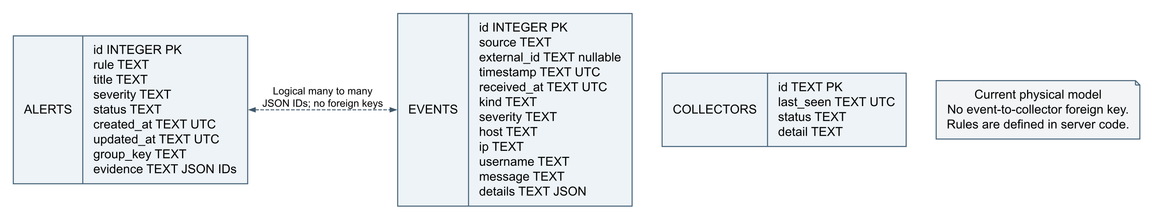
Figure 2 Existing physical schema and logical evidence relationship
An alert has at least one event when created; an event can support several alerts. The logical many to many relationship is not database enforced. Collectors are unconnected because the physical schema has no event relationship.

Planned evidence and action history
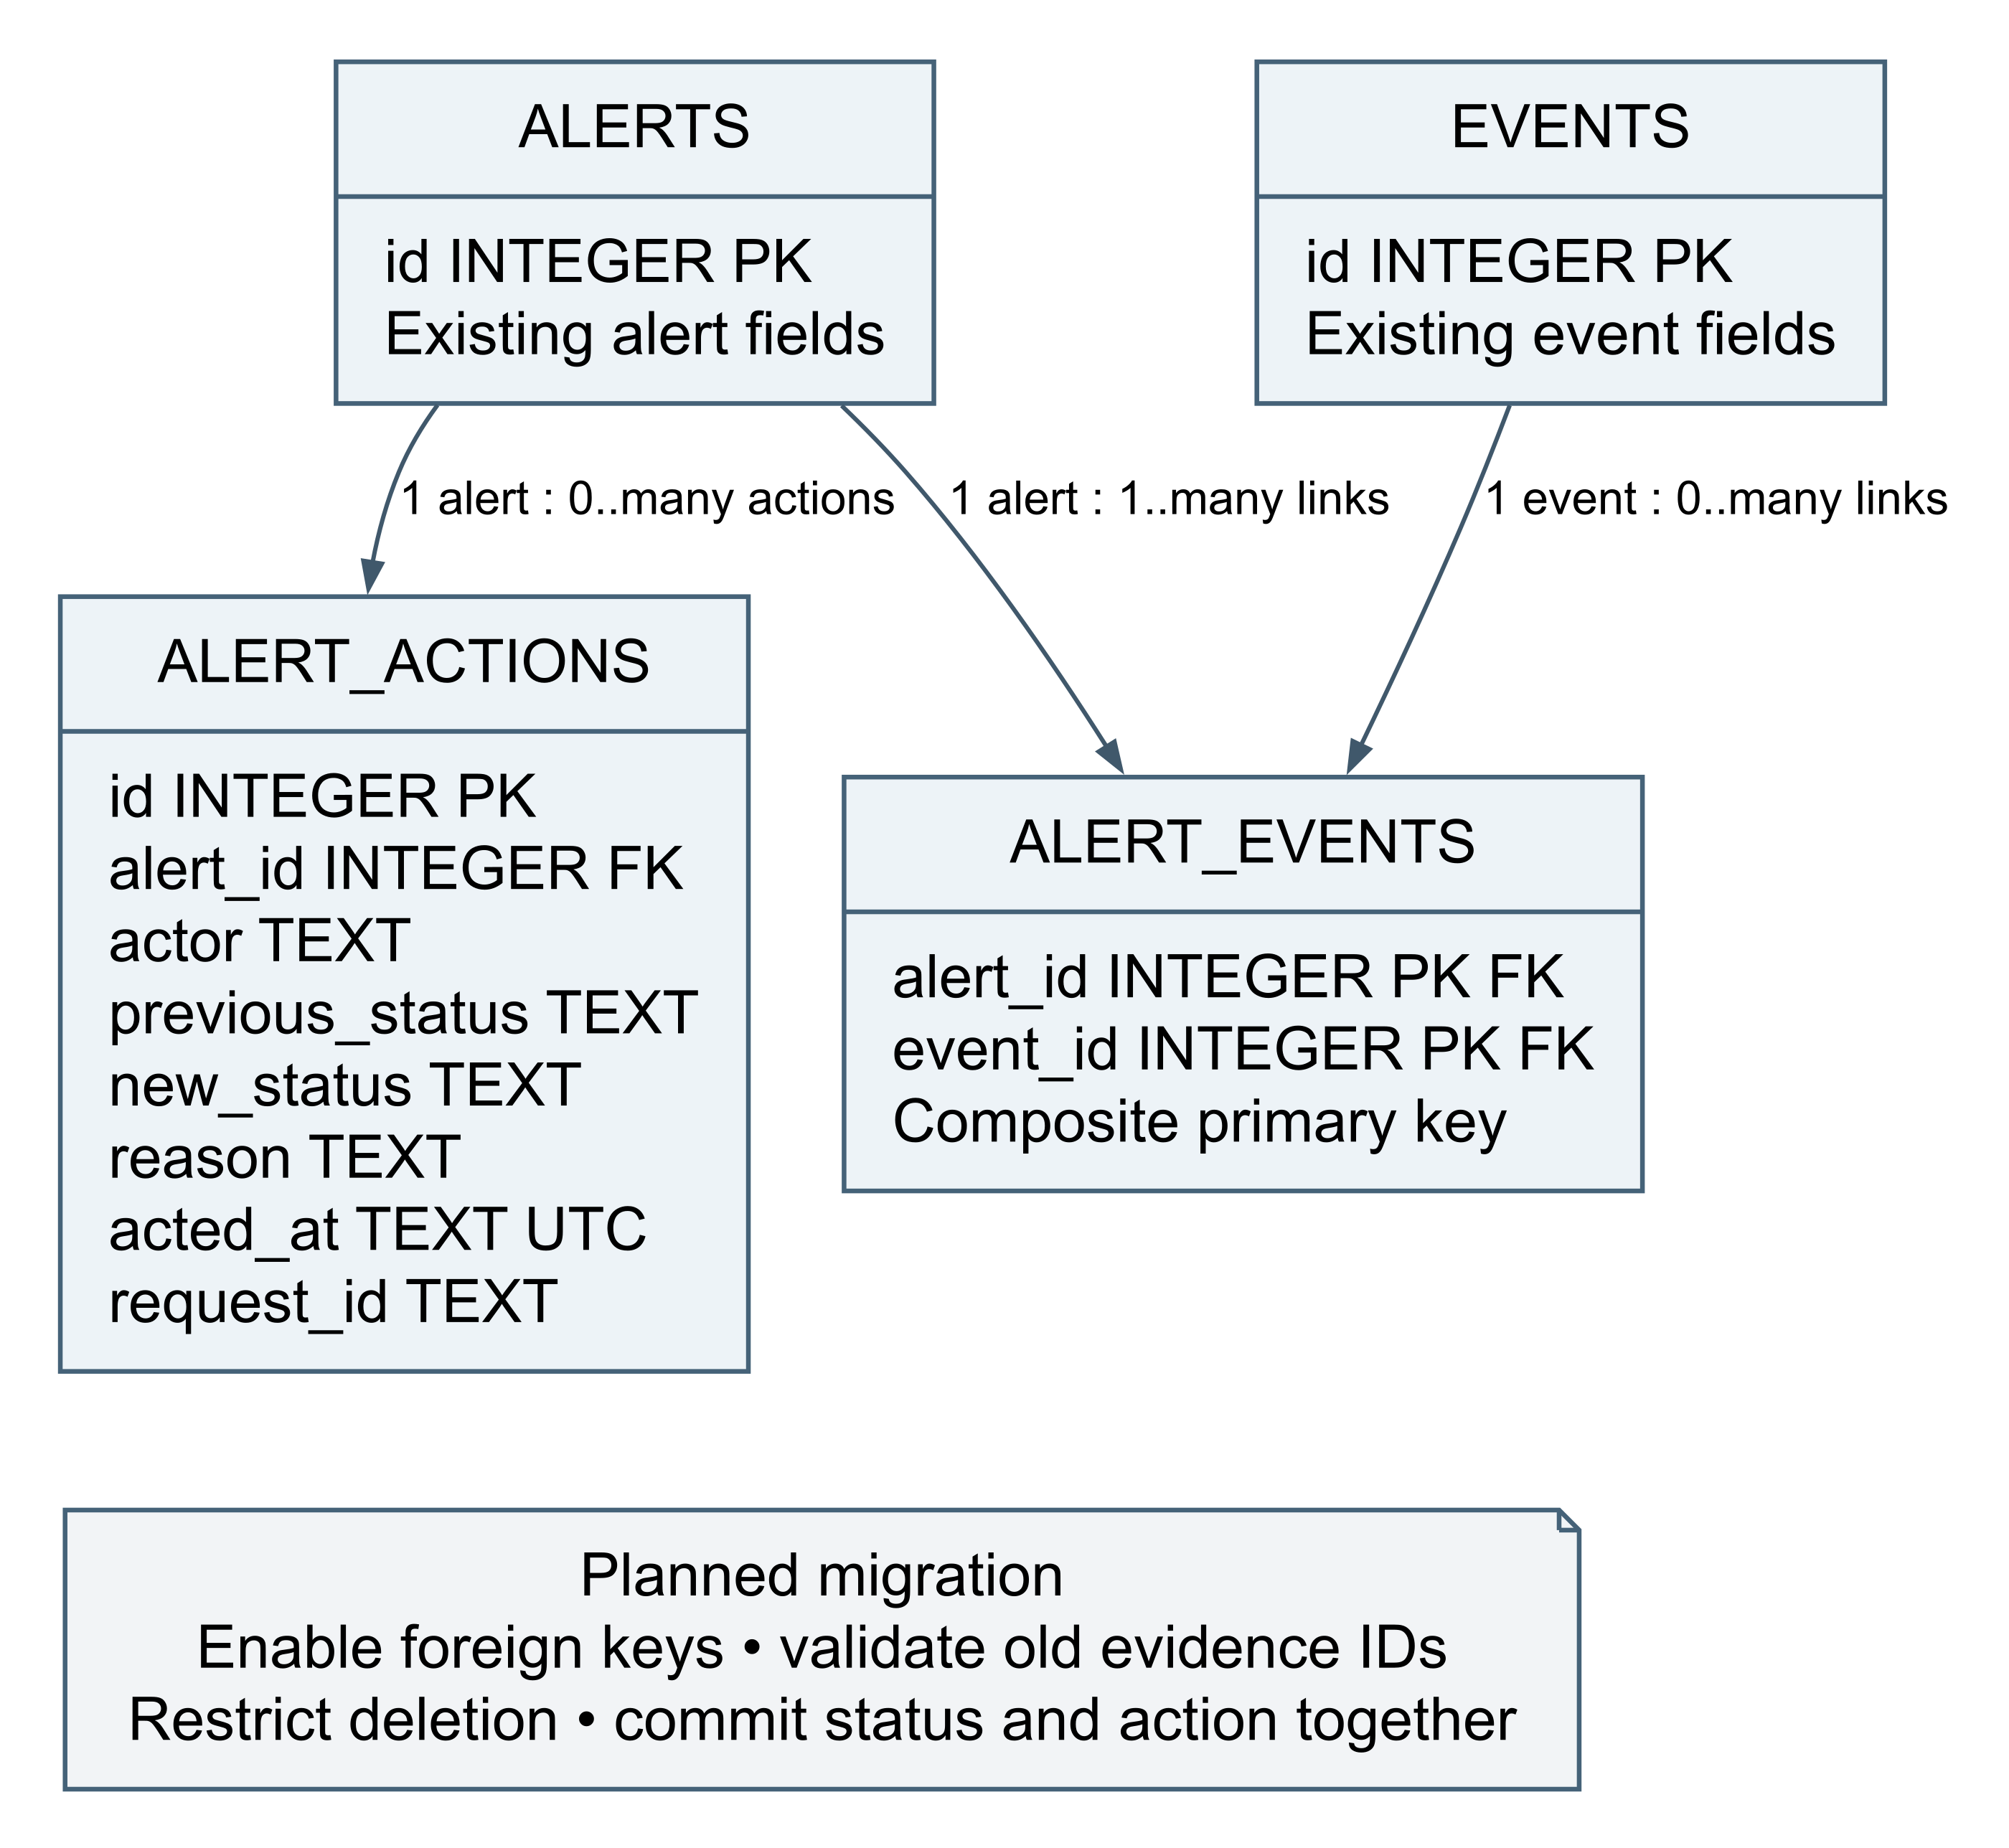
Figure 3 Planned evidence links and investigation action history
Enable PRAGMA foreign_keys=ON per connection; restrict deletion of linked evidence; add status, severity and JSON validity constraints. Commit each transition and audit row together. Local actor information records the OS operator context; distinguishing people requires authenticated sessions.
Migration: consistent backup; create tables; validate every evidence array and reference; backfill unique pairs; compare counts; switch readers/writers; retain old column through rollback validation. Missing references need review. No migration is executed by this report.

Data lifecycle
Validate complete batches before a transaction; insert events and derived alerts atomically. Stable Windows identity combines record ID and timestamp, with source and host in the unique index. Retries do not double count; a stolen key can still fabricate new identities.
Store event time and receipt time. Missing event time currently defaults to now; planned metadata should flag inferred times. Lab passwords are omitted, but Windows messages can expose accounts and paths. Minimize fields and sanitize exports.
Plan at least 90 days retention if adopting CIS safeguard 8.10, with unresolved evidence pinned and capacity/privacy approval. Current storage has no retention automation. Plan daily protected consistent backups and restore tests. Copying only a live SQLite file with active WAL is unsafe; use consistent backup support or stop the server cleanly before copying complete database state.

3 Technology Stack and Design Justification
Technology | Reason selected | Constraint
JavaScript | Shared server/browser language and inspectable rules | Explicit type and input validation needed
Node.js | Built in HTTP, crypto, filesystem and SQLite; no required npm install | Pin a supported compatible release; repository minimum 22.13, README prefers Node 24 LTS
node:http | Small allowlisted API and simple deployment | Team owns limits, routing and errors
SQLite and node:sqlite | Local transactions, parameters and low cost [5] | Synchronous work blocks event loop; limited write concurrency
HTML5 and CSS | Lightweight responsive interface and semantic controls | Direct accessibility testing required
Browser Fetch | Simple JSON queries and refresh | Polling cost and stale state handling
PowerShell and Get-WinEvent | Native Windows queries and XML extraction [6] | Windows only; channel permissions and audit policy
Loopback HTTP and JSON | Inspectable local interchange without cloud certificates | Unencrypted; trusted local boundary only
Node test runner and PowerShell fixtures | Rule, API, persistence and parser testing with few dependencies | Fixtures do not prove live collection
Git with excluded runtime data | Reviewable source without logs and keys | Ignore rules cannot remove secrets already committed

These choices fit the existing code without a React, FastAPI or cloud rewrite. Team proficiency is not measured; shared JavaScript reduces onboarding, while Windows administration and backend security testing still require assigned owners. Hosting and commercial subscriptions are not required; hardware, maintenance and protected backups still have costs.

4 Standards Cybersecurity Frameworks Benchmarks and Constraints
NIST CSF organizes risk outcomes, OWASP ASVS supplies application verification requirements, and CIS Controls guides operational safeguards. These are scoped mappings rather than compliance claims.

NIST Cybersecurity Framework 2 0
URL: https://www.nist.gov/cyberframework
Summary: A framework of cybersecurity outcomes organized into Govern, Identify, Protect, Detect, Respond and Recover. It is outcome oriented and does not prescribe one implementation [1].
Relationship: Monitoring and investigation directly support Detect and Respond. The application's own evidence also needs governance, protection and recovery.
Function | Application | Evidence or remaining work
Govern | Assign collection, retention, risk and deployment owners | Planned risk register and local use policy
Identify | Inventory host, channels, rules, data and dependencies | Architecture, source list and known gaps
Protect | Authenticate ingestion, validate inputs, restrict files and minimize data | Key checks exist; ACL and rotation verification planned
Detect | Six rules and freshness reporting | Threshold/grouping tests and source outage test
Respond | Evidence review and status workflow | Existing states; audit history and escalation runbook planned
Recover | Consistent backups and restore exercise | Planned measured recovery demonstration

Organization wide governance, institutional incident authority and enterprise recovery are outside this application's scope. Those outcomes require external processes and owners.

OWASP Application Security Verification Standard 5 0
URL: https://asvs.owasp.org/
Summary: Requirements for secure design and verification of web applications and services; the official site identifies 5.0.0 as its stable release [2].
Relationship: Network Knight accepts untrusted records, renders messages and changes investigation state through HTTP APIs.
Relevant area | Application | Verification or exclusions
Encoding and injection | SQL parameters, escaped output and static asset allowlist | Test hostile messages, markup and SQL characters
Validation and business logic | Atomic batch validation, body/time limits and status allowlist | Plan strict field types and valid bounded JSON
Authentication and authorization | Collector credential distinct from operator trust | OS boundary now; proper sessions and roles before remote use
Browser security | Host/Origin restrictions, mutation header, CSP and frame prevention | Browser testing; header does not authenticate a person
Data protection and logging | Omit lab passwords, protect files and audit decisions | ACLs, action history and retention planned
Communication/configuration | Loopback and supported runtime | TLS and secure sessions before network exposure

Maintain a version pinned applicability checklist containing requirement text, rationale, evidence and results. This report maps areas without inventing requirement IDs or asserting a verified ASVS level. Password storage requirements do not apply to current nonexistent operator password accounts; reassess if accounts are added. Remote communication requirements cannot be waived once deployment expands.

CIS Critical Security Controls v8 1
URLs: https://www.cisecurity.org/controls/v8-1 and https://www.cisecurity.org/controls/audit-log-management
Summary: Prioritized operational safeguards. Control 8 concerns collecting, alerting, reviewing and retaining audit logs [3].
Relationship: Collection and evidence preservation are central to Network Knight, but it cannot prove all host auditing is enabled.
Safeguard or control | Application | Status and limitation
8.1 Log management process | Define channels, review owner, retention and failure handling | Process approval planned
8.2 Collect audit logs | Windows channels and monitored endpoints | Existing; verify policy and permissions separately
8.3 Adequate storage | Measure volume and warn on disk pressure | Capacity measurement and warnings planned
8.4 Time synchronization | UTC event/receipt times and host clock review | UTC exists; skew reporting planned
8.9 Centralize logs | Query selected channels in one store | Partial single host scope; no enterprise aggregation
8.10 Retain logs | At least 90 days if adopting safeguard; pin unresolved evidence | No current automatic retention
8.11 Review logs | Weekly or more frequent documented review | Human process; dashboard access alone insufficient
Controls 3 and 6 | Protect log data and restrict access | Collector key exists; ACL and deployment review planned

Safeguards have implementation group applicability; selecting some does not establish full group conformance. Enterprise network and multi asset coverage are outside current scope. A shorter approved privacy/capacity retention exception must be disclosed and cannot be claimed as 8.10 alignment.

Constraints
Windows is required for real collection. Rights and audit policy determine visibility; the project must not weaken organizational policy to gain access. Student hardware, disk and one backend constrain capacity. Logs identify users, hosts and paths; obtain host owner authorization and sanitize demonstrations. No FERPA, HIPAA or PCI DSS claim is established without deployment and data classification evidence.

5 Context Diagram
The boundary contains the delivered browser UI, backend, collector, rules, database and runtime files. The human operator, Windows Event Log service and lab client are external entities. Windows is external as a source even on the same workstation. Internal stores are not context entities.
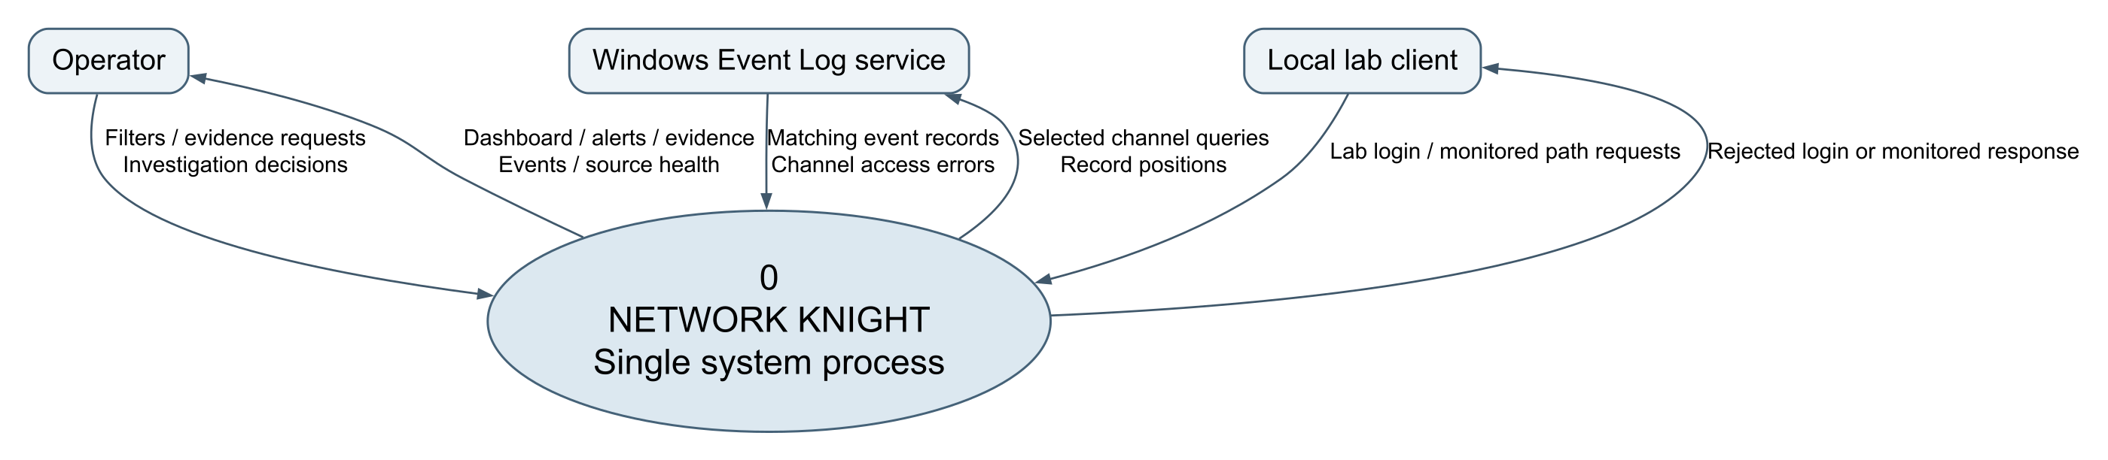
Figure 4 Level 0 context diagram
No external identity provider, notification service or cloud database exists in the current context. Remote access would change it.

6 Data Flow Diagram
Processes transform information; D1 to D4 are stores. D1, D2 and D3 are logical stores in one SQLite file. P2 invokes P3 within the ingest transaction.

Level 1 processes stores and balanced external flows
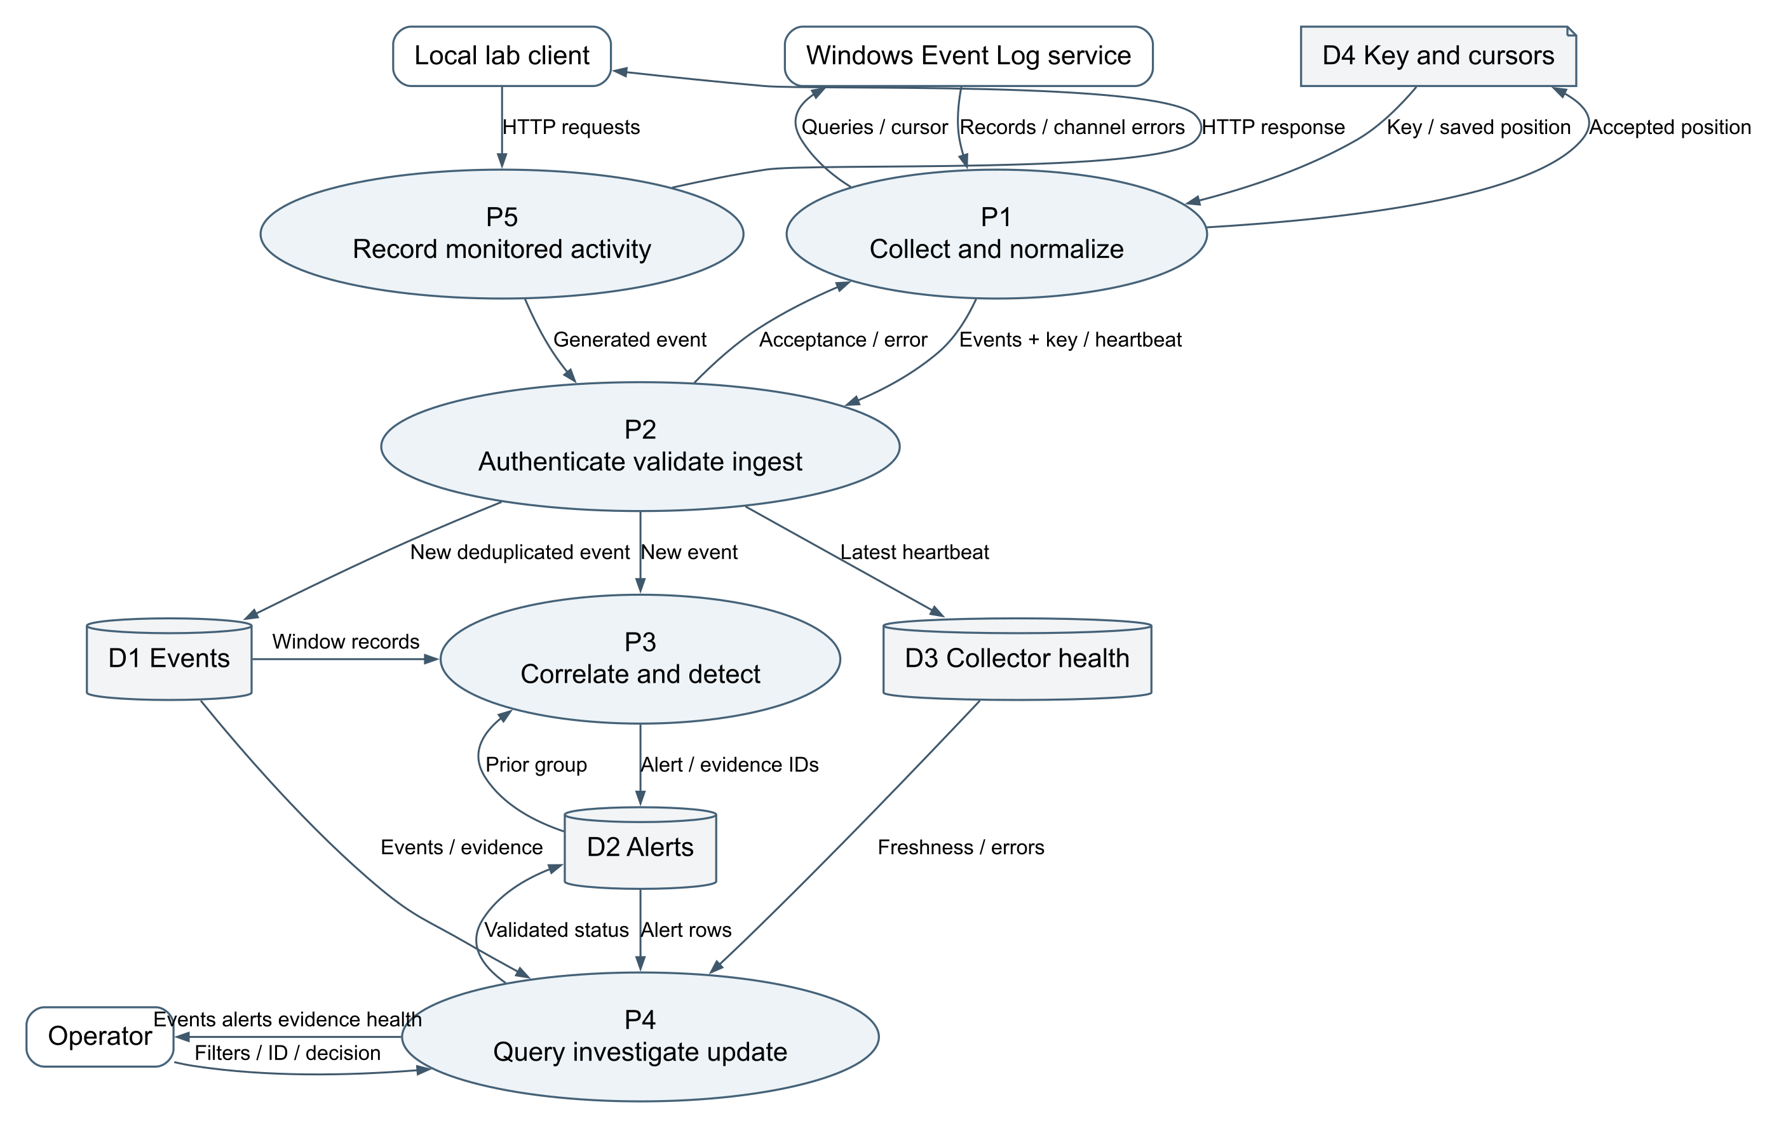
Figure 5 Level 1 processes stores and balanced external flows

External inputs and outputs balance the context diagram. The local HTTP path enters P2 as a server generated event; it is not an unauthenticated collector upload.

Ingestion and failure handling
1. Poll three channels every five seconds, at most 200 matching records per channel in oldest first order. First run starts at the current end; historical records are not automatically imported.
2. Parse XML into source, kind, host, account, available IP, UTC time and provider context. Missing values remain unknown.
3. Submit JSON with bearer credential. Validate Host and Origin where present, route, key, required fields, timestamp, batch and body limits. Each API batch has 1 to 500 events and at most 1 MiB.
4. Normalize and sort within the batch; begin transaction; deduplicate; insert new events and evaluate rules; commit.
5. Return accepted/duplicate counts. Advance a channel cursor only after acceptance. A lost reply followed by retry does not double count committed stable identities.
6. Persist cursors using temporary file replacement. Send heartbeat; unreadable channels are degraded. UI declares offline after 30 seconds without a fresh heartbeat.
Heartbeat proves recent communication, not complete collection. Audit configuration, overwritten records, outage duration and clock errors remain visibility risks.

Detection design
Rule | Condition and grouping | Severity and interpretation
AUTH-001 | Five auth_failure records in inclusive 60 seconds; source, host, IP, username | High; review repeated failures
WEB-001 | Five web_probe records in 60 seconds; source, host, IP | Medium; only this app's sensitive monitored paths
WIN-001 | Security 1102 audit_cleared | Critical; possible evidence removal
WIN-002 | Security 4720 account_created | Medium; verify authorization
WIN-003 | Security 4697 or System 7045 service_installed | Medium; verify service provenance
WIN-004 | Defender Operational 1116 malware_detected | High; inspect threat and remediation context

Security 4624, System 6005/6006 and Defender 1117 provide context. Repeated threshold matches within approximately one minute of alert creation extend evidence rather than generate repeated alerts. A resolved alert remains resolved within that suppression period even if evidence grows. Planned UI work must explain this and establish whether fresh evidence should reopen an investigation.
Sorting is within each batch. Very late events across batches are not fully re-correlated. Plan a bounded lateness policy and cross batch tests. An empty alert queue is not evidence that a host is safe.

API contracts
Method and path | Input or purpose | Response and access
GET /api/health | Liveness | Name, storage and uptime; local
POST /api/ingest | events array | Accepted/duplicate counts; bearer key
POST /api/heartbeat | id, status, detail | Latest health update; bearer key
GET /api/state | q and severity | Counts, newest 150 matching events, newest 100 alerts, rules, health
GET /api/alerts/:id | Numeric ID | Alert and available evidence; 404 if absent
PATCH /api/alerts/:id | open, acknowledged or resolved | Update; dashboard header and origin restrictions
POST /monitored/login | Lab username | Always 401; password is not stored

Plan request IDs, stable error codes, generic client errors, diagnostic logs, cursor pagination, rate limits and status reasons. Current search filters events, not the alert list; explain this scope. The 15 second request timeout does not guarantee database query cancellation.

7 User Interface and Experience Design

User flow
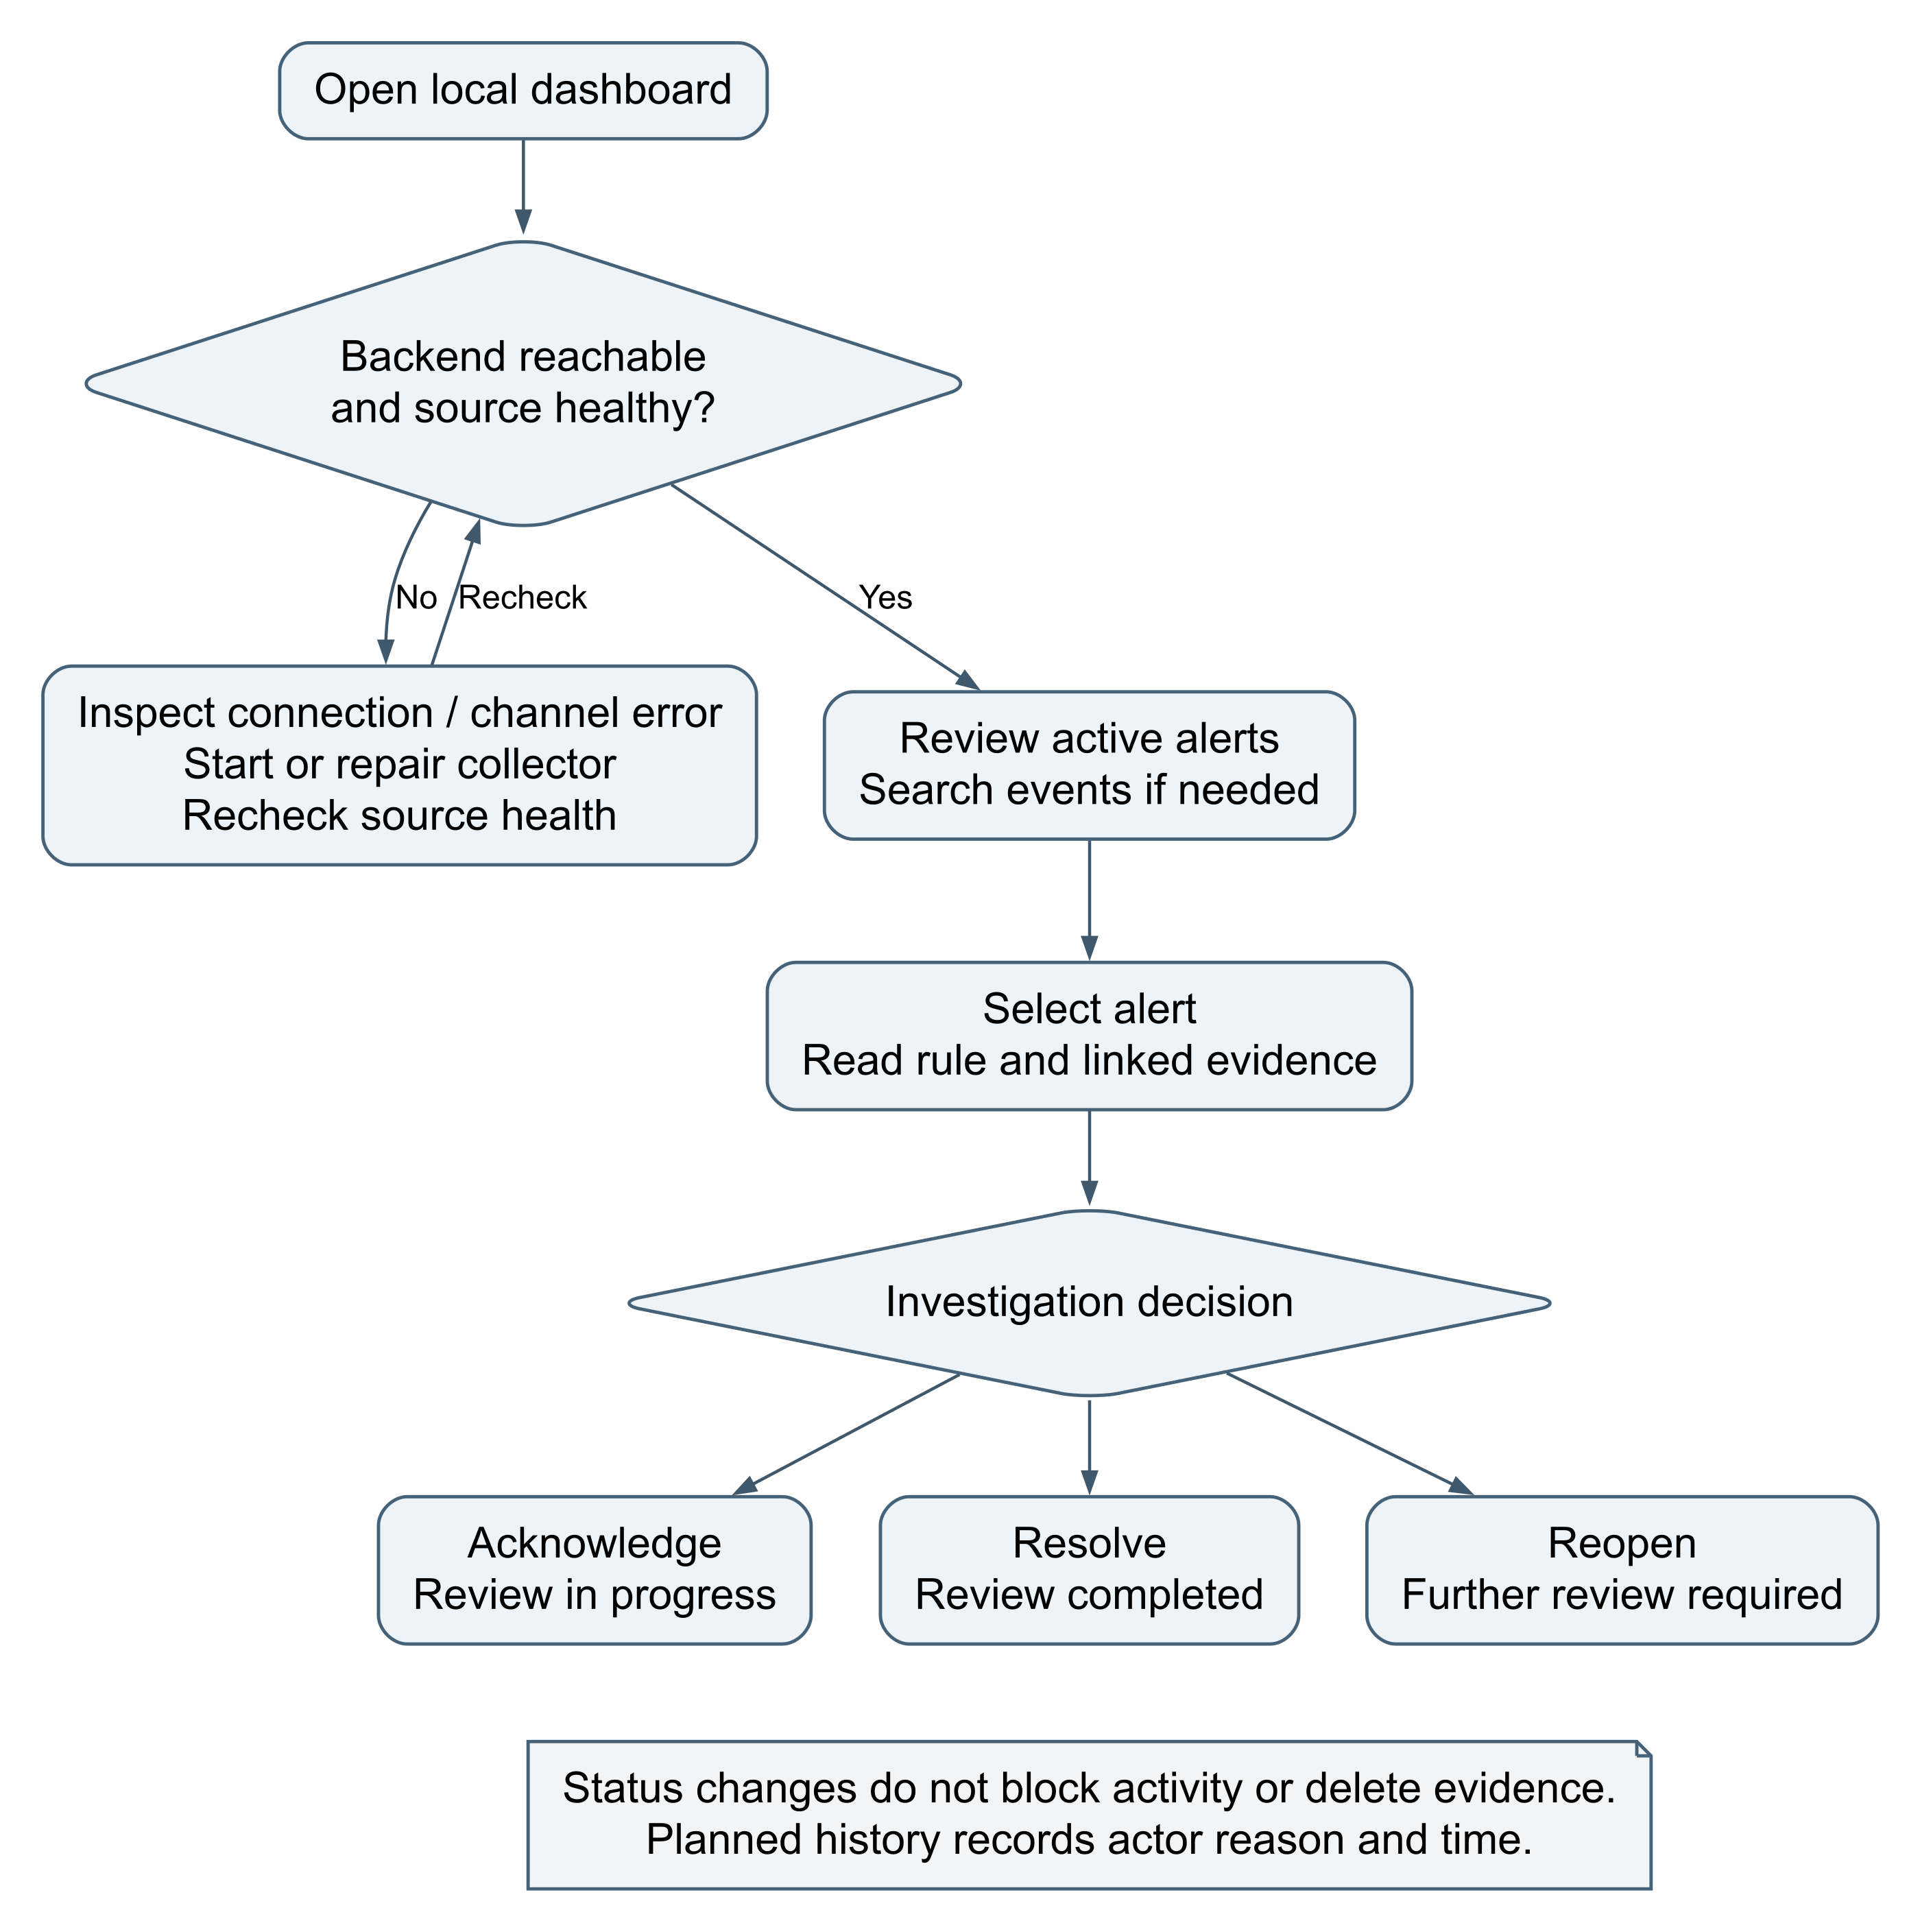
Figure 6 Operator investigation flow

Dashboard and evidence dialog wireframes
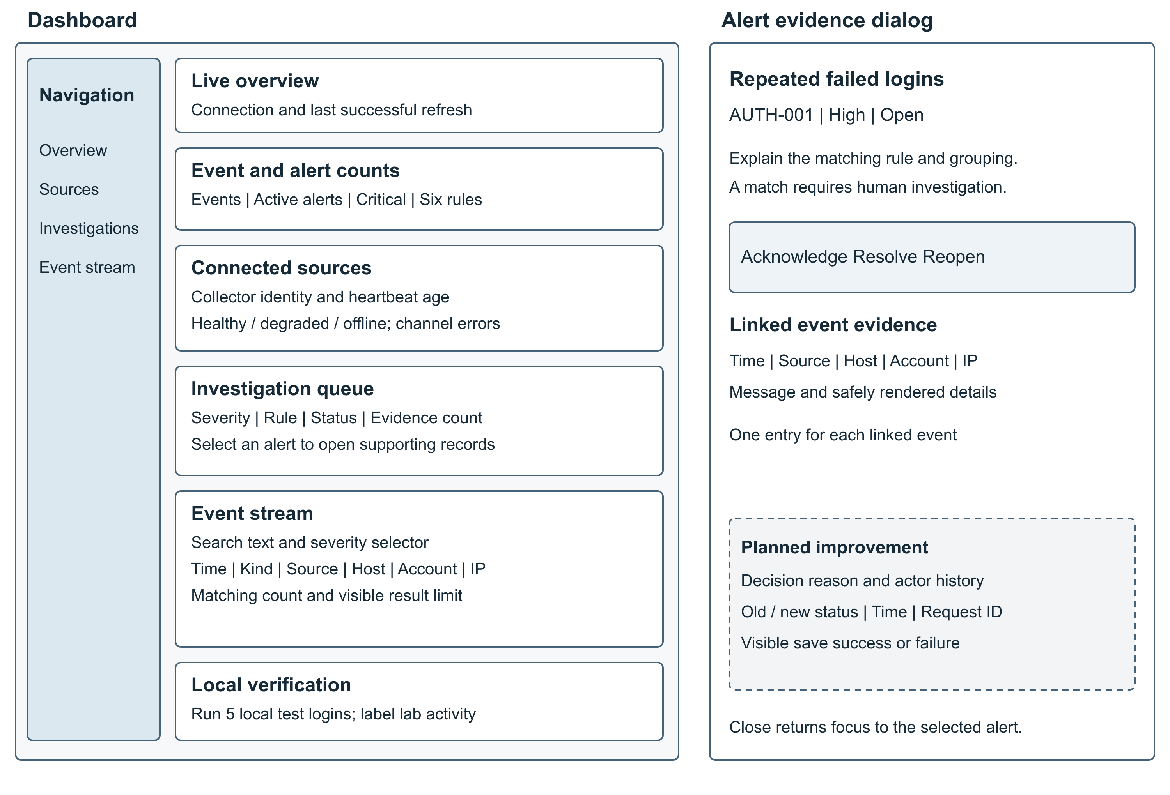
Figure 7 Dashboard and evidence dialog wireframes

Area | Content and behavior
Header | Connection, last successful update and stale warning
Summary | Stored events, active alerts, unresolved critical alerts and rule count
Sources | Collector identity, healthy/degraded/offline text, last heartbeat and channel errors
Queue | Rule title/ID, severity, status, evidence count and creation time
Stream | Account/host/IP/kind/message search, severity selection, matching count and display limit
Rows | Time, severity text, kind/message, source/host, account/IP
Lab | Explain five rejected requests; disable during run and show resulting alert

The evidence dialog displays title, rule, severity, state and each event's time, message, host, source, account, IP and escaped details. Existing actions are Acknowledge, Resolve, Reopen and Close. Add a complete trigger explanation and grouping context. Planned controls collect a reason and display actor/time/history. Use a version or updated time condition to reject stale concurrent changes. Failed updates must not imply success.
Require keyboard access, visible focus, labels, modal focus containment/restoration, contrast and severity words alongside color. Refresh must preserve typed text and focus. Retain stale results with a warning on failure. Stack panels on narrow screens and scroll wide tables horizontally. Existing labels and status roles cover part of this; full browser and screen reader behavior requires verification.

Network Knight Initial Demo
Design note: These screenshots illustrate Network Knight - Initial Demo, our primary interface design. Layout, features and integrations may change during development. They are examples of the proposed user experience.
The published demo identifies its data as synthetic and saved in this browser. Its BF-001, PE-001 and PS-001 rules are separate from the local implementation rules documented in Section 6.
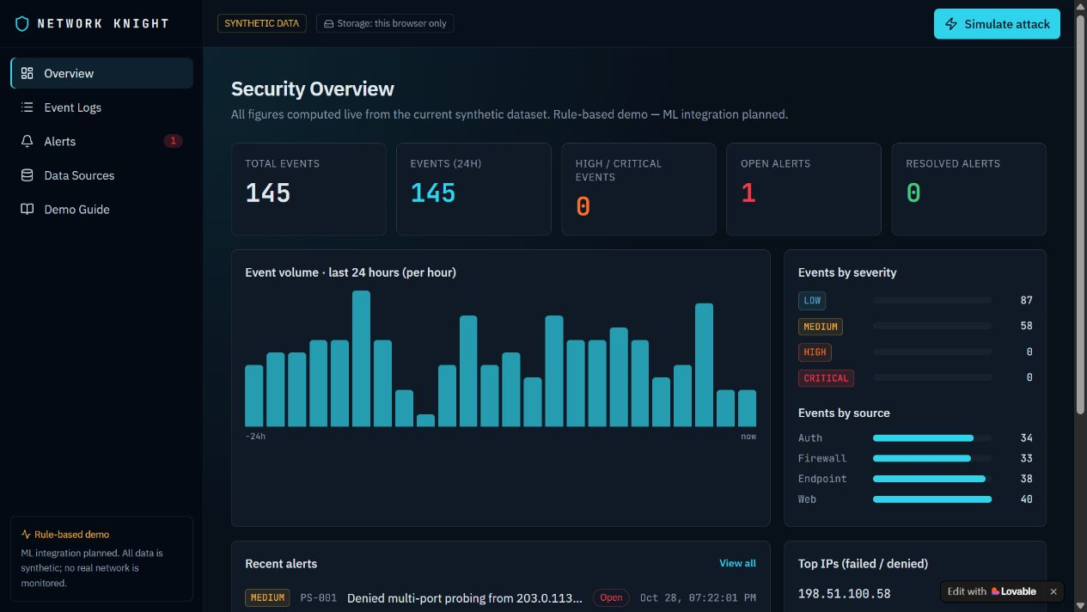
Figure 8 Network Knight - Initial Demo | Security overview
The overview brings event volume, severity distribution, source categories and active alerts into one screen.
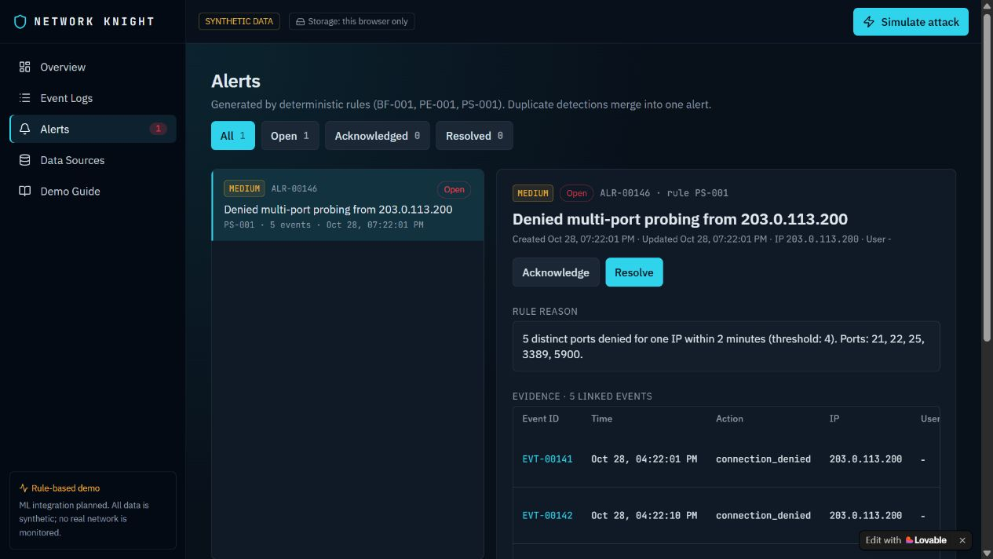
Figure 9 Network Knight - Initial Demo | Alert investigation and linked evidence
The investigation view exposes a rule explanation, supporting records and review actions.
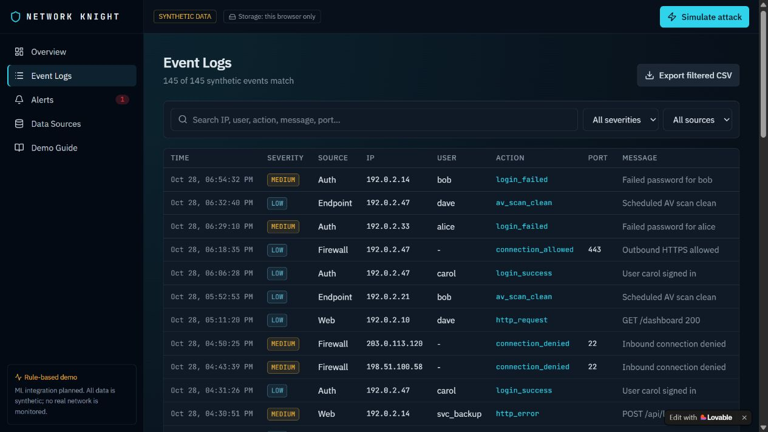
Figure 10 Network Knight - Initial Demo | Searchable event logs

8 Security and Risk Considerations

Threat Model Diagram
This model reuses DFD processes and stores. P4 includes the browser/server investigation path. Dashed arrows identify attacker activity. S, T, R, I, D and E refer to STRIDE [4]. Boundaries are logical controls, not network subnets.

Threat model with trust boundaries and STRIDE references
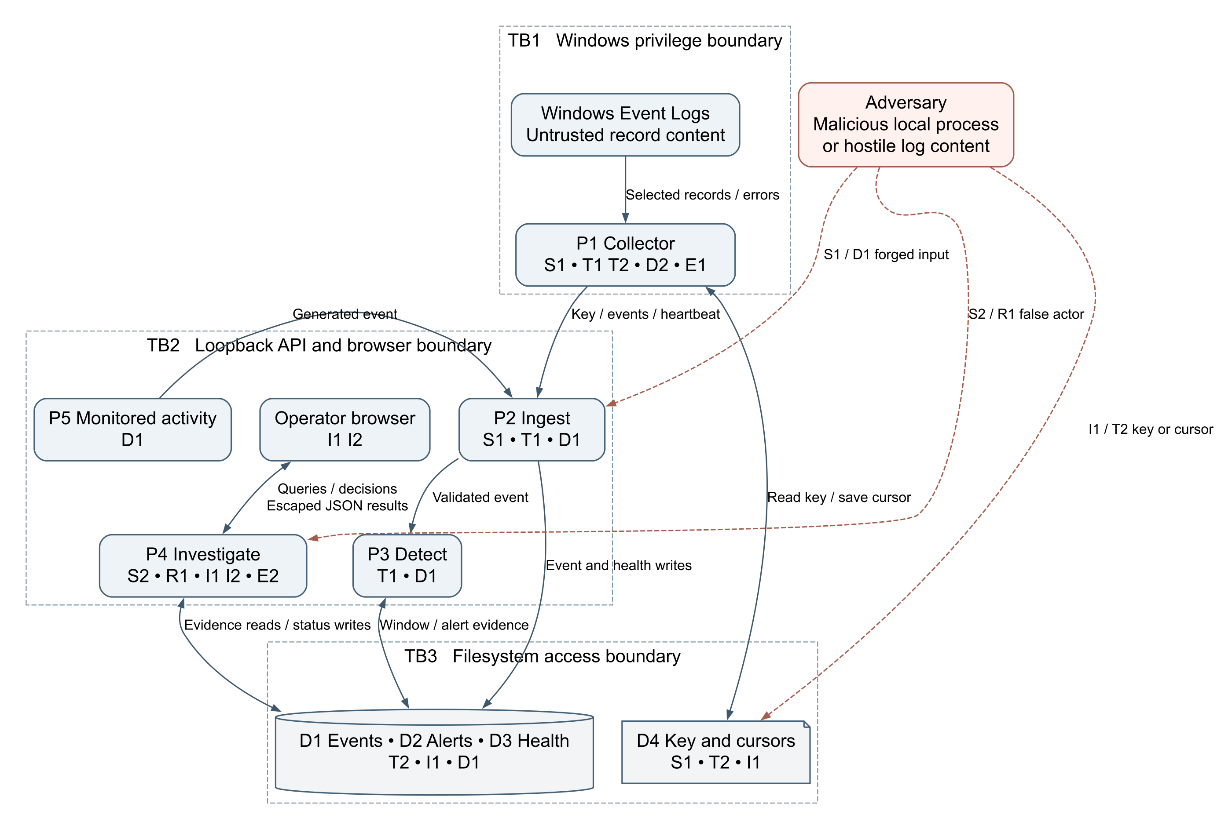
Figure 11 Threat model with trust boundaries and STRIDE references

TB1 separates privileged log access from ordinary execution; TB2 separates supplied data from trusted decisions; TB3 relies on OS file protection. Assets include evidence confidentiality/integrity, alert state, key secrecy, cursor correctness, availability and action history. Adversaries include another local account, operator context malware, hostile webpages and attackers producing malicious log content. A compromised administrator can cross all boundaries; host compromise defeats application only evidence guarantees.

STRIDE Analysis and Specific Mitigations
C is confidentiality, I integrity, A availability. Priority is a qualitative engineering judgment, not a measured exploit probability.
Threat | Components and scenario | Impact and priority | Specific controls and verification
S1 Spoofing | P1/P2/D4: stolen shared key fabricates events or heartbeats under arbitrary collector IDs | I high, A medium; high | Existing random key and timing safe check. Plan ACLs and rotation; individual credentials/source binding if expanded. Test invalid and revoked keys.
S2 Spoofing | P4: local code imitates dashboard header and changes alert state | I high, C medium; high | Explicit trusted local operator boundary. Add authenticated sessions/roles for stronger separation. Test that collector credential and header alone cannot authorize extended operator routes.
T1 Tampering | P2/P3/D1: manipulated timestamps, identities or fields alter detection grouping | I high; high | Existing limits, future time rejection, parameters, transaction and deduplication. Plan strict types, valid bounded JSON, clock skew and source binding. Test late/manipulated events.
T2 Tampering | D1/D2/D4: database or cursor changes erase evidence or skip logs | I high, A medium; high | Plan ACLs, protected backups, relational references and cursor checks. Protect integrity hashes separately if added. Test unauthorized file writes; colocated hashes cannot defeat an administrator.
R1 Repudiation | P4/D2: operator denies a status change; current store has no actor history | I high for accountability; high | Plan atomic append only application action rows with actor, old/new state, UTC time, reason and request ID. Protect audit copies separately for stronger assurance. Test exactly one history row per successful change.
I1 Information disclosure | Browser/P4/D1/backups: another user, package, screenshot or error reveals account, host and path data | C high; high | Existing loopback, no store responses and data exclusion. Plan ACLs, generic errors, protected backups and sanitized exports. Test another Windows identity. No existing encryption at rest claim.
I2 Information disclosure | Browser: log text executes script to read evidence or send actions | C high, I high; high | Existing escaping and CSP. Prefer text nodes where possible; test malicious message, details and username fields. Payload displays as text without execution.
D1 Denial of service | P2/P3/D1: repeated requests, nested details, large windows or disk growth block processing | A high, I medium from missed logs; high | Existing 1 MiB/500 event limits, truncation, request timeout and result caps. Plan rate/nesting/evidence bounds, indexes, retention and disk alerts. Measure saturation; row caps do not bound query work.
D2 Denial of service | P1/Windows: collector stopped, permissions revoked or channels overwritten | A high, I medium; high | Existing retry, cursor after acceptance, deduplication and heartbeat. Plan gap/backlog diagnostics and outage runbook. Test outages; warnings cannot restore overwritten events.
E1 Elevation of privilege | P1/P2: backend flaw inherits admin rights if whole application is elevated | C/I/A high; high | Unelevated backend, minimum collector rights and isolated elevation. Never execute commands from event content. Verify process identities and ACLs.
E2 Elevation of privilege | Future P4 roles: viewer or collector reaches analyst/admin API | C high, I high; conditional high | Deny by default route/object authorization, separate credential scopes, server enforced roles and negative role tests. Hidden buttons are insufficient; current prototype has no roles.

Residual risks include privileged host compromise, operator context malware, incomplete auditing, shared key theft, false positives/negatives, overwritten records and late arrival limitations. Resolve through engineering or explicit scope acceptance.

Security Principles and Enforcing Controls
Principle | Enforcing control | Status
Least privilege | Loopback, unelevated backend, minimal collector rights and ACLs | Binding exists; deployment identity/ACL checks planned
Complete mediation | Every request validated; each upload/heartbeat authenticated; allowed statuses | Existing for these routes; operator roles conditional
Defense in depth | Input limits, SQL parameters, escaping, CSP, origin checks, OS protection, backup | Several layers exist; OS/recovery additions planned
Secure defaults and fail closed | Reject missing keys, invalid batches, foreign hosts/origins and unknown routes | Existing; stricter schema and generic errors planned
Minimal attack surface | Small route allowlist, no required npm packages, no DB listener | Existing; runtime patching remains operational work
Data minimization | Selected IDs, omit lab passwords, exclude runtime data | Partial existing; field allowlist/export planned
Integrity/accountability | Atomic ingest, deduplication, linked evidence and action history | First three exist; relational/action controls planned
Separation of duties | Ingestion credential distinct from operator access | Partial; sessions/roles needed for shared use
Availability/recovery | Freshness, retries, bounded work, storage warnings, backup | Health/retry exist; resource/recovery additions planned
Usable security | Visible gaps, explainable alerts and human review | Existing design; browser verification pending

Performance and Reliability Considerations
The nominal collector ceiling is 200 matching records per channel per five second cycle. Across three channels that is about 120 records per second only if work completes within the cycle; queries, sequential uploads and timeouts reduce actual capacity. Uploads are per channel, but large messages can exceed the byte cap.
Dashboard limits bound returned rows, not work. Wildcard searches, counts, evidence arrays and time windows can grow expensive. The current correlation index favors authentication; consider (kind,source,host,ip,timestamp) for web grouping after query plan and load analysis. Plan pagination and bounded evidence reads before scaling.
Example capacity scenario: 10 events/second at an assumed 2 KiB per record yields about 1.65 GiB daily, or 148 GiB over 90 days before indexes, WAL and backups. This is neither measured nor expected traffic. Measure size/rate before approving retention. Warn on pressure rather than silently discard required evidence.
Proposed target | Method | Acceptance criterion
UI latency | Documented workstation, 100000 stored events, 10 events/second, one operator, 15 minutes | p95 state response below 500 ms; record resources and plans
Visibility | Authorized Windows events; healthy no backlog run | p95 event to display within 10 seconds; report clock uncertainty
Replay safety | Resubmit accepted identities after lost reply simulation | No extra records or evidence counting
Atomicity | Invalid event mixed into valid batch | No partial event/alert commit
Rule boundaries | Four/five events, separate identities and outside window records | Exact expected alerts and evidence
Outage indication | Stop collector with server/browser active | Offline on first successful refresh after heartbeat age reaches 30 seconds
Persistence | Restart after acknowledged writes | Committed evidence and states remain
Recovery | Restore latest daily consistent backup in isolation | Proposed RPO at most 24 hours; RTO at most 30 minutes; demonstrate
Exhaustion | Authorized bursts and isolated low disk simulation | Controlled errors or warnings, no silent partial commits; record saturation

Record hardware, runtime, event mix, warmup, duration, p50/p95 latency, failures, accepted rate, backlog and peak storage. Use labeled benign and authorized fixtures for false positives and rule recall. Six successful rule tests do not establish production detection accuracy.

References
Official references consulted October 28 2026. Implementation grounding: local README, package.json, server.js, collector/start-collector.ps1, collector/windows-event.ps1, public/index.html and public/app.js. Runtime records and secret values were not needed.
1. NIST. Cybersecurity Framework 2.0. https://www.nist.gov/publications/nist-cybersecurity-framework-csf-20 and https://www.nist.gov/cyberframework/faqs
2. OWASP. Application Security Verification Standard 5.0. https://asvs.owasp.org/ and https://owasp.org/projects/asvs
3. CIS. Controls v8.1 and Audit Log Management. https://www.cisecurity.org/controls/CIS-controls-navigator and https://www.cisecurity.org/controls/audit-log-management
4. Microsoft. Threat Modeling Tool threats and STRIDE. https://learn.microsoft.com/en-us/azure/security/develop/threat-modeling-tool-threats
5. Node.js. SQLite API. https://nodejs.org/api/sqlite.html
6. Microsoft. Get-WinEvent. https://learn.microsoft.com/en-us/powershell/module/microsoft.powershell.diagnostics/get-winevent
Architecture, priorities, mappings and benchmark targets are project engineering judgments. References explain technologies/frameworks; they do not certify this implementation.
7. scikit-learn. IsolationForest candidate documentation. https://scikit-learn.org/stable/modules/generated/sklearn.ensemble.IsolationForest.html
8. Network Knight published initial demo. https://network-knightinitialdash.lovable.app/ Captured October 28 2026.

Appendix A Project Scope and Implementation Status
Network Knight is the team's AI Assisted Cybersecurity Log Monitoring and Threat Detection System. The current local build is an implementation baseline: collection, storage, rule evaluation and a working investigation interface. The longer term project concept includes AI assistance and broader operating system support. Those goals must not be presented as completed features.

What is implemented and what must still be built
Capability | Evidence in local project | Status
Local event dashboard | public/index.html, style.css, app.js | Implemented
Backend and persistent storage | server.js with Node.js HTTP and SQLite | Implemented
Six explainable rules | AUTH-001, WEB-001, WIN-001 through WIN-004 in server.js | Implemented
Windows channel collection | collector/start-collector.ps1 and windows-event.ps1 | Implemented code; real permissions and collection still require demonstration
Evidence review and status changes | Alert detail and PATCH endpoints | Implemented; no operator audit history
AI or Isolation Forest | No model training, feature pipeline or scoring service in local build | Future work
Linux and macOS collection | No corresponding collectors in inspected build | Future work
React and FastAPI | Earlier discussed stack; current local UI uses plain JavaScript and Node.js | Architecture choice to reconcile before a rewrite
User login and role permissions | No operator accounts in existing local prototype | Required before shared or remote deployment
Retention, protected backups and decision history | Design proposals in this report | Planned

The Lovable dashboard and public website demonstrate a separate interface/deployment path. A public dashboard or embedded page does not establish a secure connection to the workstation collector. Do not assume cloud ingestion, AI inference, or local evidence synchronization exists without verifying the integration.
The small business and gas station use case motivates simple evidence review and lower operating cost. The current build does not integrate point of sale devices, payment systems, store cameras, routers or business accounts. Those sources need separate connectors, authorization and scope decisions.

Buildable scope recommendation
Complete and demonstrate the local vertical slice first: one workstation, selected logs, durable storage, explainable alerts and an operator decision. Keep that baseline stable while adding the minimum missing security controls. If AI remains a required final deliverable, implement it as a separate milestone with measurable evidence rather than describing the existing rule engine as AI.
There are two valid stack paths. Retaining Node.js and the existing browser UI preserves working code. Moving to React and FastAPI matches the earlier concept but requires a planned migration and renewed testing. The report recommends retaining the baseline for the current milestone; it does not declare an unapproved rewrite or remove AI from the team's final requirements.

Original measurable requirements
Team requirement | How to test it | Relationship to other targets
At least 80 percent of test users open the dashboard, find an alert and view details without assistance | Give the same task to five representative users; at least four succeed; record time and errors | A usability target, not a claim of completed testing
Dashboard displays requested data within 3 seconds under normal team workload | Define event count, event rate and workstation; measure request to usable display | The later 500 ms API target is an optional stricter engineering target
At least 95 percent of supported events are processed and analyzed within 5 seconds of backend receipt | Measure received_at through committed event and derived alert availability; report p95 | Excludes pre-receipt Windows polling; end to end visibility can take longer

These requirements preserve the team's existing goals. Establish the normal workload before claiming success. No production accuracy or capacity is inferred from a small lab demonstration.

Current verification evidence
On October 28 2026, all 13 Node.js dashboard and system tests passed again using the in process request transport and temporary test databases. They cover threshold behavior, identity separation, time windows, deduplication, authentication, atomic ingestion, Windows rule fixtures, evidence, state changes, persistence, source health, origin/Host restrictions and input limits. This is fresh test evidence for application logic; it does not prove live socket operation, native Windows collection, browser accessibility, or the proposed performance objectives.

Appendix B Step by Step Local Demonstration
This walkthrough uses the existing local application and its supplied verification tools. Complete Part 1 before attempting Windows collection. Record observed results; the expected outcomes below are not prefilled test results.

Preparation
Use an authorized Windows workstation, a compatible installed Node.js runtime, the network-knight project folder, a browser and PowerShell. Keep the Node.js server in a normal terminal; use a separate elevated PowerShell window only if channel access requires it. Do not share the data folder, collector key or unsanitized log screenshots.

Part 1 Demonstrate the application pipeline
1. Open the project folder. In File Explorer, open network-knight and confirm server.js, Start-Network-Knight.cmd, public, collector and tools are present. Keep this folder open so every later command runs from the correct location.
2. Start the backend. Double-click Start-Network-Knight.cmd and leave its terminal open. Expected: the startup message displays http://127.0.0.1:8787 and SQLite persistence. If Node.js is missing, install a compatible supported release before continuing; if the port is occupied, identify the existing process rather than launching repeated copies.
3. Open the dashboard. Enter http://127.0.0.1:8787/ in the browser. Expected: a connected backend and an update time. Windows may show Not connected because its separate collector has not started; this does not invalidate the local HTTP demonstration.
4. Generate one identifiable test. Under Test the complete pipeline, select Run 5 local test logins once and wait for completion. Expected: five rejected HTTP requests, five stored events and an AUTH-001 alert linked to those events. The endpoint intentionally has no valid accounts; the rejections are expected.
5. Inspect the evidence. Open the resulting alert and verify its rule ID, high severity, lab username, source and five evidence records. Explain the five-events-in-60-seconds rule. Record the alert ID and unique lab username; use them to locate the same investigation later.
6. Demonstrate investigation state. Select Acknowledge, verify the displayed state, then Resolve and verify it again. Explain that these actions record the current investigation status; they neither block a source nor delete the five events. Reopen only if demonstrating that action is useful.
7. Check restart persistence. Stop the backend with Ctrl+C, restart it with the launcher, refresh the browser and locate the saved alert. Expected: the evidence and last saved status remain. Record the observed result. A restart proves local persistence, not a backup restore.
Optional command-line equivalent: With the backend running, open a second normal terminal in network-knight and run node tools/verify-flow.js. Expected: a PASS message tracing five rejected HTTP logins to five stored events, an AUTH-001 alert and five evidence records. This creates a new test username; it is a separate run from the browser button.

Part 2 Demonstrate Windows collection
8. Start the collector separately. In a PowerShell window opened in network-knight, run .\collector\start-collector.ps1. Use authorized elevation if Security log reading requires it. Expected: a Windows source appears in Connected sources with recent heartbeat and ok. A degraded status means at least one channel could not be read; inspect the stated channel rather than describing collection as fully healthy.
9. Wait until collection is ready. Confirm ok before generating the Windows test. First startup begins at the current end of each channel, so events created before the collector starts are not a valid live collection test.
10. Generate the supplied Windows scenario. In another terminal in network-knight, run .\tools\Test-Windows-Detection.ps1. It attempts five rejected logons with a new nonexistent account and prints its username. Existing Windows failure auditing must generate Security 4625; the script does not enable auditing or change policy.
11. Trace the Windows records. Allow about two normal polling intervals, then search the printed username in the dashboard. Expected, when the source records are produced and collected: five windows:Security events and an AUTH-001 alert with linked evidence. Compare the source with the earlier local-web test to show that these are different ingestion paths.
12. Check collection health and shutdown. Stop only the collector with Ctrl+C while keeping the backend and dashboard open. Expected: the source becomes offline on a successful refresh after its heartbeat is at least 30 seconds old. Existing evidence remains visible. Restart the collector if continuing the lab; otherwise stop the backend with Ctrl+C when finished.

Troubleshooting checkpoints
Observation | Check | Interpretation
Dashboard cannot connect | Server terminal, exact localhost URL and port | Backend reachability must be restored before testing rules
Windows source is degraded | Named channel error and authorized read permissions | Do not treat a heartbeat as proof every channel works
PowerShell refuses the script | Local or organization execution policy with instructor/administrator | Do not override managed policy; record the blocked step
No 4625 records after the Windows test | Existing failure auditing and the test's printed username | No source event means collection/detection cannot demonstrate that scenario
Records exist but no alert appears | Matching source/host/IP/account, five events within 60 seconds and receipt ordering | Inspect grouping and timing; preserve the evidence for diagnosis

Evidence to retain
Capture only the meaningful checkpoints: connected source health, one alert with its five linked records, the persisted status after restart, and the offline transition if required. Sanitize identities and host details before sharing. Record date, runtime version, alert ID, scenario and pass/fail observation; never include the collector key or runtime database in the submission.

Appendix C How to Explain Network Knight

Start with the problem
A workstation records many security events, but raw logs are difficult to review quickly. Network Knight brings selected events into one place and highlights specific patterns with evidence. The operator still decides whether the activity is legitimate, suspicious or resolved.

Explain the system in six steps
1. Windows writes events such as failed logons or service installations into its own logs.
2. Our PowerShell collector reads selected new records. A collector is a reader and sender; it does not create Windows evidence or detect every attack.
3. The backend checks the collector credential and event format, then converts the records into a consistent structure. This is normalization.
4. SQLite saves those events. The backend checks the rules and saves an alert with IDs of the supporting records.
5. The browser asks the backend for current events, alerts and collector health every two seconds.
6. A person opens the alert, inspects the evidence, and acknowledges, resolves or reopens it.

A concrete example
Suppose five failed logons for the same source, host, IP and account arrive within 60 seconds. AUTH-001 creates a high severity alert and references those five stored events. The browser displays the alert; selecting it retrieves the evidence. Acknowledge means someone has started reviewing it. Resolve changes investigation status; it does not block an IP, fix an account or delete evidence.
For a controlled application demonstration, use the provided lab button. It sends five real HTTP requests to an endpoint that always rejects logins. That proves the HTTP event to database to rule to alert path. It does not prove collection of Windows logs. Demonstrate Windows collection separately after permissions and failure auditing are verified.

What the diagrams mean
Diagram | What to say
Architecture | These are the components we run and how they communicate. The backend is where validation, storage access and detection occur.
Context diagram | The entire application is one process. The operator, Windows logs and lab client are outside entities exchanging information with it.
Level 1 DFD | We expand the system into collection, ingestion, detection, investigation and lab recording. Stores identify where information rests.
Existing ERD | Events store observations, alerts store detections, and collectors store health. Alert evidence currently uses JSON IDs.
Planned ERD | A join table enforces evidence relationships and an action table records investigation decisions.
UI wireframe | This is where users see source health, alerts, searches and evidence. It describes interface structure.
Threat model | The same flows cross privilege, API/browser and filesystem boundaries where we apply security controls.

Explain the frameworks without memorizing them
NIST CSF helps us organize risk work: govern responsibilities, identify assets, protect data, detect suspicious events, respond through investigation and recover evidence. OWASP ASVS helps us verify the application itself, including input validation, safe output, credentials and access checks. CIS Controls helps us operate logging responsibly through collection, review, time accuracy, storage and retention. We map selected relevant practices; we are not claiming certification.

Explain STRIDE with this project
Category | Simple project example | Response
Spoofing | Someone pretends to be our collector | Credential validation, protected keys and planned rotation
Tampering | Someone edits event evidence or cursor position | Restricted file access, transactions and protected backups
Repudiation | Someone denies resolving an alert | Planned actor and transition history
Information disclosure | Logs or keys are exposed to another person | Local access boundary, ACLs, minimized fields and sanitized exports
Denial of service | Too much input fills disk or stalls detection | Limits now; rate controls, storage warnings and retention planned
Elevation of privilege | A backend flaw runs with administrator rights | Keep backend unelevated and restrict collector privilege

How to describe the AI honestly
The current build uses rules and has no trained model. If the final project requires AI assistance, a candidate is an anomaly scoring component such as Isolation Forest. This would supplement the rule evidence, not turn every anomaly into a confirmed attack.
A buildable AI milestone needs a defined event feature schema, a labeled or carefully reviewed baseline dataset, a training procedure, a versioned model, a scoring interface, score/threshold storage and a comparison against rules alone. Example candidate features are failed logon count per account/time window, distinct source count and event rate; these are proposed features, not existing implementation.
Use separate time periods or hosts for training and evaluation to reduce leakage. Record false positives on benign activity and recall on authorized scenarios. Preserve raw evidence and model version with each scored result, and show score explanations without claiming a probability of compromise. Keep scoring asynchronous or bounded so a model failure does not stop basic logging.
Python, scikit-learn and a FastAPI scoring service are possible implementation choices if the team retains that earlier direction. They remain a proposal until the team approves scope, integration, dependencies and evaluation criteria. Cross-platform collectors likewise need their own adapters and tests.

Suggested division of work
Workstream | Concrete responsibility | Integration handoff
Collection and normalization | Windows permissions, channels, parser, cursors and source health | Agreed JSON event schema and reliable upload behavior
Backend and data | Ingestion, SQLite, evidence relationships, action history and APIs | Documented routes and test fixtures
Interface and usability | Health display, alerts, evidence dialog, errors and accessibility | UI wired to real API responses
Security and validation | STRIDE controls, negative tests, benchmarks, backup/restore and final evidence | Reproducible acceptance checklist

For three members, combine security validation across all workstreams and assign one integration owner. Do not assign names without agreement. AI is a separate cross-cutting milestone once its scope is approved. Every member should be able to trace one event through the full pipeline.

Professor questions and accurate answers
Question | Answer
Is this a SIEM? | It is a small local monitoring and correlation prototype with some SIEM-like functions, not a full enterprise SIEM.
Is it really AI right now? | No. Current detections use six explicit rules. AI assistance is a proposed final-stage component if retained in scope.
Where does data go? | The inspected local build stores events, alerts and health in SQLite on the workstation.
Does opening the dashboard start collection? | No. The PowerShell collector is a separate process.
What prevents fake events? | Ingestion requires a secret, but a stolen key or compromised host remains a risk.
Does resolving an alert stop an attack? | No. It changes the investigation state; automated blocking is not implemented.
Why this stack? | It matches existing working code and minimizes deployment dependencies and cost for a single-host milestone.
Are Linux and macOS supported? | Not by the inspected collectors. They require additional adapters and validation.
What is still missing? | Live environment validation, audit history, retention/backups and stronger deployment controls; AI and broader sources if final scope requires them.

A short speaking outline
Explain the problem and intended small business user. Identify the single-host architecture. Walk through one failed-logon event from collection to evidence. Show how the operator reviews an alert. State the protections and limitations. Finish with the next build milestone and the test that will prove it works.
The strongest explanation is a demonstrated vertical slice followed by a precise account of what remains to build.

Appendix D Implementation and Verification Checklist
Order | Work | Completion evidence
1 Baseline | Pin runtime; verify backend and collector identities and permissions | API/parser tests and authorized Windows collection
2 Integrity | Evidence migration, strict JSON and action history | Copy migration, count/integrity checks, rollback exercise
3 Local security | ACLs, separated privilege, rotation and generic errors | Negative access tests and clean source packages
4 Reliability | Gap/backlog/skew indicators and lateness/suppression policy | Outage, replay, reset and late arrival tests
5 Resources | Limits, storage warnings, retention and backup | Load benchmark, pinned evidence test and restore
6 Usability | Keyboard, focus, labels, errors, search scope and stale state | Browser walkthrough
7 Review | Reconcile requirements, diagrams, threats and frameworks with code | Each implemented control has evidence; exceptions have owners

All 13 application tests passed on October 28 2026 using the in process transport and temporary databases. Live socket operation, Windows collection, accessibility and performance remain separate verification tasks.

