(Note this template is only a guide of what topics must be covered in software documentation and to what extent they should be covered)

Windows File Name Validation Assignment
Joe Blogs

Contents
1. Problem Statement 1
2. User Requirements 1
3. Software Requirements 2
4. Software Design 2
5. Requirement Acceptance Tests 4
6. Detailed Software Testing 5
7. User Instructions 6

Problem Statement

(In this section you write a few sentences about what needed to be done for the assigment)

The goal of Part 1 was to create a program in Perl that accepts Windows file names from the DOS command line, validates the input using Perl regular expressions and then outputs information about each valid file name or an error message for invalid file names.

The program must accept multiple file names in a single command. Each file name can consist of path and file name with multiple levels in the path.

User Requirements

(In this section you detail how a user is supposed to interact with or use your program code)

The following outlines the user requirements for the program:

- The user shall be able to enter as many file names on the command line as they like.
- Each one can consist of the full path of the file with multiple levels (eg. z:\path\filename.doc) or simply the file name without the path (eg. filename.doc).
- The user shall also be able enter a directory name without a file name and receive valid output.
- The user should be able to enter as many levels for each file as they want.
- File and directory names can be from 1 to 64 characters long.
- File extensions should be 3 or 4 characters preceded by a dot (eg filename.doc or filename.html)

Software Requirements

(In this section you spell out what the requirements were, taken from the assigment handout)

The following outlines the software requirements for the program:

- The program shall accept multiple file names as arguments from the command line.
- The program shall display the details of all valid files .
- The program shall display an appropriate message if a file does not exist or if a file name is invalid.
- The program shall display a message if an argument is a directory instead of a file.
- Each file name can be a simple file name or include the full path of the file with one or more levels.
- All file names must start with an alphabetical character to be considered a valid file name.
- Valid file name extensions must be 3 or 4 alphabetical characters preceded by a dot.
- Directory/level names must start with an alphabetical character to be considered valid.
- The program should be able to accept as many levels for each file name as the user wants to input. This is limited only by the number of levels allowed in Windows (approximately 120).
- Each level of the file name can be a maximum of 64 characters.

Software Design

High Level Design – Logical Block Diagram

(In this section draw a little block diagram of how your program works)

Get User input
Validate input (regular expr)
Output Message:
Check if it is a file or directoy
Process directory
Print details:
File name, access mode, size, last accessed and last modified.

true file

false neither directory

Output Message:

Structure Chart

(In this section draw a structure chart or UML diagram of your program)
A Structure Chart is a hierarchy chart, showing the breakdown of a structured program into functions (methods or modules) depicted by boxes. The names of the functions are written inside the box. Arrows join boxes that have an invocation (a calling) relationship. Sometimes additional arrows are used to show the flow of data (function parameters and return values) between the boxes. Generally each block in a "Logical block diagram" becomes one or more boxes in a structure chart.
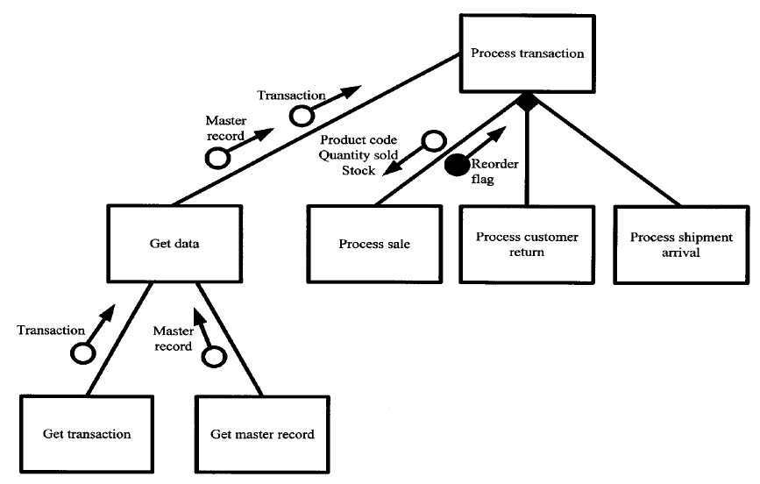

List of all functions in the software.
For each function in the list the following information is provided:
a brief description of what it does (1 or 2 sentences);
a list of the input parameters, and their data types, and what they are used for;
a list of any side effects caused by the function (ie change global or member variables, changes data passed by reference from calling function etc)
a description of the function’s return value

List of all data structures in the software. (eg linked lists, trees, arrays etc)
For each data structure in the list the following information is provided:
Type of structure (tree, list etc),
Description of where and how it is used
List of data members, and what each one is for do
List of functions that use it

Detailed Design – Pseudocode for all non-standard and non-trivial algorithms that operate on datastructures

For each name in the argv array
If (name is a valid windows file or directory name)
{
If (name is a file)
{
- print the file name
- print the access mode (readable, writable or executable)
- print file size in bytes
- call time subroutine
- print time last accessed (days, hours, mins, secs ago)
}
Else if (name is a directory)
print name is a directory

Else
print file doesn't exist

End if-else2

}
Else
print Invalid filename

End if-else1
End for each loop

Requirement Acceptance Tests

(You will need to fill out the column on the left with the requirements listed in sections 2 and 3 and the columns on the right with the results of your own testing)

Software  Requirement No | Test | Implemented (Full /Partial/ None) | Test Results (Pass/ Fail) | Comments (for partial implementation or failed test results)
1 | Accept multiple file names as arguments from the command line
2 | Display the details of all valid files
3 | Display an appropriate message if a file does not exist or if a file name is invalid
4 | Display a message if an argument is a directory instead of a file
5 | File name can be a simple file name or include the full path of the file with one or more levels
6 | file names must start with an alphabetical character
7 | Valid file name extensions must be 3 or 4 alphabetical characters preceded by a dot)
8 | Directory/level names must start with an alphabetical character to be considered valid
9 | The program should be able to accept as many levels for each file name as the user wants to input. This is limited only by the number of levels allowed in Windows (approximately 120)

Detailed Software Testing

(In this table you fill out details about what additional tests you have done in addition to the requirements acceptance tests to ensure that there are no bugs in your program)

No | Test | Expected Results | Actual Results
1.0 | Files
1.1  1.2  1.3  1.4 | File name with:  - no directory or path  (filename.doc)  - directory but no levels (z:\filename.doc)  - one level in path (z:\level\filename.doc)  - more than one level in path (z:\level1\level2\filename.doc) | For each case 1.1 - 1.4:  a. File exists: details of file displayed.  b. File doesn’t exist: “File does not exist” displayed | As expected
1.5 | File name with non alphabetical character as first character | Display “Invalid file name” | As expected
1.6  1.7  1.8 | File extension with:  - 3 or 4 alphabetical characters  - more than 4 characters  - less than 3 characters | For each case 1.6 - 1.9:  Display “Invalid file name” | “File does not exist” displayed
2.0 | Directories
2.1  2.2  2.3 | Directory with:  - no levels  - one level or  - more than one level | For each case 2.1 - 2.3:  a. Directory exists: “Is a directory!” displayed.  b. Directory doesn’t exist: “Directory does not exist” displayed | As expected
2.4 | Directory with non alphabetical character as first character (eg 2:\) | Display “Invalid file name” | “File does not exist” displayed
2.5 | Level of directory with non alphabetical character as first character (eg z:\2level) | Display “Invalid file name” | “File does not exist” displayed

User Instructions

(Here you state what a user needs to do to run and use your program(s), this also includes and special instructures on how to compile the program(s) as necessary)

- Open the file question1.cgi in OptiPerl.
- Run the program in console mode in OptiPerl.
- Enter one or more file and/or directory names as command line arguments. They can be existing or fictitious files.
- For existing files details of each file will be displayed.
- For invalid file names an error message will be displayed.
- For files that do not exist an error message will be displayed.

