

Student name: Perry, Sebastian Student ID: S5132483

*Family name, Given name*

# School of Information and Communication Technology (ICT)

## 3804ICT Data Mining

Central Exams - Trimester 2, 2021

### Reading time

10 minutes

### Writing time

2 hours

### Upload time

20 minutes

### Examination conditions

This is an open book exam.

Writing is permitted during reading time.

No dictionaries permitted.

Scientific calculator permitted.

### Instructions to students：

THIS EXAMINATION PAPER MUST NOT BE REMOVED FROM THE EXAM VENUE

### Total Marks: [100 marks]

**SECTION I: Short answer questions (20 marks)**

**Question 1.** (2*5 marks)Briefly explain the following concepts (answer in 1-2 sentences).

1. Data mining and its functions.

*Data mining is the extraction of useful patterns of knowledge that can allow the ability of the following functions: to be capable of categorizing and discriminating, to associate and correlate, and to predict.*

1. Frequent patterns and strong association rules.

*Frequent patterns are a set, or sequence of items which frequently appear in a given dataset. Strong association rules are rules which can predict the likelihood of something based of the presence of something else to the high accuracy due to knowledge gained from a dataset*

1. Two processes of supervised machine learning.

*Two processes of supervised machine learning are: Bayes Classification Methods, and support vector machines*

1. Sequential data mining.

*Is the mining of a dataset consisting of a sequence of events.*

1. Web usage data mining.

*Is the automatic discovery and analysis of a users web history and otherwise recorded web usage data.*

**Question 2.** (2*5 marks)Answer the following questions (answer in 1-3 sentences).

1. Use the Min-max normalization and the z-score normalization to normalize the following group of data: (330,470,550,680,720,810,930).

*MinMax = ((xi – min)/(max - min)) * (new max – new min) + new min*

*While new min = 0 and new max = 1*

|  |  |  |  |  |  |  |  |
| --- | --- | --- | --- | --- | --- | --- | --- |
| *X* | *330* | *470* | *550* | *680* | *720* | *810* | *930* |
| *New X* | *0.00* | *0.23* | *0.37* | *0.58* | *0.65* | *0.80* | *1.00* |

1. Briefly compare star schema, snowflake schema, and fact constellation schema.

*Star schema (the most basic form which is used to create the other 2) consists of a single fact table connected to a set of dimension tables. The Snowflake schema is a refinement of the star schema, some of the dimension tables have been normalised into a set of smaller dimension tables. Finally, the Fact constellation schema instead has multiple fact tables sharing the sets of dimension tables.*

1. What are the differences between noise and outliers?

*Noise is when a set of data instances may have a set of instances that have a high variance around a given point making it difficult to ascertain the origin. An outlier is when a data instance contains a value widely different to others which makes it distinctly alienated to the others in comparison.*

1. How many types of outliers are there? Please briefly describe them.

*There are three different types of outliers:*

*Global outliers: were an instance is considered a global outlier as is it is outside the entirety of a given dataset. E.g. a person being very tall for a human being.*

*Contextual outliers: were an instance is considered a contextual outlier as it is unusual given the context, in a different context this value may not be unusual. E.g. a female being unusually tall for a female, but this height not being unusual for a male.*

*Collective outliers: were a subset of instances are considered collective outliers as they are, as a subset, unusual to the entirety of the dataset, but not in the context of nearby instances. E.g. a race of humans being taller on average when compared to others.*

1. Please briefly describe five types of Information Retrieval queries.

*Five types of information retrieval queries are as follows:*

*Keyword queries – function with the user supplying a word, or list of words to try and find in a given document, selection of documents, or datasets. E.g. ctlr – f on a website.*

*Boolean queries – function with the user being able to make use of Boolean operators to find content logically true regarding the query. E.g. an example of this could be using tags, or filters.*

*Phrase Queries – function with the user supplying a string or sequence which will be used to find in a given document, selection of documents, or datasets were the sequence appears at least once. E.g. the usage of “” on google*

*Proximity queries – function by taking in a given instance and finding instances which are very similar in properties to the given instance. E.g. a suggestion to read a article which is similar to the current based on tags or keywords*

*Natural language queries – function in the same why people talking to each other do, with the computer inferring the context and meaning of a given question and returning the relevant answer. E.g. typing “what is the time” into google and receiving the current time in our location*.

**SECTION II: Problem solving questions (80 marks)**

**Question 3.** (20 marks) Consider the following transaction data:

|  |  |
| --- | --- |
| **TID** | **Items bought** |
| 100 | a, c, d, g, i, f, m, p |
| 200 | a, b, c, f, l, m, o |
| 300 | b, f, h, j, o, w |
| 400 | b, c, k, s, p |
| 500 | a, f, c, e, l, p, m, n |

1. (10 marks) Given the transaction data above, please use FP-Growth algorithm to find out all the frequent k-itemsets (min_support_count = 3). **You need to list the steps involved.**

Where min_support_count = 3

Step 1 - frequency of 1-itemsets

|  |  |
| --- | --- |
| Item | Sup count |
| C | 4 |
| F | 4 |
| A | 3 |
| m | 3 |
| P | 3 |
| B | 3 |
| L | 2 |
| O | 2 |
| D | 1 |
| G | 1 |
| I | 1 |
| H | 1 |
| J | 1 |
| W | 1 |
| K | 1 |
| S | 1 |
| E | 1 |
| N | 1 |

Step 2 and 3 – all items with less frequency than support count, items are also sorted in descending order

|  |  |
| --- | --- |
| Item | Sup count |
| C | 4 |
| F | 4 |
| A | 3 |
| m | 3 |
| P | 3 |
| B | 3 |

Step 4 - sort initial data based on what remains and the given order

|  |  |
| --- | --- |
| **TID** | **Items bought** |
| 100 | c, f, m, p |
| 200 | c, f, a, m, b |
| 300 | f, b |
| 400 | c, p, b |
| 500 | c, f, a, m, p |

Step 5 – construct tree

Step 5 – construct fp tree

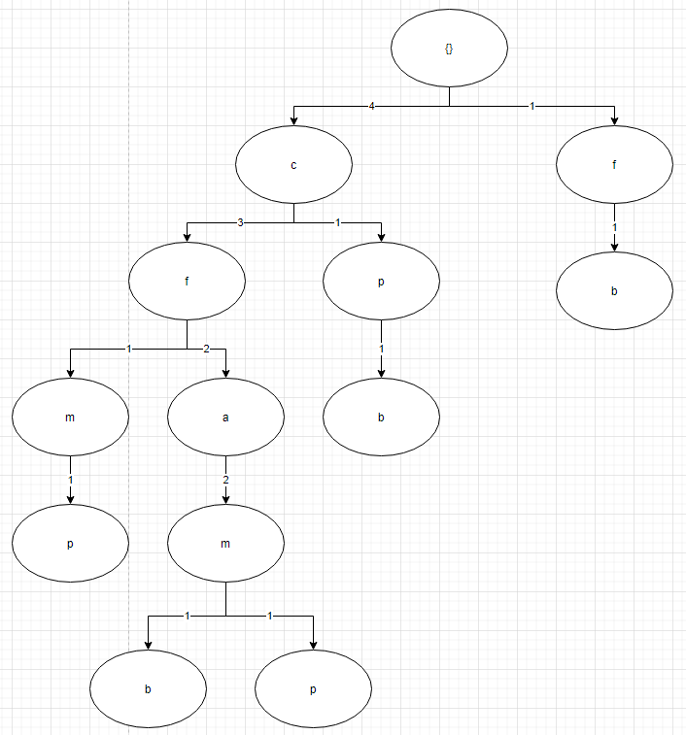

Step 6 -

1. (10 marks) Based on the frequent k-itemsets, please find out all the strong association rules (min_confidence = 75%). **You need to list the steps involved.**

**Question 4.** (10 marks) Consider the following seasonal data:

|  |  |  |  |  |
| --- | --- | --- | --- | --- |
| **Year** | **Q1** | **Q2** | **Q3** | **Q4** |
| 2019 | 67 | 86 | 78 | 96 |
| 2018 | 65 | 88 | 74 | 89 |
| 2017 | 70 | 85 | 72 | 94 |

Please calculate the seasonal index and the deseasonalized data for different quarters and years, fill in the below table. **You need to list the steps involved.**

*Step 1 - the 4 moving point average was calculated*

|  |  |  |
| --- | --- | --- |
| **Quarter** | **Actual** | **4 point moving average** |
| 2017Q1 | 70 |  |
| 2017Q2 | 85 |  |
| 2017Q3 | 72 | 80.25 |
| 2017Q4 | 94 | 79 |
| 2018Q1 | 65 | 79.75 |
| 2018Q2 | 88 | 80.25 |
| 2018Q3 | 74 | 79 |
| 2018Q4 | 89 | 79.5 |
| 2019Q1 | 67 | 79 |
| 2019Q2 | 86 | 80 |
| 2019Q3 | 78 | 81.75 |
| 2019Q4 | 96 |  |

*Step 2 – these points were both plotted to graphing software*

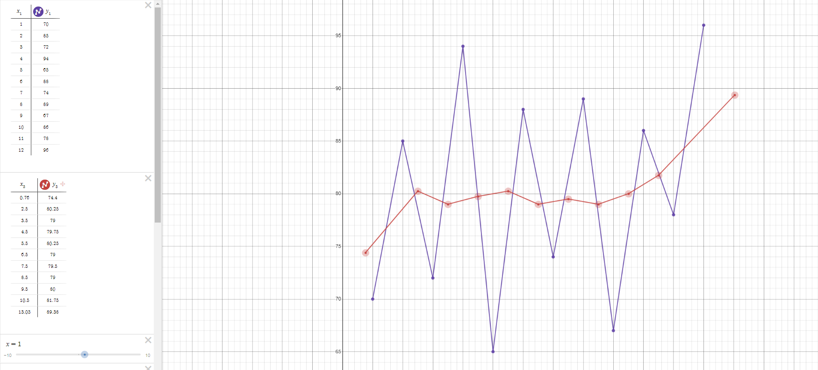

*Step 3 – the intersects on the averages line with the points were recorded as the seasonal index*

|  |  |  |  |
| --- | --- | --- | --- |
| **Quarter** | **Actual** | **Seasonal Index** | **Deseasonalized Data** |
| 2017Q1 | 70 | 78.9 | -8.9 |
| 2017Q2 | 85 | 78.5 | +6.5 |
| 2017Q3 | 72 | 79.6 | -7.6 |
| 2017Q4 | 94 | 79.3 | +14.7 |
| 2018Q1 | 65 | 80 | -15 |
| 2018Q2 | 88 | 79.6 | +8.4 |
| 2018Q3 | 74 | 79.2 | -5.2 |
| 2018Q4 | 89 | 79.2 | +93.8 |
| 2019Q1 | 67 | 79.5 | -12.5 |
| 2019Q2 | 86 | 80.9 | +5.1 |
| 2019Q3 | 78 | 81.5 | -3.5 |
| 2019Q4 | 96 | 81.4 | +14.6 |

**Question 5.** (20 marks) Consider the following sequence data:

|  |  |
| --- | --- |
| **ID** | **Sequences** |
| 1 | <{AB}{CD}{E}{C}> |
| 2 | <{A}{B}{CD}{E}> |
| 3 | <{B}{A}{BD}{E}> |
| 4 | <{CDE}{CE}> |
| 5 | <{B}{A}{BC}{AD}> |

Please use Generalised Sequential Pattern (GSP) algorithm to find out all the frequent sequential patterns (min_support = 50%). **You need to list the steps involved.**

**Step 1 get all singleton sequences**

|  |  |
| --- | --- |
| **Item** | **Sup** |
| **A** | **4** |
| **B** | **4** |
| **C** | **4** |
| **D** | **5** |
| **E** | **4** |

|  |  |  |  |  |  |
| --- | --- | --- | --- | --- | --- |
|  | a | b | c | d | e |
| a |  | ab | ac | ad | ea |
| b |  |  | bc | bd | be |
| c |  |  |  | cd | ce |
| d |  |  |  |  | de |
| e |  |  |  |  |  |

**Question 6.** (10 marks)Assume that there is a document collection D, which has 10 documents. Given a query q, the IR system returns 10 documents in an ascending order of rankings (relevance values).

Please calculate the corresponding precision, recall, and F-score at different ranking positions. *Note: There are 5 documents actually relevant (+) to the query q.* **You need to list the steps involved.**

|  |  |  |  |  |
| --- | --- | --- | --- | --- |
| Rank i | +/- | P(i) | R(i) | F(i) |
| 1 | + |  |  |  |
| 2 | + |  |  |  |
| 3 | - |  |  |  |
| 4 | - |  |  |  |
| 5 | + |  |  |  |
| 6 | - |  |  |  |
| 7 | - |  |  |  |
| 8 | + |  |  |  |
| 9 | + |  |  |  |
| 10 | - |  |  |  |

**Question 7.** (20 marks) Given a game rating dataset as below, please use Item-Item Collaborative Filtering by using Pearson similarity (the number of the nearest neighbour is 3, i.e. |N|=3) to estimate the ratings of “Battlefield I” and “Monster Hunter” by User 6 (rating: 1-5). **You need to list the steps involved.**

|  |  |  |  |  |  |  |  |  |  |
| --- | --- | --- | --- | --- | --- | --- | --- | --- | --- |
|  | Battlefield I | COD | Fortnight | Witcher 3 | Nier Automata | Monster Hunter | Uncharted | FIFA 18 | NBA  18 |
| User 1 | 5 | 4 | 2 | 5 | 5 | 3 | 4 | 1 | 1 |
| User 2 | 4 | 3 | 5 | 3 | 1 | 1 | 1 | 1 | 1 |
| User 3 | 1 | 1 | 1 | 5 | 5 | 1 | 1 | 5 | 4 |
| User 4 | 2 | 1 | 1 | 3 | 4 | 5 | 5 | 3 | 5 |
| User 5 | 1 | 2 | 3 | 2 | 5 | 5 | 3 | 1 | 1 |
| User 6 | ? | 2 | 4 | 4 | 2 | ? | 3 | 4 | 5 |
| User 7 | 2 | 3 | 3 | 4 | 4 | 3 | 5 | 2 | 3 |
| User 8 | 4 | 5 | 2 | 4 | 3 | 4 | 3 | 4 | 5 |
| User 9 | 5 | 4 | 4 | 3 | 4 | 3 | 5 | 2 | 3 |
| User 10 | 1 | 2 | 5 | 4 | 2 | 4 | 5 | 1 | 2 |

**Step 1 normalize the ratings by subtracting row mean**

|  |  |  |  |  |  |  |  |  |  |
| --- | --- | --- | --- | --- | --- | --- | --- | --- | --- |
|  | Battlefield I | COD | Fortnight | Witcher 3 | Nier Automata | Monster Hunter | Uncharted | FIFA 18 | NBA |
| 18 |
| User 1 | 1.66666667 | 0.666667 | -1.33333 | 1.666667 | 1.666667 | -0.33333 | 0.666667 | -2.33333 | -2.33333 |
| User 2 | 1.77777778 | 0.777778 | 2.777778 | 0.777778 | -1.22222 | -1.22222 | -1.22222 | -1.22222 | -1.22222 |
| User 3 | -1.66666667 | -1.66667 | -1.66667 | 2.333333 | 2.333333 | -1.66667 | -1.66667 | 2.333333 | 1.333333 |
| User 4 | -1.22222222 | -2.22222 | -2.22222 | -0.22222 | 0.777778 | 1.777778 | 1.777778 | -0.22222 | 1.777778 |
| User 5 | -1.55555556 | -0.55556 | 0.444444 | -0.55556 | 2.444444 | 2.444444 | 0.444444 | -1.55556 | -1.55556 |
| User 6 |  | -1.42857 | 0.571429 | 0.571429 | -1.42857 |  | -0.42857 | 0.571429 | 1.571429 |
| User 7 | -1.22222222 | -0.22222 | -0.22222 | 0.777778 | 0.777778 | -0.22222 | 1.777778 | -1.22222 | -0.22222 |
| User 8 | 0.22222222 | 1.222222 | -1.77778 | 0.222222 | -0.77778 | 0.222222 | -0.77778 | 0.222222 | 1.222222 |
| User 9 | 1.33333333 | 0.333333 | 0.333333 | -0.66667 | 0.333333 | -0.66667 | 1.333333 | -1.66667 | -0.66667 |
| User 10 | -1.88888889 | -0.88889 | 2.111111 | 1.111111 | -0.88889 | 1.111111 | 2.111111 | -1.88889 | -0.88889 |

End of Exam