Question 1.)
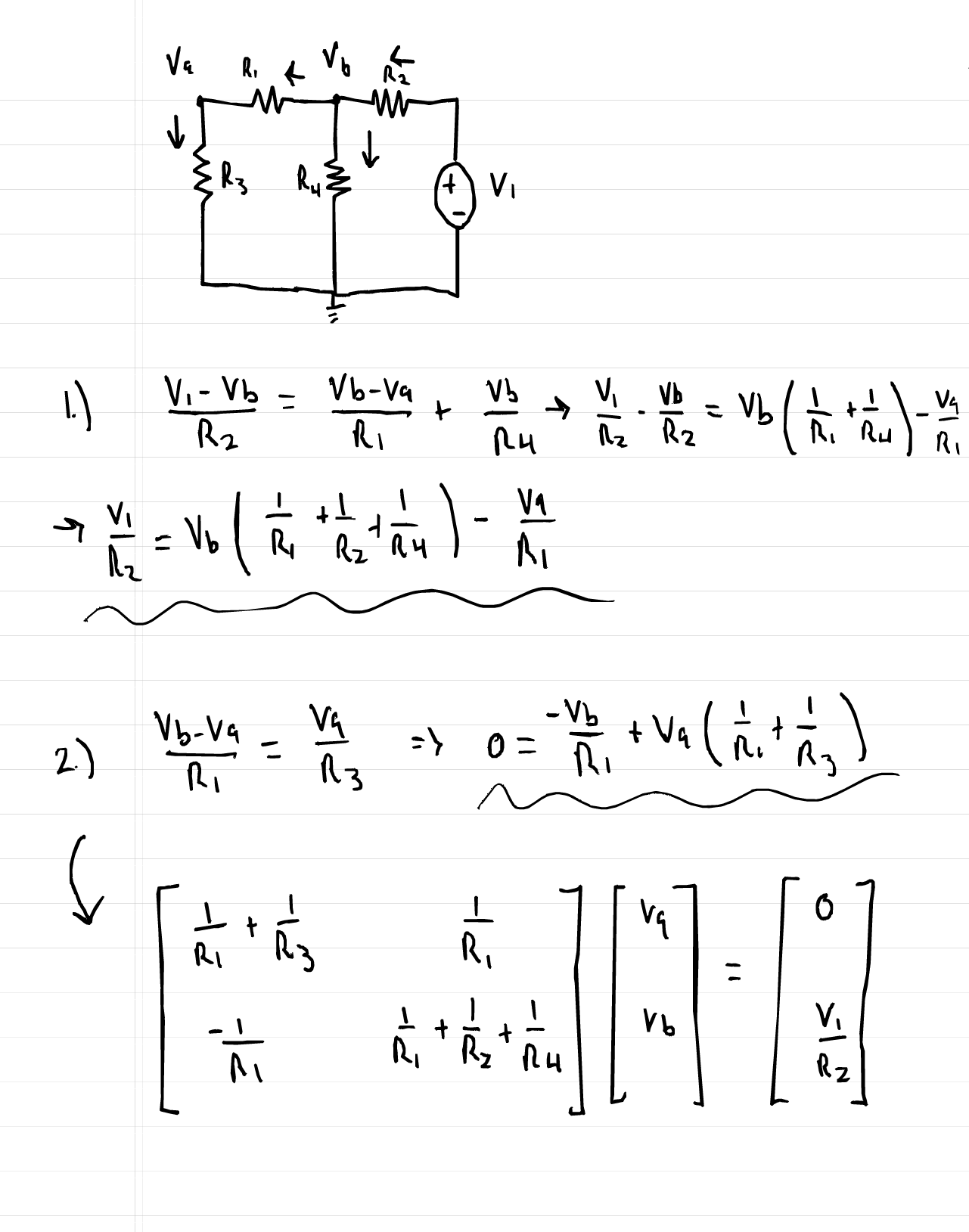
Fig 1.) – Worked out voltage equations
From code, both linalg solve and my custom gaussian elimination method, Va = 7.5V and Vb = 8.333V
Code:
_____________________________________________________________________________________
import numpy as np

v1 = 10
R1 = 1000
R2 = 1000
R3 = 9000
R4 = 10000

A=np.array([
[1/R1 + 1/R3, -1/R1],
[-1/R1, 1/R1 + 1/R2 + 1/R4]])

b = np.array([0, v1 / R2])

v = np.linalg.solve(A, b)
va, vb = v
print(f"Node voltages from numpy: va = {va:.4f}V, vb = {vb:.4f}V")

def gaussian_elim(A, b):
A= A.astype(float)
b = b.astype(float)
n = len(b)

for k in range(n):
maxindex = abs(A[k:, k]).argmax()+k #Looks at all entries in column k, takes abs value, returns index of largest
if A[maxindex, k] == 0:
raise ValueError("Matrix is singular") #If pivot is 0, raise an error
if maxindex !=k:
A[[k, maxindex]] = A[[maxindex, k]]
b[[k, maxindex]] = b[[maxindex, k]] #Swaps rows

for row in range(k+1, n):
mult = A[row, k] / A[k, k]
A[row, k:] -= mult* A[k,k:]
b[row]-= mult * b[k] #Eliminates to create upper diag.

x = np.zeros(n)
for i in range(n-1, -1, -1):
x[i] = (b[i] - np.dot(A[i, i+1:], x[i+1:])) / A[i, i]
return x #Back substitution for solutions

v_gauss = gaussian_elim(A.copy(), b.copy())
print(f"Homemade node voltages: va = {v_gauss[0]:.4f}V, vb = {v_gauss[1]:.4f}V")

if(va == v_gauss[0] and vb==v_gauss[1]):
print("Voltages match!")
else:
print("Voltages are off")

Q2.)
Heatmaps for m=10 and m=25:
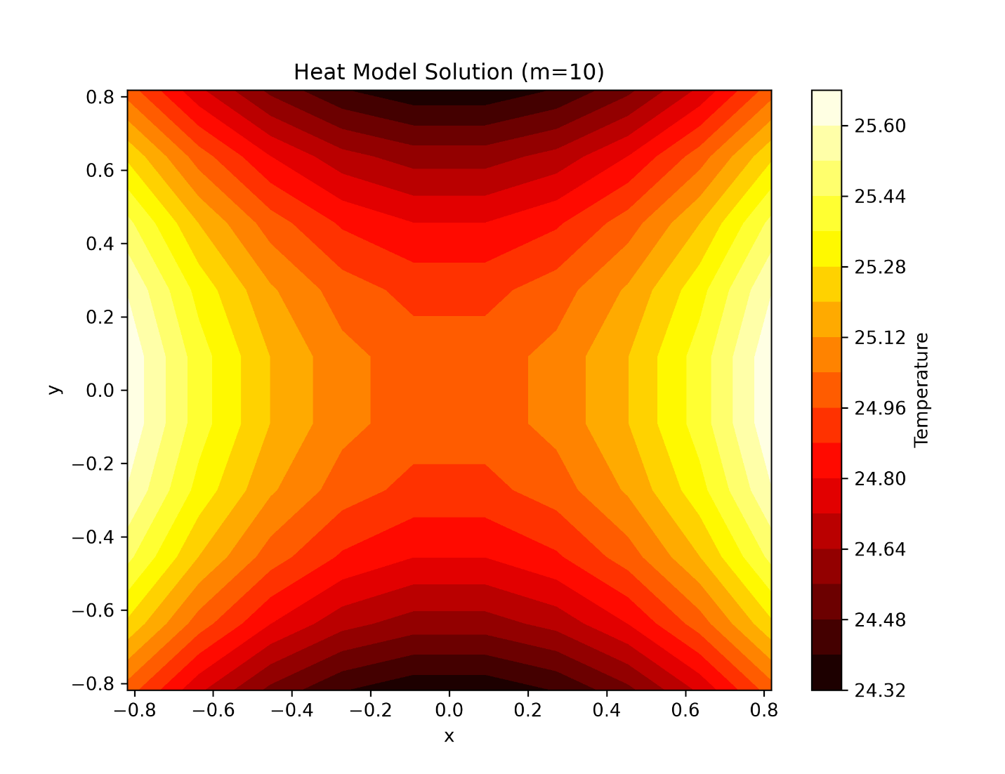
Figure 2.) Heatmap for m = 10
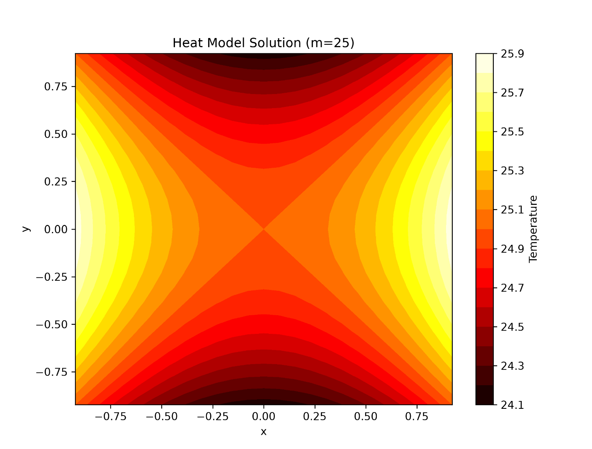
Figure 3.) Heatmap for m = 25
***Be advised, my code for the next part runs extremely slow due to the large amount of points and computations, but just let it do its thing!
Code:

import numpy as np
import matplotlib.pyplot as plt

def tridiag(m): #Creates m+m tridiagonal matrix, main diag values are all -4, above & below are 1
T = np.diag(-4 * np.ones(m)) + np.diag(np.ones(m-1), 1) + np.diag(np.ones(m-1), -1)
return T

def A_block(m): #Constructs the m^2 by m^2 block matrix A with T on main diag and Identity above and below
T = tridiag(m) #Finds tridiag T of matrix size m
I = np.identity(m) #Creates mxm identity matrix

A = np.zeros((m*m, m*m)) #Constructs m^2 by m^2 matrix of zeros

for i in range(m): #Fill in the A structure
row_start = i * m
row_end = (i+1) * m
A[row_start:row_end, row_start:row_end] = T #Place T on main diag

if i < m - 1:
col_start = (i+1) * m
col_end = (i + 2) * m
A[row_start:row_end, col_start:col_end] = I #Place identity on surrounding diagonals

if i > 0:
col_start = (i - 1) * m
col_end = i * m
A[row_start:row_end, col_start:col_end] = I
return A

def vector_b(m): #Constructs b vector using boundary conditions of f(x,y) given in homework
b = np.zeros(m*m) #Fill it with zeros
h = 2/ (m+1) #Calculate mesh spacing givem m points, two boundary points (-1 and 1) and total length of 2

for i in range(m): #Loop over x
for j in range(m): #Loop over y
x = -1 + (i + 1) * h #Calculate x and y coordinates ofcurrent grid point
y = -1 + (j + 1 )* h

if j == m - 1: #Calculate boundary values at each (-1, 1) for both x and y
b[i*m + j] -= (25 - x**2 + 1**2)

if j == 0:
b[i*m + j] -= (25 - x**2 + (-1)**2)

if i == m - 1:
b[i*m + j] -= (25 - 1**2 + y **2)

if i == 0:
b[i*m + j] -= (25 - (-1)**2 + y**2)
return b

def cholesky(A): #Computes cholesky factorization, L is lower triangular
n = A.shape[0]
L = np.zeros_like(A)

for i in range(n): #Loop over row
for j in range(i+1): #Loop over column up diag
s = sum(L[i][k] * L[j][k] for k in range(j)) #Calculate sum of products of prev columns

if i == j:
L[i][j] = np.sqrt(A[i][i] - s) #if on the diag, take square root
else:
L[i][j] = (A[i][j] - s) / L[j][j] #If not, calculate off-diag element
return L

def solve_cholesky(L, b): #Solve Ax=6 using cholesky factor L via 1.) - Forward substitution and 2.) Back substitution

n = len(b) #Forward sub, solve Lz=b for z
z = np.zeros(n)
for i in range(n):
z[i] = (b[i] - sum(L[i][j] * z[j] for j in range(i))) / L[i][i] #calculate z[i] using previously computed values

x = np.zeros(n) #Back sub, solve L^T *x = z for x
for i in range( n - 1, -1, -1):
x[i] = (z[i] - sum(L[j][i] * x[j] for j in range(i + 1, n))) / L[i][i] #Calculate x[i] using previously computed values
#L^T[i][j] = L[j][i], so sum is over j>i
return x

def solve_plot(m): #Solves heat model problem and plot solution

A = A_block(m) #Construct Matrix A and vector B
b =vector_b(m)

A = -A #Negate A and b to make A positive definite for Cholesky
b = -b

L = cholesky(A) #Compute cholesky factorization
u_flat = solve_cholesky(L, b) #Solve system using cholesky
u_grid = u_flat.reshape(m, m) #Reshape solution vector into 2D grid

h = 2/(m+1) #Create coords for plots
x = np.linspace(-1 + h, 1 - h, m)
y = np.linspace(-1 + h, 1 - h, m)
X, Y = np.meshgrid(x,y)

plt.figure(figsize=(8,6)) #Create plot
plt.contourf(X, Y, u_grid, levels=20, cmap = 'hot') #Creates filled contour plot
plt.colorbar(label = 'Temperature') #Adds color bar for temp scale
plt.title(f'Heat Model Solution (m={m})') #Adds title and labels
plt.xlabel('x')
plt.ylabel('y')
plt.show() #display

solve_plot(10) #Solve and plot for m = 10 and m = 25
solve_plot(25)

