**Hibernate**

Hibernate is an open-source, lightweight, and non-invasive Java-based ORM (Object-Relational Mapping) framework. It follows the rules and guidelines specified by the Java Persistence API (JPA), providing a portable and integrated solution for developing object-based persistence logic.

lightweight

- Hibernate is lightweight because it comes in a small-sized zip file.

- Developing and running Hibernate persistence logic requires only JDK/JVM and Hibernate libraries (jars), eliminating the need for heavyweight servers or containers.

portable

- Hibernate is portable because it allows us to develop persistence logic using objects without relying on direct SQL queries.

- This feature makes Hibernate persistence logic independent of specific database software, enabling easy portability across multiple databases.

- It provides flexibility to change the database software during development or even in production without major disruptions.

Non-invasive

- Non-invasive programming in Hibernate means that application classes are not tightly bound or connected to the underlying framework or technology APIs.

- In simple terms, app classes don't have to adopt or extend specific framework interfaces/classes.

- This loose coupling allows the flexibility to move app classes to other frameworks or technologies easily, as they are developed as regular, straightforward Java classes.

ex:: hibernate (all versions) , spring all versions, Struts 2.x and etc...

Integratable

- Hibernate is integratable because we can use its persistence logic in various types of Java applications, such as standalone, web, or distributed apps.

- This flexibility allows seamless integration of Hibernate with different Java technologies and frameworks.

- It adapts easily to diverse application types, making it a versatile choice for interacting with database software.

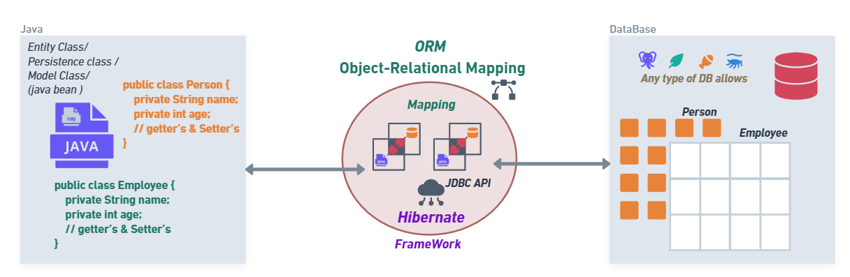

**ORM Framework for Java**

- Object-Relational Mapping, is a technique that makes it easy to store and retrieve objects in a database.

- It ensures that the objects you create in your code can be saved persistently in a relational database, simplifying the way you work with data.

- In short, ORM provides a seamless connection between your code's objects and the database, making data persistence straightforward.

- In the context of Hibernate, it's about mapping Java objects to database tables and vice versa.

Persistence

Persistence is the act of storing and managing data for a long time. It involves using secondary memory devices like HDD, CDs, DVDs, and thumb drives. Unlike storing data in application variables or objects, which vanish after execution, persistence ensures data can be used across multiple executions by writing it to secondary memory devices with the help of files and databases.