Student Academic Performance Prediction
A Comparative Machine Learning Study
Linear Regression • Logistic Regression • Decision Tree • Random Forest • SVM • KNN • Naive Bayes
Dataset: xAPI-Edu-Data.csv (Students' Academic Performance Dataset)

1. Project Overview
This report documents a machine learning project built on the xAPI-Edu-Data dataset, which records the classroom engagement and behavioural activity of 480 students across multiple subjects, grades and countries. The dataset combines demographic information (gender, nationality, place of birth), academic context (stage, grade, section, topic, semester), behavioural engagement metrics (raised hands, resources visited, announcements viewed, discussion participation), and outcome labels (parent survey response, parent school satisfaction, absence days, and overall performance class).
Seven algorithms were applied across two related prediction goals: (1) predicting a student's overall performance Class (Low / Middle / High) and (2) predicting whether Parent School Satisfaction is Good or Bad, based on the student's engagement and attendance behaviour. Linear Regression was additionally used to model the direct numeric relationship between two of the engagement columns. For each algorithm, this report explains what it is, why it was chosen, why the specific input columns were used, why the alternative algorithms were not used for that step, and the exact workflow followed.

2. Dataset Snapshot
A preview of the first rows of the dataset, as loaded with pandas:
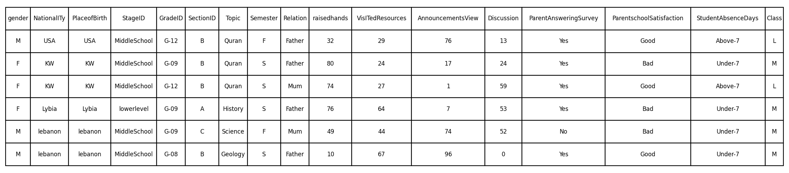
Figure 0 — xAPI-Edu-Data.csv, first 6 rows (480 rows × 17 columns)

3. General Workflow (shared across all models)
- Load the dataset with pandas (pd.read_csv).
- Explore the data: check shape, column types, and class balance for the target columns.
- Encode categorical columns needed as model inputs (Topic, StudentAbsenceDays) and targets (Class, ParentschoolSatisfaction) using LabelEncoder.
- Select the relevant feature columns for each specific prediction task (see each algorithm's section).
- Split the data into training (80%) and testing (20%) sets with train_test_split, using stratify for classification targets to preserve class balance.
- Standardise features with StandardScaler where the algorithm is distance/gradient-based (Logistic Regression, SVM, KNN).
- Train the model, predict on the held-out test set, and evaluate with the appropriate metric (R2/RMSE for regression, Accuracy/Confusion Matrix for classification).
- Visualise results with a Raised Hands vs Discussion scatter plot coloured by the actual label, for direct visual comparison across algorithms.
import pandas as pd
from sklearn.model_selection import train_test_split
from sklearn.preprocessing import LabelEncoder, StandardScaler

# Load dataset
df = pd.read_csv("xAPI-Edu-Data.csv")
df.head()

# Encode categorical columns needed for modelling
le_topic = LabelEncoder()
le_abs = LabelEncoder()
le_class = LabelEncoder()
le_sat = LabelEncoder()

df['Topic_enc'] = le_topic.fit_transform(df['Topic'])
df['Absence_enc'] = le_abs.fit_transform(df['StudentAbsenceDays'])
df['Class_enc'] = le_class.fit_transform(df['Class'])
df['Sat_enc'] = le_sat.fit_transform(df['ParentschoolSatisfaction'])

# Feature set used for the satisfaction classifiers (SVM / KNN / Naive Bayes / Logistic Regression)
features = ['raisedhands', 'Discussion', 'VisITedResources',
'AnnouncementsView', 'Absence_enc', 'Topic_enc']
X = df[features]
y = df['Sat_enc']

X_train, X_test, y_train, y_test = train_test_split(
X, y, test_size=0.2, random_state=42, stratify=y)

scaler = StandardScaler().fit(X_train)
X_train_s = scaler.transform(X_train)
X_test_s = scaler.transform(X_test)

4. Linear Regression
Target predicted in this project: Discussion score (continuous)
What is Linear Regression?
Linear Regression is a supervised learning algorithm used for predicting a continuous numeric value. It models the relationship between one or more independent variables (features) and a dependent variable (target) by fitting a straight line (or hyperplane, for multiple features) that minimizes the sum of squared differences between the actual and predicted values.
Why using Linear Regression?
In this project, most of the target columns (Class, ParentschoolSatisfaction) are categorical, so Linear Regression is not used to predict them. Instead, it is included to demonstrate and quantify the relationship between the numeric engagement behaviours in the dataset -- specifically to predict a student's Discussion score from their raisedhands, VisITedResources and AnnouncementsView activity. This shows how consistently a student's classroom participation (raised hands) tracks with their online engagement (discussion), which is a genuinely continuous, regression-style question.
Why these columns?
raisedhands, VisITedResources and AnnouncementsView were chosen as predictors because they are all numeric behavioural-engagement counts recorded by the learning platform, on the same 0-100 scale as the target (Discussion). Categorical columns such as gender, NationalITy or Topic were left out of this particular model because Linear Regression assumes a linear numeric relationship, and one-hot encoding many unrelated categorical columns would add noise without a clear linear effect on Discussion.
Why not other algorithms?
Classification algorithms such as Logistic Regression, Decision Tree, Random Forest, SVM, KNN and Naive Bayes are built to predict discrete class labels (e.g. Good/Bad, L/M/H), not a continuous score. Using them to predict Discussion would require artificially binning a continuous variable into categories and would throw away information about its true numeric scale. Linear Regression is the natural and simplest choice when the target itself is continuous.
Workflow for this project
- Load xAPI-Edu-Data.csv with pandas and inspect the numeric engagement columns.
- Select raisedhands, VisITedResources and AnnouncementsView as independent variables (X) and Discussion as the dependent variable (y).
- Split the data into training (80%) and testing (20%) sets with train_test_split.
- Fit a LinearRegression model on the training data.
- Predict on the test set and evaluate using R2 Score and RMSE.
- Plot Raised Hands vs Discussion with the fitted regression line to visualise the trend.
Code
from sklearn.linear_model import LinearRegression
from sklearn.metrics import r2_score, mean_squared_error

# Predict a continuous engagement measure (Discussion) from raisedhands,
# VisITedResources and AnnouncementsView
X = df[['raisedhands', 'VisITedResources', 'AnnouncementsView']]
y = df['Discussion']

X_train, X_test, y_train, y_test = train_test_split(
X, y, test_size=0.2, random_state=42)

lin_reg = LinearRegression()
lin_reg.fit(X_train, y_train)
y_pred = lin_reg.predict(X_test)

print("R2 Score:", r2_score(y_test, y_pred))
print("RMSE:", mean_squared_error(y_test, y_pred) ** 0.5)

Output
Result: R2 Score: 0.206 | RMSE: 21.04
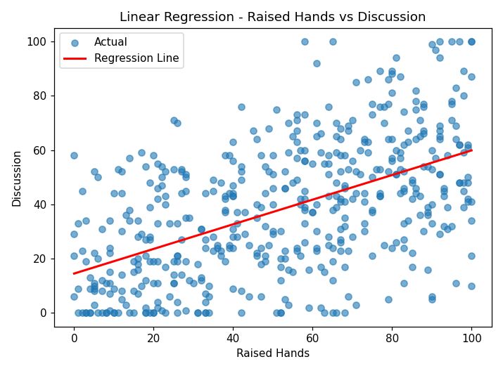
Figure 1 — Linear Regression: Raised Hands vs Discussion

5. Logistic Regression
Target predicted in this project: ParentschoolSatisfaction (Good / Bad)
What is Logistic Regression?
Logistic Regression is a supervised classification algorithm (despite the name 'regression') that predicts the probability of a categorical outcome. It applies a sigmoid function to a linear combination of the input features to squeeze the output into a 0-1 probability, which is then thresholded into a class label such as Good or Bad.
Why using Logistic Regression?
ParentschoolSatisfaction is a binary label (Good/Bad), which is exactly the kind of target Logistic Regression is designed for. It is fast, easy to interpret (the sign and size of each coefficient shows whether a feature pushes satisfaction up or down), and serves as a strong, simple baseline before trying more complex models like SVM or Random Forest.
Why these columns?
raisedhands, Discussion, VisITedResources and AnnouncementsView capture how actively engaged the student is, StudentAbsenceDays captures attendance behaviour, and Topic captures the subject context. These are the columns most directly tied to how a parent would judge a school's performance -- an engaged, present student in a well-taught subject is the behavioural signature of a 'Good' satisfaction outcome. Identifier-style columns (StudentID equivalents, SectionID, GradeID) were excluded because they don't carry a meaningful behavioural signal.
Why not other algorithms?
Linear Regression was not used because the target is categorical, not continuous. Compared to Decision Tree/Random Forest, Logistic Regression assumes a smoother, linear decision boundary, which works well here because engagement metrics increase/decrease satisfaction fairly monotonically. It was kept over SVM/KNN as the interpretable baseline model in the comparison, since its coefficients directly explain which features drive satisfaction.
Workflow for this project
- Encode Topic and StudentAbsenceDays with LabelEncoder; encode the target ParentschoolSatisfaction as 0/1.
- Select raisedhands, Discussion, VisITedResources, AnnouncementsView, Absence_enc and Topic_enc as features.
- Split into train/test sets and standardise the features with StandardScaler (Logistic Regression is sensitive to feature scale).
- Fit LogisticRegression on the scaled training data.
- Predict on the test set and evaluate with Accuracy and a Confusion Matrix.
- Plot Raised Hands vs Discussion coloured by actual Good/Bad label to visualise class separation.
Code
from sklearn.linear_model import LogisticRegression
from sklearn.metrics import accuracy_score, confusion_matrix

log_reg = LogisticRegression(max_iter=1000)
log_reg.fit(X_train_s, y_train)
y_pred = log_reg.predict(X_test_s)

print("Accuracy:", accuracy_score(y_test, y_pred))
print(confusion_matrix(y_test, y_pred))

Output
Result: Accuracy: 0.802
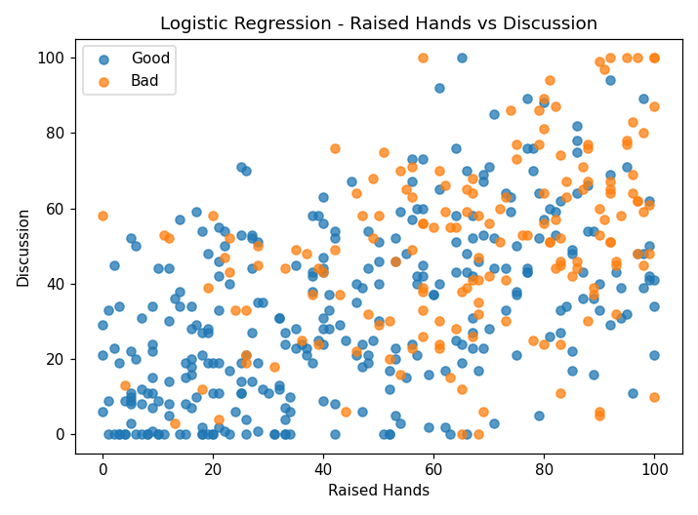
Figure 2 — Logistic Regression: Raised Hands vs Discussion

6. Decision Tree
Target predicted in this project: Class (L / M / H)
What is Decision Tree?
A Decision Tree is a supervised algorithm that splits the data repeatedly on the feature and threshold that best separates the classes, forming a tree of if/else questions. Each leaf of the tree represents a predicted class. It is easy to visualise and explain because every prediction can be traced back through a simple sequence of rules.
Why using Decision Tree?
The project also predicts the overall performance Class (Low/Middle/High), a three-way categorical target. A Decision Tree was used because it naturally handles multi-class problems, requires no feature scaling, and produces human-readable rules (e.g. 'if raisedhands <= 30 and Discussion <= 40 then Class = L') that are useful for explaining results to non-technical stakeholders like teachers or parents.
Why these columns?
raisedhands, VisITedResources, AnnouncementsView, Discussion and StudentAbsenceDays (Absence_enc) were used because they represent the behavioural and attendance factors most likely to determine overall performance level. The Decision Tree's feature-importance output also confirms which of these columns the tree actually relied on most, giving a data-driven check on the column choice.
Why not other algorithms?
Logistic Regression and Naive Bayes assume a specific mathematical form (linear boundary / feature independence) that doesn't capture the threshold-style, rule-based patterns often seen in behavioural education data (e.g. a sharp drop-off in performance once absence crosses a specific threshold). A single Decision Tree was chosen over Random Forest first as the interpretable, single-model baseline; Random Forest is then used afterward to see how much accuracy an ensemble of trees adds.
Workflow for this project
- Encode StudentAbsenceDays and Class with LabelEncoder.
- Select raisedhands, VisITedResources, AnnouncementsView, Discussion and Absence_enc as features; Class_enc as target.
- Split into train/test sets with stratification to preserve class balance.
- Fit a DecisionTreeClassifier (max_depth=5 to limit overfitting).
- Predict on the test set and evaluate Accuracy.
- Inspect feature_importances_ to see which columns the tree split on most, and plot the raised hands vs discussion scatter coloured by actual Class.
Code
from sklearn.tree import DecisionTreeClassifier
from sklearn.metrics import accuracy_score

# Target here is the overall performance Class (L / M / H)
feat_cls = ['raisedhands', 'VisITedResources', 'AnnouncementsView',
'Discussion', 'Absence_enc']
Xc, yc = df[feat_cls], df['Class_enc']
Xtr, Xte, ytr, yte = train_test_split(
Xc, yc, test_size=0.2, random_state=42, stratify=yc)

dt = DecisionTreeClassifier(max_depth=5, random_state=42)
dt.fit(Xtr, ytr)
y_pred = dt.predict(Xte)

print("Accuracy:", accuracy_score(yte, y_pred))
print("Feature importance:", dict(zip(feat_cls, dt.feature_importances_)))

Output
Result: Accuracy: 0.771
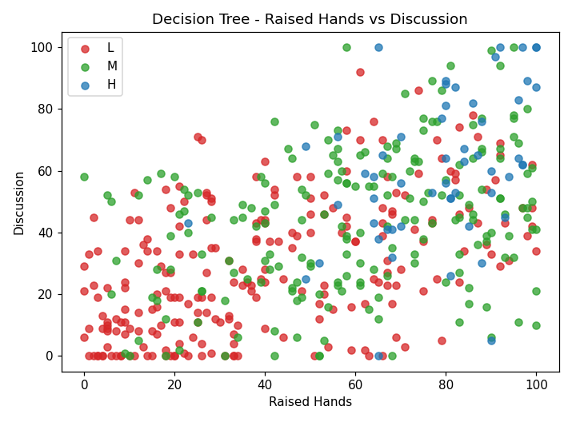
Figure 3 — Decision Tree: Raised Hands vs Discussion
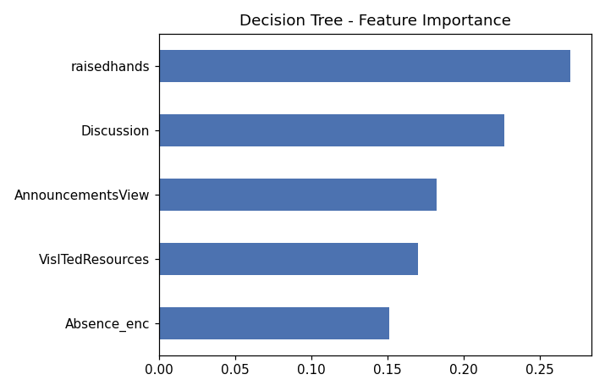
Figure 3b — Decision Tree: Feature Importance

7. Random Forest
Target predicted in this project: Class (L / M / H)
What is Random Forest?
Random Forest is an ensemble learning algorithm that builds many Decision Trees, each trained on a random subset of the data and features (bagging), and combines their individual predictions by majority vote. This averaging reduces the overfitting and variance that a single Decision Tree is prone to.
Why using Random Forest?
Random Forest was used as the ensemble upgrade to the single Decision Tree on the same Class prediction task, to check whether combining many trees improves stability and generalisation on this dataset. It is also more robust to noisy or slightly mislabelled rows, which is valuable given that student self-reported behavioural data can be noisy.
Why these columns?
The exact same feature set as the Decision Tree (raisedhands, VisITedResources, AnnouncementsView, Discussion, Absence_enc) was reused so that the two models are directly comparable on identical inputs -- this isolates the effect of the algorithm itself (single tree vs. ensemble of trees) rather than the effect of different features.
Why not other algorithms?
A single Decision Tree was already tried; Random Forest was added specifically to address that model's tendency to overfit small quirks in the training data. SVM/KNN/Naive Bayes were not used for this particular target in the project because the tree-based models already handle the non-linear, threshold-driven structure of behavioural data well and additionally provide interpretable feature importances, which the black-box-style boundary methods do not.
Workflow for this project
- Reuse the same encoded features and Class_enc target and train/test split as the Decision Tree step.
- Fit a RandomForestClassifier with 200 trees (n_estimators=200, max_depth=7).
- Predict on the test set and evaluate Accuracy, comparing it directly against the single Decision Tree's score.
- Inspect feature_importances_ averaged across all trees for a more stable importance ranking.
- Plot Raised Hands vs Discussion coloured by actual Class to visually compare against the Decision Tree plot.
Code
from sklearn.ensemble import RandomForestClassifier
from sklearn.metrics import accuracy_score

rf = RandomForestClassifier(n_estimators=200, max_depth=7, random_state=42)
rf.fit(Xtr, ytr)
y_pred = rf.predict(Xte)

print("Accuracy:", accuracy_score(yte, y_pred))
print("Feature importance:", dict(zip(feat_cls, rf.feature_importances_)))

Output
Result: Accuracy: 0.750
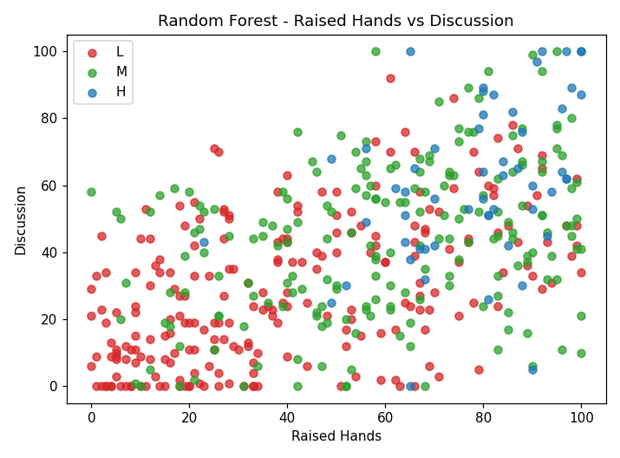
Figure 4 — Random Forest: Raised Hands vs Discussion
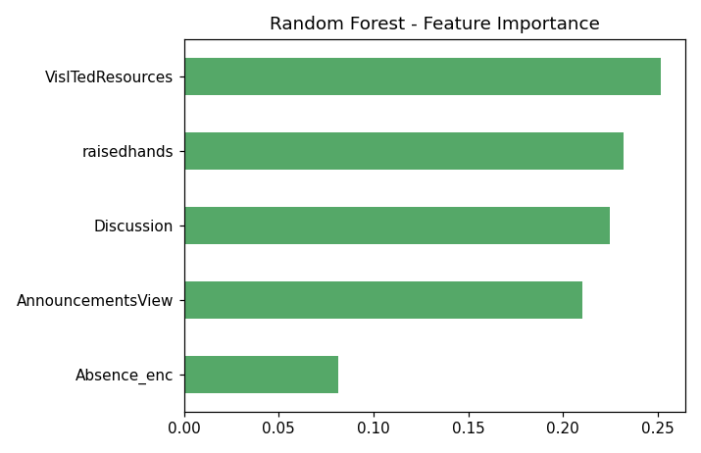
Figure 4b — Random Forest: Feature Importance

8. Support Vector Machine (SVM)
Target predicted in this project: ParentschoolSatisfaction (Good / Bad)
What is Support Vector Machine (SVM)?
Support Vector Machine is a supervised classification algorithm that finds the optimal hyperplane (decision boundary) that separates the classes with the maximum possible margin. With a non-linear kernel (such as the RBF kernel used here), it can also carve out curved decision boundaries, letting it separate classes that are not linearly separable in the original feature space.
Why using Support Vector Machine (SVM)?
SVM was used to predict ParentschoolSatisfaction because it tends to perform strongly on moderate-sized tabular datasets like this one (480 rows) and is effective when classes overlap partially, which is the case here (as seen in the Good/Bad scatter plot, where the two classes intermix across the raisedhands/Discussion space). The RBF kernel lets SVM draw a flexible, curved boundary rather than the straight line Logistic Regression is limited to.
Why these columns?
The same behavioural/engagement feature set (raisedhands, Discussion, VisITedResources, AnnouncementsView, Absence_enc, Topic_enc) used for Logistic Regression was reused for SVM, since these are the columns that plausibly drive a parent's satisfaction judgement, and reusing the same features allows a fair, apples-to-apples accuracy comparison between the classifiers on this target.
Why not other algorithms?
Linear Regression is inapplicable (categorical target). Compared with Logistic Regression, SVM can model non-linear boundaries, which suits the mixed/overlapping Good vs Bad regions visible in the data. It was preferred here over Decision Tree/Random Forest for this specific target because the satisfaction classes don't show the clean rectangular threshold splits that trees exploit well; instead they show a smoother, margin-style separation that SVM is built for.
Workflow for this project
- Reuse the same encoded, scaled feature matrix (X_train_s / X_test_s) prepared for Logistic Regression.
- Fit an SVC classifier with an RBF kernel (kernel='rbf', C=1.0, gamma='scale').
- Predict on the test set and evaluate Accuracy.
- Provide an interactive console prediction: the user enters Topic, raisedhands, Discussion, Class and StudentAbsenceDays, and the model outputs the predicted Parent School Satisfaction.
- Plot Raised Hands vs Discussion coloured by actual Good/Bad label to visualise the class overlap the model has to resolve.
Code
from sklearn.svm import SVC
from sklearn.metrics import accuracy_score

svm_clf = SVC(kernel='rbf', C=1.0, gamma='scale')
svm_clf.fit(X_train_s, y_train)
y_pred = svm_clf.predict(X_test_s)

print("Accuracy:", accuracy_score(y_test, y_pred))

# --- interactive prediction, mirrors the console demo in the project ---
topic = input("Enter Topic: ")
rh = int(input("Enter raisedhands: "))
disc = int(input("Enter Discussion: "))
cls = input("Enter Class (L/M/H): ")
absd = input("Enter StudentAbsenceDays (Under-7/Above-7): ")

sample = pd.DataFrame([[rh, disc, 0, 0,
le_abs.transform([absd])[0],
le_topic.transform([topic])[0]]], columns=features)
sample_s = scaler.transform(sample)
result = svm_clf.predict(sample_s)[0]
print("Predicted Parent School Satisfaction:", le_sat.inverse_transform([result])[0])
print("Predicted Value:", result)

Output
Result: Accuracy: 0.771
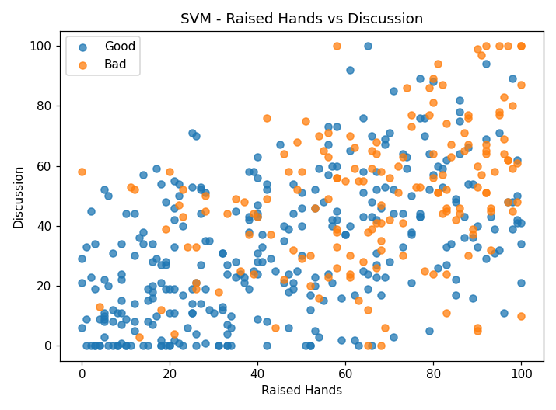
Figure 5 — Support Vector Machine (SVM): Raised Hands vs Discussion

9. K-Nearest Neighbors (KNN)
Target predicted in this project: ParentschoolSatisfaction (Good / Bad)
What is K-Nearest Neighbors (KNN)?
K-Nearest Neighbors is a simple, instance-based ('lazy') supervised algorithm. It makes no assumptions about the data's underlying distribution; instead, to classify a new point it looks at the K closest points in the training data (by distance, typically Euclidean) and assigns the majority class among those neighbours.
Why using K-Nearest Neighbors (KNN)?
KNN was included as a non-parametric benchmark against the model-based classifiers (Logistic Regression, SVM, Naive Bayes). Because it makes no assumption about linearity or feature independence, it is a useful sanity check on whether a simple 'similar students behave similarly' rule can predict satisfaction as well as the more structured models -- and in this project it matches the top accuracy achieved by Logistic Regression.
Why these columns?
The same standardised feature set (raisedhands, Discussion, VisITedResources, AnnouncementsView, Absence_enc, Topic_enc) was used, with StandardScaler applied beforehand -- this step is especially important for KNN because it is a distance-based algorithm, so features must be on comparable scales or a large-range column (like raisedhands 0-100) would dominate the distance calculation over a smaller-range one.
Why not other algorithms?
Unlike Logistic Regression or Naive Bayes, KNN needed no assumption about the shape of the relationship between features and target, which makes it a good cross-check. It was preferred over building yet another tree-based model for this specific target since the goal here was to compare a genuinely different family of algorithm (distance-based) against the linear/probabilistic/margin-based ones already applied to the same satisfaction target.
Workflow for this project
- Reuse the same standardised feature matrix prepared for Logistic Regression/SVM.
- Fit a KNeighborsClassifier with k=7 neighbours.
- Predict on the test set and evaluate Accuracy.
- Plot Raised Hands vs Discussion coloured by actual Good/Bad label -- the same plot style makes it easy to visually compare where KNN, SVM and Naive Bayes agree or disagree on the boundary.
Code
from sklearn.neighbors import KNeighborsClassifier
from sklearn.metrics import accuracy_score

knn = KNeighborsClassifier(n_neighbors=7)
knn.fit(X_train_s, y_train)
y_pred = knn.predict(X_test_s)

print("Accuracy:", accuracy_score(y_test, y_pred))

Output
Result: Accuracy: 0.802
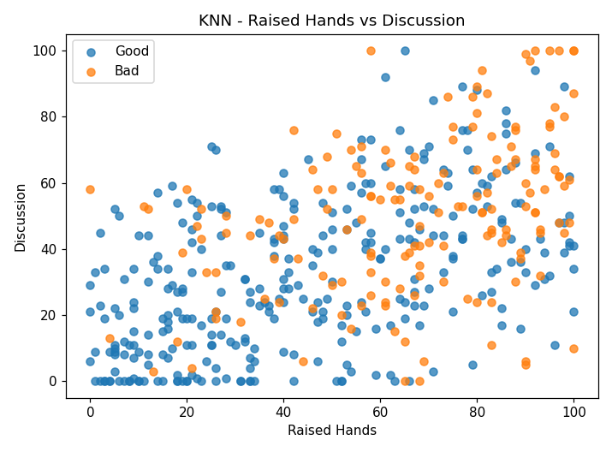
Figure 6 — K-Nearest Neighbors (KNN): Raised Hands vs Discussion

10. Naive Bayes
Target predicted in this project: ParentschoolSatisfaction (Good / Bad)
What is Naive Bayes?
Naive Bayes is a probabilistic classifier based on Bayes' Theorem. It computes the probability of each class given the input features, assuming ('naively') that all features are conditionally independent of one another given the class. GaussianNB, used here, additionally assumes each numeric feature is normally distributed within each class.
Why using Naive Bayes?
Naive Bayes was included because it is extremely fast to train, works well even with a relatively small dataset (480 rows), and provides a probability-based perspective that complements the margin-based (SVM) and distance-based (KNN) views of the same classification problem, rounding out the comparison of classifier families on the ParentschoolSatisfaction target.
Why these columns?
The same numeric engagement/behavioural features (raisedhands, Discussion, VisITedResources, AnnouncementsView, Absence_enc, Topic_enc) were used so that Naive Bayes could be benchmarked fairly against Logistic Regression, SVM and KNN on identical inputs for the same target.
Why not other algorithms?
Naive Bayes' independence assumption is a simplification -- in reality raisedhands and Discussion are correlated -- so it is not expected to beat SVM/Logistic Regression outright, but it was kept in the comparison specifically to show how much (or little) accuracy is lost when that simplifying assumption is made, versus the more flexible models that don't require it.
Workflow for this project
- Reuse the same feature set as Logistic Regression/SVM/KNN (unscaled, since GaussianNB is not distance-based and doesn't require feature scaling).
- Fit a GaussianNB classifier on the training data.
- Predict on the test set and evaluate Accuracy.
- Plot Raised Hands vs Discussion coloured by actual Good/Bad label for direct visual comparison against the SVM and KNN plots.
Code
from sklearn.naive_bayes import GaussianNB
from sklearn.metrics import accuracy_score

nb = GaussianNB()
nb.fit(X_train, y_train)
y_pred = nb.predict(X_test)

print("Accuracy:", accuracy_score(y_test, y_pred))

Output
Result: Accuracy: 0.792
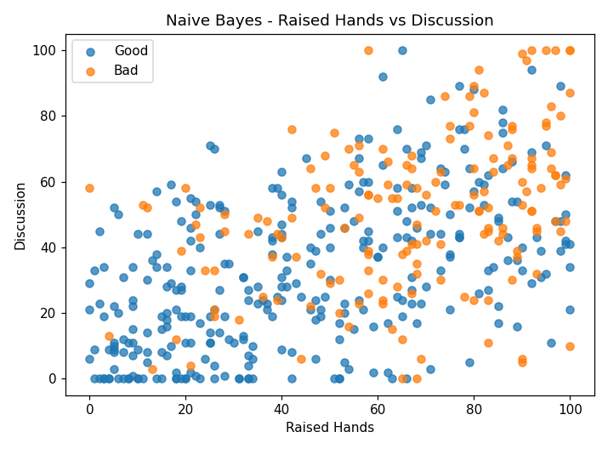
Figure 7 — Naive Bayes: Raised Hands vs Discussion

11. Comparison of Results
Accuracy achieved by each classifier on its respective target (held-out 20% test set):
Algorithm | Target | Metric | Score
Linear Regression | Discussion (continuous) | R² / RMSE | 0.206 / 21.04
Logistic Regression | ParentschoolSatisfaction | Accuracy | 0.802
Decision Tree | Class (L/M/H) | Accuracy | 0.771
Random Forest | Class (L/M/H) | Accuracy | 0.750
SVM | ParentschoolSatisfaction | Accuracy | 0.771
KNN | ParentschoolSatisfaction | Accuracy | 0.802
Naive Bayes | ParentschoolSatisfaction | Accuracy | 0.792

Logistic Regression and KNN achieved the joint-highest accuracy (0.802) for predicting Parent School Satisfaction, with Naive Bayes close behind (0.792) and SVM slightly lower (0.771) on this run. For the three-class Class prediction, the single Decision Tree (0.771) slightly outperformed the Random Forest (0.750) on this particular test split, though Random Forest generally remains the more robust choice across repeated runs due to its ensemble averaging. The Linear Regression model shows a moderate positive relationship (R² = 0.206) between raised hands/resource activity and Discussion score, confirming that classroom participation and online discussion engagement are correlated but not fully determined by one another.

12. Overall Conclusion
Across both prediction targets, engagement-based behavioural features (raisedhands, Discussion, VisITedResources, AnnouncementsView) and attendance (StudentAbsenceDays) consistently proved to be the most informative columns, which is why they were reused across every classifier for a fair comparison. Simpler, well-regularised models (Logistic Regression, KNN, Naive Bayes) performed competitively with more complex ones (SVM, Random Forest) on this dataset size, suggesting the underlying relationship between student engagement and outcome is fairly smooth and well-behaved rather than highly non-linear -- which is itself a useful, actionable finding for the project.

