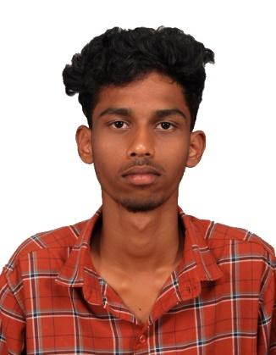

**Gunal K**

**+91 7339358018**

E-mail Id:gunalvdr395@gmail.com

LinkedIn ID: https://www.linkedin.com/in/gunal-k-302ba1275/

**CAREER OBJECTIVE:**

To get an opportunity where I can make the best of my potential and contribute to the organization growth

# +EDUCATION QUALIFICATION:

|  |  |  |  |  |
| --- | --- | --- | --- | --- |
| **DEGREE** | **DISCIPLINE** | **INSTITUTION** | **COUNTRY** | **YEAR OF PASSING/PERCENTAGE** |
| B. Tech | AI&DS | Karpagam  Academy of Higher Education | INDIA | 2025  (pursuing)  CGPA-7.84 |
| HSC | Maths-CS | Sri Shanmuka Matric Higher Secondary School | INDIA | 2021  82.3% |
| SSLC | __ | Sri Shanmuka  Matric Higher Secondary School | INDIA | 2019  76 |

# ON GOING PROJECT:

**Title : Blood Bank Management System**

**Description :**

A blood donation is a process whereby a person voluntarily has blood drawn to be used

for future transfusions when in need at hospitals for treatment procedures that require

them. Donation may be of whole blood (blood drawn directly from the body) or of

specific components of the blood, such as red blood cells, white blood cells, plasma, and

platelets. Blood banks often participate in the process of collecting blood and other

procedures such as managing stocks, approving blood requests, and updating donation

information. Donating blood for a poor people by using this app. Easy to contact and get

blood soon. The system facilitates communication with donors, healthcare

facilities, and other stakeholders through automated notifications, reminders,

and alerts. It ensures timely communication and coordination.

**Software :**

**Visual Studio Code**

**Html,Css,Javascrift**

**Sql**

**Python**

# CERTIFICATE:

* Certified in ‘Deep Learning using Python’ from Infosys Springboard in 2023
* Certified in ‘Dictionaries in Python Programming’ from Infosys Springboard in 2023
* Certified in ‘Introduction of C’ from Solo learn in 2023
* Certified in ‘Learning C’ from Linked in

# ACHIEVEMENTS:

# Received a Certificate in School in Athletic.

# AREA OF INTEREST:

* Data Scientist
* Data Visualization
* Data Analysis
* Programming

# TECHNICAL SKILLS:

* C(Basic)
* Python(Basic)
* SQL(Basic)
* Power Bi

# SOFT SKILLS:

* Team Work
* Decision Making
* Punctual
* Communication
* Adaptability

# LANGUAGES KNOWN:

* English
* Tamil

# PERSONAL DETAILS:

Address : 1/125,New Street,North Agraharam,Vaduvur-614019

Father’s Name : Kumar M

Date of Birth : 17-01-2003

# DECLARATION:

I hereby declare that all above mentioned information is in accordance with factor truth upto my knowledge.

Gunal K