Exp No: 1  Date: 7.2.25 | HTML AND CSS

AIM:

To create a web page that embeds a map with hotspots, frames, and links using embedded, external, and inline CSS

PROGRAM:

Hotspot.html

<html>
<head>
<title>Map with Hotspots</title>
</head>
<body>
<h2>Image Map Example</h2>
<img src="india map.jpg" alt="Map" usemap="#workmap" width="600" height="400">
<map name="workmap">
<area shape="rect" coords="34,44,270,350" alt="Location1" href="https://www.google.com">
<area shape="circle" coords="337,300,44" alt="Location2" href="https://www.yahoo.com">
</map>

<br>
<a href="https://en.wikipedia.org/wiki/Outline_of_India">Visit Example</a>
</body>
</html>

Style.css

@charset "ISO-8859-1";

body {
font-family: Arial, sans-serif;
margin: 0;
padding: 0;
background-color: #f4f4f4;
}

img {
display: block;
margin: 0 auto;
border-radius: 8px;
box-shadow: 0 4px 6px rgba(0, 0, 0, 0.1);
}

/* Styling for the map areas */
area {
outline: none;
border: none;
transition: transform 0.3s ease-in-out;
}

area:hover {
transform: scale(1.1);
}

OUTPUT:

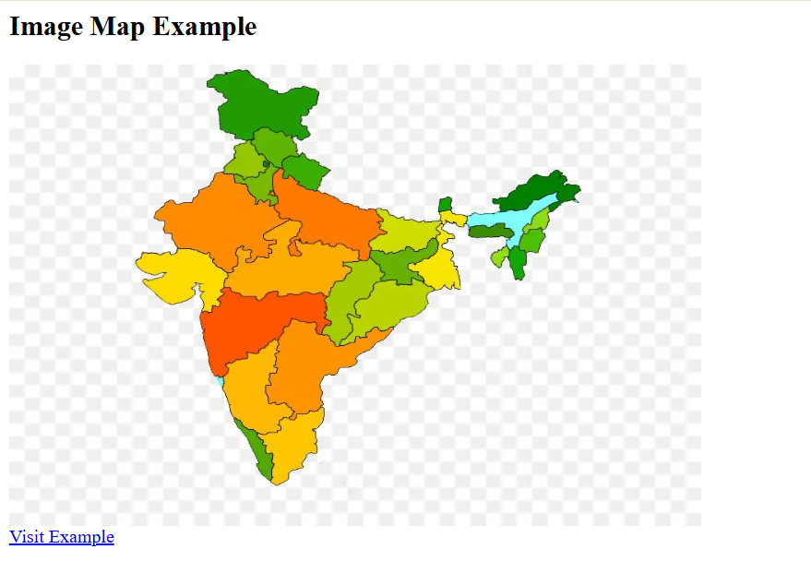

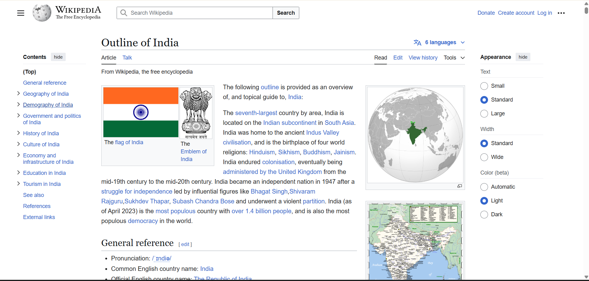

RESULT :
Thus the experiment to create a web page that embeds a map with hotspots, frames, and links using embedded, external, and inline CSS has been successfully implemented and verified .

