Exp No: 2  Date: 19.2.25 | REGISTRATION FORM

AIM:

To write a JavaScript to validate the following fields of a registration page
a) First Name ( Name should contain alphabets and the length should not be less than 6 characters
b)Password (Password should not be less than 6 characters length)
c)Email id ( should not contain any invlaid and must follow the standard pattern name@domain.com)
d)Mobile Number(phone number should contain 10 digits only )
e)Last Name and Address ( should not be Empty)

PROGRAM:

<html>
<head>
<title>Registration Form</title>
<script>
function validateForm() {
let name = document.forms["regForm"]["name"].value;
let password = document.forms["regForm"]["password"].value;
let email = document.forms["regForm"]["email"].value;
let mobile = document.forms["regForm"]["mobile"].value;

if (!/^[A-Za-z]+$/.test(name)) {
alert("Name must be alphabetic only");
return false;
}
if (password.length < 6) {
alert("Password must be at least 6 characters");
return false;
}
if (!email.includes("@")) {
alert("Invalid email format");
return false;
}
if (!/^\d{10}$/.test(mobile)) {
alert("Mobile number must be 10 digits");
return false;
}

alert("Form successfully submitted!");
return true; // allows form to submit (to same page or backend if added)
}
</script>
</head>
<body>
<center>
<h2>Registration Form</h2>
<form name="regForm" onsubmit="return validateForm()" action="#">
<label for="name">Name:</label><br>
<input type="text" name="name" id="name" required><br><br>

<label for="password">Password:</label><br>
<input type="password" name="password" id="password" required><br><br>

<label for="email">Email:</label><br>
<input type="text" name="email" id="email" required><br><br>

<label for="mobile">Mobile:</label><br>
<input type="text" name="mobile" id="mobile" required><br><br>

<input type="submit" value="Register">
</form>
</center>
</body>
</html>

OUTPUT:

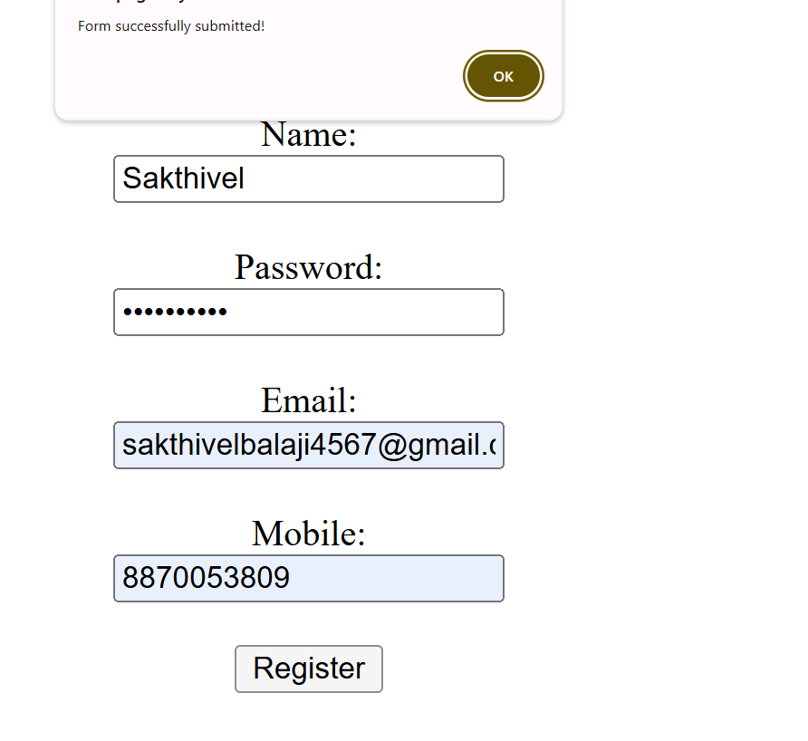

RESULT :
Thus the experiment to create a web page that embeds a map with hotspots, frames, and links using embedded, external, and inline CSS has been successfully implemented and verified .

