|  |  |
| --- | --- |
| **Exp No: 7**  **Date: 19.04.25** | servlet program to store using cookies |

**AIM :**

Write a Servlet program to store a user's preferences (like theme or language) using cookies. Retrieve and display these preferences on subsequent visits.

**PROGRAM:**

**Cookie.jsp**

<%@ page language=*"java"* contentType=*"text/html; charset=ISO-8859-1"*

pageEncoding=*"ISO-8859-1"*%>

<!DOCTYPE html>

<html>

<head>

<meta charset=*"ISO-8859-1"*>

<title>Cookies</title>

</head>

<body>

<form method = *"post"* >

<p>

<label>Username: </label>

<input type=*"text"* name=*"username"*>

</p>

<p>

<label> password: </label>

<input type=*"password"* name = *"password"*>

</p>

<button type=*"submit"*> Submit </button>

</form>

<%

// Request form method == Post

**if** ("POST".equals(request.getMethod())) {

// Get submitted preferences

String user = request.getParameter("username");

String pass = request.getParameter("password");

**if**(user.equals("gunal") && pass.equals("gunal") ){

Cookie username = **new** Cookie("username", user);

username.setMaxAge(60*60);

username.setPath("/");

response.addCookie(username);

response.sendRedirect("getCookie.jsp");

}

}

// Get current preference values

%>

</body>

</html>

**getCookie.jsp**

<%@ page language=*"java"* contentType=*"text/html; charset=ISO-8859-1"*

pageEncoding=*"ISO-8859-1"*%>

<!DOCTYPE html>

<html>

<head>

<meta charset=*"ISO-8859-1"*>

<title>Get Cookie</title>

</head>

<body>

<%

Cookie[] cookies = request.getCookies();

String cookieName = "username";

**if** (cookies != **null**) {

**for** (Cookie cookie : cookies) {

**if** (cookieName.equals(cookie.getName())) {

System.out.println("username "+cookie.getName());

out.println(cookie.getValue());

}

}

}

%>

</html>

**OUTPUT:**

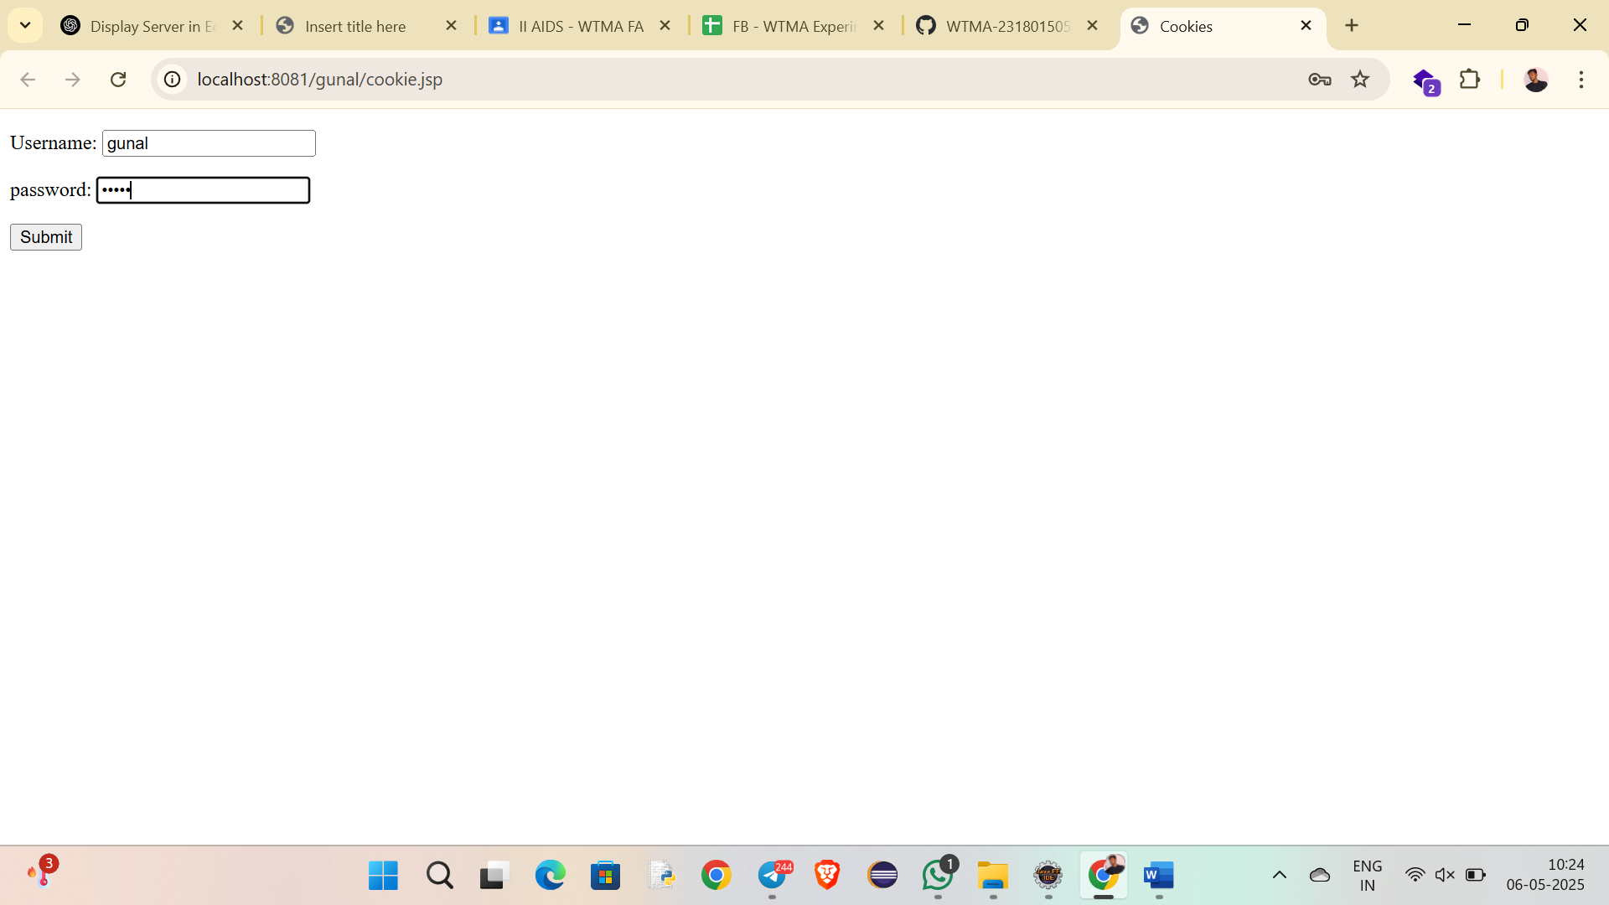

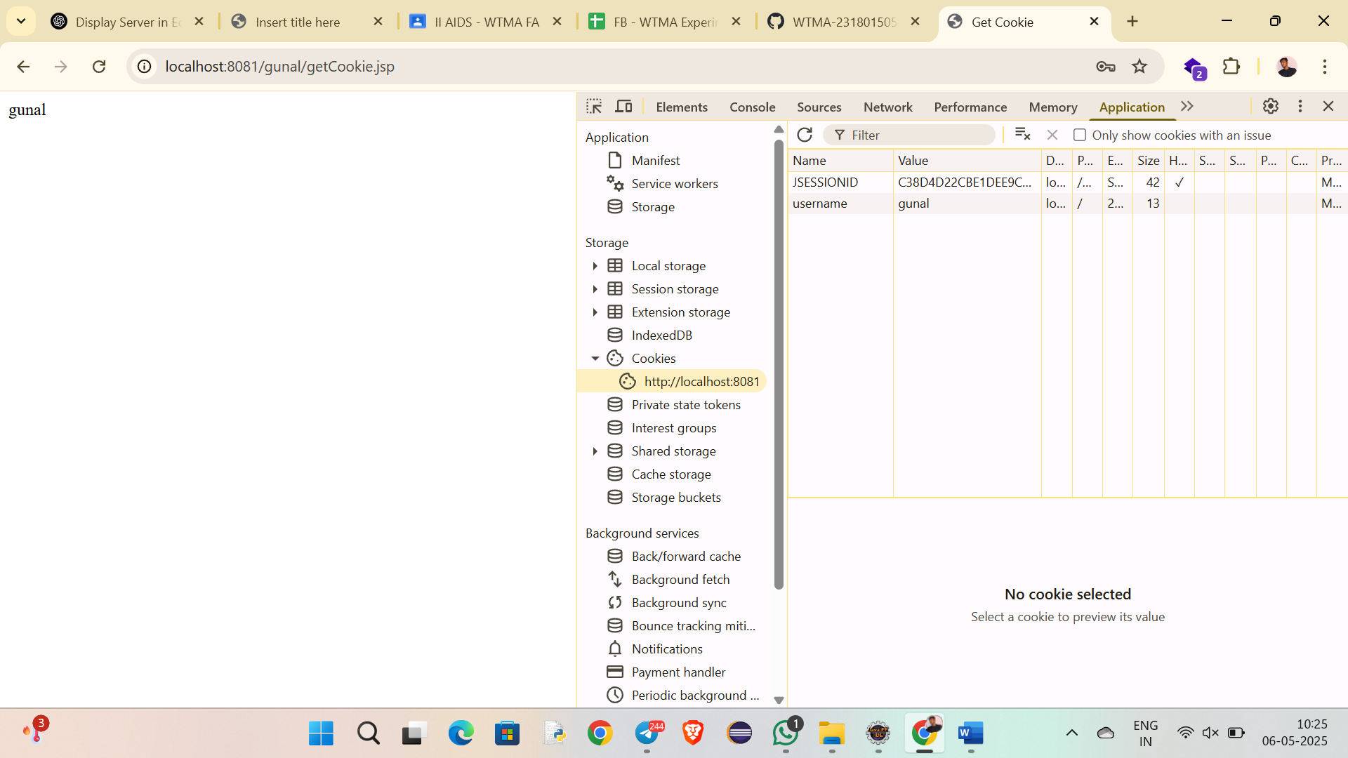

**RESULT :**Thus the experiment Write a Servlet program to store a user's preferences (like theme or language) using cookies. Retrieve and display these preferences on subsequent visits has been successfully implemented and verified successfully.