**SRI LANKA INSTITUE OF**

**INFORMATION TECHNOLOGY**



**ID No: IT20237486**

**Name: Gunarathne H.M.Y.B**

**Batch: DS weekday Assignment: 02**

# Step 1: Data source

Data warehouse designed at the Assignment I is used as the data source for this assignment. Data warehouse consists of 5-dimension tables and one fact tables to represent Super Market data altogether.

## ER Diagram for the source system

# Step 2: SSAS Cube implementation

## Data Source View

Data source view has been configured with its relevant tables as per the above design.

## Cube Design

### KPI Creation

KPI is designed on Total attribute of Measures. It checks if the total is more than $1000.If so value is set to success (True) else set to fail (False).

# Step 3: SSAS Cube implementation

In the data tab of excel Microsoft analysis services are selected from other sources. There is the relevant database to create the pivot table i.e SUPERMARKET_Cube database is selected. Then the data there gets imported as a pivot table report.

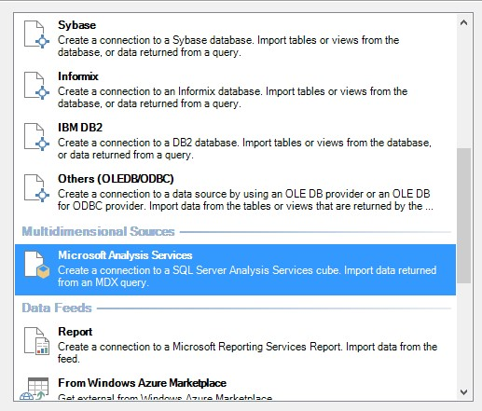

## I. Roll-Up

It can be seen Gross Income and Quantity displayed for each Product Sub category. High level understanding can be obtained.

## II. Drill-Down

It can be seen about Unit Price and Quantity of each Product Category.

## III. Slice

Income, Unit Price and Quantity applying the Product Sub Category can be filtered as below.

## IV. Dice

Income, Unit Price and Quantity applying the Product Category of Product Subcategory can be filtered as below

# Step 4: SSRS Reports

## I. Report 1: drill-Through Level 01 report

## II. Report 2: Product Income drill-down Report

## III. Report 3: Gross Income Matrix

## IV. Report 4: drill-Through Level 02 report

