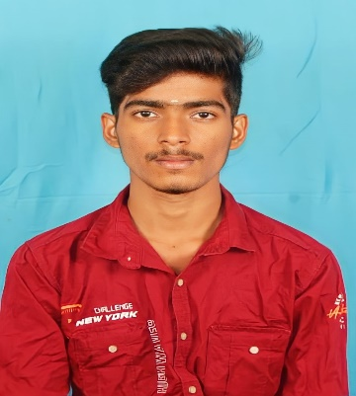

**GUNASEELAN K**

**CAREER OBJEECTIVE:**

* I am looking for an opportunity to use my skills and abilities to make a positive impact on an it oranisation.
* I am commited continuous learning and willing to take on new challenges.

**CONTACT DETAILS:**

**MOBILE NO :**+91 8248440820

**Email:** [**seelang654@gmail.com**](mailto:seelang654@gmail.com)

**Github:** <https://github.com/ranjith50677>

**Address:**

290/30a,Alangiyam Road ,Metor City ,Dharapuram,Tiruppur-638657 .

**SKILLS:**

**Programming Languages -** Java, python

**Web Technologies** - HTML,CSS, ,Bootstrap

**Editors & IDE** - Visual Studio,Eclipse.

**LANGUAGES:**

* Tamil
* English

**DECLARATION:**

I hereby declare that the information furnished above is true to the best of my knowledge.

GUNASEELAN.M

**EDUCATION :**

# BSC(computer science)- )- RVS College Of Arts And Science. (60% )

**HSC - NCP** municipality higher secondary school Dharapuram.(66%)

**SSC - NCP** municipality higher secondary school Dharapuram.(52%)