PHASE – 2

PROBLEM DEFINITION AND FLOWCHART

|  |  |
| --- | --- |
| DATE | 10-10-2023 |
| TEAM ID / TEAM NAME | Proj_224020_Team_1 |
| PROJECT NAME | Market Basket Insights |
| STUDENT NAME WITH ID | **R Gunaseelan**  K.S Illayabharathi  V Dinesh  K Gowtham |

**Market Basket Insights**

**Introduction:**

* Briefly introduce the concept of market basket analysis and its importance in retail.
* Explain the objective of the document - to analyze customer purchasing behaviour and identify cross-selling opportunities.
* Provide an overview of the Apriori algorithm as the chosen technique for this analysis.

**Problem Definition:**

This problem is to perform market basket analysis on a provided dataset to unveil hidden patterns and associations between products. The goal is to understand customer purchasing behavior and identify potential cross-selling opportunities for a retail business. This project involves using association analysis techniques, such as Apriori algorithm, to find frequently co-occurring products and generate insights for business optimization

**Flowchart:**

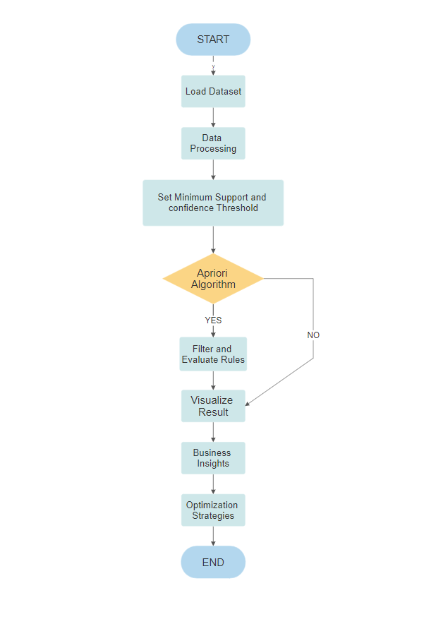

1. **Start:**

Begin the flowchart.

1. **Load Dataset:**

Retrieve and load the transaction dataset containing customer purchase data.

1. **Data Preprocessing:**
   * Clean and format the data, handling missing values or duplicates.
   * Convert data into a suitable format for analysis, such as a transaction-item matrix.
2. **Set Minimum Support and Confidence Thresholds:**

Define the minimum support and confidence thresholds for the Apriori algorithm.

1. **Apriori Algorithm:**

* Apply the Apriori algorithm to find frequent itemsets.
* Generate association rules based on the frequent itemsets.

1. **Filter and Evaluate Rules:**

* Filter out rules that meet the minimum support and confidence thresholds.
* Evaluate the remaining rules, considering lift, conviction, or other metrics.

1. **Visualize Results:**

Create visualizations (e.g., bar charts, network diagrams) to represent the discovered associations and patterns.

1. **Business Insights:**

Analyze the generated rules and patterns to gain insights into customer behavior and cross-selling opportunities.

1. **Optimization Strategies:**

Based on the insights, develop strategies for optimizing the retail business, such as product placement, bundling, or promotions.

1. **End:**

Conclude the flowchart.

**Conclusion:**

* Summarize the key findings and insights from the analysis.
* Discuss the potential impact on the retail business.
* Reflect on the significance of market basket analysis in understanding customer behaviour and improving business operations.

**References:**

List any sources, tools, or references used during the project.

Ensure that each section is detailed and well-structured, and use data visualizations to support your findings. This document will provide a comprehensive overview of your market basket analysis project, from problem statement to actionable