SQL-questions-set1

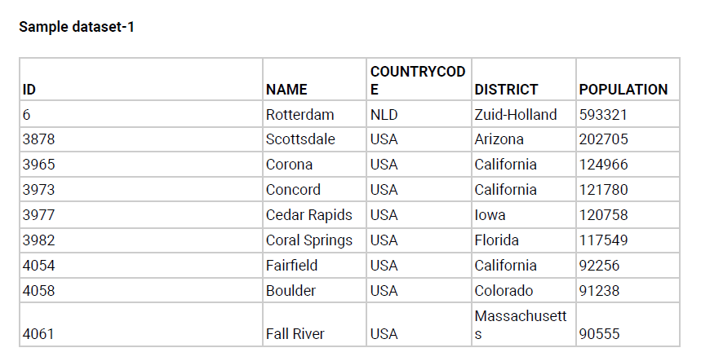

The CITY table is described as follows:

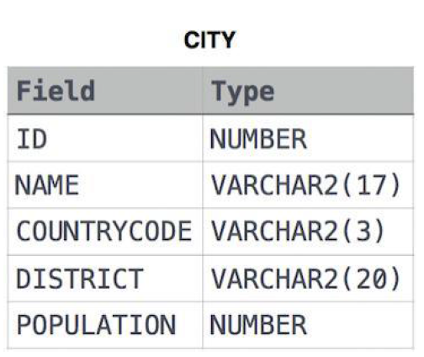

create table city(

    ID int,

    NAME varchar(17),

    COUNTRYCODE varchar(3),

    DISTRICT VARCHAR(20),

    POPULATION int

);

Insert the data:

insert into city VALUES(6,'Rotterdam','NLD','Zuid-Holland',593321),

(3878,'Scottsdale','USA','Arizona',202705),

(3965,'Corona','USA','California',124966),

(3973,'Concord','USA','California',121780),

(3977,'Cedar Rapids','USA','Iowa',120758),

(3982,'Coral Springs','USA','Florida',117549),

(4054,'Fairfield','USA','California',92256),

(4058,'Boulder','USA','Colorado',91238),

(4061,'Fall River','USA','Massachusetts',90555);

**Q1**. Query all columns for all American cities in the CITY table with populations larger than 100000.The CountryCode for America is USA.

***Solution:***

**select *from city where POPULATION>=100000 and COUNTRYCODE='USA';**

| ID int | | NAME varchar | COUNTRYCODE varchar | | DISTRICT varchar | POPULATION int |
| --- | --- | --- | --- | --- | --- | --- |
|  | 1 | 3878 | Scottsdale | USA | Arizona | 202705 |
|  | 2 | 3965 | Corona | USA | California | 124966 |
|  | 3 | 3973 | Concord | USA | California | 121780 |
|  | 4 | 3977 | Cedar Rapids | USA | Iowa | 120758 |
|  | 5 | 3982 | Coral Springs | USA | Florida | 117549 |

**Q2**. Query the NAME field for all American cities in the CITY table with populations larger than 120000.The CountryCode for America is USA.

***Solution:***

**select NAME from city where population >=120000 and countrycode='USA';**

| NAME varchar | | |
| --- | --- | --- |
|  | 1 | Scottsdale |
|  | 2 | Corona |
|  | 3 | Concord |
|  | 4 | Cedar Rapids |

**Q3.** Query all columns (attributes) for every row in the CITY table.

***Solution:***

**select *from city;**

| ID int | | NAME varchar | COUNTRYCODE varchar | | DISTRICT varchar | POPULATION int |
| --- | --- | --- | --- | --- | --- | --- |
|  | 1 | 6 | Rotterdam | NLD | Zuid-Holland | 593321 |
|  | 2 | 3878 | Scottsdale | USA | Arizona | 202705 |
|  | 3 | 3965 | Corona | USA | California | 124966 |
|  | 4 | 3973 | Concord | USA | California | 121780 |
|  | 5 | 3977 | Cedar Rapids | USA | Iowa | 120758 |
|  | 6 | 3982 | Coral Springs | USA | Florida | 117549 |
|  | 7 | 4054 | Fairfield | USA | California |  |

**Q4**. Query all columns for a city in CITY with the ID 1661.

***Solution:***

**select *from city where ID=1661;**

| ID int | | NAME varchar | COUNTRYCODE varchar | DISTRICT varchar | | POPULATION int |
| --- | --- | --- | --- | --- | --- | --- |
|  | 1 | 1661 | Tokiyo | JPN | Zukan | 559321 |

**Q5**. Query all attributes of every Japanese city in the CITY table. The COUNTRYCODE for Japan is JPN.

***Solution:***

**select *from city where countrycode='JPN';**

| ID int | | NAME varchar | COUNTRYCODE varchar | DISTRICT varchar | | POPULATION int |
| --- | --- | --- | --- | --- | --- | --- |
|  | 1 | 1661 | Tokiyo | JPN | Zukan | 559321 |
|  | 2 | 1331 | Nagasaki | JPN | dhada | 679321 |

**Q6.** Query the names of all the Japanese cities in the CITY table. The COUNTRYCODE for Japan is JPN.

***Solution:***

**select name from city where countrycode='JPN';**

| name varchar | | |
| --- | --- | --- |
|  | 1 | Tokiyo |
|  | 2 | Nagasaki |

**Sample Data set 2:**

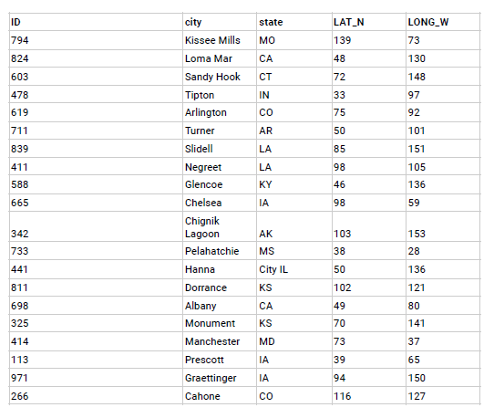

The STATION table is described as follows:

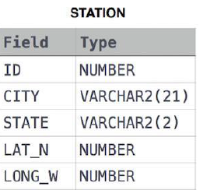

where LAT_N is the northern latitude and LONG_W is the western longitude

create table station (

    id int,

    city varchar(21),

    state varchar(2),

    lat_n int,

    long_w int

);

**Insert the data;**

insert into station values(794,'Kissee Mills','MO',139,73),

(824,'Loma Mar','CA',48,130),

(603,'Sandy Hook','CT',72,148),

(478,'Tipton','IN',33,97),

(619,'Arlington','CO',75,92),

(711,'Turner','AR',50,101),

(839,'Slidell','LA',85,151),

(411,'Negreet','LA',98,105),

(588,'Glencoe','KY',46,136),

(665,'Chelsea','IA',98,59),

(342,'Chignik Lagoon','AK',103,153),

(733,'Pelahatchie','MS',38,28),

(441,'Hanna City','IL',50,136),

(811,'Dorrance','KS',102,121),

(698,'Albany','CA',49,80),

(325,'Monument','KS',70,141),

(414,'Manchester','MD',73,37),

(113,'Prescott','IA',39,65),

(971,'Graettinger','IA',94,150),

(266,'Cahone','CO',116,127);

**Q7.** Query a list of CITY and STATE from the STATION table.

***Solution:***

**select city,state from station;**

| city varchar | | | state varchar | |
| --- | --- | --- | --- | --- |
|  | 1 | Kissee Mills | | MO |
|  | 2 | Loma Mar | | CA |
|  | 3 | Sandy Hook | | CT |
|  | 4 | Tipton | | IN |

**.**

**.**

**.**

**Q8.** Query a list of CITY names from STATION for cities that have an even ID number. Print the results in any order, but exclude duplicates from the answer.

***Solution:***

**select id, city from station GROUP BY id, city;**

| id int | | | city varchar | |
| --- | --- | --- | --- | --- |
|  | 1 | 794 | | Kissee Mills |
|  | 2 | 824 | | Loma Mar |
|  | 3 | 603 | | Sandy Hook |
|  | 4 | 478 | | Tipton |
|  | 5 | 619 | | Arlington |

**.**

**.**

**.**

**Q9**. Find the difference between the total number of CITY entries in the table and the number of distinct CITY entries in the table.

***Solution:***

**select (count(city)-count(DISTINCT(city)))as city_diff from station;**

**Q10.** Query the two cities in STATION with the shortest and longest CITY names, as well as their respective lengths (i.e.: number of characters in the name). If there is more than one smallest or largest city, choose the one that comes first when ordered alphabetically.

***Solution:***

**Step 1:** Query the city and length

**select city,length(city)as len from station**

**Step 2:** If there is more than one smallest or largest city, choose the one that comes first when ordered alphabetically.

**with cte as(**

**select city,length(city)as len from station**

**),**

**select city,len from cte**

**where len=(select min(len) from cte )**

**order by city**

**limit 1;**

**Step 3:** Union the results

**with cte as(**

**select city,length(city)as len from station**

**),**

**result_1 as(select city,len from cte**

**where len=(select min(len) from cte )**

**order by city**

**limit 1)**

**select city,len from cte where len=(select max(len) from cte)**

**UNION**

**select city,len from result_1;**

| city varchar | | | len bigint | |
| --- | --- | --- | --- | --- |
|  | 1 | Chignik Lagoon | | 14 |
|  | 2 | Albany | | 6 |

**Q11**. Query the list of CITY names starting with vowels (i.e., a, e, i, o, or u) from STATION. Your result cannot contain duplicates.

***Solution:***

**select distinct(city) from station where substr(lower(city),1,1) in ('a','e','i','o','u');**

| city varchar | | |
| --- | --- | --- |
|  | 1 | Arlington |
|  | 2 | Albany |

**Q12.** Query the list of CITY names ending with vowels (a, e, i, o, u) from STATION. Your result cannot contain duplicates.

***Solution:***

**select distinct(city) from station**

**where substr(lower(city),-1,1) in ('a','e','i','o','u');**

| city varchar | | |
| --- | --- | --- |
|  | 1 | Glencoe |
|  | 2 | Chelsea |
|  | 3 | Pelahatchie |
|  | 4 | Dorrance |
|  | 5 | Cahone |

**Q13.** Query the list of CITY names from STATION that do not start with vowels. Your result cannot contain duplicates.

***Solution:***

**select distinct(city) from station**

**where substr(lower(city),1,1) not in ('a','e','i','o','u');**

| city varchar | | |
| --- | --- | --- |
|  | 1 | Kissee Mills |
|  | 2 | Loma Mar |
|  | 3 | Sandy Hook |
|  | 4 | Tipton |
|  | 5 | Turner |

**.**

**.**

**.**

**Q14.** Query the list of CITY names from STATION that do not end with vowels. Your result cannot contain duplicates.

***Solution:***

**select distinct(city) from station**

**where substr(lower(city),-1,1) not in ('a','e','i','o','u');**

| city varchar | | |
| --- | --- | --- |
|  | 1 | Kissee Mills |
|  | 2 | Loma Mar |
|  | 3 | Sandy Hook |
|  | 4 | Tipton |
|  | 5 | Arlington |

**.**

**.**

**.**

**Q15.** Query the list of CITY names from STATION that either do not start with vowels or do not end with vowels. Your result cannot contain duplicates.

***Solution:***

**select distinct(city) from station**

**where substr(lower(city),1,1) not in('a','e','i','o','u') or**

**substr(lower(city),-1,1) not in ('a','e','i','o','u');**

|  |  |  |  |  |  |  |  |  |  |  |  |  |  |  |  |  |  |  |  |  |
| --- | --- | --- | --- | --- | --- | --- | --- | --- | --- | --- | --- | --- | --- | --- | --- | --- | --- | --- | --- | --- |
| | city varchar | | | | --- | --- | --- | |  | 1 | Kissee Mills | |  | 2 | Loma Mar | |  | 3 | Sandy Hook | |  | 4 | Tipton | |  | 5 | Arlington | | | |
|  |  |  |
|  |  |  |
|  |  |  |
|  |  |  |

**.**

**.**

**.**

**Q16.** Query the list of CITY names from STATION that do not start with vowels and do not end with vowels. Your result cannot contain duplicates.

***Solution:***

**select distinct(city) from station**

**where substr(lower(city),1,1) not in('a','e','i','o','u') and**

**substr(lower(city),-1,1) not in ('a','e','i','o','u');**

| city varchar | | |
| --- | --- | --- |
|  | 1 | Kissee Mills |
|  | 2 | Loma Mar |
|  | 3 | Sandy Hook |
|  | 4 | Tipton |

.

..

___________________________________________________________________

**Question 17;**

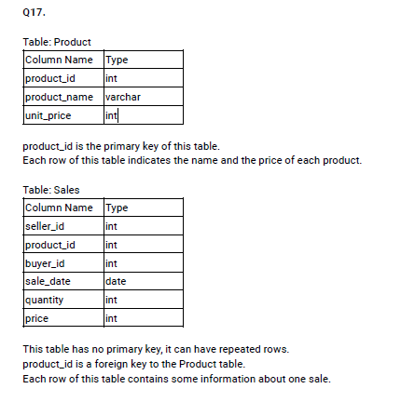

**Input data:**

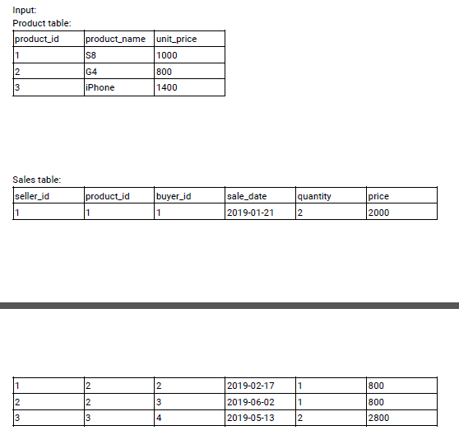

create table Product(

    product_id int,

    product_name VARCHAR(20),

    unit_price int

);

create table sales(

    seller_id int,

    product_id int,

    buyer_id int,

    sale_date date,

    quantity int,

    price int

);

insert into Product values(1,'S8',1000),

(2,'G4',800),

(3,'iPhone',1400);

insert into sales VALUES(1,1,1,'2019-01-21',2,2000),

(1,2,2,'2019-02-17',1,800),

(2,2,3,'2019-06-02',1,800),

(3,3,4,'2019-05-13',2,2800);

Write an SQL query that reports the products that were only sold in the first quarter of 2019. That is, between 2019-01-01 and 2019-03-31 inclusive.

***Solution:***

**select product_id,product_name from Product**

**where product_id not in (select product_id from sales**

**where sale_date not between '2019-01-01' and '2019-03-31' );**

| product_id int | | | product_name varchar | |
| --- | --- | --- | --- | --- |
|  | 1 | 1 | | S8 |

___________________________________________________________________

**Question 18;**

Write an SQL query to find all the authors that viewed at least one of their own articles. Return the result table sorted by id in ascending order.

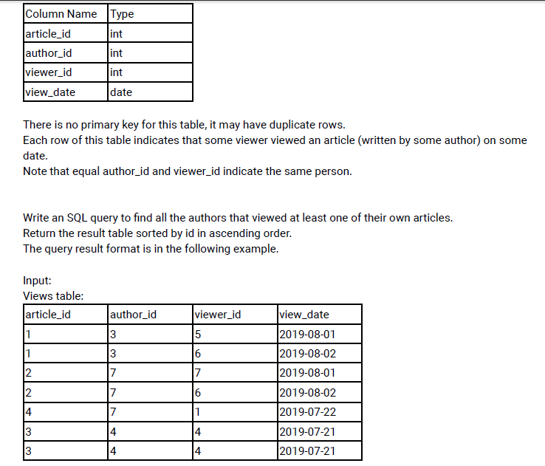

create table views(

    article_id int,

    author_id int,

    viewer_id int,

    view_date date

);

insert into views values(1,3,5,'2019-08-01'),

(1,3,6,'2019-08-02'),

(2,7,7,'2019-08-01'),

(2,7,6,'2019-08-02'),

(4,7,1,'2019-07-22'),

(3,4,4,'2019-07-21'),

(3,4,4,'2019-07-21');

***Solution:***

**select author_id from views**

**where author_id=viewer_id**

**group by author_id**

**order by author_id;**

| author_id int | | |
| --- | --- | --- |
|  | 1 | 4 |
|  | 2 | 7 |

___________________________________________________________________

**Question 19;**

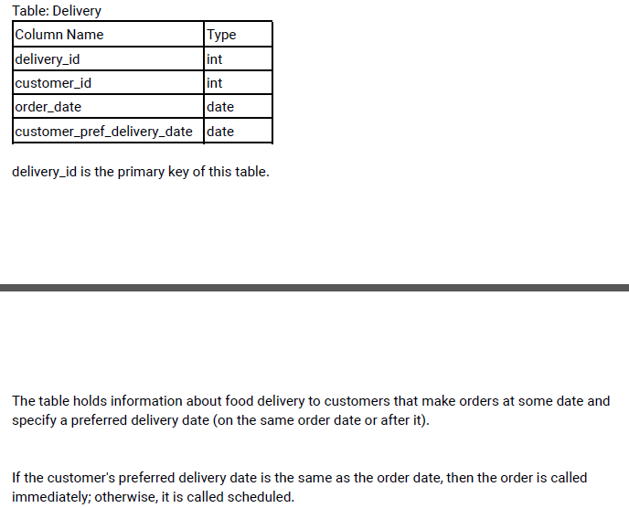

**Input data:**

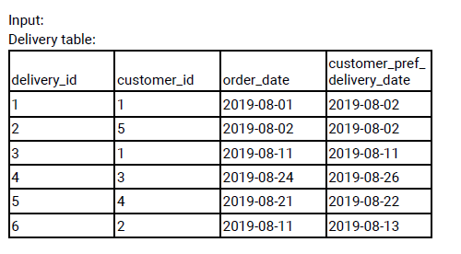

create table delivery(

    delivery_id int,

    customer_id int,

    order_date date,

    customer_pref_delivery_date date,

constraint pk PRIMARY KEY(delivery_id)

);

insert into delivery values(1,1,'2019-08-01','2019-08-02'),

(2,5,'2019-08-02','2019-08-02'),

(3,1,'2019-08-11','2019-08-11'),

(4,3,'2019-08-24','2019-08-26'),

(5,4,'2019-08-21','2019-08-22'),

(6,2,'2019-08-11','2019-08-13');

Write an SQL query to find the percentage of immediate orders in the table, rounded to 2 decimal places.

***Solution:***

**Step 1:** find immediate delivery count and total count

**select count(*)as immediate_del,**

**(select count(*) from delivery)as count**

**from delivery**

**where order_date=customer_pref_delivery_date;**

**Step 2:** Find percentage.

**with cte as(**

**select count(*)as immediate_del,(select count(*) from delivery)as count**

**from delivery**

**where order_date=customer_pref_delivery_date**

**)**

**select round(100.00*immediate_del/count,2) as immediate_percentage from cte;**

| immediate_percentage newdecimal | | |
| --- | --- | --- |
|  | 1 | 33.33 |

___________________________________________________________________

**Question 20;**

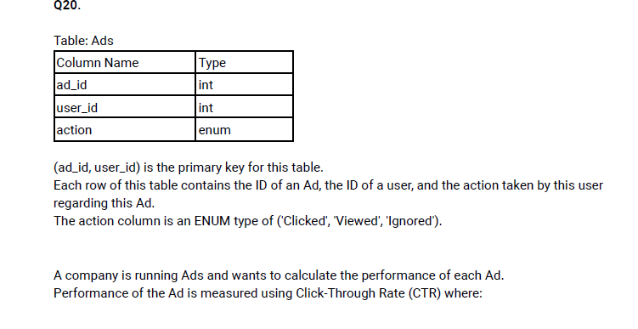

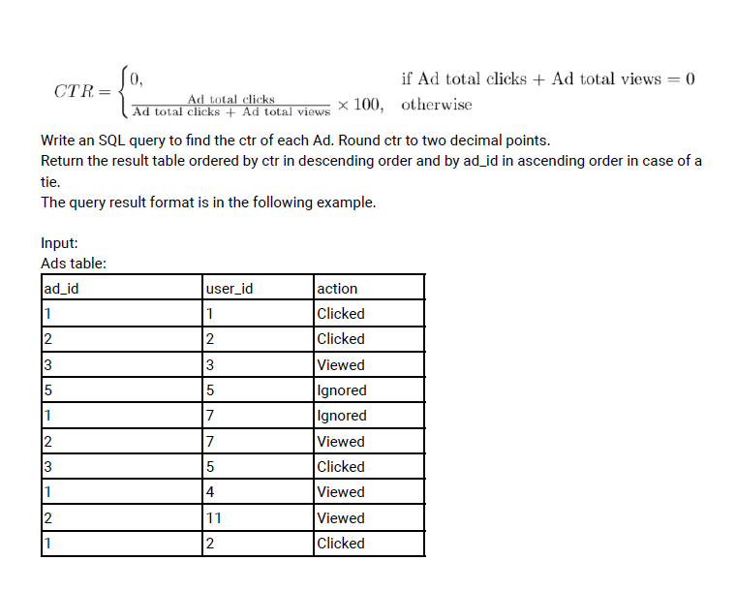

create table Ads(

    ad_id int,

    user_id int,

    action enum('Clicked', 'Viewed', 'Ignored'),

constraint pk PRIMARY KEY(ad_id,user_id)

);

insert into Ads VALUES(1,1,'Clicked'),

(2,2,'Clicked'),

(3,3,'Viewed'),

(5,5,'Ignored'),

(1,7,'Ignored'),

(2,7,'Viewed'),

(3,5,'Clicked'),

(1,4,'Viewed'),

(2,11,'Viewed'),

(1,2,'Clicked');

***Solution:***

**Step 1:** find the number of clicks and view for each ad_id

**select ad_id,**

**count(case when action='Clicked' then 1 end)as total_click,**

**count(case when action='Viewed' then 1 end)as total_view**

**from Ads**

**group by ad_id;**

**Step 2:** Calculated the ctr

**with cte as(select ad_id,**

**count(case when action='Clicked' then 1 end)as total_click,**

**count(case when action='Viewed' then 1 end)as total_view**

**from Ads**

**group by ad_id)**

**select ad_id,**

**round((total_click/(total_click+total_view))*100,2) as ctr**

**from cte;**

| ad_id int | | | ctr newdecimal |
| --- | --- | --- | --- |
|  | 1 | 1 | 66.67 |
|  | 2 | 2 | 33.33 |
|  | 3 | 3 | 50.00 |
|  | 4 | 5 | 0 |

___________________________________________________________________

**Question 21;**

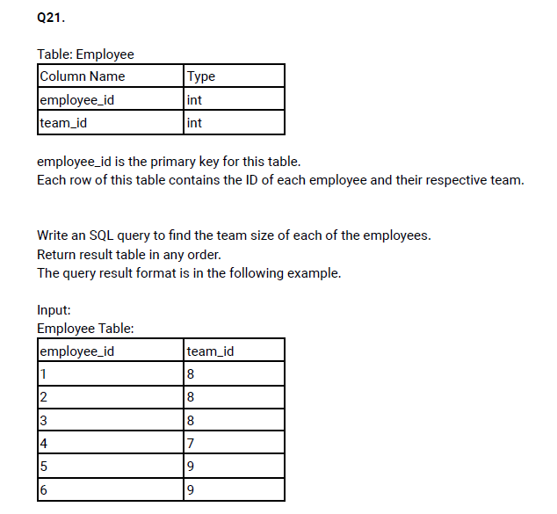

***Solution:***

create table employee(

    employee_id int,

    team_id int,

constraint emp_pk PRIMARY KEY(employee_id)

);

insert into employee values(1,8),(2,8),(3,8),(4,7),(5,9),(6,9);

**select employee_id,**

**count(team_id) over(partition by team_id) as team_count from employee**

**order by employee_id;**

| employee_id int | | | team_count bigint | |
| --- | --- | --- | --- | --- |
|  | 1 |  | | 3 |
|  | 2 |  | | 3 |
|  | 3 |  | | 3 |
|  | 4 |  | | 1 |
|  | 5 |  | | 2 |
|  | 6 |  | | 2 |

___________________________________________________________________

**Question 22;**

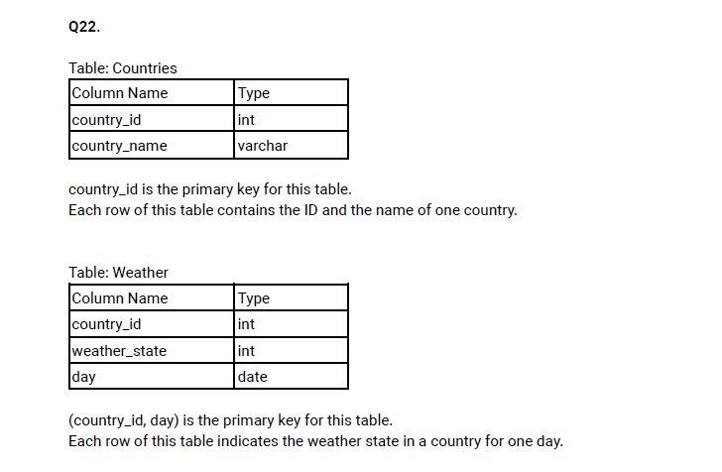

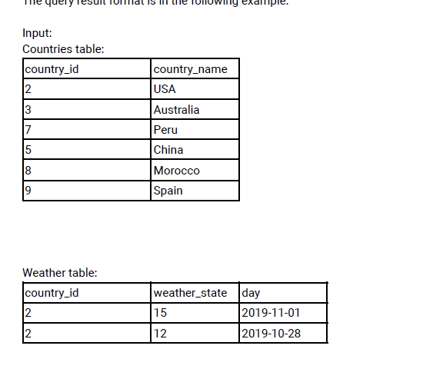

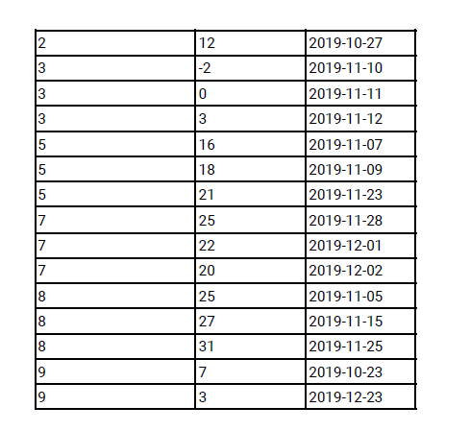

create table countries(

    country_id int,

    country_name varchar(20),

    constraint pk PRIMARY KEY(country_id)

);

insert into countries values(2,'USA'),(3,'Australia'),(7,'Peru'),(5,'China'),(8,'Morocco'),(9,'Spain');

create table Weather(

    country_id int,

    weather_state int,

    day date,

    constraint pk PRIMARY KEY(country_id,day)

);

insert into Weather VALUES(2,15,'2019-11-01'),(2,12,'2019-10-28'),(2,12,'2019-10-27'),

(3,-2,'2019-11-10'),(3,0,'2019-11-11'),(3,3,'2019-11-12'),(5,16,'2019-11-07'),

(5,18,'2019-11-09'),(5,21,'2019-11-23'),(7,25,'2019-11-28'),(7,22,'2019-12-01'),

(7,20,'2019-12-02'),(8,25,'2019-11-05'),(8,27,'2019-11-15'),(8,31,'2019-11-25'),

(9,7,'2019-10-23'),(9,3,'2019-12-23');

Write an SQL query to find the type of weather in each country for November 2019.

The type of weather is:

* Cold if the average weather_state is less than or equal 15,
* Hot if the average weather_state is greater than or equal to 25, and
* Warm otherwise.

***Solution:***

**Step 1:** join the Countries and Weather table.

**Step 2:** find Novmber 2019 data and Average weather_state

**select c.country_name,**

**Round(avg(w.weather_state),2)as weather_state**

**from countries c left join Weather w**

**on c.country_id=w.country_id**

**where extract(month from day)=11**

**group by c.country_name;**

**Step 3:** Find the weather_type based on questions

with cte as(select c.country_name,round(avg(w.weather_state),2)as weather_state from countries c left join Weather w

on c.country_id=w.country_id

where extract(month from day)=11

GROUP BY c.country_name

)

select country_name,

(case when weather_state <=15 then 'Cold'

when weather_state>=25 then 'Hot'

else 'Warm' end)as weather_type

from cte

;

| country_name varchar | | | weather_type varchar | |
| --- | --- | --- | --- | --- |
|  | 1 | USA | | Cold |
|  | 2 | Australia | | Cold |
|  | 3 | China | | Warm |
|  | 4 | Peru | | Hot |
|  | 5 | Morocco | | Hot |

___________________________________________________________________

**Question 23 & 40;**

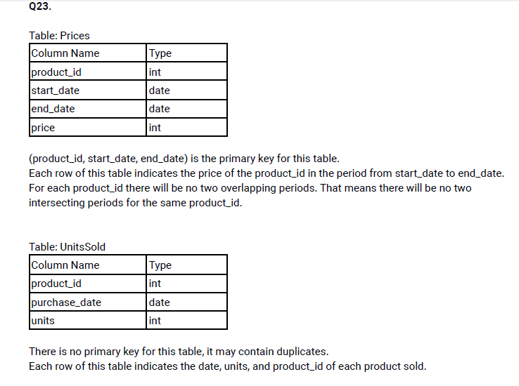

**Insert data;**

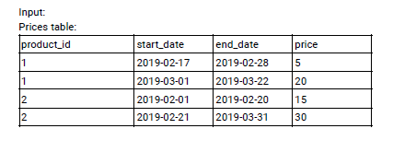

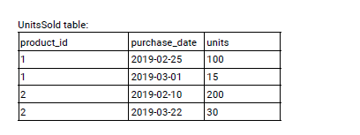

create table prices(

    product_id int,

    start_date date,

    end_date date,

    price int,

    constraint pk PRIMARY KEY(product_id,start_date,end_date)

);

insert into prices values(1,'2019-02-17','2019-02-28',5),

(1,'2019-03-01','2019-03-22',20),

(2,'2019-02-01','2019-02-20',15),

(2,'2019-02-21','2019-03-31',30);

create table unitssold(

    product_id int,

    purchase_date date,

    units int

);

insert into unitssold VALUES(1,'2019-02-25',100),

(1,'2019-03-01',15),

(2,'2019-02-10',200),

(2,'2019-03-22',30);

Write an SQL query to find the average selling price for each product. average_price should be rounded to 2 decimal places.

***Solution:***

**Step 1:** Join the two tables and find purchase_date between start_date and end_date

**select *from prices p left join unitssold u**

**on p.product_id=u.product_id**

**where u.purchase_date BETWEEN p.start_date and p.end_date;**

**step 2:** calculate average unit,

with cte as(select p.product_id,p.price,u.units from  prices p left join unitssold u

on p.product_id=u.product_id

where u.purchase_date BETWEEN p.start_date and p.end_date)

select product_id,round(sum(price*units)/sum(units),2)as avg_units

from cte

group by product_id;

| product_id int | | | avg_units newdecimal |
| --- | --- | --- | --- |
|  | 1 |  | 6.96 |
|  | 2 |  | 16.96 |

___________________________________________________________________

**Question 24;**

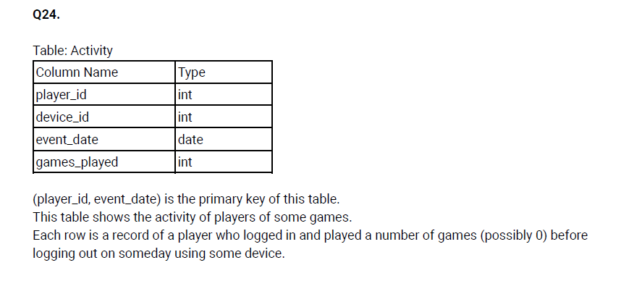

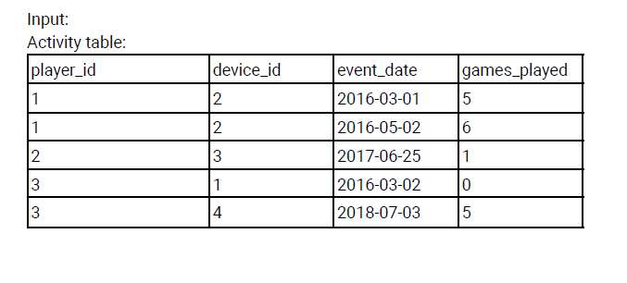Write an SQL query to report the first login date for each player.

***Solution:***

create table Activity(

    player_id int,

    device_id int,

    event_date date,

    games_played int,

    constraint pk PRIMARY KEY(player_id,event_date)

);

insert into Activity values(1,2,'2016-03-01',5),

(1,2,'2016-05-02',6),

(2,3,'2017-06-25',1),

(3,1,'2016-03-02',0),

(3,4,'2018-07-03',5);

**with cte as(select *,**

**row_number() over(partition by player_id order by event_date)as row_num**

**from Activity)**

**select player_id,event_date as first_login from cte where row_num=1;**

| player_id int | | | first_login date |
| --- | --- | --- | --- |
|  | 1 |  | 2016-03-01 |
|  | 2 |  | 2017-06-25 |
|  | 3 |  | 2016-03-02 |

___________________________________________________________________

**Question 25;**

**Table will be follow above question number 26.**

Write an SQL query to report the device that is first logged in for each player.

***Solution:***

**with cte as(select *,**

**row_number() over(partition by player_id order by event_date)as row_num**

**from Activity)**

**select player_id,device_id from cte where row_num=1;**

| player_id int | | | device_id int | |
| --- | --- | --- | --- | --- |
|  | 1 |  | | 2 |
|  | 2 |  | | 3 |
|  | 3 |  | | 1 |

___________________________________________________________________

**Question 26;**

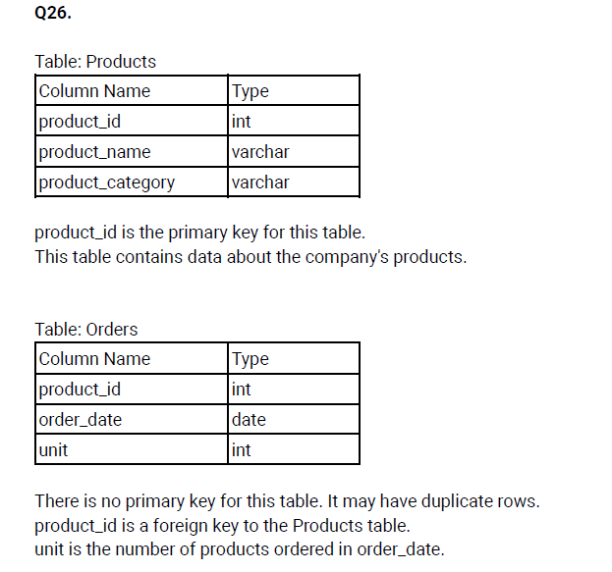

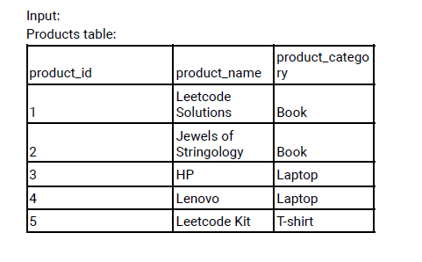

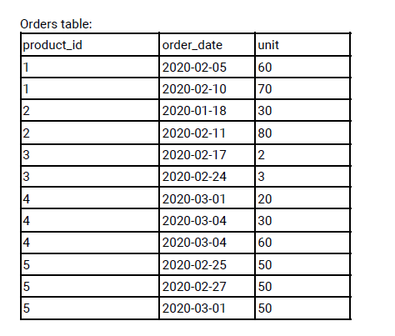

Write an SQL query to get the names of products that have at least 100 units ordered in February 2020 and their amount.

***Solution:***

create table products(

    product_id int,

    product_name varchar(40),

    product_category varchar(20),

    constraint pk PRIMARY KEY(product_id)

);

insert into products values(1,'Leetcode Solutions','Book'),

(2,'Jewels of Stringology','Book'),

(3,'HP','Laptop'),

(4,'Lenovo','Laptop'),

(5,'Leetcode Kit','T-shirt');

Create table orders(

    product_id int,

    order_date date,

    unit int

);

insert into orders values(1,'2020-02-05',60),(1,'2020-02-10',70),(2,'2020-01-18',30),

(2,'2020-02-11',80),(3,'2020-02-17',2),(3,'2020-02-24',3),(4,'2020-03-01',20),

(4,'2020-03-04',30),(4,'2020-03-04',60),(5,'2020-02-25',50),(5,'2020-02-27',50),

(5,'2020-03-01',50);

**select *from (**

**select p.product_name,sum(o.unit)as unit**

**from products p left join orders o**

**on p.product_id=o.product_id**

**where o.order_date BETWEEN '2020-02-01' and '2020-02-29'**

**group by p.product_name)s**

**where unit>=100;**

| product_name varchar | | | unit newdecimal | |
| --- | --- | --- | --- | --- |
|  | 1 | Leetcode Solutions | | 130 |
|  | 2 | Leetcode Kit | | 100 |

___________________________________________________________________

**Question 27;**

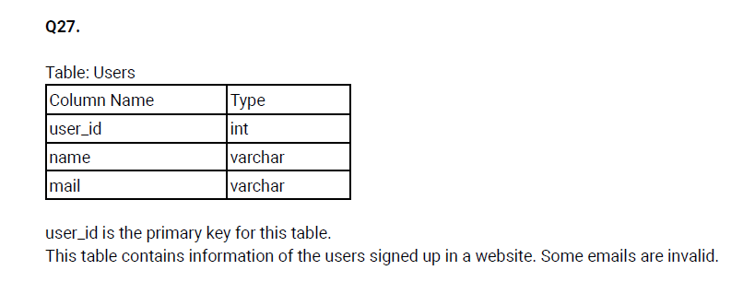

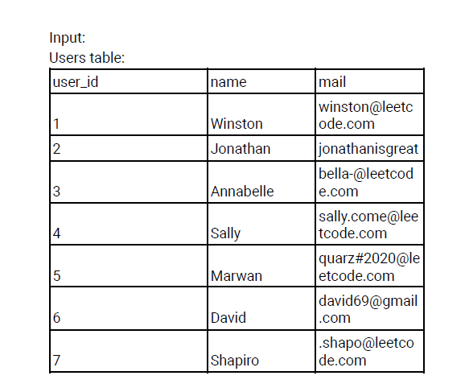

Write an SQL query to find the users who have valid emails.

A valid e-mail has a prefix name and a domain where:

* The prefix name is a string that may contain letters (upper or lower case), digits, underscore '_', period '.', and/or dash '-'. The prefix name must start with a letter.
* The domain is '@leetcode.com'.

***Solution:***

create table user(

    user_id int,

    name varchar(40),

    mail varchar(40),

    constraint pk PRIMARY KEY(user_id)

);

insert into user values(1,'Winston','winston@leetcode.com'),

(2,'Jonathan','jonathanisgreat'),

(3,'Annabelle','bella-@leetcode.com'),

(4,'Sally','sally.come@leetcode.com'),

(5,'Marwan','quarz#2020@leetcode.com'),

(6,'David','david69@gmail.com'),

(7,'Shapiro','.shapo@leetcode.com');

**Step 1:** Find domain name and name from given table;

**select user_id,mail,**

**substr(mail,1,instr(mail,'@')-1)as name,**

**substr(mail,instr(mail,'@')+1)as domain_name from user;**

**Step 2:** filter the domain name like ‘Leetcode.come’ and name start with letter**,**

**with cte as(select user_id,mail,**

**substr(mail,1,instr(mail,'@')-1)as name,**

**substr(mail,instr(mail,'@')+1)as domain_name from user)**

**select user_id,mail from cte**

**where domain_name='leetcode.com' and substr(lower(name),1,1) in('a','b','c','d','e','f','g','i','j','k','l','m','n',**

**'o','p','q','r','s','t','u','v','w','x','y','z');**

| user_id int | | | mail varchar |
| --- | --- | --- | --- |
|  | 1 |  | winston@leetcode.com |
|  | 3 |  | bella-@leetcode.com |
|  | 4 |  | sally.come@leetcode.com |
|  | 5 |  | quarz#2020@leetcode.com |

___________________________________________________________________

**Question 28;**

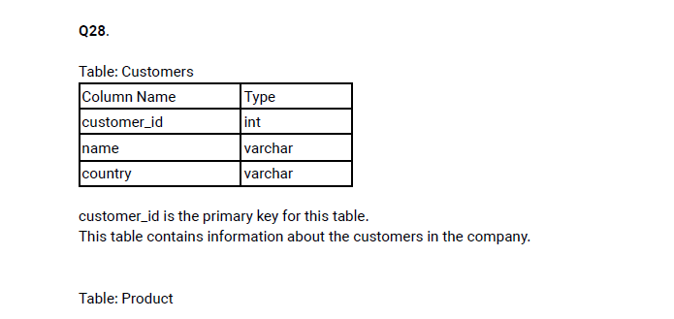

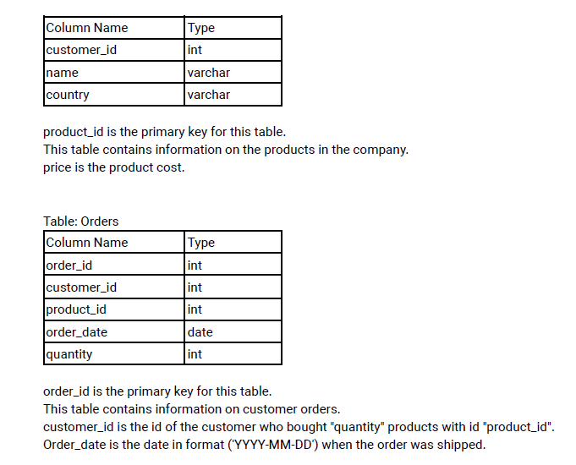

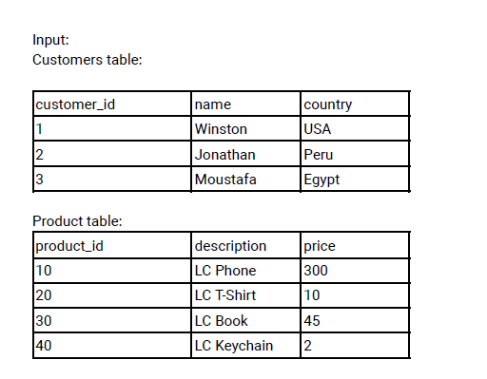

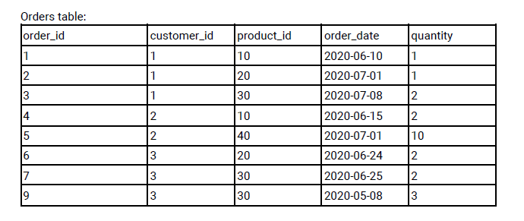

Write an SQL query to report the customer_id and customer_name of customers who have spent at least $100 in each month of June and July 2020.

***Solution:***

create table customers(

    customer_id int,

    name varchar(20),

    country varchar(20),

    constraint pk PRIMARY KEY(customer_id)

);

insert into customers values(1,'Winston','USA'),(2,'Jonathan','Peru'),(3,'Moustafa','Egypt');

create table product(

    product_id int,

    description varchar(20),

    price int,

    constraint pk PRIMARY KEY(product_id)

);

insert into product VALUES(10,'LC Phone',300),(20,'LC T-Shirt',10),

(30,'LC Book',45),(40,'LC Keychain',2);

create table ordered(

    order_id int,

    customer_id int,

    product_id int,

    order_date date,

    quantity int,

    constraint pk PRIMARY KEY(order_id)

);

insert into ordered VALUES(1,1,10,'2020-06-10',1),(2,1,20,'2020-07-01',1),(3,1,30,'2020-07-08',2),

(4,2,10,'2020-06-15',2),(5,2,40,'2020-07-01',10),(6,3,20,'2020-06-24',2),(7,3,30,'2020-06-25',2),

(9,3,30,'2020-05-08',3);

**Step 1:** Join the three table first,

**select *from ordered o left join customers c**

**on o.customer_id=c.customer_id**

**left join product p**

**on o.product_id=p.product_id;**

**step 2:** Find the month of june and july records

**select c.customer_id,c.name,extract(month from o.order_date)as month,(p.price*o.quantity)as total_price**

**from ordered o left join customers c**

**on o.customer_id=c.customer_id**

**left join product p**

**on o.product_id=p.product_id**

**where o.order_date between '2020-06-01' and '2020-07-31';**

**Step 3:** find total price of each month per person,

**with cte as(**

**select c.customer_id,c.name,extract(month from o.order_date)as month,(p.price*o.quantity)as total_price**

**from ordered o left join customers c**

**on o.customer_id=c.customer_id**

**left join product p**

**on o.product_id=p.product_id**

**where o.order_date between '2020-06-01' and '2020-07-31')**

**select customer_id,name,sum(case when month=6 then total_price end)as june,**

**sum(case when month=7 then total_price end)as july**

**from cte**

**group by customer_id,name;**

**Step 4:** Find to who have order above 100$ each month

**with cte as(select c.customer_id,c.name,extract(month from o.order_date)as**

**month,(p.price*o.quantity)as total_price**

**from ordered o left join customers c**

**on o.customer_id=c.customer_id**

**left join product p**

**on o.product_id=p.product_id**

**where o.order_date between '2020-06-01' and '2020-07-31'),**

**result_1 as (select customer_id,name,sum(case when month=6 then total_price end)as june,**

**sum(case when month=7 then total_price end)as july**

**from cte**

**group by customer_id,name)**

**select customer_id,name from result_1**

**where june>=100 and july>=100;**

| customer_id int | | | name varchar |
| --- | --- | --- | --- |
|  | 1 |  | Winston |

___________________________________________________________________

**Question 29;**

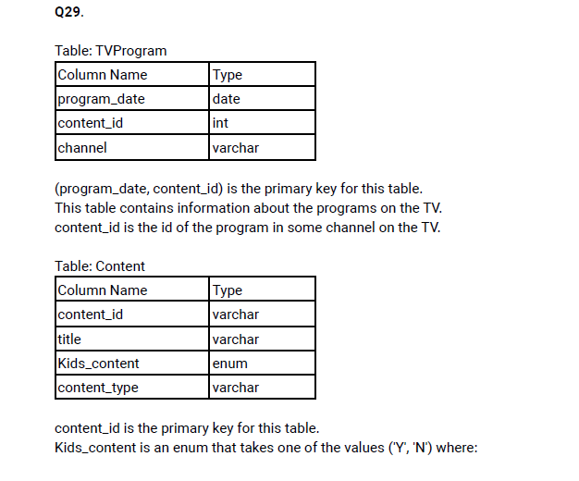

'Y' means content for kids, otherwise 'N' is not content for kids. content_type is the category of the content as movies, series, etc.

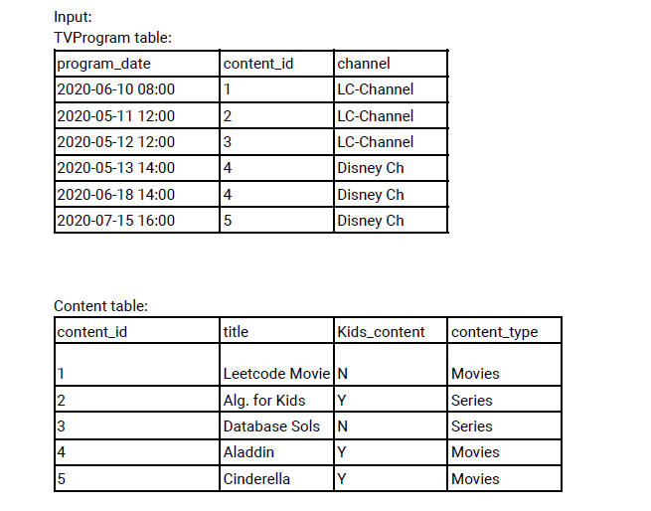

Write an SQL query to report the distinct titles of the kid-friendly movies streamed in June 2020.

***Solution:***

create table TVProgram(

    program_date date,

    content_id int,

    channel varchar(20),

    constraint pk PRIMARY KEY(program_date,content_id)

);

insert into TVProgram values('2020-06-10 08:00',1,'LC-Channel'),

('2020-05-11 12:00',2,'LC-Channel'),

('2020-05-12 12:00',3,'LC-Channel'),

('2020-05-13 14:00',4,'Disney Ch'),

('2020-06-18 14:00',4,'Disney Ch'),

('2020-07-15 16:00',5,'Disney Ch');

create table content (

    content_id VARCHAR(40),

    title VARCHAR(30),

    kids_content enum('Y','N'),

    content_type VARCHAR(30),

    constraint pk PRIMARY KEY(content_id)

);

insert into content values(1,'Leetcode Movie','N','Movies'),

(2,'Alg. for Kids','Y','Series'),

(3,'Database Sols','N','Series'),

(4,'Aladdin','Y','Movies'),

(5,'Cinderella','Y','Movies');

select distinct(c.title) from TVProgram t left join content c

on t.content_id=c.content_id

where c.kids_content like 'Y' and c.content_type like 'Movies' and extract(month from t.program_date)=6;

| title varchar | | |
| --- | --- | --- |
|  |  | Aladdin |

___________________________________________________________________

**Question 30 & 31;**

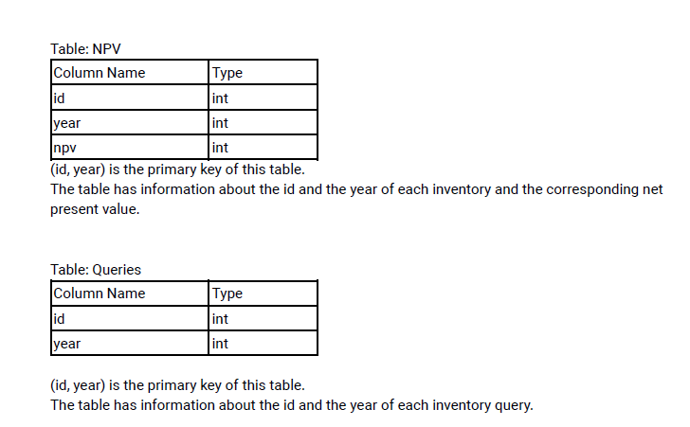

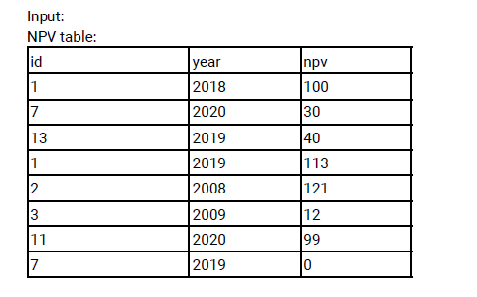

**Queries table;**

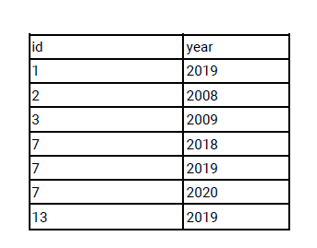

Write an SQL query to find the npv of each query of the Queries table.

create table NPV(

    id int,

    year int,

    npv int,

    constraint pk PRIMARY key(id,year)

);

insert into NPV values(1,2018,100),(7,2020,30),(13,2019,40),(1,2019,113),(2,2008,121),(3,2009,12),(11,2020,99),(7,2019,0);

create table Queries (

    id int,

    year int,

    constraint pk PRIMARY KEY(id,year)

) ;

insert into Queries values(1,2019),(2,2008),(3,2009),(7,2018),(7,2019),(7,2020),(13,2019);

***Solution:***

select q.*,

(case when n.npv is null then 0 else n.npv end)as npv

from  Queries q left join NPV n

on n.id=q.id and n.year=q.year;

| id int | | year int | | npv bigint |
| --- | --- | --- | --- | --- |
|  | 1 |  | 2019 | 113 |
|  | 2 |  | 2008 | 121 |
|  | 3 |  | 2009 | 12 |
|  | 7 |  | 2018 | 0 |
|  | 7 |  | 2019 | 0 |
|  | 7 |  | 2020 | 30 |
|  | 13 |  | 2019 | 40 |

___________________________________________________________________

**Question 32 & 37;**

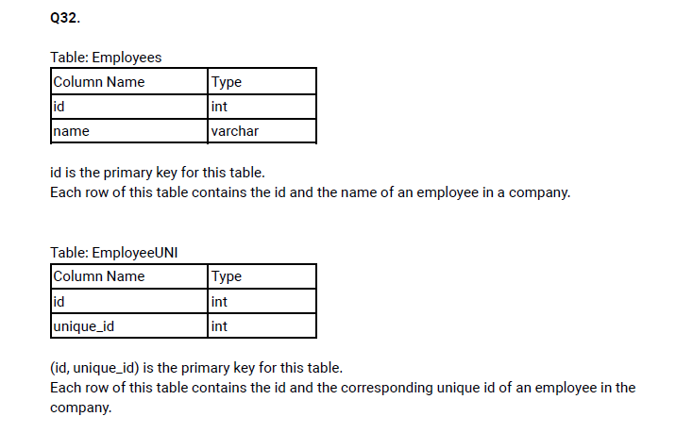

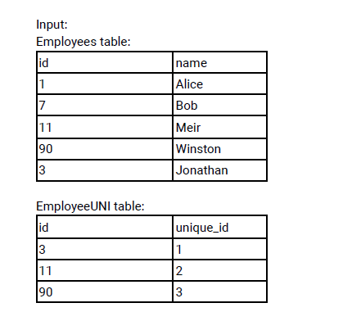

create table employee (

    id int,

    name VARCHAR(20),

    constraint pk PRIMARY KEY(id)

);

insert into employee values(1,'Alice'),(7,'Bob'),(11,'Meir'),(90,'Winston'),(3,'Jonathan');

create table employee_uni(

    id int,

    unique_id int,

    constraint pk PRIMARY KEY(id,unique_id)

);

insert into employee_uni values(3,1),(11,2),(90,3);

Write an SQL query to show the unique ID of each user, If a user does not have a unique ID replace just show null.

***Solution:***

select u.unique_id,e.name from employee e left join employee_uni u

on e.id=u.id

order by e.name;

| unique_id int | | | name varchar |
| --- | --- | --- | --- |
|  |  | (NULL) | Alice |
|  |  | (NULL) | Bob |
|  |  | 1 | Jonathan |
|  |  | 2 | Meir |
|  |  | 3 | Winston |

___________________________________________________________________

**Question 33 & 36;**

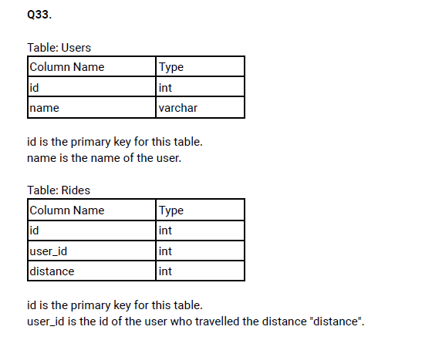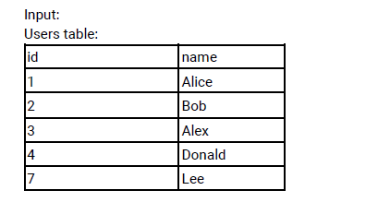

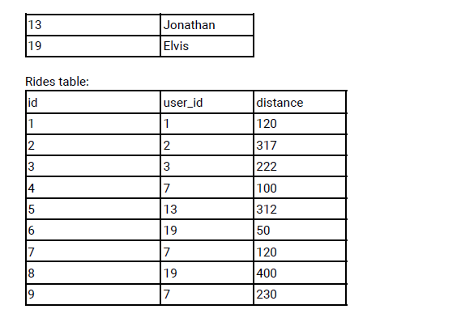

create table users(

    id int,

    name VARCHAR(20),

    constraint pk PRIMARY KEY(id)

);

insert into users values(1,'Alice'),(2,'Bob'),(3,'Alex'),(4,'Donald'),(7,'Lee'),(13,'Jonathan'),(19,'Elvis');

create table rides(

    id int,

    user_id int ,

    distance int,

    constraint pk PRIMARY KEY(id)

);

insert into rides values(1,1,120),(2,2,317),(3,3,222),(4,7,100),(5,13,312),(6,19,50),(7,7,120),(8,19,400),(9,7,230);

Write an SQL query to report the distance travelled by each user. Return the result table ordered by travelled_distance in descending order, if two or more users travelled the same distance, order them by their name in ascending order.

***Solution:***

select u.name,

sum(case when r.distance is null then 0 else r.distance end) as distance

from users u left join rides r

on u.id=r.user_id

group by u.name

order by distance desc, u.name asc;

| name varchar | | | distance newdecimal | |
| --- | --- | --- | --- | --- |
|  |  | Lee | | 450 |
|  |  | Elvis | | 450 |
|  |  | Bob | | 317 |
|  |  | Jonathan | | 312 |
|  |  | Alex | | 222 |
|  |  | Alice | | 120 |
|  |  | Donald | | 0 |

___________________________________________________________________

**Question 34;**

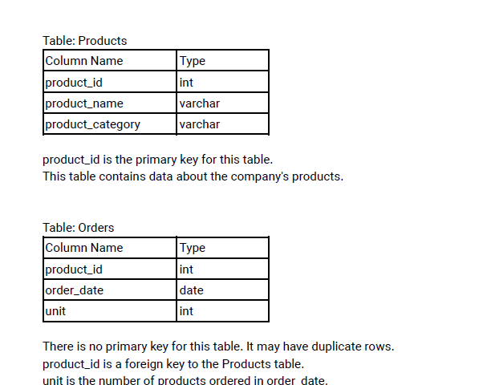

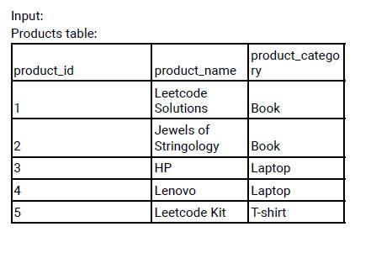

create table products(

    product_id int,

    product_name varchar(40),

    product_category varchar(20),

    constraint pk PRIMARY KEY(product_id)

);

insert into products values(1,'Leetcode Solutions','Book'),

(2,'Jewels of Stringology','Book'),

(3,'HP','Laptop'),

(4,'Lenovo','Laptop'),

(5,'Leetcode Kit','T-shirt');

Create table orders(

    product_id int,

    order_date date,

    unit int

);

insert into orders values(1,'2020-02-05',60),(1,'2020-02-10',70),(2,'2020-01-18',30),

(2,'2020-02-11',80),(3,'2020-02-17',2),(3,'2020-02-24',3),(4,'2020-03-01',20),

(4,'2020-03-04',30),(4,'2020-03-04',60),(5,'2020-02-25',50),(5,'2020-02-27',50),

(5,'2020-03-01',50);

Write an SQL query to get the names of products that have at least 100 units ordered in February 2020 and their amount.

***Solution:***

with cte as(select p.product_name,sum(o.unit)as unit  from products p left join orders o

on p.product_id=o.product_id

where extract(month from o.order_date)=2

group by p.product_name)

select *from cte where unit>=100;

| product_name varchar | | | unit newdecimal | |
| --- | --- | --- | --- | --- |
|  |  | Leetcode Solutions | | 130 |
|  |  | Leetcode Kit | | 100 |

___________________________________________________________________

**Question 35;**

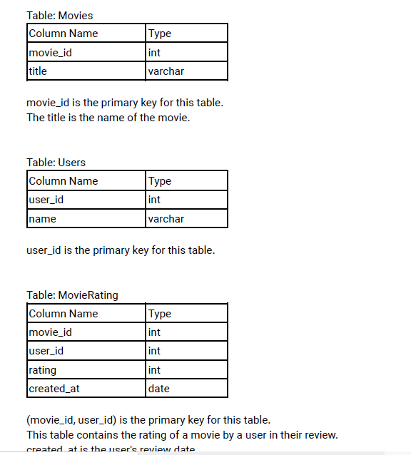

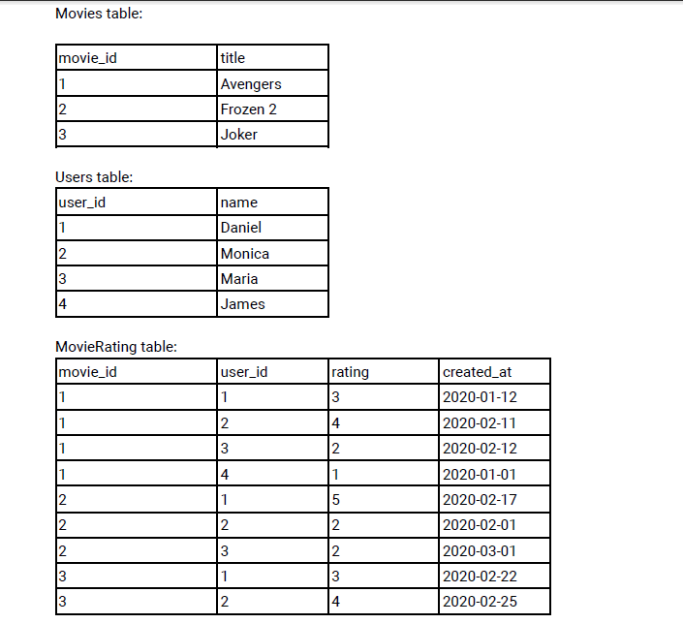

create table Movies(

movie_id int,

    title varchar(20),

    constraint pk PRIMARY KEY(movie_id)

);

insert into Movies values(1,'Avengers'),(2,'Frozen2'),(3,'Joker');

create table users(

    user_id int,

    name VARCHAR(20),

    constraint pk PRIMARY KEY(user_id)

);

insert into users values(1,'Daniel'),(2,'Monica'),(3,'Maria'),(4,'James');

create table MovieRating(

    movie_id int,

    user_id int,

    rating int,

    created_at date,

    constraint pk PRIMARY KEY (movie_id,user_id)

);

insert into MovieRating values(1,1,3,'2020-01-12'),

(1,2,4,'2020-02-11'),

(1,3,2,'2020-02-12'),(1,4,1,'2020-01-01'),(2,1,5,'2020-02-17'),

(2,2,2,'2020-02-01'),(2,3,2,'2020-03-01'),

(3,1,3,'2020-02-22'),(3,2,4,'2020-02-25');

Write an SQL query to:

* Find the name of the user who has rated the greatest number of movies. In case of a tie, return the lexicographically smaller user name.
* Find the movie name with the highest average rating in February 2020. In case of a tie, return the lexicographically smaller movie name.

Step 1: Query1

select result from(select u.name as result from MovieRating r left join Movies M

on r.movie_id=M.movie_id

left join users u on r.user_id=u.user_id

group by u.name

order by u.name limit 1)s1

step 2:Query2

select title as result from (select M.title,avg(r.rating)as rating from MovieRating r left join Movies M

on r.movie_id=M.movie_id

left join users u on r.user_id=u.user_id

where extract(month from r.created_at)=2

group by M.title

order by rating desc,M.title limit 1 )s

;

Step 3: Union the query,

select result from(select u.name as result from MovieRating r left join Movies M

on r.movie_id=M.movie_id

left join users u on r.user_id=u.user_id

group by u.name

order by u.name limit 1)s1

union

select title as result from (select M.title,avg(r.rating)as rating from MovieRating r left join Movies M

on r.movie_id=M.movie_id

left join users u on r.user_id=u.user_id

where extract(month from r.created_at)=2

group by M.title

order by rating desc,M.title limit 1 )s

;

| result varchar | | |
| --- | --- | --- |
|  |  | Daniel |
|  |  | Frozen2 |

___________________________________________________________________

**Question 38;**

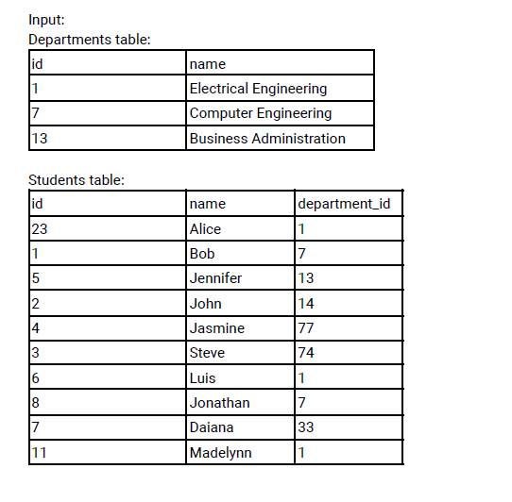

create table departments(

    id int,

    name VARCHAR(60),

    constraint pk PRIMARY KEY(id)

);

insert into departments values(1,'Electrical Engineering'),(7,'Computer Engineering'),(13,'Business Administration');

create table students(

    id int,

    name varchar(20),

    department_id int,

    constraint pk PRIMARY KEY(id)

);

insert into students values(23,'Alice',1),(1,'Bob',7),(5,'Jennifer',13),(2,'John',14),(4,'Jasmine',77),

(3,'Steve',74),(6,'Luis',1),(8,'Jonathan',7),(7,'Daiana',33),(11,'Madelynn',1);

Write an SQL query to find the id and the name of all students who are enrolled in departments that no longer exist.

***Solution:***

select id,name from  students

where department_id not in (select id from departments);

| id int | | | name varchar |
| --- | --- | --- | --- |
|  | 2 |  | John |
|  | 3 |  | Steve |
|  | 4 |  | Jasmine |
|  | 7 |  | Daiana |

___________________________________________________________________

**Question 39;**

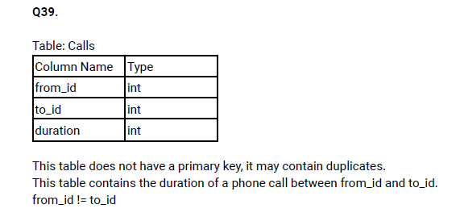

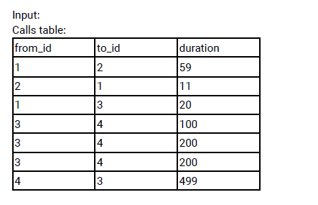

Write an SQL query to report the number of calls and the total call duration between each pair of distinct persons (person1, person2) where person1 < person2.

***Solution:***

with cte as(select from_id as person1 , to_id as person2,duration

            from calls

            union ALL

            select to_id as person1, from_id as person2, duration

            from calls

),

result_1 as(select person1,person2,duration from cte

            where person1<person2

)

select person1,person2,count(*)as call_count,sum(duration)as total_duration

from result_1

group by person1,person2;

___________________________________________________________________

**Question 41;**

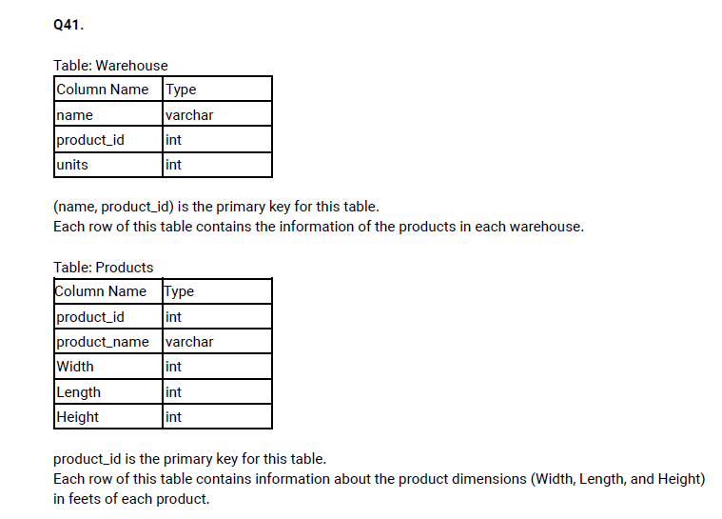

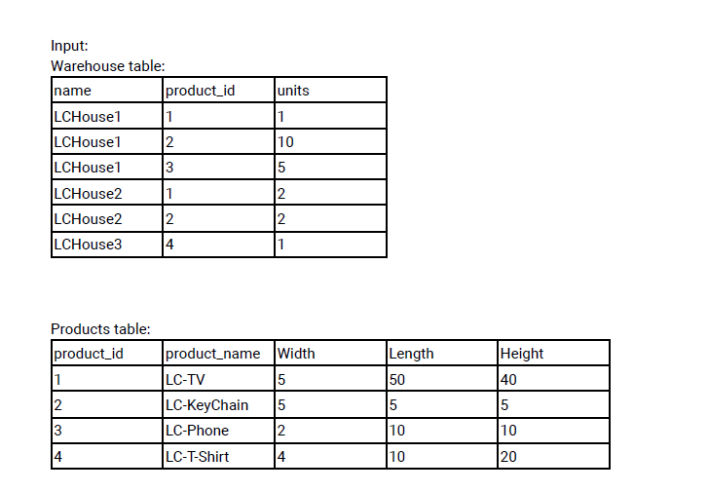

create table warehouse(

    name VARCHAR(20),

    product_id int,

    units int,

    constraint pk PRIMARY KEY(name,product_id)

);

insert into warehouse values('LCHouse1',1,1),('LCHouse1',2,10),('LCHouse1',3,5),

('LCHouse2',1,2),('LCHouse2',2,2),('LCHouse3',4,1);

create table products(

    product_id int,

    product_name varchar(20),

    Width int,

    Length int,

    Height int,

    constraint pk PRIMARY Key(product_id)

);

insert into products values(1,'LC-TV',5,50,40),(2,'LC-KeyChain',5,5,5),

(3,'LC-Phone',2,10,10),(4,'LC-T-Shirt',4,10,20);

Write an SQL query to report the number of cubic feet of volume the inventory occupies in each warehouse.

***Solution:***

with cte as(select w.name,w.product_id,(w.units*p.Width*p.Length*p.Height)as volume

            from warehouse w left join products p

            on w.product_id=p.product_id

)

select name,sum(volume)as total_volume from cte

group by name;

| name varchar | | | total_volume newdecimal | |
| --- | --- | --- | --- | --- |
|  |  | LCHouse1 | | 12250 |
|  |  | LCHouse2 | | 20250 |
|  |  | LCHouse3 | | 800 |

___________________________________________________________________

**Question 42;**

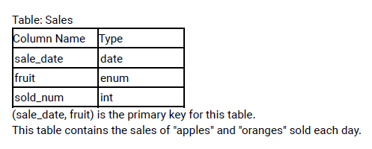

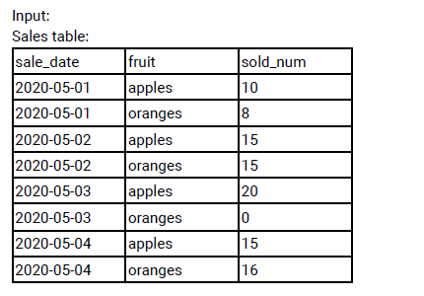

CREATE table sales(

    sale_date date,

    fruit enum('apples','oranges'),

    sold_num int,

    constraint pk PRIMARY Key(sale_date,fruit)

);

insert into sales values('2020-05-01','apples',10),('2020-05-01','oranges',8),

('2020-05-02','apples',15),('2020-05-02','oranges',15),('2020-05-03','apples',20),

('2020-05-03','oranges',0),('2020-05-04','apples',15),('2020-05-04','oranges',16);

Write an SQL query to report the difference between the number of apples and oranges sold each day. Return the result table ordered by sale_date.

***Solution:***

Step 1:

select s1.sale_date,s1.sold_num as apple_sal,s2.sold_num as orange_sal,

row_number() over(partition by s1.sale_date)as row_num

from sales s1 left join sales s2

on s1.sale_date = s2.sale_date and s1.fruit!=s2.fruit

Step 2: Find difference

with cte as(select s1.sale_date,s1.sold_num as apple_sal,s2.sold_num as orange_sal,

            row_number() over(partition by s1.sale_date)as row_num

            from sales s1 left join sales s2

            on s1.sale_date = s2.sale_date and s1.fruit!=s2.fruit

)

select sale_date,(apple_sal-orange_sal)as diff

from cte where row_num=1;

| sale_date date | | | diff bigint | |
| --- | --- | --- | --- | --- |
|  |  | 2020-05-01 | | 2 |
|  |  | 2020-05-02 | | 0 |
|  |  | 2020-05-03 | | 20 |
|  |  | 2020-05-04 | | -1 |

___________________________________________________________________

**Question 43;**





create table Activity(

    player_id int,

    device_id int,

    event_date date,

    games_played int,

    constraint pk PRIMARY KEY(player_id,event_date)

);

insert into Activity values(1,2,'2016-03-01',5),

(1,2,'2016-05-02',6),

(2,3,'2017-06-25',1),

(3,1,'2016-03-02',0),

(3,4,'2018-07-03',5);

Write an SQL query to report the fraction of players that logged in again on the day after the day they first logged in, rounded to 2 decimal places. In other words, you need to count the number of players that logged in for at least two consecutive days starting from their first login date, then divide that

number by the total number of players.

***Solution:***

**Step 1:** using LAG function find prev_date

select *,lag(event_date) over(partition by player_id order by event_date)as prev_date

from Activity

**Step 2:** using case statement if null then 0 in prev_date

with cte as(select *,lag(event_date) over(partition by player_id order by event_date)as prev_date

from Activity),

select player_id,event_date,(case when prev_date is null then 0 else prev_date end)as date  from cte

**Step 3:** find date diff from event_date and prev_date

with cte as(select *,lag(event_date) over(partition by player_id order by event_date)as prev_date

from Activity),

result_1 as(select player_id,event_date,(case when prev_date is null then 0 else prev_date end)as date  from cte),

select count(*)as immediate_login,

(select count(distinct player_id)from Activity)

as total_player

from (select *,DATEDIFF(event_date,date)as diff from result_1 ) s

where diff in (1,2);

**Step 4:** calculate the fraction

with cte as(

    select *,lag(event_date) over(partition by player_id order by event_date)as prev_date

     from Activity

),

result_1 as(

    select player_id,event_date,(case when prev_date is null then 0 else prev_date end)as date

     from cte

),

result_2 as(

select count(*)as immediate_login, (select count(distinct player_id)from Activity)as total_player

from (select *,DATEDIFF(event_date,date)as diff from result_1 ) s

where diff in (1,2)

)

select round(immediate_login/total_player,2)as login_count from result_2;

| login_count newdecimal | | |
| --- | --- | --- |
|  |  | 0.33 |

___________________________________________________________________

**Question 44;**

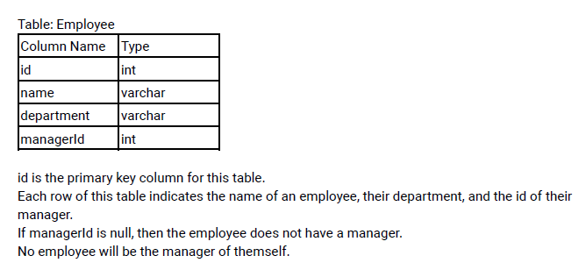

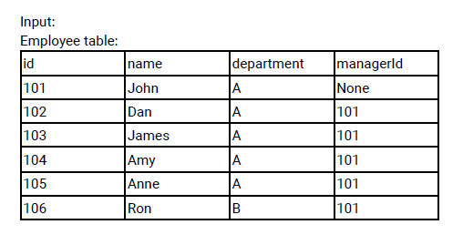

create table employee(

    id INT,

    name varchar(20),

    department varchar(20),

    managerId int,

    constraint pk PRIMARY KEY(id)

);

insert into employee values (101,'John','A',NULL),

(102,'Dan','A',101),(103,'James','A',101),

(104,'Amy','A',101),

(105,'Anne','A',101),

(106,'Ron','B',101);

Write an SQL query to report the managers with at least five direct reports.

***Solution:***

**Step 1:** count manager_id

select count(managerid) as count,managerid from employee

group by managerid

**Step 2:** Find who are getting 5 direct report

with cte as(select count(managerid) as count,managerid from employee

group by managerid)

select name from employee

where id =  (select managerid from cte where count=5);

| name varchar | | |
| --- | --- | --- |
|  |  | John |

___________________________________________________________________

**Question 45;**

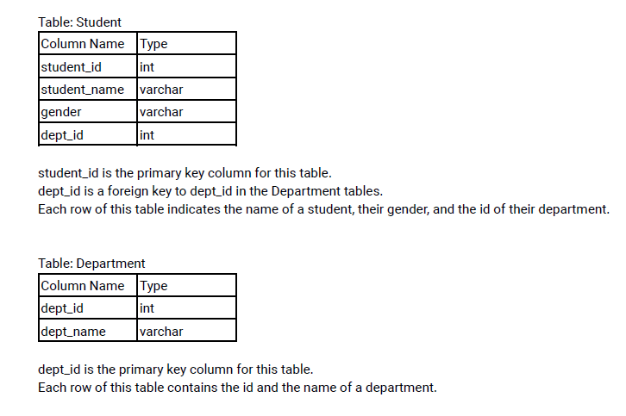

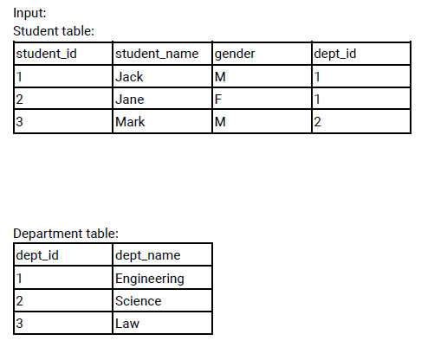

create table student(

    student_id int,

    student_name varchar(20),

    gender varchar(10),

    dept_id int,

    constraint pk PRIMARY KEY(student_id,dept_id)

);

insert into student VALUES(1,'Jack','M',1),(2,'Jane','F',1),(3,'Mark','M',2);

create table department(

    dept_id int,

    dept_name varchar(20),

    constraint pk PRIMARY KEY(dept_id)

);

insert into department values(1,'Engineering'),(2,'Science'),(3,'Law');

Write an SQL query to report the respective department name and number of students majoring in each department for all departments in the Department table (even ones with no current students). Return the result table ordered by student_number in descending order. In case of a tie, order them by

dept_name alphabetically.

***Solution:***

**Step 1:** Find count student_id based on dept_name

select d.dept_name,

           count(s.student_id) over(partition by d.dept_name )as stud_num

           from department d left join student s

on s.dept_id=d.dept_id;

**Step 2:** group by the dept_name, stud_num and order by stud_num

with cte as(select d.dept_name,

           count(s.student_id) over(partition by d.dept_name )as stud_num

           from department d left join student s

on s.dept_id=d.dept_id)

select dept_name,stud_num from  cte group by dept_name,stud_num

order by stud_num desc;

| dept_name varchar | | | stud_num bigint | |
| --- | --- | --- | --- | --- |
|  |  | Engineering | | 2 |
|  |  | Science | | 1 |
|  |  | Law | | 0 |

___________________________________________________________________

**Question 46;**

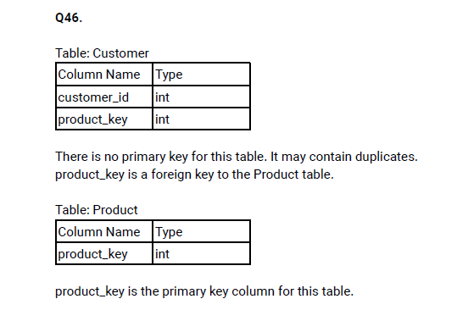

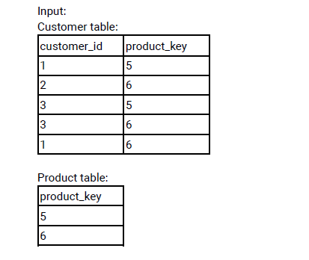

create table product(

    product_key int,

    constraint pk PRIMARY key(product_key)

);

INSERT into product values(5),(6);

create table customer(

    customer_id int,

    product_key int,

    constraint fk FOREIGN KEY(product_key) REFERENCES product(product_key)

);

insert into customer VALUES(1,5),(2,6),(3,5),(3,6),(1,6);

Write an SQL query to report the customer ids from the Customer table that bought all the products in the Product table.

***Solution:***

**Step 1:** Merge product_key based on customer_id

select customer_id,

group_concat(distinct product_key separator ',')as product_key

from customer

group by customer_id;

**Step 2:** Merge the product_key

select group_concat(product_key separator ',')as product_key

from  product

**Step 3:** find the product_key are eqeual in customer table

with cte as(select customer_id,

group_concat(distinct product_key separator ',')as product_key

from customer

group by customer_id

),

result_1 as(select group_concat(product_key separator ',')as product_key

from  product)

select customer_id from cte

where product_key = (select product_key from result_1);

| customer_id int | | |
| --- | --- | --- |
|  |  | 1 |
|  |  | 3 |

___________________________________________________________________

**Question 47;**

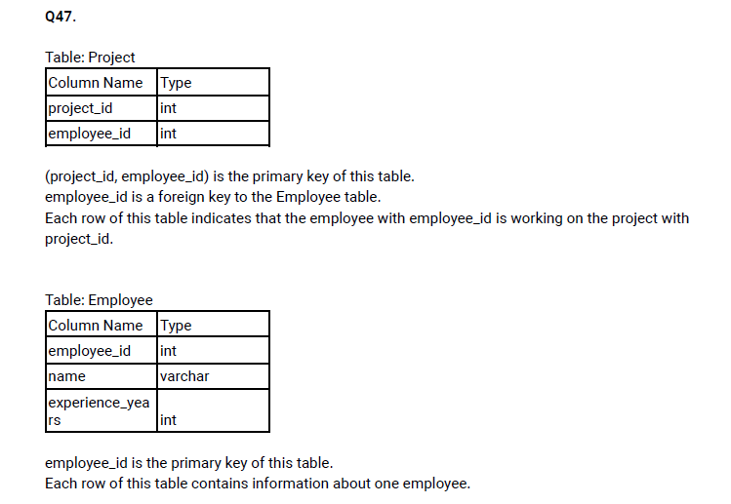

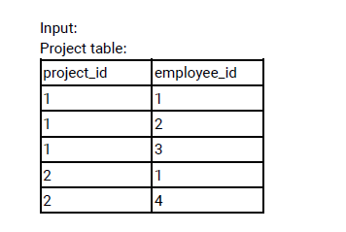

Employee table:

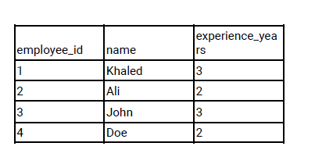

create table project(

    project_id int,

    employee_id int,

    constraint pk PRIMARY KEY(project_id,employee_id)

);

insert into project values(1 ,1),(1, 2),(1, 3),(2 ,1),(2, 4);

create table employee(

    employee_id int,

    name varchar(20),

    experience_years int,

    constraint pk PRIMARY KEY(employee_id)

);

insert into employee values(1,'Khaled',3),(2,'Ali',2),(3,'John',3),(4,'Doe',2);

Write an SQL query that reports the most experienced employees in each project. In case of a tie, report all employees with the maximum number of experience years.

***Solution:***

**Step 1:** find max_exp from those two table based on project_id

select p.*,e.experience_years,

max(e.experience_years) over(partition by p.project_id)as max_exp

from project p left join employee e

on p.employee_id=e.employee_id;

**Step 2:** filter the dataset where experience is equal to max_exp

with cte as(select p.*,e.experience_years,

max(e.experience_years) over(partition by p.project_id)as max_exp

from project p left join employee e

on p.employee_id=e.employee_id)

select project_id,employee_id from cte

where experience_years=max_exp;

| project_id int | | | employee_id int | |
| --- | --- | --- | --- | --- |
|  |  | 1 | | 1 |
|  |  | 1 | | 3 |
|  |  | 2 | | 1 |

___________________________________________________________________

**Question 49;**

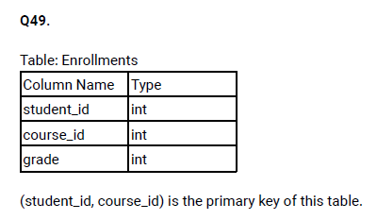

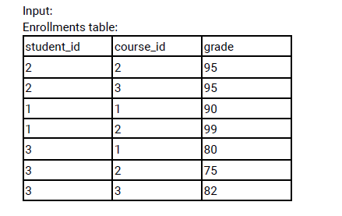

create table enrollments(

    student_id int,

    course_id int,

    grade int,

    constraint pk PRIMARY KEY(student_id, course_id)

);

insert into enrollments values(2 ,2, 95),(2, 3, 95),(1,1,90),(1,2,99),(3,1, 80),(3,2,75),(3,3,82);

Write a SQL query to find the highest grade with its corresponding course for each student. In case of a tie, you should find the course with the smallest course_id.

Return the result table ordered by student_id in ascending order.

***Solution:***

**Step 1:** Find the max_grade based on student_id order by course_id,grade desc

select student_id,course_id,grade,

rank() over(partition by student_id order by course_id,grade desc )as max_grade

from enrollments;

**Step 2:** Filter the dataset where max_grade=1

with cte as(select student_id,course_id,grade,

rank() over(partition by student_id order by course_id,grade desc )as max_grade

from enrollments

)

select student_id,course_id,grade from cte where max_grade=1;

| student_id int | | | course_id int | | grade int |
| --- | --- | --- | --- | --- | --- |
|  | 1 |  | | 1 | 90 |
|  | 2 |  | | 2 | 95 |
|  | 3 |  | | 1 | 80 |

___________________________________________________________________

**Question 50;**

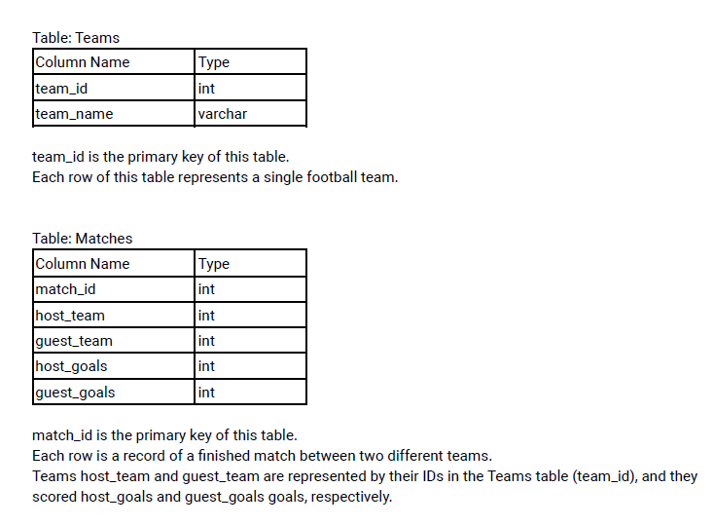

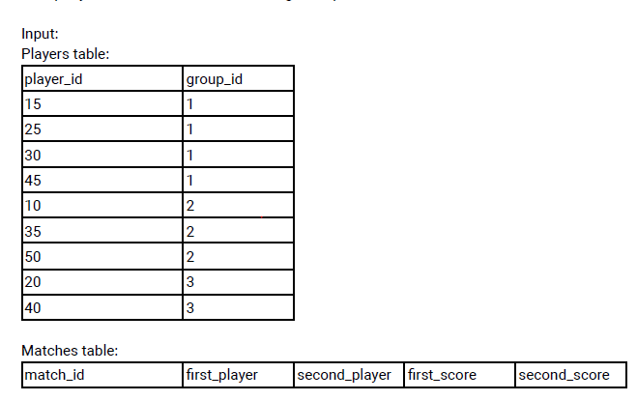

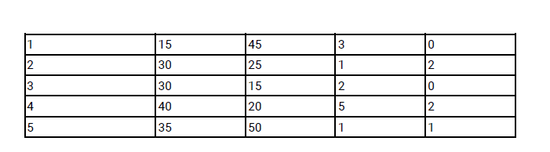

create table teams(

    player_id int,

    group_id VARCHAR(20),

    constraint pk PRIMARY KEY(player_id)

);

insert into teams values(15 ,1),(25,1),(30,1),(45,1),

(10,2),(35,2),(50,2),(20,3),(40,3);

create table matches(

    match_id int,

    first_player int,

    second_plyer int,

    first_score int,

    second_score int,

    constraint pk PRIMARY KEY(match_id)

);

insert into matches values(1,15,45,3,0),(2,30,25,1,2),

(3,30,15,2,0),(4,40,20,5,2),(5,35,50,1,1);

The winner in each group is the player who scored the maximum total points within the group. In the case of a tie, the lowest player_id wins.

Write an SQL query to find the winner in each group.

***Solution:***

**Step 1:** Join the those table and find rank of player_id based on group_id order by first_player

select m.match_id,m.first_player,t.group_id,

rank() over(partition by t.group_id order by m.first_player )as player_id

 from matches m left join teams t

on m.first_player=t.player_id;

**Step 2:** filtter the data where player_id min

with cte as (select m.match_id,m.first_player,t.group_id,

rank() over(partition by t.group_id order by m.first_player )as player_id

 from matches m left join teams t

on m.first_player=t.player_id)

SELECT group_id,first_player from cte where player_id=1;

| group_id varchar | | | first_player int | |
| --- | --- | --- | --- | --- |
|  | 1 |  | | 15 |
|  | 2 |  | | 35 |
|  | 3 |  | | 40 |

___________________________________________________________________