Create a Chat bot in python

Date | 1 November 2023
Team ID | 329
Project Name | Create a Chat bot in python
Name | Gunasekar

PROBLEM DEFINITION
Defining Problem Statement and prioritizing ideas based on Project.
It is a project that involves a computer program that can interact with user. With basic conversation.

“This Project is a software application designed to simulate human conversation and They can use our chatbot at any time”.

You May ask why this project is used for, we have given some list of ideas and thoughts that those are the reasons for creating this project.

Those reasons are given below,

PROBLEMS

Problems

Why we should use Chat Bot
&
Approaches used for Chat Bot

Ideas and Approaches

Dhanasekaren Hemanth Gunasekar

24/7
Accessibility
Efficient
Information
Retrieval
Personalized
Assistance

Generative Models
NLP(Natural
Language
Processing)
Generative
Models
Machine
Learning

Innovation
and
Modernization
Assistance
for
International
Students
Streamlined
Admissions
Process

Dilip Harish MD
Event
Reminders
& Updates
Rule-Based
Voice-Based

Campus
Navigation

Prioritizing Ideas

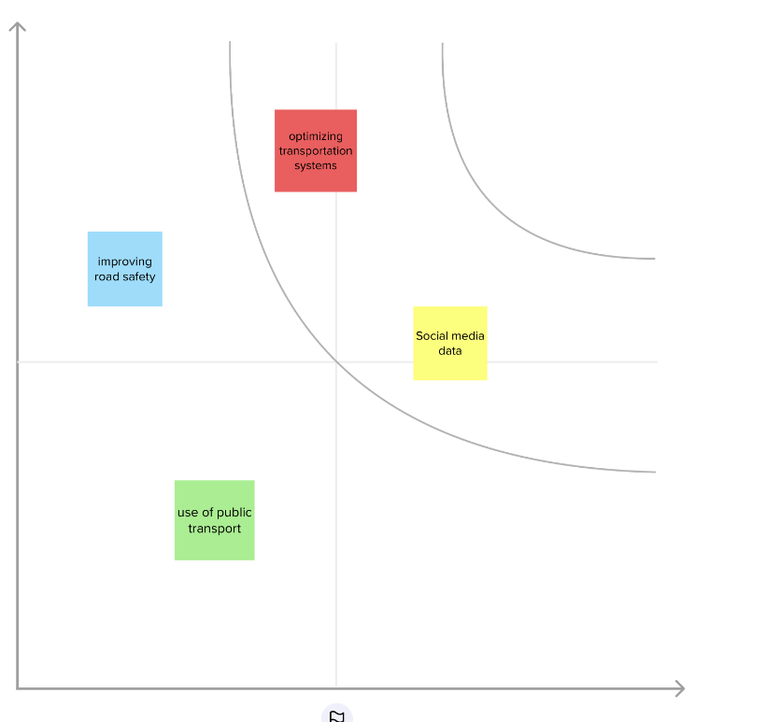

24/7
Accessibility
Generative
models
Natural
Language
Processing

Answering
Frequently
Asked
Questions

Importance
If each of these
tasks could get
done without any difficulty or cost, which would have the most positive impact

Feasibility
Regardless of their importance, which tasks are more feasible than others?
(Cost, time, effort, complexity, etc)

phases of development

phase 1: Problem statement, Design thinking process.
phase 2: Use a model, here i used Decision Tree.
Phase 3: Then use flask to create a Webpage
phase 4: Then use HTML and CSS to enhance the page

Libraries used

1.Flask
Flask is used for developing web applications using python

2.string
Strings can be used to handle textual data in Python

3.re
Regular Expression Syntax. A regular expression (or RE) specifies a set of strings that matches it; the functions in this module let you check if a particular string matches a given regular expression

4.unicodedata
This module provides access to UCD and uses the same symbols and names as defined by the Unicode Character Database

5.pandas
It provides many functions and methods to expedite the data analysis process

6.sklearn
Scikit-Learn, also known as sklearn is a python library to implement machine learning models and statistical modelling
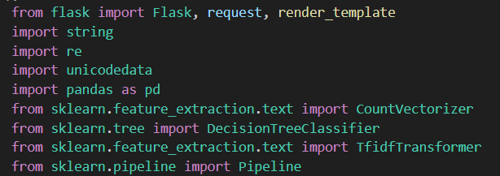

Integration of NLP techniques

Package name: transformers
Use: For GPT-3 integration
Command to install: pip install transformers
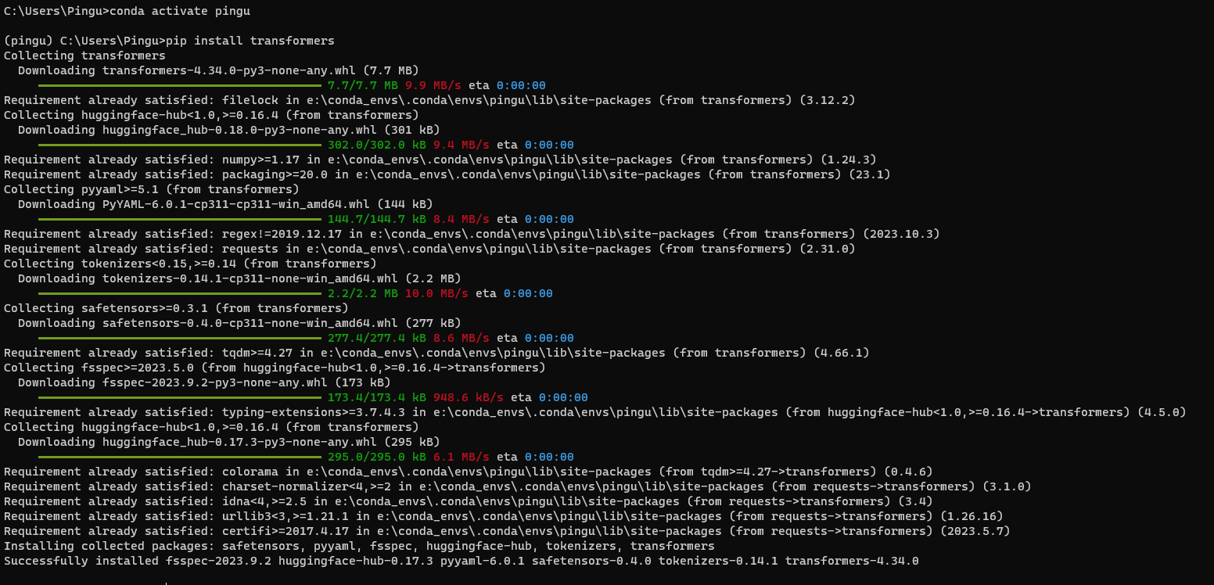

As per the phase 3 submission they want me to install transformers and flask and i installed.
In phase 3 they provided like integrate with GPT – 3 Using transformers but there is no GPT-3 in transformers only GPT – 2 function is present. So, I did not use the transformers libraries instead i used the Decision Tree in Sklearn library and made a pipe.

web application

Flask library is used to integrate with the web
Package name: Flask
Use: For web app development
Command to install: pip install Flask

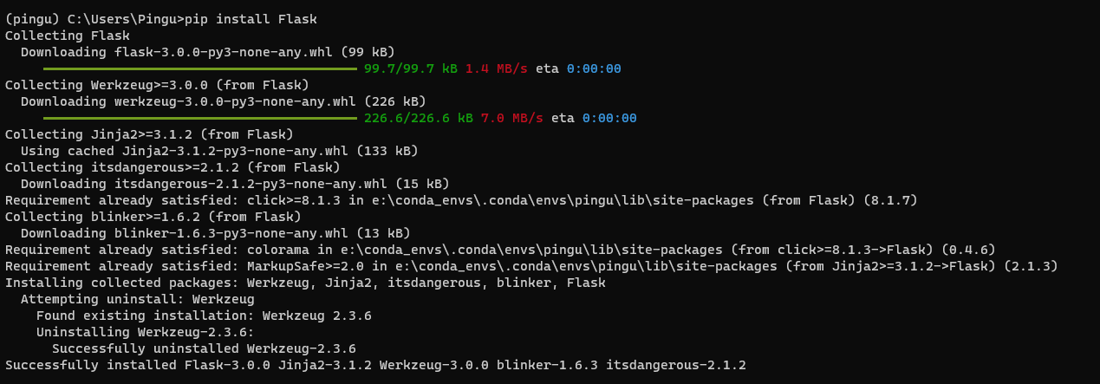

Preprocessing the dataset

I provided source code file called “AI_Phase3_source_code.ipynb” in my git hub repository

# import all required libraries

import string
from nltk.corpus import stopwords
import pandas as pd
import matplotlib.pyplot as plt
import seaborn as sns
from sklearn.feature_extraction.text import CountVectorizer
from sklearn.tree import DecisionTreeClassifier
from sklearn.feature_extraction.text import TfidfTransformer,TfidfVectorizer
from sklearn.pipeline import Pipeline

# importing the dataset

df = pd.read_csv(r"C:\Users\Pingu\Desktop\IBM\AI_Phase3\dialogs.txt", sep='\t')

df.head()
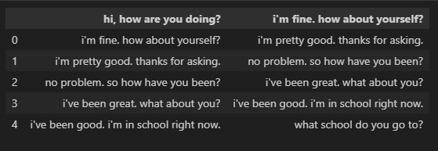

# add column names

df.columns=['Questions','Answers']
df
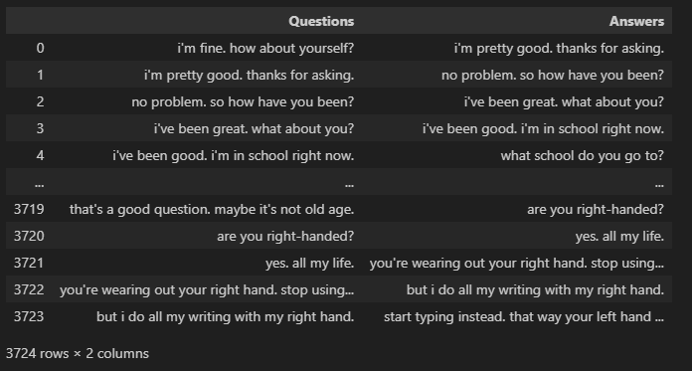

# Data Preprocessing

df['question tokens']=df['Questions'].apply(lambda x:len(x.split()))
df['answer tokens']=df['Answers'].apply(lambda x:len(x.split()))
plt.style.use('fivethirtyeight')
fig,ax=plt.subplots(nrows=1,ncols=2,figsize=(20,5))
sns.set_palette('Set2')
sns.histplot(x=df['question tokens'],data=df,kde=True,ax=ax[0])
sns.histplot(x=df['answer tokens'],data=df,kde=True,ax=ax[1])
sns.jointplot(x='question tokens',y='answer tokens',data=df,kind='kde',fill=True,cmap='YlGnBu')
plt.show()
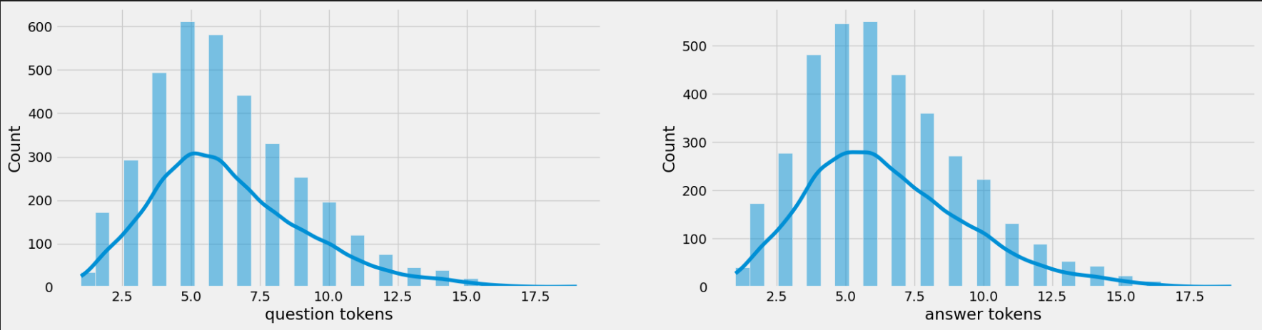
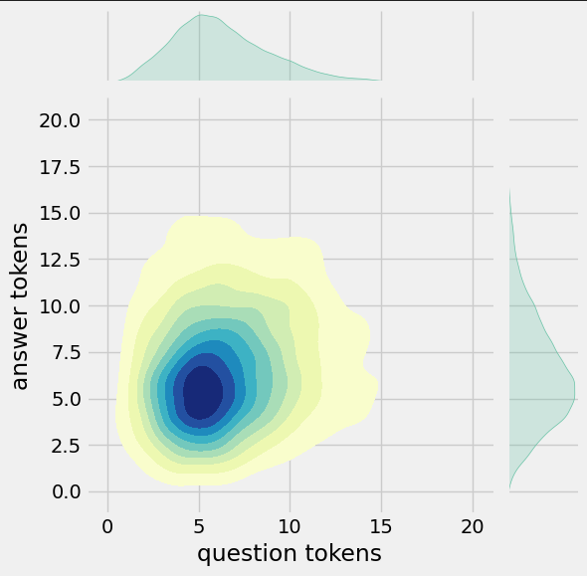

# Function for converting upper to lower case

def cleaner(x):
return [a for a in (''.join([a for a in x if a not in string.punctuation])).lower().split()]

# Model

Pipe = Pipeline([
('bow',CountVectorizer(analyzer=cleaner)),
('tfidf',TfidfTransformer()),
('classifier',DecisionTreeClassifier())
])

Pipe.fit(df['Questions'],df['Answers'])
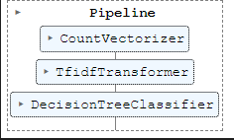

Pipe.fit(df['Questions'],df['Answers'])
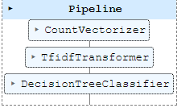

# Testing

Pipe.predict(['im fine. how about yourself'])[0]

Pipe.predict(['im pretty good. thanks for asking.'])[0]

Pipe.predict(['ive been good. im in school right now.'])[0]

Pipe.predict(['ive been great. what about you?'])[0]

Pipe.predict(['great'])[0]

Pipe.predict(['What are you doing'])[0]

Adding new data to the existing dataset

I have attached the dataset in my GitHub
GitHub link: https://github.com/dhanasekarenb/IBM_AI_Chatbot.git

Python Code:
from flask import Flask, request, render_template
import numpy as np
import string
from nltk.corpus import stopwords
import pandas as pd
import matplotlib.pyplot as plt
import seaborn as sns
from sklearn.feature_extraction.text import CountVectorizer
from sklearn.tree import DecisionTreeClassifier
from sklearn.feature_extraction.text import TfidfTransformer,TfidfVectorizer
from sklearn.pipeline import Pipeline

app = Flask(__name__)

# importing the dataset
df = pd.read_csv(r"C:\Users\zerobroz\Desktop\AI_Phase4\data_set\dialogs.txt", sep='\t')

#add column names
df.columns=['Questions','Answers']

# Function for converting upper to lower case
def cleaner(x):
return [''.join([a for a in x if a not in string.punctuation]).lower()]

# Load your pre-trained pipeline model
Pipe = Pipeline([
('bow', CountVectorizer(analyzer=cleaner)),
('tfidf', TfidfTransformer()),
('classifier', DecisionTreeClassifier())
])

# Load your pre-trained model weights
Pipe.fit(df['Questions'], df['Answers'])

# Define route for the home page
@app.route('/')
def index():
return render_template('index.html')

# Define route for processing user input and generating chatbot response
@app.route('/get_response', methods=['POST'])
def get_response():
user_input = request.form['user_input']
response = Pipe.predict([user_input])[0]
return render_template('index.html', user_input=user_input, response=response)

if __name__ == '__main__':
app.run(debug=True)

HTML file:

<!DOCTYPE html>
<html lang="en">

<head>
<meta charset="UTF-8">
<meta name="viewport" content="width=device-width, initial-scale=1.0">
<title>Chatbot</title>
<link rel="stylesheet" href="{{ url_for('static', filename='styles.css') }}">
<link rel="preconnect" href="https://fonts.googleapis.com">
<link rel="preconnect" href="https://fonts.gstatic.com" crossorigin>
<link href="https://fonts.googleapis.com/css2?family=Play&display=swap" rel="stylesheet">
</head>

<body>
<div class="container">
<div class="word-cloud">
<h2>Popular keywords</h2>
<!-- Add your most used words content here -->
<ul>
<li>hi</li>
<li>hey</li>
<li>hello</li>
<li>Tell me a joke</li>
<li>who created you?</li>
<li>what is the meaning of life?</li>
<li>tell me a fun fact.</li>
<li>another fun fact.</li>
<li>what do you like to do in your free time?</li>
<li>what languages do you speak?</li>
<li>tell me a riddle.</li>
<li>another riddle.</li>
</ul>
</div>
<div class="chat-box">
<h1>Chatbot</h1>
<div class="chat-container">
{% if user_input %}
<div class="message user-message">
You: {{ user_input }}
</div>
{% endif %}
{% if response %}
<div class="message bot-message">
Bot: {{ response }}
</div>
{% endif %}
</div>
<form id="user-form" method="POST" action="/get_response">
<input type="text" id="user_input" name="user_input" placeholder="Type your message...">
<button type="submit">Send</button>
</form>
</div>
</div>
</body>

</html>

CSS File:

body {
/* font-family: 'Times New Roman', Times, serif; */
font-family: 'Play', sans-serif;
margin: 0;
padding: 0;
background-color: #f2f2f2;
}

.container {
display: grid;
grid-template-columns: 1fr 2fr;
grid-gap: 20px;
max-width: 1200px;
height: 700px;
margin: 0 auto;
padding: 20px;
}

.word-cloud {
background-color: #fff;
padding: 50px;
box-shadow: 0 4px 8px rgba(0, 0, 0, 0.1);
}

.chat-box {
background-color: #fff;
padding: 20px;
box-shadow: 0 4px 8px rgba(0, 0, 0, 0.1);
}

h1 {
font-size: 24px;
margin-bottom: 20px;
}

.chat-container {
height: 500px;
overflow-y: auto;
padding: 10px;
border: 1px solid #ccc;
margin-bottom: 20px;
}

.message {
margin-bottom: 10px;
padding: 10px;
border-radius: 5px;
}

.user-message {
background-color: #4caf50;
color: #fff;
text-align: right;
}

.bot-message {
background-color: #008CBA;
color: #fff;
}

form {
display: flex;
align-items: center;

}

input[type="text"] {
flex: 1;
padding: 10px;
font-size: 16px;
border: 1px solid #ccc;
border-radius: 5px;
}

button {
padding: 10px 20px;
font-size: 16px;
background-color: #4caf50;
color: #fff;
border: none;
border-radius: 5px;
margin-left: 10px;
cursor: pointer;
}

button:hover {
background-color: #45a049;
}
.user-message {
color: solid black;
}

.bot-message {
color: solid black;
}

OUTPUT:
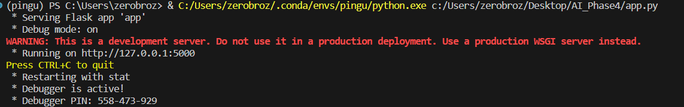

After pasting the http://127.0.0.1:5000 in browser.
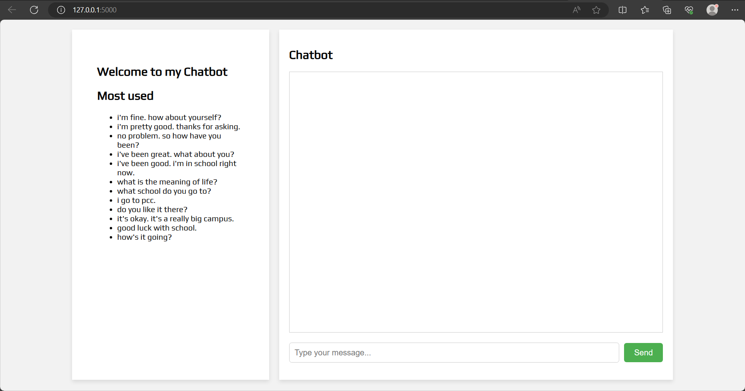

After give in the input.

