Smart Water Management using internet of things

Phase-5 Document submission

Project: Smart Water Management

1. Introduction

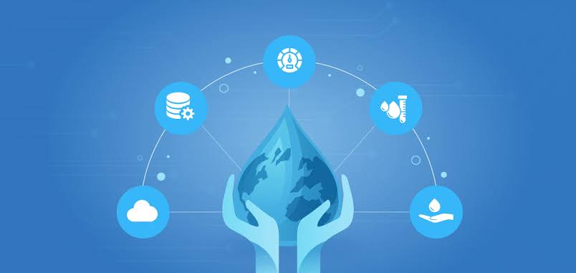

- Water is a finite and crucial resource, and its efficient management is of utmost importance. This project aims to address the challenges of water conservation and effective distribution through the implementation of a Smart Water Management system.

- The project seeks to provide a comprehensive solution for monitoring, analyzing and optimizing water usage in urban and rural areas, thereby contributing to sustainable water resource management.

2. Project Objectives

- The primary objectives of the project are as follows:

- Real-time monitoring of water quality, quantity, and distribution.

- Data analysis to identify anomalies, leaks, and trends.

- Reduction of water wastage by 20% within one year of implementation.

- These objectives are measurable, achievable, and align with the broader goal of water conservation.

3. Hardware and Software Requirements

- Hardware components include:

- Water quality sensors for pH, turbidity, and contamination detection.

- Flow meters for measuring water flow rates.

- Microcontrollers (e.g., Arduino) for sensor data collection.

- Communication modules (e.g., Wi-Fi, LoRa) for data transmission.

- Software includes:

- Data processing and analysis tools (e.g., Python, Node-RED).

- Cloud-based database for data storage and retrieval.

- IoT platform (e.g., AWS IoT, Google Cloud IoT) for data management.

4. System Architecture

- The system architecture consists of three main components: Sensors, Data Processing, and User Interface.

- Sensors collect real-time data from various sources, which is transmitted to the Data Processing layer.

- Data is processed, normalized, and stored in the cloud database.

- The User Interface provides a web-based dashboard for monitoring and control.

5. Sensor Deployment

- Sensors are strategically deployed at critical points, including:

- Water treatment plants.

- Distribution pipelines.

- Residential and commercial water meters.

- Each sensor's location is chosen to maximize data coverage.

6.Code

Const int turbiditySensorPin = A0; // Pin for turbidity sensor

Const int pH_SensorPin = A1; // Pin for pH sensor

Void setup() {

Serial.begin(9600);

}

Void loop() {

// Simulating turbidity and pH readings

Int turbidityValue = analogRead(turbiditySensorPin);

Int pH_Value = analogRead(pH_SensorPin);

// Convert sensor readings to actual values (for the purpose of simulation)

Float turbidity = map(turbidityValue, 0, 1023, 0, 100); // Simulated turbidity value

Float pH = map(pH_Value, 0, 1023, 0, 14); // Simulated pH value

// Check the values and perform actions based on the water quality

If (turbidity > 50) {

Serial.println(“Warning: High Turbidity Detected!”);

// Add your actions here for high turbidity

}

If (pH < 6 || pH > 8) {

Serial.println(“Warning: pH Out of Acceptable Range!”);

// Add your actions here for unacceptable pH levels

}

Delay(1000); // Simulated delay between readings

}

This Python script simulates a water quality sensor and generates random values for pH and turbidity. It includes a timestamp to indicate when the data was collected.

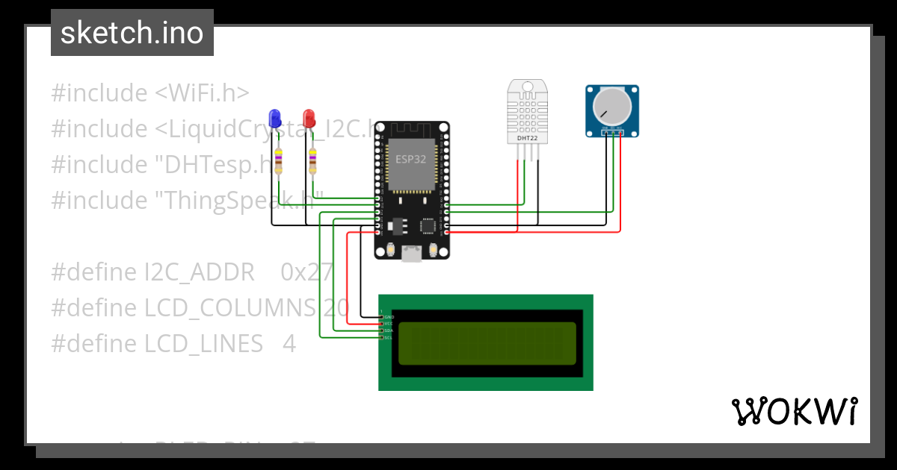Sample Output:

Warning: High Turbidity Detected!

Warning: pH Out of Acceptable Range!

Warning: High Turbidity Detected!

Warning: pH Out of Acceptable Range!

7. Data Collection

- Data is collected from sensors using various communication methods:

- Water treatment plant sensors use Wi-Fi for high-speed data transfer.

- LoRa is employed for long-range communication with remote sensors.

- Cellular networks are used for areas with limited connectivity.

8. Data Processing

- Collected data is processed using Python scripts that normalize and clean the data.

- The normalized data is then stored in a cloud-based database, ensuring data integrity and accessibility.

9. IoT Platform

- The IoT platform plays a central role in managing data flow, security, and device connectivity.

- It offers device management, data visualization, and the ability to trigger alerts and notifications.

10. User Interface

- The user interface is accessible via a web application.

- Users can monitor water quality, consumption, and distribution in real-time.

- They can also control valves and receive alerts regarding water quality or leakage.

11. Alerts and Notifications

- The system generates alerts via SMS or email in case of anomalies, such as leaks, contamination, or significant flow rate deviations.

- Notifications are sent to designated personnel for immediate response.

12. Data Visualization

- Data is presented through interactive dashboards and charts, enabling users to visualize trends and historical data.

- Real-time maps show water distribution and sensor locations.

13. Water Management Strategies

- Data analysis identifies areas of concern, such as leaks or excessive water usage.

- The system provides recommendations for addressing issues and optimizing water distribution.

14. Benefits and Impact

- The project aims to contribute to water conservation by reducing wastage.

- It also improves water quality monitoring, ensuring safer drinking water.

- Financial benefits result from reduced water loss and maintenance cost savings.

15. Future Improvements

- Potential enhancements include integrating weather data for better water management during droughts or heavy rainfall.

- Predictive analytics can be implemented to proactively address issues before they become critical.

16.Conclusion

- The Smart Water Management IoT project offers an innovative solution for sustainable water management.

- By monitoring water quality, quantity, and distribution, it provides a foundation for more efficient and responsible water resource usage.