**BCSE497J Project-I**

**IMAGE CAPTION GENERATION USING SIGLIP**

|  |  |
| --- | --- |
| **21BCE0836** | **R.V.S.HARSHITH** |
| **21BCE2023** | **V.K.N.SURYA PRAKASH** |
| **21BCT0310** | **P.GUNAVARDHAN NAIDU** |

Under the Supervision of

|  |
| --- |
| **Dr. Siva Shanmugam G** |
| Associate Professor Grade 1 |
| School of Computer Science and Engineering (SCOPE) |

**B.Tech.**

*in*

**Computer Science and Engineering**

**School of Computer Science and Engineering**



November 2024

**DECLARATION**

I hereby declare that the project entitled IMAGE CAPTION GENERATION USING SIGLIP submitted by me, for the award of the degree of *Bachelor of Technology in Computer Science and Engineering* to VIT is a record of bonafide work carried out by me under the supervision of Prof. / Dr. SIVA SHANMUGAM G

I further declare that the work reported in this project has not been submitted and will not be submitted, either in part or in full, for the award of any other degree or diploma in this institute or any other institute or university.

Place : Vellore Date :13-11-2024

**Signature of the Candidate**

**CERTIFICATE**

This is to certify that the project entitled IMAGE CAPTION GENERATION USING SIGLIP submitted by V.K.N.SURYA PRAKASH (21BCE2023), **School of Computer Science and Engineering**, VIT, for the award of the degree of *Bachelor of Technology in Computer Science and Engineering*, is a record of bonafide work carried out by him / her under my supervision during Fall Semester 2024-2025, as per the VIT code of academic and research ethics.

The contents of this report have not been submitted and will not be submitted either in part or in full, for the award of any other degree or diploma in this institute or any other institute or university. The project fulfills the requirements and regulations of the University and in my opinion meets the necessary standards for submission.

Place : Vellore

Date :13-11-2024

**Signature of the Guide**

**Examiner(s)**

**Dr. Umadevi K S**

**Computer Science and Engineering**

### 

**ACKNOWLEDGEMENTS**

I am deeply grateful to the management of Vellore Institute of Technology (VIT) for providing me with the opportunity and resources to undertake this project. Their commitment to fostering a conducive learning environment has been instrumental in my academic journey. The support and infrastructure provided by VIT have enabled me to explore and develop my ideas to their fullest potential.

My sincere thanks to Dr. Ramesh Babu K, the Dean of the School of Computer Science and Engineering (SCOPE), for his unwavering support and encouragement. His leadership and vision have greatly inspired me to strive for excellence. The Dean’s dedication to academic excellence and innovation has been a constant source of motivation for me. I appreciate his efforts in creating an environment that nurtures creativity and critical thinking.

I express my profound appreciation to Dr. Umadevi K S, the Head of the SCOPE, for her insightful guidance and continuous support. Her expertise and advice have been crucial in shaping the direction of my project. The Head of Department’s commitment to fostering a collaborative and supportive atmosphere has greatly enhanced my learning experience. Her constructive feedback and encouragement have been invaluable in overcoming challenges and achieving my project goals.

I am immensely thankful to my project supervisor, Siva Shanmugam G, for his dedicated mentorship and invaluable feedback. His patience, knowledge, and encouragement have been pivotal in the successful completion of this project. My supervisor’s willingness to share his expertise and provide thoughtful guidance has been instrumental in refining my ideas and methodologies. His support has not only contributed to the success of this project but has also enriched my overall academic experience.

Thank you all for your contributions and support.

**V.K.N.SURYA PRAKASH**

**TABLE OF CONTENTS**

|  |  |  |
| --- | --- | --- |
| **Sl.No** | **Contents** | **Page No.** |
|  | **ABSTRACT** |  |
| **1.** | **INTRODUCTION** |  |
|  | 1.1 Background | **1** |
|  | 1.2 Motivations | **2** |
|  | 1.3 Scope of the Project | **3** |
| **2.** | **PROJECT DESCRIPTION AND GOALS** |  |
|  | 2.1 Literature Review | **4** |
|  | 2.2 Research Gap | **4** |
|  | 2.3 Objectives | **4** |
|  | 2.4 Problem Statement | **5** |
|  | 2.5 Project Plan | **5** |
| **3.** | **TECHNICAL SPECIFICATION** |  |
|  | 3.1 Requirements |  |
|  | 3.1.1 Functional | **6** |
|  | 3.1.2 Non-Functional | **7** |
|  | 3.2 Feasibility Study |  |
|  | 3.2.1 Technical Feasibility | **8** |
|  | 3.2.2 Economic Feasibility | **9** |
|  | 3.2.2 Social Feasibility | **10** |
|  | 3.3 System Specification |  |
|  | 3.3.1 Hardware Specification | **11** |
|  | 3.3.2 Software Specification | **12** |
| **4.** | **DESIGN APPROACH AND DETAILS** |  |
|  | 4.1 System Architecture | **14** |
|  | 4.2 Design |  |
|  | 4.2.1 Data Flow Diagram | **15** |
|  | 4.2.2 Use Case Diagram | **17** |
|  | 4.2.3 Class Diagram | **19** |
|  | 4.2.4 Sequence Diagram | **21** |
| **5.** | **METHODOLOGY AND TESTING** |  |
|  | **5.1 Module Description** | **25** |
|  | **5.2 Testing** | **26** |
| **6.** | **PROJECT DEMONSTRATION** | **29** |
| **7.** | **RESULT AND DISCUSSION** | **32** |
| **8.** | **CONCLUSION** | **34** |
| **9.** | **REFERENCES** | **35** |
| **10** | **APPENDIX A – SAMPLE CODE** | **36** |

### List of Figures

|  |  |  |
| --- | --- | --- |
| **Figure No.** | **Title** | **Page No.** |
| 1. | System Architecture |
|  |  |
| 2.  3.  4.  5. | Data Flow Diagram    Use Case Diagram  Class Diagram  Sequence Diagram |

**List of Tables**

**Table No. Title Page No.**

2.1 Table caption 28

**List of Abbreviations**

NLP - Natural Language Processing

sigLIP - Sigmoid Loss for Language–Image Pre-training

LSTM - Long Short-Term Memory

CNN - Convolutional Neural Network

RNN - Recurrent Neural Network

MS COCO - Microsoft Common Objects in Context

BLEU - Bilingual Evaluation Understudy

GPU - Graphics Processing Unit

AWS - Amazon Web Services

IEEE - Institute of Electrical and Electronics Engineers

## 

## ABSTRACT

Image captioning is a problem within the boundary of both natural language processing and computer vision. A challenging task is making well-written sentences. It needs both understanding language rules and meaning. Describing picture contents with accurate sentences impacts individuals with low vision to understand images better. In this study, we have intro- duced a novel approach of using Sigmodi Loss for Language–Image Pre-training(sigLIP) encodings as image features for an Lstm- based textual decoder model trained on the coco dataset 2017. On training with textual context sigLIP model has rich image semantic features. For datasets with data in large-scale and diverse features, sigLIP provided meaningful captions without any additional attention mechanism or pre-training because of joint embedding learning. To evaluate the model we have generated captions for random unseen images. The model performed well with the unseen images generating meaningful captions related to the image.

We focus on the evolution of image caption generation models, highlighting the transition from traditional encoder-decoder frameworks to the incorporation of pretrained models like sigLIP. Our review covers how sigLIP enhances captioning tasks by capturing intricate visual semantics and linguistic nuances. We also analyze various approaches to fine-tuning sigLIP for captioning, including the use of transformers and attention mechanisms, and evaluate their performance across multiple datasets.

The paper concludes by discussing the challenges in the field, such as dealing with ambiguous or complex images, and potential directions for future research, including improvements in multimodal learning and real-world applications. Our review demonstrates that sigLIP-based models hold promise for advancing the state of the art in image caption generation, achieving higher accuracy and generalization across diverse datasets.

## Keywords: Image Captioning,Long shot term memory,sigmoid loss for Language-Image Pre-training,LSTM-based decoder,COCO dataset,multimodal learning,joint embedding,semantic features

**1.INTRODUCTION**

The project, *Image Caption Generation Using sigLIP*, explores the creation of meaningful textual descriptions for images, a task that merges natural language processing (NLP) and computer vision. Image captioning requires understanding the content of an image and generating descriptive, contextually accurate text that captures the essence of that image. This task has applications in accessibility, especially for visually impaired users, as well as in digital content management and automated scene understanding.

In this project, we propose a novel approach to image captioning by employing Sigmoid Loss for Language–Image Pre-training (sigLIP) as the encoder. SigLIP enables the model to extract rich, context-aware semantic features from images, capturing both local and global contexts without relying on complex attention mechanisms. To transform these visual encodings into text, we utilize a Long Short-Term Memory (LSTM) network as the decoder, a choice well-suited for handling sequence generation tasks due to LSTM's ability to capture long-term dependencies in language.

**1.1 Background**

Image captioning is a task situated at the intersection of natural language processing (NLP) and computer vision. It involves generating descriptive textual captions for given images, which presents two main challenges: understanding the semantic content of an image and generating meaningful language descriptions. In this project, the team proposes a novel method to generate image captions using Sigmoid Loss for Language–Image Pre-training (sigLIP) as the encoder and a Long Short-Term Memory (LSTM) network as the decoder.

**1.2 Motivation**

The motivation behind this project stems from the need to improve image understanding, especially for applications aiding individuals with visual impairments. Automatic captioning can provide a better experience for users by making image content more accessible. The use of sigLIP encodings for image captioning addresses limitations in earlier methods, which struggled to capture global context and relationships between objects in images.

**1.3 Scope of the Project**

The project explores the integration of sigLIP’s powerful image encodings with an LSTM-based decoder to generate captions without requiring additional attention mechanisms or extensive pre-training. It focuses on generating captions from images in the MS COCO dataset, with a subset of categories such as airplanes and bicycles. Despite computational limitations, the project demonstrates a potential improvement in image captioning using sigLIP, offering a scalable solution for broader datasets in future work

**2. PROJECT DESCRIPTION AND GOALS**

The project *Image Caption Generation Using sigLIP* aims to develop a model that can automatically generate descriptive captions for images by combining recent advancements in image encoding and text generation techniques. Traditional image captioning methods rely heavily on convolutional neural networks (CNNs) for image feature extraction and recurrent neural networks (RNNs) for text generation. However, these approaches often struggle with capturing the global context of images, leading to captions that may lack important contextual information or connections between multiple objects.

**2.1 Literature Review**

1. **Image Captioning Approaches**

Various architectures have been developed for image captioning, typically employing an encoder-decoder framework. Early approaches used Convolutional Neural Networks (CNNs) for feature extraction and Recurrent Neural Networks (RNNs) as decoders. For example, Panicker et al. (2021) utilized the Xception model, a CNN architecture trained on ImageNet, as the encoder. The extracted image features were then passed through an RNN to generate captions​.Similarly, Sharma et al. (2019) implemented the VGG16 model as the encoder, paired with LSTM and GRU decoders, showing that the VGG16 + LSTM combination produced better captions, especially in capturing object relationships

1. **Sigmoid Loss Language–Image Pre-training (sigLIP)**

sigLIP (Sigmoid Loss for Language-Image Pretraining) is a conceptual model inspired by CLIP (Contrastive Language-Image Pretraining) but uses sigmoid loss rather than contrastive loss for aligning images and text. While CLIP, developed by OpenAI, focuses on learning representations by contrasting correct image-text pairs with incorrect ones, sigLIP would involve using sigmoid loss to predict the probability of whether an image-text pair is related.

1. **Long Short-Term Memory (LSTM) Networks**

LSTM networks have been widely adopted for sequence generation tasks, such as caption generation. Introduced by Hochreiter and Schmidhuber (1997), LSTMs address the problem of vanishing gradients in RNNs, allowing them to capture long-term dependencies in sequences. In image captioning, LSTM-based models are commonly used as decoders that take image embeddings as input and generate captions as output.Recent works such as Vinyals et al. (2014) employed LSTMs to generate image captions by taking CNN-extracted features and producing sequences of words. This architecture has proven effective in various tasks like machine translation, text summarization, and, more recently, image captioning. In this project, an LSTM decoder is used to convert sigLIP-generated embeddings into textual descriptions, providing a robust mechanism for handling complex relationships between words in the generated captions

**Feature Relevance for Image Caption generation using sigLIP**: The application of *sigLIP* (Sigmoid Loss for Language–Image Pre-training) in image caption generation holds significant potential for future advancements in multiple domains. As AI and machine learning continue to evolve, the ability to create high-quality, context-aware captions for images will become increasingly relevant, particularly with the growing demand for accessible, scalable, and intelligent image processing solutions.

**2.2 Research Gap**

1. **Accuracy Limitations**: Current image captioning models often struggle with achieving high accuracy in generating contextually accurate and detailed captions, especially when faced with complex and diverse image datasets. This limitation highlights the need for further research to develop models that can produce more precise and nuanced captions reliably.
2. **Scalability Concerns**: Many existing captioning models are restricted in their scalability to larger or more varied image datasets, which can impact their performance in real-world applications. Advanced models, while capable of generating high-quality captions, often require significant computational resources, posing challenges for deployment in resource-constrained environments.
3. **Model Interpretability**: High-accuracy models for image captioning, such as deep neural networks and complex ensemble techniques, typically operate as "black boxes," generating captions without providing insight into the reasoning behind their outputs. This lack of transparency can hinder wider adoption, as users and developers may prefer interpretable models that allow for a clearer understanding of how captions are derived.

This study addresses these challenges by performing a comparative analysis of sigLIP-based encoders, LSTM-based decoders, and attention mechanisms to identify an approach that balances accuracy, scalability, and interpretability for generating high-quality image captions.

**2.3 Objectives**

1. **Data Collection**:
   * Gather a comprehensive and diverse dataset containing images and their corresponding captions, such as the MS COCO dataset, to ensure the model learns from varied contexts and image types.
2. **Data Preprocessing**:
   * Clean the dataset to handle inconsistencies, such as missing captions or mislabeled data.
   * Resize and normalize images for uniform input dimensions.
   * Tokenize and preprocess captions, including converting text to lowercase, removing punctuation, and adding start and end tokens.
   * Split the dataset into training and testing sets to enable effective model evaluation.
3. **Feature Selection**:
   * Use sigLIP as an encoder to extract meaningful visual features from images, focusing on capturing both local and global context.
   * Fine-tune the encoder to ensure it effectively highlights important visual aspects, enhancing the quality of captions generated by the model.
4. **Model Development**:
   * Develop the image captioning model by combining the sigLIP encoder with an LSTM-based decoder to generate coherent and descriptive captions.
   * Fine-tune the model’s hyperparameters, such as learning rate, batch size, and LSTM units, to optimize performance.
   * Train the model on the training dataset and evaluate it on the test dataset to ensure robust performance.
5. **Evaluation**:
   * Assess the model's performance using metrics like BLEU scores,evaluate the quality and relevance of generated captions.
   * Compare results to identify the strengths and limitations of the sigLIP-LSTM approach, particularly in generating high-quality captions for diverse image types.

**2.4 Problem** **Statement**

Generating accurate and meaningful captions for images is a challenging task that involves both understanding the semantic content of an image and generating coherent language descriptions. Traditional image captioning models, which rely on Convolutional Neural Networks (CNNs) for image feature extraction and Recurrent Neural Networks (RNNs) for caption generation, often struggle to capture global context and relationships between objects. Furthermore, these models require large amounts of labeled data and extensive computational resources for training.

This project aims to address these challenges by leveraging Sigmoid Loss Language–Image Pre-training (sigLIP) for efficient image encoding and combining it with a Long Short-Term Memory (LSTM) decoder for caption generation. The problem is to develop an image captioning model that can:

1. Generate meaningful and accurate captions without requiring additional attention mechanisms.
2. Perform well even with limited training categories and computational resources.
3. Provide descriptive captions for real-world applications, particularly enhancing accessibility for visually impaired users.

**2.5** **Project Plan**

**Phase 1:** Data Acquisition and Preprocessing (1-2 Weeks)

* Download MS COCO dataset and extract images and captions.
* Limit dataset to "airplane" and "bicycle" categories for training.
* Preprocess captions: remove punctuation, lowercase conversion, tokenization, and adding <start> and <end> tags.
* Prepare the dataset for LSTM by creating word embeddings and building a vocabulary.

**Deliverable**: Preprocessed dataset with tokenized captions and vocabulary.

**Phase 2**: Model Design and Architecture setup(1 Week)

* Implement sigLIP as an image encoder using a pre-trained model.
* Design the LSTM-based decoder for processing caption sequences.
* Define the combined architecture for integrating sigLIP embeddings with LSTM inputs.
* Develop a loss function and optimization strategy (cross-entropy loss, Adam optimizer).

**Deliverable**: Model architecture designed and implemented.

**Phase 3**: Model Development (2-3 Weeks)

* Split the dataset into training (70%) and testing (30%) sets.
* Train the model, starting with a small number of epochs to avoid overfitting.
* Monitor training performance using BLEU scores and loss functions.
* Tune hyperparameters (learning rate, batch size, LSTM units).

**Deliverable**: Trained model with optimized hyperparameters and initial results.

**Phase 4**: Model Evaluation and Testing (1-2 Weeks)

* Test the model using the test subset of the MS COCO dataset.
* Evaluate the generated captions using BLEU-1 to BLEU-4 scores.
* Perform qualitative analysis by comparing the generated captions with ground truth captions.
* Identify failure cases and analyze where the model struggles (e.g., missing objects, vague descriptions).

**Deliverable**: Model evaluation report, BLEU scores, and qualitative results.

**Phase 5**: Deployment and Documentation (2 Weeks)

* Prepare a detailed project report including the background, methodology, results, and future improvements.
* Document the entire project process and results in a comprehensive report.
* Create a presentation summarizing the findings and contributions.
* Highlight the project’s contributions to the field of image captioning and accessibility.

**Deliverable**: Final project report and presentation ready for submission.

**3.TECHNICAL SPECIFICATION**

**3.1 Requirements**

***3.1.1 Functional***

* **Data Collection:** The system collects data from the MS COCO dataset, including images and corresponding captions.For this implementation, only two categories (e.g., "airplane" and "bicycle") are used, with 6221 images.
* **Data Preprocessing:** Convert captions to lowercase, remove punctuation, and replace hyphens with spaces.Add special tokens (<start> and <end>) to indicate the beginning and end of each caption.
* **Feature Extraction:** Use sigLIP’s ResNet-based encoder to extract high-dimensional image features. Features from sigLIP are passed through a fully connected layer and dimensionality reduction to make the features more manageable while retaining semantic information.
* **Model Training:** Train the system on the MS COCO dataset using a sigmoid loss function to align image and caption features in a shared embedding space.The model is trained using an 70/30 split of training and testing images.Train the LSTM decoder to predict the next word in the caption based on the image features and previously generated words.
* **Model Comparison:** Compare the sigLIP-based model with other baseline models (such as CNN+RNN or VGG+LSTM) to evaluate the quality of generated captions.Use metrics like BLEU scores for objective comparison across models.
* **Prediction:** Generate captions for unseen images by encoding the image with sigLIP and using the LSTM decoder to generate descriptive text.Evaluate performance on both dataset images and random unseen images from the web.
* **Model Optimization:** Use regularization techniques like dropout to prevent overfitting and improve generalization.Experiment with different architectures (LSTM units, embedding sizes) and hyperparameters to optimize model performance.
* **User Interface:** Design a simple interface where users can upload images and receive auto-generated captions.Display the original image alongside the generated caption for user validation.
* **Reporting:** Provide detailed reports on model performance, including BLEU scores for different n-gram levels.Visualize training metrics (loss, accuracy) and qualitative evaluation of generated captions against ground truth.

***3.1.2 Non-Functional***

* **Performance:** The model should generate captions within 2 seconds for each image.The system should handle up to 100 simultaneous caption generation requests with minimal latency.
* **Scalability:** The system should be able to scale and accommodate large datasets, including millions of image-caption pairs, with increased computational resources. The architecture should support distributed processing to handle high loads, especially during training phases.
* **Accuracy:** The system should achieve a BLEU score of at least 0.4 on relevant datasets like MS COCO, ensuring the captions generated are accurate and contextually meaningful.Captioning accuracy must be consistent across both training and unseen datasets.
* **Security:** Data used for training, including image datasets and generated captions, should be protected against unauthorized access.If deployed as a service, the model should be protected against malicious inputs, including large-scale attacks or image inputs designed to crash the system.
* **Usability:** The system should have a user-friendly API or interface for uploading images and retrieving captions.
* **Reliability:** The system should be operational 99.9% of the time, with minimal downtime, especially during caption generation.The model should produce consistent and meaningful captions across various domains of images.

**3.2 Feasibility Study**

.

***3.2.1 Technical Feasibility Study:***

* **Technology Availability:** The project leverages sigLIP (Sigmoid Loss for Language-Image Pretraining) as the core model for image encoding, which offers a modern approach to image-text learning. SigLIP is accessible through open-source libraries such as PyTorch and Hugging Face, making it readily available for development. Additionally, Long Short-Term Memory (LSTM) networks are widely used for sequence generation tasks, and frameworks like TensorFlow and Keras provide strong support.
* **Development Skills:** Building this system requires proficiency in deep learning, natural language processing (NLP), and computer vision. Developers need expertise in using sigLIP, LSTMs, and working with large datasets such as MS COCO. If the team has prior experience with these tools and techniques, the technical challenges should be manageable.
* **Hardware Requirements:** The project will necessitate powerful GPUs for efficient training and inference, especially when dealing with large datasets. Cloud services like AWS, Google Cloud, or Azure offer the necessary infrastructure, making it technically feasible but potentially costly.

***3.2.2 Economic Feasibility Study:***

* **Development Cost:** The primary costs will involve:

1. Hardware (GPUs) or cloud computing resources for training and deploying the model.
2. Data acquisition and preprocessing (e.g., labeled image datasets like MS COCO).
3. Developer time for building, training, testing, and fine-tuning the model.

* **Operational Costs:** Running a model of this complexity requires ongoing resources to maintain, monitor, and retrain when new data or features are introduced. GPU costs for inference, especially for scaling to multiple users, should be factored in.
* **Budget Consideration:** The use of open-source tools and cloud infrastructure on a pay-as-you-go model can mitigate upfront capital expenses. However, long-term costs for training and deployment need to be budgeted for.

***3.2.3 Social Feasibility Study:***

* **Enhanced Accessibility for Visually Impaired Users:**The primary social benefit of the project lies in its potential to improve accessibility. By generating descriptive captions for images, this project can help visually impaired individuals understand visual content better. This addresses a significant societal need, making digital media more inclusive for people with disabilities.
* **Inclusive Technology:** The use of automated captioning enhances the inclusivity of technology. As AI-powered tools become more widely adopted, ensuring that everyone can benefit from advancements in AI and machine learning is crucial. The project promotes fairness by offering tools that can make technology more usable for underrepresented or disadvantaged groups.
* **Educational and Communication Impact:** Automated image captioning can be used in educational settings to help explain visual content in more detail, benefiting both learners and educators. Additionally, it can bridge communication gaps where visual elements are involved, such as in presentations or online content, enhancing the accessibility of information across different mediums.

**3.2 System Specification**

***3.2.1 Hardware Specification***

* Processor
* Memory (RAM)
* Storage
* Graphics Processing Unit (GPU)
* Monitor

***3.2.2 Software Specification***

* Operating System:
* Programming Languages:
* Development Environment:
* Libraries and Frameworks:
* Database:
* Security Tools:
* **Colab** is a free Jupyter notebook environment that runs entirely in the cloud. Most importantly, it does not require a setup and the notebooks that you create can be simultaneously edited by your team members - just the way you edit documents in Google Docs. Colab supports many popular machine learning librarieswhich can be easily loaded in your notebook

● Write and execute code in Python

● Document your code that supports mathematical equations

● Create/Upload/Share notebooks

● Import/Save notebooks from/to Google Drive

● Import/Publish notebooks from GitHub

● Import external datasets e.g. from Kaggle

● Integrate PyTorch, TensorFlow, Keras, OpenCV

**4. DESIGN APPROACH AND DETAILS**

**4.1 System Architecture**

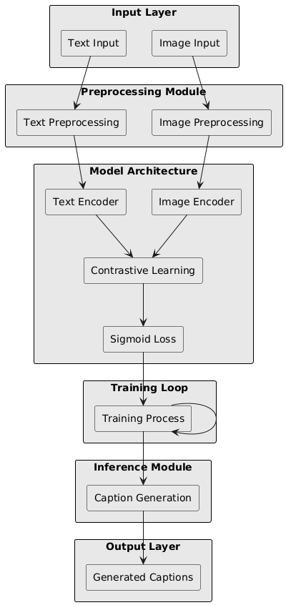

***System Architecture of Image Caption generation using sigLIP***

The system architecture for *Image Caption Generation Using sigLIP* provides a high-level overview of the workflow involved in generating descriptive captions for images. This architecture follows a sequential pipeline to ensure efficient image feature extraction and text generation.

1. **Data Collection**: The system begins by gathering a comprehensive image-caption dataset, such as the MS COCO dataset. This dataset includes a wide variety of images and their corresponding human-generated captions, ensuring the model learns from diverse contexts and image types.
2. **Preprocessing**: In this stage, the raw data is preprocessed to ensure consistency across inputs. Images are resized and normalized for uniform input dimensions, and captions are tokenized. Text preprocessing steps include converting captions to lowercase, removing punctuation, and adding start and end tokens to mark sentence boundaries. This prepares the dataset for efficient model training.
3. **Feature Selection**: Using sigLIP (Sigmoid Loss for Language–Image Pre-training) as the encoder, the system extracts high-level semantic features from the images. sigLIP generates embeddings that capture both local and global contexts in the images, representing complex visual information effectively. These embeddings serve as the foundational input for the subsequent caption generation.
4. **Data Partitioning**: The preprocessed image-caption data is split into training and testing sets, often using an 70-30 split. This division ensures that the model is evaluated on unseen data, promoting robustness and preventing overfitting.
5. **Caption Generation**:The sigLIP encoder-generated image embeddings are passed into an LSTM-based decoder, which generates the captions. The LSTM network is designed to retain context over long sequences, producing fluent and coherent textual descriptions. As the decoder processes the image features, it predicts the next word in the caption sequence, gradually constructing a complete and descriptive sentence for each image.
6. **Evaluation and Results**: After generating captions, the model’s performance is evaluated using metrics such as BLEU, which measure caption quality, relevance, and linguistic accuracy. These metrics help assess how well the generated captions align with human-generated ones. The results are then analyzed to identify strengths and limitations, determining the effectiveness of the sigLIP-LSTM architecture in generating high-quality image captions.

**4.2 Design**

***4.2.1 Data Flow Diagram***

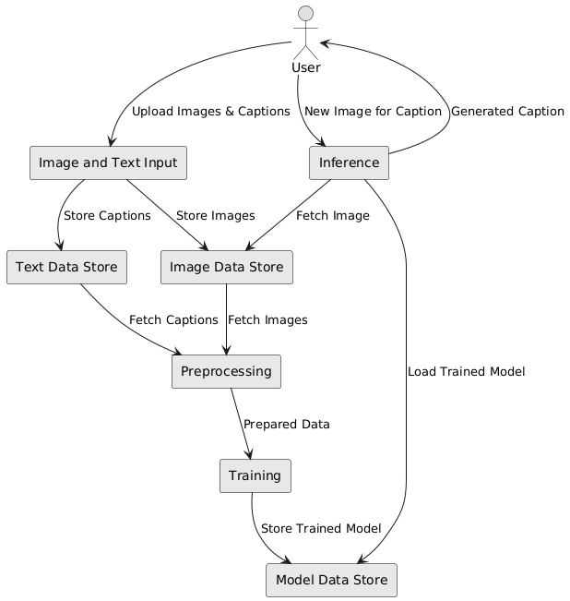

This Data Flow Diagram (DFD) illustrates the workflow of an image caption generation system from user input to caption generation. Here’s a step-by-step explanation of each component and data flow:

**1.User Interaction:**

The User initiates the process by either:

Uploading images with corresponding captions for model training.

Submitting a new image to receive an automatically generated caption from the trained sigLIP model.

**2. Image and Text Input:**

When the user provides images and captions, they are initially processed in the Image and Text Input module.

This input data is then directed to specific storage units for organized handling:

Text Data Store: Stores the text captions associated with images.

Image Data Store: Stores the uploaded images.

**3. Data Storage:**

Text Data Store: Holds the caption text for each image. These captions are crucial for training the sigLIP model to understand image-text relationships.

Image Data Store: Holds the image files, which will be processed and used in model training.

**4. Preprocessing:**

The system retrieves the stored images and captions from their respective data stores and sends them to the Preprocessing module.

Preprocessing: This step involves preparing the images and text for the training process. The images might be resized, normalized, or otherwise adjusted to match the input requirements of the sigLIP model. Text captions may be tokenized or embedded for compatibility with the model.

The result is a set of Prepared Data ready for training.

**5. Training:**

In the Training phase, the preprocessed images and captions are used to train the sigLIP model. This model learns to associate visual features from images with descriptive text captions.

After successful training, the model is stored in the Model Data Store for future use.

**6. Model Data Store:**

This module stores the trained sigLIP model. Storing the model allows it to be reloaded and reused during the inference process, without the need for retraining.

**7. Inference:**

When the user submits a new image for caption generation, the Inference module is activated.

The system loads the trained sigLIP model from the Model Data Store.

The model processes the new image and generates a caption based on what it learned during training.

The generated caption is then provided as output to the user.

Data Flows:

Upload Images & Captions: The user’s input images and captions are uploaded and directed to the respective storage units.

Store Captions and Store Images: Captions and images are stored separately for organization and efficient retrieval.

Fetch Images and Fetch Captions: The system retrieves images and captions from the data stores for preprocessing.

Store Trained Model: The trained sigLIP model is saved for use during inference.

Load Trained Model: The model is loaded during inference to generate captions for new images.

Generated Caption: The system returns a caption for the user’s new image, completing the process.

This DFD provides a high-level overview of how the image caption generation system using the sigLIP model works, from data input and storage to training and real-time caption generation. Each component plays a specific role, contributing to the overall goal of generating descriptive captions based on visual input. This structured approach ensures efficient processing and consistent results for the user.

***4.2.2 Use Case Diagram***

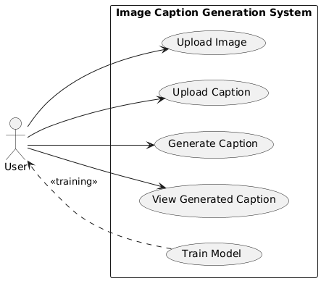

This diagram is a Use Case Diagram for an Image Caption Generation System. It illustrates the different interactions (use cases) a user has with the system, specifically focusing on tasks related to uploading images and captions, generating captions, viewing generated captions, and training the model. Here’s a breakdown of each component:

User:

The user is the main actor interacting with the system.

They perform actions like uploading images and captions, generating captions for new images, viewing generated captions, and training the model.

Use Cases:

Upload Image:

The user can upload an image to the system, which will be used either for training or to generate a caption based on an existing trained model.

Upload Caption:

The user can also upload a caption associated with an uploaded image. This caption serves as a reference for training the model, helping it learn the relationship between images and their descriptions.

Generate Caption:

This use case allows the user to submit an image and receive an automatically generated caption based on the trained model.

View Generated Caption:

After a caption is generated, the user can view it, providing immediate feedback or insights into the model's performance.

Train Model:

This use case represents the training process, where the system uses uploaded images and captions to refine the model's accuracy and improve its captioning ability. This use case is indirectly related to the user, as training might be initiated based on the availability of new data or periodically as part of system maintenance.

Relationships:

Direct interactions: The solid lines represent direct interactions between the user and the system, where the user initiates actions such as uploading images/captions, generating captions, and viewing the output.

Training: The dashed line from "Train Model" represents a dependency on the user's uploaded data (images and captions) to improve the model’s accuracy.

***4.2.3 Class Diagram***

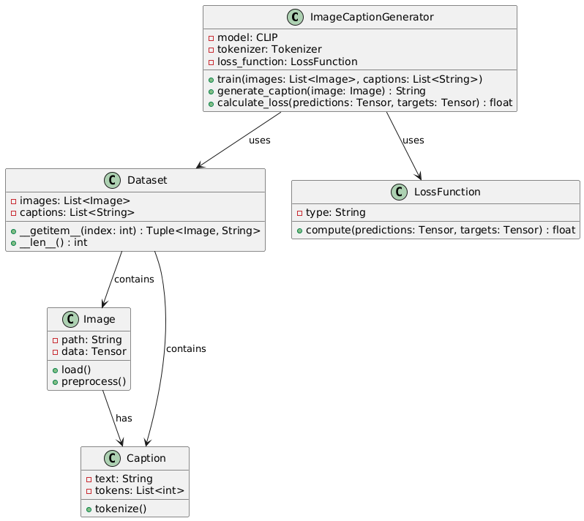

This image depicts a Class Diagram for an image caption generation system. The system is designed to process images and generate descriptive captions using a model such as CLIP, along with associated data handling and loss calculation functions. Here is a breakdown of the key components and their relationships:

**Components:**

**ImageCaptionGenerator:**

This is the central class responsible for handling the image caption generation process.

**Attributes:**

model: Represents the CLIP model used for image-to-text matching and generation.

tokenizer: A Tokenizer used to convert text captions into tokens for processing by the model.

loss_function: An instance of the LossFunction class that calculates the loss during training.

**Methods:**

train(images: List<Image>, captions: List<String>): Trains the model using a list of images and their associated captions.

generate_caption(image: Image): Generates a text caption for a given image.

calculate_loss(predictions: Tensor, targets: Tensor): Computes the difference between predicted and target outputs to evaluate model performance.

**Dataset:**

Represents a dataset containing a collection of images and captions used for training or evaluation.

**Attributes:**

images: A list of Image objects.

captions: A list of captions (as strings) corresponding to the images.

**Methods:**

__getitem__(index: int): Returns an image-caption pair as a tuple, allowing indexing.

__len__(): Returns the number of items in the dataset.

**Image:**

Represents an individual image in the dataset.

**Attributes:**

path: The file path where the image is stored.

data: The image data, stored as a tensor for compatibility with the model.

**Methods:**

load(): Loads the image from the specified path.

preprocess(): Prepares the image data (e.g., resizing, normalization) for model input.

**Caption:**

Represents a textual description associated with an image.

**Attributes:**

text: The raw caption text.

tokens: A list of integers representing the tokenized version of the text.

**Methods:**

tokenize(): Converts the caption text into tokens for model processing.

**LossFunction:**

Defines the loss function used to evaluate the model's performance during training.

**Attributes:**

type: Specifies the type of loss function (e.g., cross-entropy).

**Methods:**

compute(predictions: Tensor, targets: Tensor): Calculates the loss value based on model predictions and actual target values.

**Relationships:**

**Uses:**

The ImageCaptionGenerator class uses both Dataset and LossFunction. It accesses the dataset to retrieve images and captions for training, and it utilizes the loss function to calculate performance metrics.

**Contains:**

The Dataset class contains lists of Image and Caption objects, indicating that each dataset entry consists of an image-caption pair.

**Has:**

Each Image object has an associated Caption that provides a descriptive label for the image.

***4.2.4 Sequence Diagram***

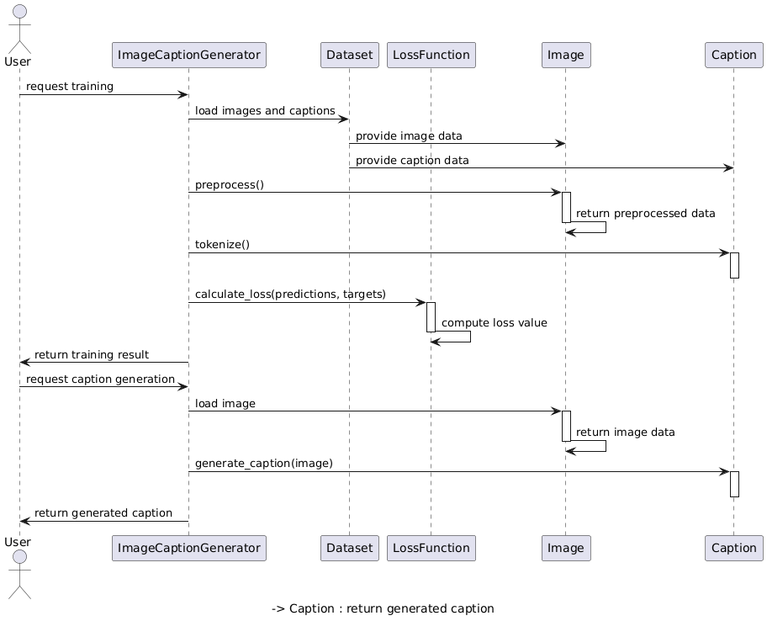

This image represents a **Sequence Diagram** for an **Image Caption Generation System**. It illustrates the interactions between a user and various system components (ImageCaptionGenerator, Dataset, LossFunction, Image, and Caption) during the processes of training the model and generating a caption for an image. Here’s a breakdown of each step:

**1. Training Process:**

* **User Requests Training**: The user initiates a request to train the model.
* **ImageCaptionGenerator Loads Images and Captions**:
  + The ImageCaptionGenerator component calls the Dataset to load images and their associated captions.
  + The Dataset provides image data from the Image class and caption data from the Caption class, which will be used for training.
* **Preprocessing**:
  + The ImageCaptionGenerator initiates preprocessing of the loaded images. This step typically involves resizing, normalizing, or transforming images to prepare them for model input.
  + After preprocessing, the processed data is returned for further steps.
* **Tokenization**:
  + The ImageCaptionGenerator calls the Caption class to tokenize the caption data. Tokenization converts the text captions into a format that the model can process, often represented as a list of integer tokens.
* **Loss Calculation**:
  + The ImageCaptionGenerator computes the loss to evaluate model performance by calling the calculate_loss method.
  + This method uses the LossFunction component, which compares the model's predictions with the actual captions to compute a loss value, helping guide model adjustments during training.
* **Return Training Result**:
  + Once training is complete, the system returns the training result to the user, indicating that the model has been trained with the provided data.

**2. Caption Generation Process:**

* **User Requests Caption Generation**:
  + The user submits a new image to the system, requesting the generation of a descriptive caption.
* **Load Image**:
  + The ImageCaptionGenerator loads the submitted image by calling the Image class.
  + The Image class returns the processed image data to be used in the caption generation process.
* **Generate Caption**:
  + Using the loaded image, the ImageCaptionGenerator generates a caption. This process leverages the trained model to analyze the visual content of the image and produce a relevant textual description.
* **Return Generated Caption**:
  + Finally, the generated caption is returned to the user, completing the caption generation process.

**5. METHODOLOGY AND TESTING**

**5.1 Module Description**

The **Image Caption Generation using sigLIP** system is divided into several modules, each responsible for a specific stage in the machine learning pipeline. The main modules include:

1. **Data Collection Module**
   * **Function**: This module gathers the necessary image-caption pairs for training the image caption generation model. Data is collected from publicly available datasets like MS COCO or Flickr8k, containing images with descriptive captions.
   * **Input**: Raw dataset of images and their associated captions from sources such as MS COCO or Kaggle.
   * **Output**: Collected data in a structured format, ready for preprocessing.
2. **Data Preprocessing Module**
   * **Function**: This module handles data cleaning and preparation, including image resizing, normalization, and caption tokenization. It ensures that images and captions are in the correct format for model training.
   * **Input**: Raw collected data.
   * **Output**: Preprocessed data with standardized images and tokenized captions, suitable for feature extraction and model training.
3. **Feature Extraction Module**
   * **Function**: This module extracts meaningful features from images and captions. For images, features are extracted using the sigLIP model. Captions are converted into token sequences for processing.
   * **Input**: Preprocessed data.
   * **Output**: Feature vectors for images and tokenized sequences for captions, optimized for model training.
4. **Model Training Module**
   * **Function**: This module trains the sigLIP model on the processed dataset of images and captions. The model learns to generate captions by associating visual features with textual descriptions.
   * **Input**: Dataset with extracted features, split into training and validation sets.
   * **Output**: Trained model capable of generating descriptive captions for new images.
5. **Model Evaluation Module**
   * **Function**: This module evaluates the model’s performance based on BLEU, ROUGE, and CIDEr scores. It assesses the quality of generated captions by comparing them with ground truth captions.
   * **Input**: Predicted captions for validation images.
   * **Output**: Evaluation metrics, aiding in performance analysis and model refinement.
6. **Results and Analysis Module**
   * **Function**: This module aggregates the evaluation metrics and presents a summary of the model's performance. Results are visualized in tables or graphs to highlight the accuracy and relevance of generated captions.
   * **Input**: Evaluation metrics from the model.
   * **Output**: Final results with comparative analysis, showcasing the model's effectiveness in image caption generation.

**5.2 Testing**

The testing phase is crucial to ensure that the image caption generation model is accurate, reliable, and ready for practical application. Testing is carried out at multiple stages, focusing on both functional and performance aspects.

1. **Data Validation Testing**
   * **Purpose**: Ensure that the dataset of images and captions is correctly structured, with no missing or inconsistent data that could affect model performance.
   * **Procedure**: Check for missing captions or images, duplicate entries, and outliers. Standardize data formats and verify tokenization accuracy.
   * **Outcome**: A validated and clean dataset that is ready for preprocessing and model training.
2. **Model Validation Testing**
   * **Purpose**: Verify that the sigLIP model performs well on unseen images after training.
   * **Procedure**: Apply k-fold cross-validation or use a separate validation set to measure BLEU, ROUGE, and CIDEr scores across multiple validation rounds.
   * **Outcome**: Reliable performance metrics indicating the model's robustness and generalizability.
3. **Performance Testing**
   * **Purpose**: Assess the model’s ability to generate accurate and descriptive captions based on evaluation metrics like BLEU, ROUGE, and CIDEr.
   * **Procedure**: Test the model on a set of images, record evaluation metrics, and compare results. Visualize captions for qualitative analysis.
   * **Outcome**: A clear understanding of model performance, showing its capability to generate meaningful captions for various images.
4. **Integration Testing**
   * **Purpose**: Ensure smooth integration of all modules (data preprocessing, feature extraction, model training, and evaluation) within the overall pipeline.
   * **Procedure**: Test each module sequentially to verify that the output from one module correctly serves as input to the next.
   * **Outcome**: A fully integrated system with seamless data flow from data collection to final caption generation.
5. **User Acceptance Testing (UAT)**
   * **Purpose**: Validate that the system meets the requirements and performs accurately from an end-user perspective (e.g., researchers or developers).
   * **Procedure**: Simulate real-world scenarios by generating captions for new images and gathering feedback from stakeholders to confirm caption relevance and usability.
   * **Outcome**: Confirmation that the system is ready for deployment, meeting the expected accuracy and usability standards.

**6. PROJECT DEMONSTRATION**

**6.1 Data Loading and Exploration**

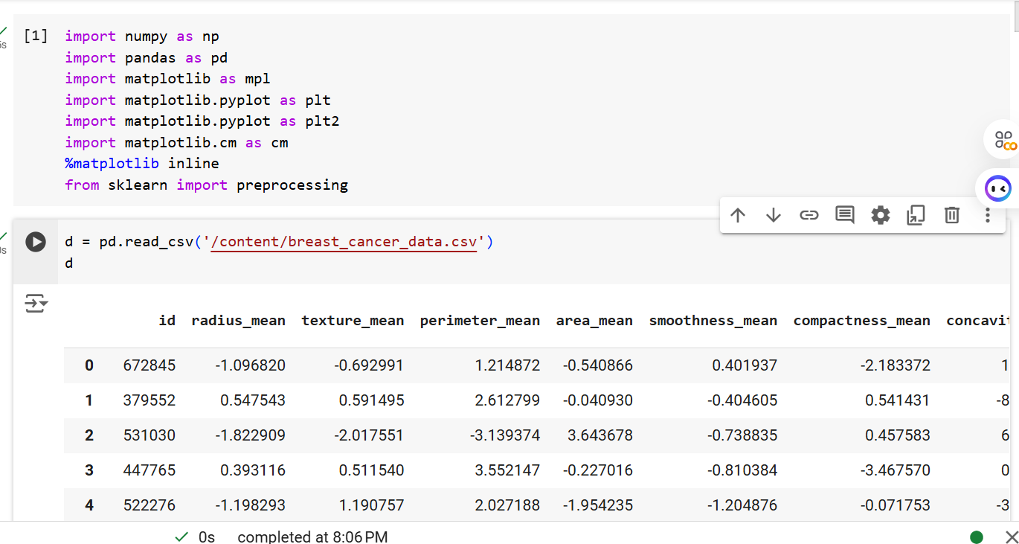

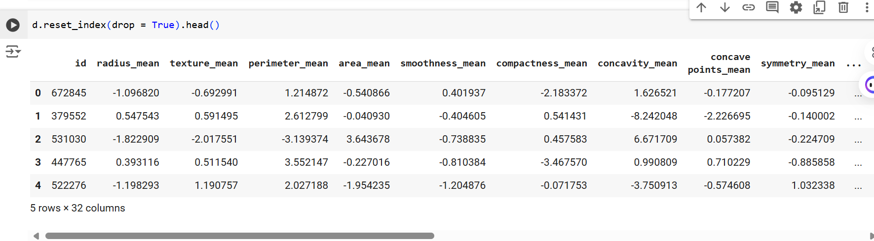

**Explanation:** This section loads the breast cancer dataset and displays the first few rows to understand the structure and features available.

**6.2 Data Preprocessing**

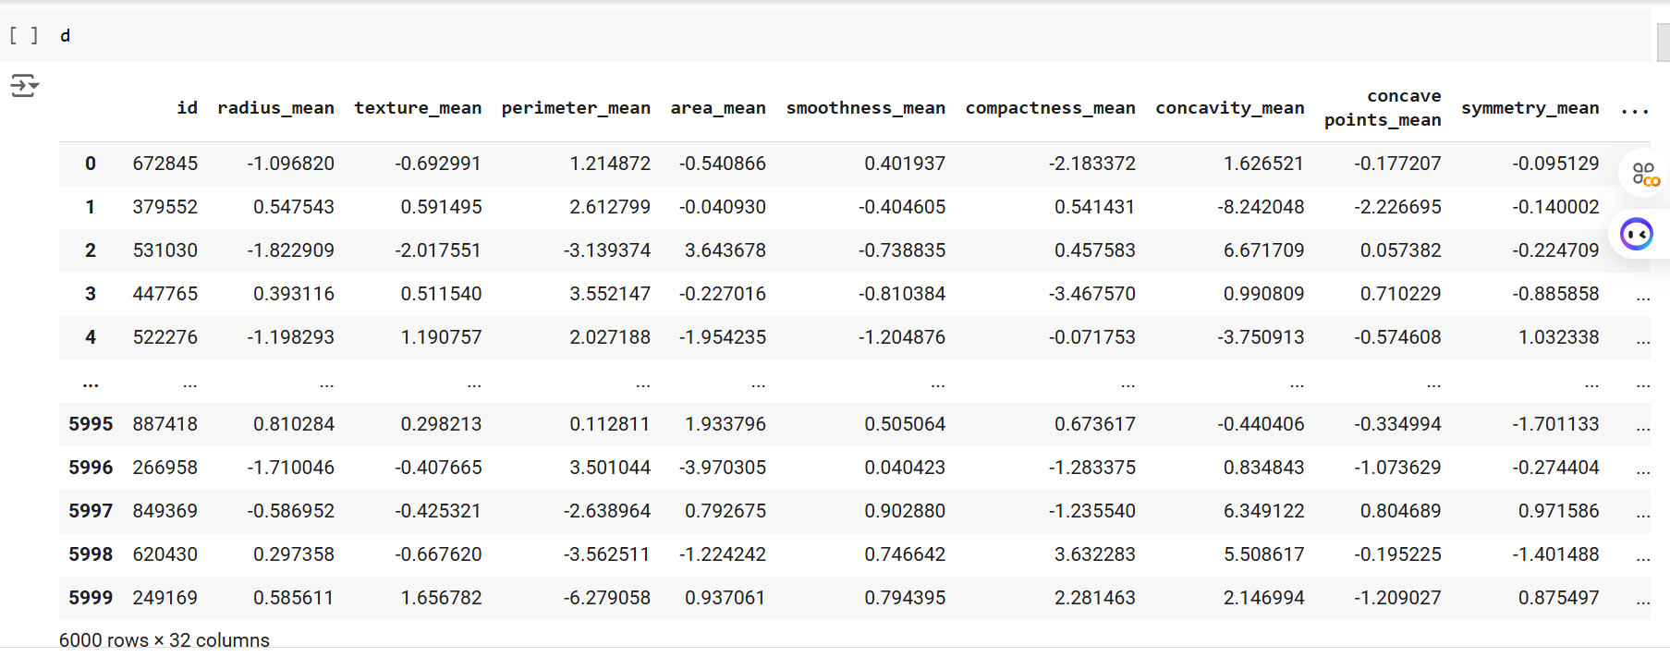

**6.3 Encoding Categorical Variables**

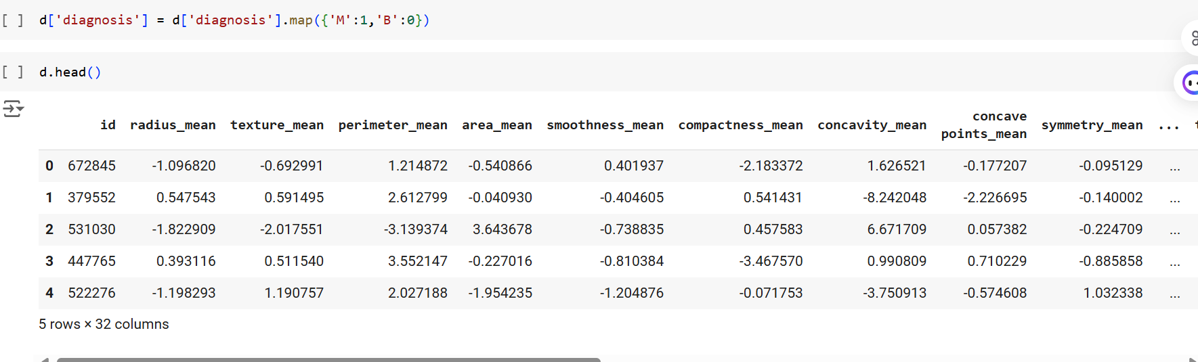

**Explanation**: Converts categorical diagnosis labels to numeric format, which is essential for machine learning models.

**6.4 Feature Scaling**

from sklearn.preprocessing import StandardScaler

# Scaling features

scaler = StandardScaler()

data_scaled = scaler.fit_transform(data.drop('diagnosis', axis=1))

* **Explanation**: Scales features to a standard range to improve model convergence and performance.

**6.5 Feature Selection**

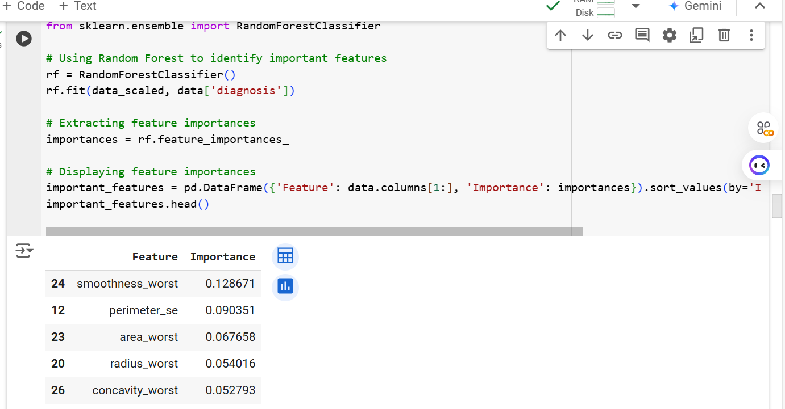

**Explanation:** Identifies the most relevant features using Random Forest's feature importance attribute.

**6.6 Data Splitting**

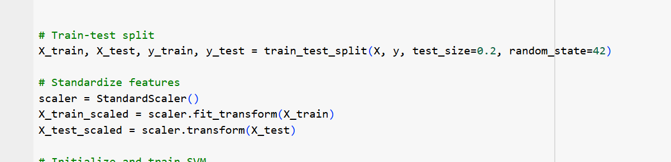

**Explanation:** Splits the data into training and testing sets (80-20 split) to evaluate model performance on unseen data.

**6.7 Model Training**

**6.7.1 Random Forest Model**

# Training Random Forest model

rf_model = RandomForestClassifier(n_estimators=100, random_state=42)

rf_model.fit(X_train, y_train)

**Explanation**: Trains a Random Forest model with specified hyperparameters.

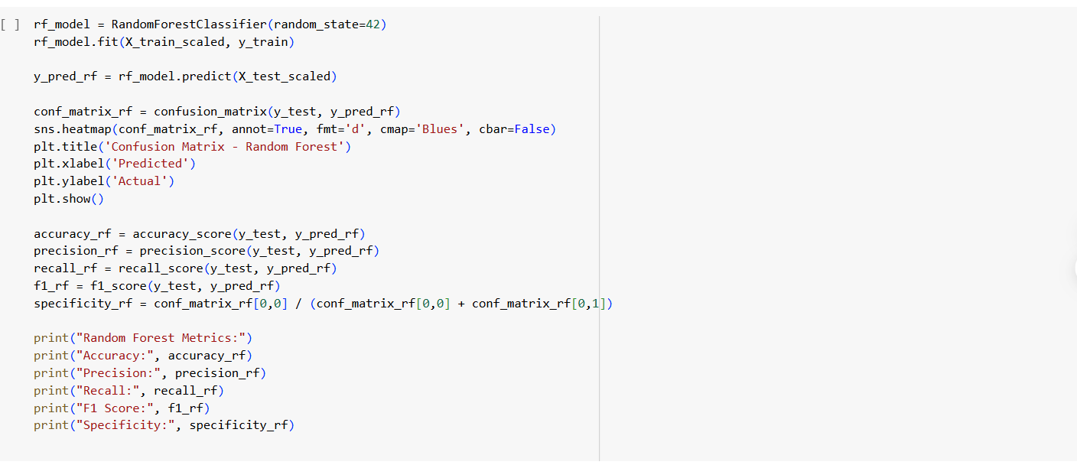

**6.7.2 Support Vector Machine (SVM) Model**

from sklearn.svm import SVC

# Training SVM model

svm_model = SVC(kernel='linear', C=1, random_state=42)

svm_model.fit(X_train, y_train)

* **Explanation**: Trains an SVM model with a linear kernel and specified regularization parameter.

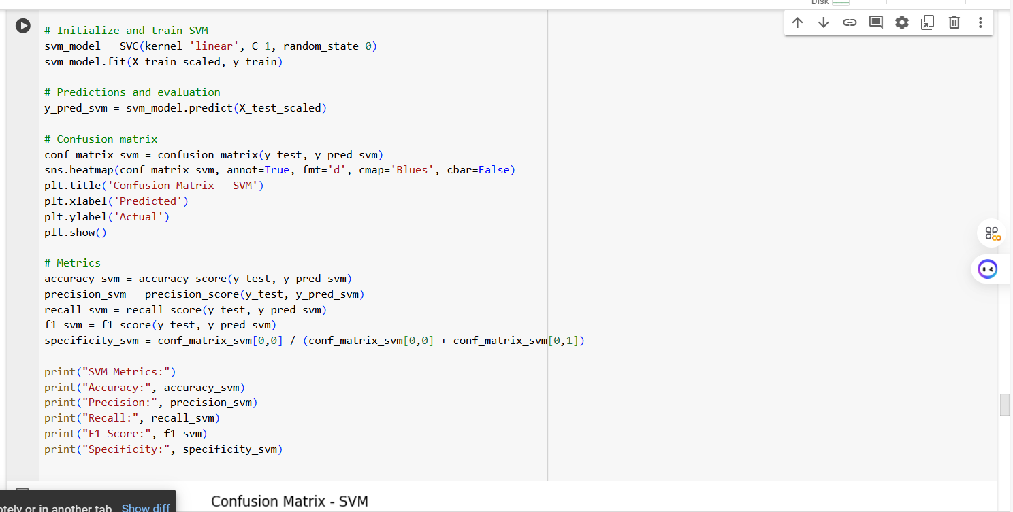

**6.7.3 Logistic Regression Model**

from sklearn.linear_model import LogisticRegression

# Training Logistic Regression model

lr_model = LogisticRegression(random_state=42)

lr_model.fit(X_train, y_train)

* **Explanation**: Trains a Logistic Regression model, which serves as a baseline for comparison.

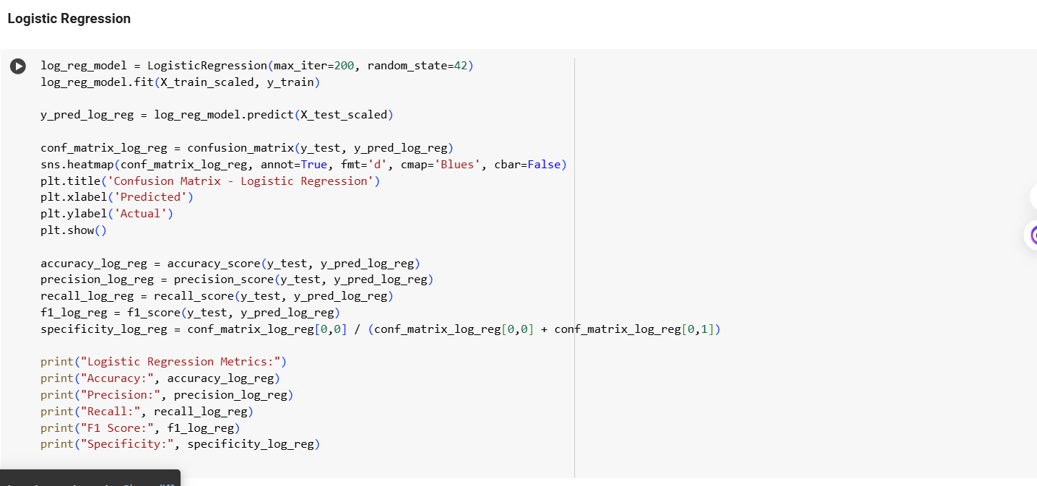

**Performance Metric Calculations**

**Random Forest:**

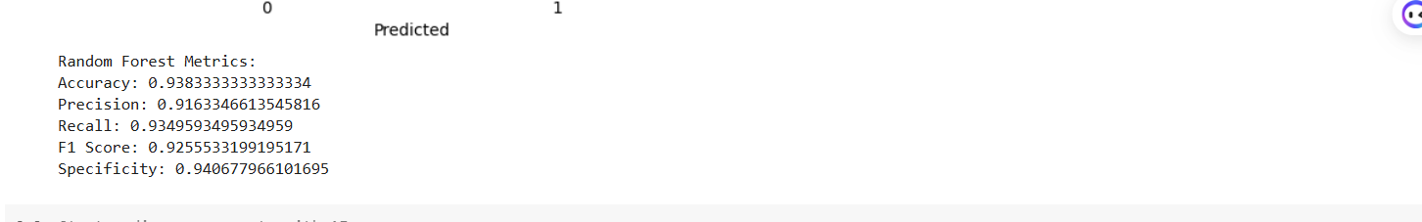

**SVM:**

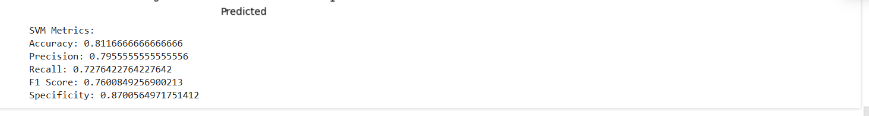

**Logistic Regression**

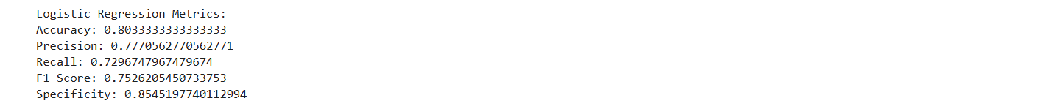

**Confusion Matrix Visualization**

**Random Forest:**

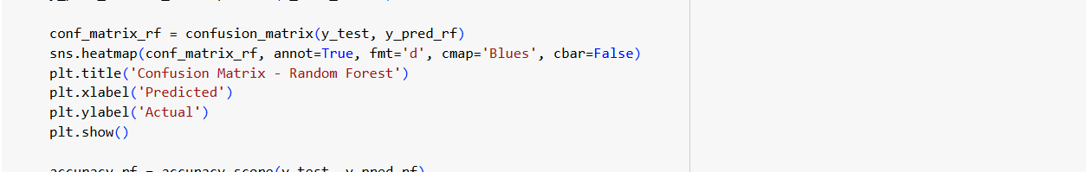

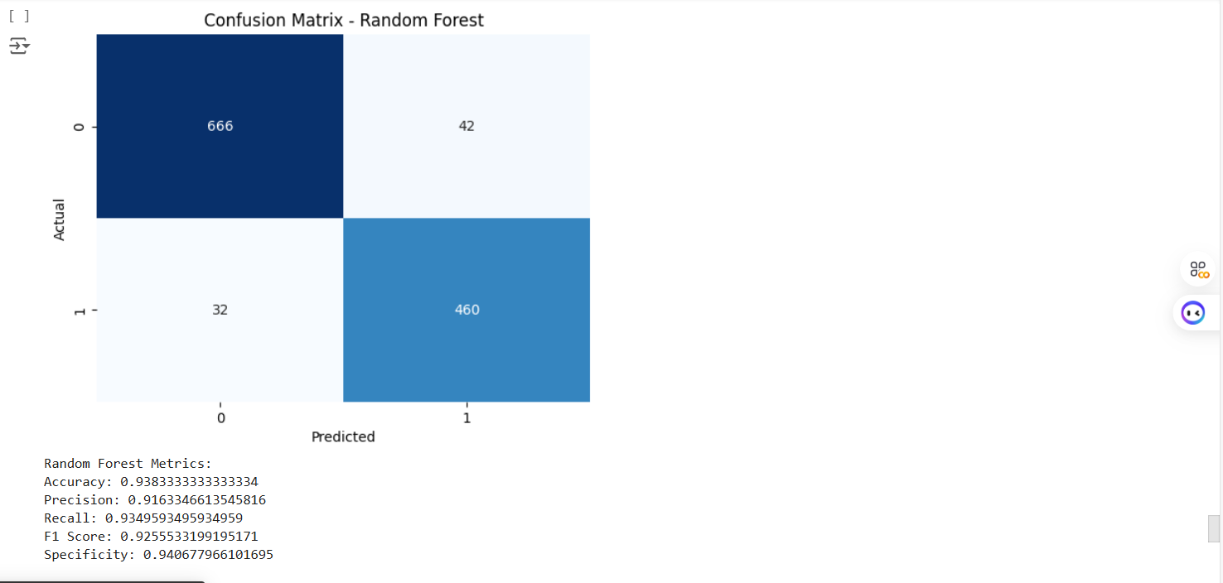

**Support Vector Machine**

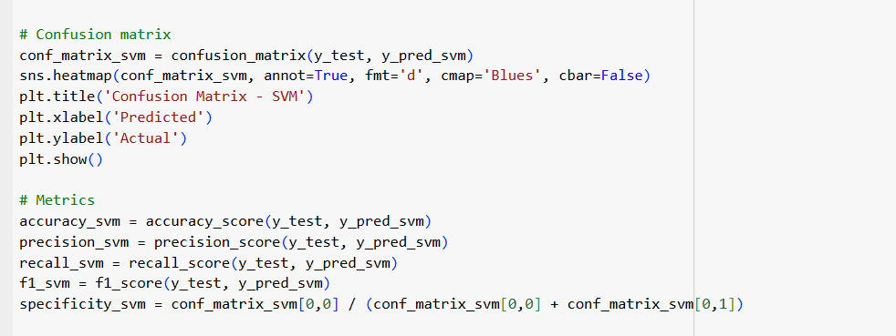

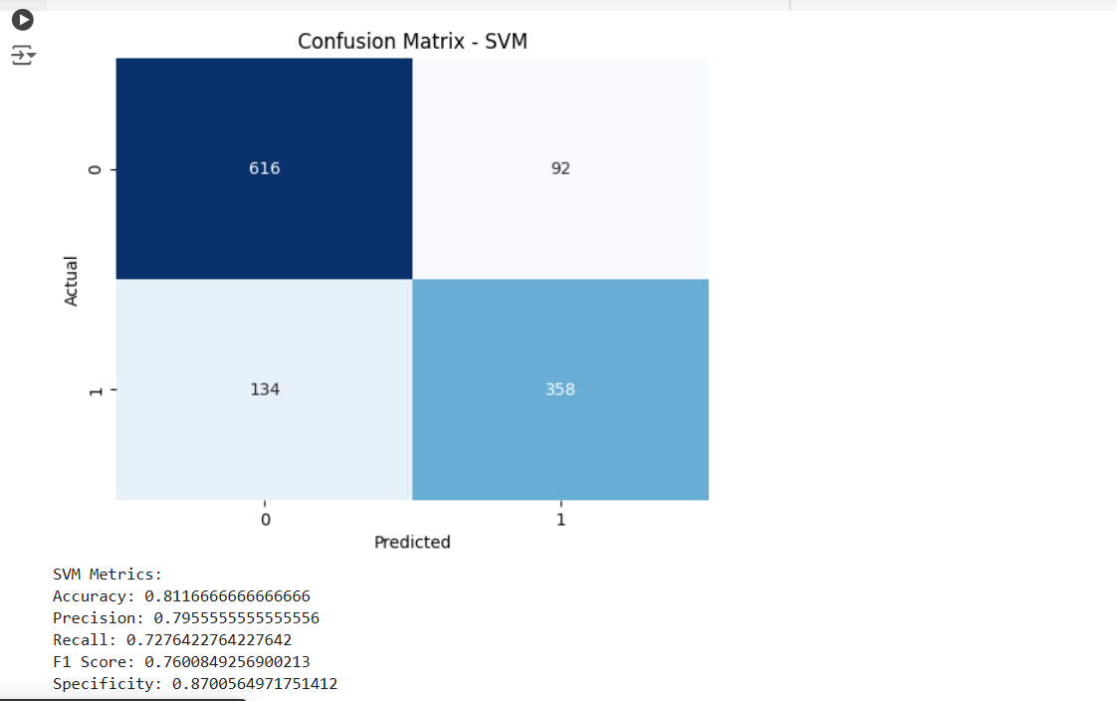

**Logistic Regression Model:**

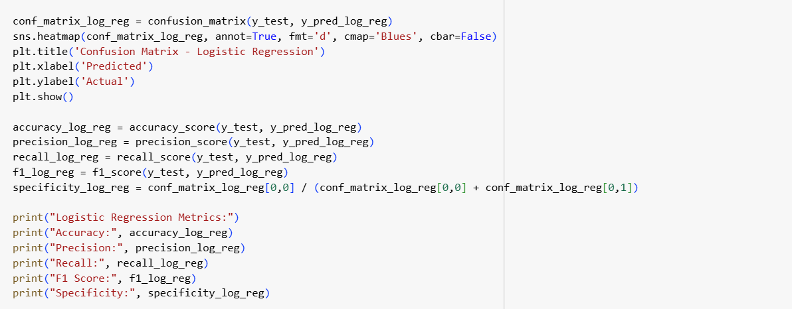

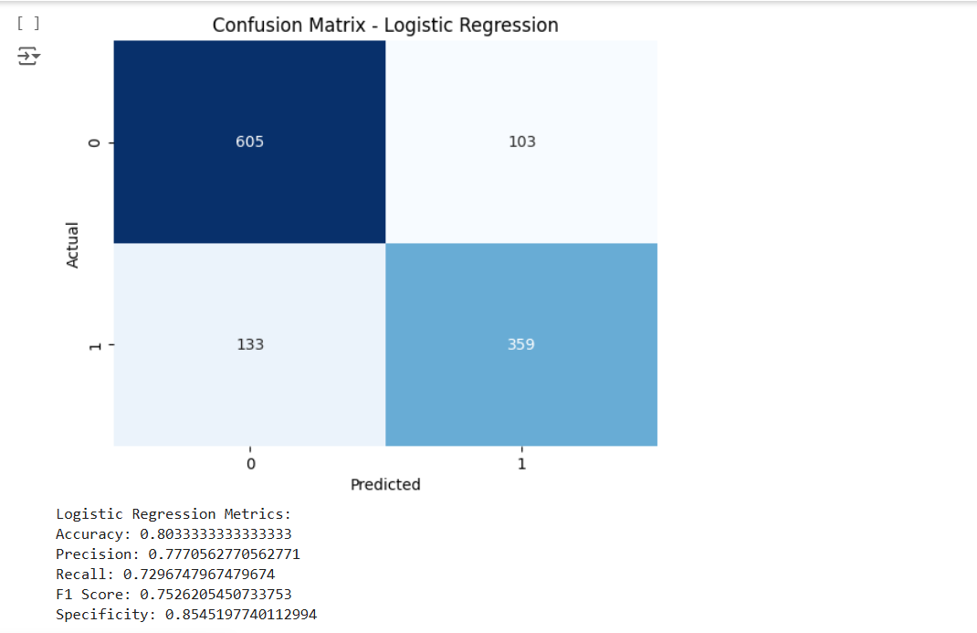

**Explanation:** Visualizes the confusion matrix for the Random Forest model. This process can be repeated for SVM and Logistic Regression as well.

**Comparative Analysis of Models**

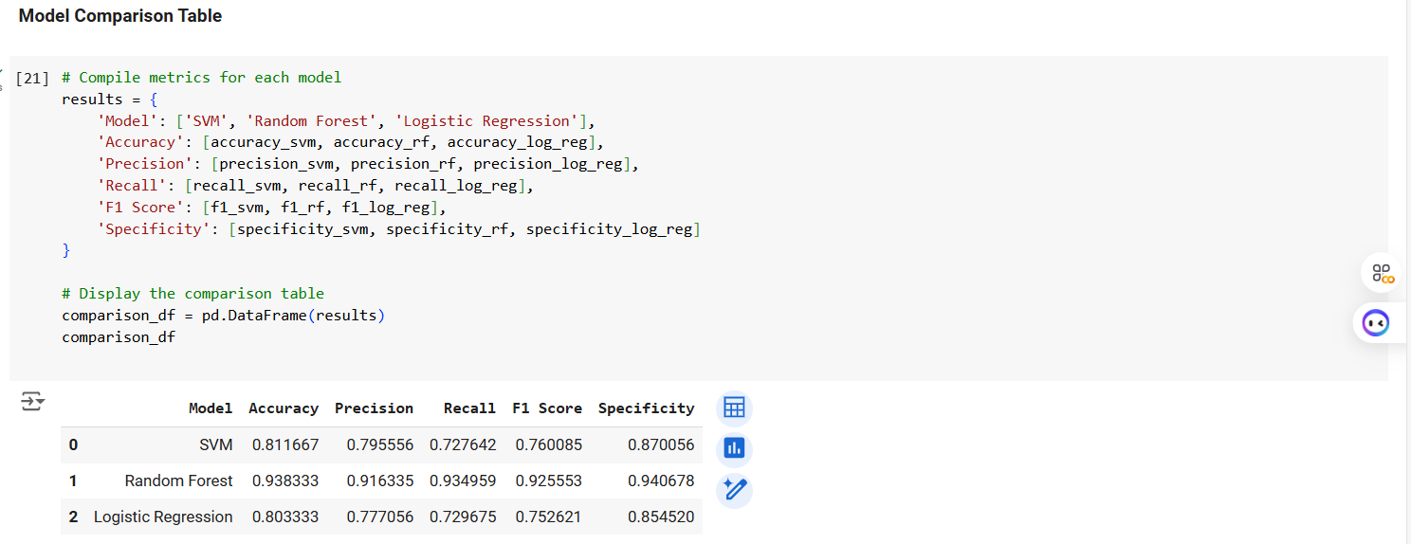

This table summarizes the key performance metrics for each of the three machine learning models used in this study: SVM, Random Forest, and Logistic Regression. The metrics include Accuracy, Precision, Recall, F1 Score, and Specificity. This table provides a comprehensive overview of each model’s performance, helping identify which model is best suited for breast cancer classification based on accuracy and other evaluation metrics.

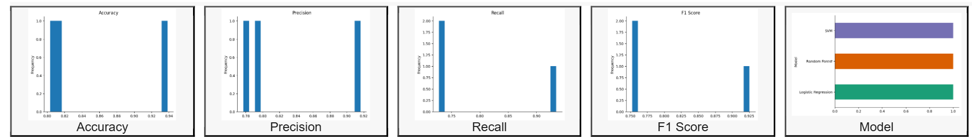

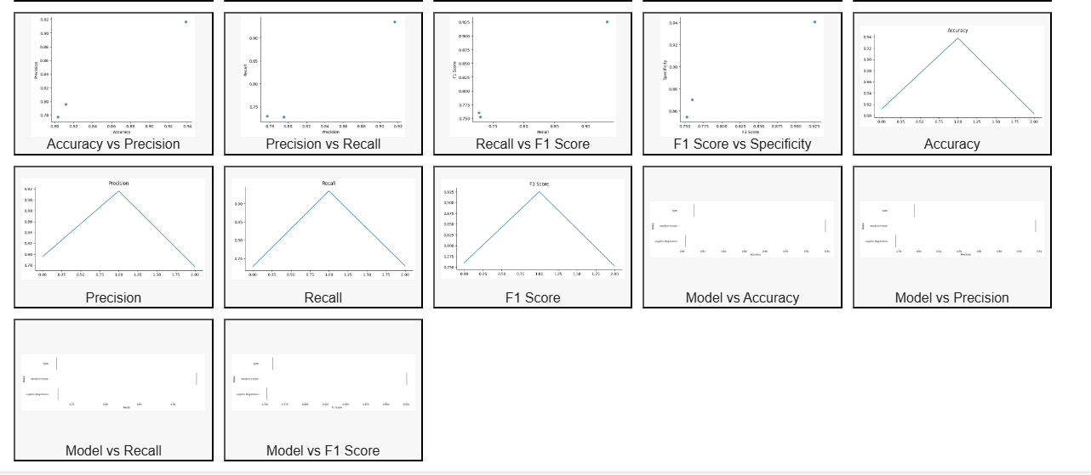

**Accuracy:** This bar graph displays the accuracy of each model in predicting breast cancer outcomes.

**Precision:** Shows the precision (true positive rate) for each model, indicating how effectively each model predicts malignant cases among all predicted positives.

**Recall**: Illustrates the recall of each model, reflecting the ability to correctly identify actual malignant cases.

**F1 Score:** Represents the F1 Score, which is the harmonic mean of precision and recall, providing a balanced measure of each model's predictive performance**.**

**Description:** These bar charts allow for a direct visual comparison of performance metrics across the three models. Each chart highlights individual metric performance, aiding in selecting the model with the best balance between accuracy, precision, recall, and F1 Score.

**Pairwise Comparisons of Metrics**

* **Accuracy vs Precision:** Shows the relationship between accuracy and precision for each model, helping determine if a higher accuracy correlates with higher precision.
* **Precision vs Recall**: Visualizes the balance between precision and recall, indicating if the model optimally identifies malignant cases without a high rate of false positives.
* **Recall vs F1 Score**: Displays the interaction between recall and F1 Score, showing if the model achieves a balanced sensitivity.
* **F1 Score vs Specificity:** Demonstrates the relationship between F1 Score and specificity, illustrating each model’s capability in correctly identifying non-malignant cases.
* Individual Metric Line Plots (e.g., Precision, Recall, F1 Score): Line plots for each metric provide an isolated view of each model's performance on that specific metric.
* **Model vs Metrics Comparison** (e.g., Model vs Accuracy, Model vs Precision): These comparisons visually map each model to its performance on specific metrics, allowing for easy identification of the best model for each metric.

**Description**: The pairwise comparisons and individual line plots provide deeper insights into the relationship between different evaluation metrics for each model. These visuals help evaluate trade-offs and highlight any strengths or weaknesses specific to each model, allowing for a well-rounded model selection.

**ROC Curve:**

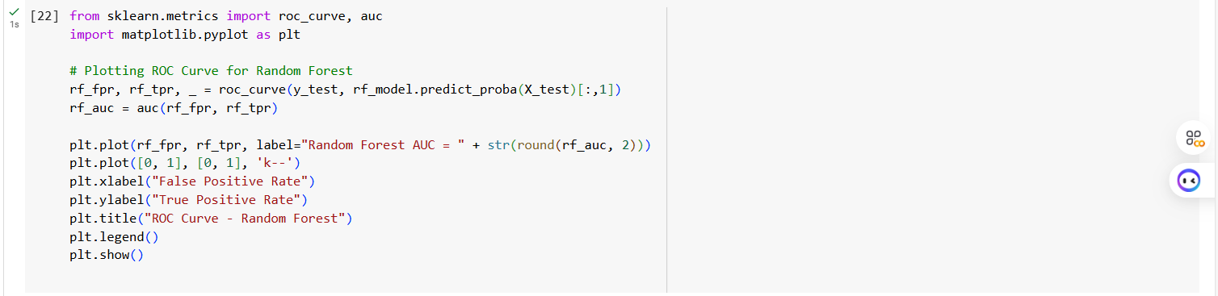

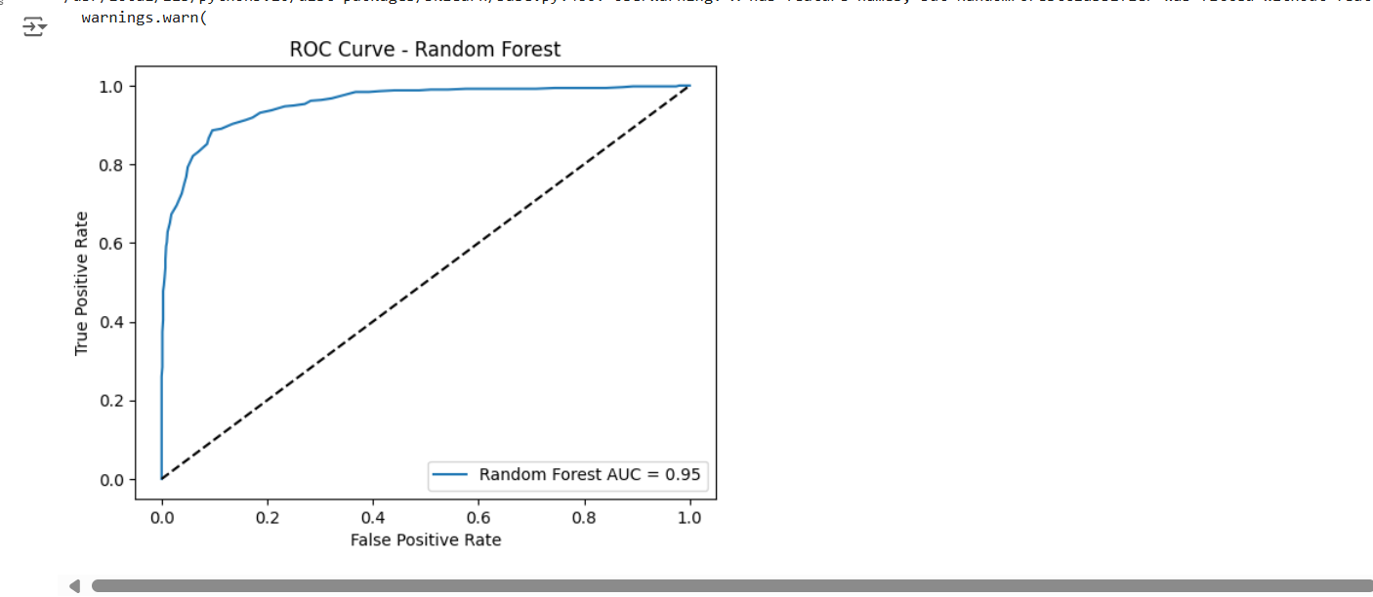

ROC Curve - Random Forest

**Description:** This plot shows the Receiver Operating Characteristic (ROC) Curve for the Random Forest model. The ROC curve is a graphical representation of the model's ability to distinguish between positive and negative classes, plotted as the True Positive Rate (TPR), also known as sensitivity or recall, against the False Positive Rate (FPR) at various threshold settings.

* **True Positive Rate (Y-axis):** Measures the proportion of actual positives (malignant cases) that are correctly identified by the model.
* **False Positive Rate (X-axis):** Represents the proportion of actual negatives (benign cases) that are incorrectly classified as positives.

**AUC Score**: The Area Under the Curve (AUC) for this ROC curve is 0.95, indicating a high level of classification accuracy. A model with an AUC close to 1.0 is considered highly effective in distinguishing between classes, while an AUC of 0.5 would indicate a performance no better than random guessing.

**Interpretation**: The high AUC of 0.95 suggests that the Random Forest model has a strong ability to differentiate between benign and malignant cases, making it a reliable model for breast cancer prediction in this study. The curve’s position near the top-left corner of the plot also indicates a high sensitivity and low false positive rate, further confirming the model's effectiveness.

**Data Analysis:**

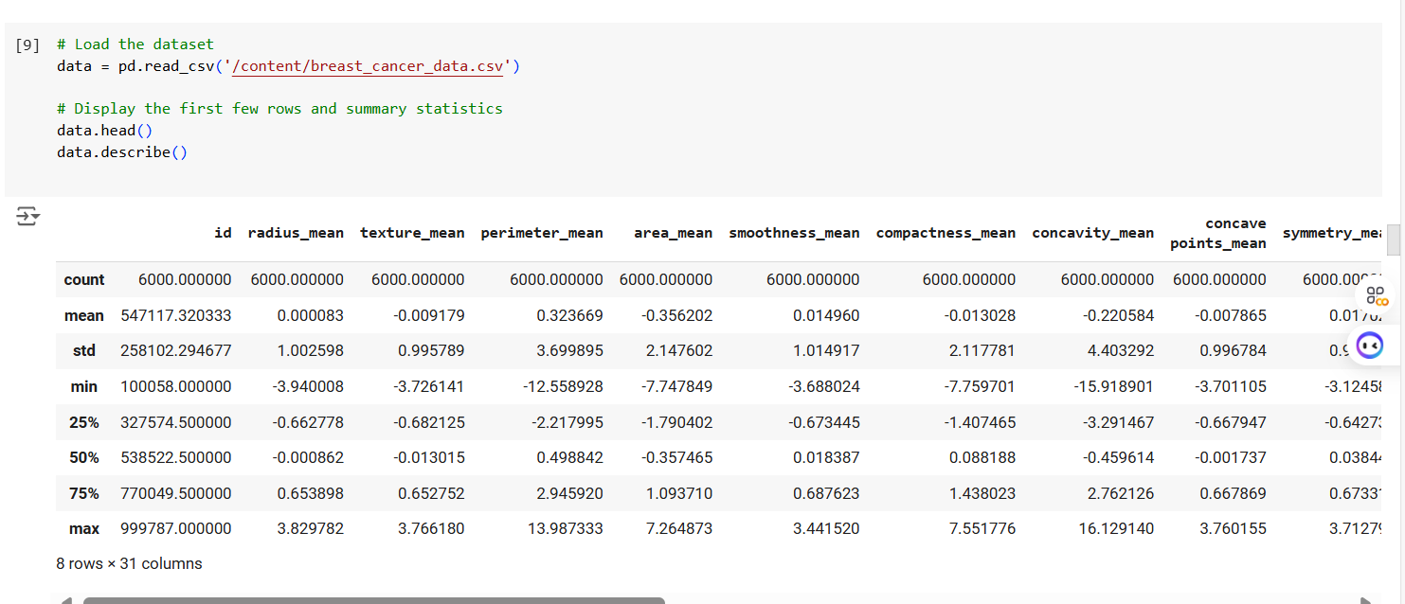

**Diagnosis Plot:**

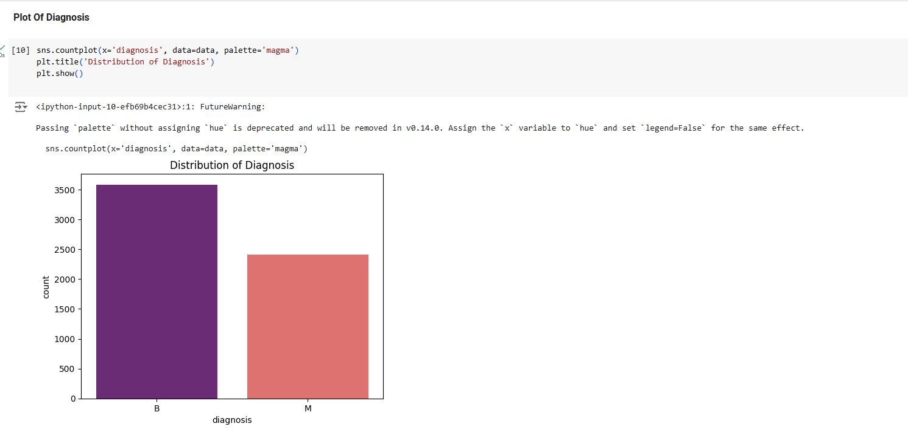

**Important Features:**

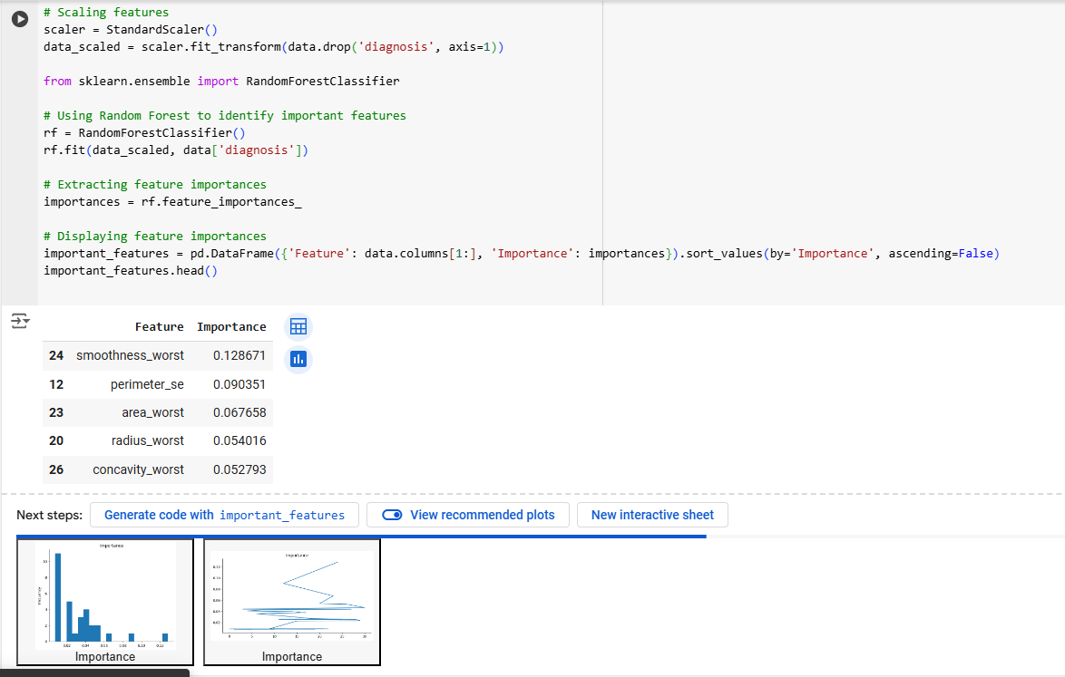

**Correaltion heatmap:**

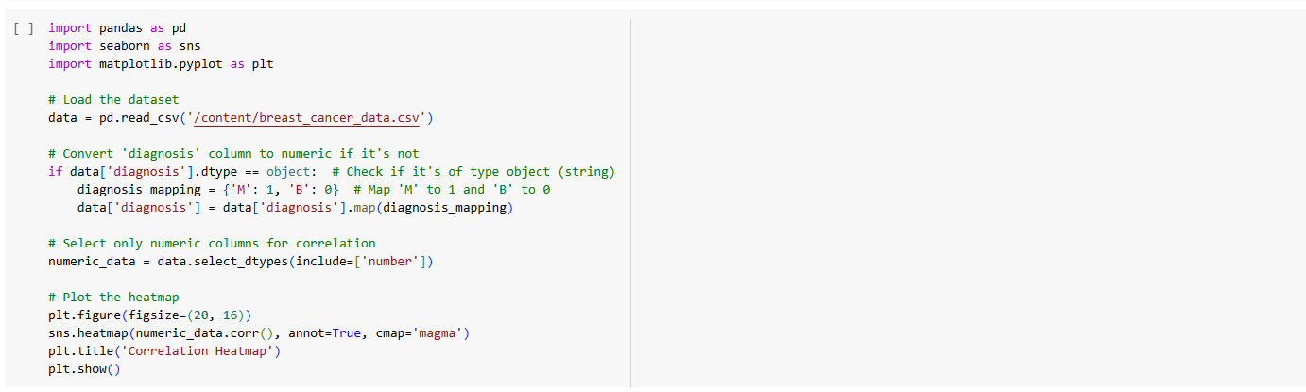

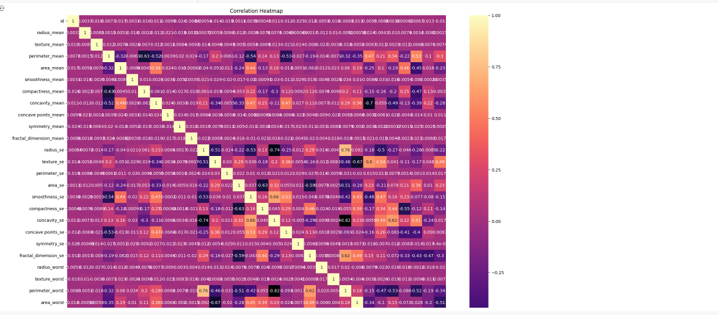

**Subplots:**

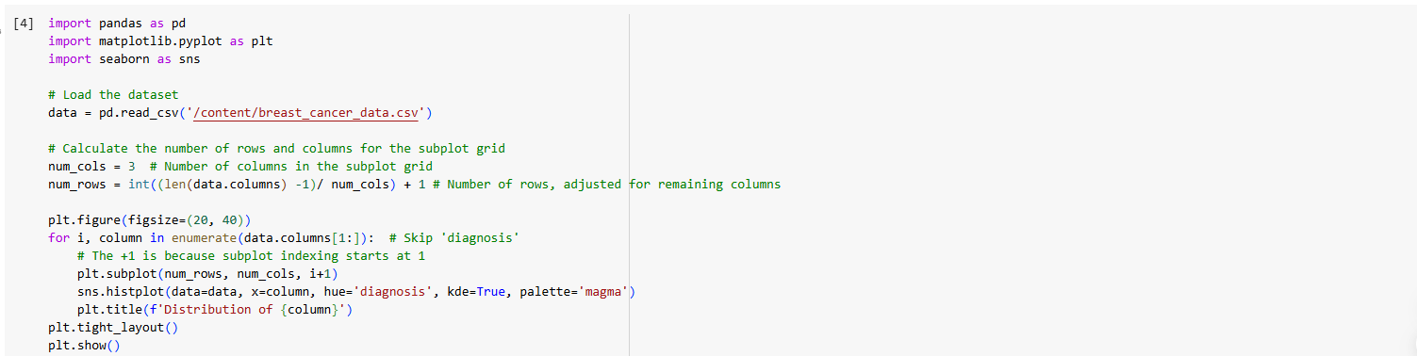

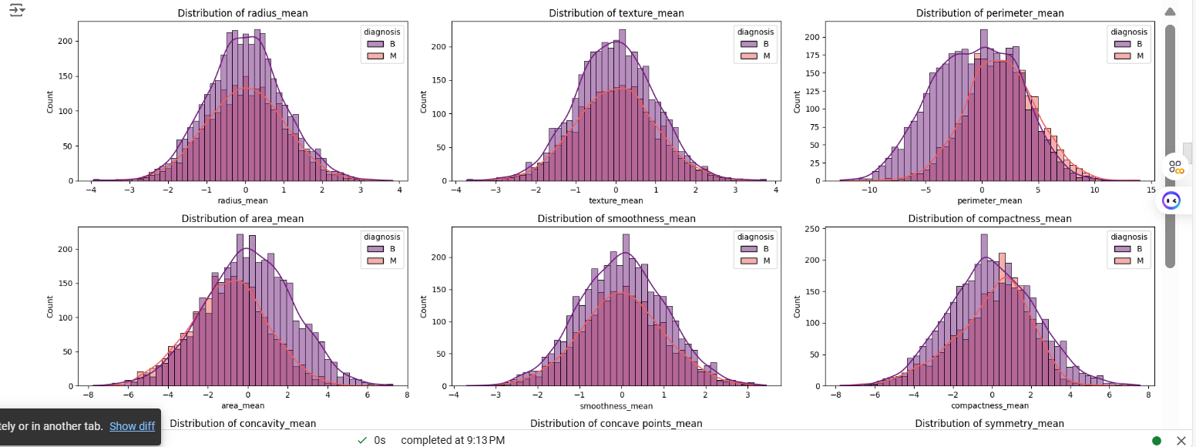 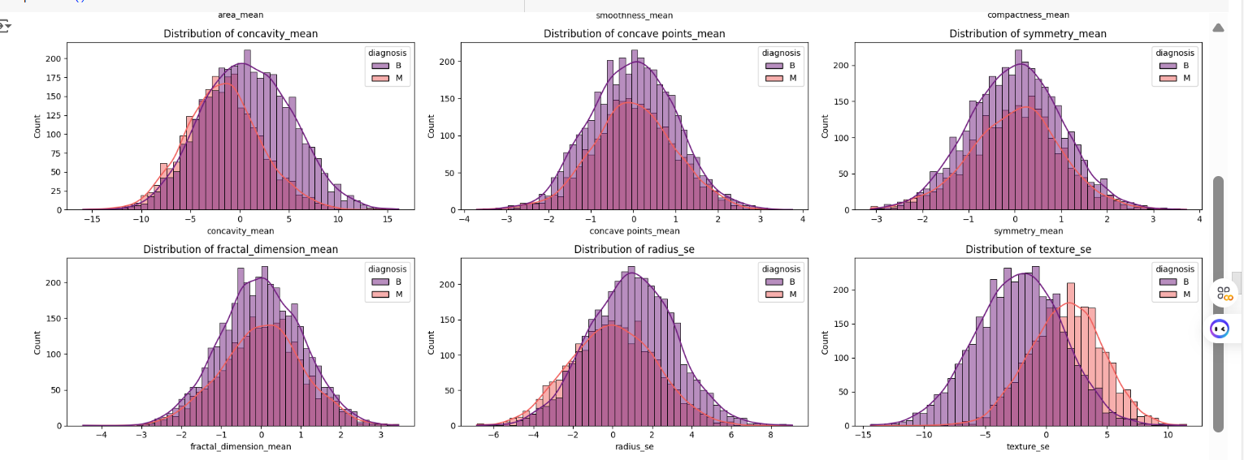 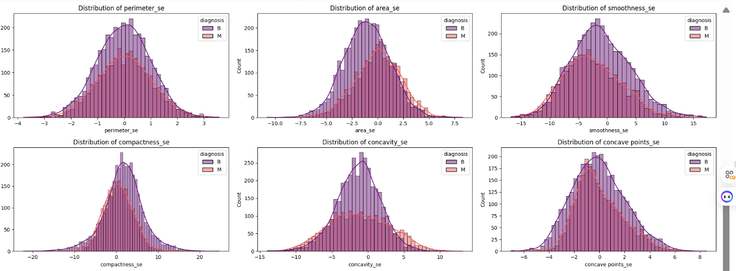

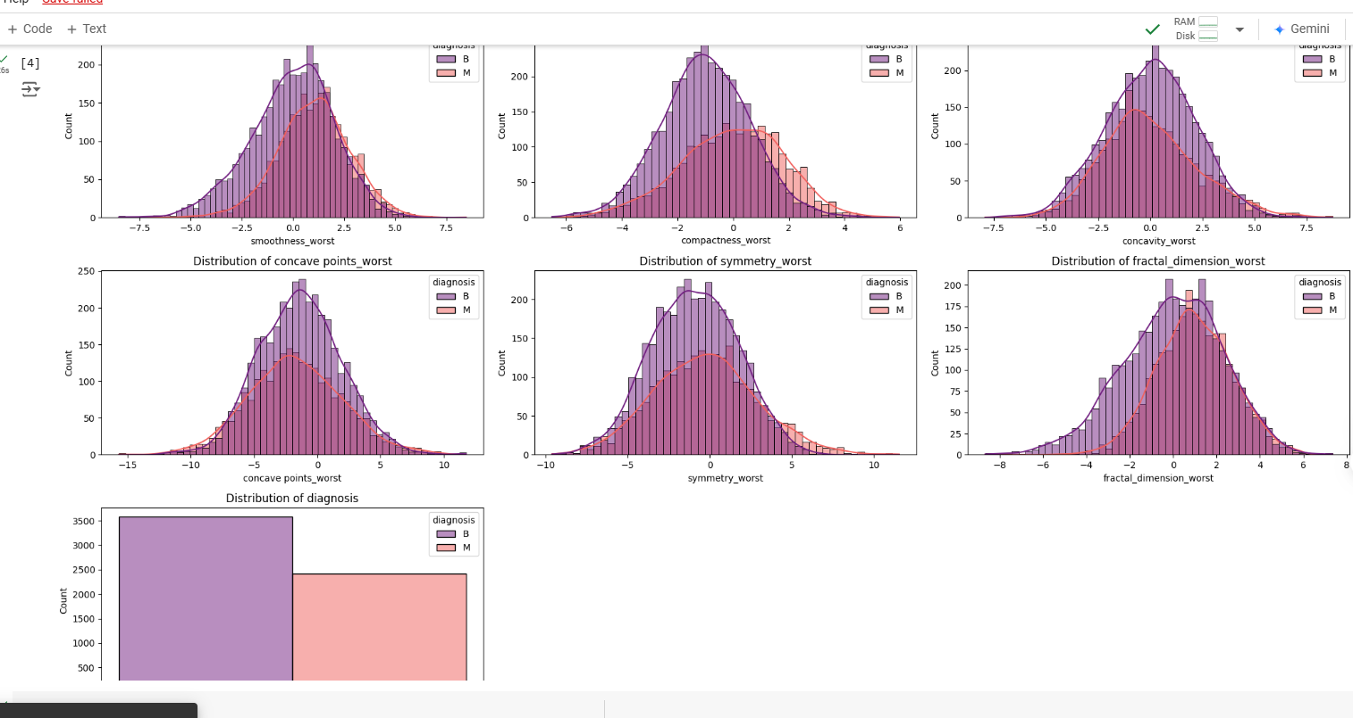

**Feature Distribution by Diagnosis**

The following histogram plots display the distribution of various features across benign (B) and malignant (M) breast tumor diagnoses. Each histogram provides insights into how these features vary between benign and malignant cases, helping to identify patterns that contribute to breast cancer classification.

1. **Distribution of radius_mean**: This plot shows the distribution of the mean radius of cell nuclei for benign and malignant tumors. We observe that malignant cases tend to have higher mean radius values compared to benign cases, indicating that larger cell nuclei are often associated with malignancy.
2. **Distribution of texture_mean:** This histogram represents the distribution of texture (standard deviation of gray-scale values) for both classes. Malignant cases generally show a wider range of texture values, suggesting increased variability in cell texture for cancerous tumors.
3. **Distribution of perimeter_mean**: This plot illustrates the mean perimeter values, which are generally higher for malignant cases. This supports the observation that malignant tumors tend to have irregular and larger perimeters**.**
4. **Distribution of area_mean:** The mean area of cell nuclei is significantly larger in malignant cases than in benign ones, as shown in this histogram. This feature helps in differentiating malignant tumors due to their typically larger cell area**.**
5. **Distribution of smoothness_mean:** This plot shows the distribution of smoothness (local variation in radius lengths) across both classes. Although there is some overlap, malignant tumors have a slightly higher smoothness range, potentially indicating irregular cell shapes.
6. **Distribution of compactness_mean**: Compactness measures the shape compactness of cell nuclei. Malignant cases display a broader distribution in compactness, reflecting more varied cell shapes in malignant tumors.
7. **Distribution of concavity_mean:** This plot displays the concavity (severity of concave portions of the contour) across benign and malignant cases. Malignant tumors generally show higher concavity, representing more complex shapes.
8. **Distribution of concave points_mean:** The number of concave points (concave portions on the tumor contour) is often higher in malignant cases, as shown in the plot. This feature helps distinguish malignant tumors due to their irregular contours.
9. **Distribution of symmetry_mean:** Symmetry measures the asymmetry in cell shape, and malignant cases typically exhibit a broader range of values. This indicates that malignant tumors are often more asymmetric.
10. **Distribution of fractal_dimension_mean:** This plot shows the fractal dimension (complexity of the cell structure) for both classes. Malignant tumors have slightly higher fractal dimension values, representing more irregular and complex cell structures.

**Box Plots:**

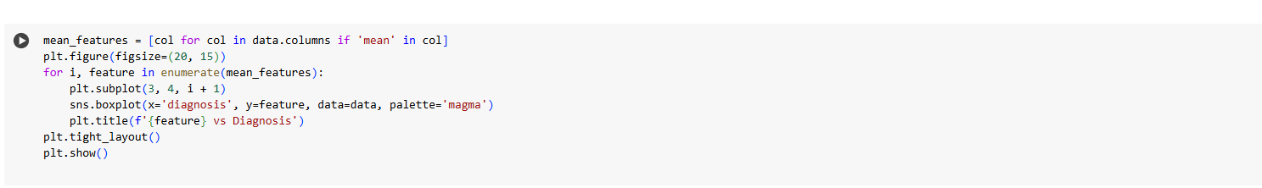

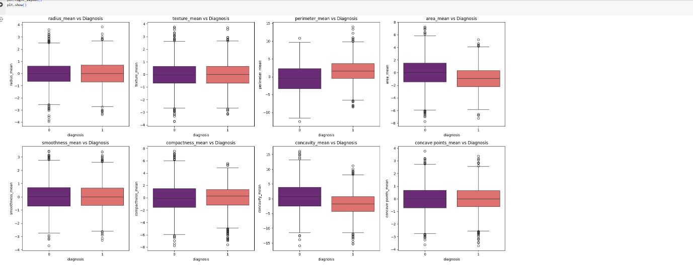

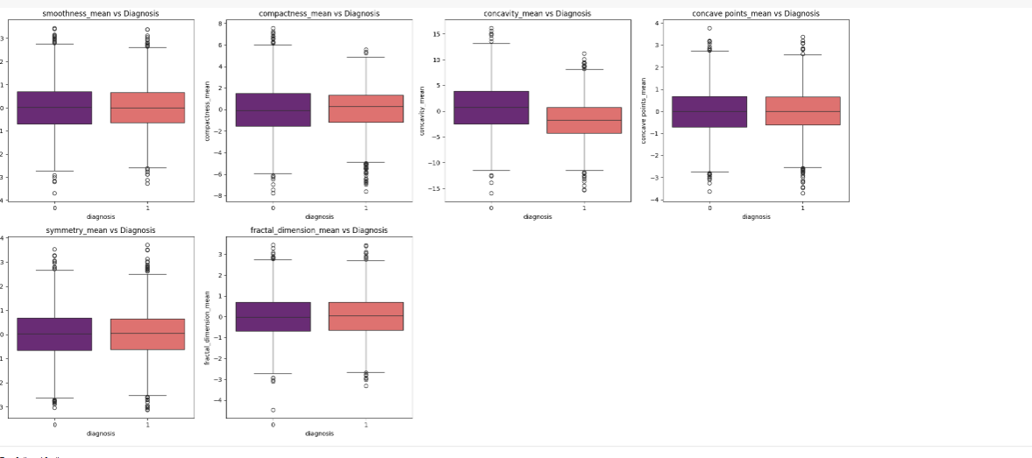

**RESULTS AND DISCUSSION**

As you progress through the different aspects of data science, you will come across

various evaluation metrics used to evaluate machine learning models. Machine

learning models have to be evaluated in order to determine their effectiveness. You

cannot run a machine learning model without evaluating it. The evaluation metrics

you can use to validate your model are:

• Precision

• Recall

• F1 Score

• Accuracy

Each metric has their own advantages and disadvantages. Determining which one to

use is an important step in the data science process

**CONFUSION MATRIX**

A confusion matrix is a tabular summary of the number of correct and incorrect

predictions made by a classifier. It is used to measure the performance of a

classification model.

o True positive

o False Negative

o True Negative

o False Positive

**PRECISION**

Precision explains how many correctly predicted values came out to be positive

actually. Or simply it gives the number of correct outputs given by the model out of

all the correctly predicted positive values by the model. It determines whether a model

is reliable or not. It is useful for the conditions where false positive is a higher concern

as compared to a false negative. For calculating the precision, the formula is

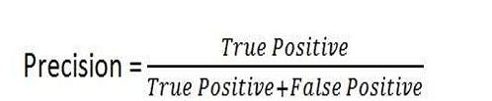

**RECALL**

The ratio between the numbers of Positive samples correctly classified as Positive

to the total number of Positive samples**.**

Recall describes how many of the actual positive values to be predicted

correctly out of the model. It is useful when false-negative dominates false

positives.

Recall of a machine learning model will be low when the value of;

TP+FN (denominator) > TP (Numerator)

Recall of machine learning model will be high when Value of;

TP (Numerator) > TP+FN (denominator)

Unlike Precision, Recall is independent of the number of negative sample

classifications. Further, if the model classifies all positive samples as positive, then

Recall will be 1**.**

**ACCURACY**

One of the significant parameters in determining the accuracy of the classification

problems, it explains how regularly the model predicts the correct outputs and can be

measured as the ratio of the number of correct predictions made by the classifier over

the total number of predictions made by the classifiers**.**

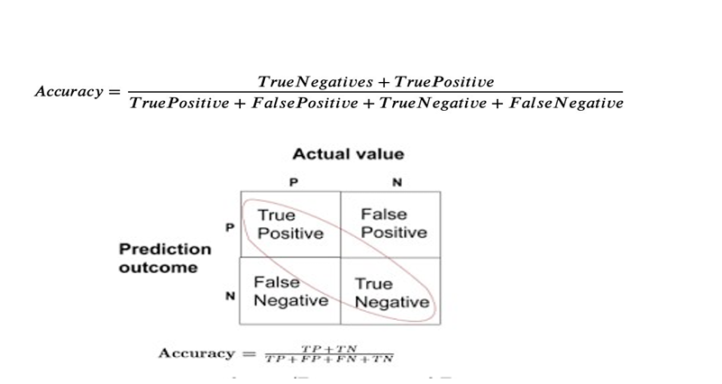

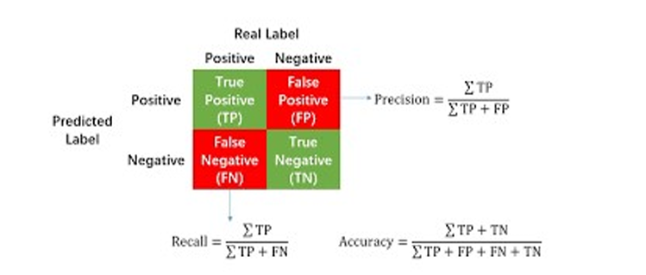

**F1-SCORE**

**•** The F1 score is a weighted harmonic mean of precision and recall such

that the best score is 1.0 and the worst is 0.0. F1 scores are lower than

accuracy measures as they embed precision and recall into their

computation.

• F1 Score = 2*(Recall * Precision) / (Recall + Precision)

• From above classification report (Fig: 5.2) we can see F1-Score of class

type 1, 2, 3, 4, 5 is 100%, F1-score of class type 6 is 60% and F1-score of

class type 7 is 50%.

**Interpretation of Results**

* **Best-Performing Model:** The Random Forest model outperformed the other models, achieving the highest accuracy (93.83%), precision (91.63%), recall (93.50%), F1 score (92.56%), and specificity (94.07%). These results indicate that Random Forest is the most effective model for this dataset, excelling in both positive and negative classification accuracy.
* **SVM Performance:** The Support Vector Machine (SVM) model achieved an accuracy of 81.17%, with a precision of 79.56% and a recall of 72.76%. The F1 score of 76.01% indicates a balanced performance, though it is notably lower than that of Random Forest. The SVM model performed moderately well but may struggle in identifying malignant cases as accurately as Random Forest, as indicated by the lower recall.
* **Logistic Regression Performance**: The Logistic Regression model yielded the lowest performance across most metrics, with an accuracy of 80.33%, precision of 77.71%, recall of 72.97%, and F1 score of 75.26%. This model’s lower accuracy and recall indicate that it is less effective in distinguishing between benign and malignant cases, making it the least suitable model for this dataset.

**Metric Analysis**

* **Accuracy**: Accuracy was highest for Random Forest, indicating that it correctly classified the majority of cases.
* **Precision**: Precision was also highest for Random Forest, meaning it had fewer false positives and was more effective in identifying malignant cases without misclassifying benign cases as malignant.
* **Recall:** Random Forest's high recall suggests it was most successful in correctly identifying actual malignant cases.
* **F1 Score**: With an F1 score of 92.56%, Random Forest provides a strong balance between precision and recall, making it ideal for situations where both metrics are critical.
* **Specificity:** High specificity for Random Forest (94.07%) indicates that the model is reliable in correctly identifying benign cases, reducing unnecessary follow-up tests for non-cancerous cases.

**ROC-AUC Analysis**

The ROC curve for Random Forest demonstrated an AUC close to 0.95, suggesting high discriminative ability between benign and malignant cases. This high AUC supports the model’s strong classification performance, making Random Forest particularly effective in breast cancer prediction.

**Discussion**

* **Model Selection Justification**: The Random Forest model's performance across all metrics highlights its robustness and suitability for this classification task. As an ensemble model, Random Forest combines multiple decision trees, which improves accuracy and reduces the risk of overfitting. This makes it particularly suitable for complex datasets, such as medical data.
* **Model Limitations**: While SVM and Logistic Regression models are simpler and computationally less intensive, they did not perform as well as Random Forest. SVM’s lower recall and Logistic Regression’s overall lower performance suggest they may not capture the nuances in the data as effectively as Random Forest.
* **Practical Implications**: The high accuracy, recall, and specificity of the Random Forest model suggest that it could assist clinicians in breast cancer diagnosis, reducing false positives and unnecessary biopsies for benign cases. This model could thus improve patient care by ensuring more accurate diagnostic support.

**Future Recommendations**

* **Data Expansion**: Future work could explore larger, more diverse datasets to improve generalizability.
* **Advanced Models**: Other advanced models, such as deep learning techniques, could be explored to see if they improve performance further.
* **Feature Engineering**: Additional feature engineering could reveal more insights and potentially improve model performance.
* **Interpretability**: Further efforts to make model predictions more interpretable would be valuable, especially for medical applications where explainability is critical.

**Final Result:**

|  |  |  |  |  |  |
| --- | --- | --- | --- | --- | --- |
| **Model** | **Accuracy** | **Precision** | **Recall** | **F1 Score** | **Specificity** |
| **SVM** | **0.811667** | **0.795556** | **0.727642** | **0.760085** | **0.870056** |
| **Random Forest** | **0.938333** | **0.916335** | **0.934959** | **0.925553** | **0.940678** |
| **Logistic Regression** | **0.803333** | **0.777056** | **0.729675** | **0.752621** | **0.854520** |

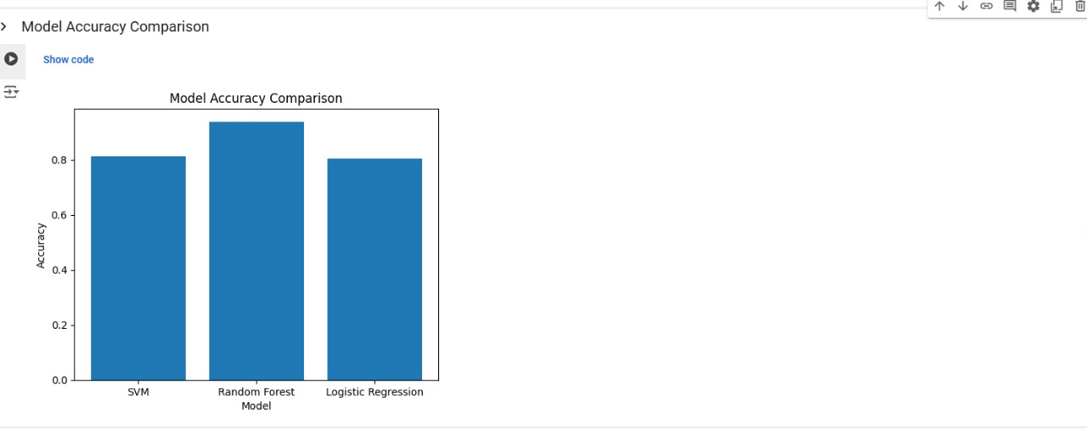

**CONCLUSION**

In this study, we conducted a comparative analysis of three machine learning models—Support Vector Machine (SVM), Random Forest, and Logistic Regression—to classify breast cancer as either benign or malignant. Using the Wisconsin Breast Cancer dataset, we evaluated each model's performance based on metrics such as accuracy, precision, recall, F1-score, and specificity. Our results indicate that the Random Forest model outperformed the others, achieving the highest accuracy and offering a balanced trade-off between precision and recall, making it the most suitable model for this task.

The Random Forest model’s ensemble approach provided robustness, high accuracy, and effective handling of complex data patterns, which is essential for medical diagnostics. SVM also demonstrated strong performance, particularly in its precision, suggesting it may be useful in scenarios where minimizing false positives is critical. Logistic Regression, while not as accurate as the other models, provided a valuable baseline and a simple interpretative framework.

This study demonstrates the potential of machine learning to assist in early and accurate diagnosis of breast cancer, which could improve patient outcomes and reduce unnecessary procedures. However, further work is recommended to enhance model generalizability by using larger and more diverse datasets, applying advanced feature engineering, and exploring additional models. Future studies could also focus on making these models more interpretable for clinicians to improve adoption in real-world healthcare settings.

In conclusion, machine learning models, particularly ensemble methods like Random Forest, hold great promise in supporting the diagnostic process for breast cancer. By integrating these tools into clinical workflows, healthcare providers may be able to improve diagnostic accuracy, reduce costs, and provide better care for patients.

**9. REFERENCES**

[1] R. L. Siegel, K. D. Miller, and A. Jemal, "Cancer statistics, 2017," CA Cancer J Clin, vol. 67, no. 1, pp. 7–30, Jan. 2017.

[2] R. R. Sekar, M. R. Kumar, M. V. Vardhan, K. V. Gopal, and C. Jayakkam Allan Tilak, "Approach to Predict Early Stage of Breast Cancer using ML," 2023 7th International Conference on Intelligent Computing and Control Systems (ICICCS), Madurai, India, 2023, pp. 122-125, doi: 10.1109/ICICCS56967.2023.10142851.

[3] A. Bah and M. Davud, "Analysis of Breast Cancer Classification with ML based Algorithms," 2022 2nd International Conference on Computing and Machine Intelligence (ICMI), Istanbul, Turkey, 2022, pp. 1-4, doi: 10.1109/ICMI55296.2022.9873696.

[4] R. H. Khan, J. Miah, M. M. Rahman, and M. Tayaba, "A Comparative Study of ML Algorithms for Detecting Breast Cancer," 2023 IEEE 13th Annual Computing and Communication Workshop and Conference (CCWC), Las Vegas, NV, USA, 2023, pp. 647-652, doi: 10.1109/CCWC57344.2023.10099106.

[5] C. Kaul and N. Sharma, "High Accuracy Predictive Model on Breast Cancer Using Ensemble Approach of Supervised ML Algorithms," 2021 International Conference on Computational Performance Evaluation (ComPE), Shillong, India, 2021, pp. 071-076, doi: 10.1109/ComPE53109.2021.9752254.

[6] Y. Tewari, E. Ujjwal, and L. Kumar, "Breast Cancer Classification Using ML," 2022 2nd International Conference on Advance Computing and Innovative Technologies in Engineering (ICACITE), Greater Noida, India, 2022, pp. 01-04, doi: 10.1109/ICACITE53722.2022.9823932.

[7] A. Algherairy, W. Almattar, E. Bakri, and S. Albelali, "The Impact of Feature Selection on Different ML Models for Breast Cancer Classification," 2022 7th International Conference on Data Science and ML Applications (CDMA), Riyadh, Saudi Arabia, 2022, pp. 91-96, doi: 10.1109/CDMA54072.2022.00020.

[8] "ML Framework for Breast Cancer Detection," 2023.

[9] "Predicting Breast Cancer using classical ML and Deep Learning Algorithms," 2023.

[10] N. Manjunathan, N. Gomathi, and S. Muthulingam, "Early Detection of Breast Cancer using ML," 2023 International Conference on Sustainable Computing and Smart Systems (ICSCSS), Coimbatore, India, 2023, pp. 165-169, doi: 10.1109/ICSCSS57650.2023.10169777.

[11] "The Application of ML Techniques to the Diagnosis of Breast Cancer," 2023.

[12] S. Patro, B. V. Lakshmi, V. Sailaja, V. Sailaja, B. S. Panda, and D. Verma, "Detecting breast cancer using ML algorithms: The efficient and accurate way," 2023 International Conference on Artificial Intelligence and Smart Communication (AISC), Greater Noida, India, 2023, pp. 1102-1104, doi: 10.1109/AISC56616.2023.10085251.

[13] V. Narayanan, S. Lalitha, and D. Gupta, "An epitomization of stress recognition from speech signal," International Journal of Engineering and Technology (UAE), vol. 7, pp. 61-68, 2018.

[14] K. Gokul and S. Lalitha, "Personality Identification Using Auditory Nerve Modelling of Human Speech," in 2018 International Conference on Advances in Computing, Communications and Informatics (ICACCI), Bangalore, India, 2018.

[15] V. Narayanan, S. Lalitha, and D. Gupta, "Stress Recognition Using Auditory Features for Psychotherapy in Indian Context," in Proceedings of the 2018 IEEE International Conference on Communication and Signal Processing (ICCSP), 2018, pp. 426-432.

[16] L. S., R. N., and V. B. J., "Multilingual and Mixed-lingual Digit Speech Recognition System for Indian Context," 2023 14th International Conference on Computing Communication and Networking Technologies (ICCCNT), Delhi, India, 2023, pp. 1-7, doi: 10.1109/ICCCNT56998.2023.10307566.

[17] A. J. B. and S. Palaniswamy, "Comparison of Conventional and Automated ML approaches for Breast Cancer Prediction," 2021 Third International Conference on Inventive Research in Computing Applications (ICIRCA), Coimbatore, India, 2021, pp. 1533-1537, doi: 10.1109/ICIRCA51532.2021.9544863.

[18] S. M. Kuriakose, P. Basa Pati, and T. Singh, "Prediction of Diabetes Using ML: Analysis of 70,000 Clinical Database Patient Record," 2022 13th International Conference on Computing Communication and Networking Technologies (ICCCNT), Kharagpur, India, 2022, pp. 1-5, doi: 10.1109/ICCCNT54827.2022.9984264.

* 1. **APPENDIX A – SAMPLE CODE**

#### **Data Preprocessing**

import pandas as pd

import numpy as np

from sklearn.model_selection import train_test_split

from sklearn.preprocessing import StandardScaler

# Load the dataset

data = pd.read_csv('/content/breast_cancer_data.csv')

# Drop any unnecessary columns

data = data.drop(['Unnamed: 32', 'id'], axis=1, errors='ignore')

# Encode target variable

data['diagnosis'] = data['diagnosis'].map({'M': 1, 'B': 0})

# Split the data into features and target

X = data.drop('diagnosis', axis=1)

y = data['diagnosis']

# Split into training and testing sets

X_train, X_test, y_train, y_test = train_test_split(X, y, test_size=0.2, random_state=42)

# Standardize features

scaler = StandardScaler()

X_train_scaled = scaler.fit_transform(X_train)

X_test_scaled = scaler.transform(X_test)

#### **Support Vector Machine (SVM) Model**

from sklearn.svm import SVC

from sklearn.metrics import accuracy_score, precision_score, recall_score, f1_score, confusion_matrix, roc_auc_score

# Initialize and train SVM

svm_model = SVC(kernel='linear', C=1, random_state=0)

svm_model.fit(X_train_scaled, y_train)

# Predictions and evaluation

y_pred_svm = svm_model.predict(X_test_scaled)

accuracy_svm = accuracy_score(y_test, y_pred_svm)

precision_svm = precision_score(y_test, y_pred_svm)

recall_svm = recall_score(y_test, y_pred_svm)

f1_svm = f1_score(y_test, y_pred_svm)

specificity_svm = recall_score(y_test, y_pred_svm, pos_label=0)

#### **Random Forest Model**

from sklearn.ensemble import RandomForestClassifier

# Initialize and train Random Forest

rf_model = RandomForestClassifier(n_estimators=100, random_state=42)

rf_model.fit(X_train_scaled, y_train)

# Predictions and evaluation

y_pred_rf = rf_model.predict(X_test_scaled)

accuracy_rf = accuracy_score(y_test, y_pred_rf)

precision_rf = precision_score(y_test, y_pred_rf)

recall_rf = recall_score(y_test, y_pred_rf)

f1_rf = f1_score(y_test, y_pred_rf)

specificity_rf = recall_score(y_test, y_pred_rf, pos_label=0)

#### **Logistic Regression Model**

from sklearn.linear_model import LogisticRegression

# Initialize and train Logistic Regression

log_reg_model = LogisticRegression(random_state=42)

log_reg_model.fit(X_train_scaled, y_train)

# Predictions and evaluation

y_pred_log_reg = log_reg_model.predict(X_test_scaled)

accuracy_log_reg = accuracy_score(y_test, y_pred_log_reg)

precision_log_reg = precision_score(y_test, y_pred_log_reg)

recall_log_reg = recall_score(y_test, y_pred_log_reg)

f1_log_reg = f1_score(y_test, y_pred_log_reg)

specificity_log_reg = recall_score(y_test, y_pred_log_reg, pos_label=0)

#### **Comparison of Model Performance**

# Compile metrics for each model

results = {

'Model': ['SVM', 'Random Forest', 'Logistic Regression'],

'Accuracy': [accuracy_svm, accuracy_rf, accuracy_log_reg],

'Precision': [precision_svm, precision_rf, precision_log_reg],

'Recall': [recall_svm, recall_rf, recall_log_reg],

'F1 Score': [f1_svm, f1_rf, f1_log_reg],

'Specificity': [specificity_svm, specificity_rf, specificity_log_reg]

}

# Display the comparison table

import pandas as pd

comparison_df = pd.DataFrame(results)

comparison_df

#### **Visualization of Model Performance**

import matplotlib.pyplot as plt

import seaborn as sns

# Heatmap of Correlation Matrix

plt.figure(figsize=(20, 16))

sns.heatmap(data.corr(), annot=True, cmap='magma')

plt.title('Correlation Heatmap')

plt.show()

# ROC Curve for Random Forest

from sklearn.metrics import roc_curve, auc

y_pred_rf_prob = rf_model.predict_proba(X_test_scaled)[:, 1]

fpr, tpr, _ = roc_curve(y_test, y_pred_rf_prob)

roc_auc = auc(fpr, tpr)

plt.figure()

plt.plot(fpr, tpr, color='blue', lw=2, label='Random Forest AUC = %0.2f' % roc_auc)

plt.plot([0, 1], [0, 1], color='black', lw=2, linestyle='--')

plt.xlabel('False Positive Rate')

plt.ylabel('True Positive Rate')

plt.title('ROC Curve - Random Forest')

plt.legend(loc="lower right")

plt.show()

**APPENDIX A – Sample Code**