DiscoveryHub
E-Discovery & Legal Hold Platform — Intern Project Requirements
Teams | 4 teams × 5 members. All teams build the same product from scratch.
Duration | 4 days
Architecture | Microservices-based, built end to end (backend, messaging, storage, search, frontend, deployment).
Presentation | 1 hour per team, including live demo.

1. Background
Regulated firms (banks, broker-dealers, advisors) must retain business communications and produce them on demand during investigations, litigation, or regulatory inquiries. When a matter arises, an investigator must be able to find relevant communications, freeze them so they cannot be deleted, and export them as evidence with a verifiable trail of who did what.
DiscoveryHub is the platform that makes this possible.

2. Business Workflow
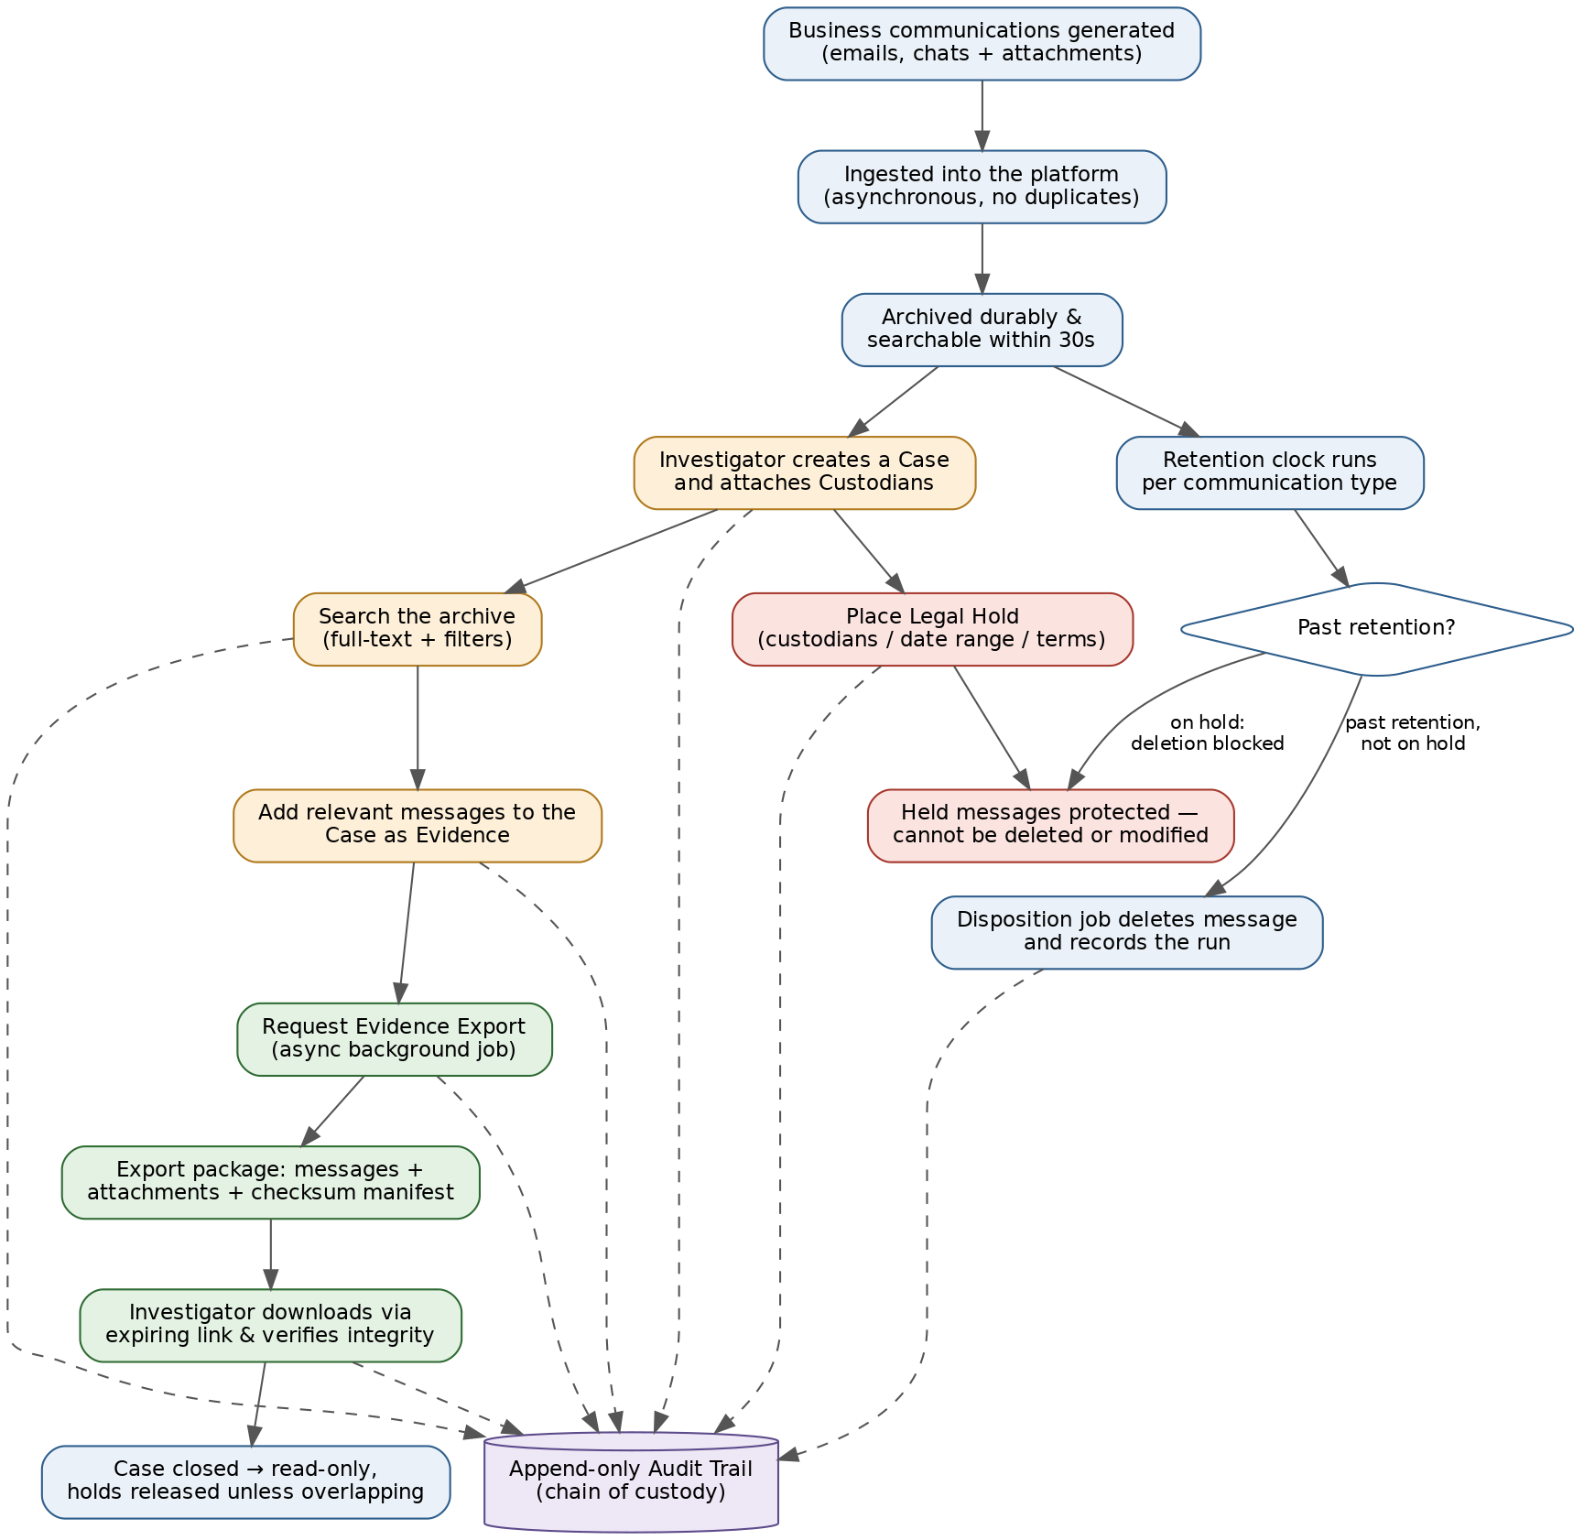
End-to-end business workflow: ingestion and archival (blue), investigation (amber), legal hold (red), export (green), audit (purple). Dashed lines indicate actions recorded in the audit trail.

3. User Persona
A single user persona: the Investigator / Compliance Officer — creates cases, searches communications, places holds, exports evidence, and reviews the audit trail. No login is required; the application opens directly to the working screens.

4. Functional Requirements

FR-1: Communication Corpus & Ingestion
1. The system must ingest simulated business communications. At minimum two communication types: email and chat messages.
2. Since no real data source exists, the team must build a data generator that produces a realistic corpus: at least 10,000 messages across at least 20 fictional employees (custodians), with realistic subjects, bodies, timestamps, participants, and threads.
3. At least 5% of messages must carry attachments (files of varied types/sizes).
4. Ingestion must be asynchronous and decoupled: the component that accepts messages must not be the component that stores them.
5. Every ingested message must be assigned a unique, immutable ID and stored durably along with its attachments.
6. Ingestion must be idempotent — re-submitting the same message must not create duplicates.
7. Every message must be searchable within a short delay of ingestion (target: under 30 seconds).

FR-2: Case Management
1. Investigators can create a case with: name, description, matter type (investigation / litigation / regulatory inquiry), owner, and created date.
2. A case has a lifecycle: Draft → Active → Under Review → Closed. Only valid transitions are allowed; invalid transitions must be rejected with a clear error.
3. A case can have one or more custodians (employees whose communications are in scope) attached.
4. Investigators can add individual messages or entire search result sets to a case as evidence items.
5. A closed case becomes read-only (no new evidence, holds, or exports).

FR-3: Search
1. Full-text search across message subject, body, and participants.
2. Filters: date range, communication type, custodian(s), has-attachment, on-hold status.
3. Search results must show highlighted matching terms.
4. Results must be paginated and sortable (by date, relevance).
5. Investigators can save a search per case and re-run it later.
6. Bulk action: "add all results on this page to case" (and, as stretch, "add all results").

FR-4: Legal Hold
1. An investigator can place a hold on a case, scoped by: custodian(s), date range, and optionally search terms.
2. All messages matching the hold scope must be marked as held. Held messages cannot be deleted or modified by any part of the system, including retention/cleanup processes.
3. Holds must propagate asynchronously — placing a hold on a large scope must not block the user.
4. The UI must show hold status on every message and the total count of held items per case.
5. Releasing a hold (when a case closes or manually) removes the protection, unless the message is covered by another active hold. Overlapping holds must be handled correctly.
6. There must be a demonstrable proof that deletion of a held message is blocked (e.g., a retention job or delete API that refuses held items).

FR-5: Retention & Disposition
1. The system must support a configurable retention period per communication type (e.g., emails 7 years, chats 3 years — configurable, and for demo purposes must be settable to minutes).
2. A scheduled disposition process must find messages past retention and delete them — except those on hold.
3. Every disposition run must record what was deleted, what was skipped due to hold, and when.

FR-6: Evidence Export
1. An investigator can request an export of a case’s evidence items (or a hold’s full scope).
2. Export runs as an asynchronous background job — the user gets a job ID immediately and can watch its progress (Queued → Running → Completed / Failed).
3. The export package must contain: the messages in a readable format, all attachments, and a manifest listing every item with a per-item checksum and a package-level checksum.
4. Completed packages must be stored durably and downloadable from the UI via a link that expires.
5. An export must be reproducible and verifiable: re-computing checksums against the manifest must pass. Any tampering must be detectable.
6. A failed export job must be retryable without producing a corrupt or duplicate package.

FR-7: Audit Trail (Chain of Custody)
1. Every significant action must be recorded in an append-only audit log: case created/updated/transitioned, custodian added, evidence added/removed, hold placed/released, search executed, export requested/downloaded, disposition runs.
2. Each audit entry: timestamp, actor, action, target entity, and before/after details where relevant.
3. Audit entries can never be updated or deleted through any API.
4. The audit trail can be viewed and filtered per case and across the system.

FR-8: Frontend
1. A single web application covering: case dashboard, case detail (evidence, custodians, holds), search with filters and highlighting, hold management, export jobs with live status, audit trail viewer.
2. A simple dashboard/home page with system counts: total messages, active cases, active holds, exports completed.
3. Usable, consistent UI — clarity over beauty, but navigation must be self-explanatory during the demo.

5. Non-Functional Requirements
- NFR-1 Architecture: Minimum 4 independently deployable backend services plus a frontend. Each service owns its own data — no shared database schemas between services. Services communicate via well-defined APIs and asynchronous messaging.
- NFR-2 Resiliency: If any single backend service is down, the others must degrade gracefully (no cascading crashes). Ingestion during a downstream outage must not lose messages — they must be processed once the service recovers. Demonstrate this in the demo.
- NFR-3 Scale: The system must handle the 10,000+ message corpus comfortably; search must return within 2 seconds; bulk hold over the full corpus must complete asynchronously without timing out the UI.
- NFR-4 Deployment: The full system must start with a single command on a laptop (containerized). Deploying at least one service to an orchestrated cluster is a stretch goal.

6. Technology Constraint
Every technology covered in the training program must be used somewhere in the solution, meaningfully (not as decoration). Which technology plays which role is a team design decision — and defending those choices is part of the evaluation. Expect the question "why did you use X here and not Y?" for every major choice.

7. Deliverables
1. Working system, demoed live end to end: generate corpus → ingest → search → create case → place hold → prove deletion is blocked → export → verify checksums → show audit trail.
2. Source code in a shared repository with meaningful commit history from all five members (feature branches + pull requests expected).
3. Test suite runnable with one command, with a coverage report.
4. A 1-hour team presentation: architecture, design decisions and trade-offs, what broke and how it was fixed, live demo, and the resiliency demonstration.

8. Evaluation Rubric

8.1 Team Score (100 points)
Area | Points
End-to-end functionality (FR-1 … FR-8) | 35
Architecture & justified technology choices | 15
Non-functional requirements (NFR-1 … NFR-4) | 15
Code & design quality | 10
Test quality & coverage | 10
Team collaboration (commit history, PRs, task split) | 15

8.2 Individual Score (100 points)
Scored per team member, primarily from the shared repository history and the presentation. Commit under your own identity — work that is not visible in the repository cannot be credited.
Area | Points
Ownership & completeness of assigned service/module | 20
Consistent contribution across all 4 days (commits, feature branches under own identity) | 20
End-to-end integration — own component works within the whole system, not just in isolation; contribution to wiring, integration fixes, and helping other components connect | 20
Tests written for owned code | 20
Ability to explain the entire application — not just own work — during the presentation Q&A | 20

9. Prerequisites — Complete Before Day 1
Every team member must have the following ready before the project starts. Losing half of Day 1 to environment setup is the most common way teams fall behind.
- GitHub account created; git installed locally and configured with your own name and email (this identity is used for individual scoring). Each team creates one shared repository with all five members as collaborators.
- Free AWS account created (free tier), with billing alerts enabled so nothing runs up a cost. Verify you can log in to the console and create resources.
- Docker Desktop installed and working — verify you can run a container. Ensure a local Kubernetes option is available (Docker Desktop Kubernetes, minikube, or kind).
- JDK (current LTS) and a Java IDE installed; build tool (Maven or Gradle) working — verify you can build and run a Hello World project.
- Node.js (current LTS) and npm installed for frontend tooling; verify you can scaffold and serve a starter app.
- An API client (e.g., Postman or curl) for testing services.

