**Laporan minggu 2 praktikum wokwi**

**Kelembapan Suhu**

*Gunawan Danyarto*

*University of Brawijaya Vocation Faculty*

*Email : [gunawandany11@gmail.com](mailto:gunawandany11@g,ail.com)*

**Abstract**

This experiment aims to simulate and analyze the implementation of a temperature and humidity monitoring system using the DHT11 sensor and ESP32 microcontroller in the Wokwi simulation environment. The system is designed to measure environmental conditions and display the results in real-time via the Serial Monitor. The results demonstrate the effectiveness of Wokwi as a tool for simulating IoT projects, providing a practical understanding of sensor integration and data visualization.

**1. Introduction**

* 1. **Background of the IoT Experiment**

The Internet of Things (IoT) has revolutionized the way we interact with the environment by enabling real-time monitoring and control of physical devices. Temperature and humidity sensors, such as the DHT11, are widely used in IoT applications to collect environmental data. Wokwi, an online IoT and electronics simulator, provides a platform for designing, testing, and simulating IoT projects without the need for physical hardware. This experiment focuses on simulating a temperature and humidity monitoring system using Wokwi to understand the integration of sensors and microcontrollers in IoT applications.

* 1. **Objective of the Experiment**

**The primary objectives of this experiment are:**

To simulate a temperature and humidity monitoring system using the DHT11 sensor and ESP32 microcontroller in Wokwi.

To analyze the accuracy and reliability of the DHT11 sensor in measuring environmental conditions.

To demonstrate the use of Wokwi as a tool for IoT project simulation and prototyping.

**2. Methodology (Metodologi)**

**2.1 Tools & Materials**

The following tools and materials were used in this experiment:

Microcontroller:

ESP32 (simulated in Wokwi).

Sensor:

DHT11 (temperature and humidity sensor).

Software:

Wokwi (https://wokwi.com) for simulation.

Arduino IDE for writing and uploading code.

Additional Components:

Virtual Serial Monitor for displaying sensor data.

**2.2 Implementation Steps**

1. Open Wokwi and select the ESP32 microcontroller.

2. Add the DHT11 sensor to the project and connect it to the ESP32:

* **VCC** to **3.3V**.
* **GND** to **GND**.
* **Data** to **GPIO 4**.

1. Write the code to read temperature and humidity data from the DHT11 sensor.
2. Simulate the project in Wokwi to ensure it works as expected.

**2.2.2 Writing the Code**

The following code was used to read data from the DHT11 sensor and display it on the Serial Monitor:

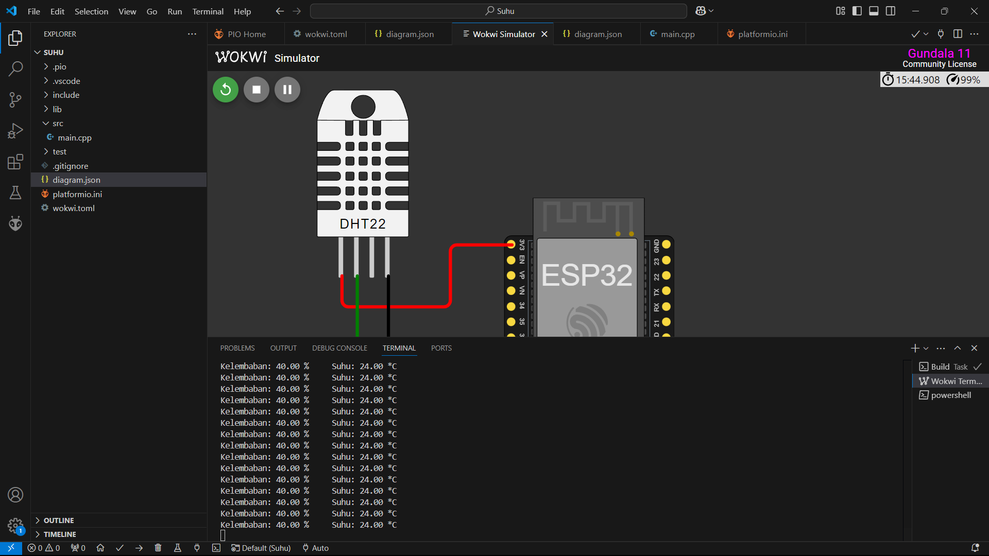

2.2.3 Simulating the Project

Upload the code to the ESP32 in the Wokwi simulator.

Open the Serial Monitor to observe the temperature and humidity readings.

Verify that the sensor data is displayed correctly and updates every 2 seconds.

**3.1 Experimental Results**

**3. Results and Discussion**

The simulation results were as follows:

**Temperature**: The DHT11 sensor successfully measured the temperature in degrees Celsius (°C).

**Humidity**: The sensor accurately measured the relative humidity in percentage (%).

**Serial Monitor Output**: The data was displayed in the following format:

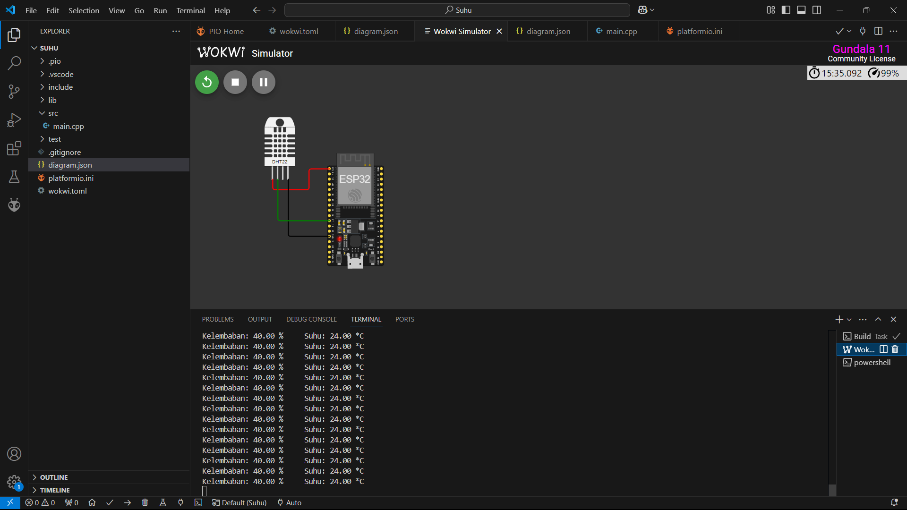

3.2 Discussion

Effectiveness of Wokwi: Wokwi proved to be an excellent tool for simulating IoT projects. It allowed for easy integration of the DHT11 sensor and ESP32 microcontroller, providing real-time feedback through the Serial Monitor.

Accuracy of DHT11: The DHT11 sensor provided reliable and consistent readings for both temperature and humidity. However, it is important to note that the DHT11 has a limited range and accuracy compared to more advanced sensors like the DHT22.

Applications: This experiment demonstrates the potential of using temperature and humidity sensors in real-world IoT applications, such as smart homes, agriculture, and environmental monitoring.

1. **Conclusion**

The experiment successfully simulated a temperature and humidity monitoring system using the DHT11 sensor and ESP32 microcontroller in Wokwi. The results highlight the effectiveness of Wokwi as a simulation tool and the reliability of the DHT11 sensor for basic environmental monitoring. Future work could explore the integration of additional sensors and the use of MQTT for real-time data transmission in a more complex IoT system.