**Laporan minggu 4 praktikum wokwi**

**Sensor Jarak**

*Gunawan Danyarto*

*University of Brawijaya Vocation Faculty*

*Email : [gunawandany11@gmail.com](mailto:gunawandany11@g,ail.com)*

**Abstract**

This experiment aims to analyze the implementation of a distance sensor (HC-SR04) in an IoT system using the Wokwi simulator. The system consists of an ESP32 microcontroller, an HC-SR04 ultrasonic sensor, and serial communication for monitoring distance measurements. The results demonstrate the effectiveness of using Wokwi for simulating IoT projects and the accuracy of the HC-SR04 sensor in measuring distances. This practice also highlights the integration of Wokwi and GitHub for project management and version control.

**1. Introduction**

**1.1 Background of the IoT Experiment**

Wokwi is an online platform for simulating IoT and electronics projects, while GitHub is a widely used platform for version control and collaborative coding. Combining these tools allows developers to design, simulate, and share IoT projects efficiently. In this experiment, the HC-SR04 ultrasonic sensor is used to measure distances, and the ESP32 microcontroller processes the data. The results are displayed on the Serial Monitor.

**1.2 Objective of the Experiment**

The goal of this practice is to :

1. Simulate an IoT project using the HC-SR04 distance sensor and ESP32 microcontroller in Wokwi.
2. Measure and display the distance in centimeters and inches.
3. Learn how to manage the project code using GitHub.

**2. Methodology**

**2.1 Tools & Materials**

Microcontroller: ESP32 (simulated in Wokwi).

Sensor: HC-SR04 Ultrasonic Distance Sensor.

Software:

Wokwi (https://wokwi.com) for simulation.

GitHub (https://github.com) for version control.

Arduino IDE for code development.

**2.2 Implementation Steps**

**2.2.1 Creating a Wokwi Project**

1. Open Wokwi and select the ESP32 microcontroller.

2. Add the HC-SR04 ultrasonic sensor to the project.

3. Connect the sensor to the ESP32 as follows:

* VCC to 5V
* GND to GND
* TRIG to GPIO 5
* ECHO to GPIO 18

1. Write the code to measure and display the distance (see code below).
2. Simulate the project directly on the Wokwi platform to ensure it works correctly.

**2.2.2 Using Wokwi Extension in VS Code**

1. Install the Wokwi extension in Visual Studio Code (VS Code):

* Open VS Code and go to the Extensions Marketplace.
* Search for "Wokwi" and install the extension.

1. Create a new project or open an existing one in VS Code.
2. Use the Wokwi extension to configure the ESP32 and add the HC-SR04 sensor.
3. Write and debug the code directly in VS Code.
4. Simulate the project using the Wokwi extension by clicking the "Start Simulation" button.
5. Observe the simulation results in the Wokwi visualizer within VS Code.

**2.2.3 Experiment: Distance Measurement**

1. Program the ESP32 to measure distance using the HC-SR04 sensor.

2. Display the measured distance in centimeters and inches on the Serial Monitor.

3. Simulate and observe the results using the Wokwi platform or VS Code extension.

**3. Results and Discussion**

**3.1 Experimental Results**

* Distance Measurement: The HC-SR04 sensor successfully measured distances in centimeters and inches.
* Serial Monitor Output: The distance values were displayed accurately on the Serial Monitor.
* Simulation: The project was successfully simulated in Wokwi, and the results matched the expected behavior.

**3.2 Discussion**

1. Benefits of Using Wokwi :

* Wokwi provides an intuitive platform for simulating IoT projects without the need for physical hardware.
* It allows for real-time debugging and visualization of sensor data.

1. Advantages of Using GitHub :

* GitHub enables version control, making it easy to track changes and collaborate on projects.
* It provides a centralized repository for storing and sharing project code.

4. Code Implementation

C++ Code for Distance Measurement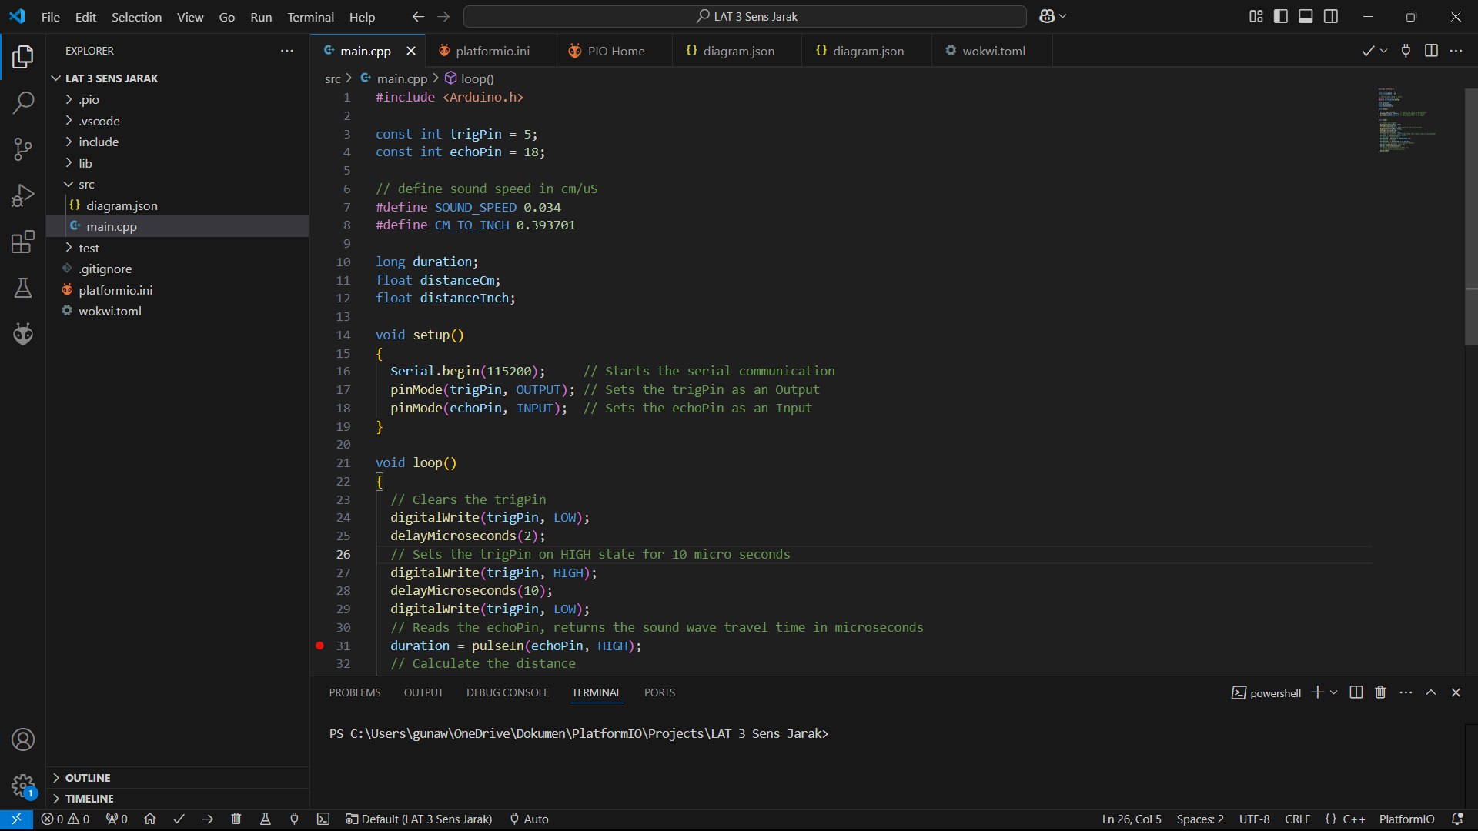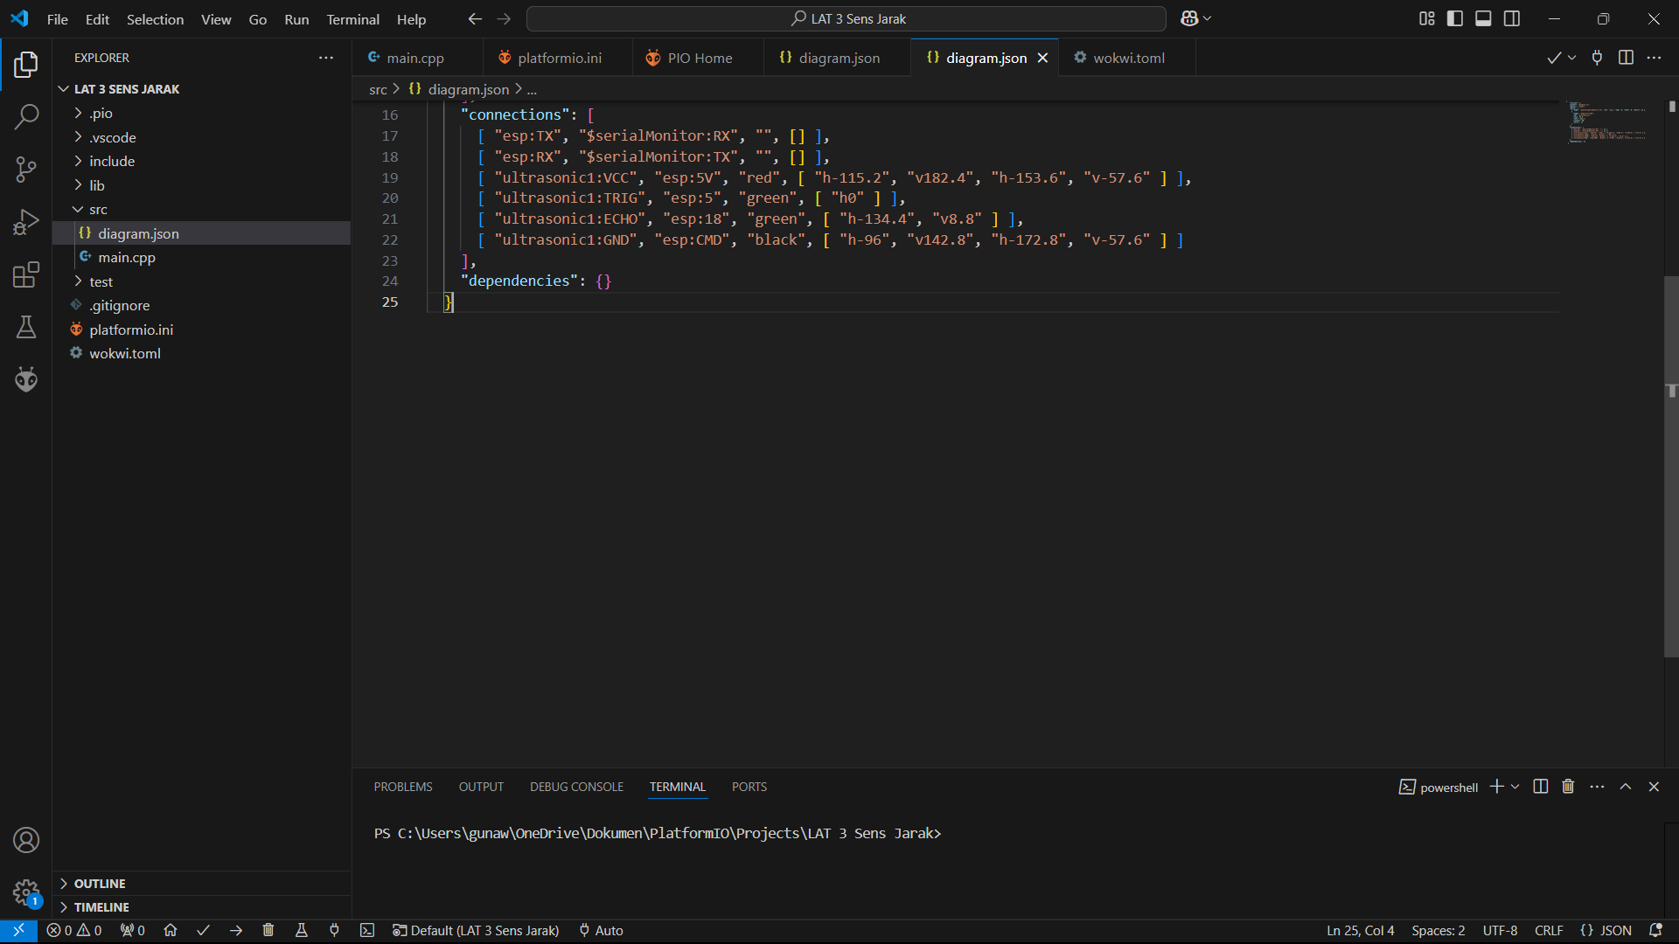

**5. Conclusion**

The experiment successfully demonstrated the use of the HC-SR04 distance sensor with the ESP32 microcontroller in the Wokwi simulator. The results confirmed the accuracy of the sensor in measuring distances and the effectiveness of Wokwi for IoT project simulation. The integration of GitHub further enhanced the project's manageability and collaboration potential.