**Laporan minggu 5 praktikum wokwi**

*Relay Button LED*

*Gunawan Danyarto*

*University of Brawijaya Vocation Faculty*

*Email : [gunawandany11@gmail.com](mailto:gunawandany11@g,ail.com)*

**Abstract**

This experiment aims to demonstrate the implementation of a relay-controlled LED system using an ESP32 microcontroller and a pushbutton. The system allows the user to control both an LED and a relay module via a single button. The project is simulated using the Wokwi platform, and the results confirm the functionality of the relay and LED control. This practice also highlights the integration of Wokwi and GitHub for project management and version control.

**1. Introduction**

**1.1 Background of the IoT Experiment**

Wokwi is an online platform for simulating IoT and electronics projects, while GitHub is a widely used platform for version control and collaborative coding. Combining these tools allows developers to design, simulate, and share IoT projects efficiently. In this experiment, a pushbutton is used to control an LED and a relay module, demonstrating basic input/output operations in an IoT system.

**1.2 Objective of the Experiment**

The goal of this practice is to :

1. Simulate an IoT project using an ESP32 microcontroller, a pushbutton, an LED, and a relay module in Wokwi.
2. Control the LED and relay using the pushbutton.
3. Learn how to manage the project code using GitHub.

**2. Methodology**

**2.1 Tools & Materials**

* Microcontroller: ESP32 (simulated in Wokwi).
* Components: Pushbutton
* LED (Red)

**Relay Module**

**Software:**

* Wokwi (https://wokwi.com) for simulation.
* GitHub (https://github.com) for version control.
* Arduino IDE for code development.

**2.2 Implementation Steps**

**2.2.1 Creating a Wokwi Project**

1. Open Wokwi and select the ESP32 microcontroller.

2. Add the following components to the project :

* Pushbutton
* LED (Red)
* Relay Module

3. Connect the components to the ESP32 as follows:

**Pushbutton :**

* Pin 1 to GPIO 19
* Pin 2 to GND

**LED :**

* Anode (A) to GPIO 18
* Cathode (C) to GND

**Relay Module :**

* VCC to 3.3V
* GND to GND
* IN to GPIO 23

1. Write the code to control the LED and relay using the pushbutton (see code below). 5. Simulate the project directly on the Wokwi platform to ensure it works correctly.

**2.2.2 Using Wokwi Extension in VS Code**

1. Install the Wokwi extension in Visual Studio Code (VS Code) :

* Open VS Code and go to the Extensions Marketplace.
* Search for "Wokwi" and install the extension.

1. Create a new project or open an existing one in VS Code.
2. Use the Wokwi extension to configure the ESP32 and add the pushbutton, LED, and relay module.
3. Write and debug the code directly in VS Code.
4. Simulate the project using the Wokwi extension by clicking the "Start Simulation" button.
5. Observe the simulation results in the Wokwi visualizer within VS Code.

**2.2.3 Experiment: Distance Measurement**

1. Program the ESP32 to control the LED and relay using the pushbutton.

2. When the button is pressed, the LED and relay should turn ON.

3. When the button is released, the LED and relay should turn OFF.

4. Simulate and observe the results using the Wokwi platform or VS Code extension.

**3. Results and Discussion**

**3.1 Experimental Results**

* Button Press : When the button is pressed, the LED turns ON, and the relay is activated.
* Button Release : When the button is released, the LED turns OFF, and the relay is deactivated.
* Simulation : The project was successfully simulated in Wokwi, and the results matched the expected behavior.

**3.2 Discussion**

**1. Benefits of Using Wokwi :**

Wokwi provides an intuitive platform for simulating IoT projects without the need for physical hardware.

It allows for real-time debugging and visualization of component behavior.

1. **Advantages of Using GitHub :**

GitHub enables version control, making it easy to track changes and collaborate on projects. It provides a centralized repository for storing and sharing project code.

4. Code Implementation

C++ Code for Distance Measurement

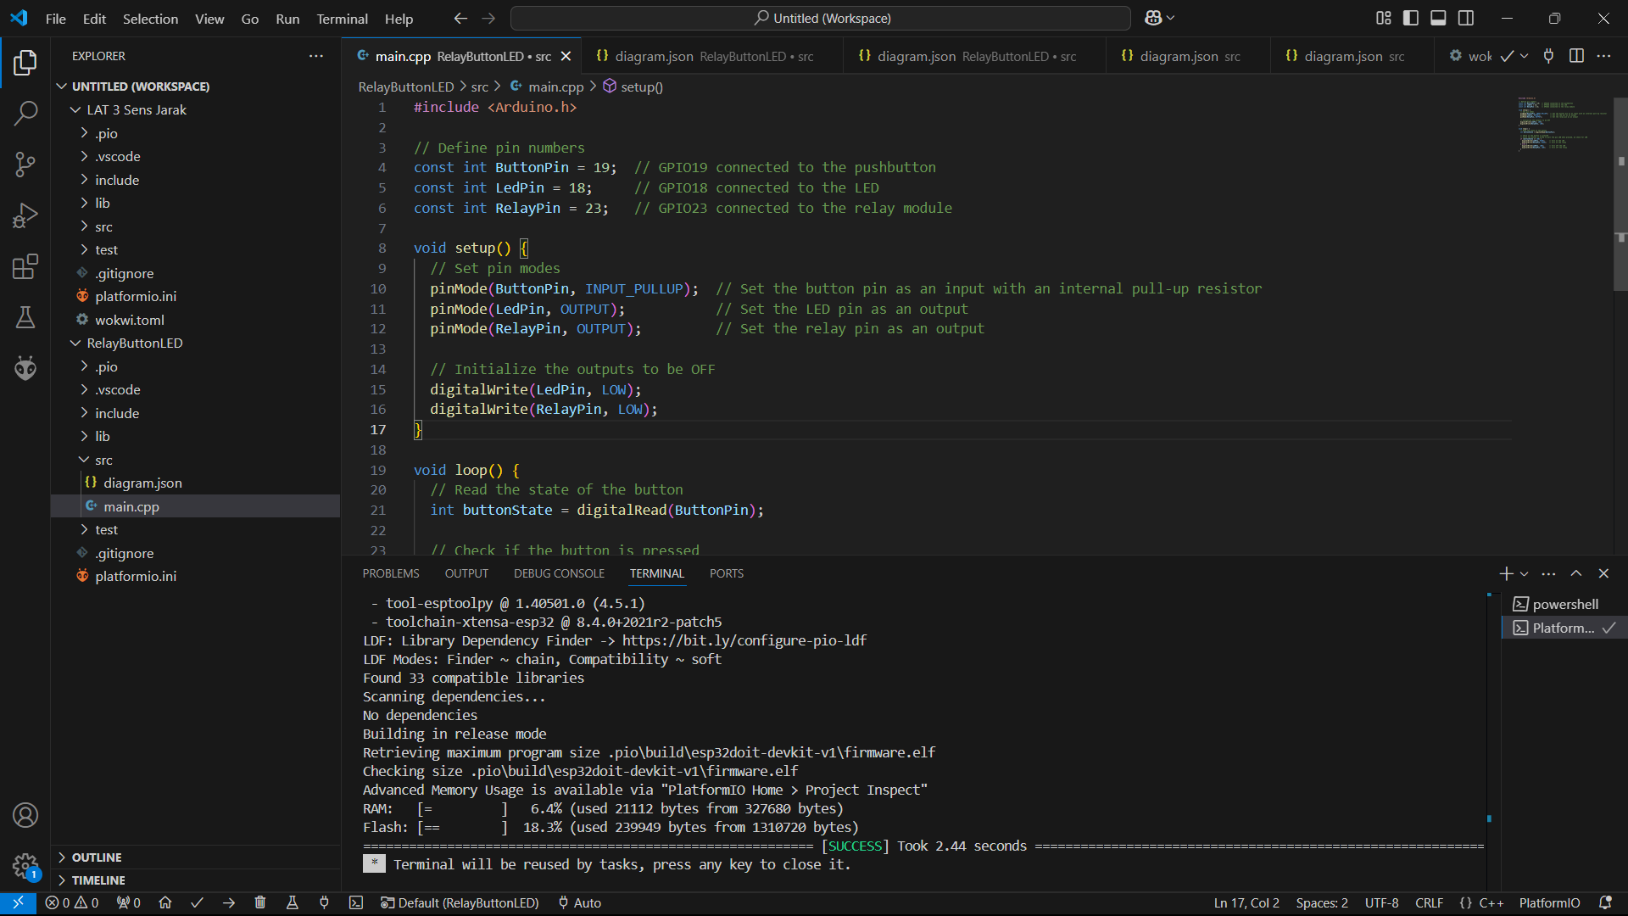

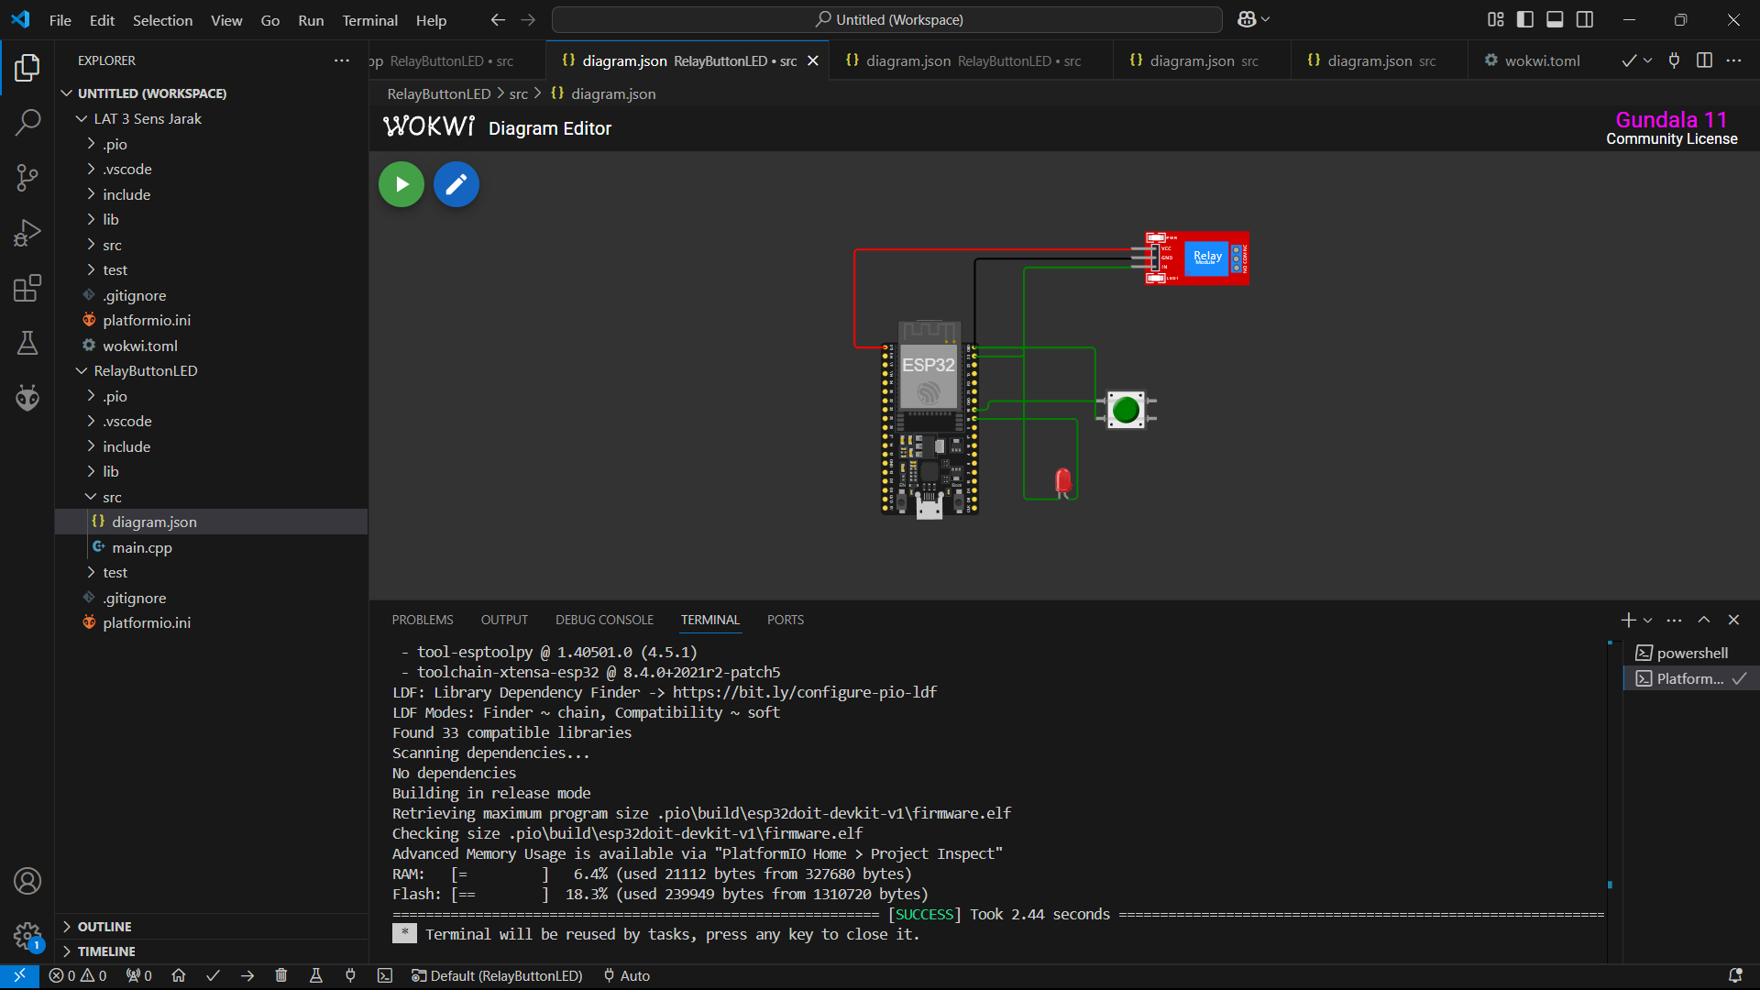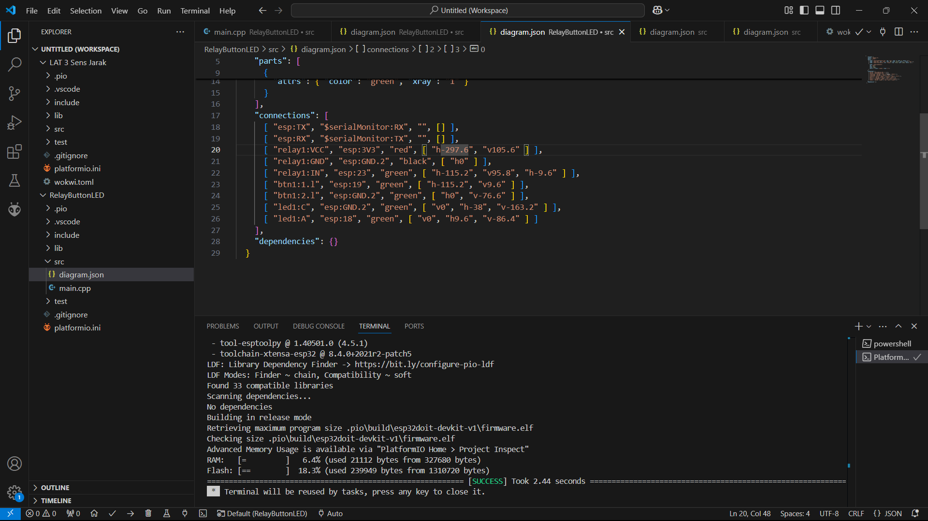

**5. Conclusion**

The experiment successfully demonstrated the use of a pushbutton to control an LED and a relay module using the ESP32 microcontroller in the Wokwi simulator. The results confirmed the functionality of the system and the effectiveness of Wokwi for IoT project simulation. The integration of GitHub further enhanced the project's manageability and collaboration potential.