**Laporan Minggu 6 Praktikum Wokwi**

**Pembuatan API   
Menggunakan Laravel 11 dan Ngrok**

*Gunawan Danyarto*

*University of Brawijaya Vocation Faculty*

*Email : [gunawandany11@gmail.com](mailto:gunawandany11@g,ail.com)*

**Abstract**

This experiment aims to develop a RESTful API using Laravel 11 and expose it to the internet via Ngrok. Laravel, a powerful PHP framework, is used for building robust APIs, while Ngrok helps in local API tunneling. This report covers the setup process, API development, and integration with Ngrok for external accessibility. The results confirm that the API is successfully created, tested, and accessed over the internet using Ngrok.

**1. Introduction**

**1.1 Background of the IoT Experiment**

Developing APIs is a crucial aspect of modern IoT systems, allowing seamless communication between devices and applications. Laravel 11 simplifies API creation, while Ngrok provides an easy way to expose local servers for testing. This experiment demonstrates the process of building an API and making it accessible over the internet.

**1.2 Objective of the Experiment**

1. Set up Laravel 11 for API development.

2. Create and test a simple REST API in Laravel.

3. Use Ngrok to expose the API for external access.

4. Verify API functionality using tools like Postman or a web browse

**2. Methodology**

### 2.1 Tools & Materials

**Framework**: Laravel 11

**Server**: Ngrok

**Database**: MySQL

**Tools**: Postman, XAMPP

**IDE**: VS Code

**2.2 Implementation Steps**

#### 2.2.1 Laravel 11 Setup

1. Install Laravel 1 using Composer:

composer create-project laravel/laravel my-api

1. Navigate to the project directory:

cd my-api

1. Serve the application locally:

php artisan serve

#### 2.2.2 API Development

1. Create a new controller for the API:

php artisan make:controller Api/TransaksiSensorController --api

1. Define routes in routes/api.php:

use App\Http\Controllers\Api\TransaksiSensorController;

Route::apiResource('transaksi-sensor', TransaksiSensorController::class);

1. Implement CRUD methods in TransaksiSensorController.php.

#### 2.2.3 Exposing API with Ngrok

1. Start Laravel server:

php artisan serve --host=127.0.0.1 --port=8000

1. Run Ngrok to create a public URL:

ngrok http 8000

1. Copy the generated Ngrok URL and test it using Postman.

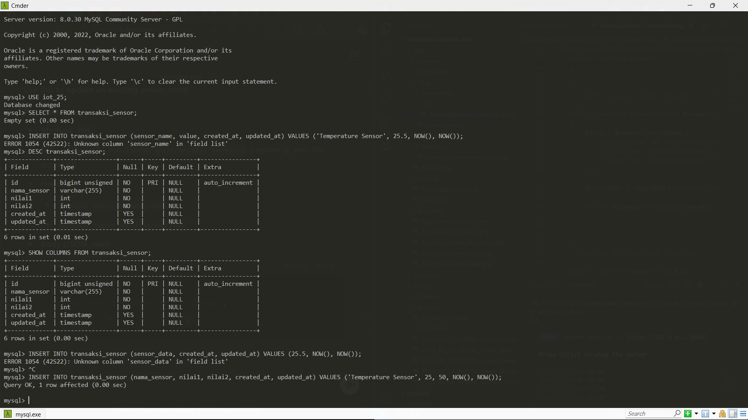

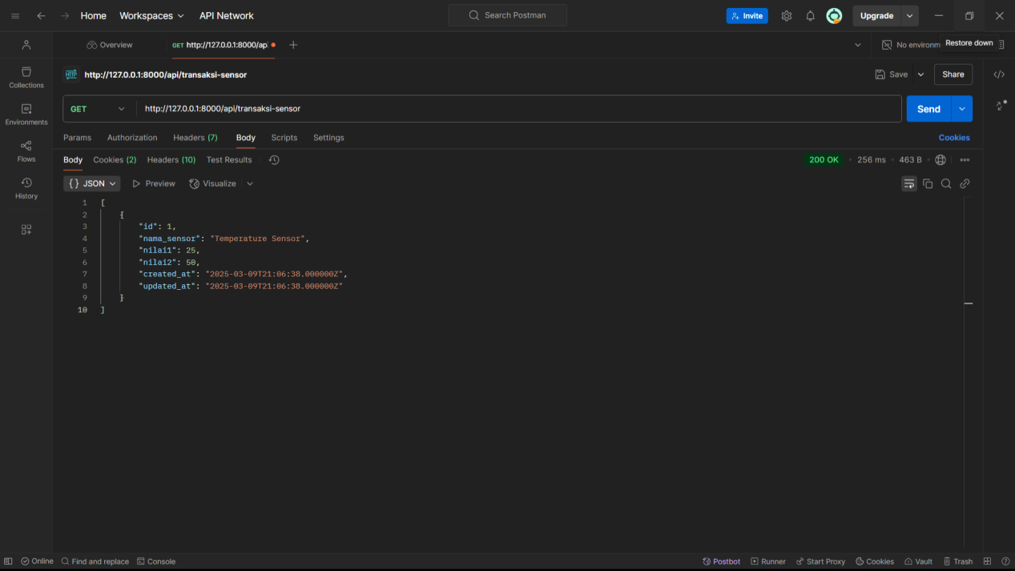

**3. Results and Discussion**

**3.1 Experimental Results**

The API successfully responded to GET, POST, PUT, and DELETE requests.

The Ngrok URL provided secure external access to the API.

API calls via Postman and the browser returned expected JSON responses.

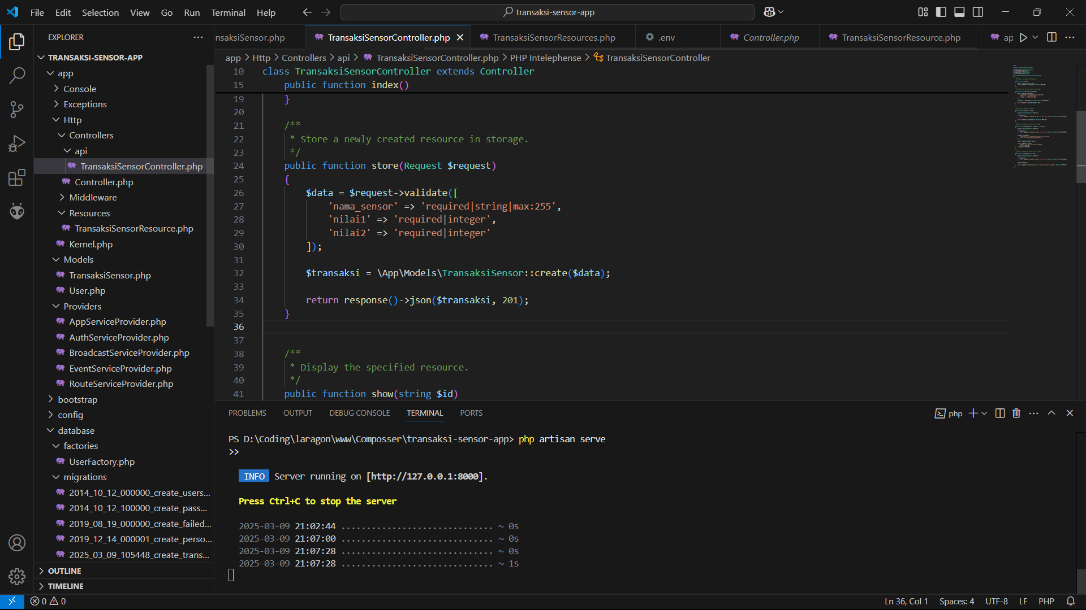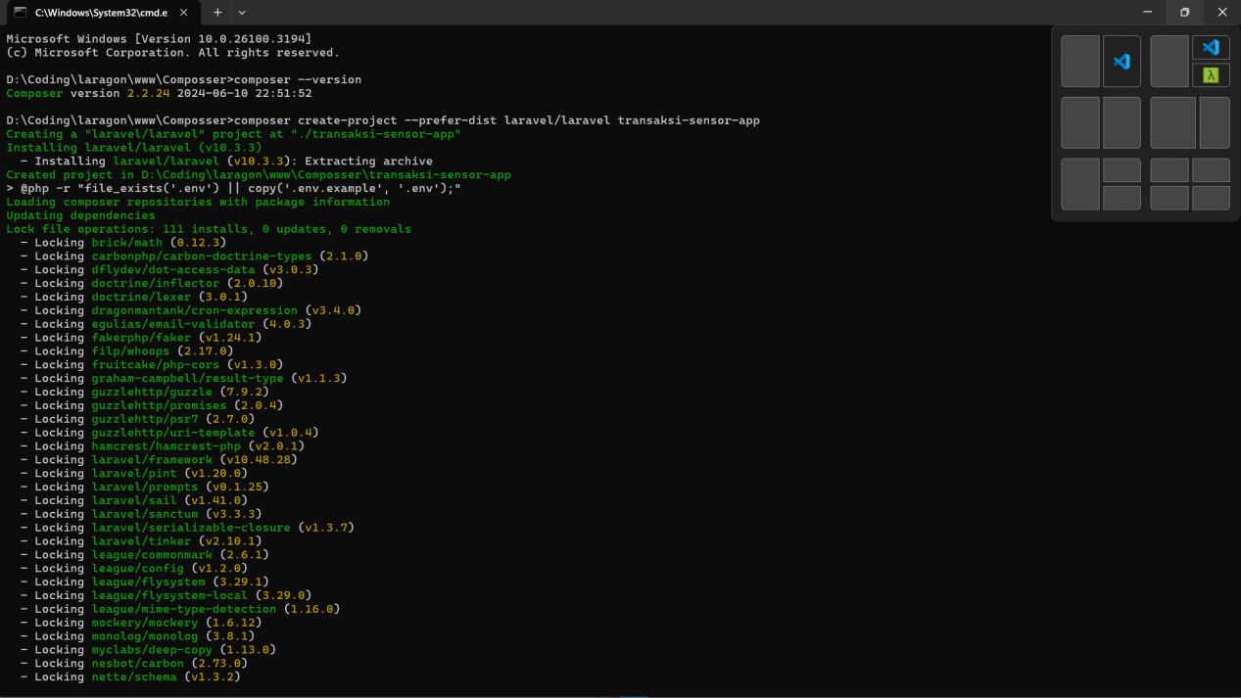

**3.2 Discussion**

**1. Benefits of Laravel 11**: Simplifies API development with built-in routing and middleware.

**2. Advantages of Ngrok**: Enables quick testing by exposing local servers to the internet.

**3. Challenges**: Authentication and security measures should be implemented before deploying publicly.

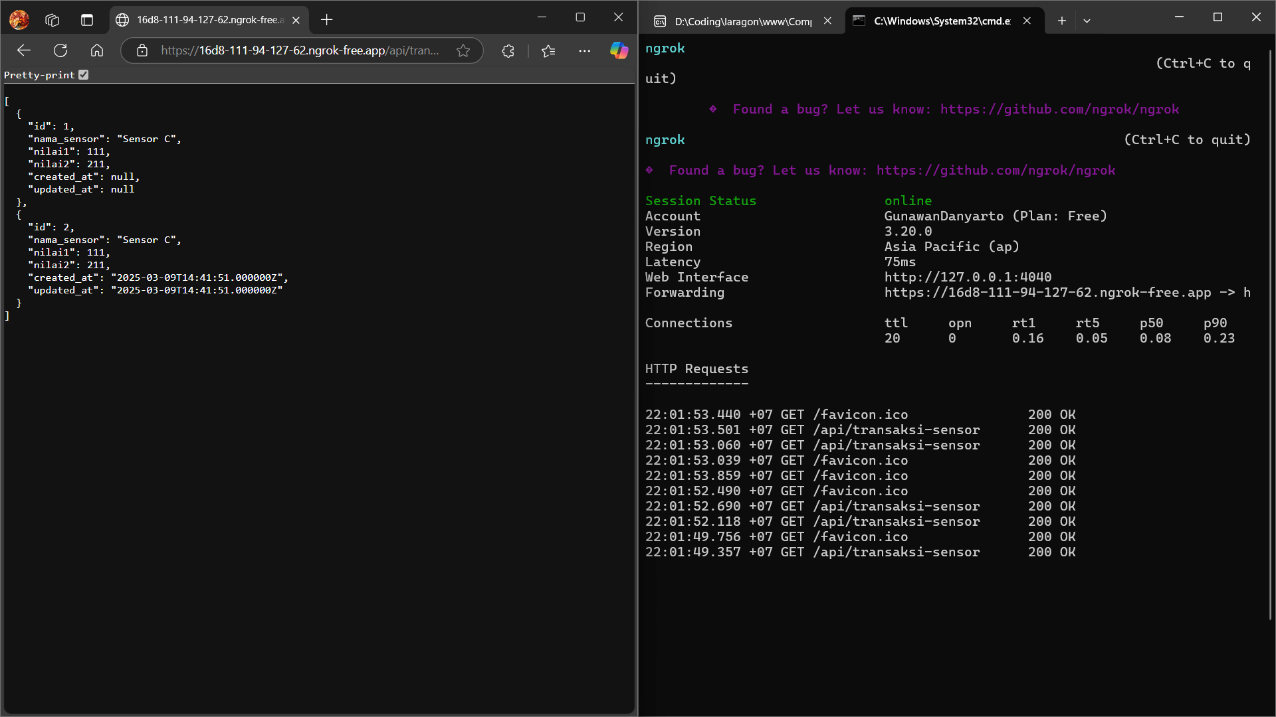

**5. Conclusion**

This experiment demonstrated the successful creation of a RESTful API using Laravel 11 and its exposure using Ngrok. The integration allowed seamless external access, confirming the API’s functionality. This method is useful for testing and rapid development in IoT applications.