**Laporan Minggu 9 (Bab 14 LED, Suhu, Jarak) Praktikum Wokwi**

**Akses API Melalui   
Simulasi WOKWI**

*Gunawan Danyarto*

*University of Brawijaya Vocation Faculty*

*Email : [gunawandany11@gmail.com](mailto:gunawandany11@g,ail.com)*

**Abstract**

This experiment explores real hardware implementation using the ESP32 microcontroller. It includes steps for recognizing the ESP32 on a computer, installing necessary drivers, uploading code via PlatformIO, and testing Wi-Fi connectivity and sensor data transmission. The experiment aims to bridge simulation knowledge from WOKWI into actual ESP32 deployment, focusing on LED control, temperature-humidity sensing, and API integration.

**1. Introduction**

**1.1 Background**

After successful simulations in WOKWI, it is essential to transfer and test the program on actual hardware. This ensures compatibility, real-time performance, and practical understanding of how microcontrollers function in real environments. ESP32 offers integrated Wi-Fi and GPIO control, suitable for controlling LEDs, sensors, and IoT communication.

**1.2 Objective of the Experiment**

· Ensure ESP32 is detected on the computer

· Upload LED and sensor code using PlatformIO

· Perform Wi-Fi network scanning

· Read temperature and humidity using DHT22

· Send sensor data to API endpoints via HTTP POST

**2. Methodology**

### 2.1 Tools & Materials

|  |  |
| --- | --- |
| No | Item |
| 1 | ESP32 Board |
| 2 | USB Cable |
| 3 | Jumper Wires & Breadboard |
| 4 | LED, Resistors, DHT22 Sensor |
| 5 | PlatformIO + VSCode |
| 6 | Driver Silicon Labs CP210x |
| 7 | Ngrok + Laravel API |

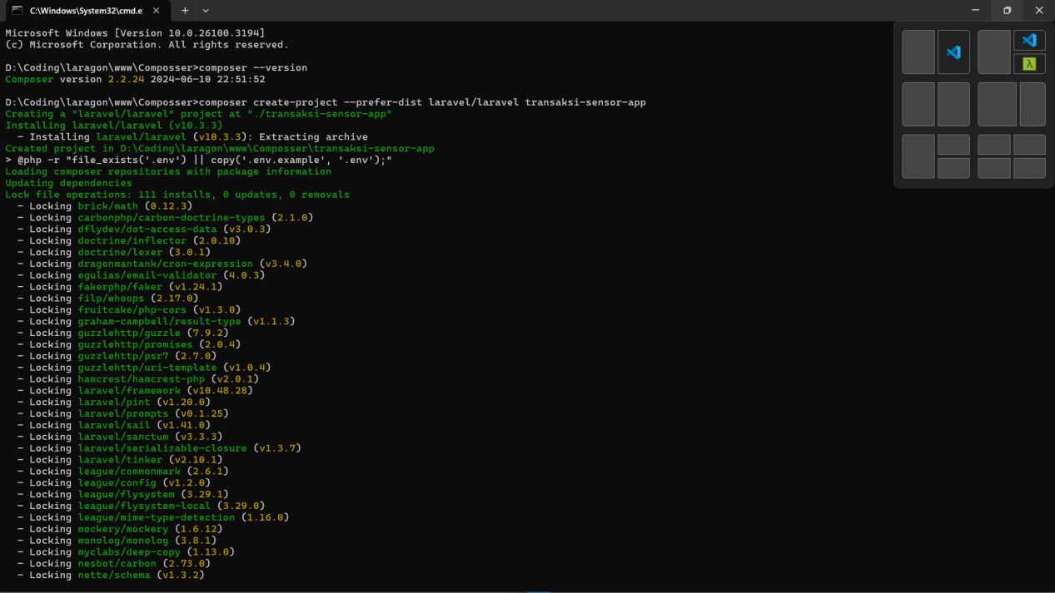

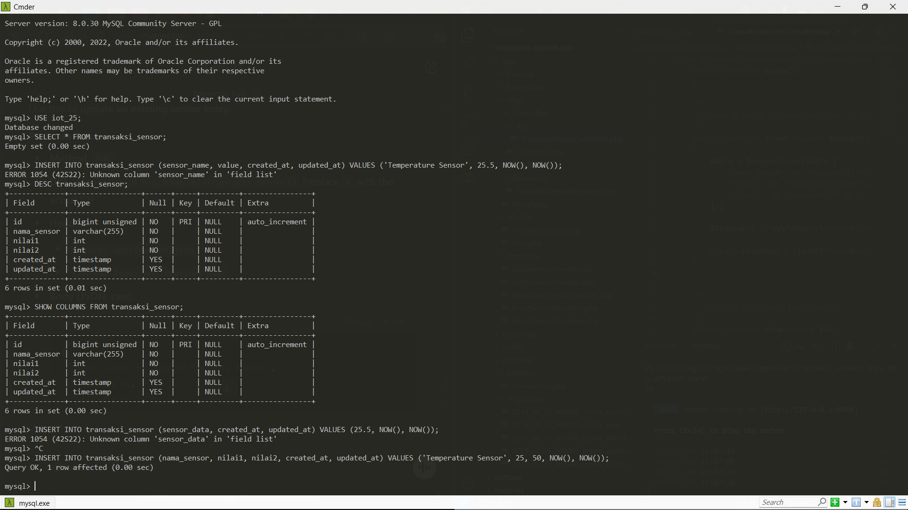

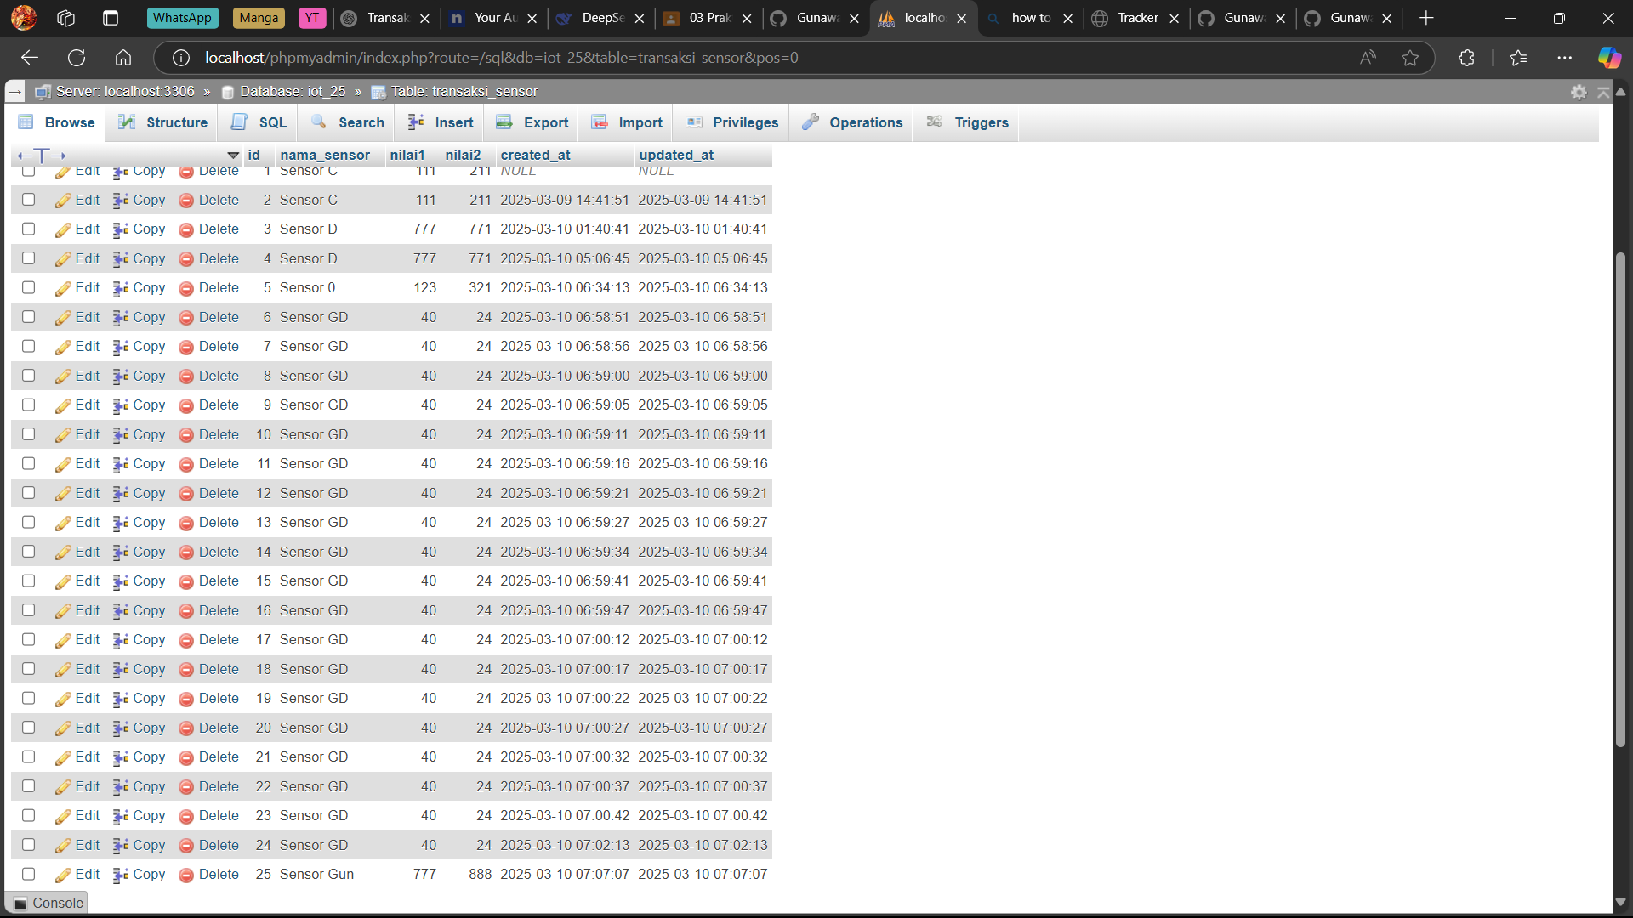

1. **Methodology**

**3.1 Hardware Setup**

· Connect ESP32 via USB.

· Check **Device Manager > Ports (COM & LPT)**.

· Install **CP210x Driver** if not recognized.

**3.2 LED Control via PlatformIO**

· Setup VSCode with PlatformIO.

· Create project and modify platformio.ini :

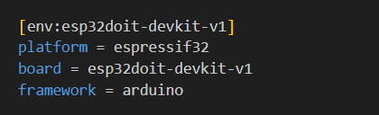

**3.2 LED :**

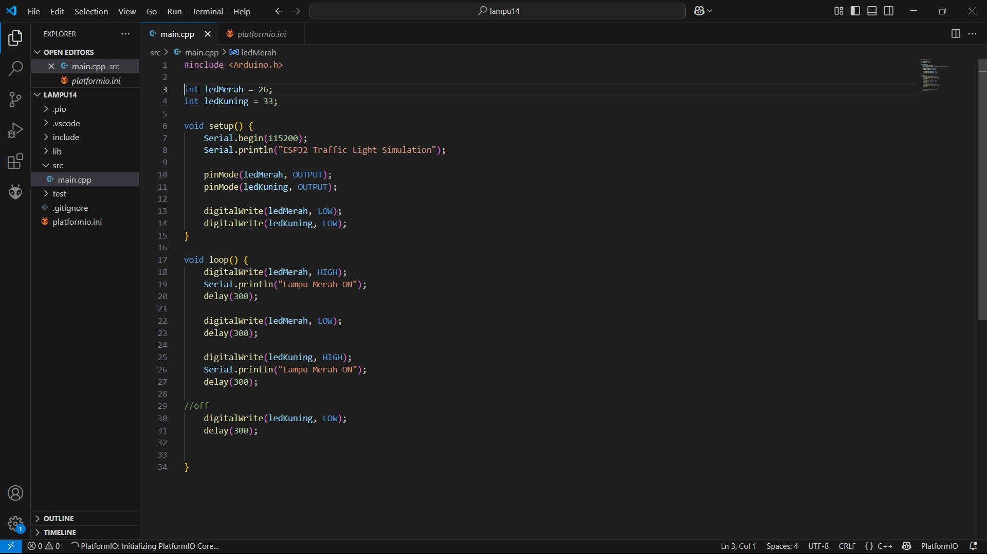

**3.3 Wi-Fi Scanning :**

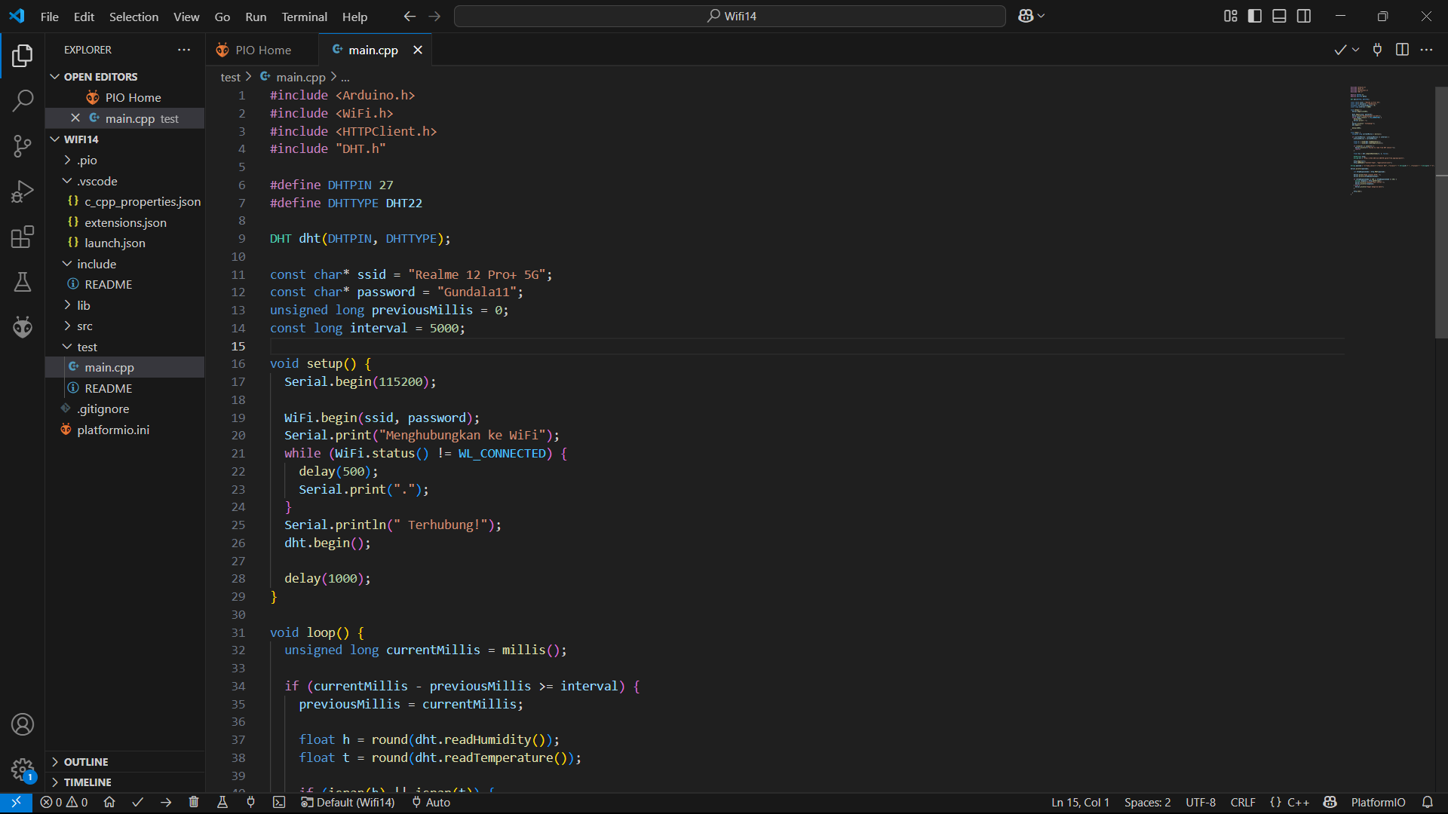

**Platform.ini tambah monitor_speed = 115200   
  
3.4 DHT22 Sensor + API Integration**

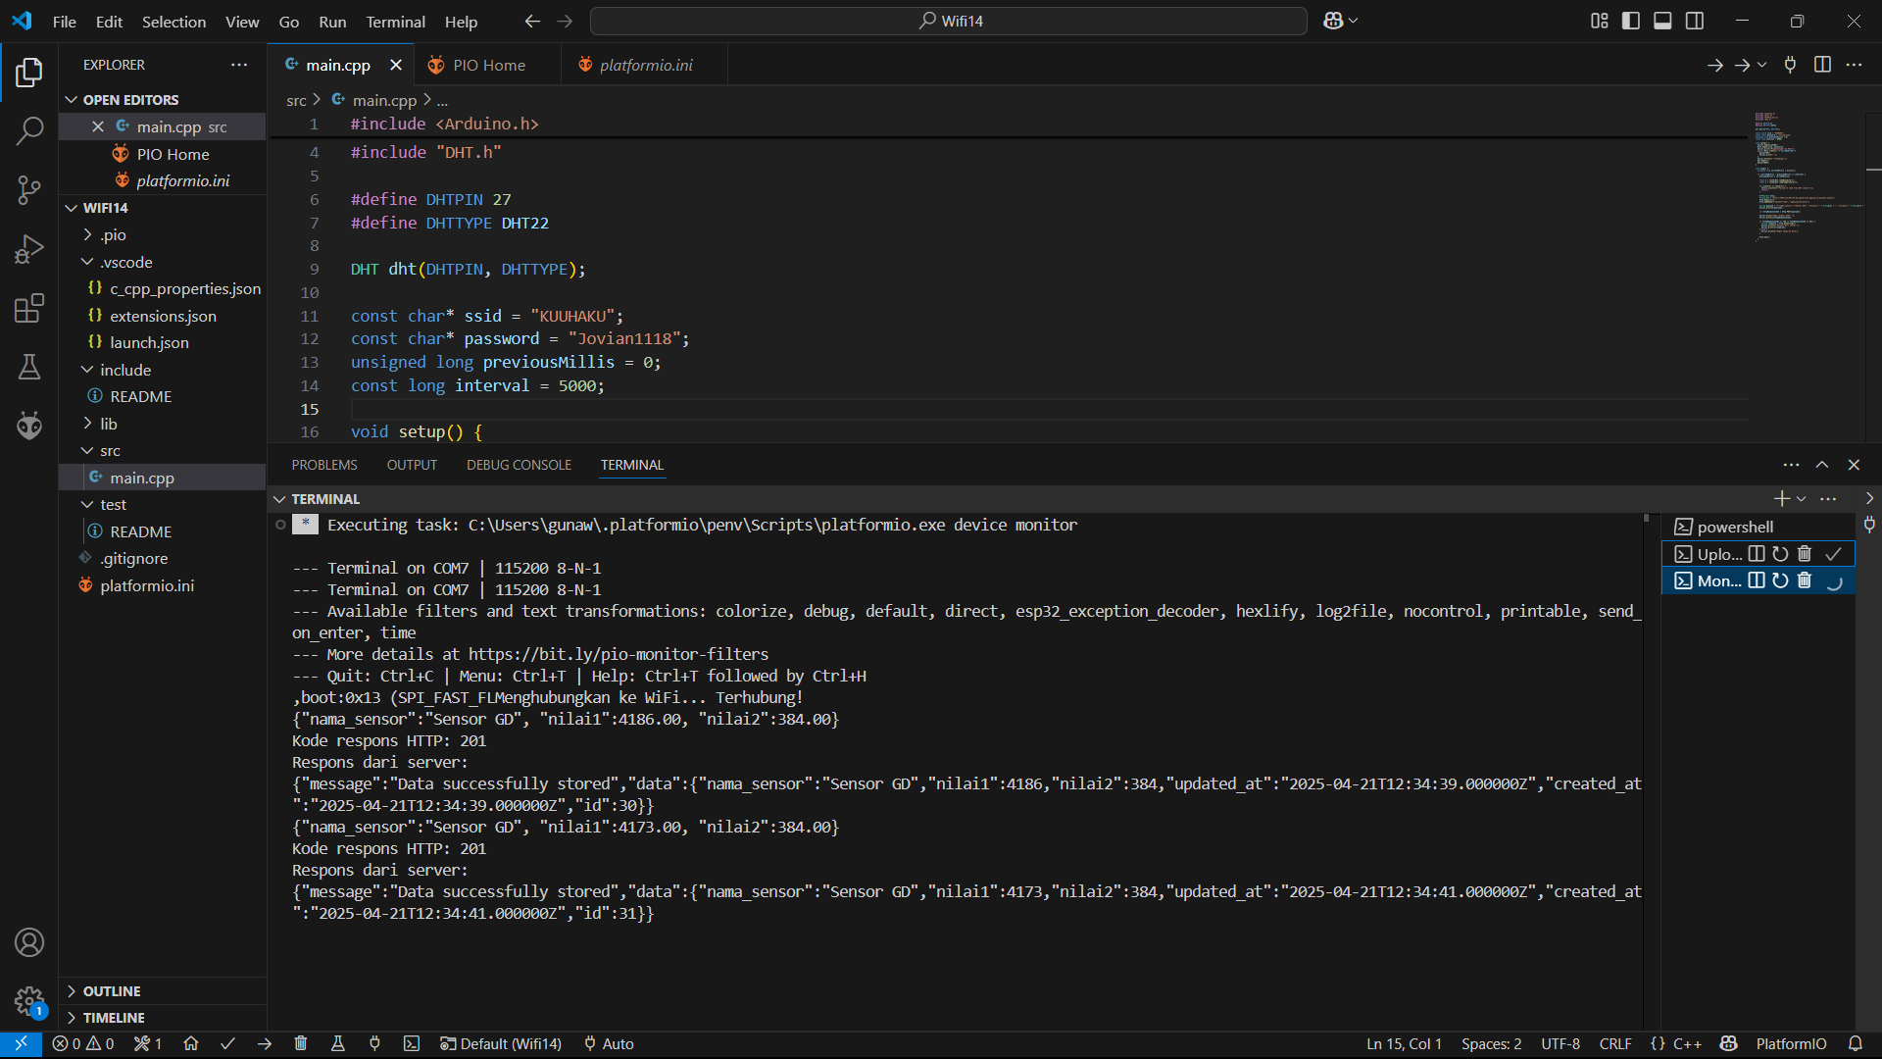

**3.5 Distance Sensor**

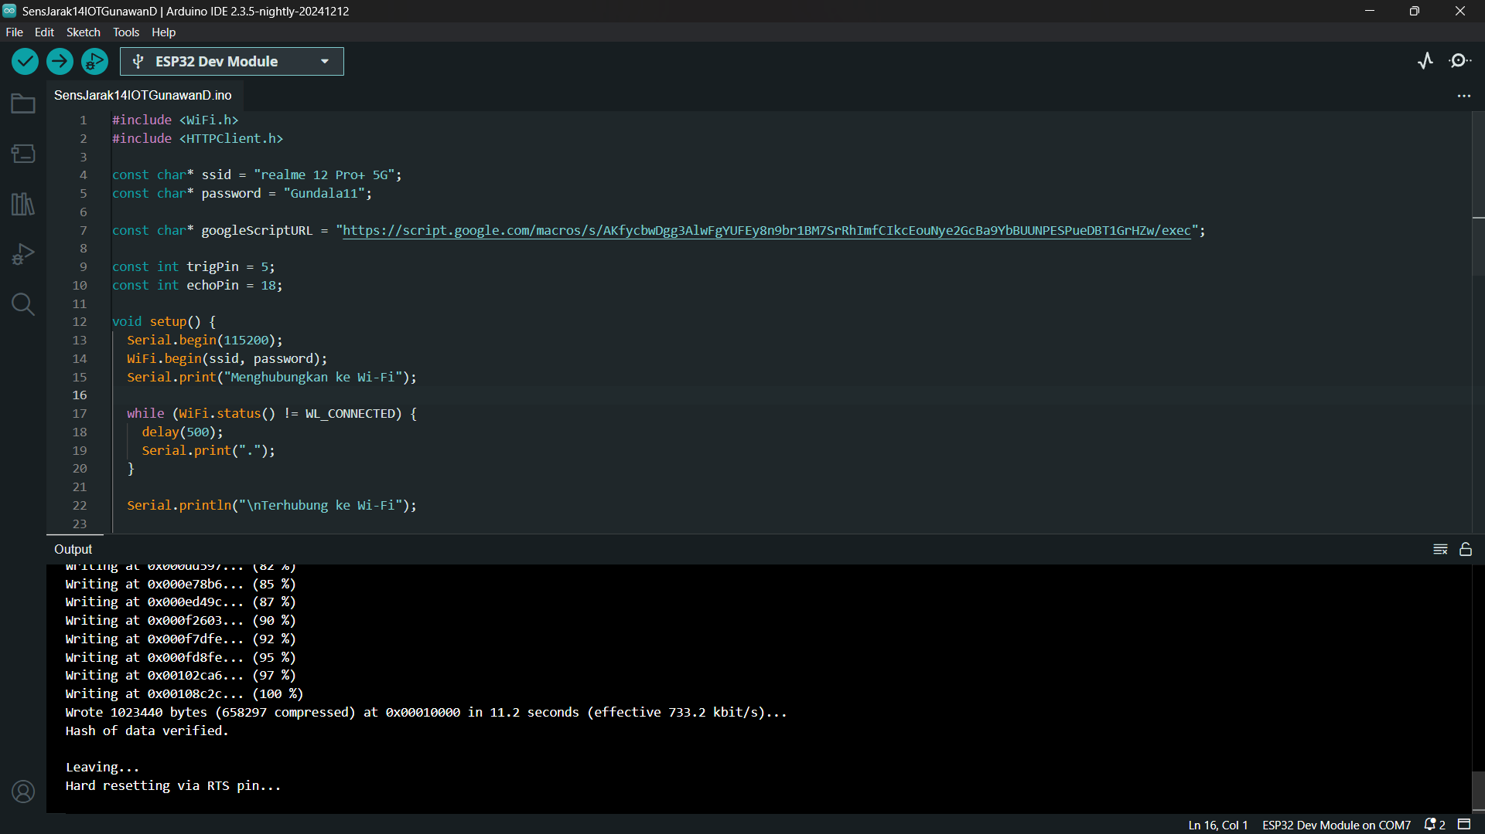

1. **Results :  
     
   LED :**

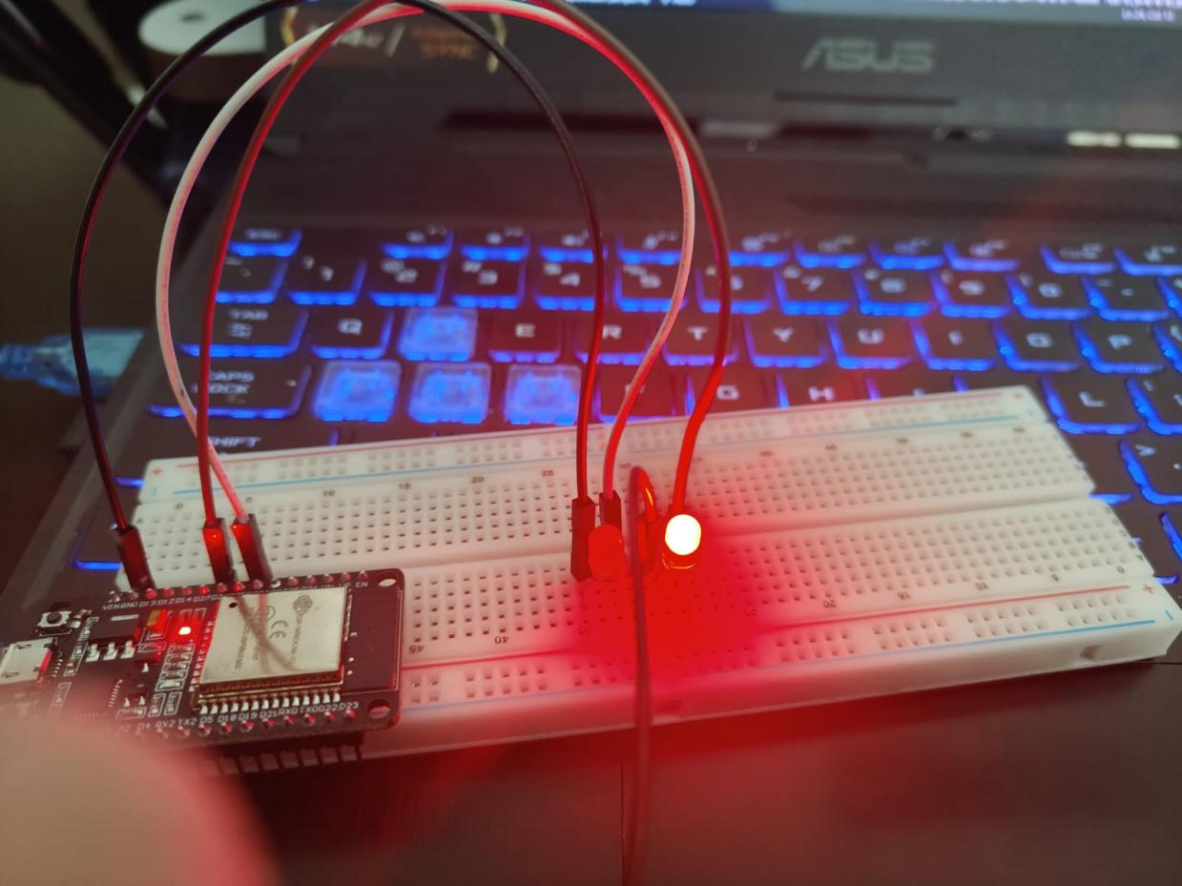

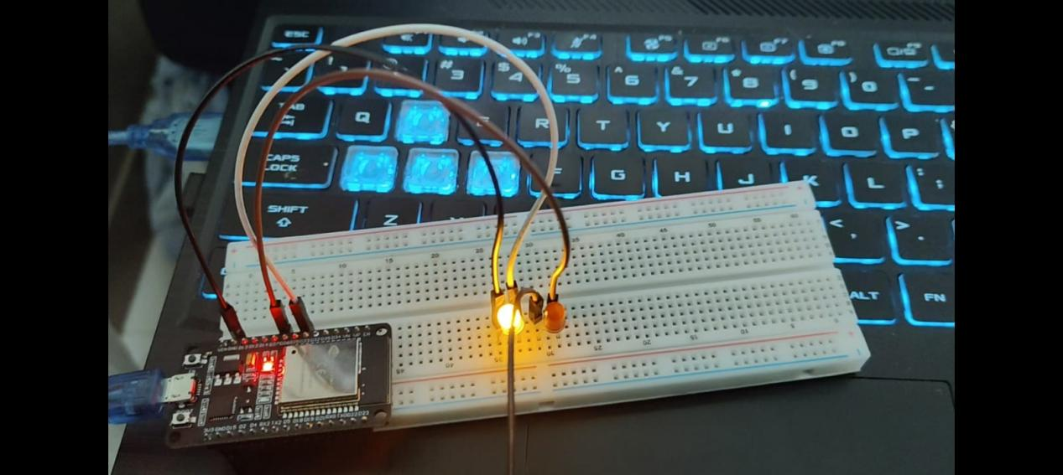

**Wifi Scanning :**

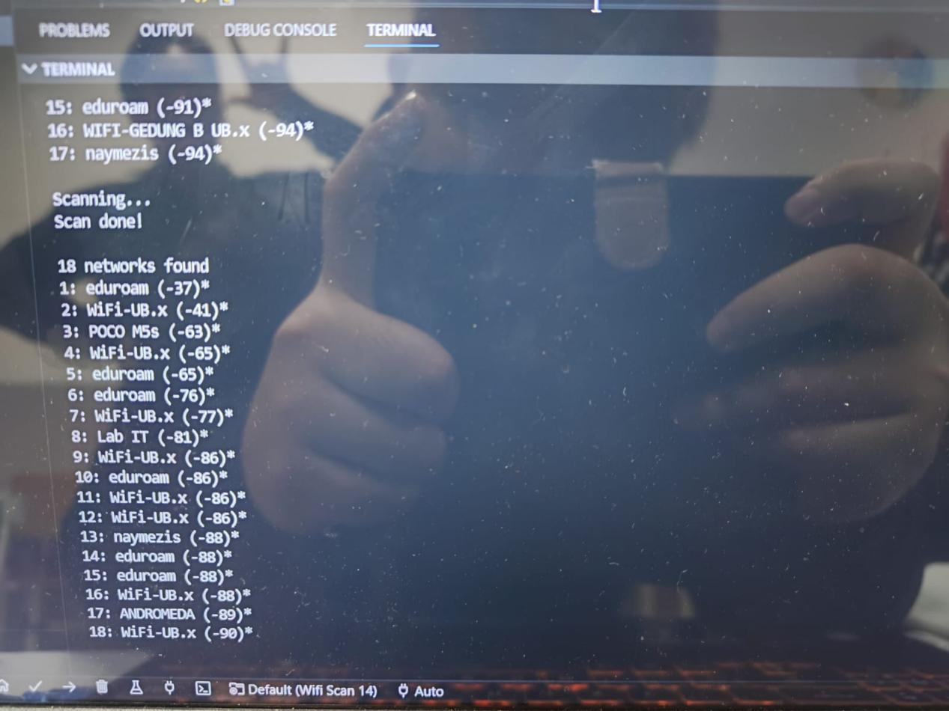

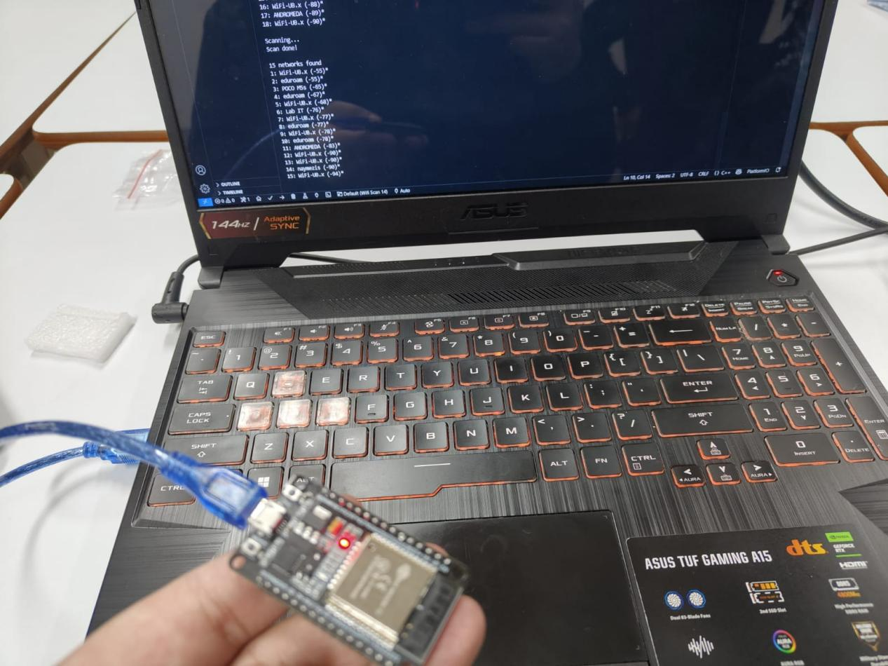

**DHT :**

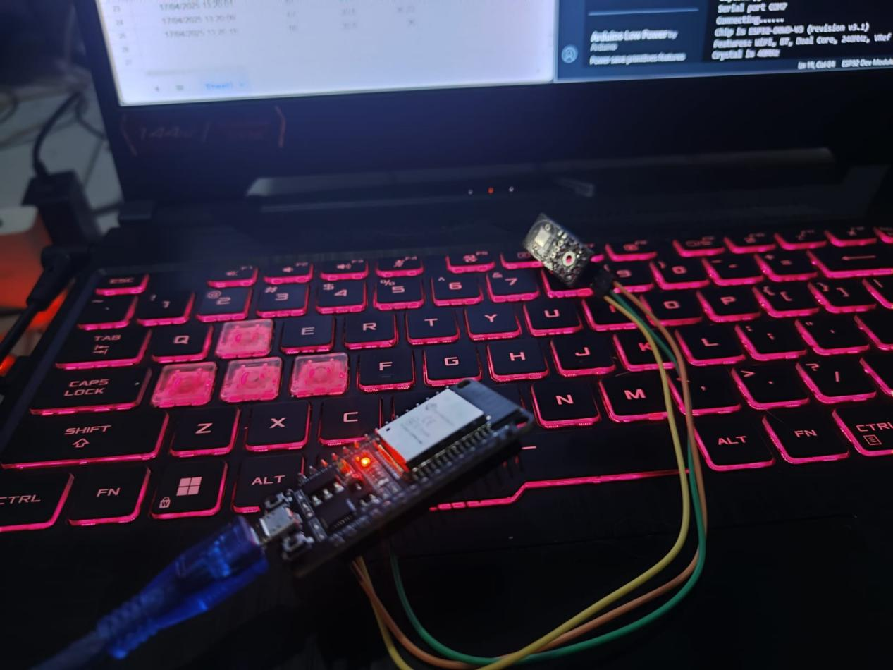

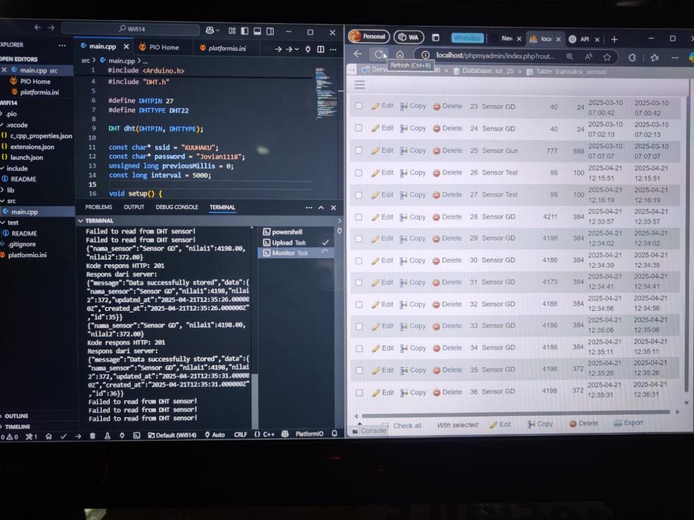

**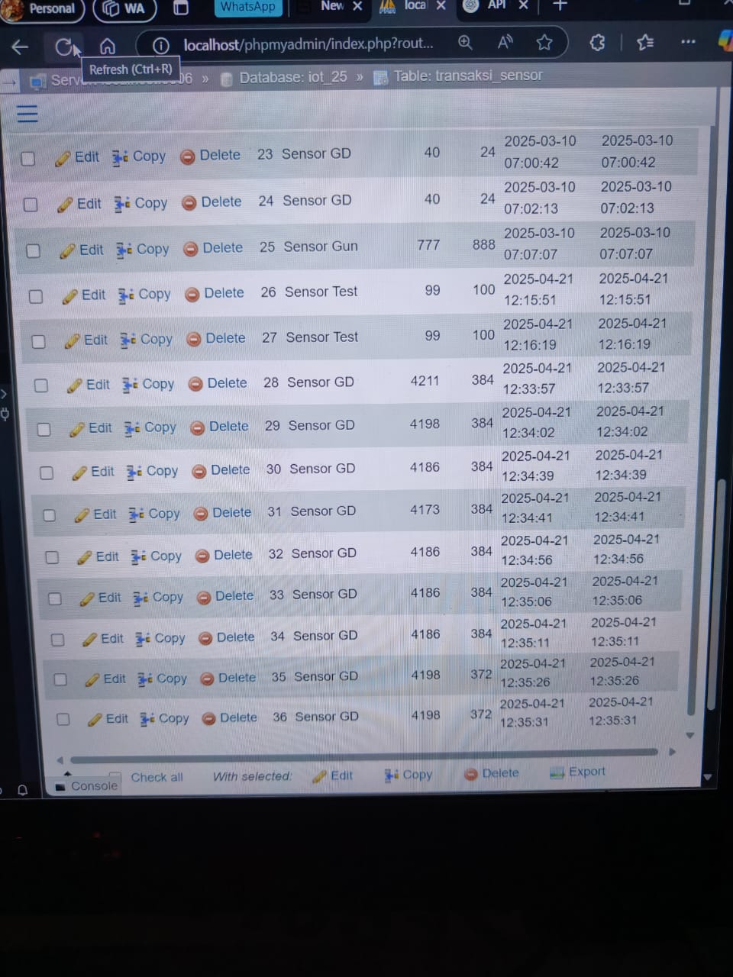  
Distance Sensor :**

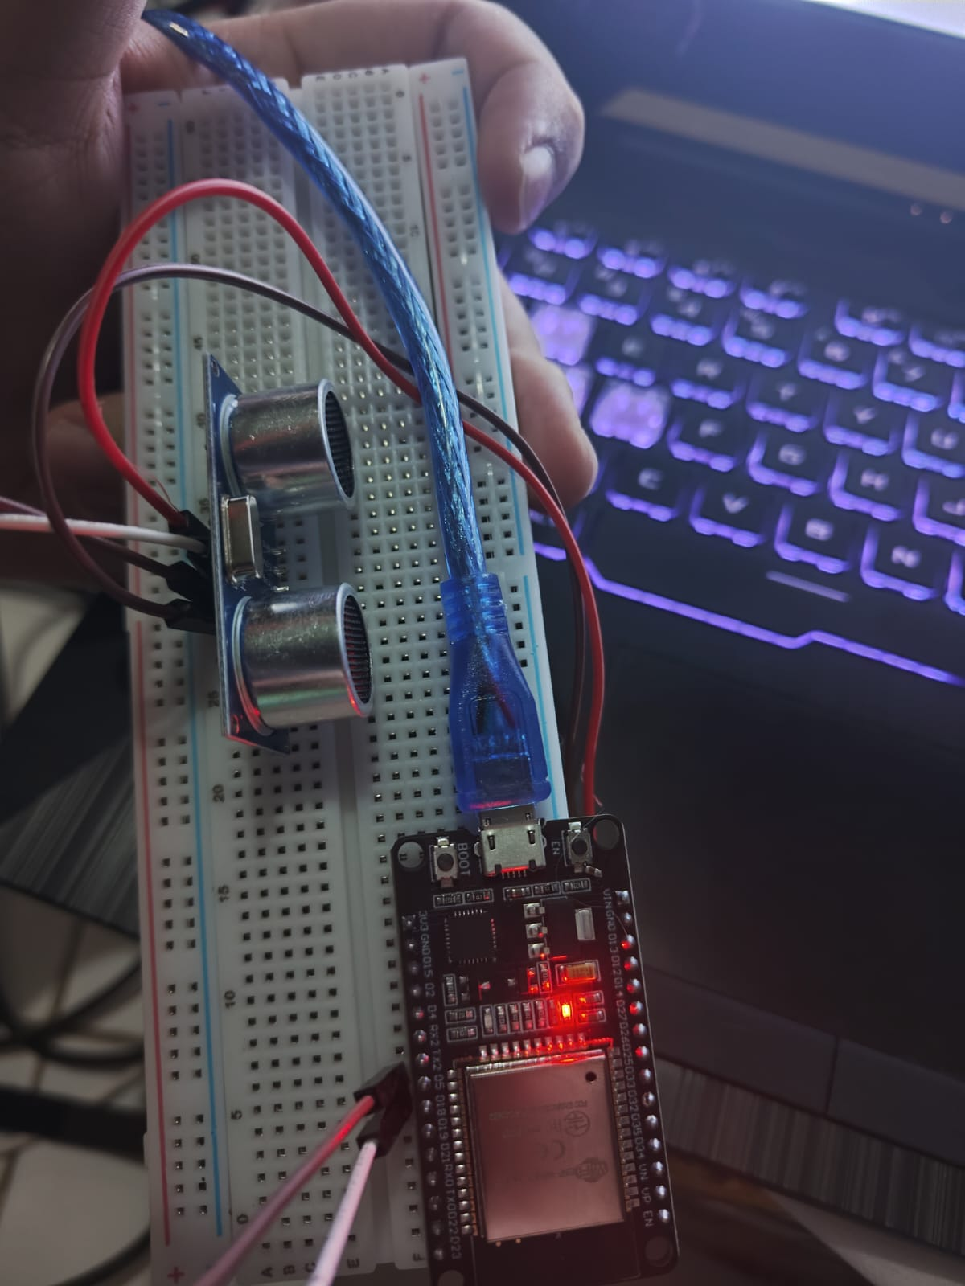

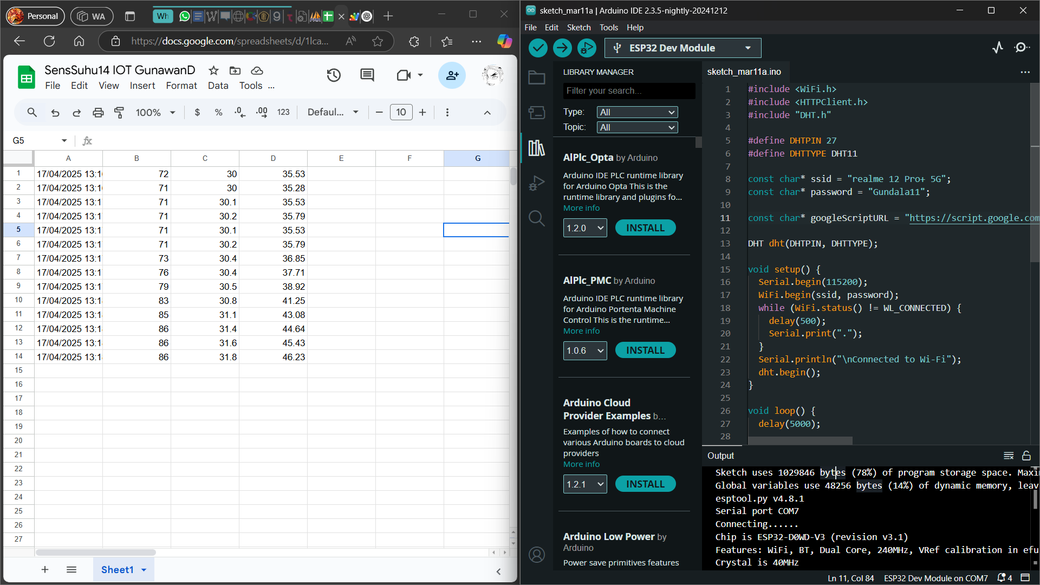

**5. Conclusion**

This chapter demonstrates the transition from simulation to real hardware using ESP32. With successful LED control, Wi-Fi scanning, and API data transmission from a DHT22 sensor, the hardware is now capable of functioning as an IoT node. PlatformIO, combined with proper wiring and code structuring, enables developers to confidently build and test embedded applications in real-world conditions.