Install gmsa on Domain Controller, AKS with gmsa, ACR, Docker Images
1.Run in Domain Controller lines:
************************************************************************************
# To install the AD module on Windows Server, run:
Install-WindowsFeature RSAT-AD-PowerShell
New-ADGroup -Name "gmsaGroup" -GroupScope DomainLocal
Add-KdsRootKey -EffectiveTime (Get-Date).AddHours(-10)
New-ADServiceAccount -Name "gmsaAKS" -DnsHostName "gmsaAKS.coremanaged.co.uk" -ServicePrincipalNames "host/gmsaAKS", "host/gmsaAKS.coremanaged.co.uk" -PrincipalsAllowedToRetrieveManagedPassword "gmsaGroup"
New-ADUser -Name "nonproduser1" -AccountPassword (ConvertTo-SecureString -AsPlainText "p@ssw0rd" -Force) -Enabled 1
Add-ADGroupMember -Identity "gmsaGroup" -Members "nonproduser1"
Set-ADServiceAccount gmsaAKS -PrincipalsAllowedToRetrieveManagedPassword nonproduser1, gmsaGroup
Get-ADServiceAccount gmsaAKS -Properties PrincipalsAllowedToRetrieveManagedPassword
Get-ADServiceAccount -Identity gmsaAKS -Properties *
** ****************************************************************************
2.Create Azure Container Registry
ACR
Quickstart - Create registry in portal - Azure Container Registry | Microsoft Learn
**************************************************************************
3. Install Windows Docker Desktop
Install Docker Desktop on Windows | Docker Documentation
Learn about Containers on a Windows Operating System using Docker - YouTube -15 min watch
*****************************************************************************
4. Pull /Tag/Push Docker Images
Push & pull container image - Azure Container Registry | Microsoft Learn

5. AKS, Nodes, Pods, Networking
Why do we need Kubernetes?
This is why you need Kubernetes - YouTube
What is a Pod in kubernetes ? Why do you need it ? - YouTube
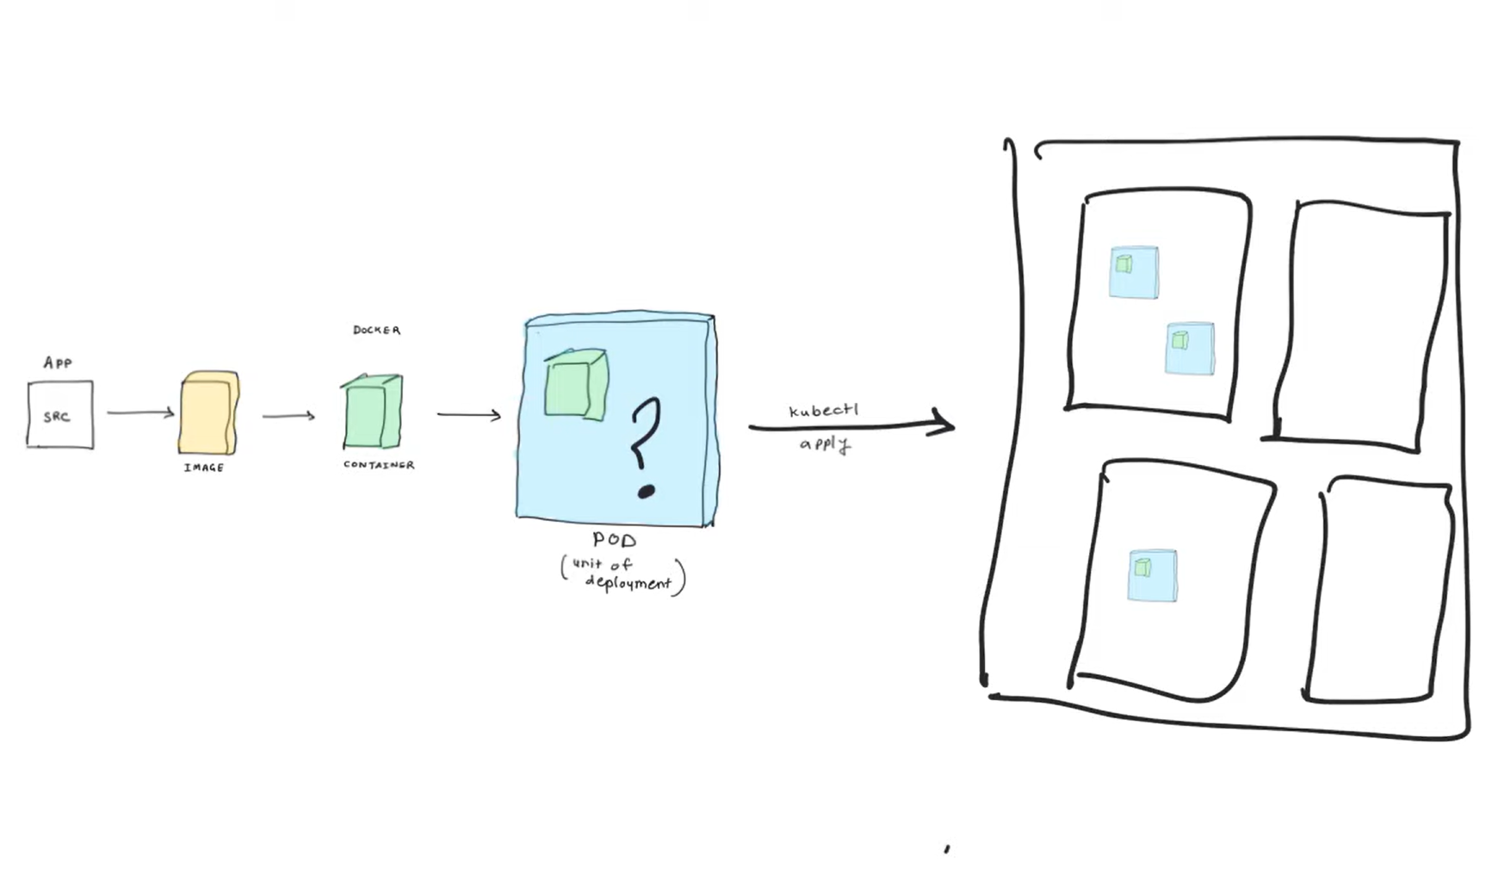

Kubernetes Basics: Pods, Nodes, Containers, Deployments and Clusters - YouTube
Kubernetes Basics: Pods, Nodes, Containers, Deployments & Clusters - YouTube
Viewing Pods and Nodes | Kubernetes
Azure CNI networking explained in plain English in less than 5 minutes-azure kubernetes services-AKS - YouTube
Kubernetes vs Docker | Understand the Difference | Docker vs Kubernetes - YouTube
Kubernetes Architecture, Components, Master/Worker Node & Pods - YouTube
Accessing Kubernetes Dashboard | Kubernetes Dashboard Overview | Kubernetes Tutorial - YouTube
AKS Kubenet networking explained in plain English - in less than 5 minutes - YouTube
Kubernetes Deployment | Kubernetes Cluster | K21Academy - YouTube
Azure Services - Performance Checks-e0b95375-35ac-4f81-be72-c4acdad6e397 (1).pdf
Introduction To AKS Architecture | Azure Kubernetes Service Overview 2023 | K21 Academy - YouTube
AKS Kubenet networking explained in plain English - in less than 5 minutes - YouTube
Scaling an AKS (Azure Kubernetes Services) cluster explained in plain English - YouTube
AKS Patching and Node Pool Upgrade Azure Kubernetes Services (AKS) explained in plain English - YouTube
AKS Persistent Volumes, Persistent Volume Claims and Storage Classes explained in plain English - YouTube
Azure Kubernetes Services (AKS) Overview - YouTube
How to create AKS Cluster | Setting Up & Deploying an Azure Kubernetes Service Cluster | K21Academy - YouTube
6. Create AKS from portal and enable gmsa on AKS
1. Create Vnet/Subnet ( if you using application gateway then 172.17.160.0/20 ) 172.17.160.0/21
2. Create Key Vault with Secret, and private endpoint
key vault non-proKV

from azure portal all selected network create secret (GMSADomainUserCred and value: coremanaged.co.uk\nonproduser1:p@ssw0rd)

3. Peering this vnet with domain controller one
4.

*****************************************

