LAB ASSIGNMENT – 03

COURSE: AI ASSISTED CODING
HALLTICKET NO: 2403A51370
NAME: Gunda Sindhuja
BATCH: 15
SCHOOL OF COMPUTER SCIENCE AND ARTIFICIAL INTELLIGENCE |  |  |  |  | DEPARTMENT OF COMPUTER SCIENCE ENGINEERING
ProgramName:B. Tech |  |  |  | Assignment Type: Lab |  |  | AcademicYear:2025-2026
CourseCoordinatorName |  |  |  | Venkataramana Veeramsetty
Instructor(s)Name |  |  |  | 1. Dr. Mohammed Ali Shaik  2. Dr. T Sampath Kumar  3. Mr. S Naresh Kumar  4. Dr. V. Rajesh  5. Dr. Brij Kishore  6. Dr Pramoda Patro  7. Dr. Venkataramana  8. Dr. Ravi Chander  9. Dr. Jagjeeth Singh
CourseCode |  |  | 24CS002PC215 | CourseTitle |  | AI Assisted Coding
Year/Sem |  |  | II/I | Regulation |  | R24
Date and Day  of Assignment |  |  | Week2-Tuesday | Time(s)
Duration |  |  | 2 Hours | Applicableto  Batches |  | 24CSBTB01 To 24CSBTB39
AssignmentNumber:3.2(Present assignment number)/24(Total number of assignments)
 | Q.No. | Question |  |  |  |  |  | ExpectedTime  to complete

 | 1 | Lab 3: Prompt Engineering – Improving Prompts and Context Management  Lab Objectives:  - To understand how prompt structure and wording influence AI-generated code.  - To explore how context (like comments and function names) helps AI generate relevant output.  - To evaluate the quality and accuracy of code based on prompt clarity.  - To develop effective prompting strategies for AI-assisted programming.  Lab Outcomes (LOs):  After completing this lab, students will be able to:  - Generate Python code using Google Gemini in Google Colab.  - Analyze the effectiveness of code explanations and suggestions by Gemini.  - Set up and use Cursor AI for AI-powered coding assistance.  - Evaluate and refactor code using Cursor AI features.  - Compare AI tool behavior and code quality across different platforms.  Task Description#1  - Ask AI to write a function to calculate compound interest, starting with only the function name. Then add a docstring, then input-output example  Expected Output#1  - Comparison of AI-generated code styles  Task Description#2  - Do math stuff, then refine it to: # Write a function to calculate average, median, and mode of a list of numbers.  Expected Output#2  - AI-generated function evolves from unclear to accurate multi-statistical operation.  Task Description#3  - Provide multiple examples of input-output to the AI for convert_to_binary(num) function. Observe how AI uses few-shot prompting to generalize.  Expected Output#3  - Enhanced AI output with clearer prompts  Task Description#4  - Create an user interface for an hotel to generate bill based on customer requirements  Expected Output#4  - Consistent functions with shared logic  Task Description#5  - Analyzing Prompt Specificity: Improving Temperature Conversion Function with Clear Instructions  Expected Output#5  - Code quality difference analysis for various prompts  Note: Report should be submitted a word document for all tasks in a single document with prompts, comments & code explanation, and output and if required, screenshots  Evaluation Criteria:  Criteria Max Marks  Task#1 0.5  Task#2 0.5  Task #3 0.5  Task #4 0.5  Task #5 0.5  Total 2.5 Marks | 03.08.2025 EOD

LAB ASSIGNMENT – 3
TASK 1
PROMPT:
Write a Python function named calculate_compound_interest based on User Input. Add a docstring that explains what it does, its parameters (principal, rate, time, n), and what it returns. Include an example in the docstring.
CODE:
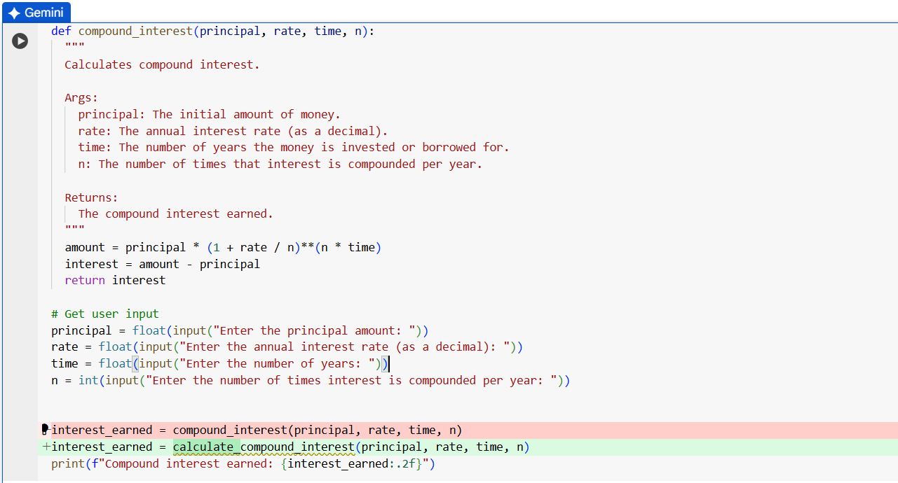

OUTPUT:
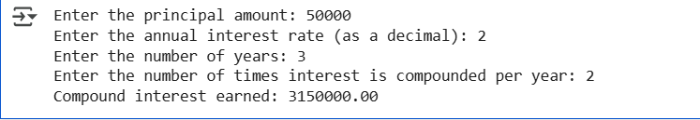

EXPLANATION:

TASK 2
PROMPT:
Write a Python Function that calculate average, median, and mode of a list of numbers based on User Input.

CODE:
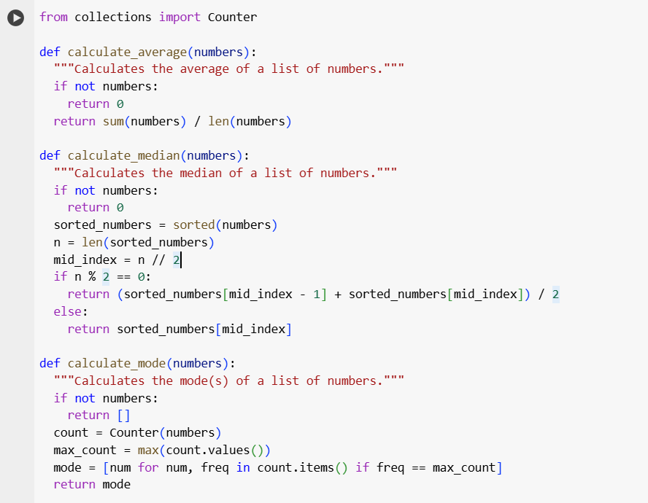
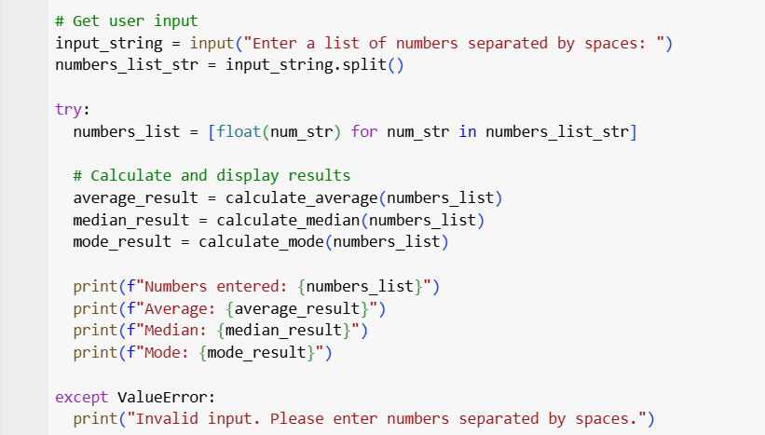
OUTPUT:
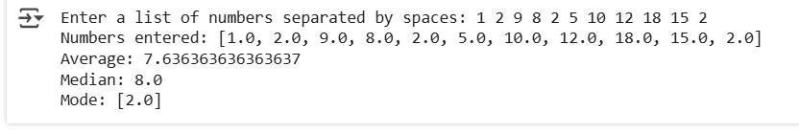

EXPLANATION:
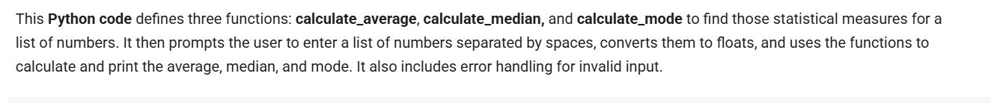

TASK 3
PROMPT:
Write a Python function called convert_to_binary(num) that takes an integer and converts it into binary form based on user input.
For examples:
Input: 0, Output:'0'
Input: 1, Output:'1'
Input: 2, Output:'10'
Input: 5, Output'101'

CODE:
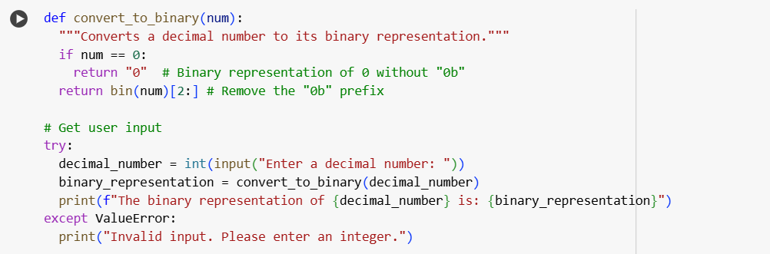

OUTPUT:


EXPLANATION:
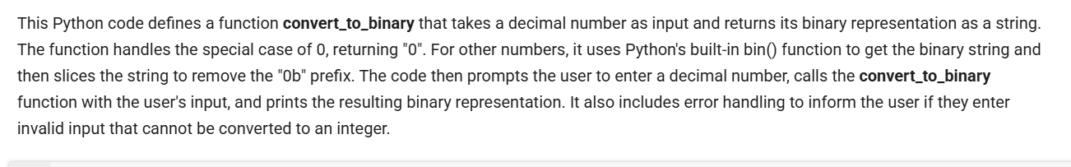

TASK 4

PROMPT:
Write a Python Program using Functions to create an user interface for an hotel to generate bill based on customer requirement

CODE:

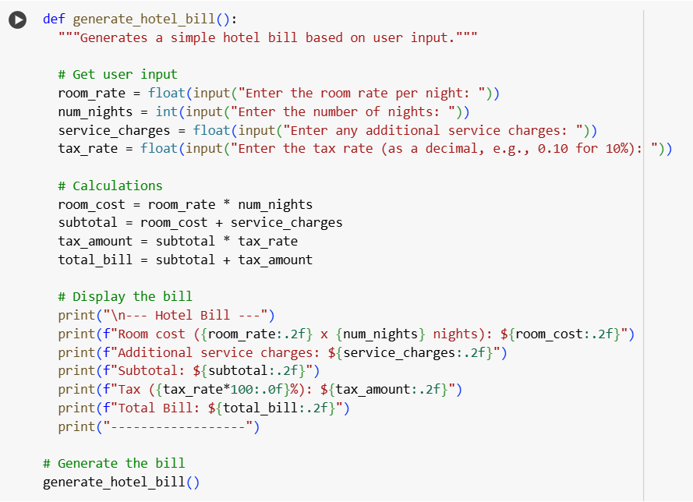

OUTPUT:
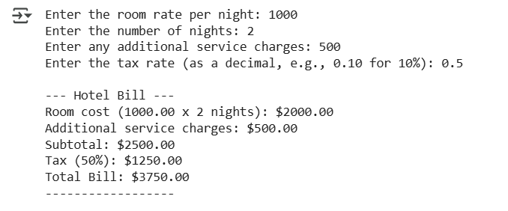

EXPLANATION:

TASK 5
PROMPT:
Write a Python program for Temperature conversion like Celsius to Fahrenheit, Fahrenheit to Celsius, Celsius to Kelvin, Kelvin to Celsius, Fahrenheit to Kelvin, Kelvin to Fahrenheit. The Input should accept float and the output should be rounded off to 1 decimal point.
CODE:
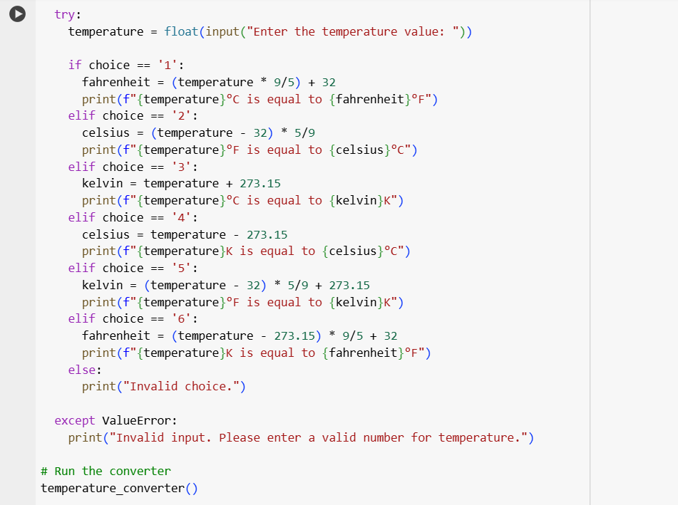

OUTPUT:

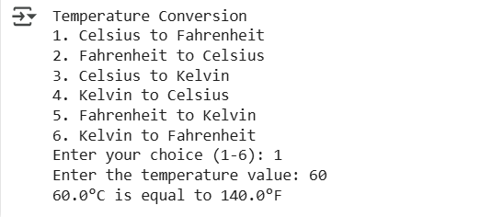

EXPLANATION:

