LAB ASSIGNMENT – 9.3

COURSE: AI ASSISTED CODING
HALLTICKET NO: 2403A51370
NAME: Gunda Sindhuja
BATCH: 15

SCHOOL OF COMPUTER SCIENCE AND ARTIFICIAL INTELLIGENCE |  |  |  |  | DEPARTMENT OF COMPUTER SCIENCE ENGINEERING
ProgramName:B. Tech |  |  |  | Assignment Type: Lab |  |  | AcademicYear:2025-2026
CourseCoordinatorName |  |  |  | Venkataramana Veeramsetty
Instructor(s)Name |  |  |  | Dr. V. Venkataramana (Co-ordinator)  Dr. T. Sampath Kumar  Dr. Pramoda Patro  Dr. Brij Kishor Tiwari  Dr.J.Ravichander  Dr. Mohammand Ali Shaik  Dr. Anirodh Kumar  Mr. S.Naresh Kumar  Dr. RAJESH VELPULA  Mr. Kundhan Kumar  Ms. Ch.Rajitha  Mr. M Prakash  Mr. B.Raju  Intern 1 (Dharma teja)  Intern 2 (Sai Prasad)  Intern 3 (Sowmya)  NS_2 ( Mounika)
CourseCode |  |  | 24CS002PC215 | CourseTitle |  | AI Assisted Coding
Year/Sem |  |  | II/I | Regulation |  | R24
Date and Day  of Assignment |  |  | Week4 - Wednesday | Time(s)
Duration |  |  | 2 Hours | Applicableto  Batches
AssignmentNumber:9.3(Present assignment number)/24(Total number of assignments)
 | Q.No. | Question |  |  |  |  |  | ExpectedTime  to complete
 | 1 | Lab 9: Documentation Generation: Automatic documentation and code comments  Lab Objectives:  - To understand the importance of documentation and code comments in software development.  - To explore how AI-assisted coding tools can generate meaningful documentation and inline comments.  - To practice generating function-level and module-level docstrings automatically.  - To evaluate the quality, accuracy, and limitations of AI-generated documentation.  - To develop a small automated tool for documentation generation in Python..  Lab Outcomes (LOs):  After completing this lab, students will be able to:  - Apply AI-assisted coding tools to generate docstrings and inline comments for Python code.  - Critically analyze AI-generated documentation for correctness, completeness, and readability.  - Create structured documentation (function-level, module-level) following standard formats.  - Design and implement a mini documentation generator tool to automate code commenting and docstring creation.  Task Description#1 Basic Docstring Generation  - Write python function to return sum of even and odd numbers in the given list.  - Incorporate manual docstring in code with Google Style  - Use an AI-assisted tool (e.g., Gemini, Copilot, Cursor AI) to generate a docstring describing the function.  - Compare the AI-generated docstring with your manually written one.  Expected Outcome#1: Students understand how AI can produce function-level documentation.  Task Description#2 Automatic Inline Comments  - Write python program for sru_student class with attributes like name, roll no., hostel_status and fee_update method and display_details method.  - Write comments manually for each line/code block  - Ask an AI tool to add inline comments explaining each line/step.  - Compare the AI-generated comments with your manually written one.  Expected Output#2: Students critically analyze AI-generated code comments.  Task Description#3  - Write a Python script with 3–4 functions (e.g., calculator: add, subtract, multiply, divide).  - Incorporate manual docstring in code with NumPy Style  - Use AI assistance to generate a module-level docstring + individual function docstrings.  - Compare the AI-generated docstring with your manually written one.  Expected Output#3: Students learn structured documentation for multi-function scripts  Push documentation whole workspace as .md file in GitHub Repository  Note: Report should be submitted a word document for all tasks in a single document with prompts, comments & code explanation, and output and if required, screenshots |  |  |  |  |  | Week4 - Wednesday

TASK 1:
PROMPT :
- Write a python program to find addition of odd and even numbers from the list 1 to 10 without docstring and inline comment.
- Please add docstrings and inline comments.

CODE:
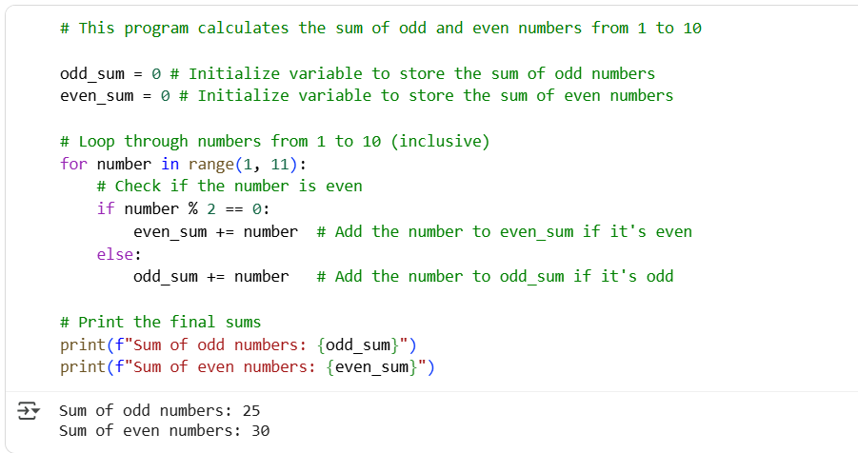

EXPLANATION:
The version of the code with docstrings and inline comments includes explanatory text directly within the code. Docstrings, enclosed in triple quotes, serve as documentation for modules, classes, and functions, explaining their purpose, arguments, and return values. Inline comments, starting with #, provide brief explanations for specific lines or blocks of code. The code without these lacks this internal documentation. While both versions execute identically, the documented version is significantly more readable and understandable for anyone reading the code, including the original author in the future. This is crucial for collaboration and long-term maintenance. Docstrings can also be used to generate automated documentation. In essence, adding comments and docstrings is a best practice that improves code clarity and maintainability without changing its functionality.

TASK 2:
PROMPT:
1.Write a program in python to create a python class sru_student with attributes like name, roll no., hostel_status and fee_update method and display_details method without docstrings and inline comments.
2.Please add 5 sample details and display them.
3.Please add docstring and inline comments.

CODE:
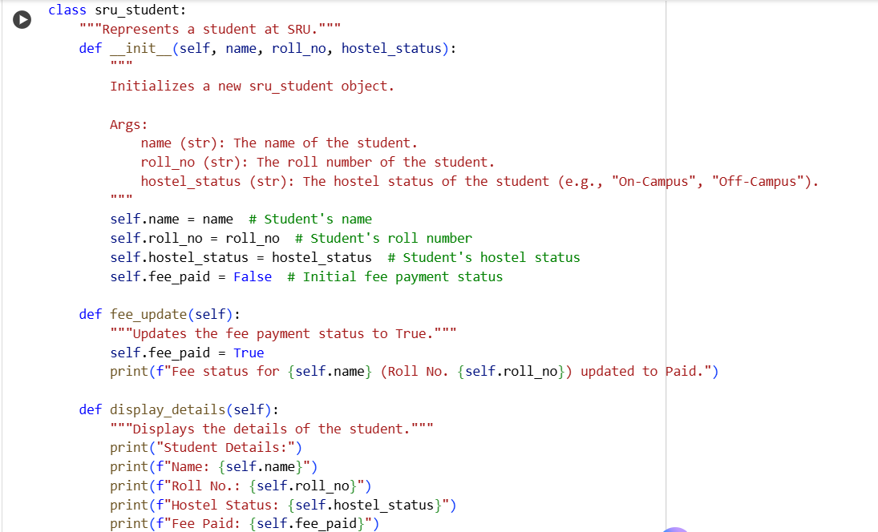
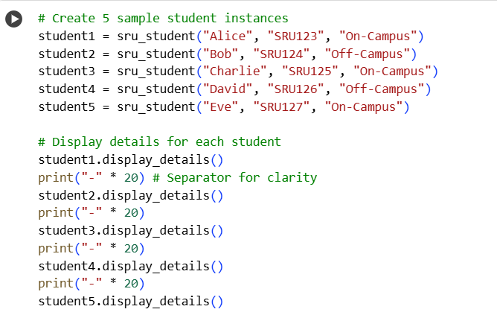

OUTPUT: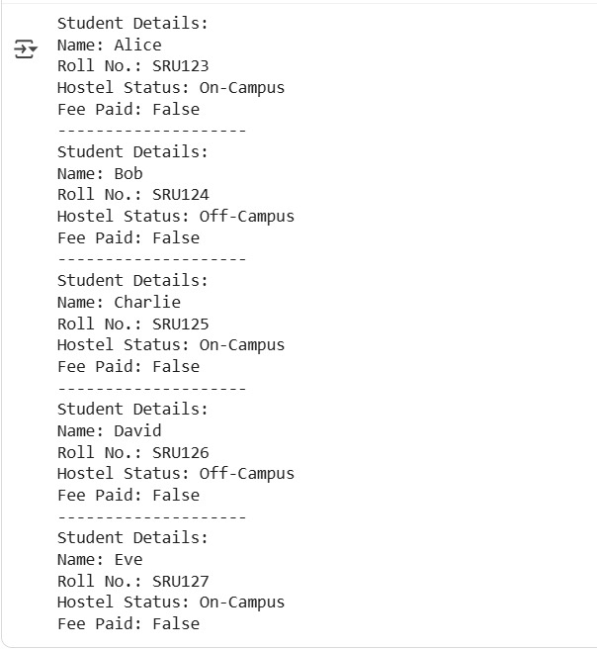
EXPLANATION:
The version with docstrings and inline comments includes explanatory text within the code itself. Docstrings, enclosed in triple quotes, provide a high-level overview of what a class or method does, its arguments, and what it returns. Inline comments, starting with #, explain specific lines or small blocks of code. The version without these lacks this explanatory text. The presence of docstrings and comments makes the code significantly easier for others (or your future self) to understand and maintain, even though both versions execute and produce the same output. In essence, comments and docstrings are for human readers, improving code readability and maintainability without affecting the program's execution. This is especially crucial in larger projects or when collaborating with others, as it significantly reduces the time and effort required to grasp the code's functionality and purpose. Well-documented code is a hallmark of good programming practice.

TASK 3:
PROMPT:
- Write a python code with functions like Addition,Subtraction,Multiplication and Division without docstrings or inline comments.
- Now generate a module-level docstring + individual function docstrings.
CODE:
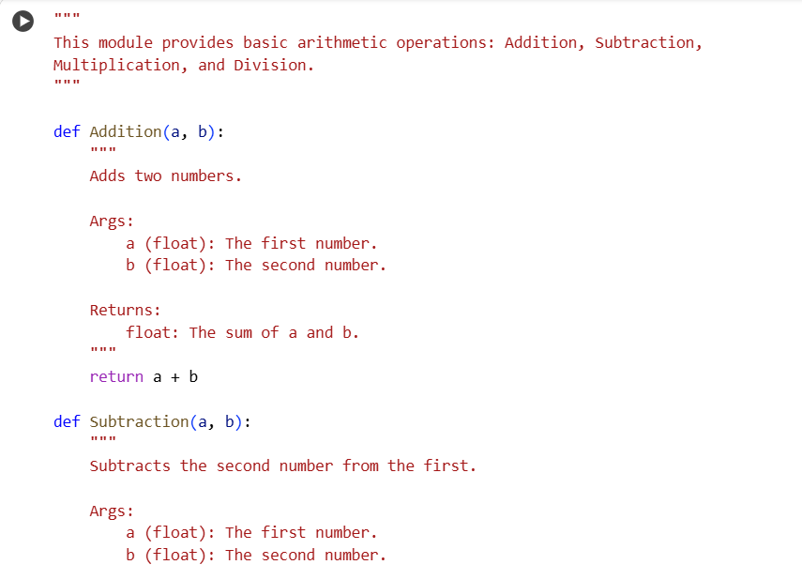
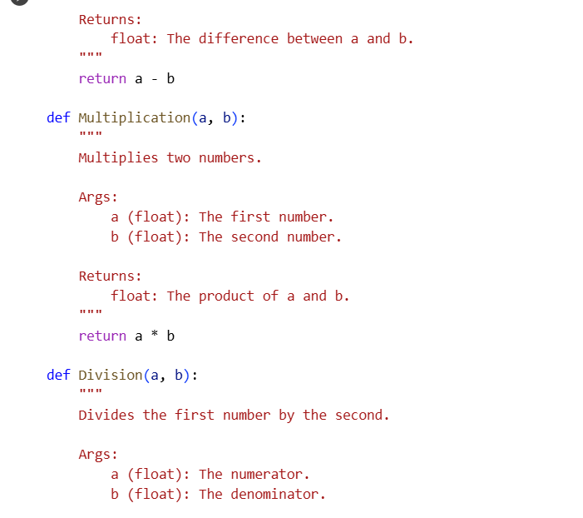
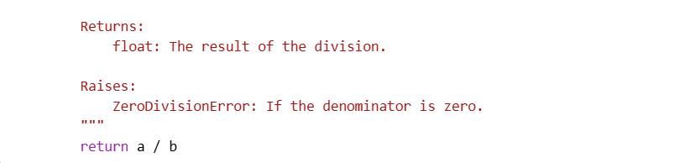
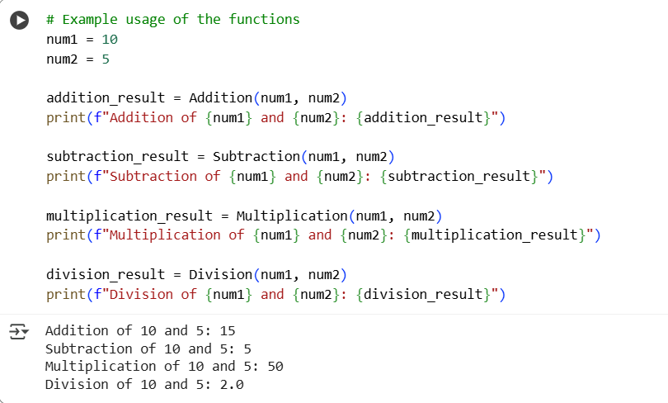

EXPLANATION:
This Python code defines a module for basic arithmetic operations. It includes four functions: Addition, Subtraction, Multiplication, and Division. Each function takes two numerical arguments (a and b). The Addition function returns the sum of a and b. The Subtraction function returns the difference between a and b (a minus b). The Multiplication function returns the product of a and b. The Division function returns the result of dividing a by b. Docstrings are included for the module and each function to explain their purpose, arguments, and return values. The code is designed to be a simple, reusable set of arithmetic tools. It demonstrates how to define and document basic functions in Python.

