LAB ASSIGNMENT – 01

COURSE: AI ASSISTED CODING
HALLTICKET NO: 2403A51370
NAME: Gunda Sindhuja
BATCH: 15

SCHOOL OF COMPUTER SCIENCE AND ARTIFICIAL INTELLIGENCE |  |  |  |  | DEPARTMENT OF COMPUTER SCIENCE ENGINEERING
ProgramName:B. Tech |  |  |  | Assignment Type: Lab |  |  | AcademicYear:2025-2026
Course Coordinator Name |  |  |  | Venkataramana Veeramsetty
Instructor(s)Name |  |  |  | Dr. V. Venkataramana (Co-ordinator)  Dr. T. Sampath Kumar  Dr. Pramoda Patro  Dr. Brij Kishor Tiwari  Dr.J.Ravichander  Dr. Mohammand Ali Shaik  Dr. Anirodh Kumar  Mr. S.Naresh Kumar  Dr. RAJESH VELPULA  Mr. Kundhan Kumar  Ms. Ch.Rajitha  Mr. M Prakash  Mr. B.Raju  Intern 1 (Dharma teja)  Intern 2 (Sai Prasad)  Intern 3 (Sowmya)  NS_2 ( Mounika)
CourseCode |  |  | 24CS002PC215 | CourseTitle |  | AI Assisted Coding
Year/Sem |  |  | II/I | Regulation |  | R24
Date and Day  of Assignment |  |  | Week1 - Thursday | Time(s)
Duration |  |  | 2 Hours | Applicableto  Batches |  | 24CSBTB01 To 24CSBTB39
AssignmentNumber:1.4(Present assignment number)/24(Total number of assignments)
 | Q.No. | Question |  |  |  |  |  | ExpectedTime  to complete
 | 1 | Lab 1: Environment Setup – GitHub Copilot and VS Code Integration  Lab Objectives:  - To install and configure GitHub Copilot in Visual Studio Code.  - To explore AI-assisted code generation using GitHub Copilot.  - To analyze the accuracy and effectiveness of Copilot's code suggestions.  - To understand prompt-based programming using comments and code context  Lab Outcomes (LOs):  After completing this lab, students will be able to:  - Set up GitHub Copilot in VS Code successfully.  - Use inline comments and context to generate code with Copilot.  - Evaluate AI-generated code for correctness and readability.  - Compare code suggestions based on different prompts and programming styles.  Task Description #1  • Install and configure GitHub Copilot in VS Code. Take screenshots of each step.  Expected Output #1  • Successfully install and activate GitHub Copilot in VS Code. Include screenshots showing installation, authentication via GitHub, and an example suggestion from Copilot.  Task Description #2  • A function in Python that returns the maximum of three numbers using GitHub Copilot. Use an appropriate comment as a prompt.  Prompt: fk,jsfhjkhjds  Expected Output #2  • Python function that takes three inputs and returns the largest value. Include the code and output.  Task Description #3  • Use GitHub Copilot to create a recursive Python function that calculates the factorial of a number.  Expected Output #3  • Python function for factorial using recursion with input and output examples.  Task Description #4  • Prompt GitHub Copilot to create a class named Student with attributes name, roll_no, and marks. Add a method to display student details.  Expected Output #4  • Python class definition with an initializer and a display method. Include object creation and output.  Task Description #5  • Ask GitHub Copilot to generate a Python function that takes a string as input and returns the frequency of each word.  Expected Output #5  • Python function that returns word frequency using a dictionary. Provide sample input and output.  Note: Report should be submitted a word document for all tasks in a single document with prompts, comments & code explanation, and output and if required, screenshots  Evaluation Criteria:  Criteria Max Marks  Install and configure GitHub Copilot in VS Code (Task #1) 0.5  Python function that takes three inputs and returns the largest value (Task #2) 0.5  Python function for factorial using recursion (Task #3) 0.5  Python class definition with an initializer and a display method (Task #4) 0.5  Function that returns word frequency using a dictionary (Task #5) 0.5  Total 2.5 Marks |  |  |  |  |  | Week1 - Thursday

TASK 1:

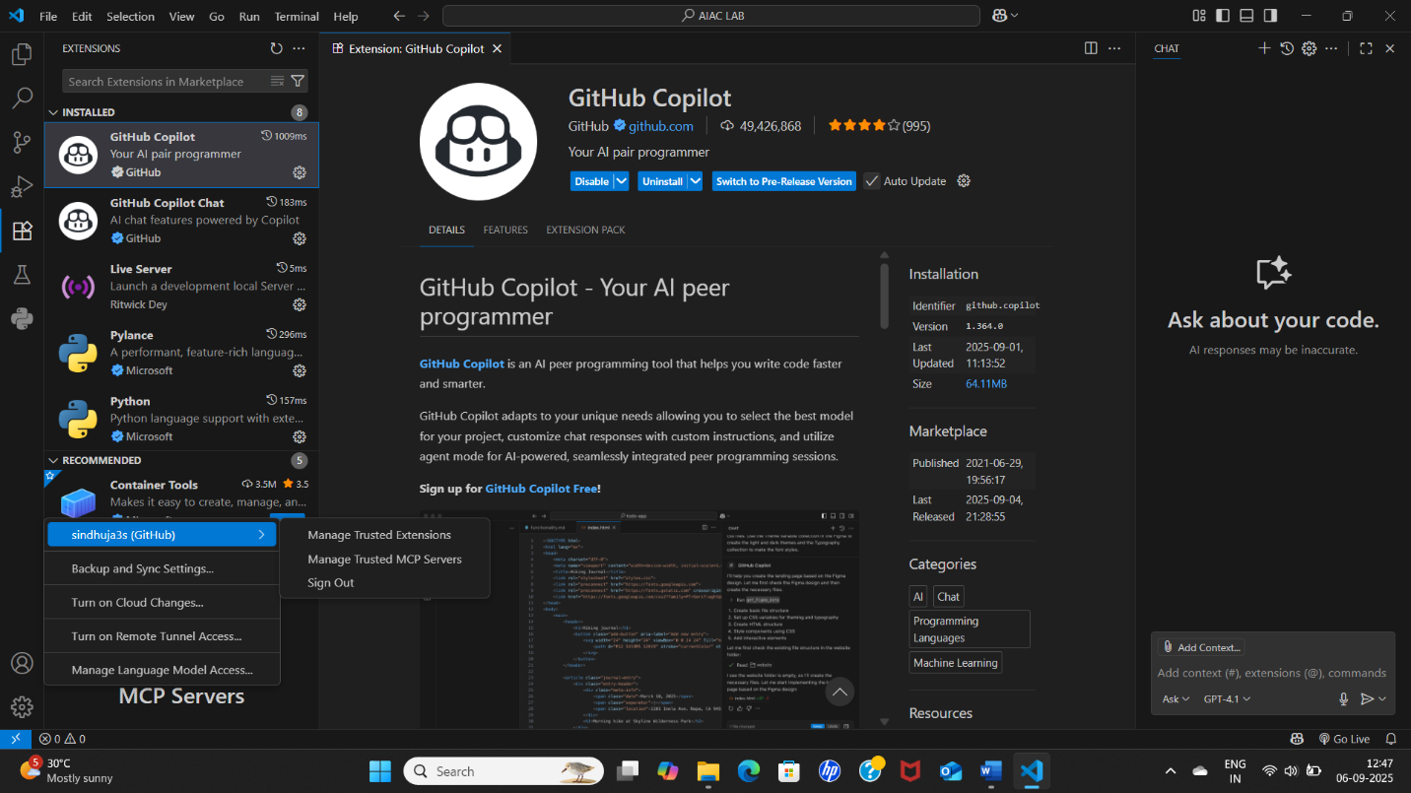

TASK 2
PROMPT:
Write a Python program to find the largest number among three numbers based on User Input.
CODE:

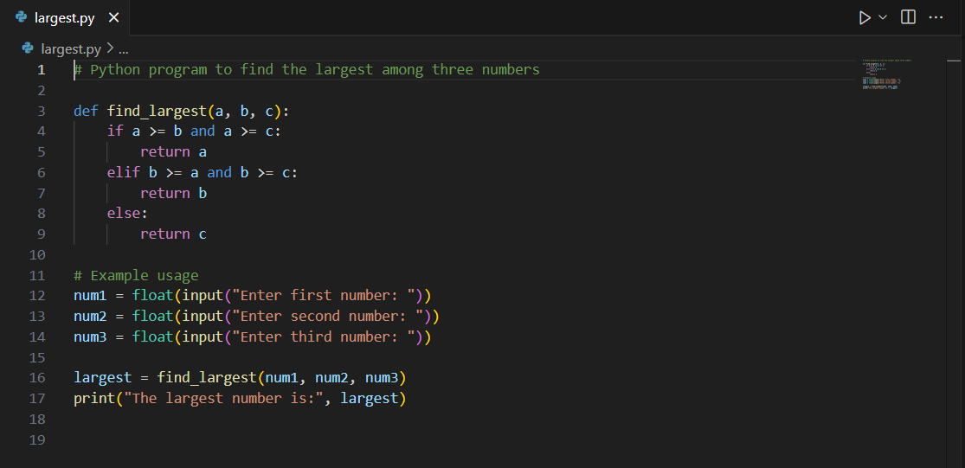

OUTPUT:
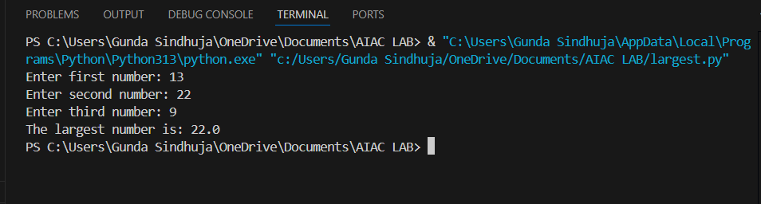

EXPLANATION:
This Python program finds the largest of three numbers entered by the user.
- The find_largest function compares the three numbers using if-elif-else statements and returns the largest.
- The user is prompted to input three numbers.
- The largest number is calculated and printed.

TASK 3
PROMPT:
Write a Python Function using Reccursion that calculates the factorial of a number based on User Input.
CODE:
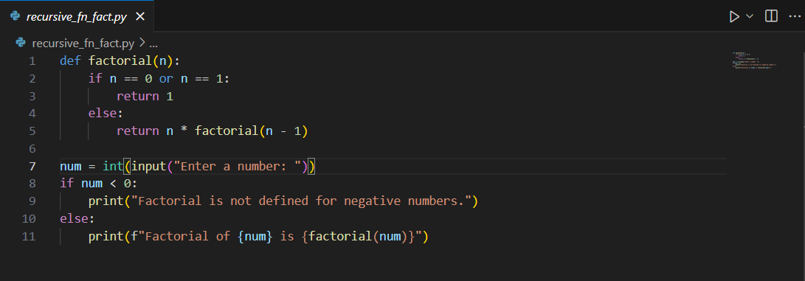

OUTPUT:
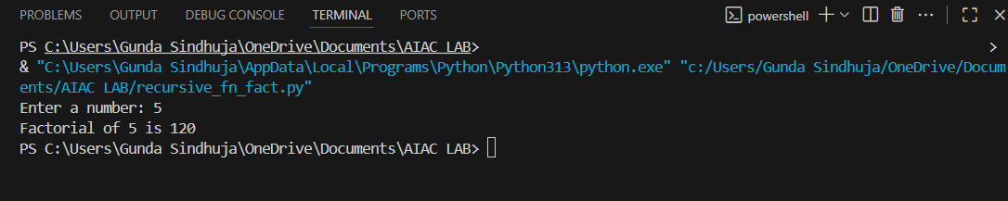

EXPLANATION:
This program calculates the factorial of a number using recursion.
- The factorial function calls itself until n is 0 or 1, returning 1 in those cases.
- The user enters a number.
- If the number is negative, it prints an error message.
- Otherwise, it prints the factorial of the entered number.

TASK 4
PROMPT:Create a Python class named Student with attributes name, roll_no,marks based on user input. Add an instance method called display_details() that prints the student's details.

CODE:
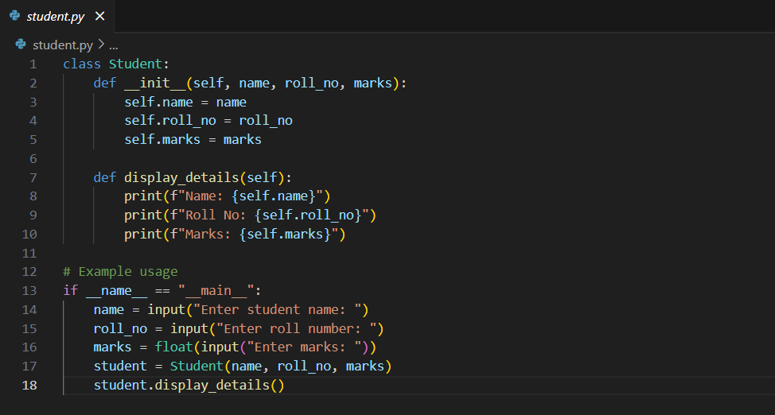

OUTPUT:
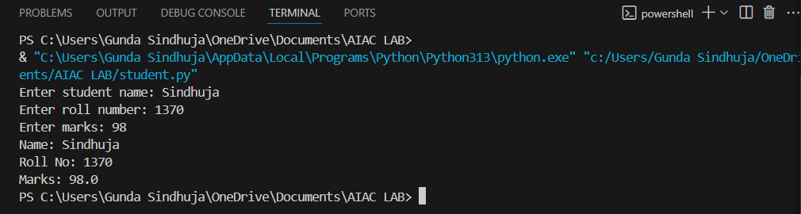

EXPLANATION:
This program defines a Student class with attributes for name, roll number, and marks.
- The display_details method prints the student's details.
- The user is prompted to enter student information.
- An object is created and its details are displayed.

TASK 5
PROMPT: Write a Python Function that takes a String as input and returns the ferquency of each word based on user input

CODE:
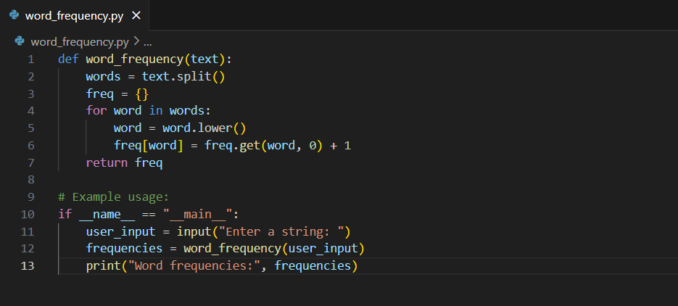

OUTPUT:
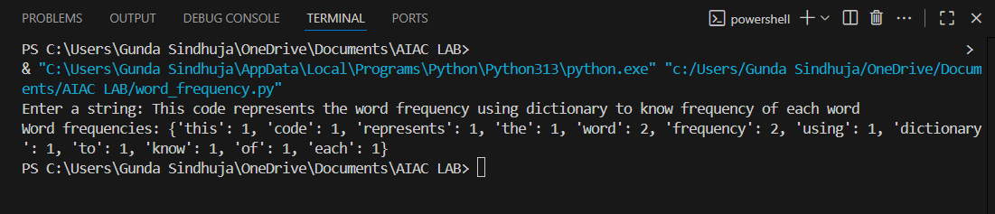

EXPLANATION:
This code defines a function word_frequency that takes a string of text as input and returns a dictionary where keys are the words from the text (in lowercase) and values are their respective frequencies (how many times each word appears).
The example usage part of the code prompts the user to enter a string, calculates the word frequencies using the function, and then prints the resulting dictionary.

