LAB ASSIGNMENT – 12.4

COURSE: AI ASSISTED CODING
HALLTICKET NO: 2403A51370
NAME: Gunda Sindhuja
BATCH: 15

SCHOOL OF COMPUTER SCIENCE AND ARTIFICIAL INTELLIGENCE |  |  |  |  | DEPARTMENT OF COMPUTER SCIENCE ENGINEERING
Program Name: B. Tech |  |  |  | Assignment Type: Lab |  |  | Academic Year:2025-2026
Course Coordinator Name |  |  |  | Venkataramana Veeramsetty
Instructor(s) Name |  |  |  | Dr. V. Venkataramana (Co-ordinator)  Dr. T. Sampath Kumar  Dr. Pramoda Patro  Dr. Brij Kishor Tiwari  Dr.J.Ravichander  Dr. Mohammand Ali Shaik  Dr. Anirodh Kumar  Mr. S.Naresh Kumar  Dr. RAJESH VELPULA  Mr. Kundhan Kumar  Ms. Ch.Rajitha  Mr. M Prakash  Mr. B.Raju  Intern 1 (Dharma teja)  Intern 2 (Sai Prasad)  Intern 3 (Sowmya)  NS_2 ( Mounika)
Course Code |  |  | 24CS002PC215 | Course Title |  | AI Assisted Coding
Year/Sem |  |  | II/I | Regulation |  | R24
Date and Day  of Assignment |  |  | Week6 - Thursday | Time(s)
Duration |  |  | 2 Hours | Applicable to  Batches
AssignmentNumber:12.1(Present assignment number)/24(Total number of assignments)
 | Q.No. | Question |  |  |  |  |  | Expected Time  to complete
 | 1 | Lab 12: Algorithms with AI Assistance – Sorting, Searching, and Optimizing Algorithms  Lab Objectives:  - Apply AI-assisted programming to implement and optimize sorting and searching algorithms.  - Compare different algorithms in terms of efficiency and use cases.  - Understand how AI tools can suggest optimized code and complexity improvements.  Task 1: Implementing Bubble Sort with AI Comments  - Task: Write a Python implementation of Bubble Sort.  - Instructions:  - Students implement Bubble Sort normally.  - Ask AI to generate inline comments explaining key logic (like swapping, passes, and termination).  - Request AI to provide time complexity analysis.  - Expected Output:  - A Bubble Sort implementation with AI-generated explanatory comments and complexity analysis.  Task 2: Optimizing Bubble Sort → Insertion Sort  - Task: Provide Bubble Sort code to AI and ask it to suggest a more efficient algorithm for partially sorted arrays.  - Instructions:  - Students implement Bubble Sort first.  - Ask AI to suggest an alternative (Insertion Sort).  - Compare performance on nearly sorted input.  - Expected Output:  - Two codes (Bubble Sort + Insertion Sort).  - AI explanation of why Insertion Sort is more efficient for partially sorted data.  Task 3: Binary Search vs Linear Search  - Task: Implement both Linear Search and Binary Search.  - Instructions:  - Use AI to generate docstrings and performance notes.  - Test both algorithms on sorted and unsorted data.  - Ask AI to explain when Binary Search is preferable.  - Expected Output:  - Two implementations with docstrings.  - A student observation table comparing performance (Linear vs Binary Search). |  |  |  |  |  | Week6 - Thursday
Task 4: Quick Sort and Merge Sort Comparison
- Task: Implement Quick Sort and Merge Sort using recursion.
- Instructions:
  - Provide AI with partially completed functions for recursion.
  - Ask AI to complete the missing logic and add docstrings.
  - Compare both algorithms on random, sorted, and reverse-sorted lists.
- Expected Output:
  - Working Quick Sort and Merge Sort implementations.
  - AI-generated explanation of average, best, and worst-case complexities.

Task 5: AI-Suggested Algorithm Optimization
- Task: Give AI a naive algorithm (e.g., O(n²) duplicate search).
- Instructions:
  - Students write a brute force duplicate-finder.
  - Ask AI to optimize it (e.g., by using sets/dictionaries with O(n) time).
  - Compare execution times with large input sizes.
- Expected Output:
  - Two versions of the same algorithm (brute force + optimized).
  - AI explanation of how complexity was improved.

TASK 1
PROMPT :
write a python program for bubble sort and add inline comments and docstrings. please consider one example.

CODE :
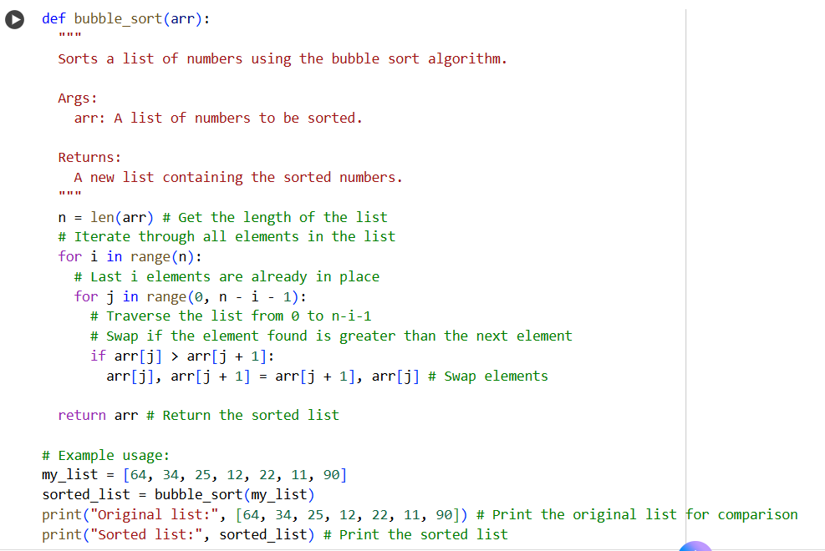

OUTPUT :
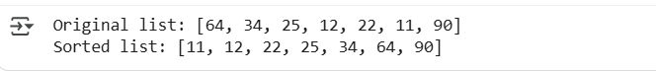

EXPLANATION :
This Python code defines a bubble_sort function that sorts a list of numbers. It works by repeatedly stepping through the list, comparing adjacent elements, and swapping them if they are in the wrong order. The function iterates through the list multiple times, with the largest element "bubbling up" to its correct position in each pass. The example usage demonstrates sorting the list [64, 34, 25, 12, 22, 11, 90] and prints both the original and the sorted lists.

TASK 2:
PROMPT :
- generate a simple bubble sort code
- now modify the code for insertion sort

CODE :
1.
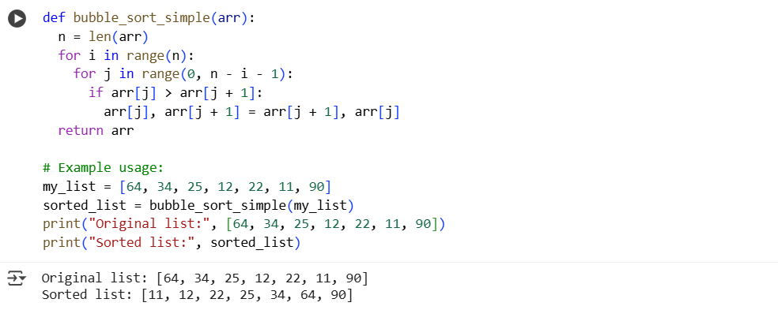

2.
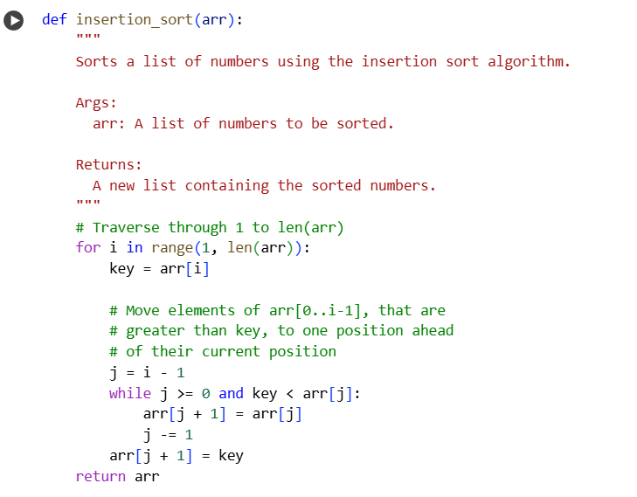
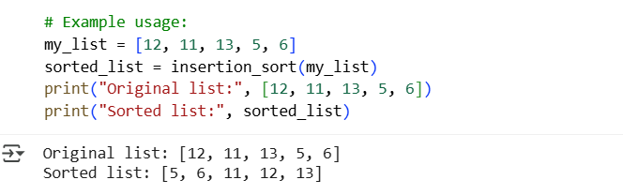

EXPLANATION :
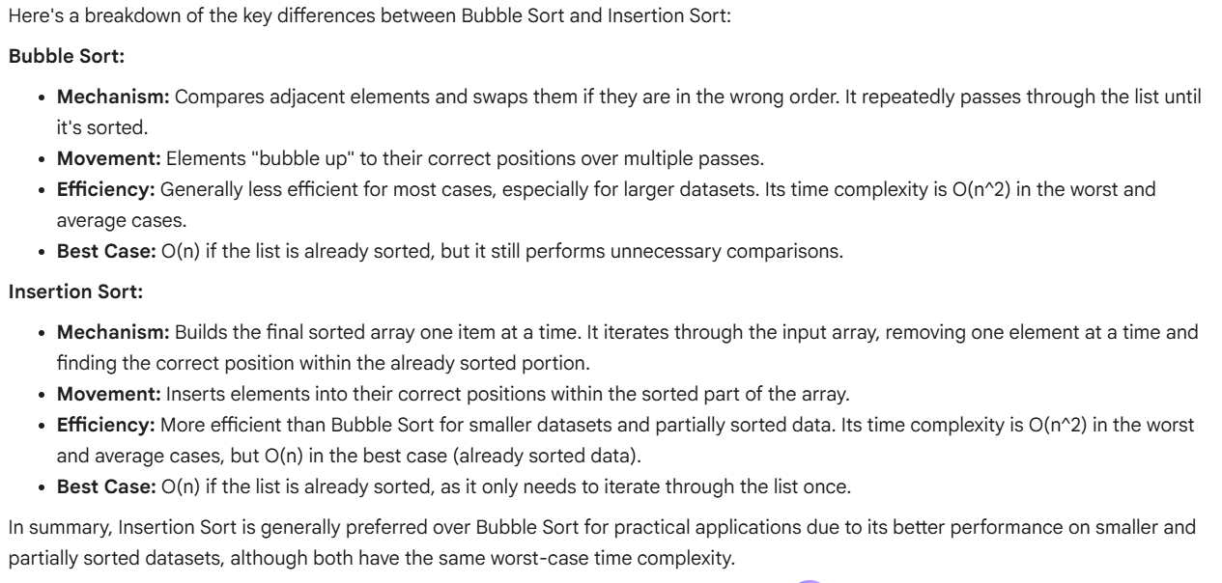

TASK 3
PROMPT :
write a python code to perform linear search and binary search on both sorted and unsorted data. Also provide inline comments and docstrings.

CODE :
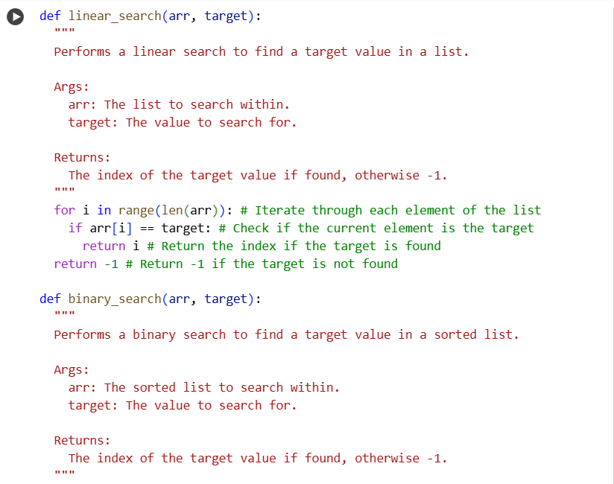
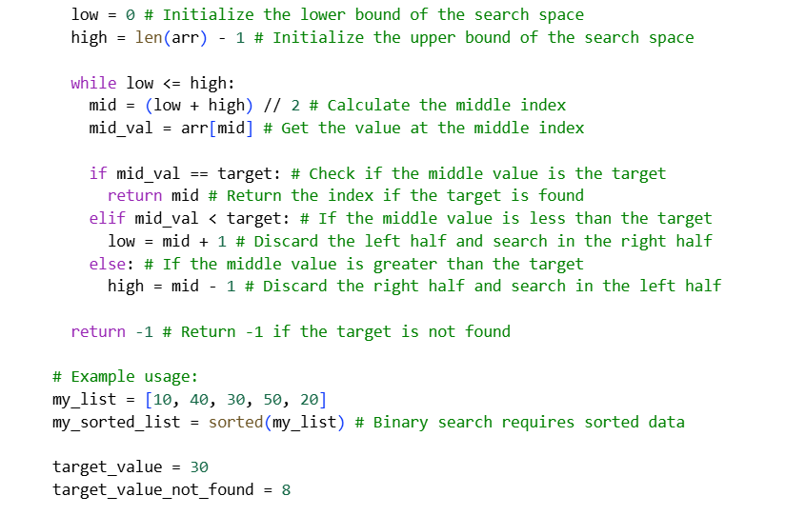
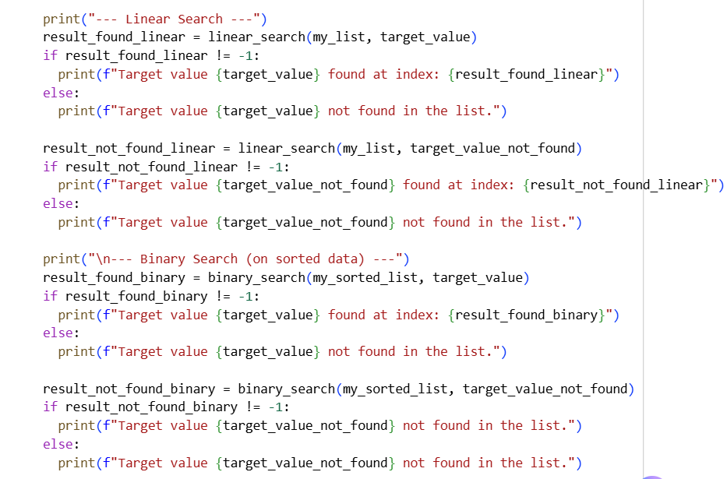

OUTPUT :
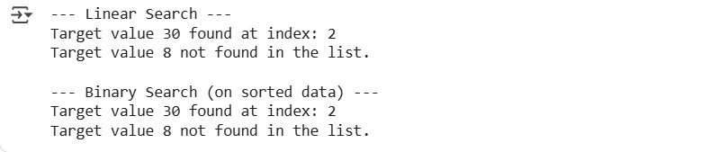

EXPLANATION :
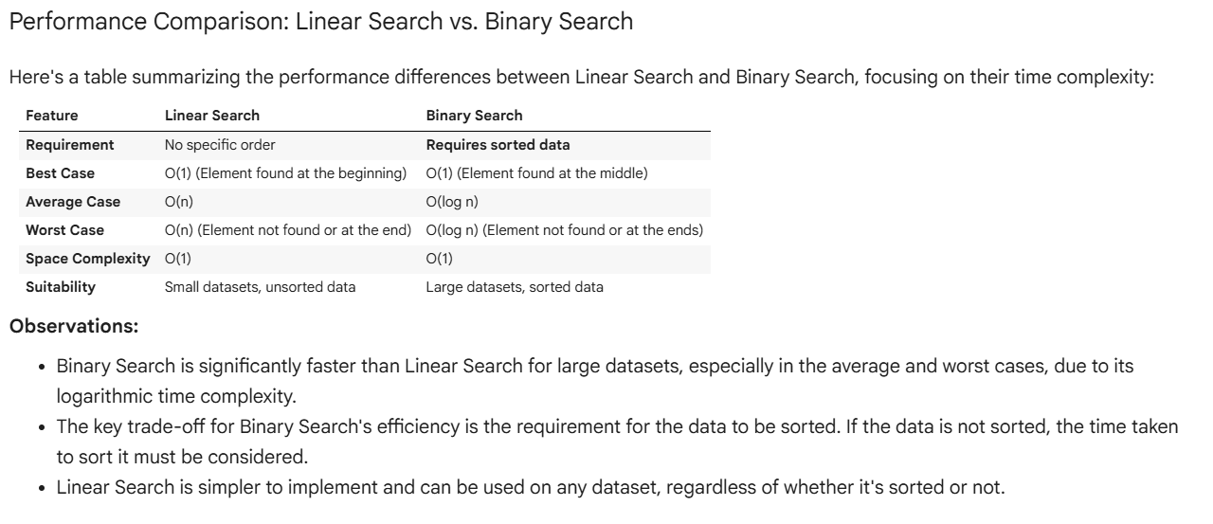

TASK 4
PROMPT :
write a python program to Implement Quick Sort and Merge Sort using recursion.Add inline comments and docstrings.Compare both algorithms on random, sorted, and reverse-sorted lists.

CODE :
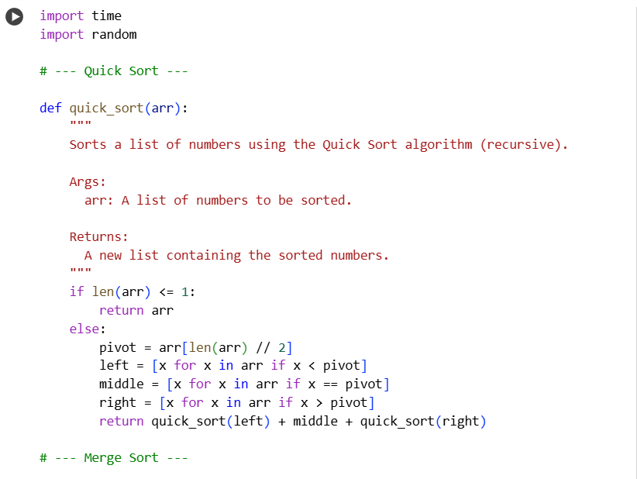
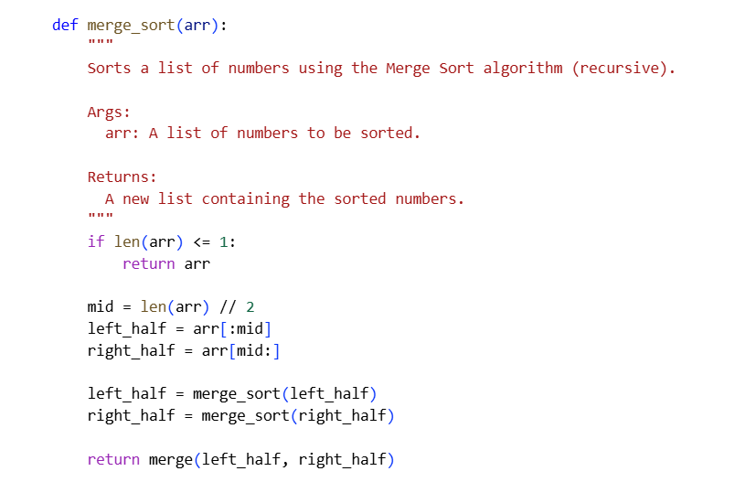
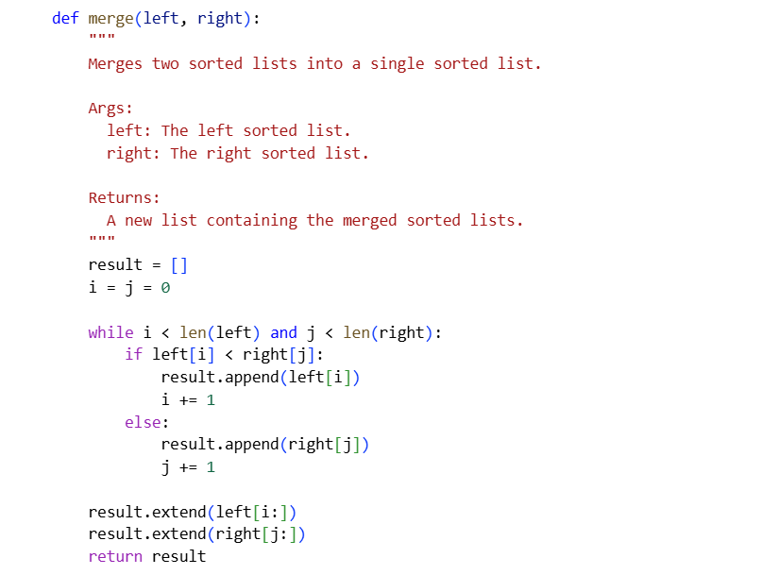
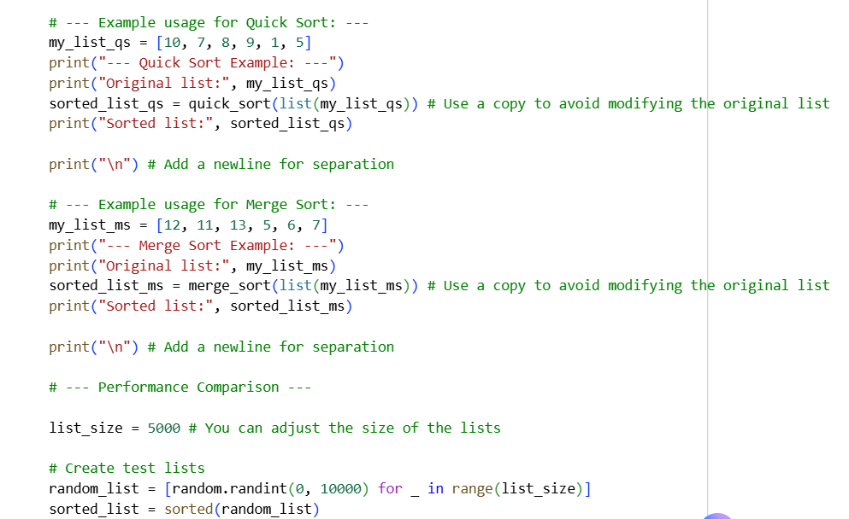
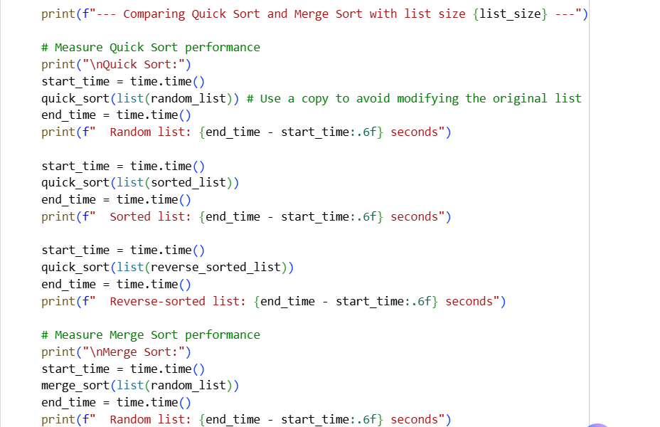
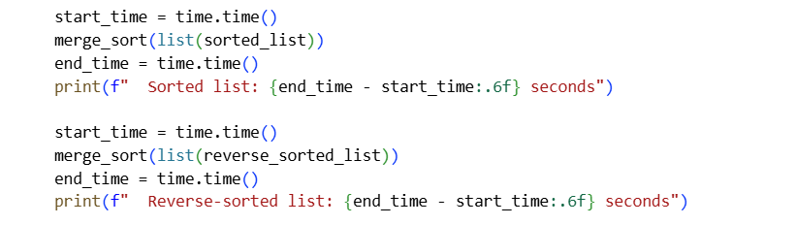

OUTPUT :
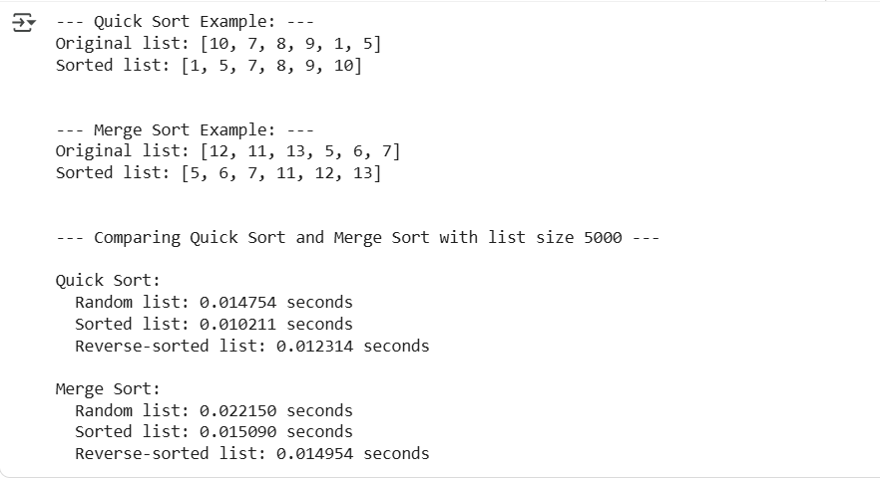

EXPLANATION :
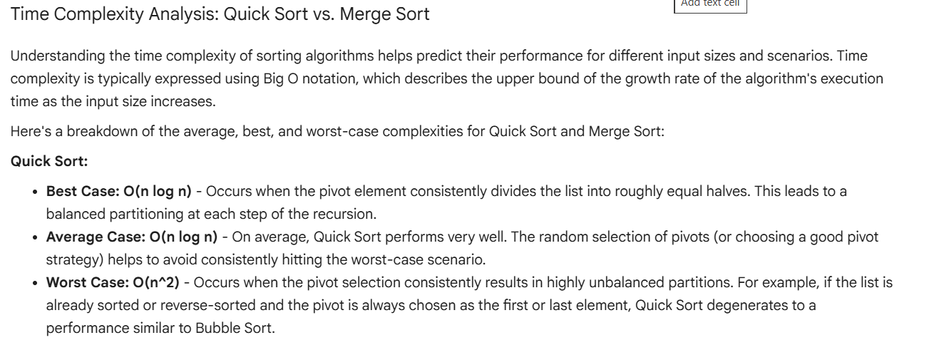
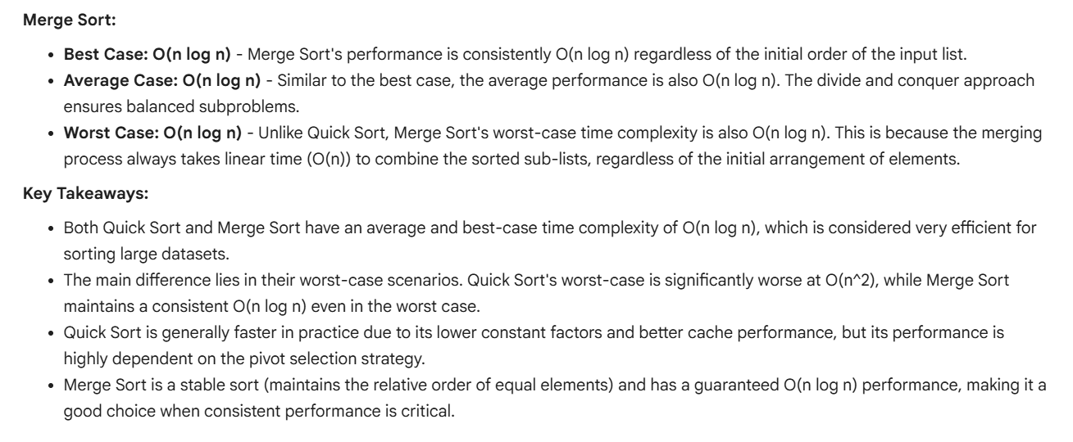

TASK 5
PROMPT :
- provide naive (brute-force) algorithm to find duplicates in a list having O(n²) time complexity
- now optimize the code by using sets/dictionaries with O(n) time) and explain how the time complexity improves and compare execution times for both methods using large input lists.
CODE :
1.
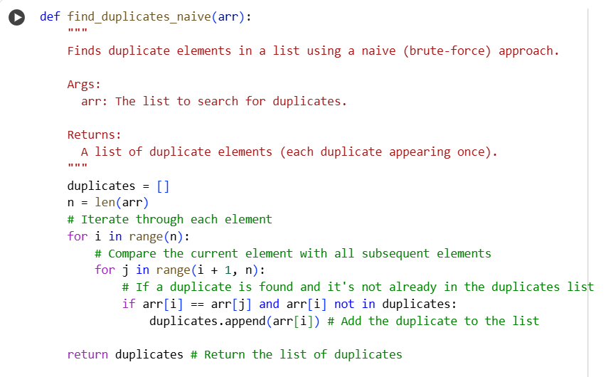
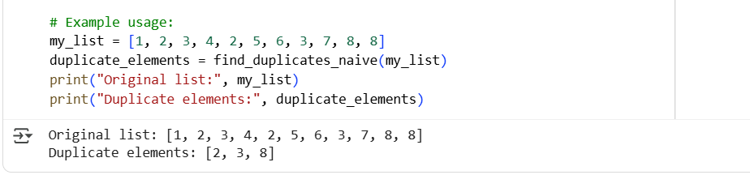

2.
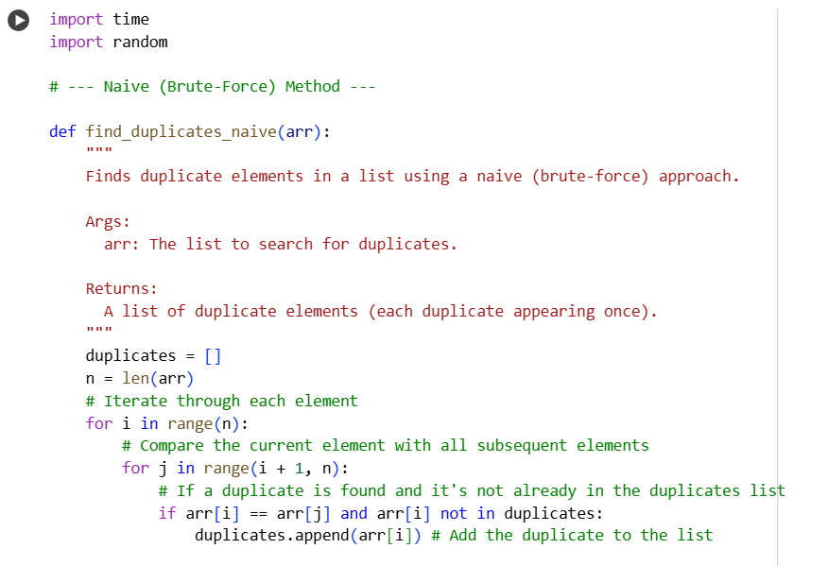
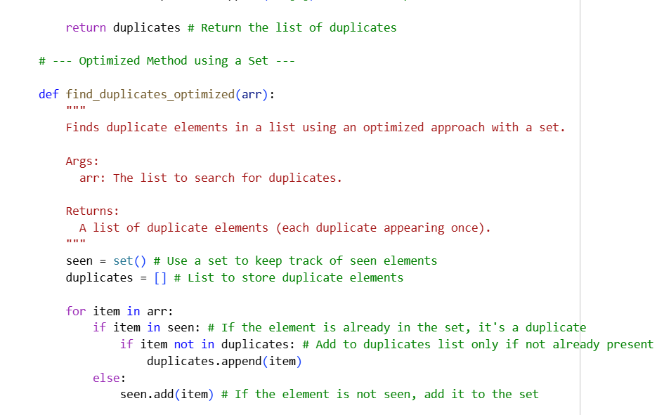
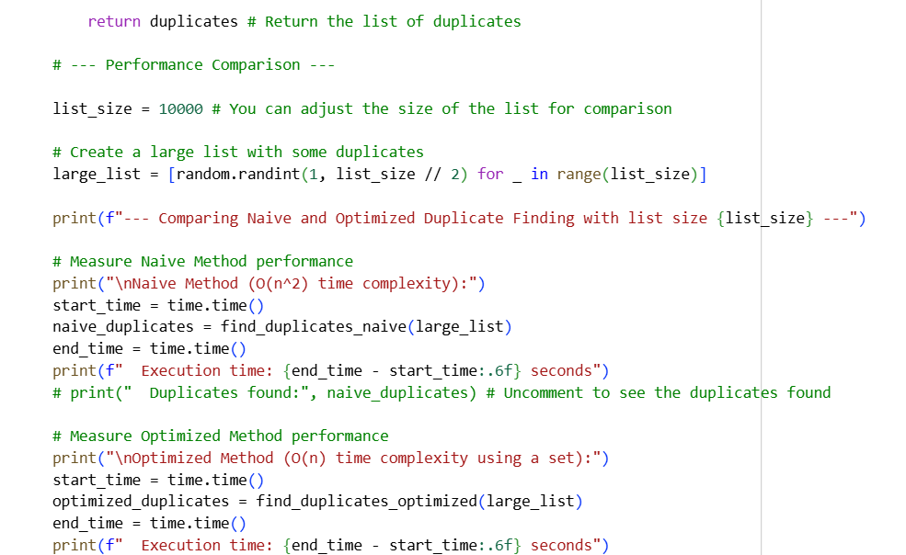
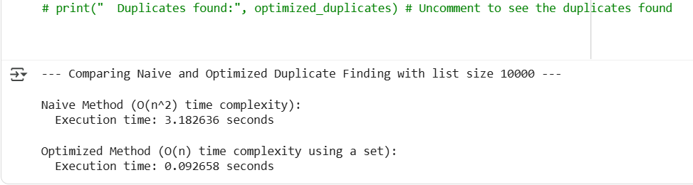

EXPLANATION :
