LAB ASSIGNMENT – 9.3

COURSE: AI ASSISTED CODING
HALLTICKET NO: 2403A51370
NAME: Gunda Sindhuja
BATCH: 15
SCHOOL OF COMPUTER SCIENCE AND ARTIFICIAL INTELLIGENCE |  |  |  |  | DEPARTMENT OF COMPUTER SCIENCE ENGINEERING
Program Name: B. Tech |  |  |  | Assignment Type: Lab |  |  | Academic Year:2025-2026
Course Coordinator Name |  |  |  | Venkataramana Veeramsetty
Instructor(s) Name |  |  |  | Dr. V. Venkataramana (Co-ordinator)  Dr. T. Sampath Kumar  Dr. Pramoda Patro  Dr. Brij Kishor Tiwari  Dr.J.Ravichander  Dr. Mohammand Ali Shaik  Dr. Anirodh Kumar  Mr. S.Naresh Kumar  Dr. RAJESH VELPULA  Mr. Kundhan Kumar  Ms. Ch.Rajitha  Mr. M Prakash  Mr. B.Raju  Intern 1 (Dharma teja)  Intern 2 (Sai Prasad)  Intern 3 (Sowmya)  NS_2 ( Mounika)
Course Code |  |  | 24CS002PC215 | Course Title |  | AI Assisted Coding
Year/Sem |  |  | II/I | Regulation |  | R24
Date and Day  of Assignment |  |  | Week5 - Thursday | Time(s)
Duration |  |  | 2 Hours | Applicable to  Batches
AssignmentNumber:10.4(Present assignment number)/24(Total number of assignments)
 | Q.No. | Question |  |  |  |  |  | Expected Time  to complete
 | 1 | Lab 10 – Code Review and Quality: Using AI to Improve Code Quality and Readability  Lab Objectives  - Use AI for automated code review and quality enhancement.  - Identify and fix syntax, logical, performance, and security issues in Python code.  - Improve readability and maintainability through structured refactoring and comments.  - Apply prompt engineering for targeted improvements.  - Evaluate AI-generated suggestions against PEP 8 standards and software engineering best practices  Task 1: Syntax and Error Detection  Task: Identify and fix syntax, indentation, and variable errors in the given script.  # buggy_code_task1.py  def add_numbers(a, b)  result = a + b  return reslt  print(add_numbers(10 20))  Expected Output:  - Corrected code with proper syntax (: after function, fixed variable name, corrected function call).  - AI should explain what was fixed.  Task 2: Logical and Performance Issue Review  Task: Optimize inefficient logic while keeping the result correct.  # buggy_code_task2.py  def find_duplicates(nums):  duplicates = []  for i in range(len(nums)):  for j in range(len(nums)):  if i != j and nums[i] == nums[j] and nums[i] not in duplicates:  duplicates.append(nums[i])  return duplicates  numbers = [1,2,3,2,4,5,1,6,1,2]  print(find_duplicates(numbers))  Expected Output:  - More efficient duplicate detection (e.g., using sets).  - AI should explain the optimization.  Task 3: Code Refactoring for Readability  Task: Refactor messy code into clean, PEP 8–compliant, well-structured code.  # buggy_code_task3.py  def c(n):  x=1  for i in range(1,n+1):  x=x*i  return x  print(c(5))  Expected Output:  Function renamed to calculate_factorial.  Proper indentation, variable naming, docstrings, and formatting.  AI should provide a more readable version.  Task 4: Security and Error Handling Enhancement  Task: Add security practices and exception handling to the code.  # buggy_code_task4.py  import sqlite3  def get_user_data(user_id):  conn = sqlite3.connect("users.db")  cursor = conn.cursor()  query = f"SELECT * FROM users WHERE id = {user_id};" # Potential SQL injection risk  cursor.execute(query)  result = cursor.fetchall()  conn.close()  return result  user_input = input("Enter user ID: ")  print(get_user_data(user_input))  Expected Output:  Safe query using parameterized SQL (? placeholders).  Try-except block for database errors.  Input validation before query execution.  Task 5: Automated Code Review Report Generation  Task: Generate a review report for this messy code.  # buggy_code_task5.py  def calc(x,y,z):  if z=="add":  return x+y  elif z=="sub": return x-y  elif z=="mul":  return x*y  elif z=="div":  return x/y  else: print("wrong")  print(calc(10,5,"add"))  print(calc(10,0,"div"))  Expected Output:  AI-generated review report should mention:  - Missing docstrings  - Inconsistent formatting (indentation, inline return)  - Missing error handling for division by zero  - Non-descriptive function/variable names  - Suggestions for readability and PEP 8 compliance |  |  |  |  |  | Week5 - Thursday

TASK 1
PROMPT:
Find the Error and correct the code.

CORRECTED CODE:
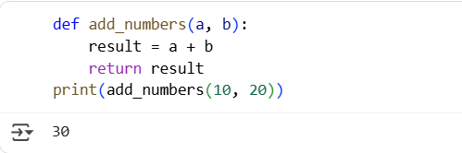
EXPLANATION:
The error message SyntaxError: expected ':' means that you are missing a colon at the end of the function definition line def add_numbers(a, b). Additionally, there's a typo in the return statement (reslt should be result) and a missing comma in the function call (10 20 should be 10, 20). I've corrected these errors in the code below.

TASK 2
PROMPT:
Optimize the code for more efficient duplicate detection.

CODE:
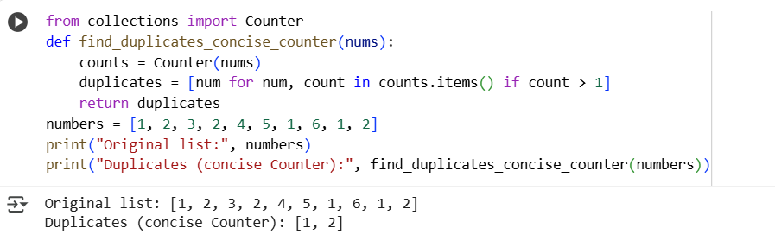
EXPLANATION:
This Python code uses collections.Counter to efficiently find duplicates in a list. First, it imports the Counter class. Then, a function find_duplicates_concise_counter is defined, taking a list nums. Inside the function, Counter(nums) quickly counts element occurrences, storing them in counts. A list comprehension [num for num, count in counts.items() if count > 1] creates the duplicates list. It iterates through counts, adding numbers with counts greater than 1 to duplicates. Finally, the function returns the duplicates list. The example demonstrates its usage with a sample list.

TASK 3
PROMPT :
Refactor the code to be clean, PEP 8–compliant, and more readable. Rename the function to calculate_factorial, use meaningful variable names, add docstrings, and keep the same functionality.

CORRECTED CODE:
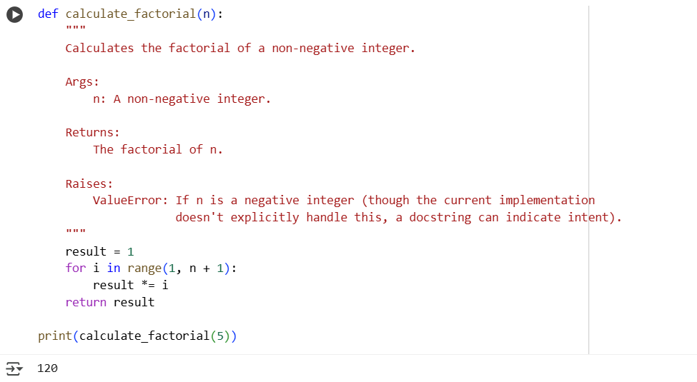
EXPLANATION:
This Python code defines a function called calculate_factorial that computes the factorial of a non-negative integer. It initializes a result variable to 1. Then, it iterates from 1 up to the input number n (inclusive). In each iteration, it multiplies the result by the current number i. After the loop finishes, the accumulated result holds the factorial value. The function then returns this result. The code demonstrates calling the function with the number 5 and printing the returned factorial. This is a standard iterative approach to calculating factorials.

TASK 4
PROMPT :
Refactor the code to add security practices and exception handling. Use parameterized SQL queries (? placeholders) instead of string formatting to prevent SQL injection, add a try-except block for database errors, and validate user input before running the query. Keep the same functionality.

CORRECTED CODE:
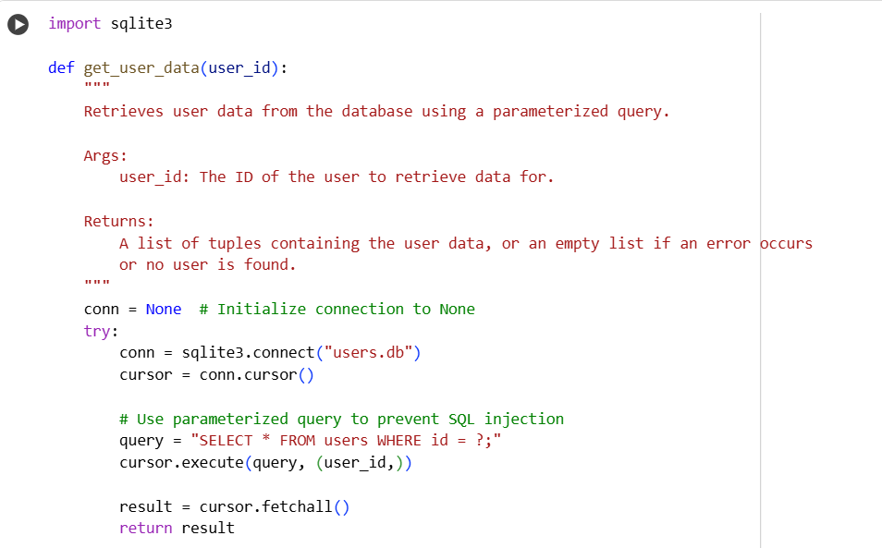
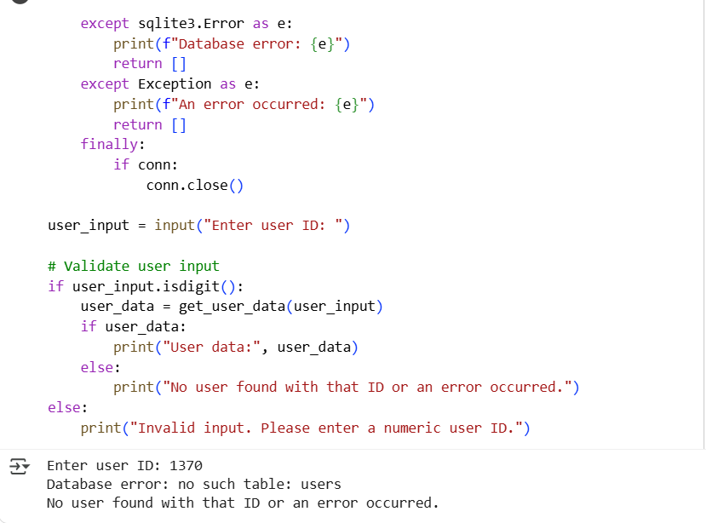
EXPLANATION:
This Python code retrieves user data from an SQLite database securely. It defines get_user_data that takes a user ID. Inside, it connects to users.db and uses a try-except block to handle potential database errors. Crucially, it uses a parameterized SQL query (?) to prevent SQL injection by separating the query structure from the user-provided data. The cursor.execute(query, (user_id,)) safely passes the user ID. It fetches and returns the results or an empty list on error. A finally block ensures the database connection is closed. The code also validates user input to ensure it's a number before querying.

TASK 5
PROMPT:
Generate an automated code review report for the code. The report should point out missing docstrings, inconsistent formatting (indentation, inline return), missing error handling for division by zero, non-descriptive function/variable names, and suggestions for readability and PEP 8 compliance.
CODE:
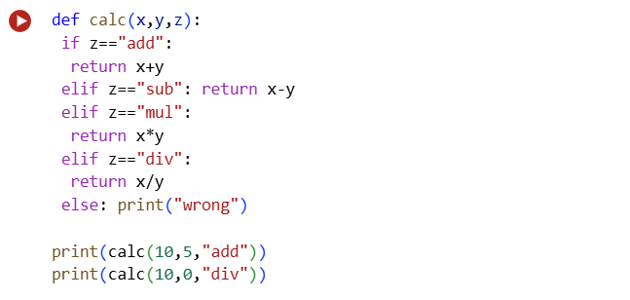

AI-generated review report:

