LAB ASSIGNMENT – 04

COURSE: AI ASSISTED CODING
HALLTICKET NO: 2403A51370
NAME: Gunda Sindhuja
BATCH: 15

SCHOOL OF COMPUTER SCIENCE AND ARTIFICIAL INTELLIGENCE |  |  |  |  | DEPARTMENT OF COMPUTER SCIENCE ENGINEERING
ProgramName:B. Tech |  |  |  | Assignment Type: Lab |  |  | AcademicYear:2025-2026
CourseCoordinatorName |  |  |  | Venkataramana Veeramsetty
Instructor(s)Name |  |  |  | Dr. V. Venkataramana (Co-ordinator)  Dr. T. Sampath Kumar  Dr. Pramoda Patro  Dr. Brij Kishor Tiwari  Dr.J.Ravichander  Dr. Mohammand Ali Shaik  Dr. Anirodh Kumar  Mr. S.Naresh Kumar  Dr. RAJESH VELPULA  Mr. Kundhan Kumar  Ms. Ch.Rajitha  Mr. M Prakash  Mr. B.Raju  Intern 1 (Dharma teja)  Intern 2 (Sai Prasad)  Intern 3 (Sowmya)  NS_2 ( Mounika)
CourseCode |  |  | 24CS002PC215 | CourseTitle |  | AI Assisted Coding
Year/Sem |  |  | II/I | Regulation |  | R24
Date and Day  of Assignment |  |  | Week2 - Wednesday | Time(s)
Duration |  |  | 2 Hours | Applicableto  Batches
AssignmentNumber:2.3(Present assignment number)/24(Total number of assignments)
 | Q.No. | Question |  |  |  |  |  | ExpectedTime  to complete
 | 1 | Lab 4: Advanced Prompt Engineering – Zero-shot, One-shot, and Few-shot Techniques  Lab Objectives:  - To explore and apply different levels of prompt examples in AI-assisted code generation.  - To understand how zero-shot, one-shot, and few-shot prompting affect AI output quality.  - To evaluate the impact of context richness and example quantity on AI performance.  - To build awareness of prompt strategy effectiveness for different problem types.  Lab Outcomes (LOs):  After completing this lab, students will be able to:  - Use zero-shot prompting to instruct AI with minimal context.  - Use one-shot prompting with a single example to guide AI code generation.  - Apply few-shot prompting using multiple examples to improve AI responses.  - Compare AI outputs across the three prompting strategies.  Task Description#1  - Zero-shot: Prompt AI to write a function that checks whether a given year is a leap year.  Expected Output#1  - AI-generated function with no examples provided  Task Description#2  - One-shot: Give one input-output example to guide AI in writing a function that converts centimeters to inches.  Expected Output#2  - Function with correct conversion logic  Task Description#3  - Few-shot: Provide 2–3 examples to generate a function that formats full names as “Last, First”.  Expected Output#3  - Well-structured function respecting the examples  Task Description#4  - Compare zero-shot and few-shot prompts for writing a function that counts the number of vowels in a string.  Expected Output#4  - Functional output and comparative reflection  Task Description#5  - Use few-shot prompting to generate a function that reads a .txt file and returns the number of lines.  Expected Output#5  - Working file-processing function with AI-guided logic  Note: Report should be submitted a word document for all tasks in a single document with prompts, comments & code explanation, and output and if required, screenshots  Evaluation Criteria:  Criteria Max Marks  Zero Shot (Task #1) 0.5  One Shot (Task#2) 0.5  Few Shot (Task#3 & Task #5) 1.0  Comparison (Task#4) 0.5  Total 2.5 Marks |  |  |  |  |  | Week2 - Wednesday

TASK 1:
PROMPT:
Write a Python Function that checks whether a given year is a leap year or not based on User input.

CODE:
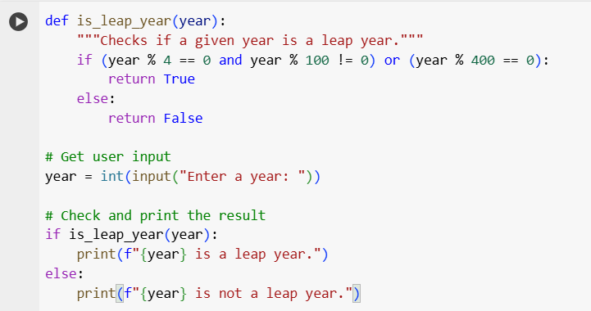

OUTPUT:
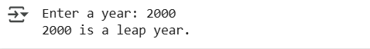
EXPLANATION:
This code checks if a year entered by the user is a leap year using a function that follows the rules for determining leap years. It then prints whether the year is a leap year or not.

TASK 2
PROMPT:
Write a Python Function that converts Centimeters to Inches based on User Input.For example if the input is 5 (in centimeters) the output should be 1.96 (in inches)

CODE:
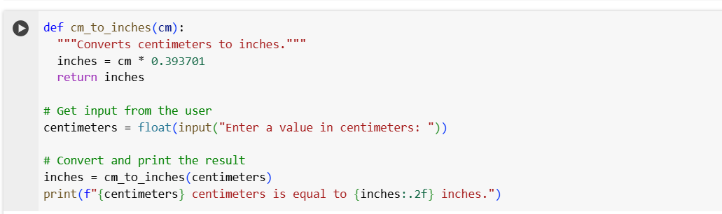

OUTPUT:
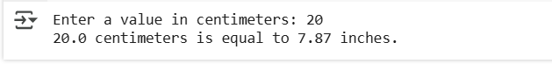
EXPLANATION:
This code defines a function cm-to_inches that takes a value in centimeters and converts it to inches by multiplying it by 0.393701. It then prompts the user to enter a centimeter value, calls the function to perform the conversion, and prints the result formatted to two decimal places.

TASK 3
PROMPT:
Write a Python Function that takes full name string as input and transforms in the format as “Last, First”. For example if the input is "Hardik Pandya" the output should be "Pandya, Hardik", if the input is "Virat Kohli" the output should be "Kohli, Virat", if the input is "Rohit Sharma" the output should be "Sharma, Rohit".

CODE:
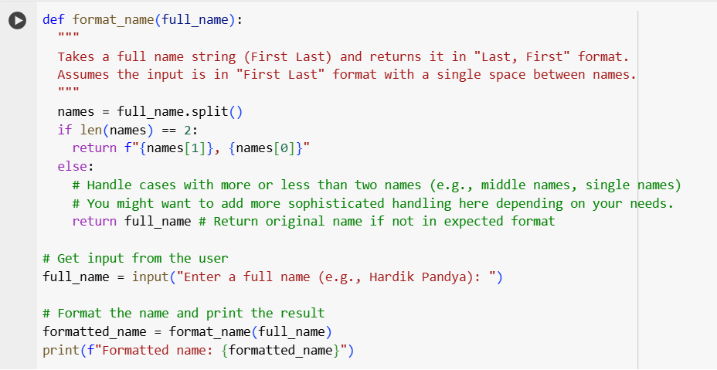

OUTPUT:

EXPLANATION:
This code defines a function called format_name that takes a full name
(like "First Last"), splits it into parts, and if there are two parts, it rearranges them to be "Last, First". If there are more or fewer than two parts, it returns the original name. The code then asks the user for a name and prints the formatted result.

TASK 4
PROMPT:
Zero-Shot Instruction: Write a function that counts the number of vowels in a string. Few-Shot Instruction: Count the number of vowels in a string. Vowels are: a, e, i, o, u (case-insensitive). Ignore non-alphabetic characters.For Example: Input: "hello" Output: 2, Input: "Python" Output: 1, Input: "Program" Output: 2

CODE:
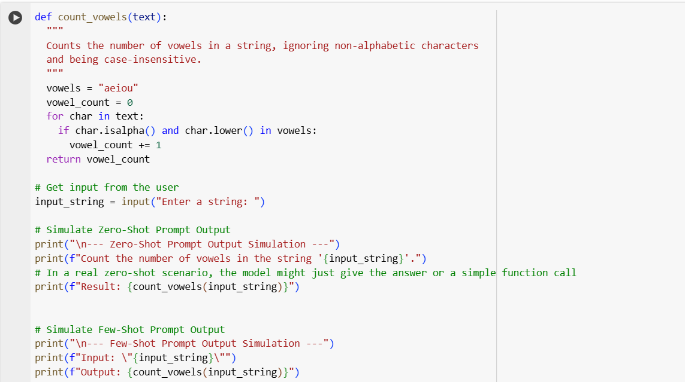
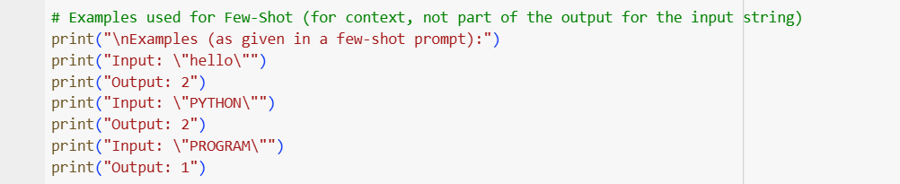

OUTPUT:
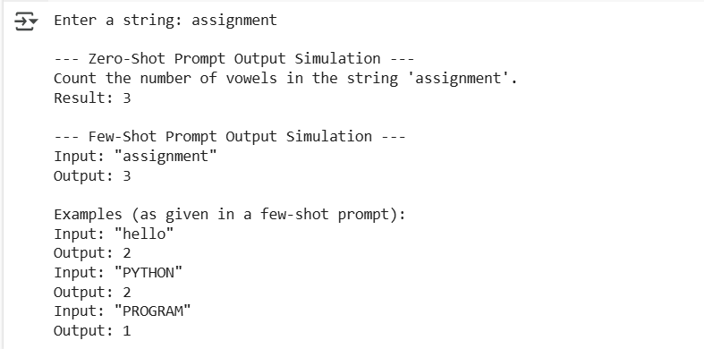
EXPLANATION:
This code takes a string input from the user, counts the number of vowels in it (ignoring case and non-alphabetic characters), and then prints the result in two different formats to simulate how a language model might respond to a zero-shot prompt (just the request and result) and a few-shot prompt (input-output pair with examples).

TASK 5
PROMPT:
Write a Python Function that reads a .txt file and returns the number of lines in it based on user entering the data into the file. For Example
1. in a file "example1.txt"
content:
line1
line2
The output should be 2 lines
2. in a file "example2.txt"
content:
hello world
welcome to class
learn python programming
The output should be 3 lines
3.in a file "example3.txt"
content:
good morning
The output should be 1 line

CODE:

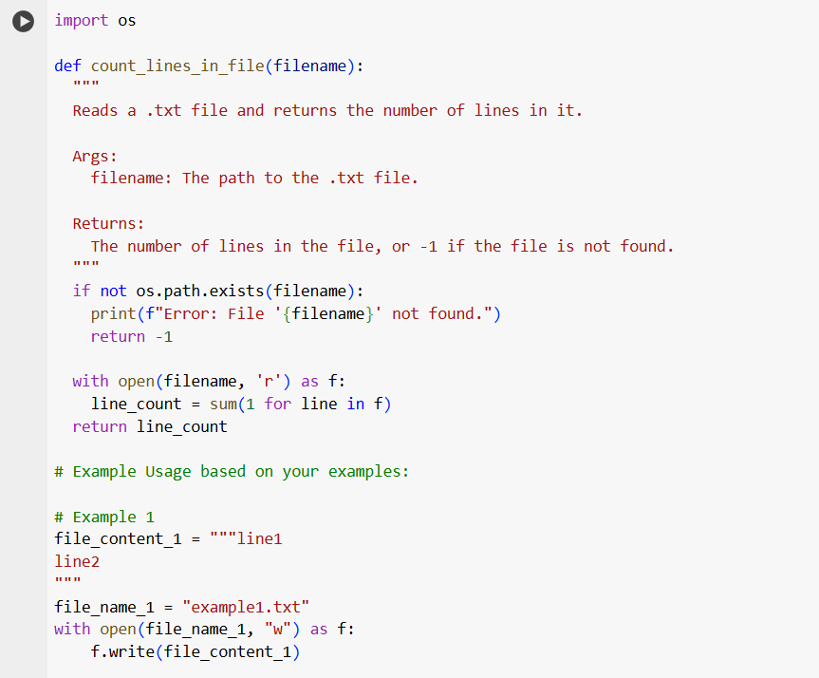
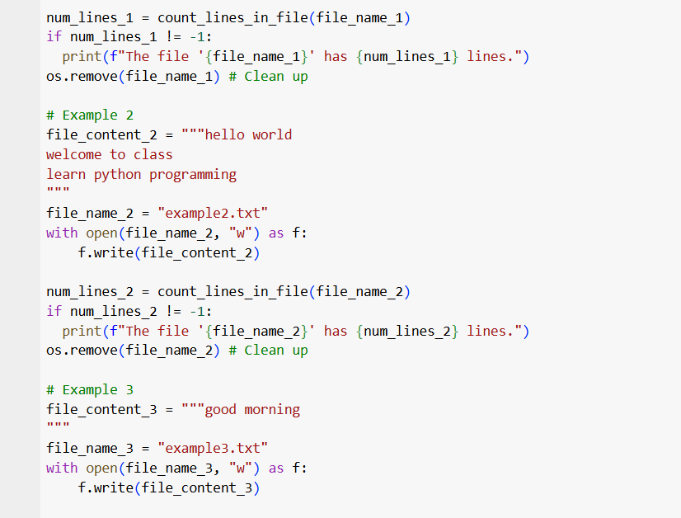
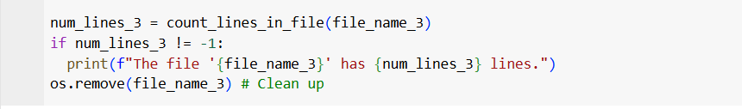

OUTPUT:
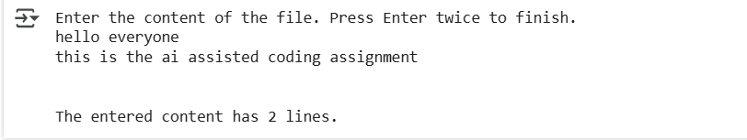

EXPLANATION:
This code prompts the user to enter multiple lines of text, reads their input until an empty line is entered, joins the lines into a single string, and then uses the splitlines() method to count the number of lines in the entered text and prints the result.

