LAB ASSIGNMENT – 4.1

COURSE : AI ASSISTED CODING

NAME : G.SINDHUJA

HALLTICKET NO : 2403A51370

BATCH : 15

SCHOOL OF COMPUTER SCIENCE AND ARTIFICIAL INTELLIGENCE |  |  |  |  | DEPARTMENT OF COMPUTER SCIENCE ENGINEERING
Program Name: B. Tech |  |  |  | Assignment Type: Lab |  |  | Academic Year:2025-2026
Course Coordinator Name |  |  |  | Venkataramana Veeramsetty
Instructor(s) Name |  |  |  | Dr. V. Venkataramana (Co-Ordinator)  Dr. T. Sampath Kumar  Dr. Pramoda Patro  Dr. Brij Kishor Tiwari  Dr.J.Ravichander  Dr. Mohammand Ali Shaik  Dr. Anirodh Kumar  Mr. S.Naresh Kumar  Dr. RAJESH VELPULA  Mr. Kundhan Kumar  Ms. Ch.Rajitha  Mr. M Prakash  Mr. B.Raju  Intern 1 (Dharma teja)  Intern 2 (Sai Prasad)  Intern 3 (Sowmya)  NS_2 ( Mounika)
Course Code |  |  | 24CS002PC215 | Course Title |  | AI Assisted Coding
Year/Sem |  |  | II/I | Regulation |  | R24
Date and Day  of Assignment |  |  | Week2 - Monday | Time(s)
Duration |  |  | 2 Hours | Applicable to  Batches
Assignment Number:4.1(Present assignment number)/24(Total number of assignments)
 | Q.No. | Question |  |  |  |  |  | Expected Time  to complete
 | 1 | Lab 4: Advanced Prompt Engineering – Zero-shot, One-shot, and Few-shot Techniques  Lab Objectives:  - To explore and apply different levels of prompt examples in AI-assisted code generation.  - To understand how zero-shot, one-shot, and few-shot prompting affect AI output quality.  - To evaluate the impact of context richness and example quantity on AI performance.  - To build awareness of prompt strategy effectiveness for different problem types.  Lab Outcomes (LOs):  After completing this lab, students will be able to:  - Use zero-shot prompting to instruct AI with minimal context.  - Use one-shot prompting with a single example to guide AI code generation.  - Apply few-shot prompting using multiple examples to improve AI responses.  - Compare AI outputs across the three prompting strategies.  Task #1 – Zero-Shot Prompting with Conditional Validation  Objective  Use zero-shot prompting to instruct an AI tool to generate a function that validates an Indian mobile number.  Requirements  - The function must ensure the mobile number:  - Starts with 6, 7, 8, or 9  - Contains exactly 10 digits  Prompt:  Write a Python program using function that validates an Indian mobile number based on user input that must starts with 6,7,8 or 9 and the number must contain 10 digits. If the number is Invalid mention the reason.  Code:  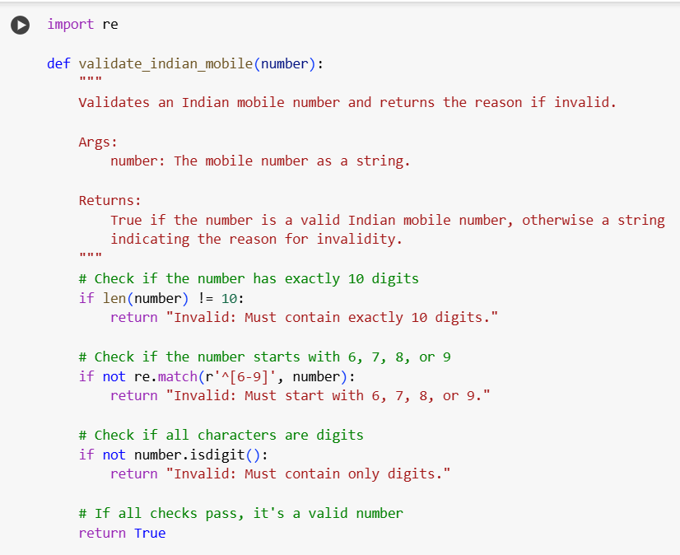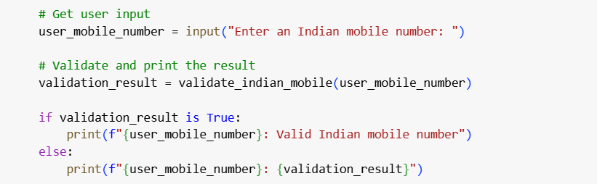  Output:  Explanation:  This Python code defines a function validate_indian_mobile that checks if a user-provided string is a valid 10-digit Indian mobile number starting with 6, 7, 8, or 9. If the number is invalid, the function returns a string explaining why (e.g., incorrect length, wrong starting digit, or contains non-digits). The program then takes user input, calls this function, and prints whether the number is valid or, if not, the reason for its invalidity.  Task #2 – One-Shot Prompting with Edge Case Handling  Objective:  Use one-shot prompting to generate a Python function that calculates the factorial of a number.  Requirements  - Provide one sample input-output pair in the prompt to guide the AI.  - The function should handle:  - 0! correctly  - Negative input by returning an appropriate message  Prompt:  Write a Python function to calculate Factorial of a number based on User Input.For example if the input is 5 the output should be 120. And it also generate output for 0 input and if the input is Negative it should raise an error by giving an appropriate message.  Code:  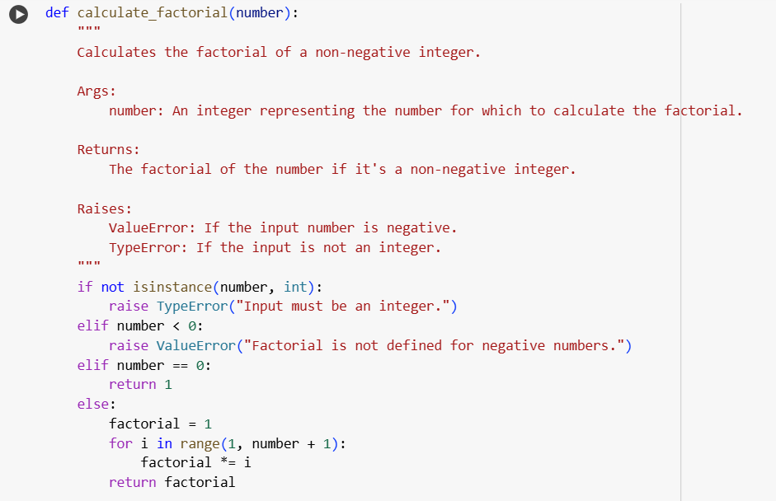  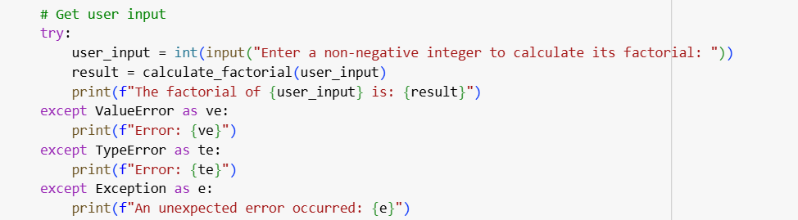  Output  Explanation:  This Python code defines a function calculate_factorial that computes the factorial of a non-negative integer. It specifically handles the case where the input is 0 (returning 1) and raises errors with messages for negative or non-integer inputs. The program then prompts the user for an integer, calls the function within a try-except block to handle potential errors, and prints the result or an error message.  Task #3 – Few-Shot Prompting for Nested Dictionary Extraction  Objective  Use few-shot prompting (2–3 examples) to instruct the AI to create a function that parses a nested dictionary representing student information.  Requirements  - The function should extract and return:  - Full Name  - Branch  - SGPA  Prompt:  Write Python Function that to exratct student full name,branch,sgpa from nested dictionaries representing student details based on user input. For Example:student_1 = { "student": { "personal_info": { "first_name": "virat", "last_name": "kohi" }, "academic_info": { "branch": "Computer Science", "grades": { "SGPA": 8.9 } } } } student_2 = { "student": { "personal_info": { "first_name": "hardik", "last_name": "pandya" }, "academic_info": { "branch": "Mechanical Engineering", "grades": { "SGPA": 9.1 } } } }  Code:  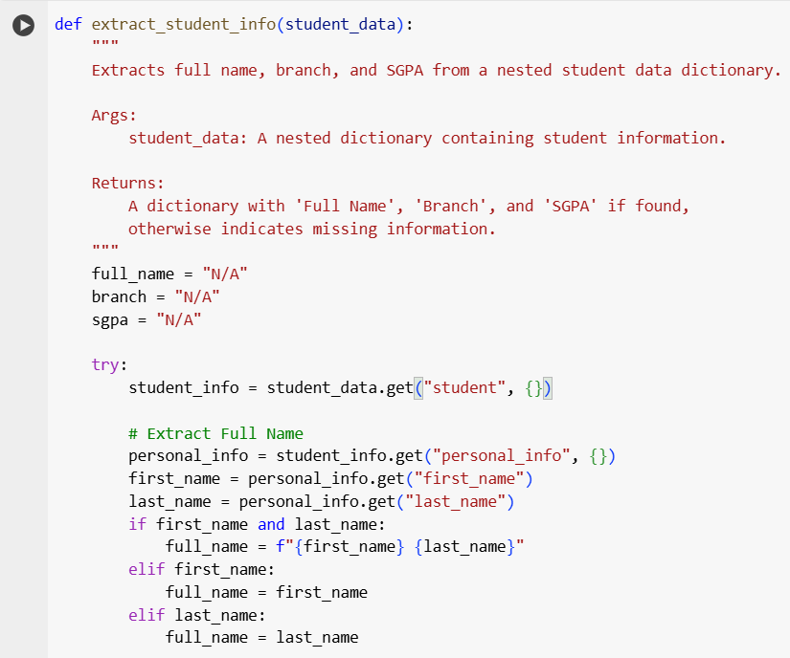  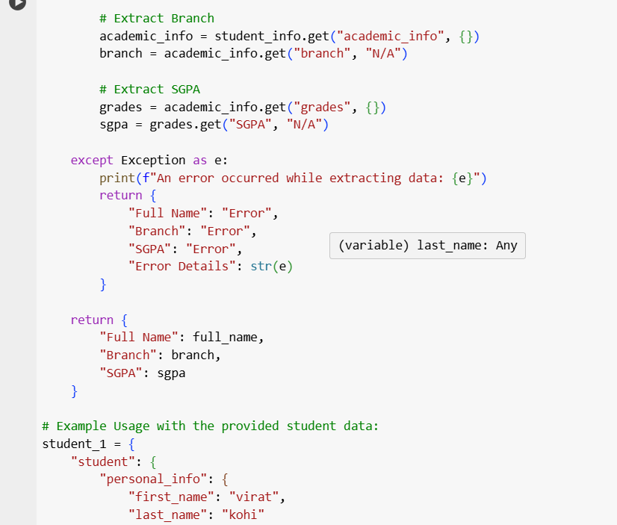  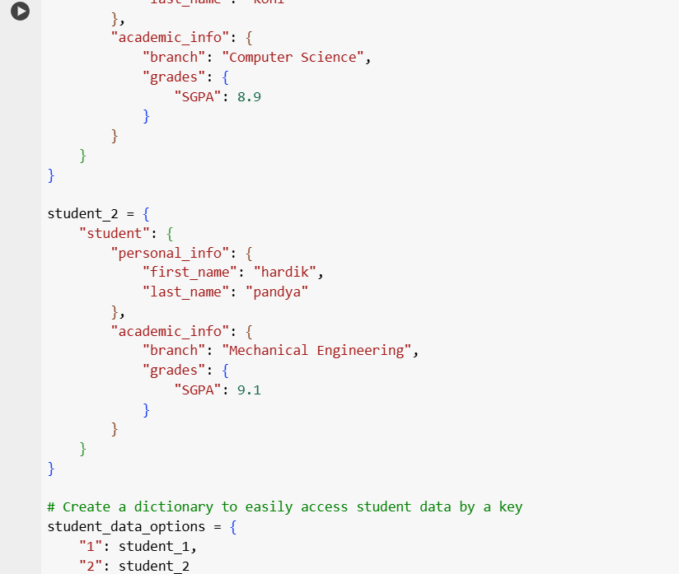  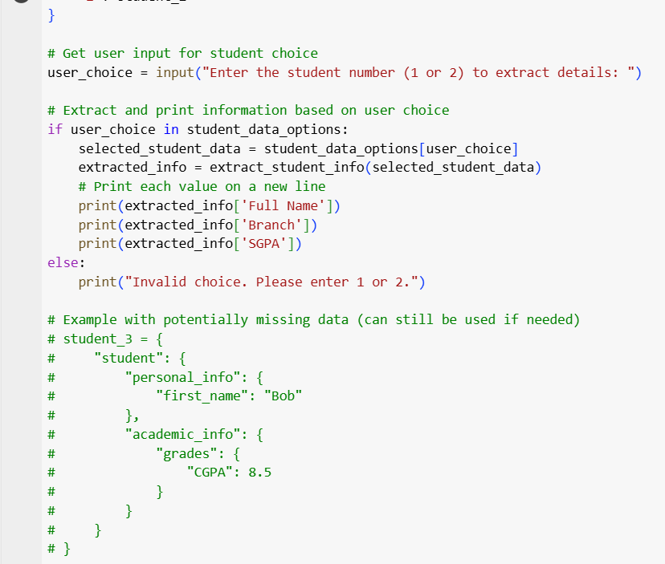  Output:  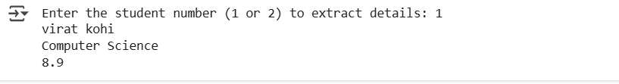  Explanation:  This Python code defines a function extract_student_info to get a student's full name, branch, and SGPA from a nested dictionary. It includes example student data and prompts the user to choose a student by number. Based on the user's input, it calls the function to extract the details and then prints the full name, branch, and SGPA on separate lines. It also handles invalid user input.  Task #4 – Comparing Prompting Styles for File Analysis  Objective  Experiment with zero-shot, one-shot, and few-shot prompting to generate functions for CSV file analysis.  Requirements  - Each generated function should:  - Read a .csv file  - Return the total number of rows  - Count the number of empty rows  - Count the number of words across the file  Expected Output  - Working Python functions for each prompting style, with a brief reflection comparing their accuracy, clarity, and efficiency.  Task #5 – Few-Shot Prompting for Text Processing and Word Frequency  Objective  Use few-shot prompting (with at least 3 examples) to generate a Python function that processes text and analyzes word frequency.  Requirements  The function must:  - Accept a paragraph as input  - Convert all text to lowercase  - Remove punctuation  - Return the most frequently used word  Expected Output  - A functional Python script that performs text cleaning, tokenization, and returns the most common word using only the examples provided in the prompt  Note: Report should be submitted a word document for all tasks in a single document with prompts, comments & code explanation, and output and if required, screenshots  Evaluation Criteria:  Criteria Max Marks  Zero Shot (Task #1) 0.5  One Shot (Task#2) 0.5  Few Shot (Task#3, Task#4 & Task #5) 1.5  Total 2.5 Marks |  |  |  |  |  | Week2 - Monday

