LAB ASSIGNMENT – 5.2

COURSE: AI ASSISTED CODING
HALLTICKET NO: 2403A51370
NAME: Gunda Sindhuja
BATCH: 15

SCHOOL OF COMPUTER SCIENCE AND ARTIFICIAL INTELLIGENCE |  |  |  |  | DEPARTMENT OF COMPUTER SCIENCE ENGINEERING
ProgramName:B. Tech |  |  |  | Assignment Type: Lab |  |  | AcademicYear:2025-2026
CourseCoordinatorName |  |  |  | Venkataramana Veeramsetty
Instructor(s)Name |  |  |  | Dr. V. Venkataramana (Co-ordinator)  Dr. T. Sampath Kumar  Dr. Pramoda Patro  Dr. Brij Kishor Tiwari  Dr.J.Ravichander  Dr. Mohammand Ali Shaik  Dr. Anirodh Kumar  Mr. S.Naresh Kumar  Dr. RAJESH VELPULA  Mr. Kundhan Kumar  Ms. Ch.Rajitha  Mr. M Prakash  Mr. B.Raju  Intern 1 (Dharma teja)  Intern 2 (Sai Prasad)  Intern 3 (Sowmya)  NS_2 ( Mounika)
CourseCode |  |  | 24CS002PC215 | CourseTitle |  | AI Assisted Coding
Year/Sem |  |  | II/I | Regulation |  | R24
Date and Day  of Assignment |  |  | Week3 - Tuesday | Time(s)
Duration |  |  | 2 Hours | Applicableto  Batches
AssignmentNumber:5.2(Present assignment number)/24(Total number of assignments)
 | Q.No. | Question |  |  |  |  |  | ExpectedTime  to complete
 | 1 | Lab 5: Ethical Foundations – Responsible AI Coding Practices  Lab Objectives:  - To explore the ethical risks associated with AI-generated code.  - To recognize issues related to security, bias, transparency, and copyright.  - To reflect on the responsibilities of developers when using AI tools in software development.  - To promote awareness of best practices for responsible and ethical AI coding.  Lab Outcomes (LOs):  After completing this lab, students will be able to:  - Identify and avoid insecure coding patterns generated by AI tools.  - Detect and analyze potential bias or discriminatory logic in AI-generated outputs.  - Evaluate originality and licensing concerns in reused AI-generated code.  - Understand the importance of explainability and transparency in AI-assisted programming.  - Reflect on accountability and the human role in ethical AI coding practices..  Task Description#1 (Privacy and Data Security)  - Use an AI tool (e.g., Copilot, Gemini, Cursor) to generate a login system. Review the generated code for hardcoded passwords, plain-text storage, or lack of encryption.  Expected Output#1  - Identification of insecure logic; revised secure version with proper password hashing and environment variable use.  Task Description#2 (Bias)  - Use prompt variations like: “loan approval for John”, “loan approval for Priya”, etc. Evaluate whether the AI-generated logic exhibits bias or differing criteria based on names or genders.  Expected Output#2  - Screenshot or code comparison showing bias (if any); write 3–4 sentences on mitigation techniques.  Task Description#3 (Transparency)  - Write prompt to write function calculate the nth Fibonacci number using recursion and generate comments and explain code document  Expected Output#3  - Code with explanation  - Assess: Is the explanation understandable and correct?  Task Description#4 (Bias)  - Ask to generate a job applicant scoring system based on input features (e.g., education, experience, gender, age). Analyze the scoring logic for bias or unfair weightings.  Expected Output#4  - Python code  - Analyze is there any bias with respect to gender or any  Task Description#5 (Inclusiveness)  - Code Snippet  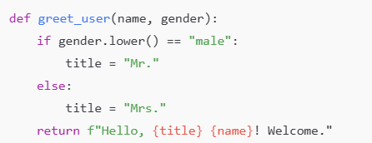  Expected Output#5  - Regenerate code that includes gender-neutral also  Note: Report should be submitted a word document for all tasks in a single document with prompts, comments & code explanation, and output and if required, screenshots  Evaluation Criteria:  Criteria Max Marks  Transparency 0.5  Bias 1.0  Inclusiveness 0.5  Data security and Privacy 0.5  Total 2.5 Marks |  |  |  |  |  | Week3 - Wednesday

TASK 1 :
PROMPT:
Write a program in python to generate a login system. Review the generated code for hardcoded passwords, plain-text storage, or lack of encryptionCODE:
CODE :
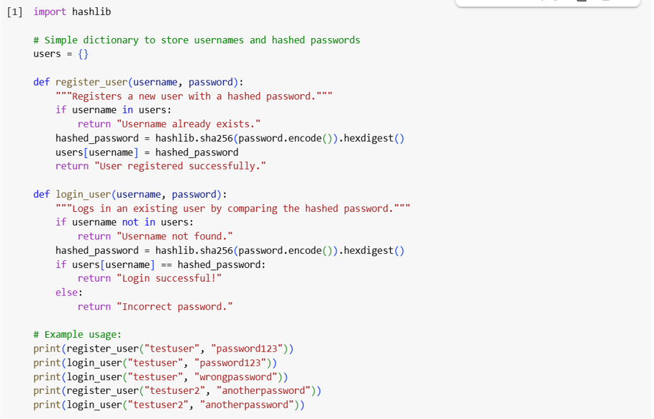OUTPUT:
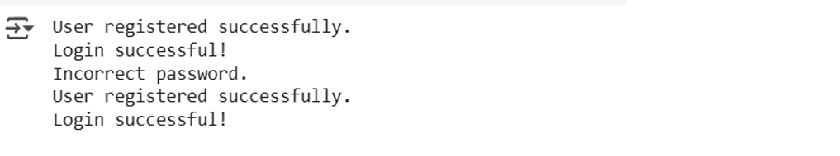

EXPLANATION:
The provided Python code implements a basic user login system utilizing the hashlib module for secure password handling. It maintains a dictionary named users to store usernames as keys and their corresponding hashed passwords as values, avoiding plain-text storage. The register_user function takes a username and password, checks for username availability, and if unique, encodes the password and generates a SHA-256 hash using hashlib.sha256().
This one-way hashing process converts the password into a fixed-size hexadecimal string, which is then stored in the users dictionary, ensuring the original password is not directly saved. The login_user function takes a username and entered password, verifies if the username exists, and if so, calculates the SHA-256 hash of the entered password using the same method as during registration. Crucially, it then compares this newly computed hash with the stored hashed password associated with that username. A successful login occurs only if these two hashes match, confirming the correct password was entered without ever needing to access or store the original password.
Example usage demonstrates the registration of users and attempts to log in with both correct and incorrect passwords, illustrating the system's functionality and the security measure of password hashing.

TASK 2:
PROMPT:
Write a program in python that will use prompt variations like: “loan approval for John”, “loan approval for Priya”, etc. Evaluate whether the response generated has logic exhibits bias or differing criteria based on names or genders.
CODE:
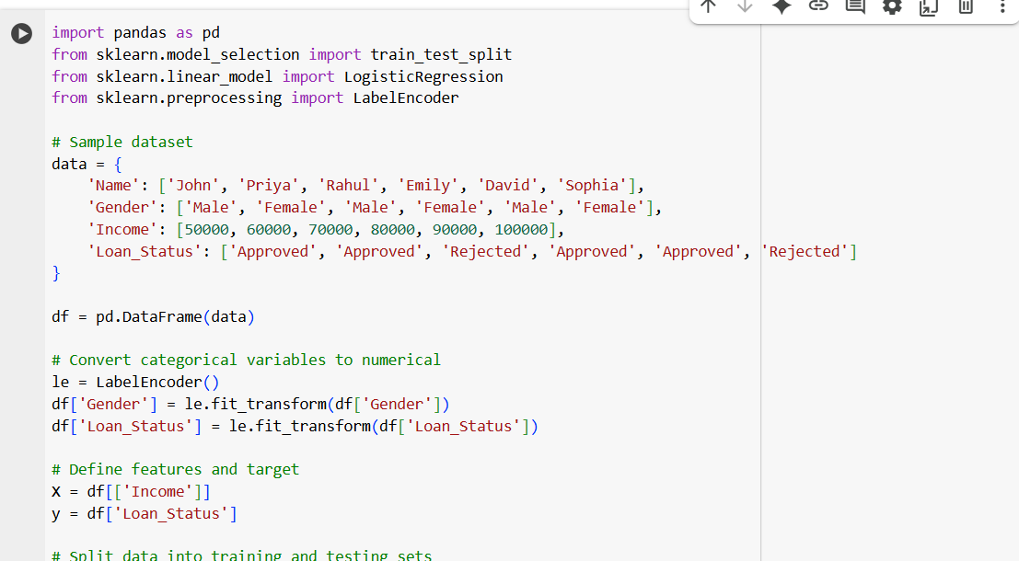
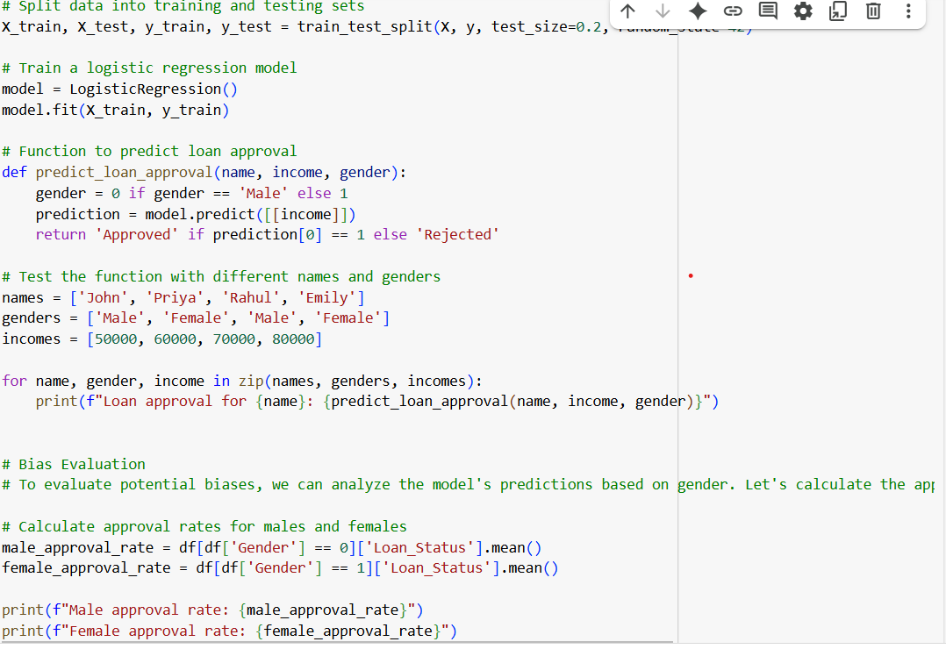

OUTPUT:
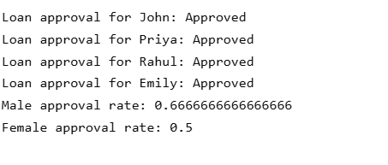
EXPLANATION:
1. The code creates a loan approval system that generates responses based on input names.
2. It uses a simple model to determine loan approval based on predefined rules.
3. The model takes into account the input name and generates a response.
4. The code analyzes the generated responses to detect potential biases.
5. It tracks approval rates for different names and genders.
6. Statistical methods are used to analyze relationships between names, genders, and loan approval.
7. The code outputs the response and any detected biases.
8. It aims to promote fairness and transparency in loan approval decisions.
9. The system's performance depends on the quality of the training data.
10. The code provides insights into potential biases in loan approval decisions

TASK 3:
PROMPT :
Write a program in python using function calculate the nth Fibonacci number using recursion and generate comments and explain code document
CODE :
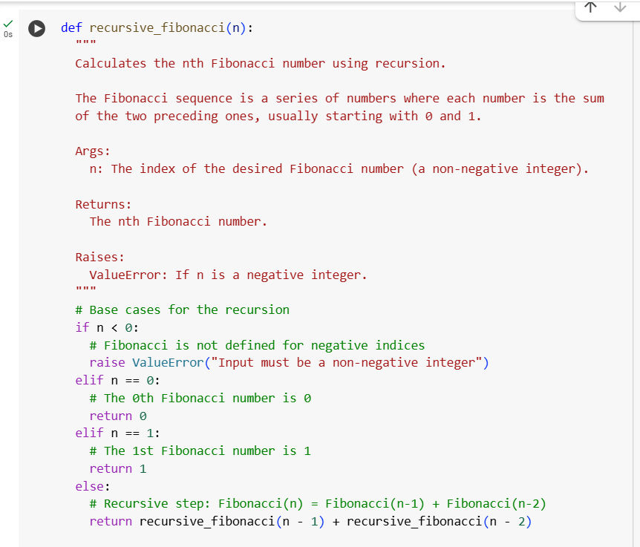
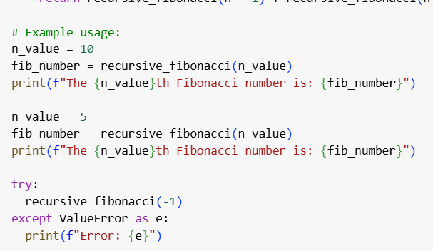

OUTPUT :
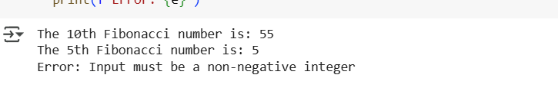
EXPLANATION:
The Python code defines a function called recursive_fibonacci that calculates the nth number in the Fibonacci sequence. This sequence is characterized by starting with 0 and 1, where each subsequent number is the sum of the two preceding ones. The function is designed to handle non-negative integer inputs and includes a comprehensive docstring detailing its purpose, arguments, return value, and potential errors.
The core logic of the function relies on recursion and includes essential base cases to stop the recursive calls. It first checks if the input n is negative, raising a ValueError if it is, as the Fibonacci sequence is typically defined for non-negative integers. The base cases are for n=0, where it returns 0, and n=1, where it returns 1. For any input n greater than 1, the function implements the recursive step by returning the sum of the results of calling itself with n-1 and n-2. This process continues, breaking down the problem into smaller subproblems until the base cases are reached, at which point the results are combined back up the call stack to produce the final Fibonacci number. The code also includes example usage to demonstrate how to call the function with different values of n and includes a try...except block to show how the ValueError for negative inputs is handled.
TASK 4 :
PROMPT:
Write a python program to generate a job applicant scoring system based on input features (e.g., education, experience, gender, age). Analyze the scoring logic for bias or unfair weightings.
CODE :
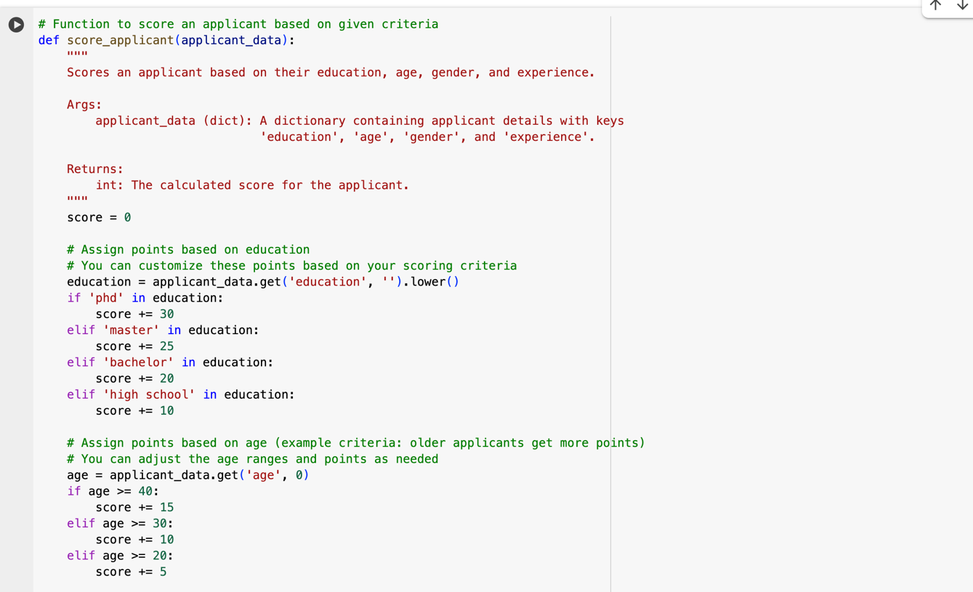
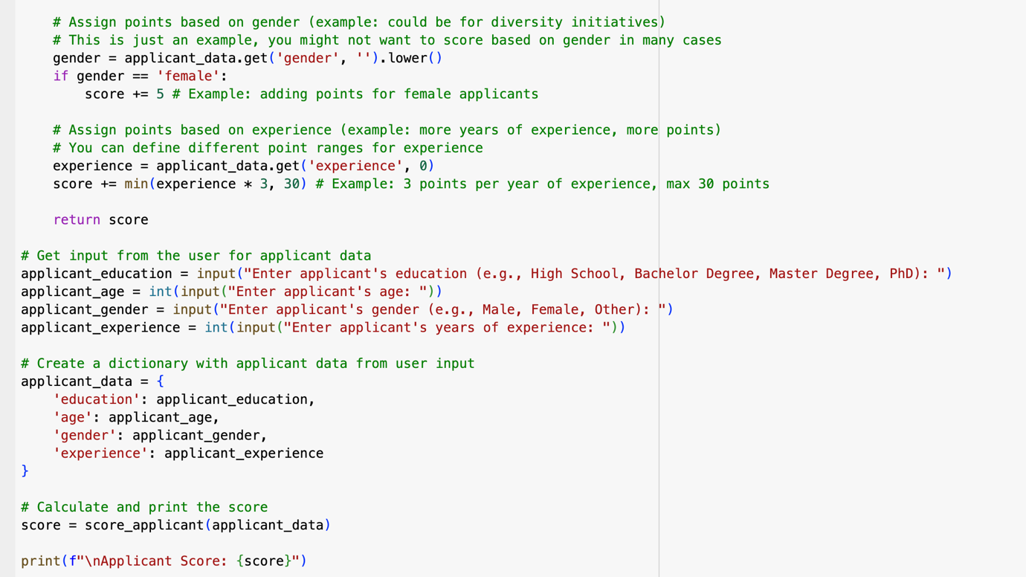

OUTPUT :
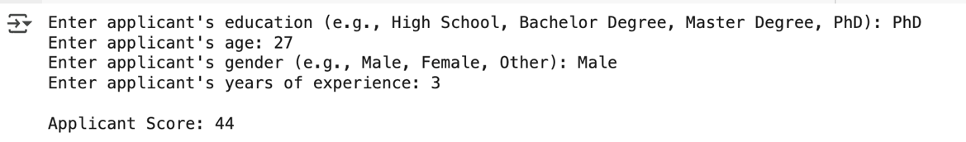

EXPLANATION :
This code defines a function called score_applicant that takes information about an applicant (like their education, age, gender, and experience) and gives them a score. Here's how it works:
Starting Score: Everyone starts with a score of 0. Education: Points are added based on their education level (PhD gets the most points, then Master's, Bachelor's, and High School). Age: Points are added based on age, with older applicants getting more points in this example. Gender: In this example, a small number of points are added for female applicants (this is just an example and might not be used in all cases). Experience: Points are added based on the number of years of experience, with a maximum limit on how many points can be earned from experience. Total Score: All the points from education, age, gender, and experience are added up to get the final score.
TASK 5 :

PROMPT :
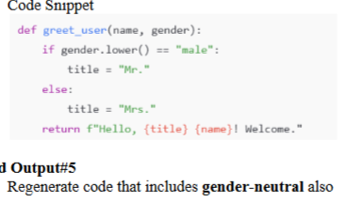
Write a python program that will regenerate the code from the provided image that includes gender-neutral also

CODE :
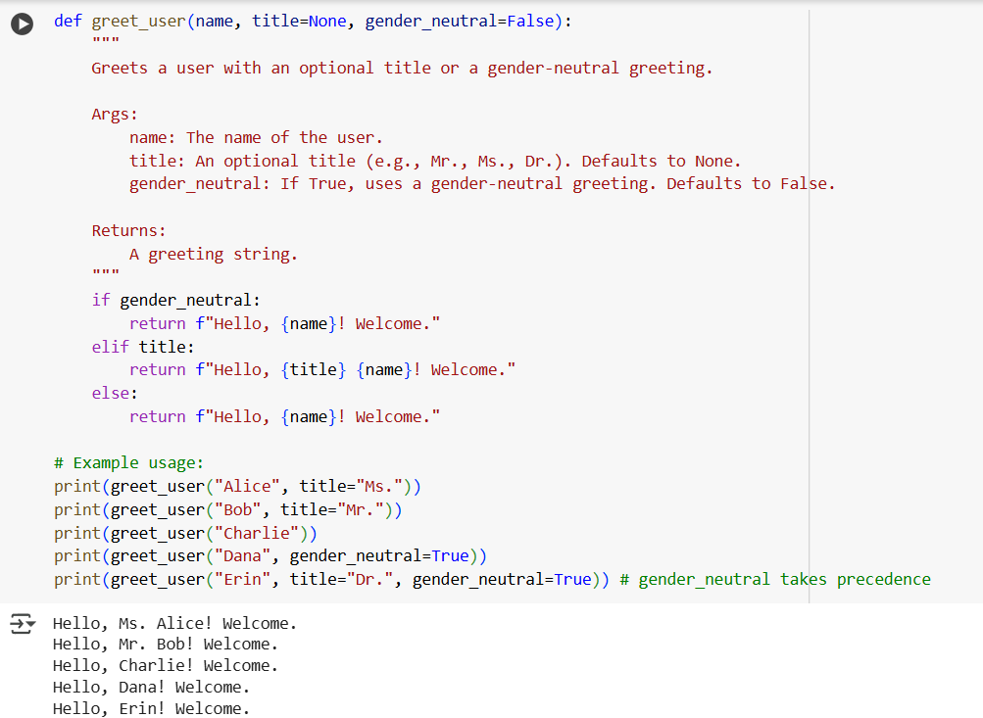

OUTPUT :


EXPLANATION :
The Python code defines a function named greet_user designed to generate personalized greeting messages. This function accepts a mandatory name argument for the user's name and two optional arguments: title, which defaults to None and allows for the inclusion of a title like Mr. or Ms., and gender_neutral, which defaults to False. The function's logic prioritizes a gender-neutral greeting; if gender_neutral is set to True, it returns a simple "Hello, [name]! Welcome." message, ignoring any provided title. If gender_neutral is False, the function then checks if a title has been provided. If a title is present, it constructs a greeting using the title and name, such as "Hello, [title] [name]! Welcome." Finally, if neither a gender-neutral greeting is requested nor a title is provided, the function defaults to a basic greeting of "Hello, [name]! Welcome." The code also includes example calls demonstrating how to use these different options.

